Skander Botakoz

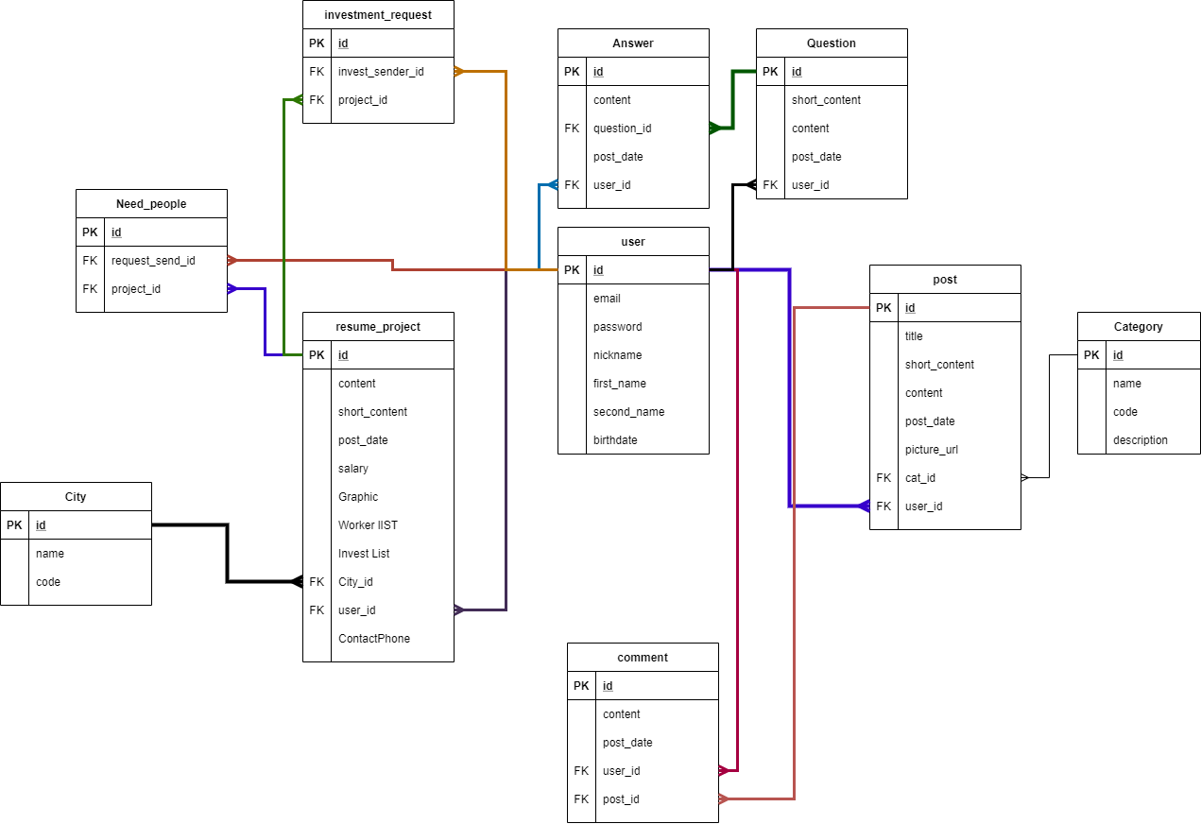

Model

using System;

using System.Collections.Generic;

using System.Linq;

using System.Web;

namespace project22.Models

{

public class Answer

{

public int AnswerId { get; set; }

public String Content { get; set; }

public DateTime PostDate { get; set; }

public int? QuestionId { get; set; }

public Question Question { get; set; }

public int? UserId { get; set; }

public User User { get;set; }

}

}

using System;

using System.Collections.Generic;

using System.Linq;

using System.Web;

using project22.Models;

namespace project22.Models

{

public class Category

{

public int Id { get; set; }

public String Name { get; set; }

public String Code { get; set; }

public String Description { get; set; }

public ICollection<Post> Posts { get; set; }

public Category()

{

Posts = new List<Post>();

}

}

}

using System;

using System.Collections.Generic;

using System.Linq;

using System.Web;

namespace project22.Models

{

public class City

{

public int Id { get; set; }

public String Name { get; set; }

public String Code { get; set; }

public ICollection<ResumeProject> ResumeProjects { get; set; }

public City()

{

ResumeProjects = new List<ResumeProject>();

}

}

}

using System;

using System.Collections.Generic;

using System.Linq;

using System.Web;

namespace project22.Models

{

public class Comment

{

public int CommentId { get; set; }

public String Content { get; set; }

public DateTime PostDate { get; set; }

public int? UserId { get; set; }

public User User { get;set; }

public int? PostId { get; set; }

public Post Post { get; set; }

}

}

using System;

using System.Collections.Generic;

using System.Linq;

using System.Web;

namespace project22.Models

{

public class InvestmentRequest

{

public int InvestmentRequestId { get; set; }

public int? UserId { get; set; }

public User User { get; set; }

public int? ResumeProjectId { get; set; }

public ResumeProject ResumeProject { get; set; }

}

}

using System;

using System.Collections.Generic;

using System.Linq;

using System.Web;

namespace project22.Models

{

public class Post

{

public int PostId { get; set; }

public String Title { get; set; }

public String ShortContent { get; set; }

public String Content { get; set; }

public String PictureUrl{ get; set; }

public DateTime PostDate { get; set; }

public int? CategoryId { get; set; }

public Category Category { get; set; }

public int? UserId { get; set; }

public User User { get; set; }

public ICollection<Comment> Comments { get; set; }

public Post()

{

Comments = new List<Comment>();

}

}

}

using System;

using System.Collections.Generic;

using System.Linq;

using System.Web;

namespace project22.Models

{

public class Question

{

public int QuestionId { get; set; }

public String ShortContent { get; set; }

public String Content { get; set; }

public DateTime PostDate { get; set; }

public int? UserId { get; set; }

public User User { get; set; }

public ICollection<Answer> Answers { get; set; }

public Question()

{

Answers = new List<Answer>();

}

}

}

using System;

using System.Collections.Generic;

using System.Linq;

using System.Web;

namespace project22.Models

{

public class ResumeProject

{

public int ResumeProjectId { get; set; }

public String Title { get; set; }

public String Content { get; set; }

public String ShortContent { get; set; }

public DateTime PostDate { get; set; }

public double Salary { get; set; }

public bool InvestList { get; set; }

public bool WorkerList { get; set; }

public String ContactPhone { get; set; }

public String Graphic { get; set; }

public int? CityId { get; set; }

public City City { get; set; }

public int? UserId { get; set; }

public User User { get; set; }

public ICollection<InvestmentRequest> InvestmentRequests { get; set; }

public ICollection<WorkerRequest> WorkerRequests { get; set; }

public ResumeProject()

{

InvestmentRequests = new List<InvestmentRequest>();

WorkerRequests = new List<WorkerRequest>();

}

}

}

using System;

using System.Collections.Generic;

using System.Linq;

using System.Web;

using System.Data.Entity;

namespace project22.Models

{

public class StartupContext:DbContext

{

public DbSet<Answer> Answers { get; set; }

public DbSet<Question> Questions { get; set; }

public DbSet<Category> Categories { get; set; }

public DbSet<City> Cities { get; set; }

public DbSet<Comment> Comments { get; set; }

public DbSet<InvestmentRequest> InvestmentRequests { get; set; }

public DbSet<Post> Posts { get; set; }

public DbSet<ResumeProject> ResumeProjects { get; set; }

public DbSet<WorkerRequest> WorkerRequests { get; set; }

public DbSet<User> Users { get; set; }

}

}

using System;

using System.Collections.Generic;

using System.Linq;

using System.Web;

namespace project22.Models

{

public class User

{

public int Id { get; set; }

public String Email { get; set; }

public String Password { get; set; }

public String Nickname { get; set; }

public String FirstName { get; set; }

public String SecondName { get; set; }

public DateTime Birthdate { get; set; }

public ICollection<Post> Posts { get; set; }

public ICollection<Answer> Answers { get; set; }

public ICollection<Comment> Comments { get; set; }

public ICollection<Question> Questions { get; set; }

public ICollection<ResumeProject> ResumeProjects { get; set; }

public ICollection<InvestmentRequest> InvestmentRequests { get; set; }

public ICollection<WorkerRequest> WorkerRequests { get; set; }

public User()

{

Posts = new List<Post>();

Answers = new List<Answer>();

Questions = new List<Question>();

Comments = new List<Comment>();

ResumeProjects = new List<ResumeProject>();

InvestmentRequests = new List<InvestmentRequest>();

WorkerRequests = new List<WorkerRequest>();

}

}

}

using System;

using System.Collections.Generic;

using System.Linq;

using System.Web;

namespace project22.Models

{

public class WorkerRequest

{

public int WorkerRequestId { get; set; }

public int? UserId { get; set; }

public User User { get; set; }

public int? ResumeProjectId { get; set; }

public ResumeProject ResumeProject { get; set; }

}

}



