# Duel – User Manual

**DUEL**

**A thrilling fight to the death across an array of buttons**

## Table of Contents

Duel – User Manual 1

Table of Contents 2

1.1 Introduction 3

1.2 How to install 3

1.2.1 Glossary of terms 6

1.2.2 How to play 7

1.2.3 In-Depth Game Mechanics 8

## Introduction

This program is a fully automated digital version of the game duel. It was designed for the St James Boys School Duel Society but can be downloaded and used anywhere. The interface is easy to use and everything you need to know about what the game is and how to play it is explained in this user manual.

## How to install

The program is distributed in a ZIP file. This ZIP file is called Duel. From your location of download into the C: Drive. (Picture below). Users are emailed this file and, after downloading the file from your Email program or website it will be located in this folder. Browse to C:\Users\**YOURNAME**\Downloads

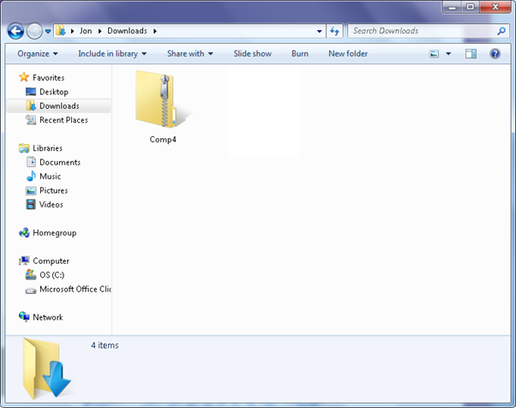

Right click the file and Select Extract all

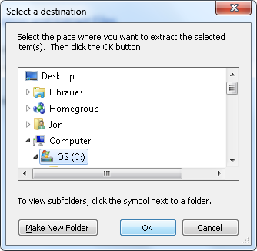Select the C: Drive (Important)

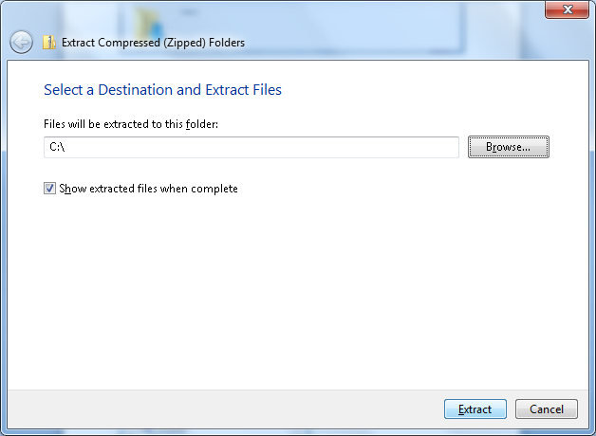Extract

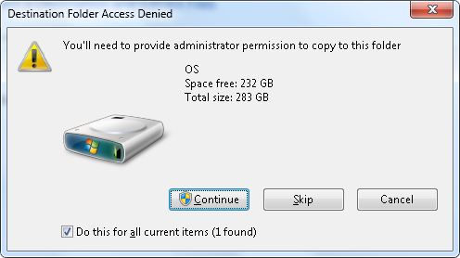

Press continue to this screen

Browse to C:\ and simply double click the file



### Glossary of terms

**Duel**: The game that is the heart of my coursework. Any use of the word **duel** within my coursework refers to the game (unless stated otherwise).

**Duel Board**: The 8x8 grid on which the game is played.

**Avatar**: Each player controls a fictional character on the board and they move this ‘person’ around and fight the other players’ character with it. This character is called an avatar.

**Inventory**: Items that the avatar is carrying with them on the game board.

**The Scribe**: The player designated to take note of information about both players’ avatars Etc.

**A Round**: A round is the time from either the last death of an Avatar to the next death of an Avatar, or from the beginning of the game to the first death of an Avatar. At the beginning of a game of duel the number of rounds is agreed upon. This is much like the concept, in tennis, of a number of games being defined as a match.

**Health Points (HP)**: A measurement of how much damage an Avatar can take before they die. When a new game begins each Avatar has 100 HP. This can increase by levelling up. HP is measured, in the HP bar, and a player loses the round when their Avatar’s health reaches 0.

**Champion**: The Avatar with health remaining at the end of a round.

**A Game**: A game is a set of rounds. The number of rounds is defined at the beginning of the game and must be written down by the scribe. The number of rounds must be odd to ensure that a champion emerges victorious.

**Coins**: In-Game currency awarded for completing a round. Both players will receive coins at the end of each round for participation and the Champion receives bonus coins for winning.

**Armoury**: A place for players to exchange their coins for weapons and armour.

**Experience Points (XP)**: Avatars are awarded XP as they fight. XP is gained every time the enemy Avatar is damaged. XP is calculated relative to the size of the damage inflicted. XP contributes to the XP-Meter of an Avatar. Every time the XP-Meter is filled the related Avatar gains a level. Avatars start with 0 xp.

**Avatar Level**: Starting at level 1, an Avatar gains levels through the accumulation of XP. With each level comes an increase in Health and the stats of an Avatar.

**Vital Statistics (Stats)**: Each Avatar has a set of statistics which define how much damage they can inflict on the enemy Avatar. The base statistics of an Avatar are enhanced through gaining levels and can be further increased through the use of weapons and armour (For as long as they are wielded by the avatar).

**Resurrection**: At the beginning of each round both Avatars are restored to full health. Everything is carried over from the previous round (as if death/loss of health had not occurred).This includes XP, Health, and Inventory etc.

**Obstacle**: A square on the board which cannot be accessed and must be walked around. 2 per round

### How to play

Duel is a game in which two players battle each other on the duel board until one of the players’ avatars is killed. Every death ends a round and a game is made up of a set of rounds. The game requires the players to employ a mix of tactics and good fortune to win the game with the roll of a die.

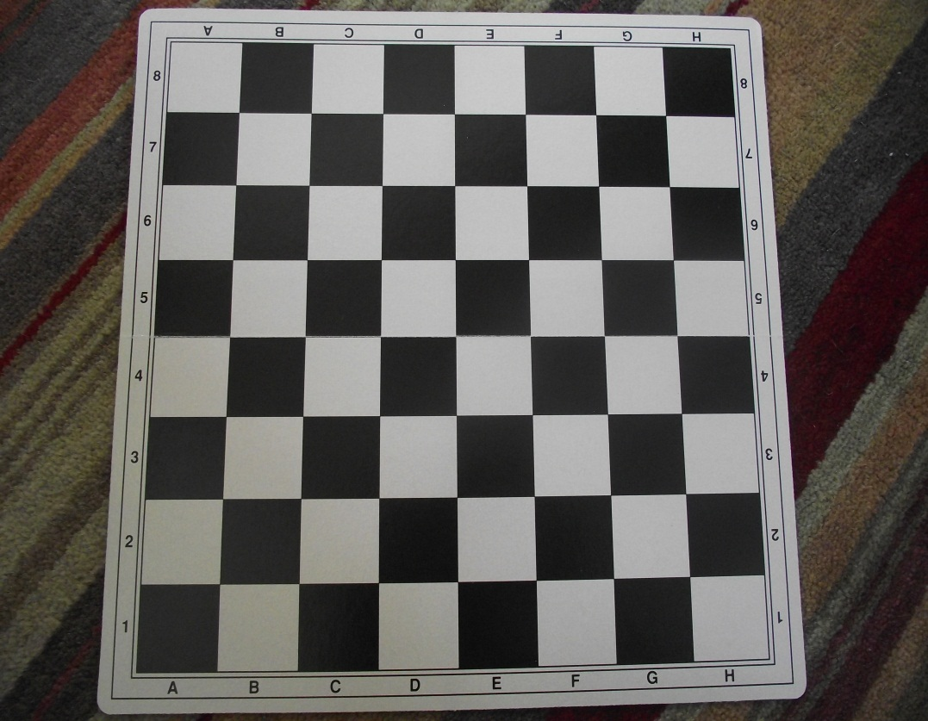Duel is played on an 8x8 grid. A standard chess board is usually used to avoid having to draw out the game arena by hand. Each players’ avatar is represented by a counter, usually a simple square of paper. Information about the players’ avatar and inventory is stored on a sheet of paper which is annotated by the scribe.

*Above: A “Duel Board”*

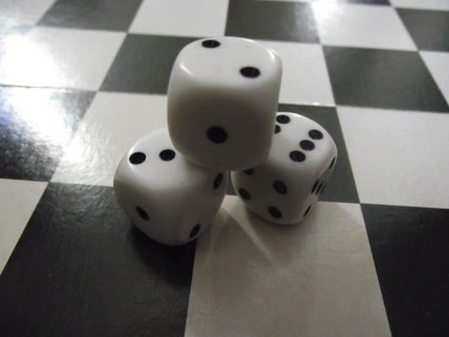Players take turns to move around the board, moving round obstacles, attacking each other using weapons from the armoury until one of the Avatars is killed. Death occurs when an Avatar’s health reaches 0. Coins are awarded to each Avatar at the end of each round and XP is rewarded relative to damage done to the enemy Avatar. At the beginning of the next round Avatars are restored to full health, keeping all previously gained items and stats. The game continues until the round limit defined at the beginning of the game is reached. The player who has won the most rounds wins the game.

Dice are used in the game to calculate damage and how far an Avatar can move that turn.

### In-Depth Game Mechanics

The following section is a run through of a round of duel from start to finish. Refer to **Glossary of terms** for all Duel-related words used.

* Before the game begins the amount of rounds that will make up the game is agreed upon (must be odd).
* Each Avatar begins the game with the following stats and equipment.
  + 100 Health Points (HP)
  + 0 Experience Points (XP)
  + 0 coins
  + A Sword (In their Inventory)
  + Stats: 0% Defence, 40% Accuracy, 1 Strength
* The Duel board is reset at the beginning of every round. Obstacles and Avatars are replaced.
* Avatars are randomly placed in one of the squares (1 to 64) on the board. This is calculated by rolling two six sided die. The first dice determines the multiple of ten and the second dice digit following it. Rolls of 5 and 6 are discounted on the second dice, if the first dice rolls a 6, and it must be re-rolled till a value of 1 to 4 is attained. As an example, if two dice are rolled and the numbers facing up are 3 and 2 then the Avatar is placed on the 32nd square. If the dice show 6 and 5 then the second dice must be re-rolled.
* Obstacles are placed in the same way. 2 obstacles are placed per round. Obstacles cannot be placed in the following places, 1-4 in the diagram, at the same time (to prevent blocking movement of an Avatar).
* Each turn comprises of 2 stages: Movement and Combat. The armoury can be used at any point in either players turn.
* Avatars can move up to 6 squares each turn. A six-sided dice is rolled and this determines how far an Avatar can move that turn. Moves must be into adjacent squares, not diagonally (as shown in the diagram).

|  |  |  |  |  |  |  |  |
| --- | --- | --- | --- | --- | --- | --- | --- |
|  | **1** |  |  |  |  | **2** |  |
| **1** |  |  |  |  |  |  | **2** |
|  |  |  |  |  |  |  |  |
|  |  |  |  |  |  |  |  |
|  |  |  | **A** |  |  |  |  |
|  |  |  |  |  |  |  |  |
| **3** |  |  |  |  |  |  | **4** |
|  | **3** |  |  |  |  | **4** |  |

*Obstacles cannot block the corners, Diagonal moves are illegal*

* When two Avatars are adjacent to each other on the board they may attack each other. You cannot attack diagonally (similar to movement).
* Players attack each other in turns: blow for blow. This will sometimes mean that the player who attacks first wins due to the other Avatar always having lower health than them; however this can be combatted by improving stats and wielding better weapons and armour.

#### Combat

The combat system in Duel is split into several sections.

1. Accuracy / Weapons and Armour
2. Base hit
3. Stat-Multiplier
4. XP
5. Level
6. Coins

Damage is calculated by multiplying the base hit by the attacking Avatars’ strength stat. This damage is then taken from the enemy Avatars’ Health Points.

Accuracy/ Weapons and Armour

Before damage is done, Accuracy determines whether an Avatar will hit or not. Accuracy is calculated by adding the Accuracy stat of the attacking Avatar to its weapon and subtracting the defensive stat of the defending Avatar and its armour. Accuracy is measured as a percentage. When you begin a new game your avatar has an Accuracy of 40%. Weapons stack additively with the Accuracy stat and armour stacks additively with the defence stat.

The sword, your starting weapon, has an Accuracy of 10% meaning that you start each new game with a 50% chance of hitting your opponent.

Base Hit

The base hit is calculated from the roll of a six-sided dice multiplied by two. A roll of six would create a base hit of 12.

Stat-Multiplier

The base hit is then multiplied by the Strength stat of the Avatar. A base hit of 12 would stay at 12 damage when multiplied by the starting Strength of 1.

XP

XP is awarded relative to how much damage is done. 12 damage would give 12 XP. XP needed for each level increases in increments of 10. The XP needed for level 2 is 100 XP. Level 5 requires 140XP (140XP from level 4, accumulatively it would be more).

Level

You can gain up to 5 levels in duel. With each level comes 10 HP and increase of the Defence, Accuracy and Strength stat.

* HP increases in increments of 10 up to a maximum of 140 HP
* Defence can be increased in increments of 5% to a maximum of 20%
* Accuracy can be increased in increments of 10% to a maximum of 80%
* Strength can be increased in increments of 1 to a maximum of 5

Coins

Coins are received at 10% of all damage done. Inflicting 10 damage would give an Avatar 1 coin. Coins can be used in the armoury to purchase weapons and armour.

* Once the combat phase has begun, the Avatars cannot move. This is to prevent cowardice through fleeing battle.
* The combat phase ends when one of the Avatars reaches 0HP. The Board is then reset and the next round begins. If the final round ends then the player who has killed his opponent more times than he has been killed is crowned the Champion of the match and the game ends.

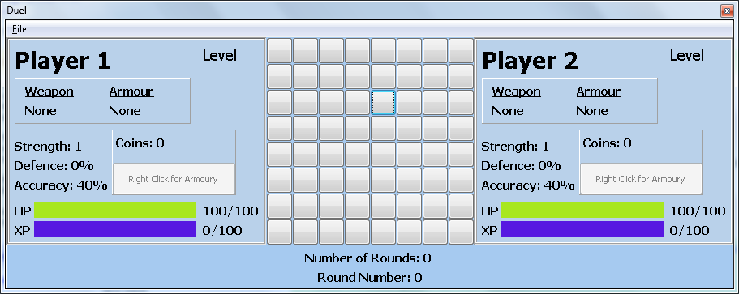

The interface is simple to use.

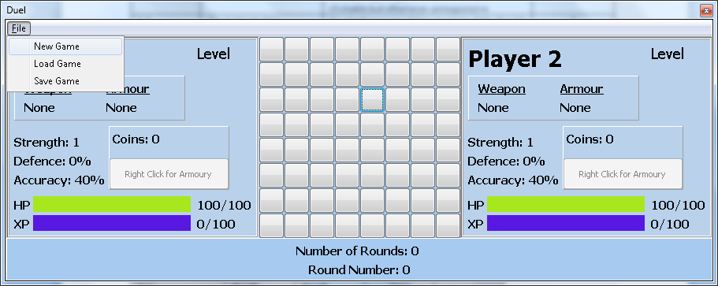

Start a new game, Load a game, or save a game using the File tab