# The first schoolwork of Computational Physics

万炫均 物理1701 U201710170

**Description of this chapter:**

This chapter aims to master the basic skill of using Fortran language to program.

1. Input and output

* Description of the problem:

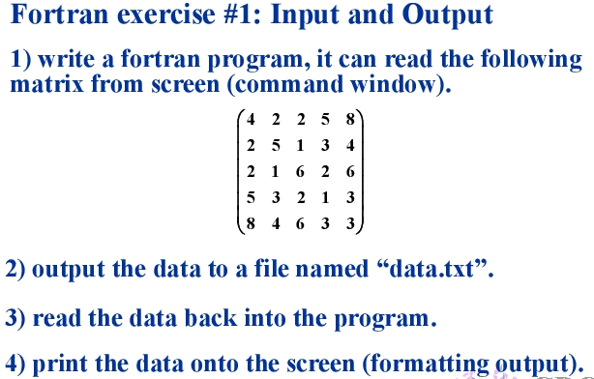

* The formula to use:

None

* Flow chart

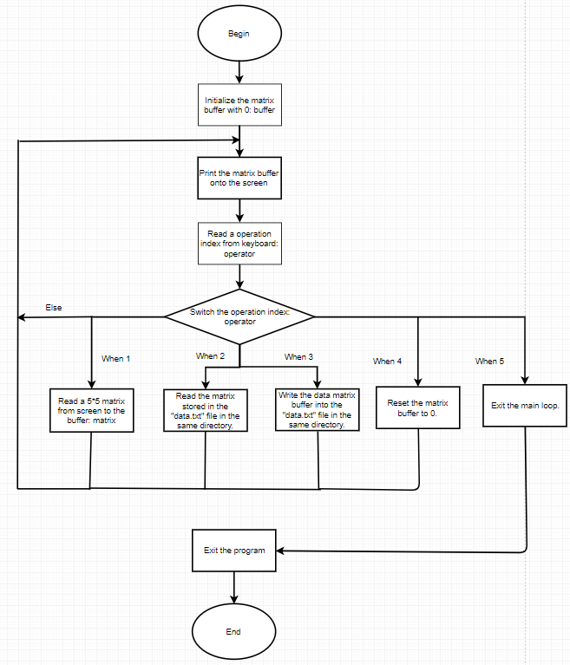

* Source code:

program IOProgram

*!Hyper parameter the dim of the matrix*

    integer,parameter :: ndim = 5

    real*8 :: matrix(ndim,ndim) = 0

    integer :: operator

*!Main function loop*

    do while (.true.)

        print *,"======================="

        print *,"Current buffered matrix"

*!Print buffered matrix*

        do i = 1, ndim

            print"(5f8.3)",matrix(i,:)

        end do

        call ReadOperator(operator)

        select case(operator)

            case (1)

                call ReadMatrixFromScreen(matrix)

            case (2)

                call ReadMatrixFromFile(matrix)

            case (3)

                call SaveMatrixToFile(matrix)

            case (4)

                matrix = 0

                 print *,"Reseted the matrix buffer"

            case (5)

                exit

            case default

                print *,"Wrong operation number!"

                cycle

        end select

    end do

end program

subroutine ReadOperator(operator)

    integer,intent(out) :: operator

    print *,"Choose the command you would like to use."

    print *,"1.Read a new matrix from screen"

    print *,"2.Read a the matrix from the file"

    print *,"3.Save the buffered matrix into the file"

    print *,"4.Clear the matrix buffer"

    print *,"5.Exit program"

*!Program pauses here*

    read *,operator

end subroutine

subroutine ReadMatrixFromScreen(matrix)

    real*8,intent(out) :: matrix(5,5)

    print *,"Please enter 25 numbers to form a 5*5 matrix"

    read *,matrix

    matrix = transpose(matrix)

    print *,"Read matrix complete"

end subroutine

subroutine ReadMatrixFromFile(matrix)

    real*8,intent(out) :: matrix(5,5)

    open(file="./data.txt",unit=10)

    read (10,*)matrix

    matrix = transpose(matrix)

    close(unit=10)

    print *,"Read matrix complete"

end subroutine

subroutine SaveMatrixToFile(matrix)

    real*8,intent(in) :: matrix(5,5)

    open(file="./data.txt",unit=10)

    do i = 1,5

        write(10,"(5f8.3)") matrix(i,:)

    end do

    close(unit=10)

    print *,"Save matrix complete"

end subroutine

* Result and example:

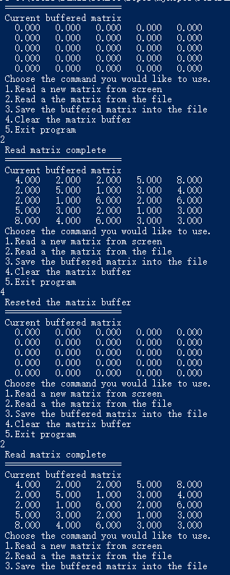

* Demo:

Check the folder ”IOProgram” in the directory.

1. Subroutine

* Description of the problem:

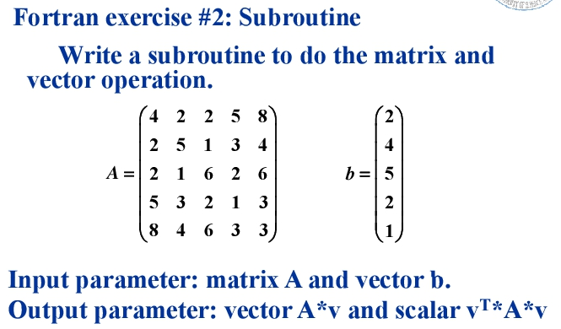

* The formula to use:

The dot product of matrices.

* Flow chart

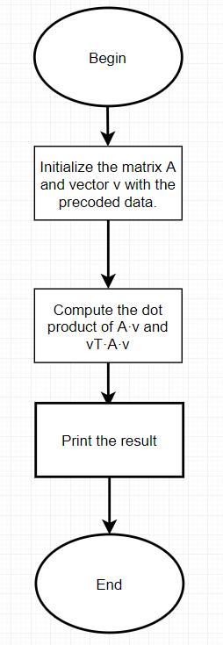

* Source code:

program Sub

    implicit none

    integer :: i

    real*8 :: A(5,5)

    real*8 :: v(5,1)

    real*8 :: AvResult(5,1)

    real*8 :: vAvResult(1,1)

*!Initialize*

    A = transpose(reshape((/4,2,2,5,8,2,5,1,3,4,2,1,6,2,6,5,3,2,1,3,8,4,6,3,3/),shape(A)))

    v = reshape((/2,4,5,2,1/),shape(v))

    call Calculate(A,v,AvResult,vAvResult)

*!Print the final result*

    print *,"A matrix:"

    do i=1,5

        print "(5f8.3)",A(i,:)

    end do

    print *,"v vector:"

    do i=1,5

        print "(f8.3)",v(i,:)

    end do

    print *,"AvResult:"

    do i=1,5

        print "(f8.3)",AvResult(i,:)

    end do

    print *,"vAvResult:"

    print "(f8.3)",vAvResult

end program

*!Core calculation routine*

subroutine Calculate(A, v, AvResult, vAvResult)

    implicit none

    real*8,intent(in) :: A(5,5)

    real*8,intent(in) :: v(5,1)

    real*8,intent(out) :: AvResult(5,1)

    real*8,intent(out) :: vAvResult(1,1)

    AvResult = matmul(A,v)

    vAvResult = matmul(transpose(v),matmul(A,v))

end subroutine

* Result and example:

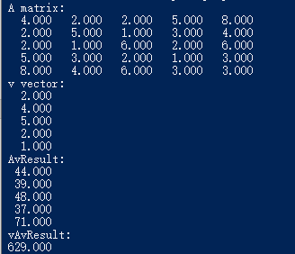

* Demo:

Check the folder ”Subroutine” in the directory.

1. Cycle

* Description of the problem

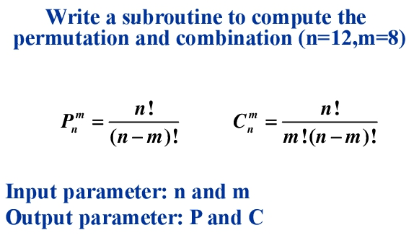

* Formula to use:

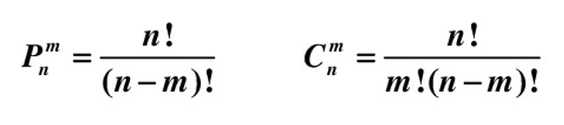

* Flow chart:

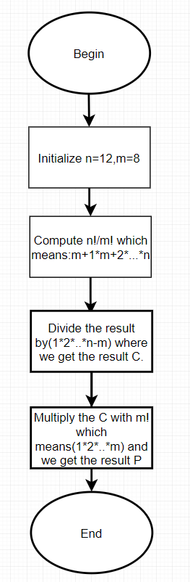

* Source code:

program CycleProgram

    implicit none

    integer :: n,m

    real*8 :: P,C

    n = 12

    m = 8

    call Calculate(n,m,P,C)

    print "(a,i8)","n:",n

    print "(a,i8)","m:",m

    print "(a,f16.3)","P:",P

    print "(a,f16.3)","C:",C

end program CycleProgram

subroutine Calculate(n,m, P,C)

    implicit none

    integer,intent(in) :: n,m

    real*8,intent(out) :: P,C

    integer :: i

    P = 1

    C = 1

    do i=m+1,n

        C = C*i

    end do

    do i=1,n-m

        C = C/i

    end do

    P = C

    do i=1,m

        P = P*i

    end do

end subroutine Calculate

* Result and example:



* Demo:

Check the folder “Cycle” in the directory.