# The second schoolwork of Computational Physics

万炫均 物理1701 U201710170

**Description of this chapter:**

For this chapter, we try various of computing methods to find out roots of functions, which is a quite basic problem in mathematic.

* **Description of the problem**

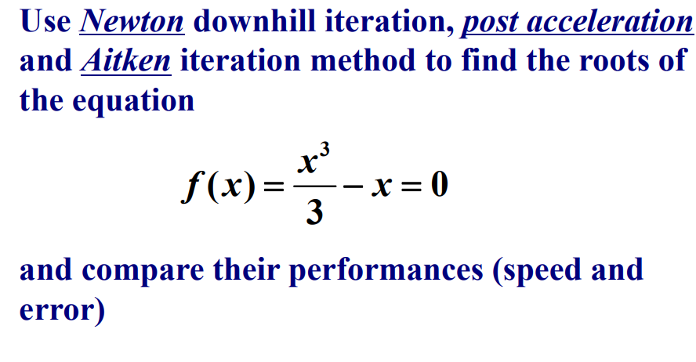

* **Formula to use**

Here we will use four methods in total:

Jacobi method,

Newtown downhill method,

Post acceleration method,

Aitken method.

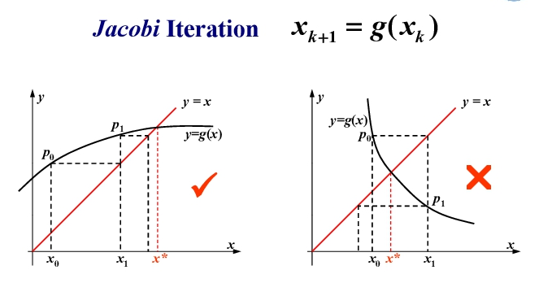

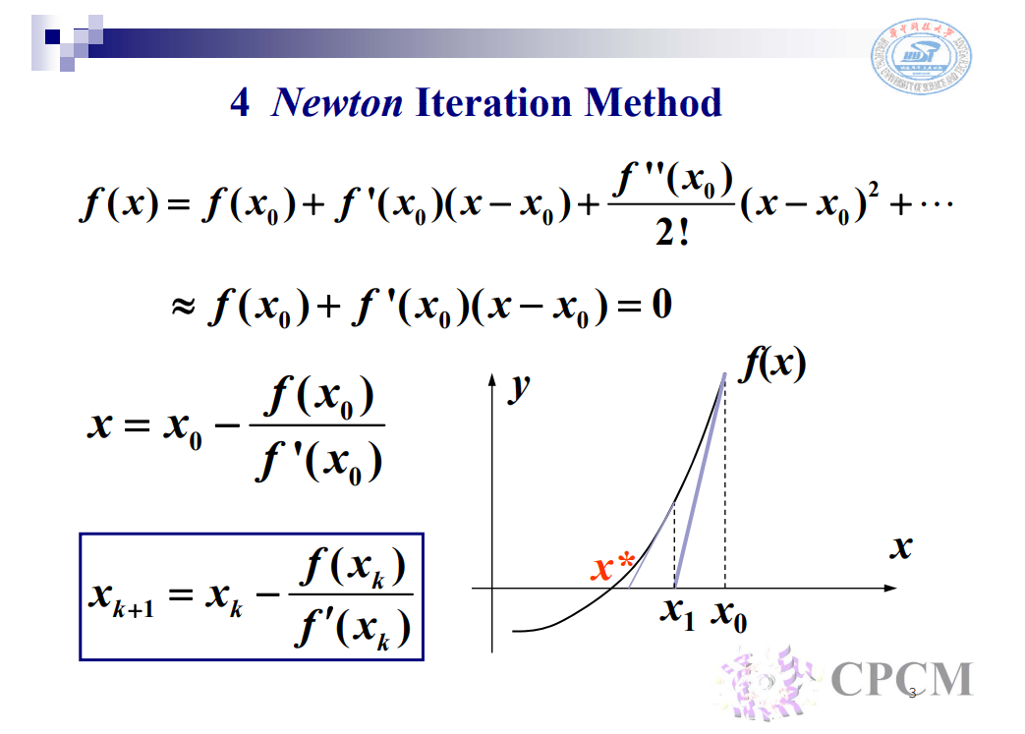

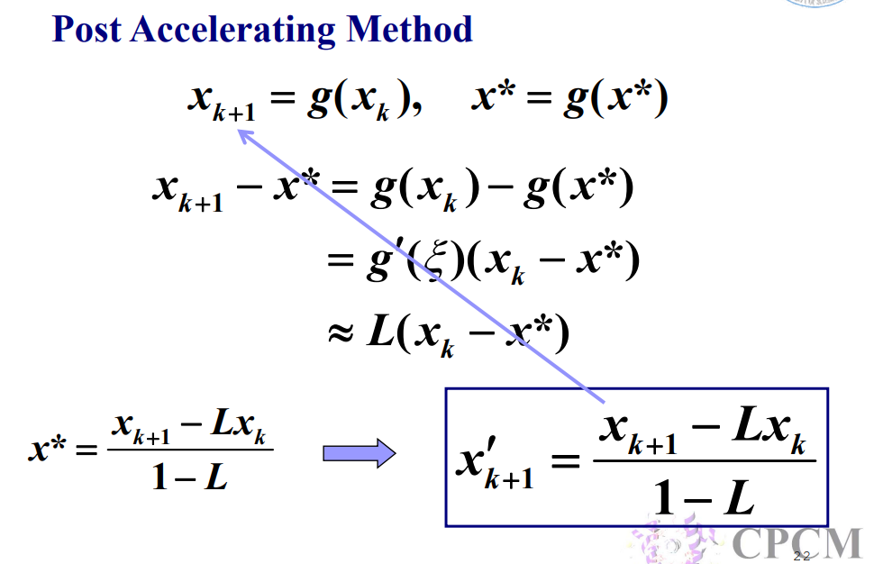

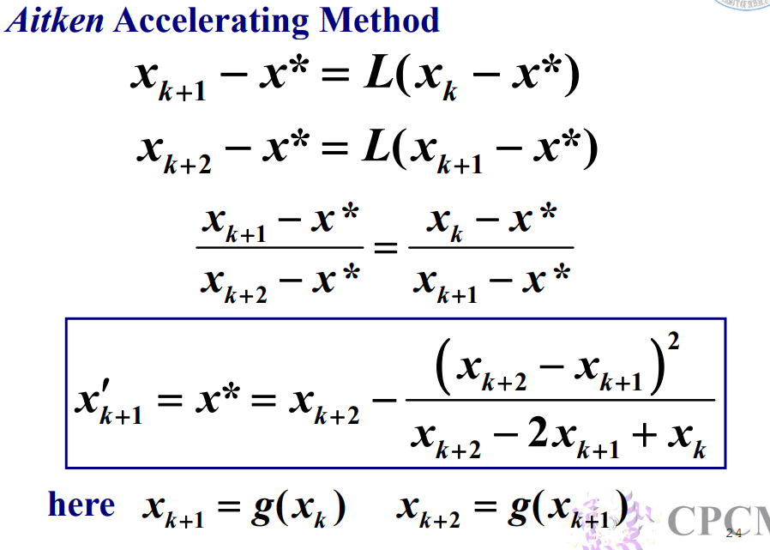

* **Flow chart**

1. **Jacobi Method Flow Chart**

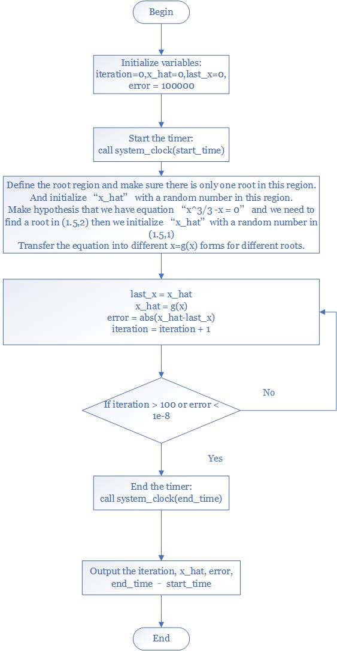

1. **Newton Downhill Method Flow Chart**

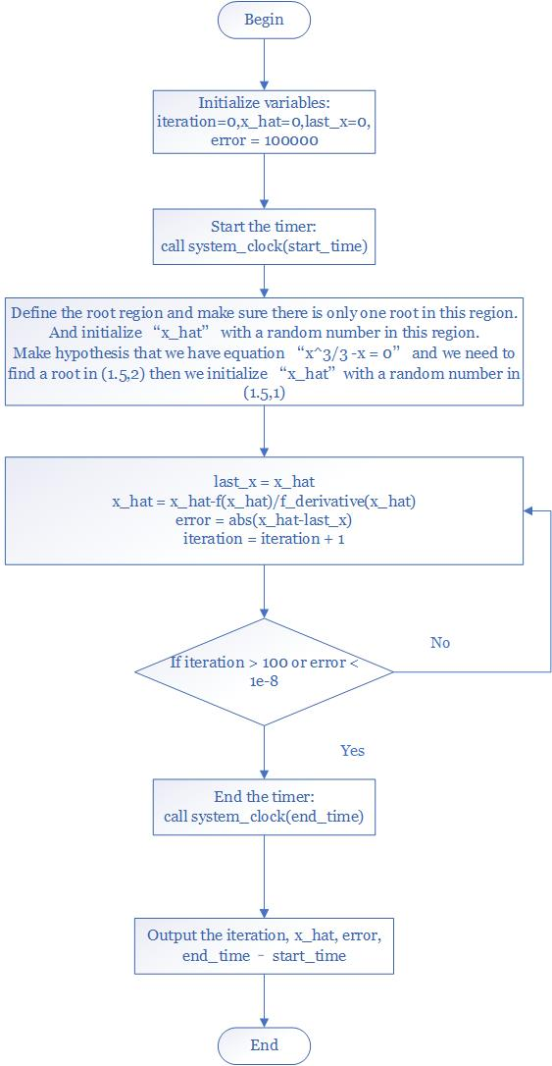

1. **Post Accelerating Method Flow Chart**

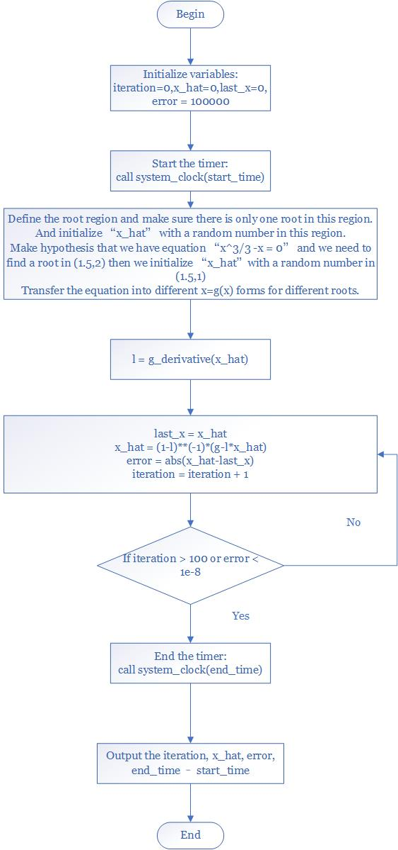

1. **Aitken Method Flow Chart**

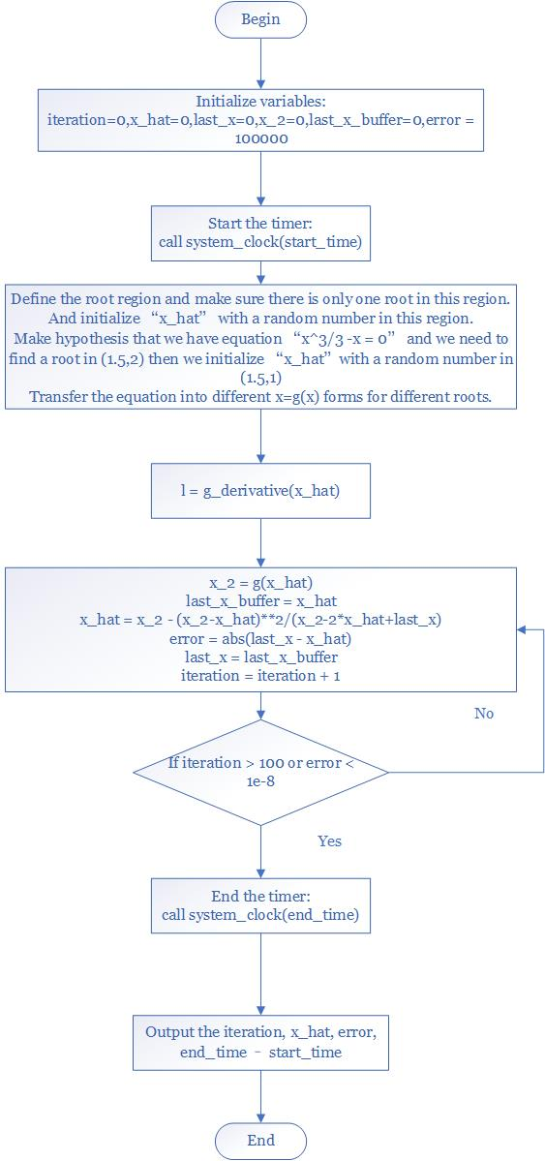

* **Source Code**

Here is the code. I have compressed the four methods of finding all the three roots into one program so it is easy to run the program.

* program Root
* real*8 :: x_hat,error
* integer :: iteration
* *!Clock to measure*
* integer*8 :: start_time,end_time
* *!Procedures for different methods*
* do j = 1,4
* *!Start the system timer*
* call system_clock(start_time)
* *!Loop for different roots*
* print *,"================================="
* do i = 1,3
* select case(j)
* case(1)
* call JacobiCalculate(x_hat,error,iteration,i)
* if (i==1) then
* print "(a,/)","#Jacobi Method"
* end if
* case(2)
* call NewtonCalculate(x_hat,error,iteration,i)
* if (i==1) then
* print "(a,/)","#Newton Method"
* end if
* case(3)
* call AccCalculate(i, x_hat,error,iteration)
* if (i==1) then
* print "(a,/)","#Post Acceleration Method"
* end if
* case(4)
* call AitkenCalculate(i, x_hat,error,iteration)
* if (i==1) then
* print "(a,/)","#Aitken Method"
* end if
* case default
* print "(a,/)","Unknown procedure id!!!"
* end select
* *!Stop the system timer*
* call system_clock(end_time)
* print "(a,i8)","Root id",i
* print "(a,f8.4,/,a,es16.3,/,a,i4,/a,es16.3)","Root:",x_hat,"Error:",error,"Iteration:",iteration
* print "(a,i16,/)","Used time:",(end_time-start_time)
* end do
* end do
* end program Root
* *!The core calculation subroutine*
* subroutine JacobiCalculate(x_hat,error,iteration,root_id)
* implicit none
* real*8 :: g1
* real*8 :: g2
* integer,intent(in):: root_id
* real*8,intent(out) :: x_hat,error
* integer,intent(out) :: iteration
* real*8 :: last_x
* iteration = 0
* x_hat = 0
* last_x = 0
* *!Set a large number*
* error = 1000000
* do while(abs(error)>1d-8 .and. iteration < 100)
* last_x = x_hat

* *!Choose different functions for different roots*
* select case(root_id)
* case (1)
* x_hat = g1(x_hat)
* *!Set the x a random number in (-1,0)*
* if ( iteration == 0 ) then
* call random_number(x_hat)
* x_hat = x_hat*(-1)
* end if
* case (2)
* x_hat = g2(x_hat)
* *!Set the x a random number in (1,2)*
* if ( iteration == 0 ) then
* call random_number(x_hat)
* x_hat = x_hat+1
* end if
* case (3)
* x_hat = g2(x_hat)
* *!Set the x a random number in (-2,-1)*
* if ( iteration == 0 ) then
* call random_number(x_hat)
* x_hat = x_hat*(-1)-1
* end if
* end select
* error = abs(x_hat-last_x)
* iteration = iteration + 1
* end do
* end subroutine JacobiCalculate
* subroutine NewtonCalculate(x_hat,error,iteration,root_id)
* integer,intent(in) :: root_id
* real*8,intent(out) ::x_hat,error
* integer,intent(out) :: iteration
* real*8 :: f,f_derivative
* real*8 :: last_x
* *!Initialize the x with a random number in different regions*
* select case(root_id)
* case (1)
* *!Set the x a random number in (0,1)*
* call random_number(x_hat)
* case (2)
* *!Set the x a random number in (1,2)*
* call random_number(x_hat)
* x_hat = x_hat+1
* case (3)
* *!Set the x a random number in (-2,-1)*
* call random_number(x_hat)
* x_hat = (x_hat+1)*(-1)
* end select
* iteration = 0
* *!Set a large number*
* error = 10000000
* *!Main calculation loop*
* do while(abs(error)>1d-8 .and. iteration < 100)
* last_x = x_hat
* x_hat = x_hat-f(x_hat)/f_derivative(x_hat)
* error = abs(last_x - x_hat)
* iteration = iteration + 1
* end do
* end subroutine
* *!Post Acceleration Method*
* subroutine AccCalculate(root_id, x_hat,error,iteration)
* implicit none
* integer,intent(in) :: root_id
* real*8,intent(out) :: x_hat,error
* integer,intent(out) :: iteration
* real*8 :: g,g1,g2,g1_derivative,g2_derivative,l
* real*8 :: last_x
* *!Initialize the x with a random number in different regions*
* *!Initialize the factor l*
* select case(root_id)
* case (1)
* *!Set the x a random number in (0,1)*
* call random_number(x_hat)
* l = g1_derivative(x_hat)
* case (2)
* *!Set the x a random number in (1,2)*
* call random_number(x_hat)
* x_hat = x_hat+1
* l = g2_derivative(x_hat)
* case (3)
* *!Set the x a random number in (-2,-1)*
* call random_number(x_hat)
* x_hat = x_hat*(-1)-1
* l = g2_derivative(x_hat)
* end select
* iteration = 0
* *!Set a large number*
* error = 10000000
* do while(abs(error)>1d-8 .and. iteration < 100)
* last_x = x_hat
* select case(root_id)
* case(1)
* g = g1(x_hat)
* case default
* g = g2(x_hat)
* end select
* x_hat = (1-l)**(-1)*(g-l*x_hat)
* error = abs(last_x - x_hat)
* iteration = iteration + 1
* end do
* end subroutine AccCalculate
* *!Aitken Calculation*
* subroutine AitkenCalculate(root_id, x_hat,error,iteration)
* implicit none
* integer,intent(in) :: root_id
* real*8,intent(out) :: x_hat,error
* integer,intent(out) :: iteration
* real*8 :: g,g1,g2,g1_derivative,g2_derivative,l
* real*8 :: last_x,last_x_buffer,x_2
* *!Initialize the x with a random number in different regions*
* *!Initialize the factor l*
* select case(root_id)
* case (1)
* *!Set the x a random number in (0,1)*
* call random_number(x_hat)
* l = g1_derivative(x_hat)
* case (2)
* *!Set the x a random number in (1,2)*
* call random_number(x_hat)
* x_hat = x_hat+1
* l = g2_derivative(x_hat)
* case (3)
* *!Set the x a random number in (-2,-1)*
* call random_number(x_hat)
* x_hat = x_hat*(-1)-1
* l = g2_derivative(x_hat)
* end select
* select case(root_id)
* case(1)
* last_x = g1(x_hat)
* x_hat = g1(last_x)
* case default
* last_x = g2(x_hat)
* x_hat = g2(last_x)
* end select
* iteration = 0
* *!Set a large number*
* error = 10000000
* *!Main loop*
* do while(abs(error)>1d-8 .and. iteration < 100)
* select case(root_id)
* case(1)
* x_2 = g1(x_hat)
* case default
* x_2 = g2(x_hat)
* end select
* last_x_buffer = x_hat
* x_hat = x_2 - (x_2-x_hat)**2/(x_2-2*x_hat+last_x)
* error = abs(last_x - x_hat)
* last_x = last_x_buffer
* iteration = iteration + 1
* end do
* end subroutine AitkenCalculate
* *!Functions definitions*
* function f(x)
* implicit none
* real*8 :: x
* real*8 :: f
* f = x**3/3-x
* end function
* function f_derivative(x)
* implicit none
* real*8 :: x
* real*8 :: f_derivative
* f_derivative = x**2-1
* end function
* *!g1 = x**3/3*
* function g1(x)
* implicit none
* real*8 :: x
* real*8 :: g1
* g1 = x**3/3
* end function
* function g1_derivative(x)
* implicit none
* real*8 :: x
* real*8 :: g1_derivative
* g1_derivative = x**2
* end function
* *!g2 = x**(1.0/3)/3*
* function g2(x)
* implicit none
* real*8 :: x
* real*8 :: g2
* if ( x>0 ) then
* g2 = (3*x)**(1.0/3)
* else
* g2 = sign(abs(3*x)**(1.0/3.0),x)
* end if
* end function
* *!g2 = x**(1.0/3)/3*
* function g2_derivative(x)
* implicit none
* real*8 :: x
* real*8 :: g2_derivative
* if ( x>0 ) then
* g2_derivative = (3*x)**(dble(-2.0)/dble(3.0))
* else
* g2_derivative = sign(abs(3*x)**(dble(-2.0)/dble(3.0)),x)
* end if
* end function
* **Results and examples:**

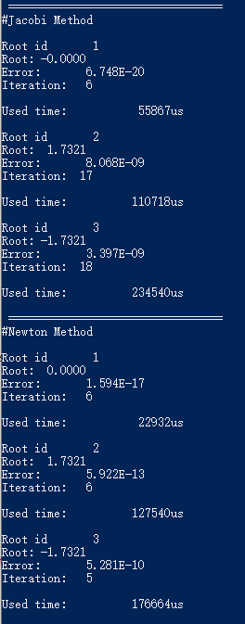

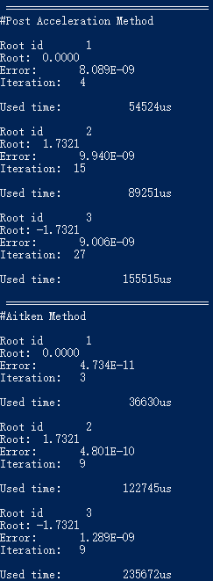

Iteration Comparison

|  |  |  |  |
| --- | --- | --- | --- |
| **Method** | **X1** | **X2** | **X3** |
| Jacobi | 6 | 17 | 18 |
| Newton Downhill | 6 | 6 | 5 |
| Post Acc | 4 | 15 | 27 |
| Aitken Acc | 3 | 9 | 9 |

Execution Time Comparison (unit = us)

|  |  |  |  |
| --- | --- | --- | --- |
| **Method** | **X1** | **X2** | **X3** |
| Jacobi | 55867us | 110718us | 234540us |
| Newton Downhill | 22932us | 127540us | 176664us |
| Post Acc | 54524us | 89251us | 155515us |
| Aitken Acc | 36630us | 122745us | 235672us |

* **Demo:**

Check the folder “Root” in the directory.

Run the program “a.exe”