# The sixth schoolwork of Computational Physics

万炫均 物理1701 U201710170

**Description of this chapter:**

Solving ordinary derivative equations is a very common problem in physics. Here we use basic Euler method and Runge-Kutta method to solve ordinary equations by iterative methods.

**Description of the problem**

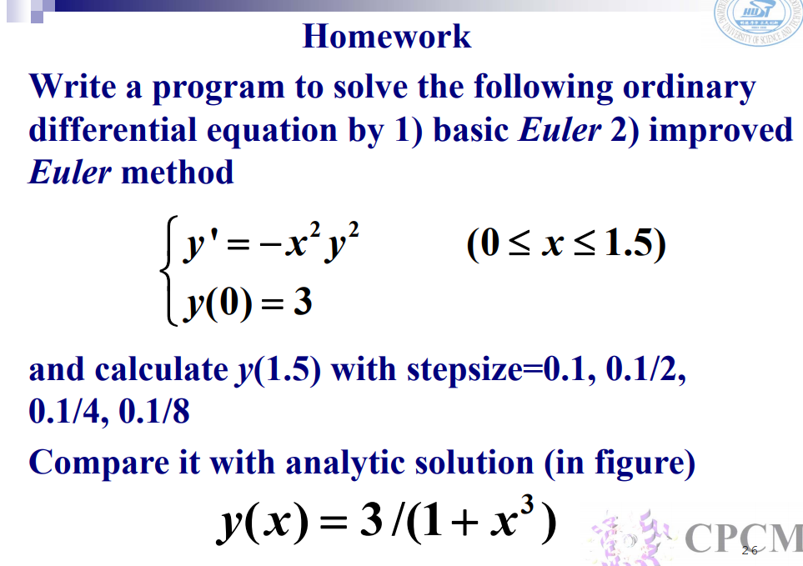

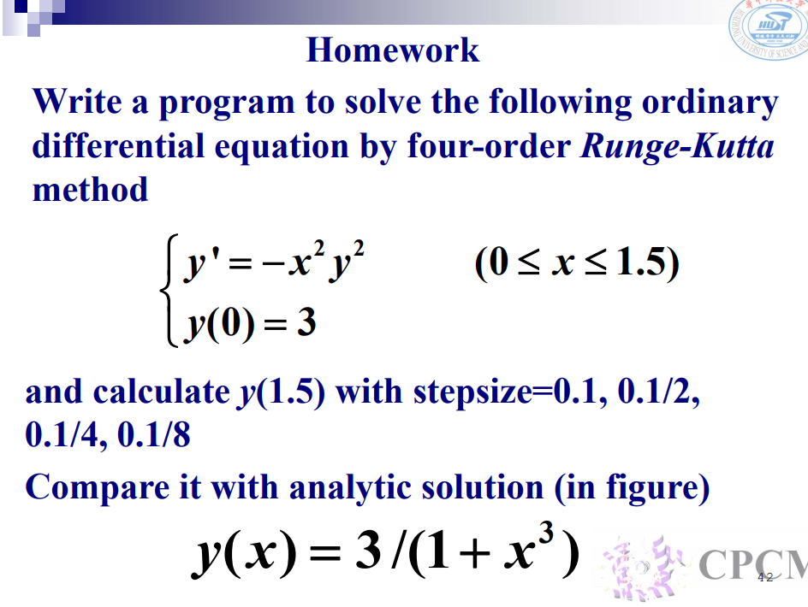

* **Formula to use**
  + Euler Method

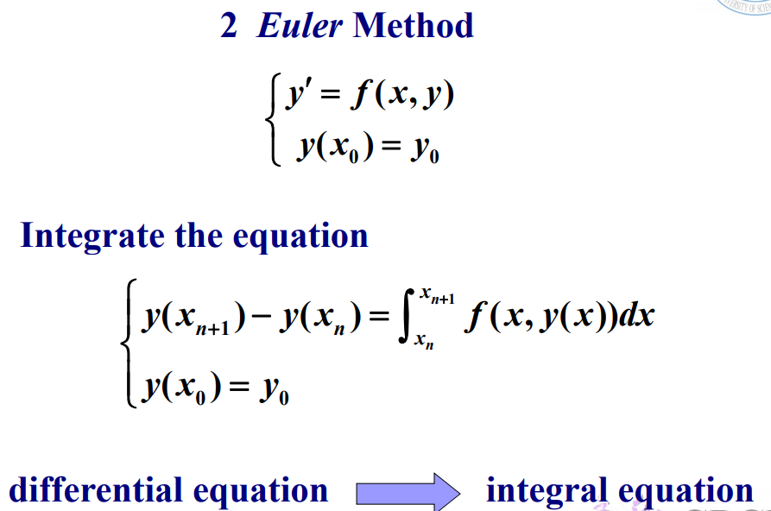

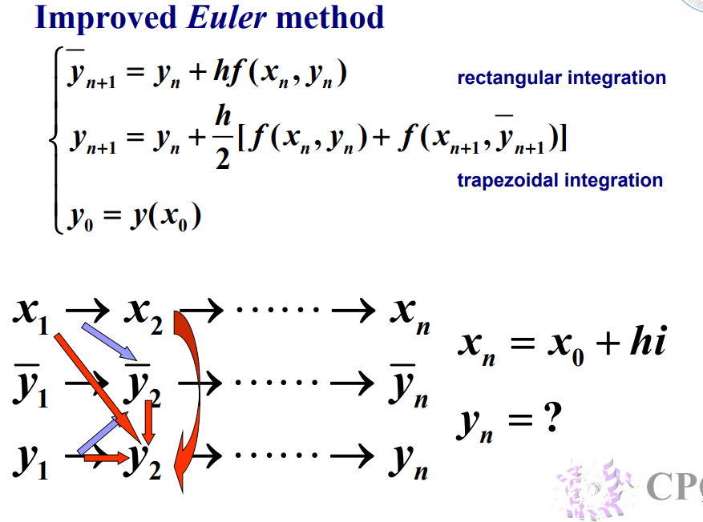

* + Runge-Kutta Method

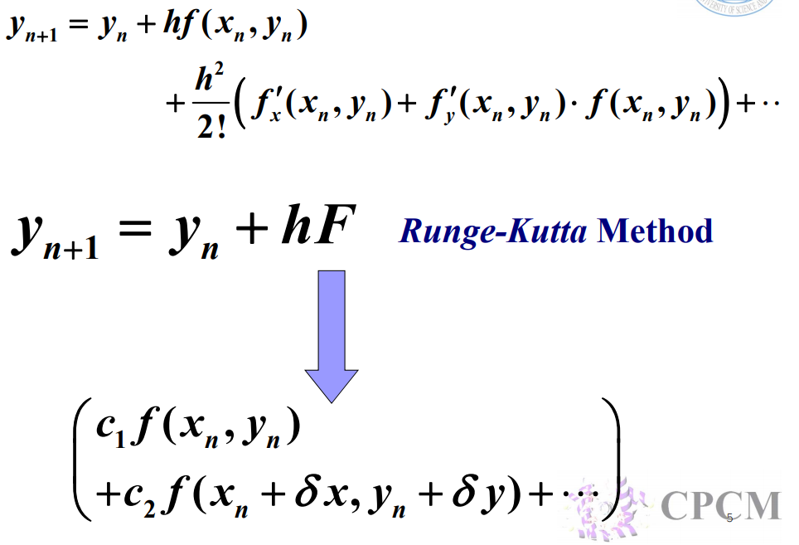

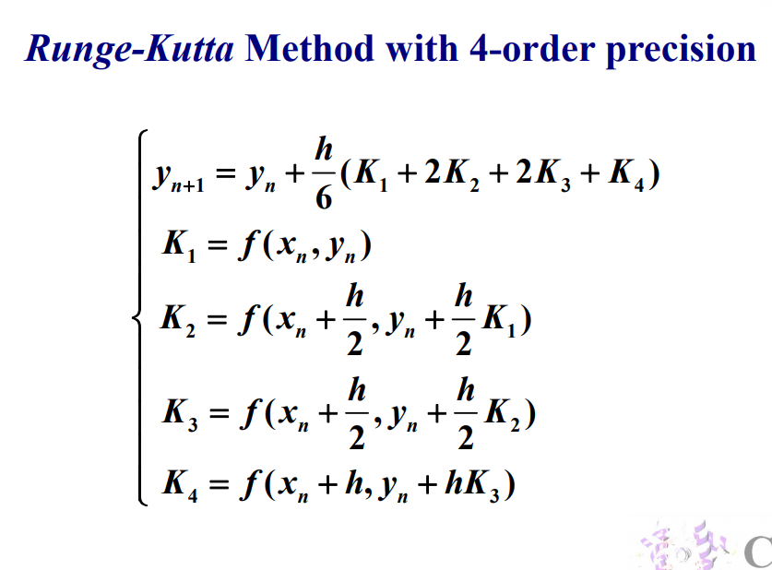

* **Flow chart**
  + **Euler Method Flowchart**

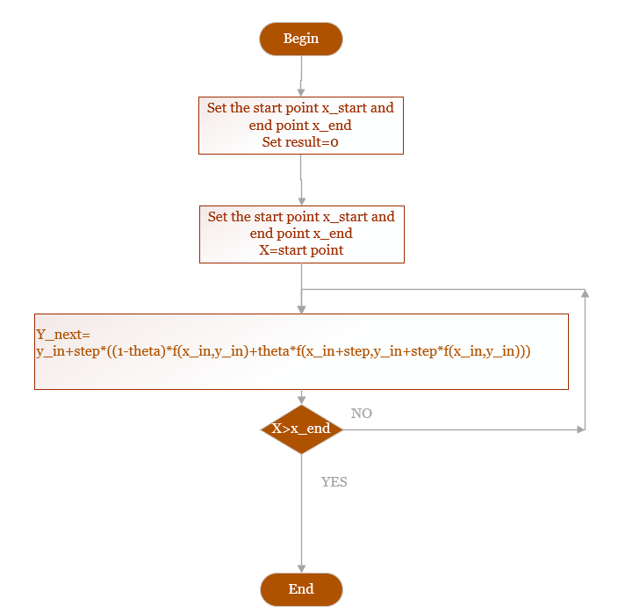

* + **Runge-Kutta Method Flowchart**

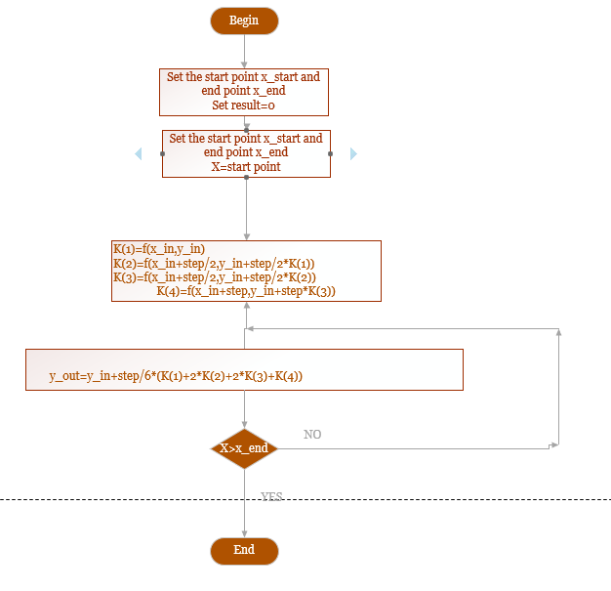

* **Source code**
* program MainProgram
* do i=1,4
* call Euler0(0.1/dble(i))
* call Euler5(0.1/dble(i))
* call RK4(0.1/dble(i))
* end do
* end program MainProgram
* subroutine Euler0(step)
* !TODO_add_body
* use ODE_Solver
* use IO
* real*8,intent(in)  :: step
* real*8 :: x,y,y_next
* character(len=64) :: path
* procedure (func), pointer :: f_ptr => null()
* external f
* f_ptr => f
* x=0
* y=3
* write (path,"(a,f4.3,a)")"./data/euler0_",step,".txt"
* call ClearFile(path)
* do while(x<=1.5)
* call EulerSolver(x,y,f_ptr,step,dble(0),y_next)!0 for explicit Euler solver
* call WriteNumToFile(path,y_next,.true.)
* y=y_next
* x=x+step
* end do
* end subroutine Euler0
* subroutine Euler5(step)
* !TODO_add_body
* use ODE_Solver
* use IO
* real*8,intent(in)  :: step
* real*8 :: x,y,y_next
* character(len=64) :: path
* procedure (func), pointer :: f_ptr => null()
* external f
* f_ptr => f
* x=0
* y=3
* write (path,"(a,f4.3,a)")"./data/euler5_",step,".txt"
* call ClearFile(path)
* do while(x<=1.5)
* call EulerSolver(x,y,f_ptr,step,dble(0.5),y_next)!0 for explicit Euler solver
* call WriteNumToFile(path,y_next,.true.)
* y=y_next
* x=x+step
* end do
* end subroutine Euler5
* subroutine RK4(step)
* !TODO_add_body
* !TODO_add_body
* use ODE_Solver
* use IO
* real*8,intent(in)  :: step
* real*8 :: x,y,y_next
* character(len=64) :: path
* procedure (func), pointer :: f_ptr => null()
* external f
* f_ptr => f
* x=0
* y=3
* write (path,"(a,f4.3,a)")"./data/rk4_",step,".txt"
* call ClearFile(path)
* do while(x<=1.5)
* call RungeKutta4(x,y,f_ptr,step,y_next)!0 for explicit Euler solver
* call WriteNumToFile(path,y_next,.true.)
* y=y_next
* x=x+step
* end do
* end subroutine RK4
* function f (x,y)
* real*8, intent (in) :: x,y
* real*8 :: f
* f=-(x**2)*(y**2)
* end function f

module ODE_Solver

    implicit none

    abstract interface

        !Function form definition of function f to define the function pointer

        function func (x,y)

            real*8, intent (in) :: x,y

            real*8 :: func

        end function func

    end interface

contains

    subroutine EulerSolver(x_in,y_in,f_ptr,step,theta,y_out)

        !y_in:The current inputted y value

        !x_in:Thecurrent x value

        !f_ptr:The function pointer to f(x,y)

        !step:The step interval

        !theta:0 for the explicit euler function,1 for the implicit euler function

        !y_out:The out put of the next y value

        procedure (func), pointer,intent(in) :: f_ptr

        real*8,intent(in) :: y_in,x_in,step

        real*8,optional::theta

        real*8,intent(out) :: y_out

        if (.not.present(theta))then

            theta = 0.5

        end if

        y_out=y_in+step*((dble(1)-theta)*f_ptr(x_in,y_in)+theta*f_ptr(x_in+step,y_in+step*f_ptr(x_in,y_in)))

    end subroutine

    subroutine RungeKutta4(x_in,y_in,f_ptr,step,y_out)

        !y_in:The current inputted y value

        !x_in:Thecurrent x value

        !f_ptr:The function pointer to f(x,y)

        !step:The step interval

        !y_out:The out put of the next y value

        procedure (func), pointer :: f_ptr

        real*8,intent(in) :: y_in,x_in,step

        real*8,intent(out) :: y_out

        !Local vars

        real*8 :: K(4)

        !Setup K values

        K(1)=f_ptr(x_in,y_in)

        K(2)=f_ptr(x_in+step/2,y_in+step/2*K(1))

        K(3)=f_ptr(x_in+step/2,y_in+step/2*K(2))

        K(4)=f_ptr(x_in+step,y_in+step*K(3))

        y_out=y_in+step/6*(K(1)+2*K(2)+2*K(3)+K(4))

    end subroutine

end module ODE_Solver

* **Example and Result**
  + **Improved Euler Method**

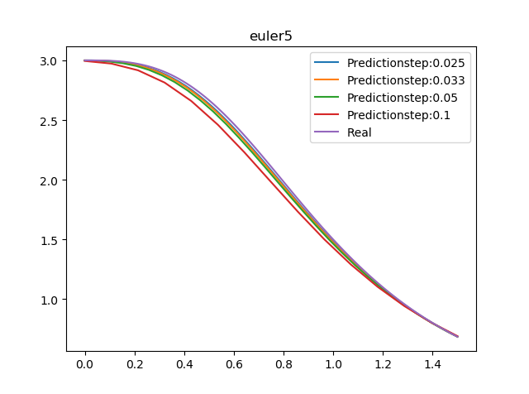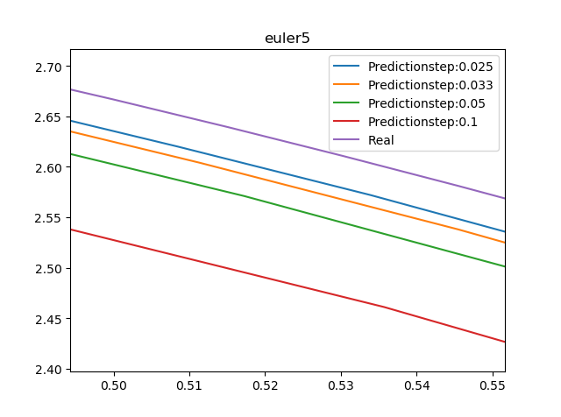

* + **Explicit Euler Method**

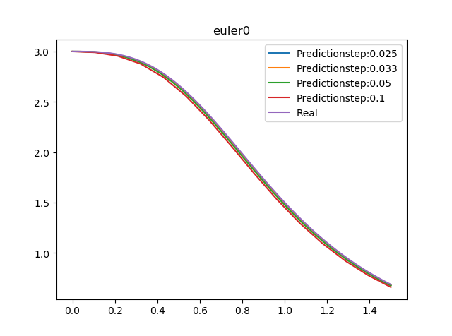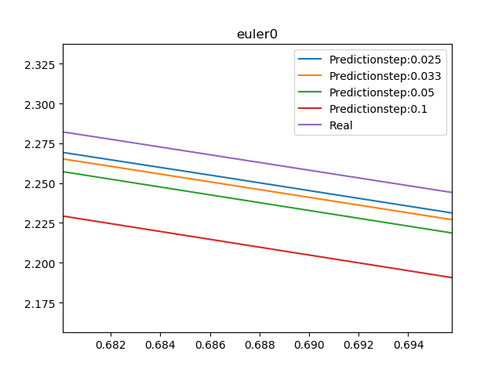

* + **4-order Runge-Kutta method**

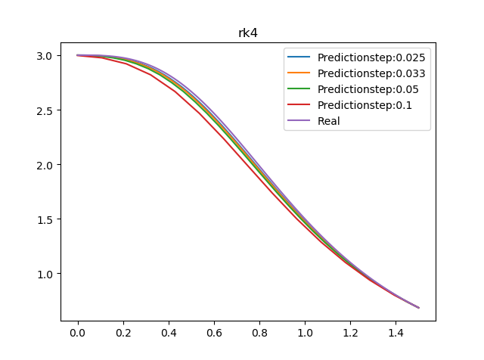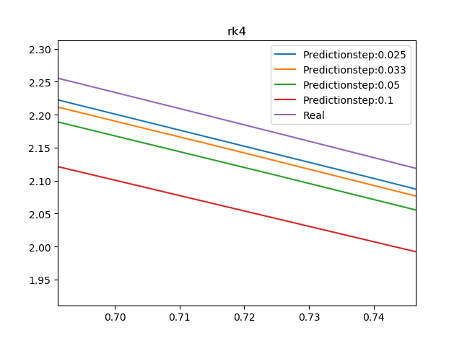

* **Demo**

Check the folder ”ODE” in the directory and follow the instruction to set up the matrices and vector