**Response**

Based on the feedback from the instructor, it became clearer to me that I had to do a thorough job and not just an airdrop. So I set out on an iterative design thinking to have the illustrative representation of the Cholera outbreak as described in John Snow’s account. I had sketches and annotated diagrams of what my graph should be revealing to a probing mind or anyone who is interested in discovering nuances and deriving insights for present scenario application.

I had to practice SVG on W3 Schools to dust my skills on SVG fundamentals. I resorted to watching <https://www.youtube.com/watch?v=_8V5o2UHG0E> on YouTube and I reference peer project <https://www.youtube.com/watch?v=yv137pmGteA> .on what has been done before. I took another deeper dive into d3 and java scripting. From the descriptive map, I conceived ideas on what I wanted to explore and analyze in my interactive framework.

The map has the ability to zoom in and zoom out. The pumps, streets especially notable locations like the brewery and workhouse are represented on the map. Clicking any coordinate on the map will highlight the age and gender of victims that lost their lives in during the outbreak in various parts of the cities.

I chose to work with three different graphs to give a holistic representation of the nuances in the data and map from the account of John Snow. The choice of stacked bar graph, and two bar graphs to display death by age, death by age and death by age based on the units of observation and analysis as contained in the account of John Snow. Each you time you click a point on the graph it displays corresponding texts on the right side of the window pane.

The YouTube link to my video description on YouTube is map

**Explicative Approach to Deriving Insights**

* What is the lowest and higher number of deaths by age, gender and death, sequentially?
* Does the variables distribution support a natural cause and effect elimination captured by John Snow’s account?
* Are there peculiarities in consumption patterns of the population-the brewery workers and non-brewery workers?
* Was immunity, susceptibility and resistivity evident at the time of the endemic?

**Inferences from the Graphs**

As shown in Fig.1, during the outbreak of the cholera disease on 8-19, I person died which is the usual trend in the outbreak of an endemic. This was largely because every stakeholder at that time including Dr. John Snow had no idea of the cholera outbreak

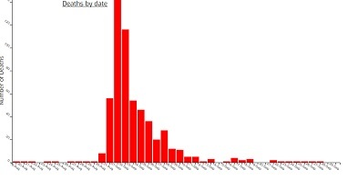

Fig.1 Death by Age

1. Single case of death was recorded from August 1-30, a single death was recorded The peak of the outbreak occurred on September 1 which totaled 143 deaths of the population. At this point in time the people were still drinking water from the public pump unabated with the false thinking that the cholera was an airborne disease. After which there was a steady decline in the number of infections

From Figure 1 above, disease outbreak curve started to flatten out from September 8-28 which was evident in the strides of Dr. John Snow to disprove with overwhelming evidence that miasma was not the cause but water from the public pump with 1 recorded death per day for that duration. Although there were odd rates on September. 16th with 4 cases of death recorded. and 3 deaths on September 18th

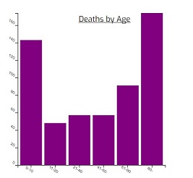

Figure 2 Death by Age

From figure 2 above children between the ages of 0-10 years old suffered more casualties numbering 143 deaths due to what could be attributed to poor resistivity in terms of immunity .Another cause that could be attributed to the cause is population of children who lived in the workhouse that was unhygienic and unfit for healthy living.

From Figure 2 above, adults who were 80 years old at that time suffered most casualty number 174 deaths. This outcome is not unusual given the vulnerability of the aged to diseases due to extremely weak immune system. They also sought shelter in the workhouse, an over populated and unhygienic place to live.

Young adults between the ages of 11-20 years recorded the least of amount of deaths totaling 48 partly due to strong immunity system. (Please refer to Figure 2)

From Figure 2 above population with ages 21-40 and 41-60 suffered less casualties totaling 57 deaths, respectively. This age range were the active working population at the time who worked in brewery and drank beer and least exposed to the cholera outbreak. Due to income bracket they would have been able to afford decent housing rather than seeking shelter in workhouse

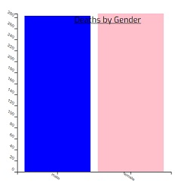

Figure 3 Deaths by Gender Distribution

As shown in Figure 3 above, 284 and 287 males and females, particularly were recorded dead as the time of the outbreak. However this is not enough deviation to hypothesize immunity of male and female thresholds.

In all, 571 people lost their lives to the cholera outbreak.

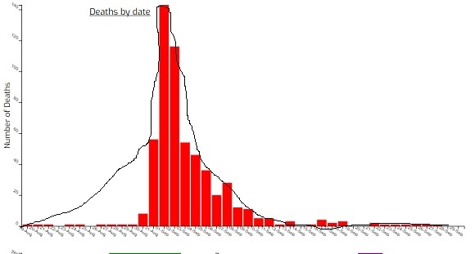

Figure 4 Normal Distribution of Death Rate

Death by Date graph resembles a normal distribution or a bell shaped curve in Fig. 4 below which lend credence to the landmark discovery of Dr. John Snow in medicine and his pioneer work on Data Analysis & Visualization. The outbreak started spreading slowly until it became a wild fire and the curve flattened out as prescriptive and preventive measures were taken. Calculating the mean median, mode and standard deviation of the mean fall outside the scope of this course