**Data Wrangling Project Act Report Case Study Twitter WeRateDog Post**

In this Data wrangling data was gathered from three source which are:

Gathering Data.

1. Downloading twitter_archive csv file from Udacity website and reading the data on Jupiter notebook environment.
2. Downloading image prediction post using request.get method from twitter WeRateDog website from link below <https://d17h27t6h515a5.cloudfront.net/topher/2017/August/599fd2ad_image-predictions/image-predictions.tsv>' which was given by Udacity.
3. Th third source is the use of Twitter API which the JSON file was downloaded from Udacity website and read on Jupiter notebook environment using pandas.

Accessing

The dataset was accessed so as to get more information about the dataset using programmatical and Visual approach.

Cleaning

During cleaning the following data quality where cleaned.

1. Removal of in reply to status id, in reply to status user id, retweeted status id, retweeted status user id, retweeted status timestamp, lang, retweeted_status, quoted_status_id, quoted_status_id_str, quoted_status, id str, entities extended_entities, display_text_range and truncated column
2. Dropping of the null values in the 3 datasets
3. Data type of Timestamp and created_at is object which supposed to be datetime
4. Renaming timestamp column to Date, create_at to Date and id to tweet_id, column header p1, p1_conf, p2_conf, p2, p3, p3_conf, p1_dog, p2_dog and p3_dog
5. Stripping off of href infront of source column needs to be removed from Tweet_API_clean and Enhance_twitter_clean
6. Stripping off of Time from date in both datasets Enhance_twitter_clean and Tweet_twitter_clean
7. Arranging the date and text column in Enhance_twitter_clean and Tweet_API_clean dataset
8. Dropping of the null values in the 3 datasets
9. Renaming missing values in name column from None to NaN and remove all rows with any NaN values
10. Some tweet has no pictures which needs to be removed
11. Some rating numerators are incorrect because they are below the range usually given (lower than 10 and greater than 13)
12. Remove retweet from the json file by removing all rows where retweet status is not null

I also try to make the dataset to be tidier by carrying out the following process

1. Merging the three datasets together to be a master dataset.
2. Merge each dog status column into a one column and named it Stage and remove the duplicated values
3. The rating numerators as well as the denominator column need to be a single column called Ratings

The following Insight was derived from the dataset.

Distribution of Favorite count in the dataset

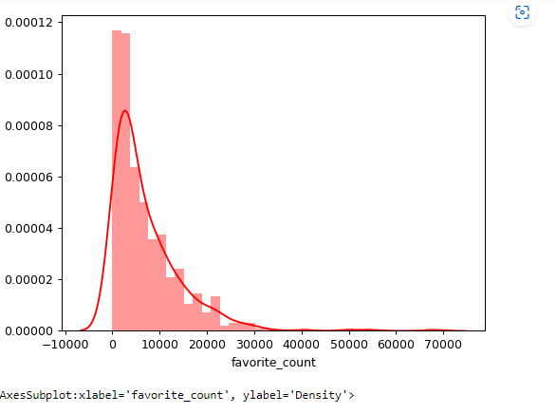

***fig 1.0 the plot above shows the distribution of favourite_count in the dataset which indicate a gradual increase of the count.***

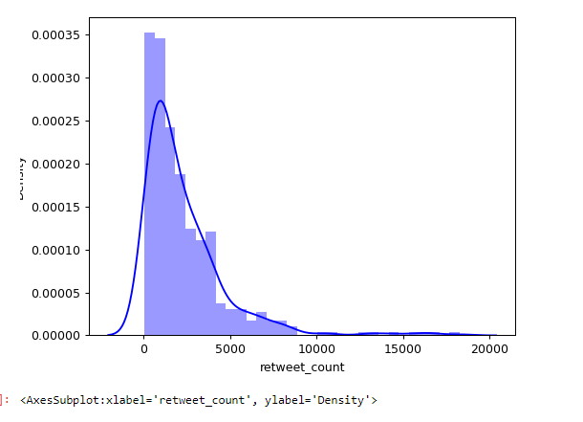

***fig 2.0 the plot above shows the distribution of retweet_count in the dataset.***

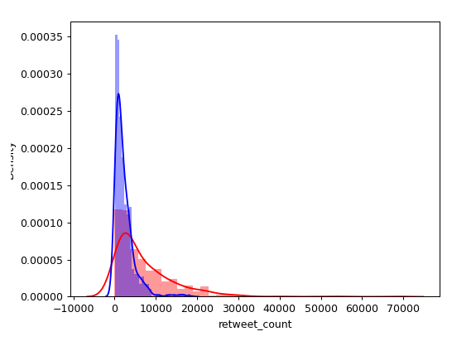

***fig 3.0 the plot above shows the distribution of retweet_count and favourite_count in the dataset***

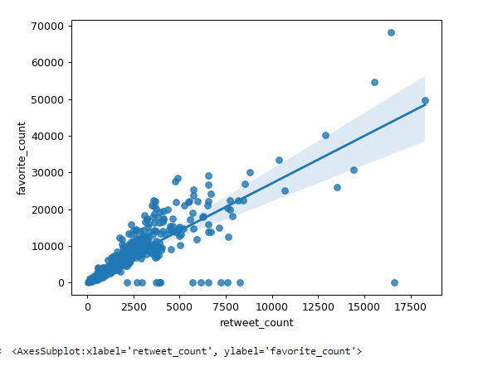

***fig 4.0 the plot above shows the linear relationship between retweet_count and favourite_count***

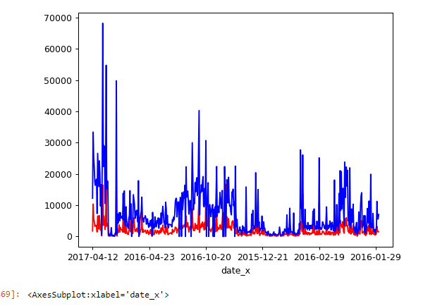

***fig 5.0 the plot above shows the impact of favourite_count and retweet-count over a period of time***

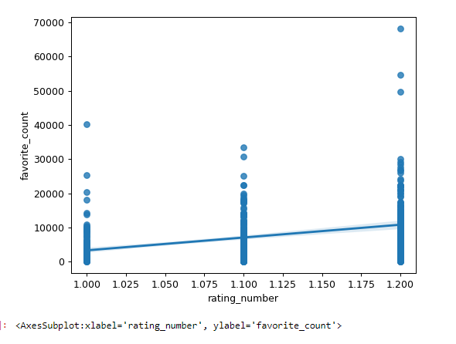

***fig 6.0 plot above show the linear relationship between favourite_count and rating_number***

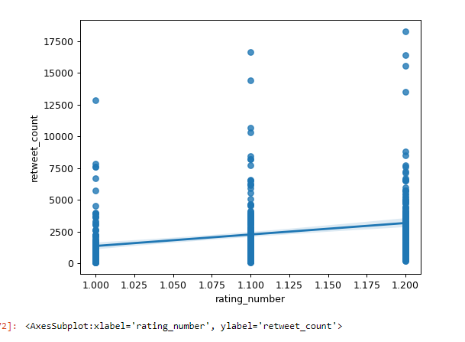

***fig 7.0 plot above show the linear relationship between retweet_count and rating_numbers***

1. Which dog prediction has the highest prediction confidence

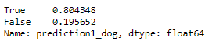





*From the above analysis it can be concluded that Dog prediction 2 has the highest Prediction confidence followed by Dog prediction 1*

1. Which dog type has the highest Rating

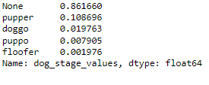

*From above analysis Pupper has the highest rating count followed by Doggo while Puppo has the lowest rating count*

1. Which image has the highest favorite count

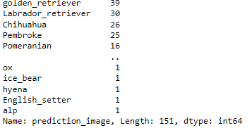

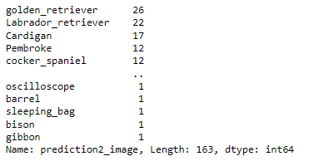

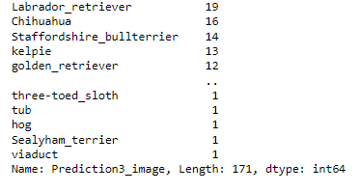

*On prediction image 1-3 the followings are the top 2 image predicted:*

1. *Labrador retriever*
2. *Golden retrieve*
3. When do we have the highest rating in the dataset?

