|  |
| --- |
| MakeMy Trip –Live Project |
| **Project Functional Requirement Specification Version 1.0** |
|  |
| **Prepared by:** Haritha Bammidi (845034)            **Reviewed by :** Raghavendra.BN |
|  |

Contents

1. Purpose of the document: 4

2. Project Overview: 4

2.1 Audience 4

2.2 Hardware Requirements and software requirements: 4

2.2.1 Hardware Requirements 4

2.2.2 Software Requirements: 4

3. Information Architecture 4

3.1 Registration 4

3.2 Login 5

3.3 Booking Tickets 7

3.3.1 Flight Tickets 7

3.3.2 Train Tickets 8

3.3.3 Bus Tickets 9

3.3.4 Hotel Bookings: 9

3.4 Commercial Details 11

3.5 Cancellation of Tickets 13

3.6 Special offers 15

4. Sign-Off Document 18

# 1. Purpose of the document:

# Nurtured from the seed of a single great idea - to empower the traveller – MakeMy Trip went on to pioneer the entire online travel industry in India.MakeMyTrip.com, India’s leading online travel company was founded in the year 2000 by Deep Kalra. Created to empower the Indian traveller with instant booking and comprehensive choices, the company began its journey in the US-India travel market.

MakeMy Trip Limited is an Indian online travel company founded in2000.Headquartered in Gurugram, Haryana, and the company provides online travel services including flight tickets, domestic and international holiday packages, hotel reservations, and rail and bus tickets. MakeMy Trip has offices in New York, Singapore, Kuala Lumpur, Bangkok, and Dubai.

# 2. Project Overview:

## 2.1 Audience

This document is intended as a complete guide for travelling purposes. This document is specially designed for non-specialists; specialists may find the document a useful point of reference. By reading this guide, you will learn how to use MakeMy Trip website and provides some of the trip ideas. It will hopefully guide you around some common problems that frequently appear for common people.

2.2 Hardware Requirements and software requirements:

2.2.1 Hardware Requirements

* Laptop
* Mobile
* Desktop
* Internet/LAN

2.2.2 Software Requirements:

MakeMy Trip uses Bitla software. It is said to be an innovative tool operator. It is founded in 2007 they are the Global Technology leader for the Online Ticketing Ecosystem and we have transformed and revolutionized the Online Booking Ecosystem with our world class technologies Bitla is the India’s leading SaaS/Cloud mobile technology solutions provider for travel, hospitality, holidays & leisure and logistics businesses.

# 3. Information Architecture

## 3.1 Registration

Becoming the registered member of MakeMy Trip is easy and free of cost.

* For the registration you have to provide the details of first and last name, email Id. After entering the details, click on the arrow button.
* Once your email Id is verified your registration process is done.
* After registering process is done, you have to login.

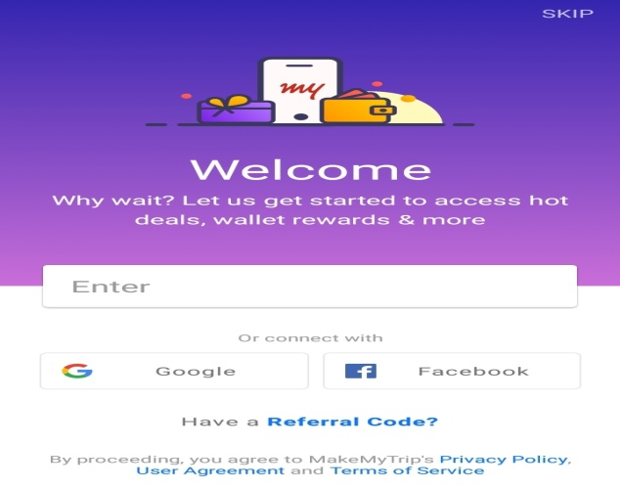

Figure 1: Welcome Page

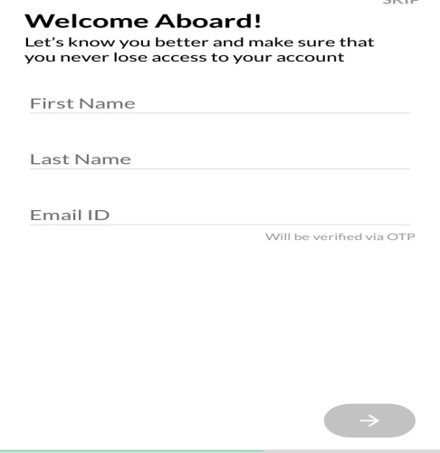

Figure 2: Registration Page

## 3.2 Login

To login into the MakeMy Trip,

* Enter the mobile number.
* For verification of the mobile number, an OTP is sent.
* Once it is verified, the login process is done.

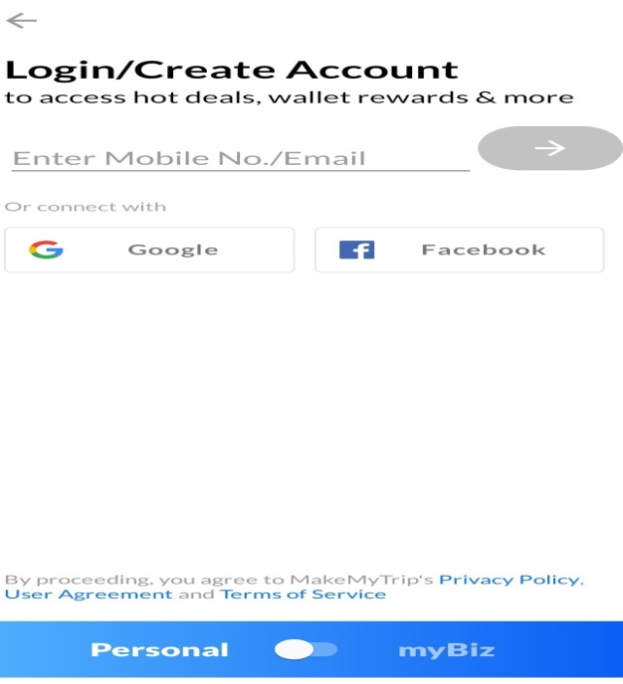

Figure 3: Login Page

* For verification of the mobile number, the OTP has sent to the registered mobile number.

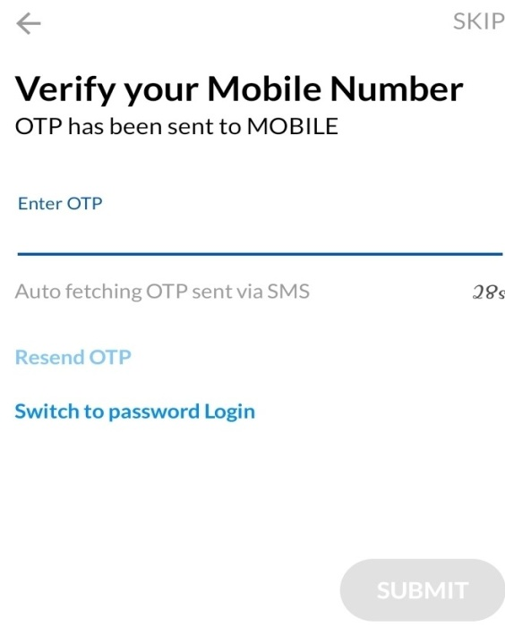

Figure 4: Verifying OTP

## 3.3 Booking Tickets

### 3.3.1 Flight Tickets

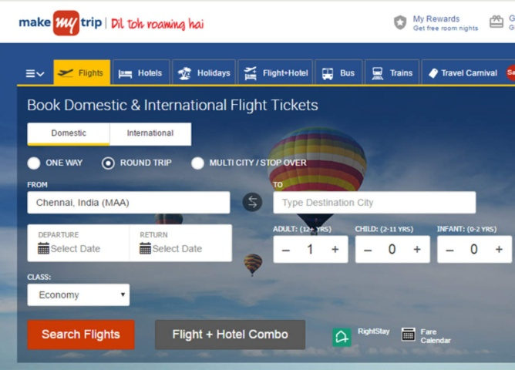

Figure 5: Selecting domestic/international flights

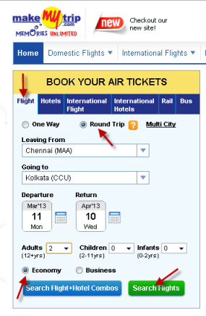

Figure 6 : Booking Flight Tickets

If you want to book the flights then all you have to do is follow these simple steps:

Step 1: Visit the official website, makemytrip.com

Step 2: After that click on the Flights tab.

Step 3: Enter your point of origin and your preferred destination.

Step 4: After that enter the date and the type of your preferred cabin class.

Step 5: Tap on the Filter tab and choose flight type you want to book (Connecting flights or a non-stop flight)

Step 6: At last set the price range to your preferred and click on the Apply button.

Step 7: The available flight result will be displayed on the screen and at the top of the page will show you the flights with the lowest airfare.

### 3.3.2 Train Tickets

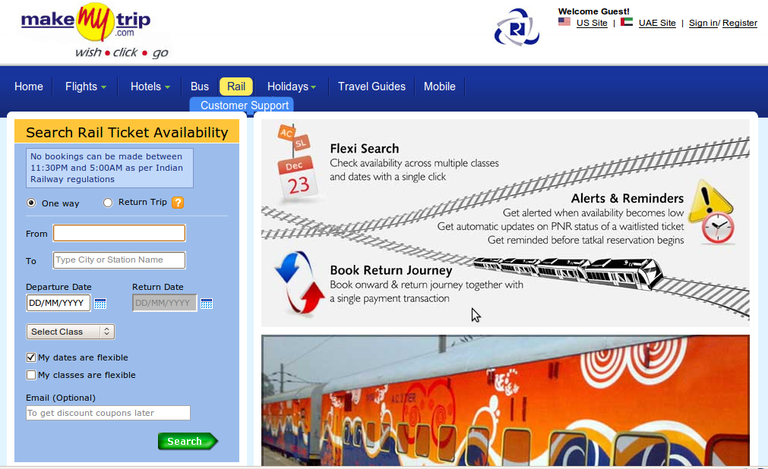

Figure 7: Searching Train Tickets

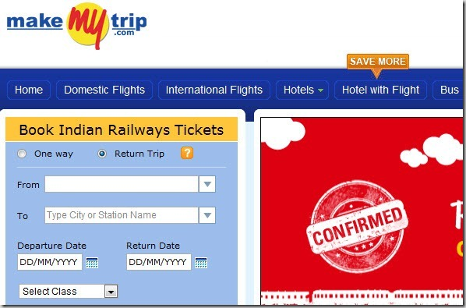

Figure 8: Booking Train Tickets

If you want to book the trains then all you have to do is follow these simple steps:

Step 1: Visit the official website, MakeMy Trip.com

Step 2: After that click on the Trains tab.

Step 3: Enter the source point and your destination.

Step 4: After that enter the date and select the type you want to book.

Step 5: Tap on the Filter tab and choose train type you want to book (Connecting trains or a direct train)

Step 6: The available train result will be displayed on the screen.

### 3.3.3 Bus Tickets

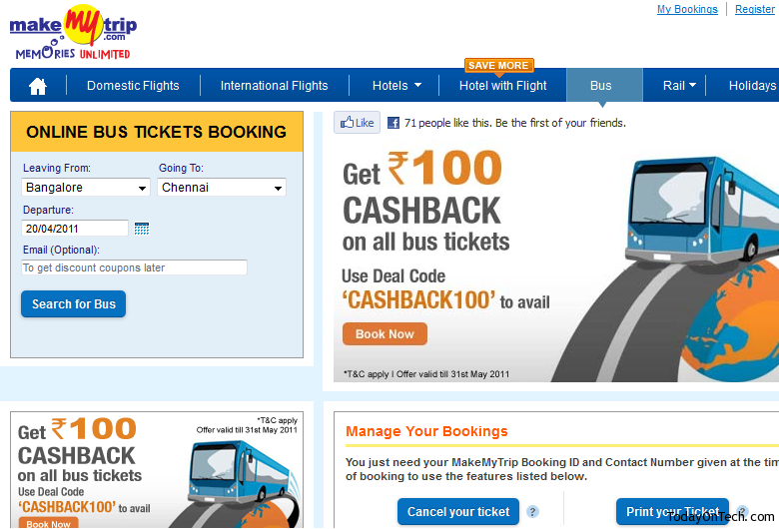

Figure 9: Booking Bus Ticket

If you want to book the Buses then all you have to do is follow these simple steps:

Step 1: Visit the official website, MakeMy Trip.com.

Step 2: After that click on the Buses tab.

Step 3: Enter your source Location and Destination Location.

Step 4: After that Enter the Date and the Email (optional).

Step 5: Click on search for Bus option.

Step 6: The available Buses result will be displayed on the screen and select the bus which you want to book.

### 3.3.4 Hotel Bookings:

If you want to book the Hotels then all you have to do is follow these simple steps:

Step 1: Visit the official website, MakeMy Trip.com.

Step 2: After that click on the Hotels tab.

Step 3: Enter your preferred Location.

Step 4: The available Hotels will be displayed on the screen.

Step 5: After that select the preferred hotel with the requirements.

Step 6: Then add the guest details and continue with the payment.

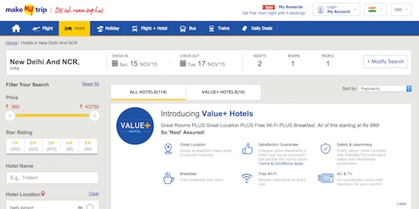

Figure 10: Booking Hotel

Step 7: After confirming the hotel room, you will receive a message or mail to the registered number.

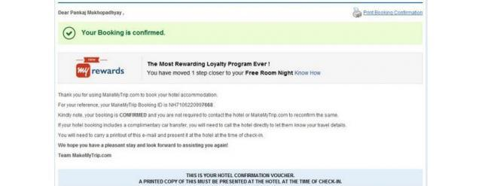

Figure 11: Hotel booking confirmed

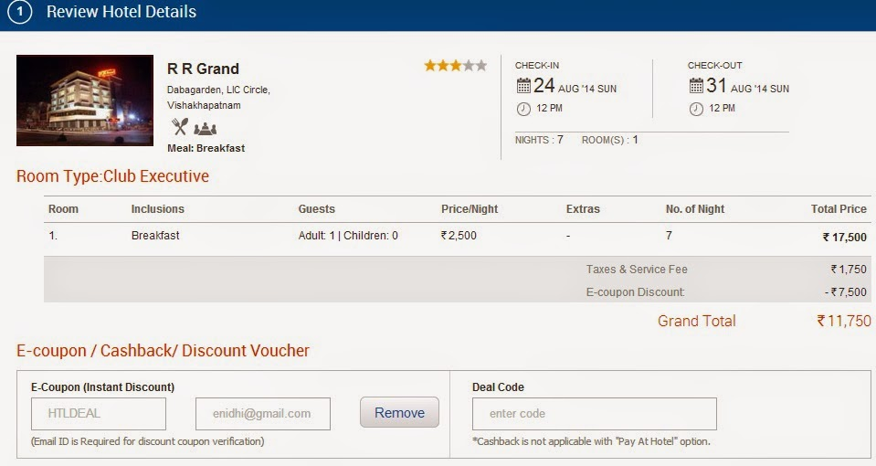

Figure 12: Review of booking

## 3.4 Commercial Details

1. To make payment through wallet,

* Select my wallet option, enter the amount and click on the make payment option.

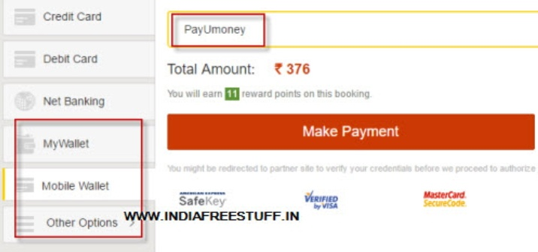

Figure 13: Payment using wallet

2. Payment using credit or debit cards

* Select the credit/debit card option.

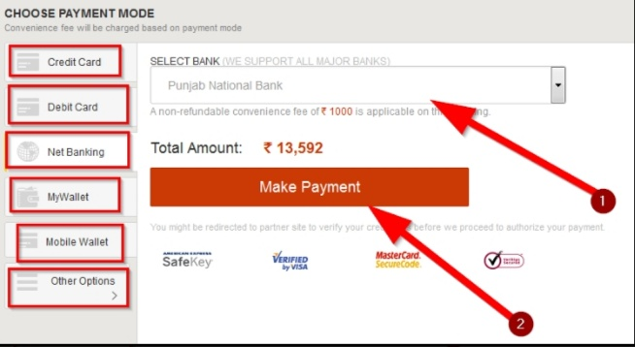

Figure 14: Payment using credit/debit cards

3. If any fraud happens during payment

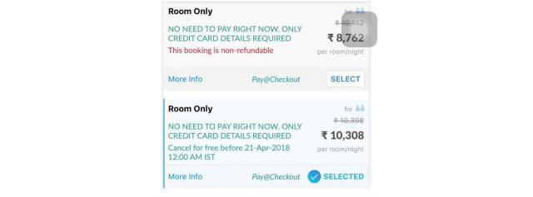

Figure 15: Fraud during payment

## 3.5 Cancellation of Tickets

Cancellation of flight tickets through MakeMy Trip is not a tough task. You can easily make changes or cancel your cancel flight tickets with MakeMy Trip in just a few steps. Different airlines have flight cancellation charges and its own fare rules which you should communicate at the time of purchase. Follow the below steps to cancel your flight tickets through MakeMy Trip.

Here is MakeMy Trip flight ticket cancellation procedure:

Step 1: At first visit the website

Step 2: Click on the Customer Support

Step 3: Login by entering your email id or mobile number.

Step 4: After that log onto Manage your Bookings.

Step 5: Here enter the MakeMy Trip Booking ID corresponding to your booking and the Contact number that you gave at the time of the booking.

Step 6: Here you get the option to cancel your entire booking or cancel any specific passengers or sectors in your booking after you log in.

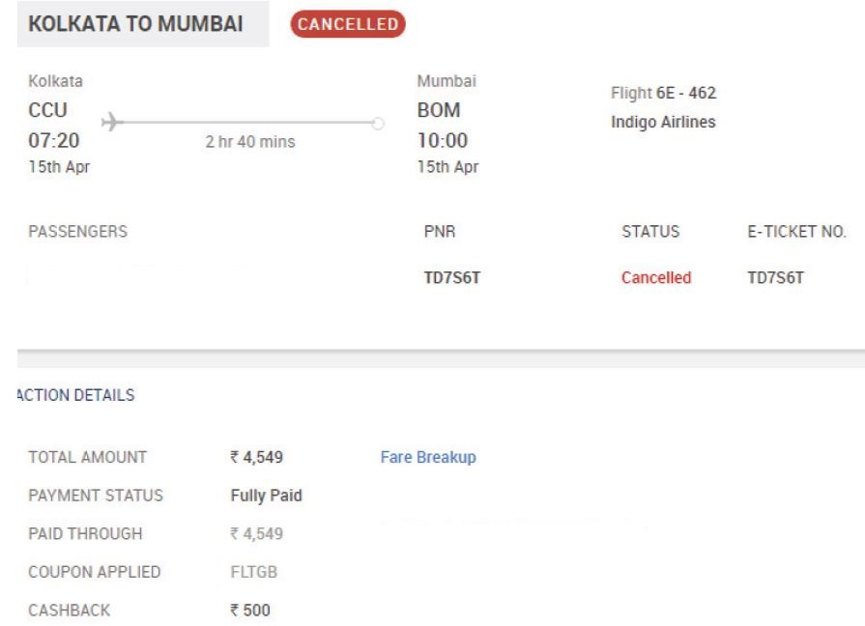

Figure 16: Cancellation of Ticket

Step 7: Before you confirm to cancel the booking, please review the cancellation penalty and refund amount.

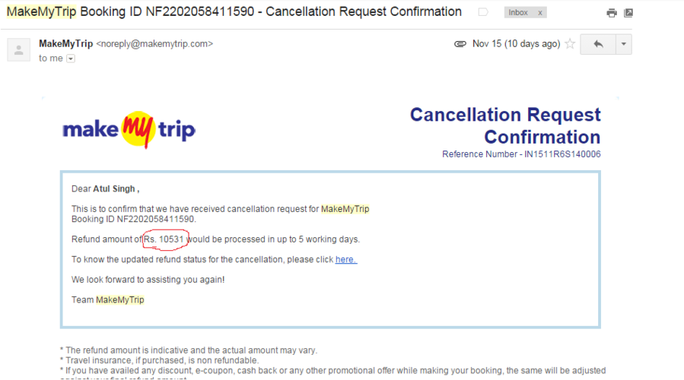

Figure 17: Cancellation Request confirmation

Step 8: The refund amount would reflect in the same account that was used to make the payment at the time of the booking.

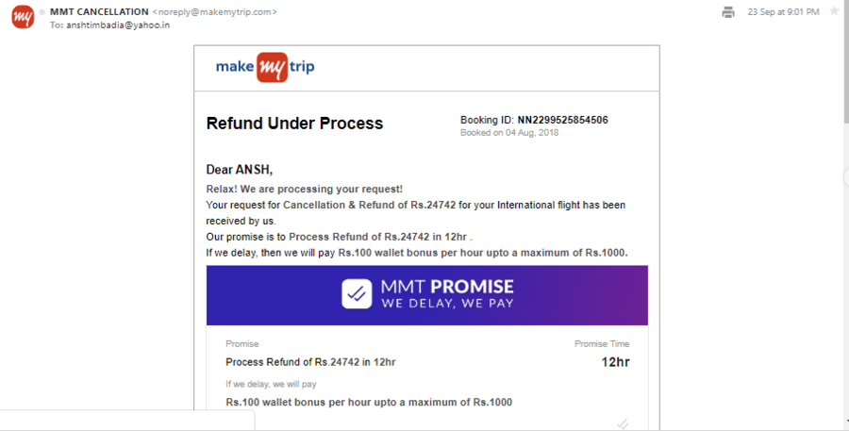

Figure 18: Refund Process

Apart from this, you can even cancel your tickets by logging into your MakeMy Trip account using your email id and password under the My Bookings section on the Customer Support page. Before you book your flight tickets plan your trip and book your tickets according to that.

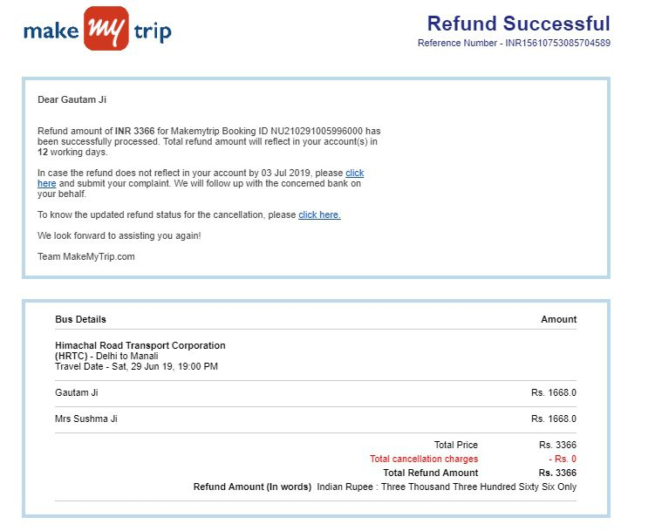

Figure 19: Refund successful

## 3.6 Special offers

Day by day, the air travel sector is growing by leaps and bounds, especially within India. Tourism, employment, education, politics, business or a visit to relatives; the reasons for people to take flights are many.

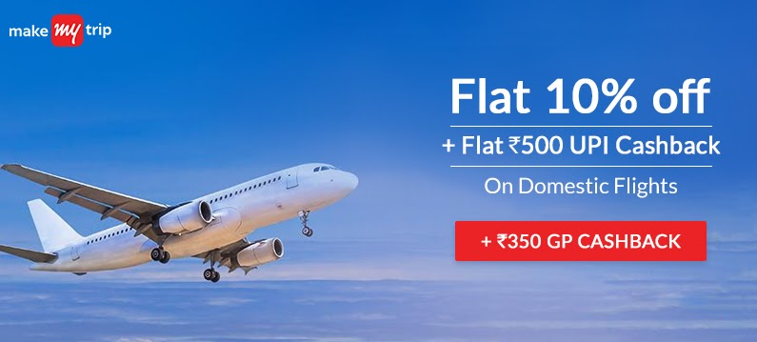

Figure 20: Offer on Cashback

The arrival of new airlines, especially low cost carriers, has made flying more accessible to the common folk. However, with the raising demand for tickets, air fares can be a bit high. This trend is also seen during festivals like Diwali, Pongal, New Year and Holi.



Figure 21: Offer on Credit/Debit cards

During such times, trains and buses are packed to capacity, so flying is the only option left, leading to a further increase in ticket prices. But, you do not have to worry as MakeMy Trip is committed to making your journey hassle-free and budget friendly, this is why, we offer a range of flight coupons.

Leisure or business travelers, looking to fly economically, can make use of the domestic flight coupons. Customers with net banking and credit or debit cards can easily avail promotional discount codes for online domestic flight bookings.

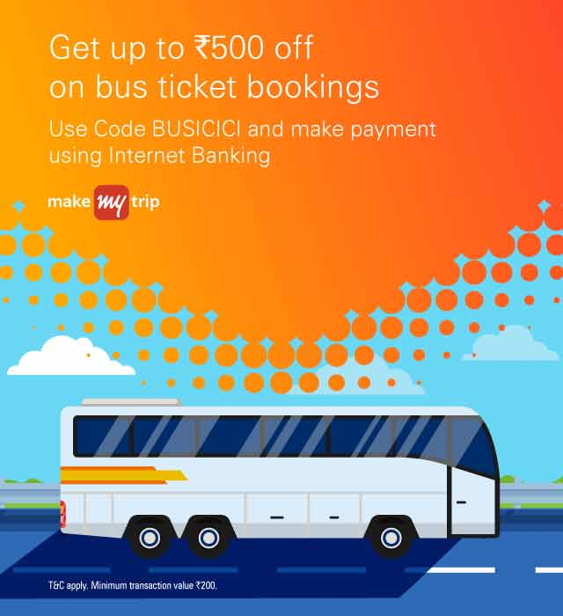

Figure 22: Offer on Bus Tickets

MakeMy Trip has tie-ups with numerous national and international banks, such as ICICI, SBI, and Kotak Mahindra that further adds to the discount percentage. The OTA offers exciting cash back, if you make payment through these banks.

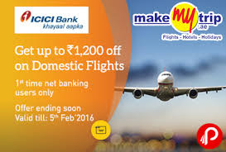

Figure 23: Offer on Flights

To avail domestic flight coupons, you have to visit the MakeMy Trip website and click on the flight tab. From there, you can book a flight as per your preferred timing and destination.

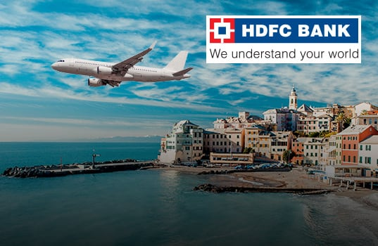

Figure 24: Offer on HDFC Bank

For lucrative deals, you can go to MakeMy Trip coupons page and select the coupon. Post that enters the code while booking and you will get the discount. So, that’s how, you can book a flight to your preferred destination at the best price, and save money with MakeMy Trip domestic flight coupons.

# 4. Sign-Off Document

The following parties have read and agree with this Requirements Definition document for the MakeMy Trip application account module functionality. After approval of this Requirements Definition phase, any significant changes in the scope of this project will require validation of existing project costs and schedules.

_______________________________________________________________________

Name Date

Business Lead

______________________________________________________________________

Name Date

Project Manager