**Holidify**

1. **Login Section**

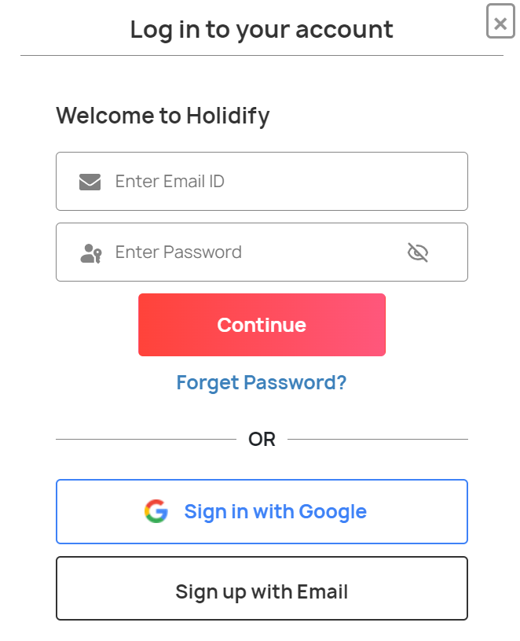

* **Three main components**
  + **Packages**
  + **Hotels**
  + **Collections/Explore**

All attractions in Manali

Click on an attraction to view it on map

*  1. Hidimba Temple
*  2. Solang Valley
*  3. Manu Temple
*  4. Rohtang Pass
*  5. Vashisht Temple
*  6. Paragliding in Manali
*  7. Old Manali
*  8. Manali Mall Road
*  9. Manikaran
*  10. Atal Tunnel
*  11. Van Vihar, Manali
*  12. Jogini Waterfall
*  13. Sethan Valley
*  14. Skiing in Manali
*  15. Jana Waterfall
*  16. Parvati Valley
*  17. The Great Himalayan National Park
*  18. Kullu
*  19. Arjun Gufa
*  20. Bhrigu Lake
*  21. Museum of Himachal Culture & Folk Art
*  22. Nehru Kund
*  23. Naggar
*  24. Adventure Activities in Manali
*  25. Malana
*  26. Himalaya Nyingmapa Buddhist Temple
*  27. Kothi Village Manali
*  28. Gulaba
*  29. Rahala Falls
*  30. Beas Kund Trek
*  31. Hampta Pass Trek
*  32. Manali Club House
*  33. Manali Sanctuary
*  34. Jagatsukh
*  35. Chanderkhani Pass
*  36. Bara Bhangal Trek
*  37. Hampta Valley
*  38. Deo Tibba Trek
*  39. Gayatri Temple
*  40. Gadhan Thekchhokling Gompa Monastery
*  41. Siyali Mahadev Temple
*  42. Chandratal Baralacha Trek
*  43. Gauri Shankar Temple
*  44. Rozy Waterfalls
*  45. Zorbing in Manali
*  46. Bhunter
*  47. Knoi Waterfalls
*  48. Sagoo Waterfall