Assignment no 1.1

Title : Create job in Jenkins and write pipeline-script of apache httpd and do build now and see whether ip is hiting on browser or not .

Step1: Created one index.html file in local repository

Vi index.html



Step2: Select pipeline option when u create job of pipeline

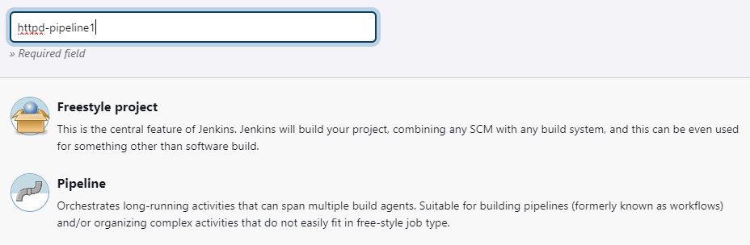

Step3: Created job in Jenkins dashboard

* Pipeline-Script of apache httpd

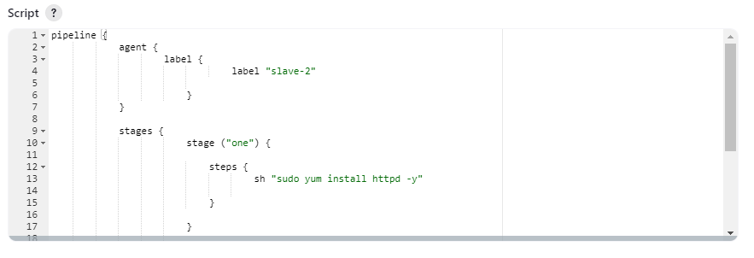

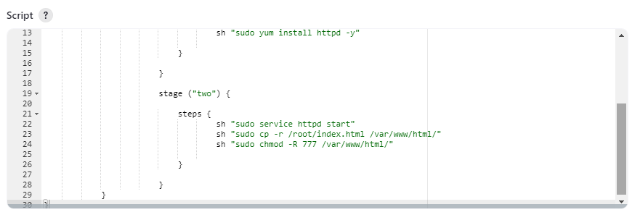

Step4: Created one job in jenkins



Step5: Console output:

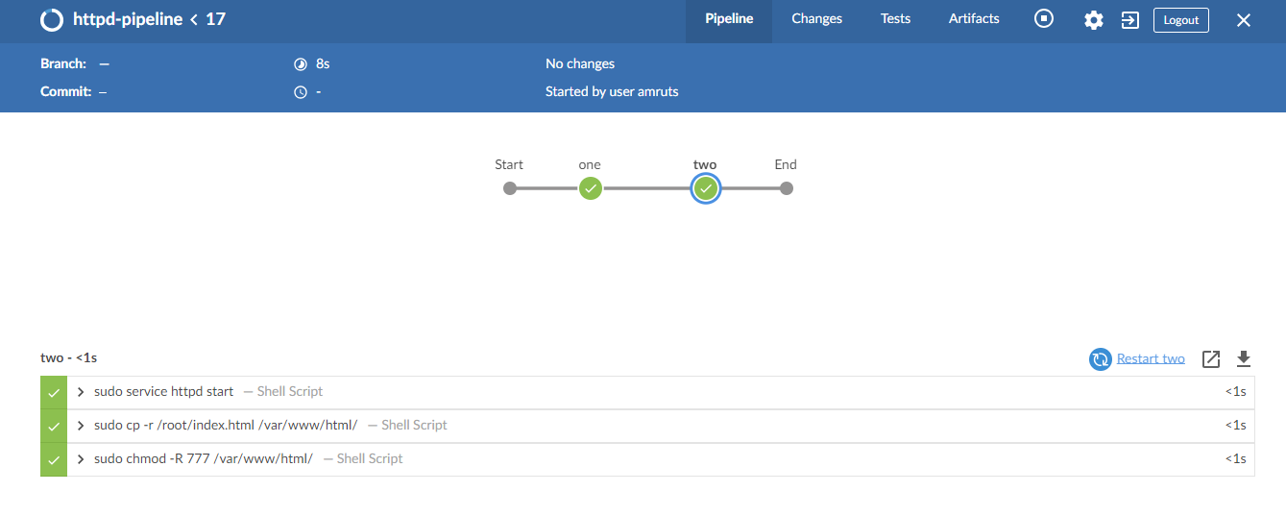

Step6: public ip hit on browser (output):

