Jenkins Assignment 1

Title : Create job in Jenkins and write script of apache httpd and do build now and see whether ip is hiting on browser or not .

Step1: Creating job in Jenkins dashboard

* Script of apache httpd

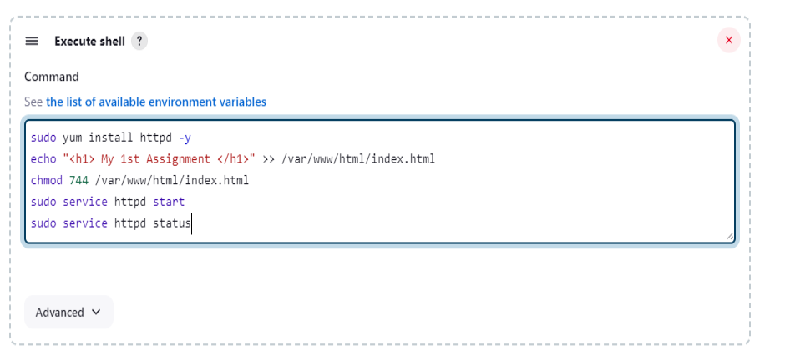

Step2: Job is created and excute successfully

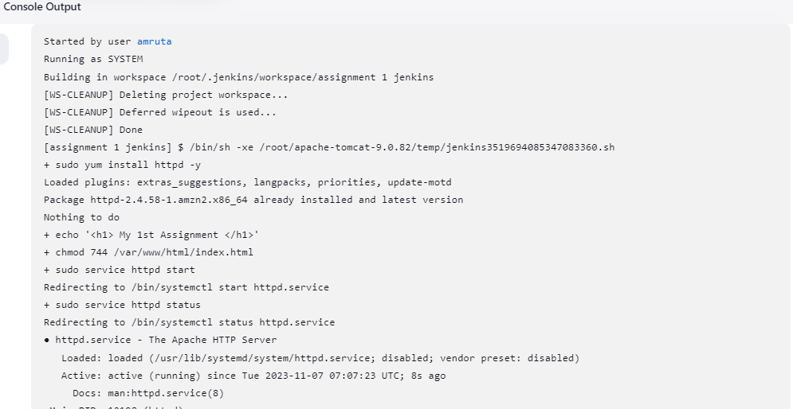

Step3: Public IP hit on Browser and excute successfully

