**Jenkins Assignment 2**

**Jenkins assignment no- 2:** Create a git repository with three branches 2023Q1, 2023Q2, 2023Q3 each branch has its own index.html file. Create 3 jobs for three branches, run each job and website should be deploy on our httpd server with different code for different job:

Step1: First of all, I have setup a public git repository as httpd-repo.

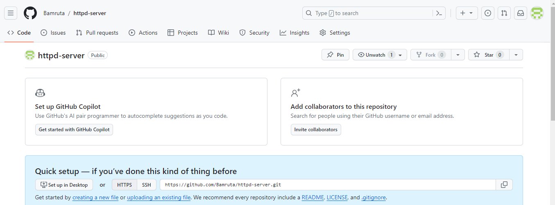

Step2: Cloned git repository on local machine.

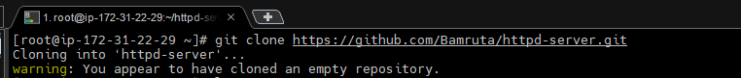

Step3: **:** Created 3 release branches for first 3 quarter release- 2023Q1, 2023Q2, 2023Q3 and pushed 3 branches to git repository



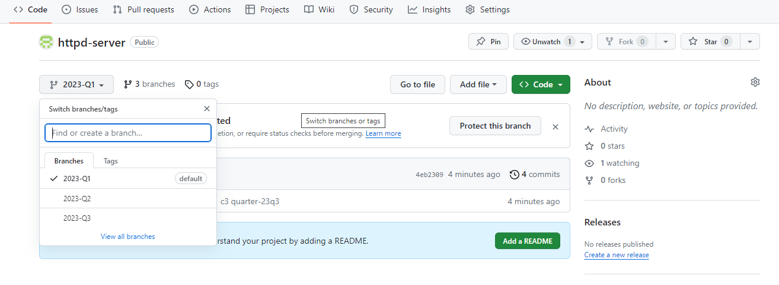

Step4 : After that I’ve created 3 new jobs as 2023Q1, 2023Q2, 2023Q3:

**JOB:** 2023Q1

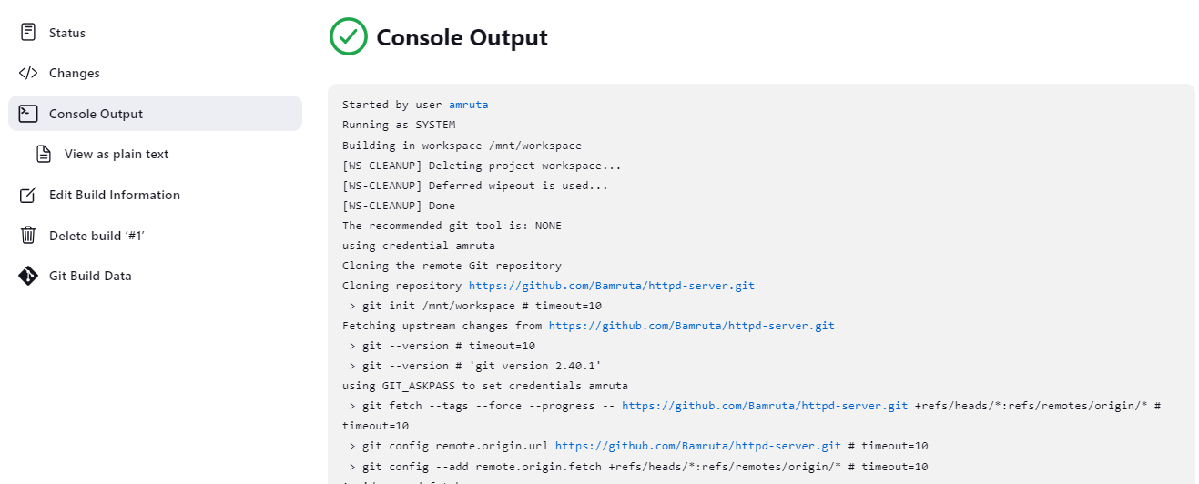

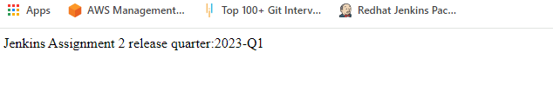**JOB:** 2023Q2

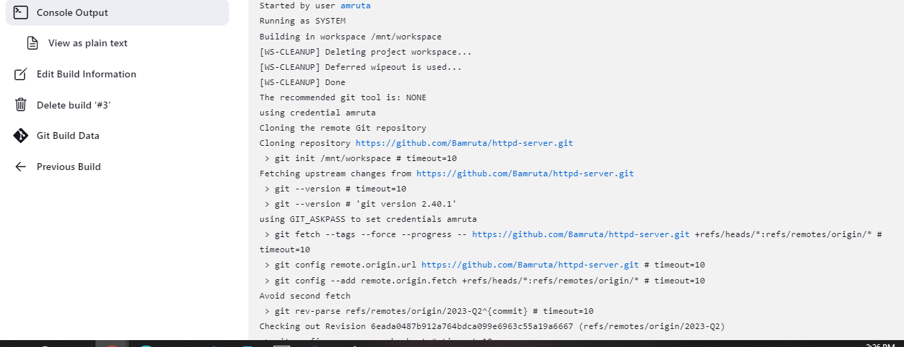

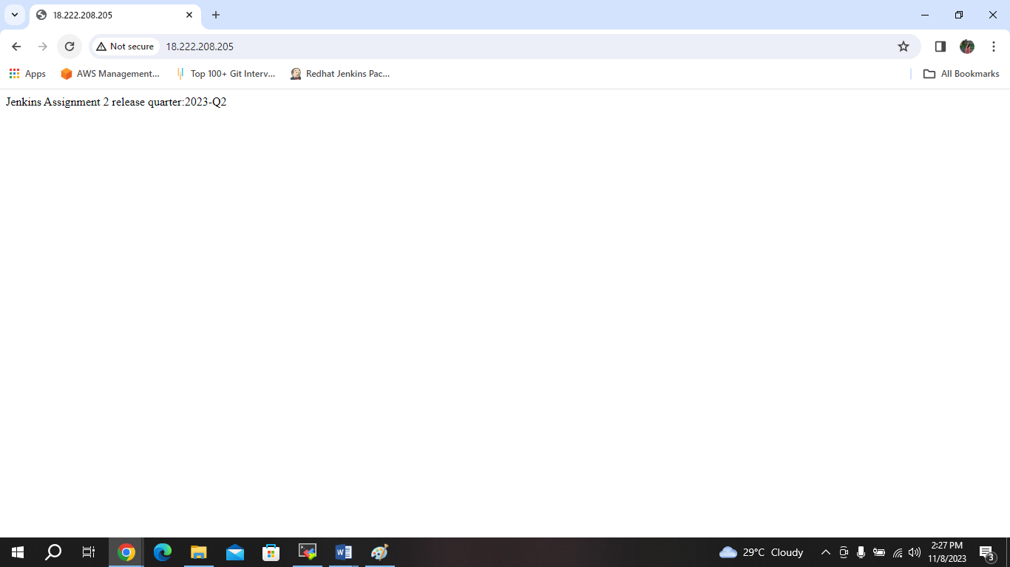

**JOB:** 2023Q3

