Assignment -3

Title : Create 3 repo in local repository and in each repo create index.html file and push these repo one by one to remote repository and also create 3 jobs in Jenkins dashboard . Now when u will edit index.html file from any repository and pushed again to local repo then automatic job should be build .

Step1: Created three repo in local repository

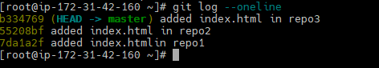

Step2: Created central repository in github

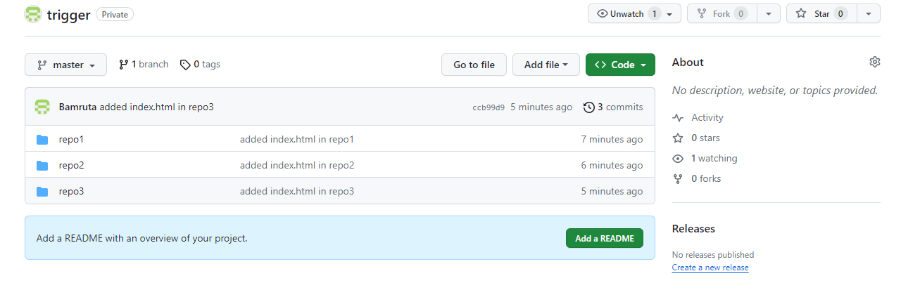

Step3: Created 3 jobs in Jenkins dashboard (1 job for 1 repo)

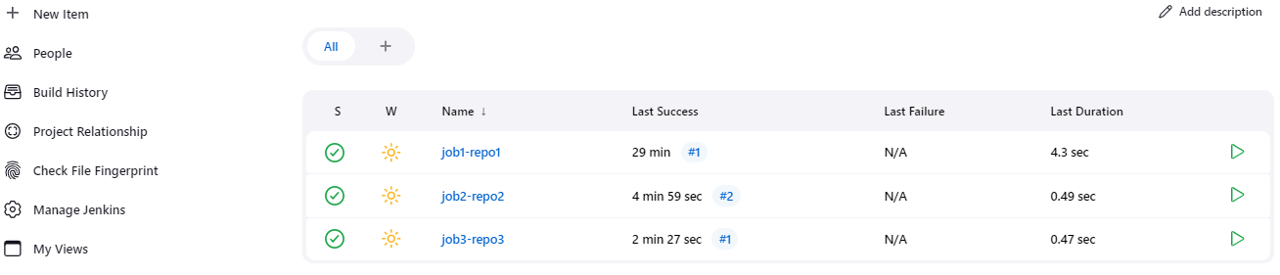

Step4: Created webhook in all repos

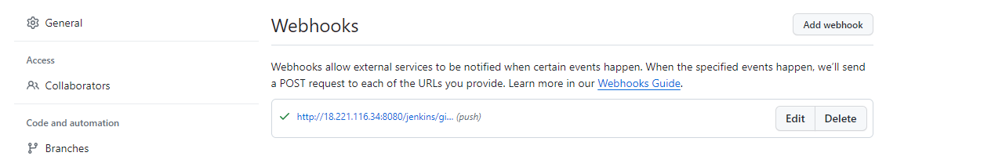

Step5: Edit content in index.html (repo2)

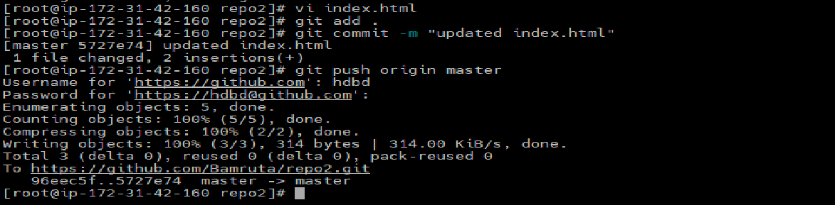

Step6: Build automatically when I edit index.html in repo2

