Assignment 4

Title: Copying .war file from one machine to another machine with the help of scp command.

Step1: Launch one ec2 instance *i.e* In these I have installed java, maven in /mnt/builds_tools and git to clone repository and also installed tomcat.

Step2: Created keypair file in maven master (means in first machine)

vi instance2kp.pem

given permission to pem file *i.e* chmod 000 instance2kp.pem

Step3: In second machine I have installed java and tomcat

Given permission to tomcat *i.e* chmod -R 777 apache-tomcat-9.0.82

Step4: Connect to Jenkins dashboard

Step5: Installed maven in Jenkins also i.e manage Jenkins security maven installation give name goal .

Step6: Created job in Jenkins

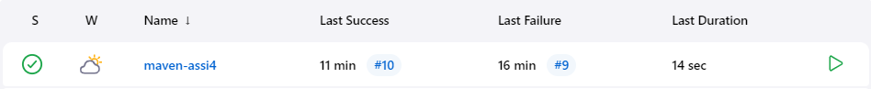

* execute shell :-

rm -rf /root/.m2/repository

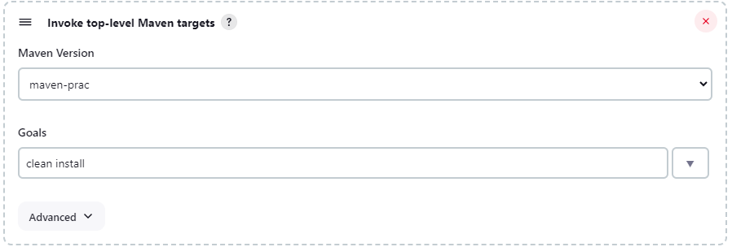

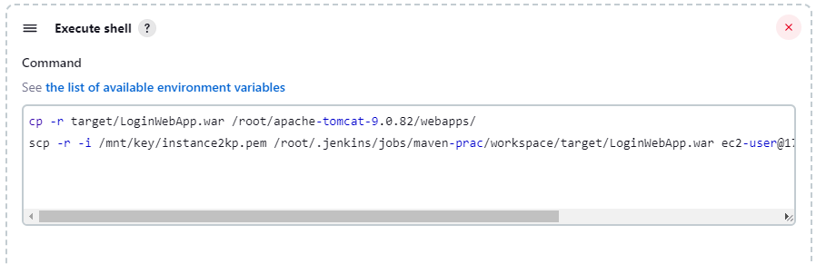

Step7: Console output on job

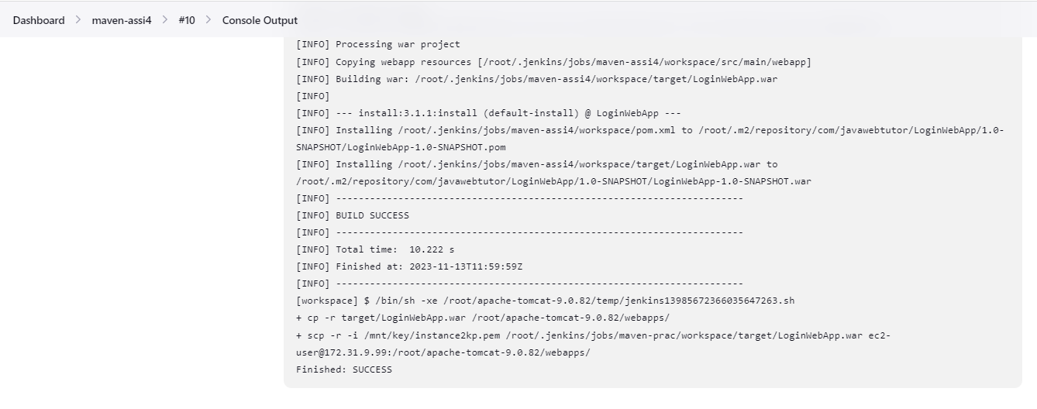

Step8: Public ip hit on browser

*i.e* output

