Assignmnet no : 5

Title: You have one Jenkins Master server and 2 slaves connected (JNLP or SSH), you to create .war file on Jenkins master and then deploy war on both slaves. Both slaves have Apache tomcat preinstalled.

Step1: Prepared Jenkins master server and install maven using zip file.

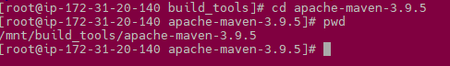

Also setup environment variable so that maven can launch maven from any location.

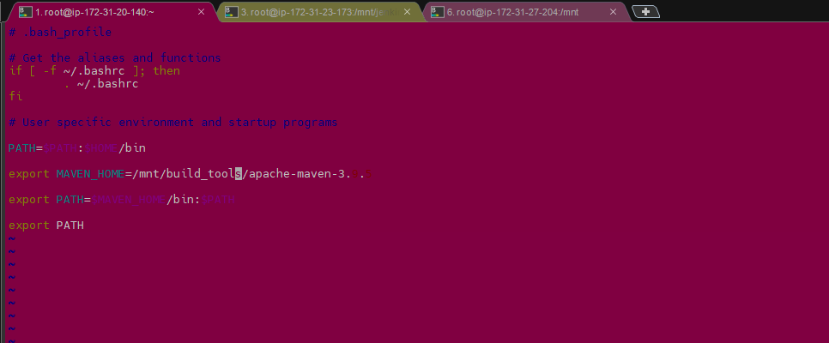

Step2: Installed git



Step3:

We have already launch apache tomcat on both slaves

Also created and saved .pem key file for slaves on Jenkins master

Configured both the slaves with private IP for SCP on master server using CLI.

Slave-1



Slave-2

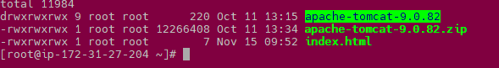

Step4: Created pipeline-script in Jenkins job

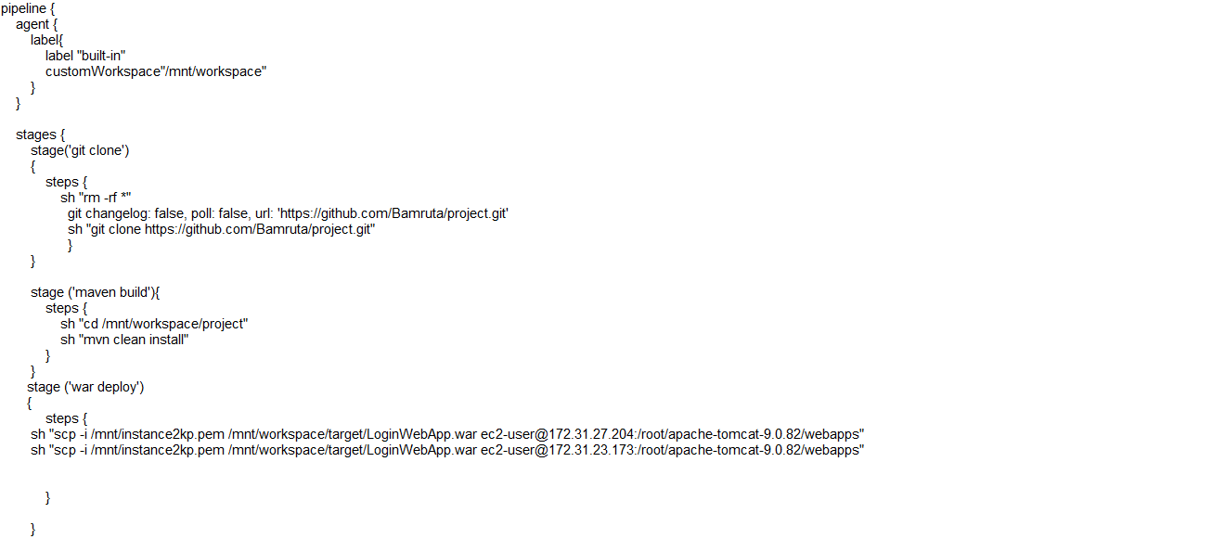

**Successfully build pipeline-job**

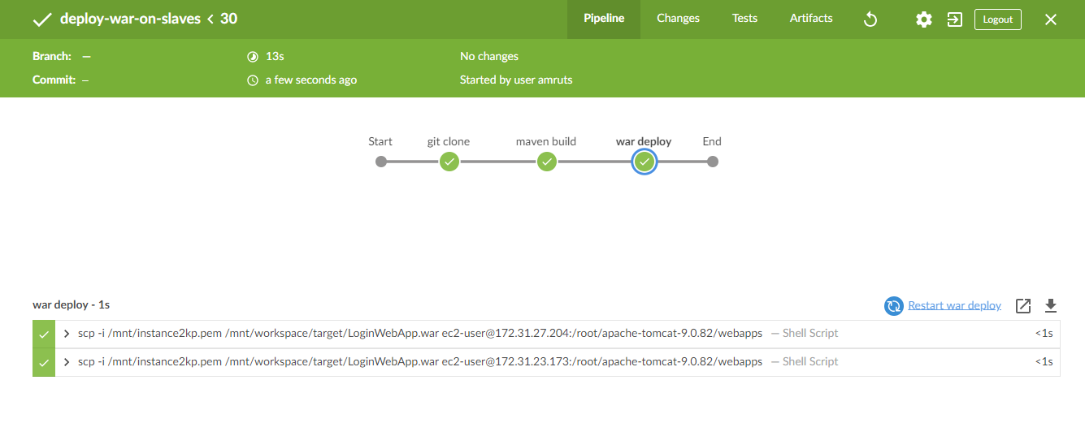

Slave-1

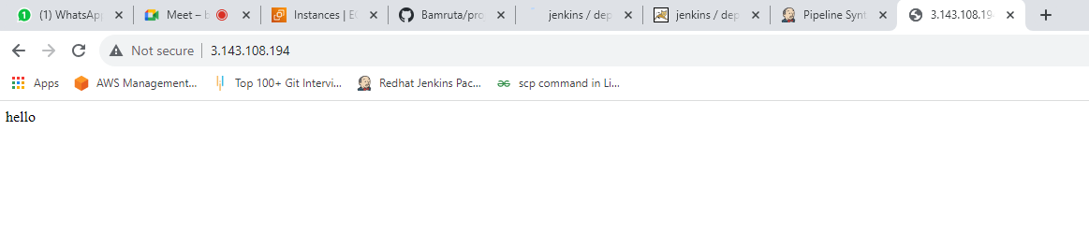

Slave-2

