COMSATS University Islamabad, Abbottabad Campus

**Department of Computer Science**

**LAB #4**

**Object Oriented Programming Class: BSE- 3 A & B**

***Note: Use of classes, objects and methods is compulsory, also suggest the names for classes and methods.***

Q1. Write a program to read a set of numbers and store them in an Array. After entering the numbers, again read a number from the keyboard and find how many times the same number existed in the Array also display its position/index.

Q2. Write a program to read a set of numbers to store it in one dimensional array A, copy the elements in another Array B in reverse order, find the sum of individual array A and B and copy the result in array C and display all three arrays.

.Q3. Write a program using ***Array*** that display Fibonacci series of n number. For example if n=7 the generated output should look like:

1 1 2 3 5 8 13 so on

Q4. Write a program in which one can insert an element at the location specified by the user.

*Numbers in Array:* ***10 20 30 40 50***

*Enter location.* ***2***

*The element to be inserted is:* ***99***

***The output look like as:10 20 99 30 40 50***

Q5. Write a function sub-program program that uses three arrays Mangos, Oranges, and Banana to store the number of fruits purchase by the customer. The program input the number of Mangos, Oranges and Banana to be purchased by the customer and store them in corresponding arrays. The program finally displays the total bill of each customer according to the following prices: Rs. 30 per Mango,

Rs. 15 per Orange and Rs.10 per Banana The output should appears as:

|  |  |  |  |  |  |
| --- | --- | --- | --- | --- | --- |
| **Cust_No** | **Mangoes** | **Oranges** |  | **Banana** | **Total Bill** |
| 1 | 10 | 20 | 12 | ??????? |  |
| 2 | 5 | 12 | 6 | ?????? |  |

Q6. Find the sum of each row and each column of the following matrix.

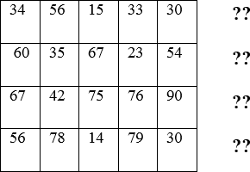

Q7. Declare a 2-Dimensional array of integer numbers. The array consists of 5 rows and 5 columns. Write a program to find out the sum of all elements of 2D-array above and below the diagonal shown in the figure:

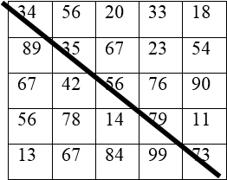

Q8. Find the maximum number in each row and minimum in each column in the given matrix below. You can use the variables called **min, max** to store the minimum and maximum numbers for each row and column. Display the result in the following format.

