# COMSATS University Islamabad, Abbottabad Campus

Department of Computer Science

# LAB FINAL (OBJECT ORIENTED PROGRAMMING) – FALL 2021

Class: BSE 3 A & B Date: 11th JAN 2022

Time Allowed: 2 hours Max Marks: 50

**Note: Attempt any TWO questions of your choice. All questions carry equal marks You are required to upload Java code + Screen shots on CUOnline.**

Q1. (A GUI app.) Create a very basic virtual telephone in JAVA that display a textbox and a button named "Call". Configure your file so that when you type a telephone number into your textbox and press "Call", you are presented with a message confirming the number you are calling. Also presented with another button called "Disconnect" that, when pressed, returns you to your code. Using the switch construct, associate three particular telephone numbers with three names, so that when you press the "Call" button, your confirmation message contains the name of the person you are 'calling' rather than just the telephone number.

Q2. Develop a Java (GUI) program that has *two* Multiple-choice lists. The first Multiple-choice list displays Fast Food stuff and the second Multiple-choice list displays Soft Drinks. The selected items from all the lists should be captured and displayed in a Message Box or in a Text area along with their respective costs. On clicking the ‘Click Once’ Button the total cost of all selected items is calculated and displayed in the textbox. (Suggest the prices for all items)

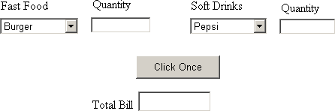

Q3. Create a class named **Movie** that can be used with your video rental business. The Movie class should have **ID Number, and movie title** with appropriate **getter()** and **setter()** methods. Also create an **equal()** method that overrides Object ’s **equals()** method, where two movies are equal if their ID number is identical. Next, create three additional classes named **Action, Comedy, and Drama** that are derived from **Movie**. Finally, create an overridden method named **calcLateFees()** that takes as input the number of days a movie is late and returns the late fee for that movie. The default late fee is Rs. 100/day. Action movies have a late fee of Rs. 30/day, comedies are Rs. 20/day, and dramas are Rs. 10/day. Test your classes from a main method.