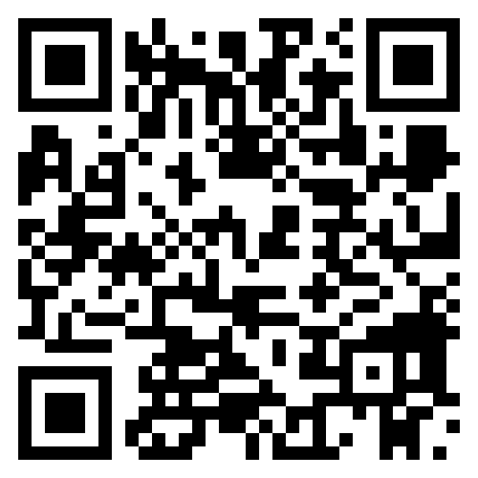**Bonsuck Koo**

LinkedIn:

[bonsuckkoo@gmail.com](mailto:bonsuckkoo@gmail.com) • (347) 798-5104• [LinkedIn](https://www.linkedin.com/in/bonsuckkoo/)

**EDUCATION**

**The University of Texas at Austin GPA: 3.92/4.00**

*Integrated Masters and Bachelor of Science in Mechanical Engineering Dec 2024*

Relevant Coursework: Aerial Robotics, Spacecraft Dynamics, Automated Control Systems Lab, Stochastic estimation and control

**WORK EXPERIENCE**

**Sandia National Laboratories,** *Navigation and Guidance Control Graduate Intern 05/2024-08/2024*

* Modeling, simulation, and analysis of flight vehicles in MATLAB and Simulink

**Aerial Robotics,** *Drone Project 01/2024 – 05/2024*

* Develop C++ algorithm for the drone to find a path through obstacles and finish a race in 2nd place
* Model UAV dynamics, sensor measurements, and develop attitude and position controller in MATLAB

**Blue Origin,** *Guidance Navigation and Control Intern* *09/2023-12/2023*

* Implemented MATLAB and Simulink models for rocket launch simulation, improving its overall fidelity

**Automated Control Systems Lab Course,** *Mini-Segway Project*, *Team Member* *01/2023 – 05/2023*

* Analyzed dynamics of Mini-Segway toy on Python and implemented a LQR controller, which successfully controlled the segway to stay upright for 5 seconds

**Trane Technologies,** *Systems Engineering Team, Co-op 05/2021 – 01/2022*

* Analyzed products against new federal standard using Alteryx and Tableau, contributing to potential savings of $ 400,000
* Validated performance of mechanical fittings that can reduce residential installation time by 25%, and collaborated with technicians to define verification requirements
* Developed a Tableau tool that analyzes product margins, sales, and performance to understand customer demands and simplify company’s product portfolio
* Collaborated with a component supplier throughout the internship to obtain test specimen and specification

**Samsung Semiconductors,** *CMP, Engineering Intern 05/2022 – 08/2022*

* Debugged technical documents that tracked production failures using VBA, saving 1 hour for the technicians every shift
* Created a website version of the technical documents using JavaScript, CSS, and HTML

**LEADERSHIP**

**Senior Capstone Design Project,** *Southwest Research Institute, Team Leader*  *08/2022 – 12/2022*

* Optimized the hammer design to produce zero stress on the hammer pivot upon impact
* Designed a CAD model of Medium Weight Shock Machine that comply with MIL-DTL-901E
* Organized weekly meetings with sponsors, teaching staff and advisors

**Republic of Korea Army,** *Radiotelephone Operator, Counselor**12/2018 – 08/2020*

* Received top marks for promotion tests every quarter by directing 7 squad members in tactical courses using leadership and promoting teamwork
* Received a merit award for effectively relaying orders and situations directly to and from officers in the field
* Counseled fellow soldiers adjust within the military and held quarterly individual counsel sessions with them

**SKILLS**

Simulink, MATLAB, Git, Python, C++