CEBU INSTITUTE OF TECHNOLOGY
UNIVERSITY

COLLEGE OF COMPUTER STUDIES

Software Requirements Specifications
for
ProjectSync

Change History

Table of Contents

Change History 2
Table of Contents 3
1. Introduction 4
1.1. Purpose 4
1.2. Scope 4
1.3. Definitions, Acronyms and Abbreviations 4
1.4. References 4
2. Overall Description 5
2.1. Product perspective 5
2.2. User characteristics 5
2.4. Constraints 5
2.5. Assumptions and dependencies 6
3. Specific Requirements 7
3.1. External interface requirements 7
3.1.1. Hardware interfaces 7
3.1.2. Software interfaces 7
3.1.3. Communications interfaces 7
3.2. Functional requirements 7
Module 1 7
Module 2 8
3.4 Non-functional requirements 8
Performance 8
Security 8
Reliability 8

Introduction

Purpose

- Describe the purpose of the SRS;
- Specify the intended audience for the SRS.

Scope

- Identify the software product(s) to be produced by name (e.g., Host DBMS, Report Generator, etc.);
- Explain what the software product(s) will, and, if necessary, will not do;
- Describe the application of the software being specified, including relevant benefits, objectives, and goals;
- Be consistent with similar statements in higher-level specifications (e.g., the system requirements specification), if they exist.

Definitions, Acronyms and Abbreviations

- provide the definitions of all terms, acronyms, and abbreviations required to properly interpret the SRS

References

- Provide a complete list of all documents referenced elsewhere in the SRS;
- Identify each document by title, report number (if applicable), date, and publishing organization;
- Specify the sources from which the references can be obtained.

Overall Description

ProjectSync is designed to streamline the entire project lifecycle with a range of powerful features. It allows users to create detailed project timelines, define clear project goals, and add team members, fostering better collaboration. Visual Gantt charts provide a dynamic view of the project’s progress, helping users track deadlines and task dependencies. Within the app, task management is made easy by enabling users to create to-do lists, assign tasks to team members, set due dates, and update task statuses as progress is made. This ensures everyone knows their responsibilities and deadlines.

Product perspective

- Put software product into perspective with other related products. If the product is independent and totally self-contained, it should be so stated here. If the SRS defines a product that is a component of a larger system, as frequently occurs, then this subsection should relate the requirements of that larger system to functionality of the software and should identify interfaces between that system and the software.
- A block diagram showing the major components of the larger system, interconnections, and external inter- faces can be helpful.
- Describe the modular decomposition of the components using the format below:
Module 1
Transaction 1.1
Transaction 1.2
Module 2
Transaction 2.1
Transaction 2.2
. . .

User characteristics
- Describe all user types and their roles and privileges in the system

2.4. Constraints
- Provide a general description of any other items that will limit the developer’s options.
- Regulatory policies;
- Hardware limitations (e.g., signal timing requirements);
- Interfaces to other applications;
- Parallel operation;
- Audit functions;
- Control functions;
- Reliability requirements;
- Criticality of the application;
- Safety and security considerations.

2.5. Assumptions and dependencies
This subsection of the SRS should list each of the factors that affect the requirements stated in the SRS. These factors are not design constraints on the software but are, rather, any changes to them that can affect the requirements in the SRS. For example, an assumption may be that a specific operating system will be available on the hardware designated for the software product. If, in fact, the operating system is not avail- able, the SRS would then have to change accordingly.

Specific Requirements

External interface requirements

3.1.1. Hardware interfaces
This should specify the logical characteristics of each interface between the software product and the hard- ware components of the system. This includes configuration characteristics (number of ports, instruction sets, etc.). It also covers such matters as what devices are to be supported, how they are to be supported, and protocols. For example, terminal support may specify full-screen support as opposed to line-by-line support.

3.1.2. Software interfaces
This should specify the use of other required software products (e.g., a data management system, an operating system, or a mathematical package), and interfaces with other application systems (e.g., the linkage between an accounts receivable system and a general ledger system).

3.1.3. Communications interfaces
This should specify the various interfaces to communications such as local network protocols, etc.

Functional requirements

Module 1 – Project Planning and Scheduling

1.1 Create Project

Use Case Diagram
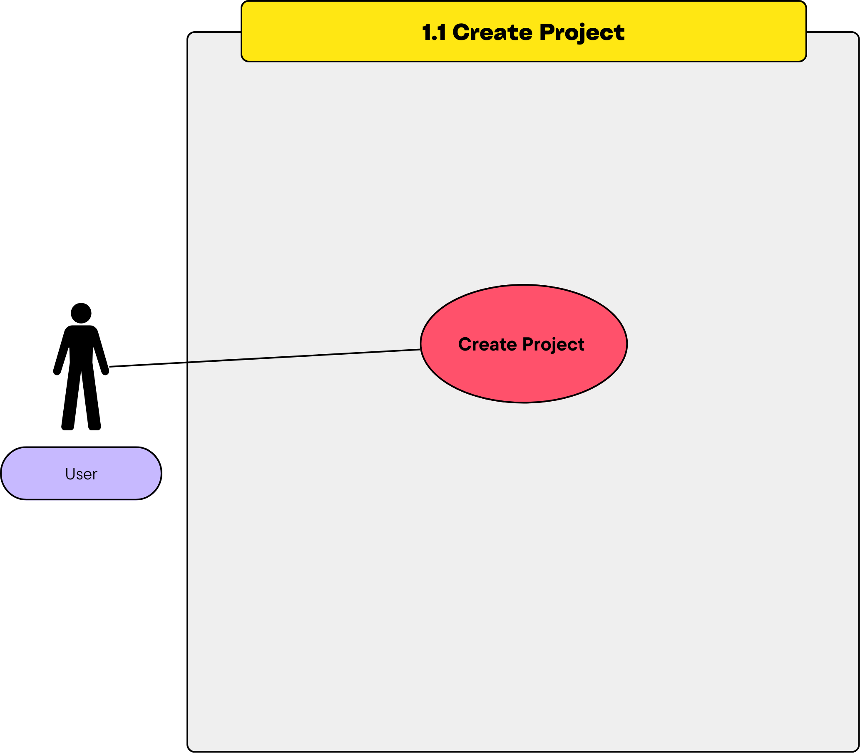

Use Case Description
  - Primary Actor: User
  - Stakeholders:
    - User: Wants to create a new project.
    - System: Stores project information.
  - Preconditions:
    - User must be authenticated and authorized.
  - Postconditions:
    - A new project is created and saved in the system.
  - Main Flow:
- User clicks the "Create Project" button.
- System displays a form for project details (e.g., name, description, start date, end date).
- User fills out the form and submits.
- System validates the data.
- System saves the project and displays a confirmation message.
  - Alternative Flows:
    - Invalid Data: System displays an error message if required fields are missing.

Activity Diagram
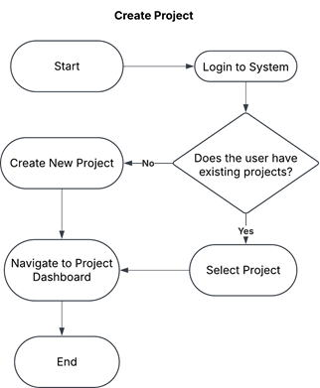
- Wireframe

1.2 Deleting a Project
- Use Case Diagram
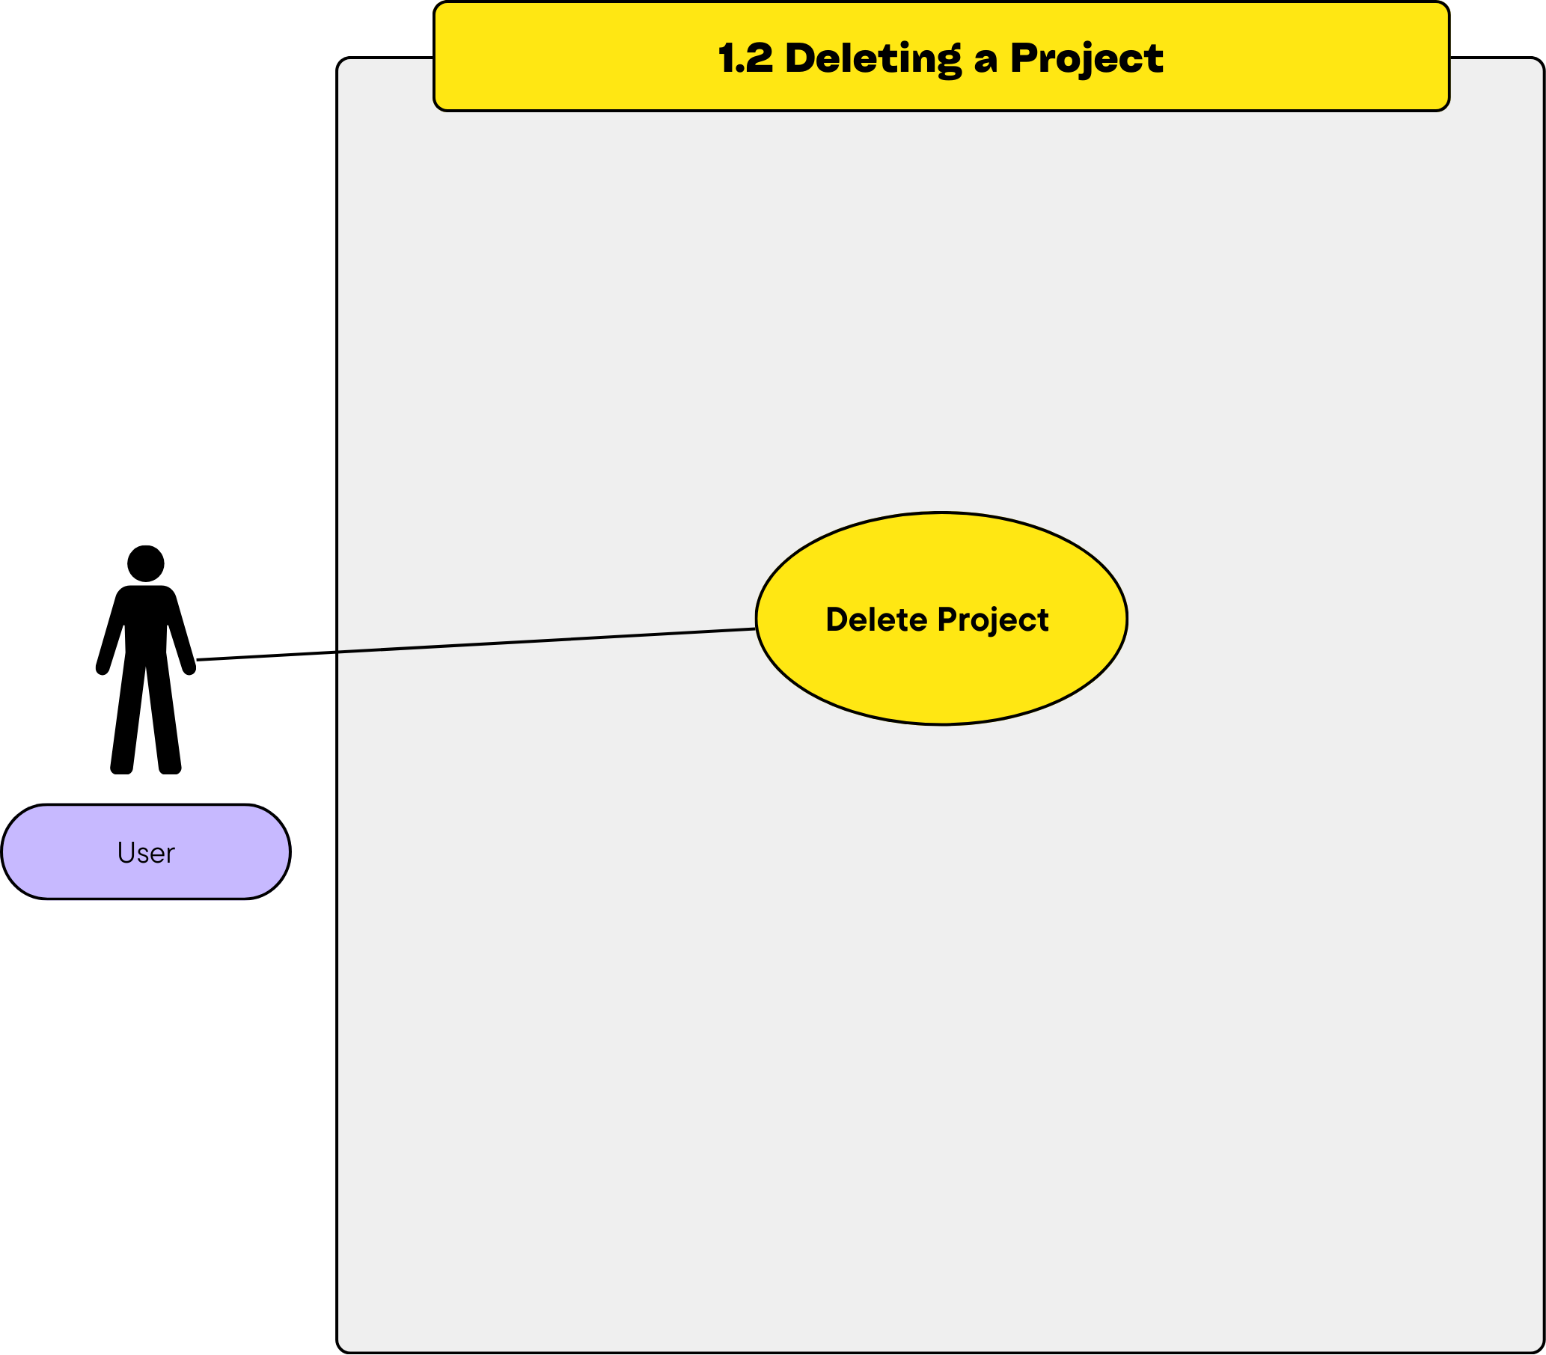
- Use Case Description
  - Primary Actor: User
  - Stakeholders:
    - User: Wants to remove an unnecessary or completed project.
    - System: Manages the deletion process.
  - Preconditions:
    - The project must already exist.
    - User must have permission to delete the project.
  - Postconditions:
    - The selected project is deleted from the system.
  - Main Flow:
- User selects the project to delete.
- System displays a confirmation prompt.
- User confirms the deletion.
- System deletes the project and displays a success message.
  - Alternative Flows:
    - Cancellation: If the user cancels, the project remains in the system.
- Activity Diagram
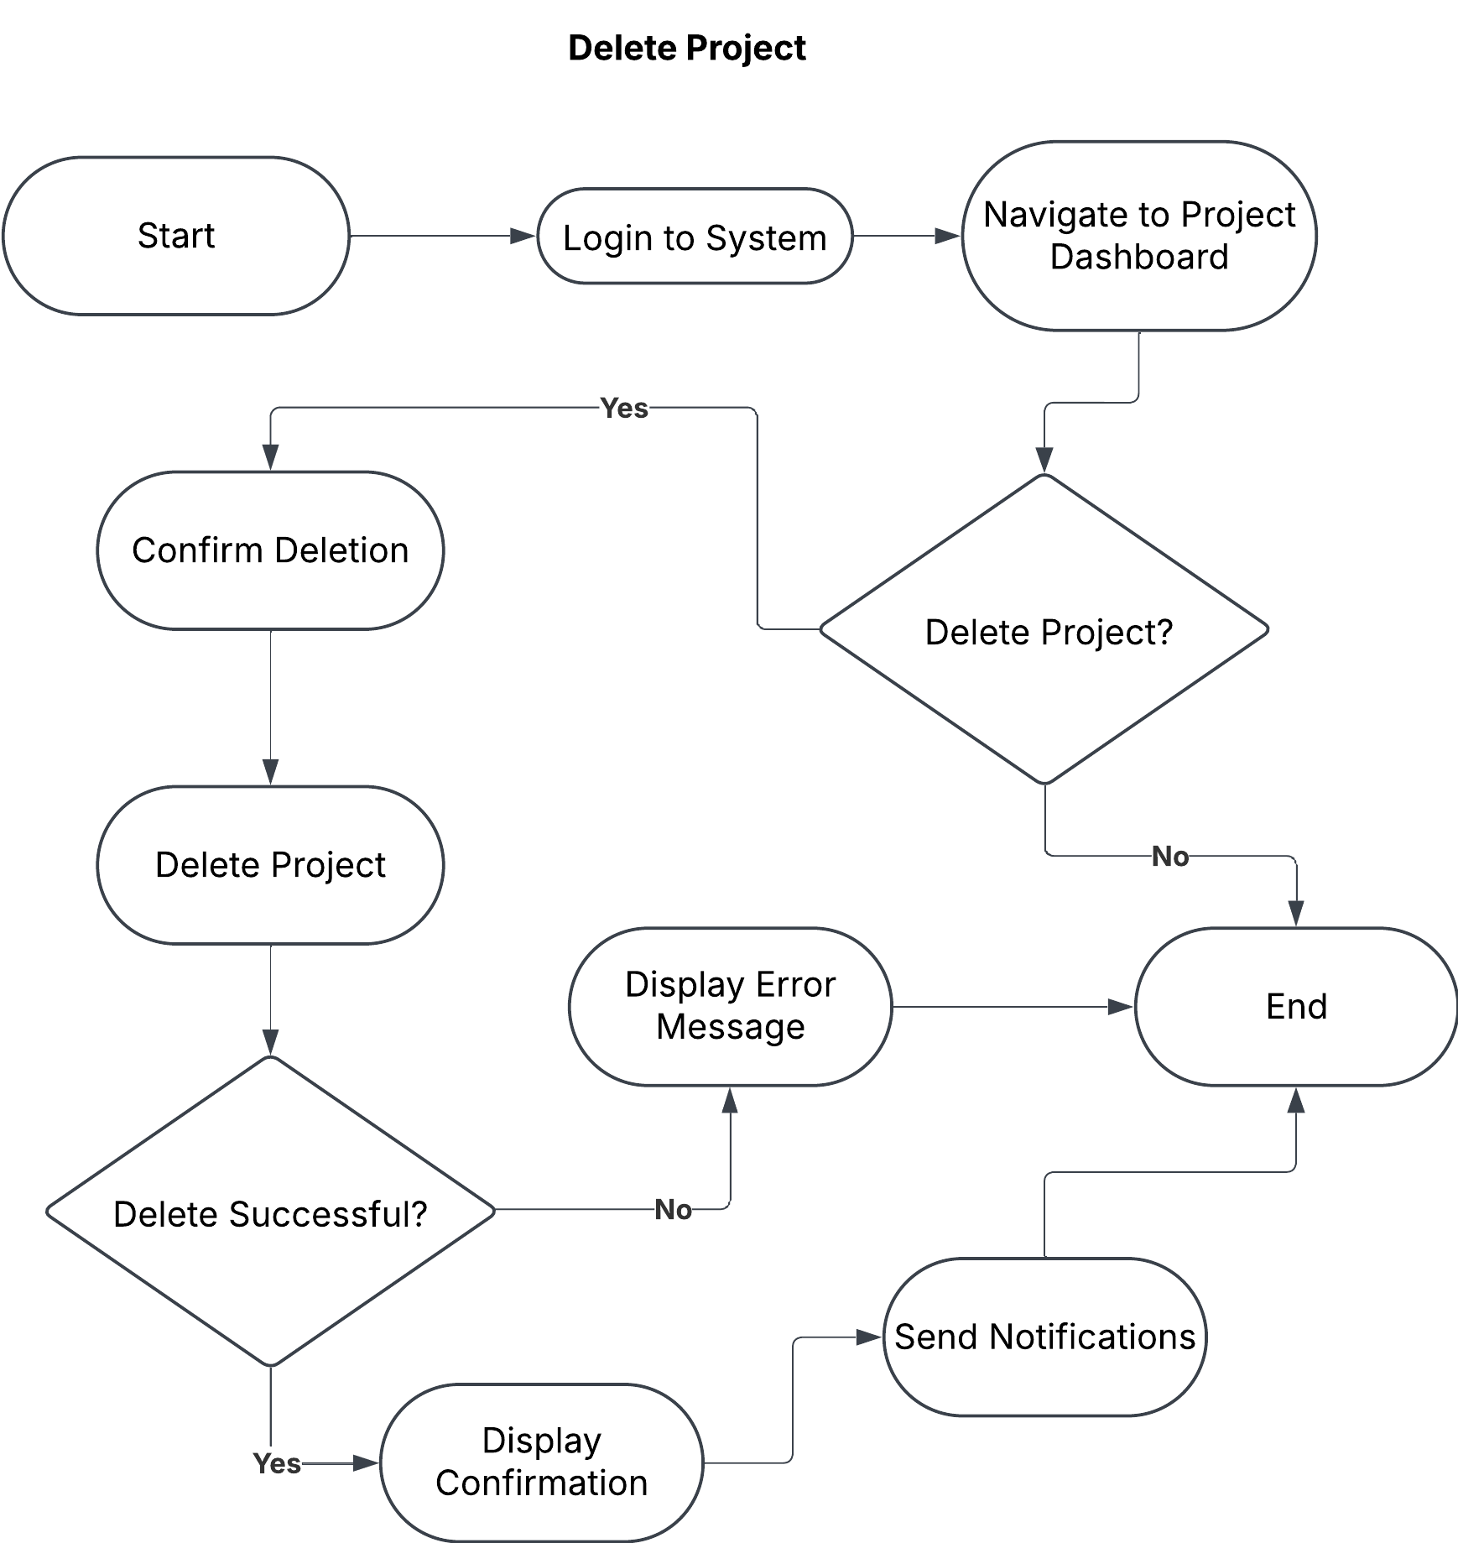
- Wireframe

1.3 Add/Modify a Timeline
- Use Case Diagram
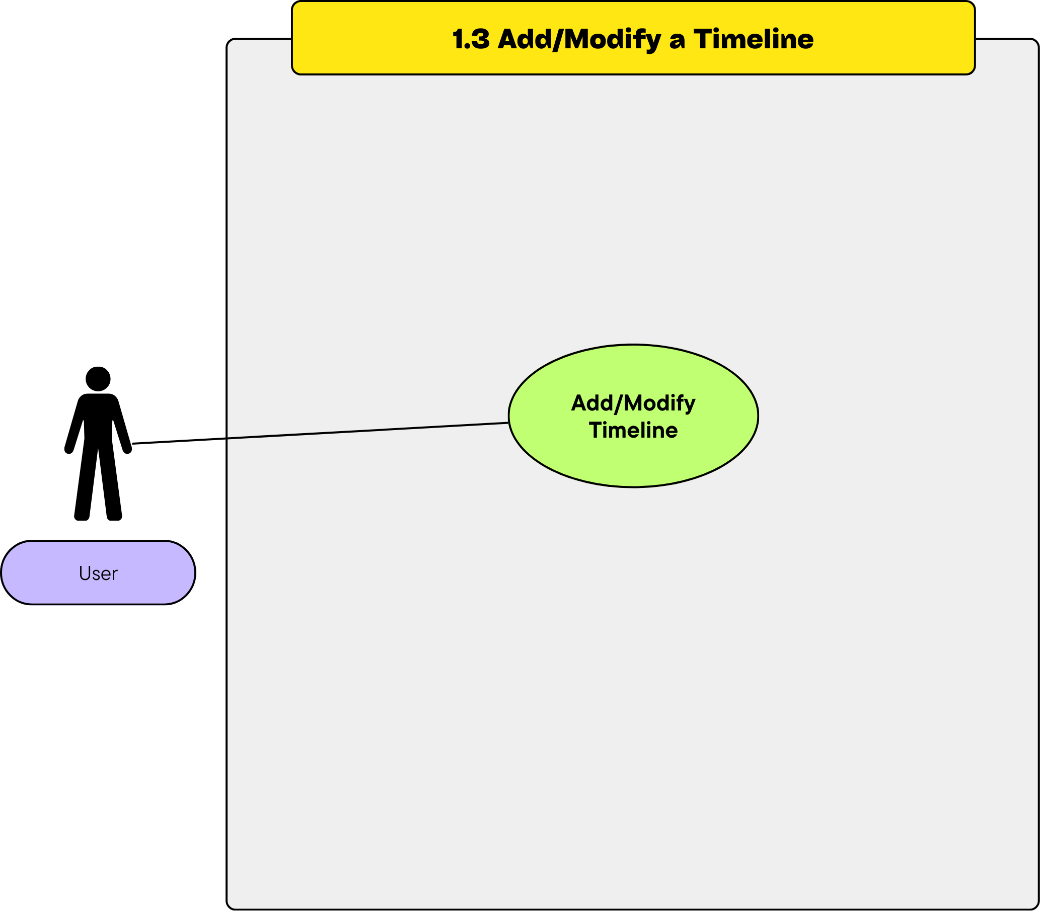
- Use Case Description
- Primary Actor: User
- Stakeholders:
  - User: Wants to manage the project timeline.
  - System: Manages timeline updates.
- Preconditions:
  - A project must be selected.
  - User must have permission to modify timelines.
- Postconditions:
  - imeline is added or modified in the system.
- Main Flow:
  - User navigates to the project timeline section.
  - User clicks the "Add Timeline" or "Modify Timeline" button.
  - System displays a timeline editing form.
  - User enters or updates timeline details and submits the form.
  - System validates and saves the changes.
  - System displays a success message.
- Alternative Flows:
  - Invalid Data: System displays an error message if timeline details are invalid.
- Activity Diagram
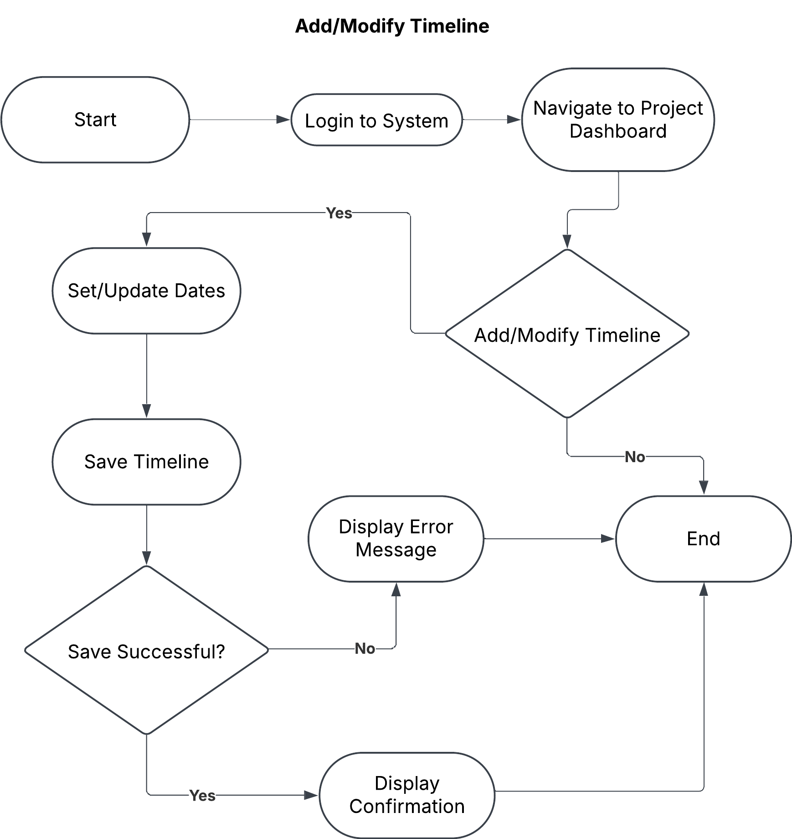
- Wireframe

1.4 View Timeline
- Use Case Diagram
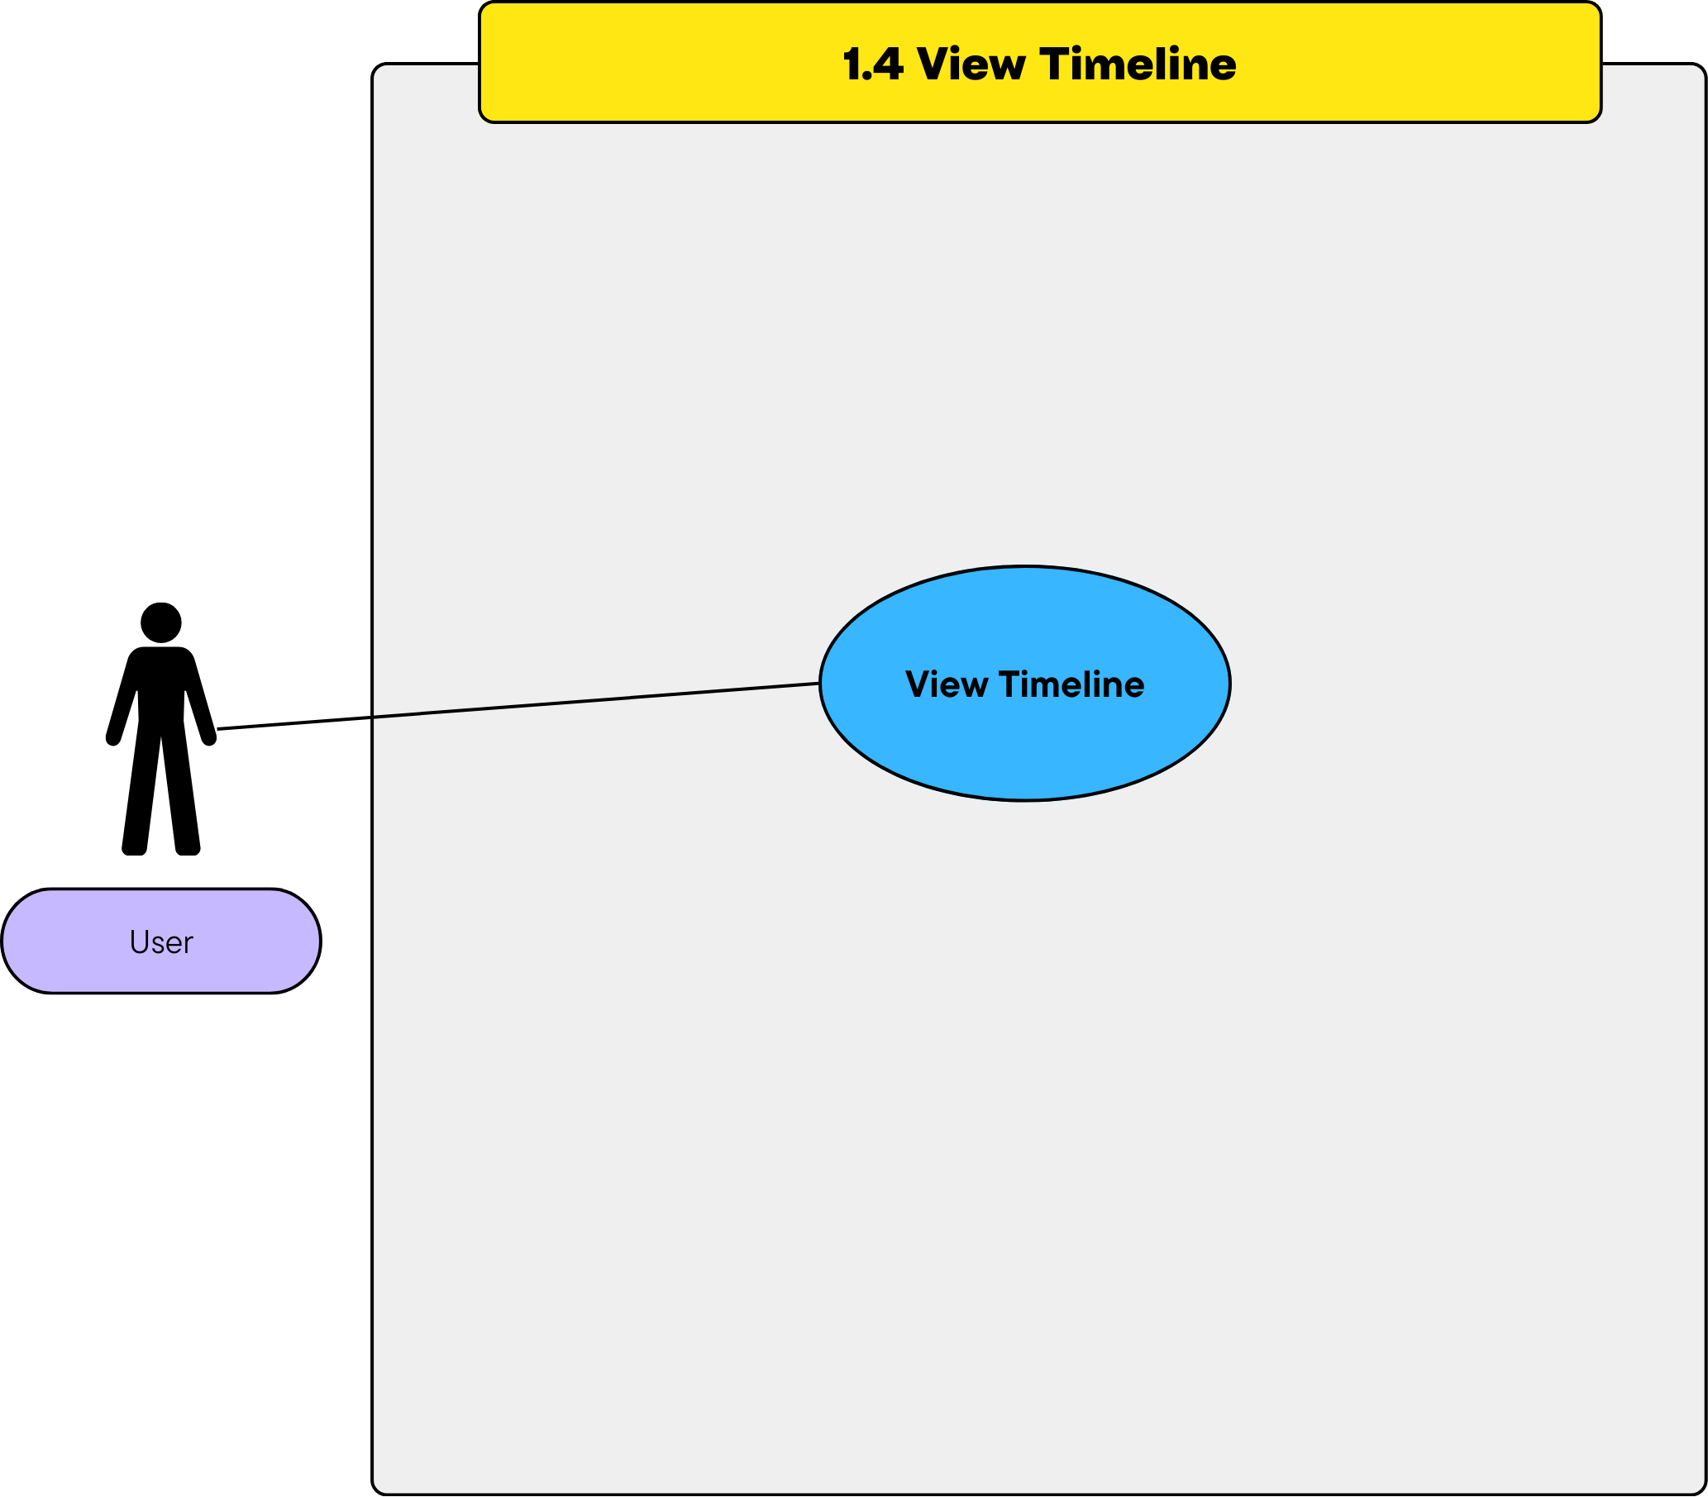
- Use Case Description
  - Primary Actor: User
  - Stakeholders:
    - User: Wants to view the current project timeline.
    - System: Displays timeline information.
  - Preconditions:
    - User must be authenticated.
    - Timeline must be associated with a project.
  - Postconditions:
    - Timeline is displayed on the user interface.
  - Main Flow:
    - User selects a project.
    - System displays the project dashboard.
    - User clicks the "View Timeline" button.
    - System retrieves and displays the timeline for the selected project.
  - Alternative Flows:
    - No Timeline Available: System displays a message indicating no timeline is set.
- Activity Diagram
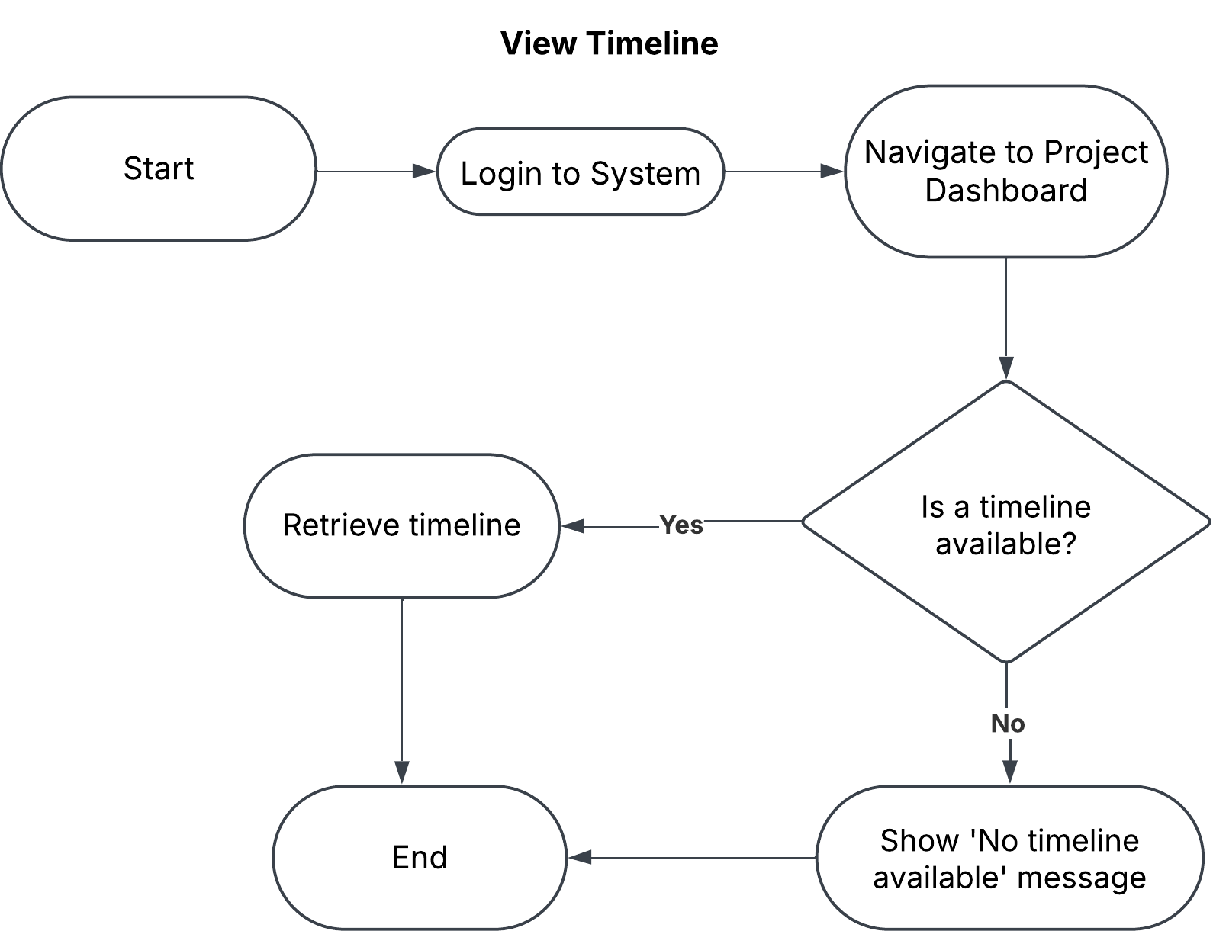
- Wireframe

Module 2 – Task Management

1.1 Create a to-do list for the project

Use Case Diagram
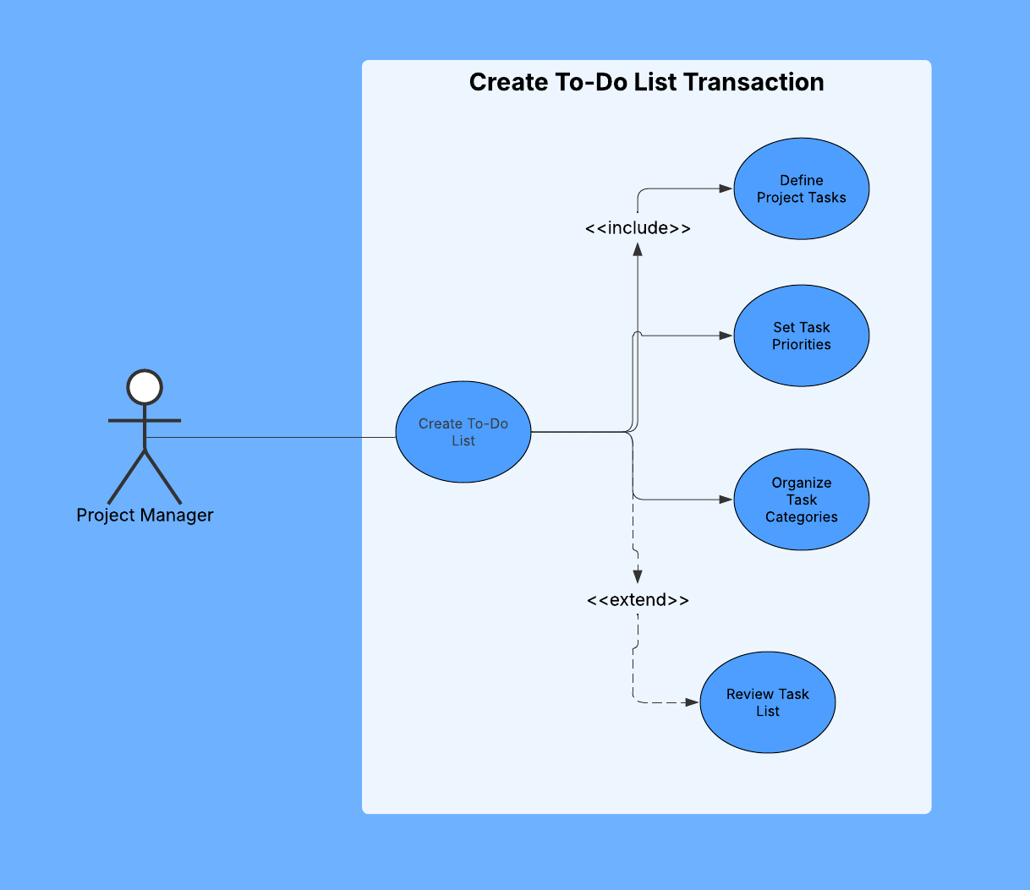

Use Case Description
FIELD | DESCRIPTION
Use Case Name | Create To-Do List
Actor(s) | Project Manager
Description | Project Manager creates and organizes tasks needed to complete the project
Precondition | Project has been defined in the system
Main Flow | 1. Project manager selects Create new tasks option  2. System displays tasks creation interface  3. Project Manager defines project tasks  4. Project Manager sets task priorities  5. System saves the task list
Alternative Flow | 4a. Project Manager imports tasks from template  6a. Project Manager reviews task list before saving
Postcondition | Task list is created and stored in the system

Activity Diagram
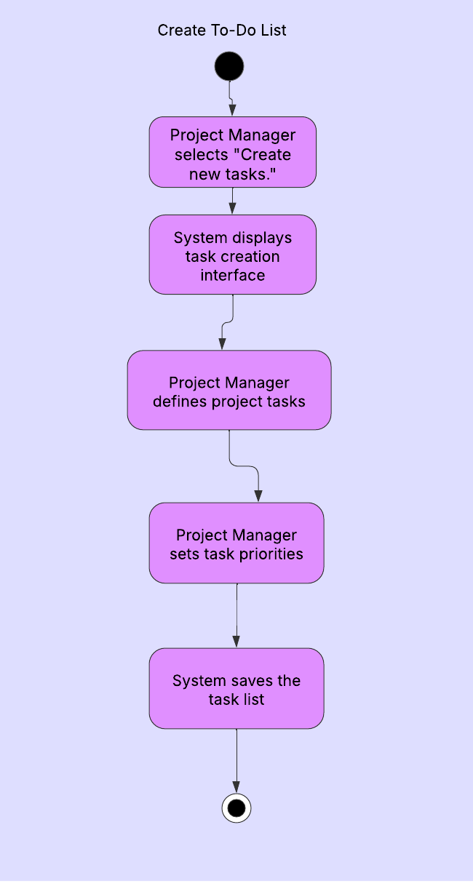

Wireframe

1.2 Assign tasks to members

Use Case Diagram
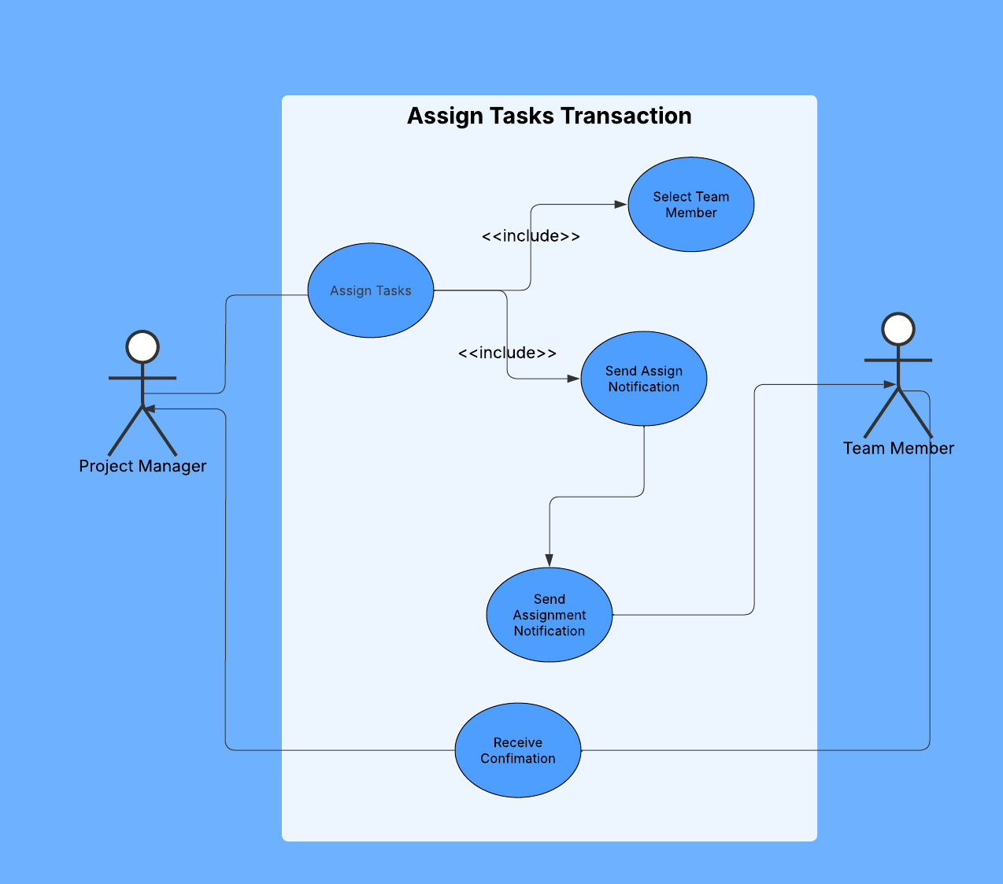

Use Case Description
FIELD | DESCRIPTION
Use Case Name | Assign Tasks
Actor(s) | Project Manager, Team Member
Description | Project Manager delegates tasks to specific team members
Precondition | To-Do list has been created
Main Flow | 1. Project Manager selects "Assign Tasks" option  2. System displays available team members  3. Project Manager selects team member  4. Project Manager assigns selected tasks  5. System sends assignment notification  6. Team Member receives notification  7. Team Member confirms assignment
Alternative Flow | None
Postcondition | Tasks are assigned to team members

Activity Diagram
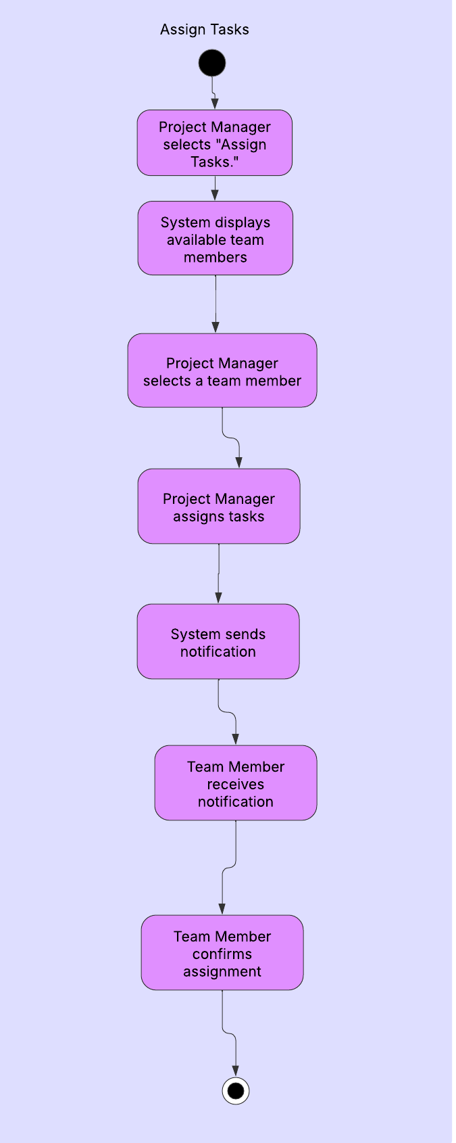

Wireframe

1.3 Set due dates for tasks

Use Case Diagram
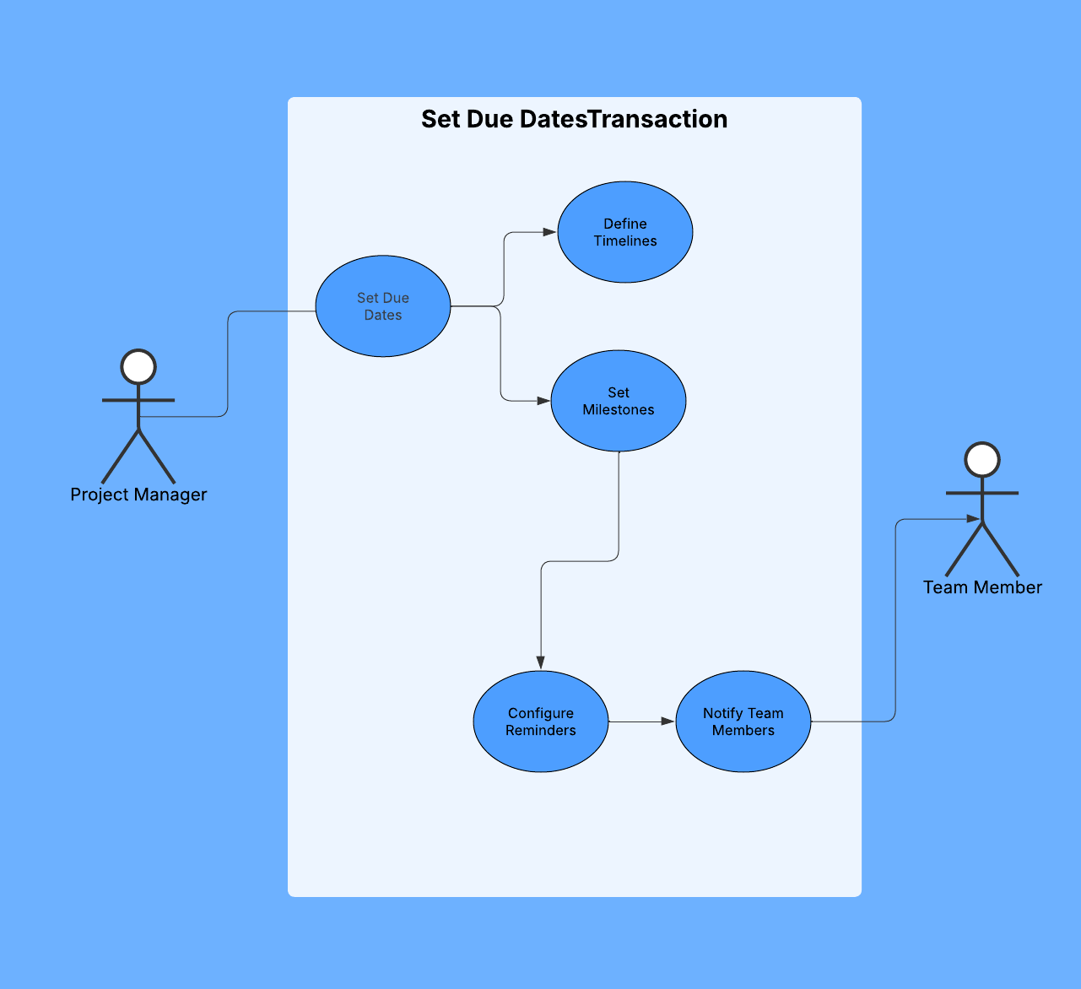

Use Case Description
FIELD | DESCRIPTION
Use Case Name | Set Due Dates
Actor(s) | Project Manager, Team Member
Description | Project Manager establishes deadlines for tasks
Precondition | Tasks have been created and assigned
Main Flow | 1. Project Manager selects "Set Due Dates"  2. System displays tasks and calendar  3. Project Manager defines timelines  4. Project Manager configures reminders  5. System notifies team members  6. System updates project timeline
Alternative Flow | None
Postcondition | Due dates are established for all tasks

Activity Diagram
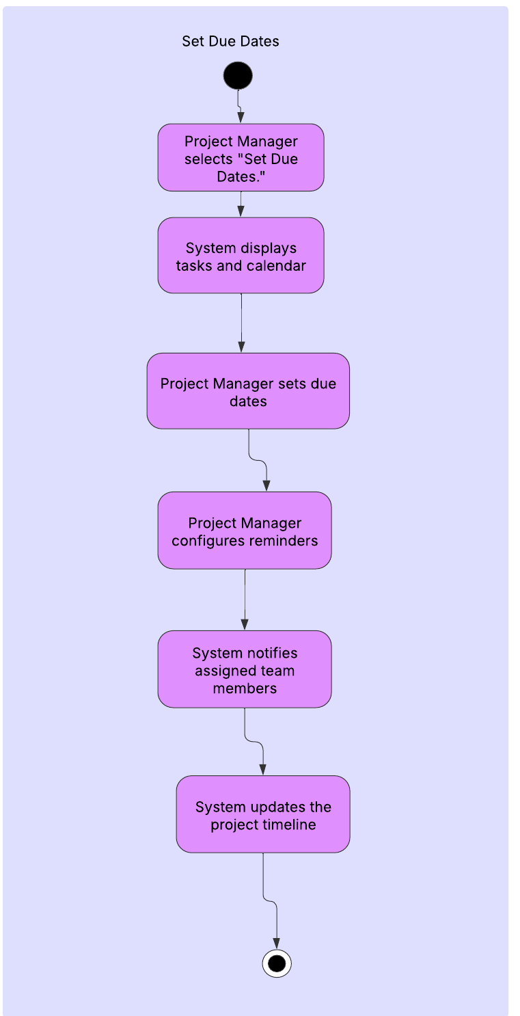

Wireframe

1.4 Update task status

Use Case Diagram
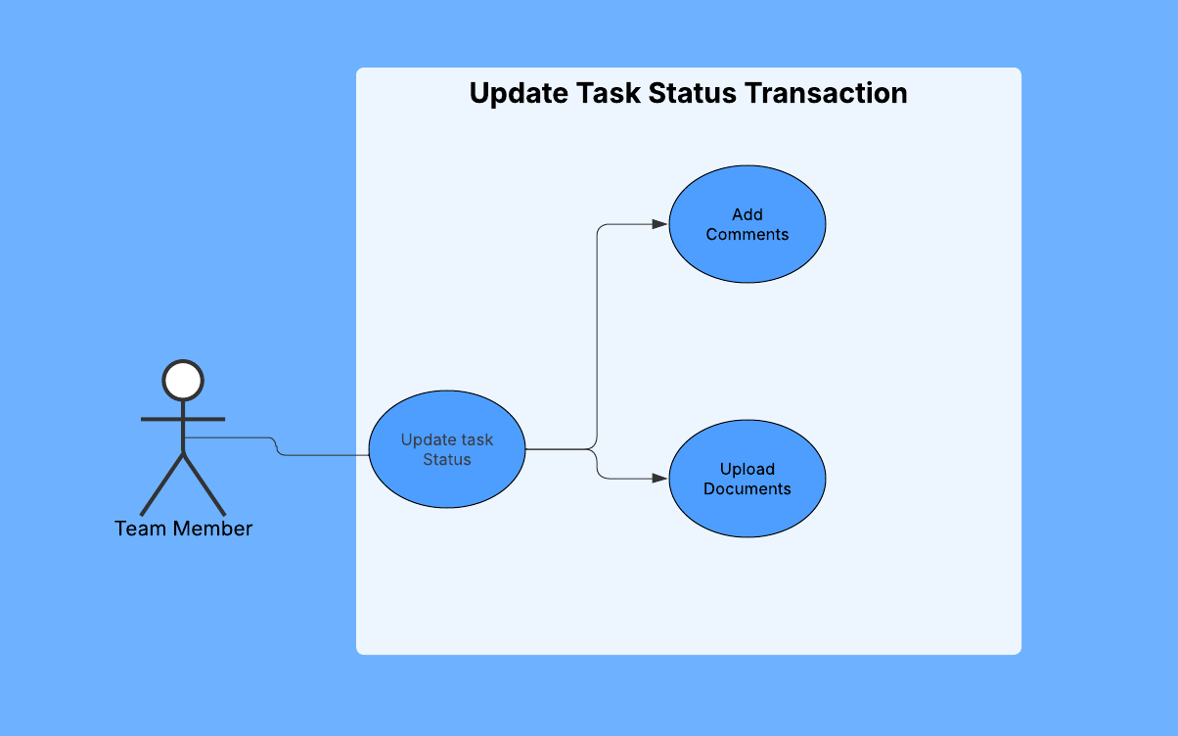

Use Case Description
FIELD | DESCRIPTION
Use Case Name | Update Task Status
Actor(s) | Team Member
Description | Team Member updates the progress of assigned tasks
Precondition | Tasks have been assigned with due dates
Main Flow | 1. Team Member selects "Update Status"  2. System displays assigned tasks  3. Team Member selects task to update  4. Team Member adds comments if needed  5. Team Member uploads relevant documents  6. System updates task status
Alternative Flow | 5a. Team Member reports blockers
Postcondition | Task status is updated in the system

Activity Diagram
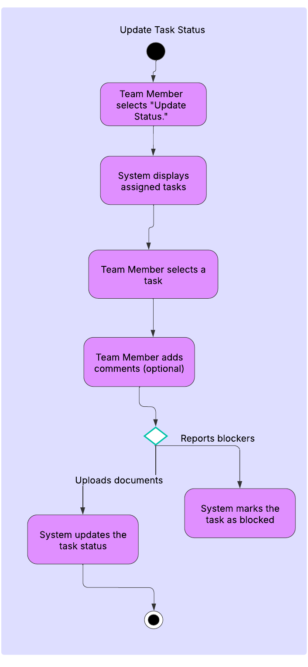

Wireframe

1.5 Track overall progress

Use Case Diagram
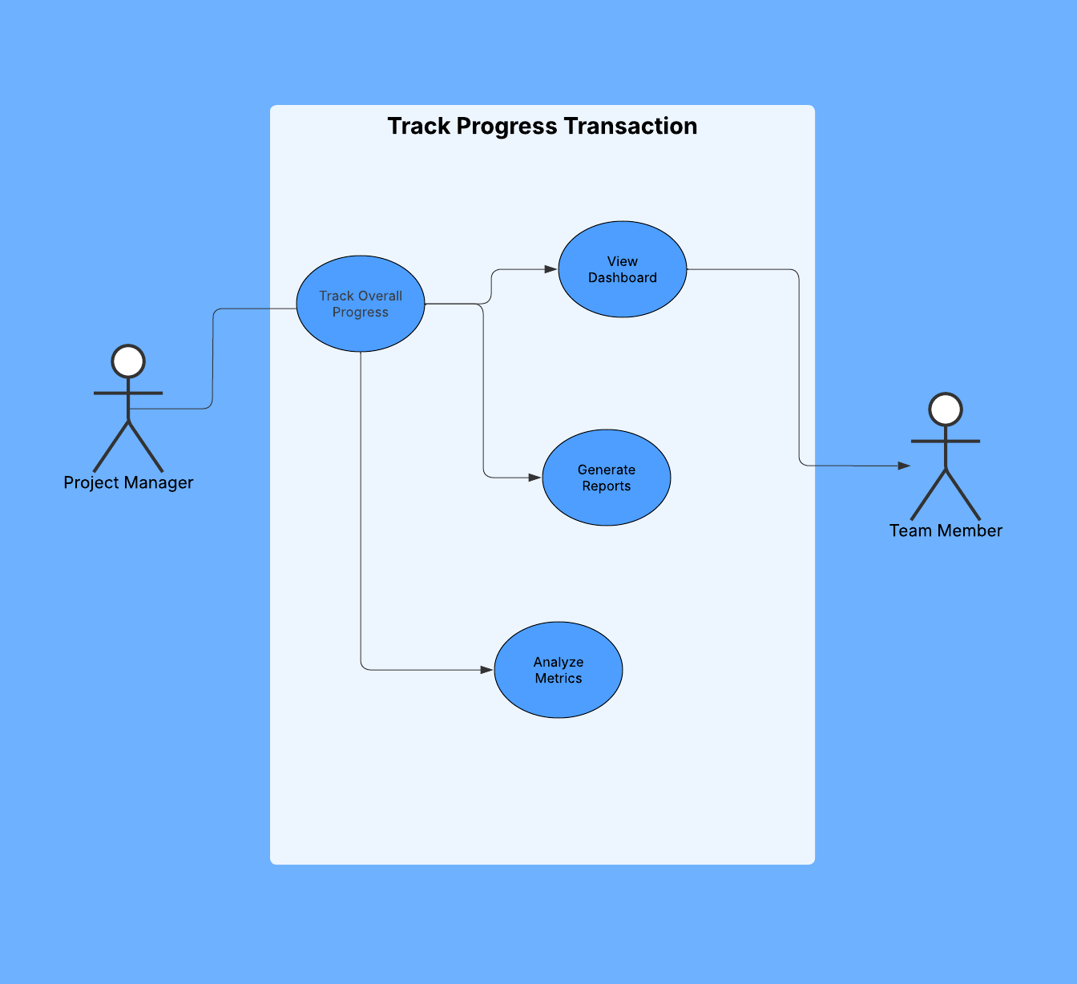

Use Case Description
FIELD | DESCRIPTION
Use Case Name | Track Progress
Actor(s) | Project Manager, Team Member
Description | Monitor the overall completion status of the project
Precondition | Tasks have been assigned and statuses are being updated
Main Flow | 1. User selects "Track Progress" option  2. System displays dashboard with project metrics  3. User can generate detailed reports  4. User can export statistics
Alternative Flow | None
Postcondition | Project progress is reviewed and documented

Activity Diagram
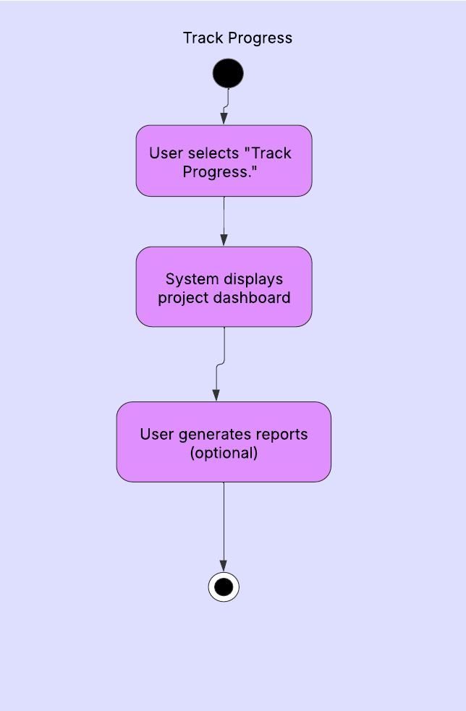

Wireframe

Module 3 – Real-Time Collaboration

1.1 Get notifications about project updates

Use Case Diagram
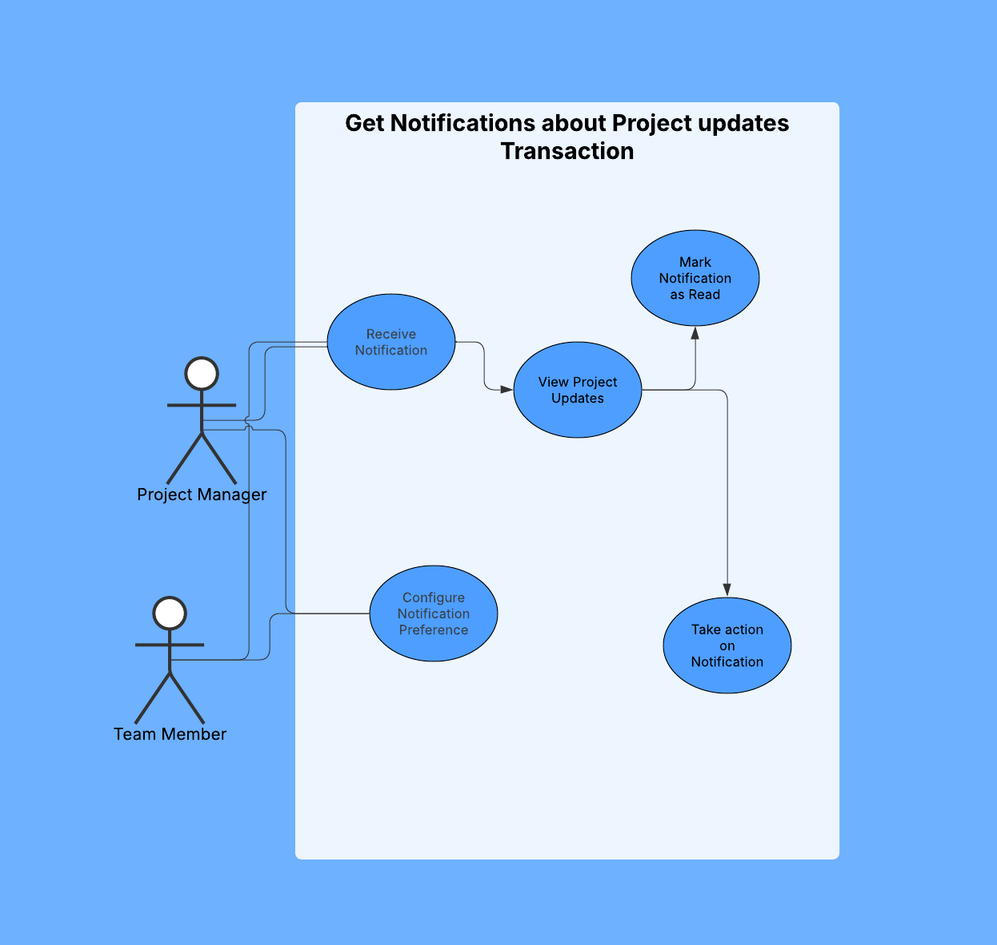

Use Case Description
FIELD | DESCRIPTION
Use Case Name | Get Notifications about project Updates
Actor(s) | Project Manager, Team Member
Description | Users receive and manage notifications about changes and updates to the project
Precondition | User is authenticated and has access to the project
Main Flow | 1. System detects a project update (task assignment, deadline change, comment, etc.)  2. System generates a notification based on user preferences  3. System delivers notification to user through various channels (email, app)  4. User receives notification  5. User views notification details  6. User takes appropriate action based on notification content  7. User marks notification as read
Alternative Flow | 3a. User has disabled certain notification types in preferences  4a. User sets "Do Not Disturb" mode for specific time periods  6a. User dismisses notification without action  6b. User snoozes notification for later
Postcondition | User is informed about project updates and can respond accordingly

Activity Diagram
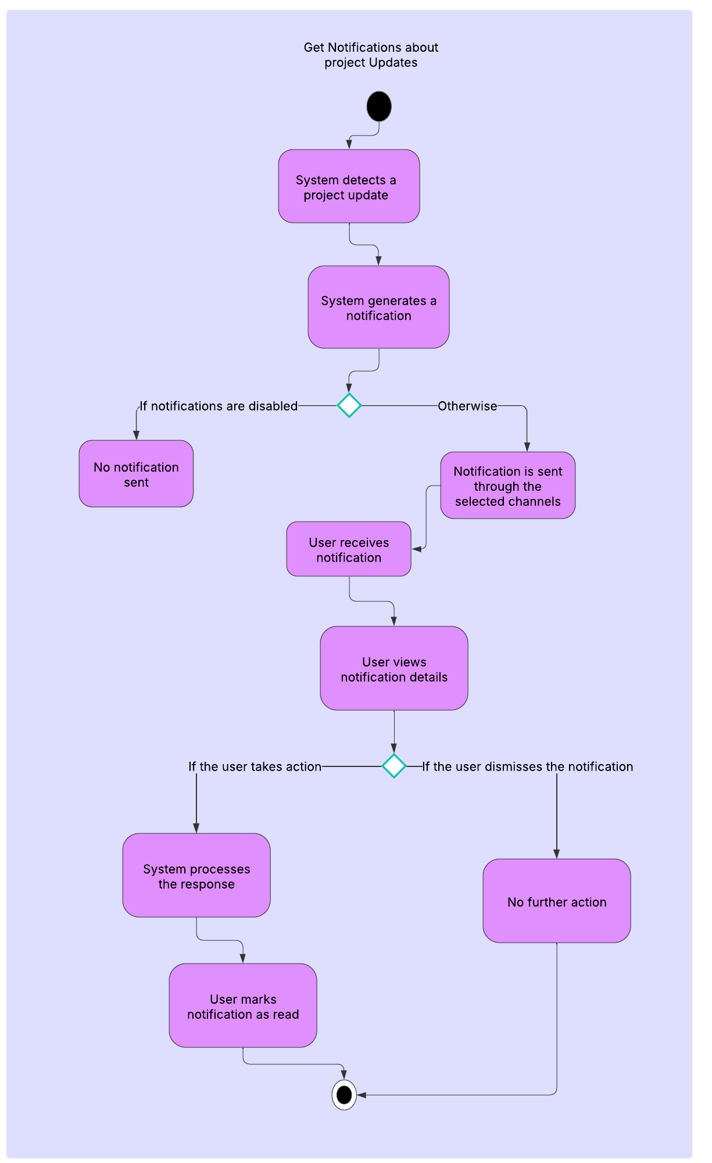

Wireframe

1.2 Work on the same project simultaneously

Use Case Diagram
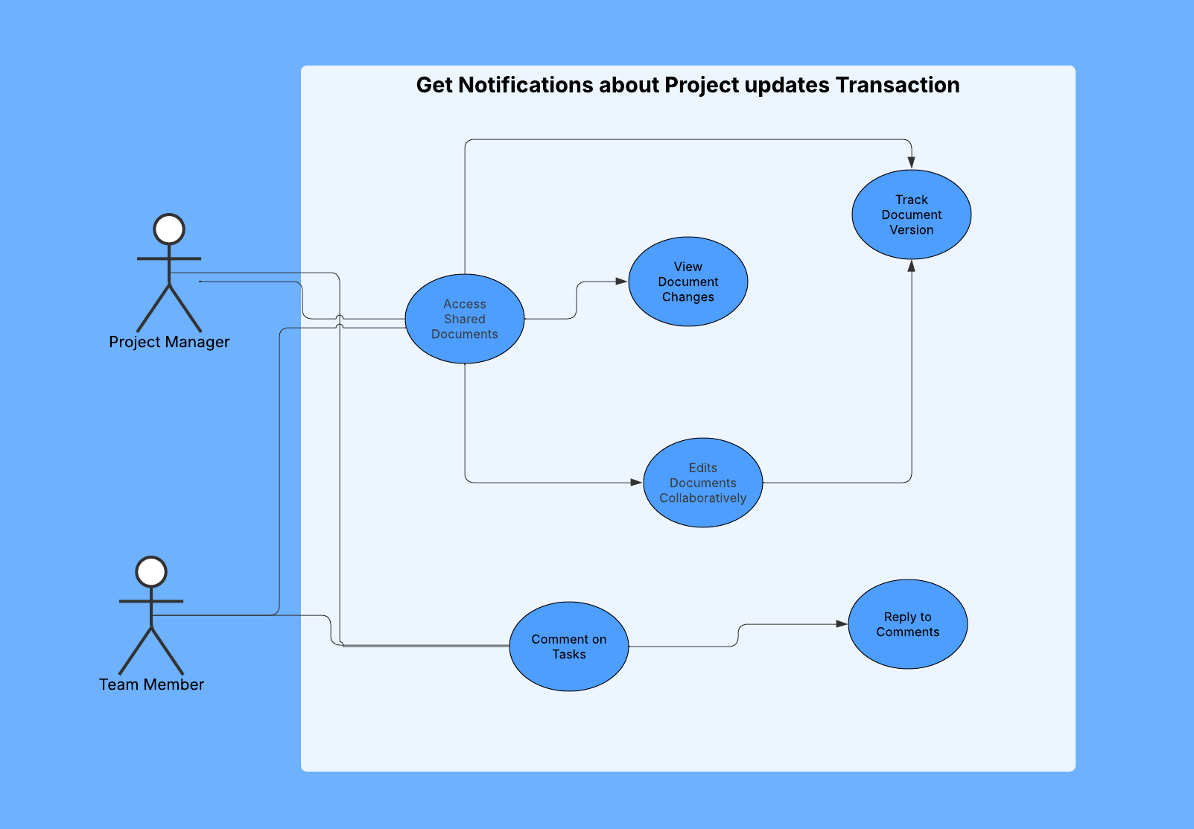

Use Case Description
FIELD | DESCRIPTION
Use Case Name | Work on Same Project Simultaneously
Actor(s) | Project Manager, Team Member
Description | Multiple users collaborate by accessing shared documents and commenting on tasks
Precondition | Users are authenticated and have appropriate permissions for the project
Main Flow – Document Access | 1. User accesses shared document repository  2. System displays available documents  3. User opens a document for viewing  4. Track version
Main Flow – Task Commenting | 1. User navigates to a specific task  2. User adds a comment to the task  3. System timestamps and attributes the comment  4. System notifies relevant users about the new comment  5. Other users view the comment  6. Users can reply
Alternative Flow – Task Commenting | 4a. User disables notification for this comment thread
Postcondition | User is informed about project updates and can respond accordingly

Activity Diagram
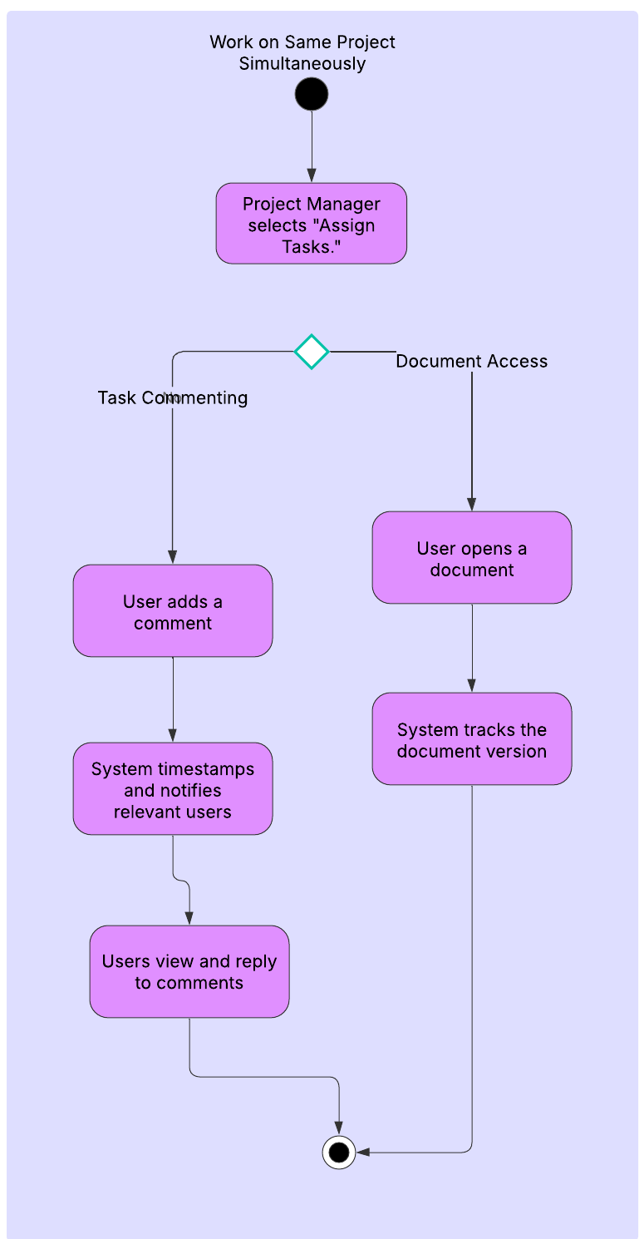

Wireframe

Module 4 – User Authentication

4.1 Create user accounts
- Use Case Diagram
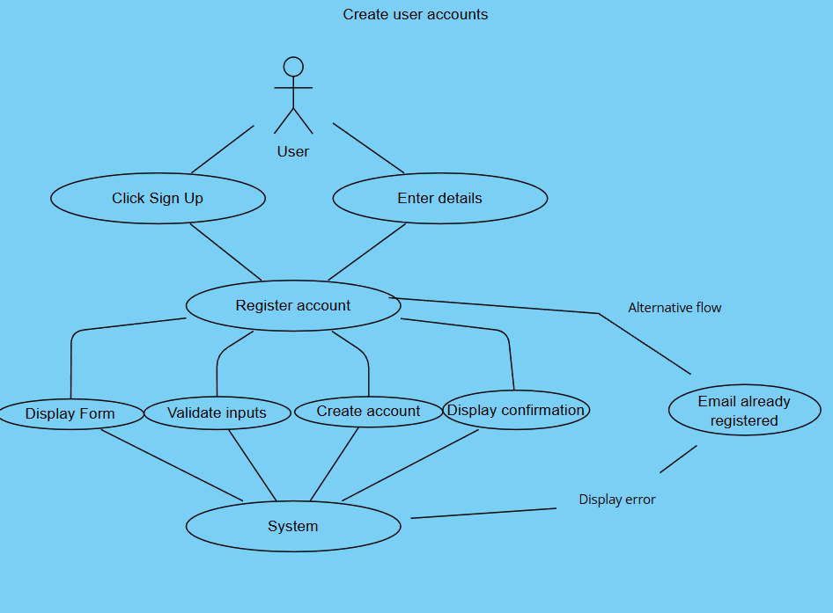
- Use Case Description
  - Actor(s): New User, System
  - Precondition: User must have valid credentials (email, password).
  - Main Flow:
    - User clicks "Sign Up."
    - System displays a registration form.
    - User enters details (name, email, password, etc.).
    - System validates inputs.
    - System creates a new user account.
    - Confirmation message is displayed.
  - Postcondition: User is registered in the system.
- Activity Diagram
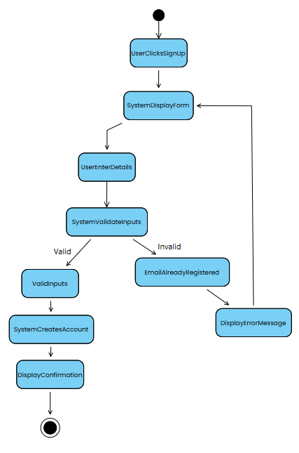

Wireframe

4.2 Log in securely
- Use Case Diagram
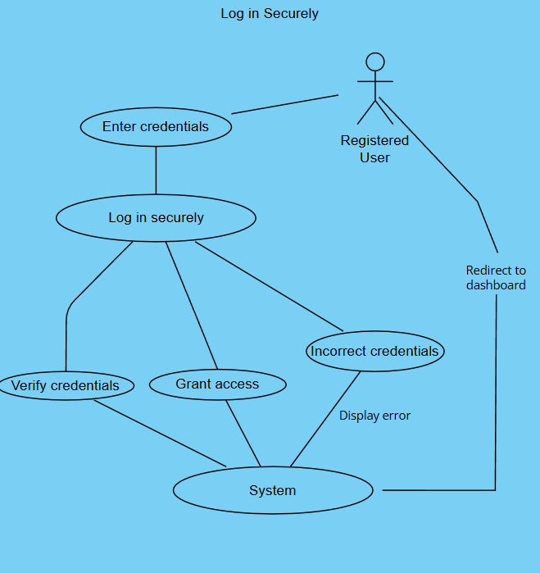
- Use Case Description
  - Actor(s): Registered User, System
  - Precondition: User must be registered.
  - Main Flow:
    - User enters email and password.
    - System verifies credentials.
    - System grants access and redirects to the dashboard.
  - Postcondition: User is authenticated.
  - Alternative Flow: If credentials are incorrect, an error message appears.
- Activity Diagram
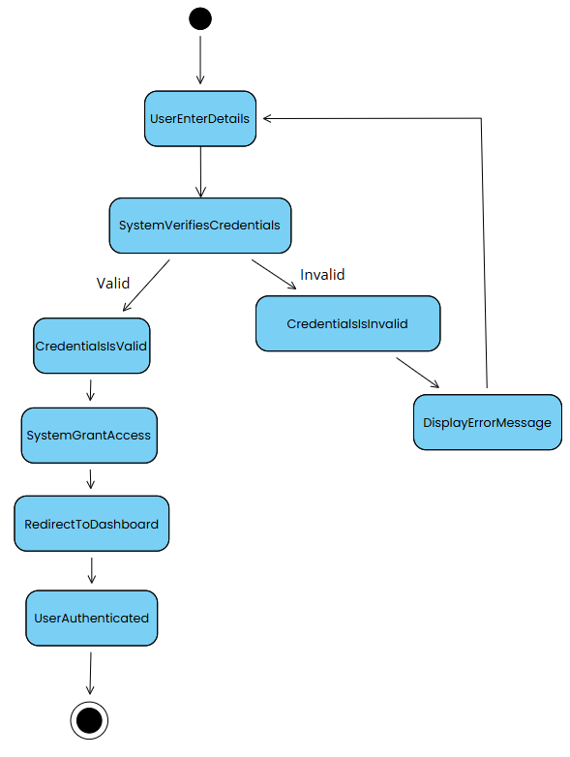

Wireframe

4.3 Reset Forgotten passwords
- Use Case Diagram
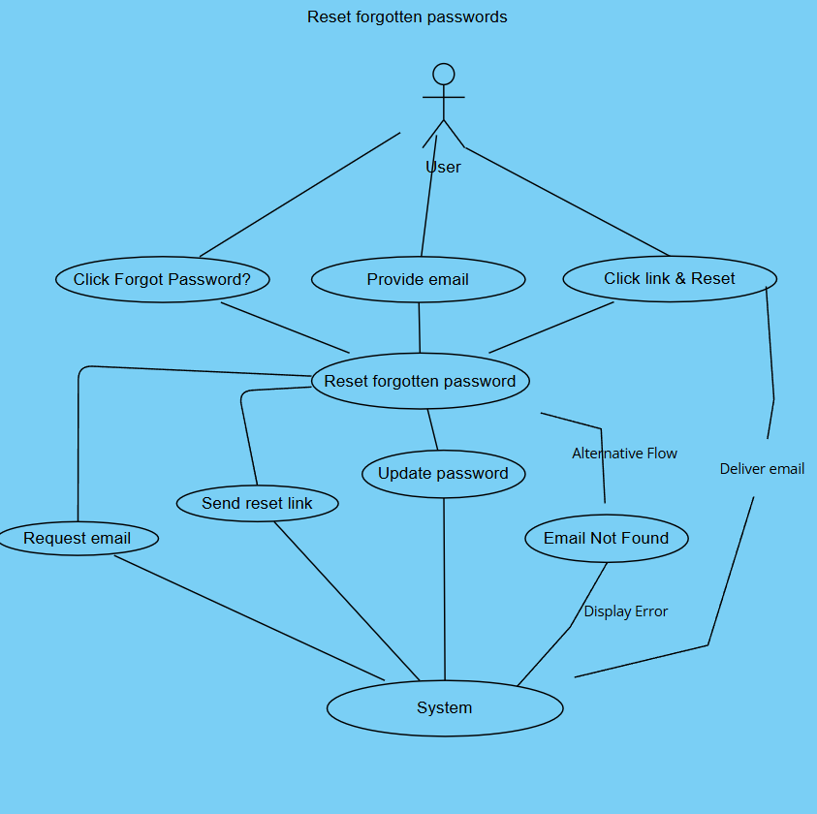
- Use Case Description
  - Actor(s): User, System
  - Precondition: User has a registered email.
  - Main Flow:
    - User clicks "Forgot Password?"
    - System asks for email.
    - System sends a password reset link.
    - User resets password via email link.
  - Postcondition: Password is reset successfully.
  - Alternative Flow: If email is not found, an error is displayed.
- Activity Diagram
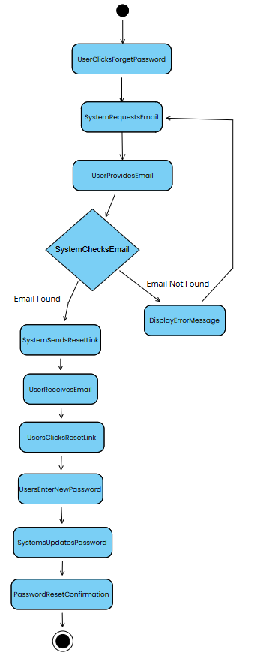

Wireframe

Module 5 – Reporting Analytics

1.1 Track Time Spent on Tasks
- Use Case Diagram
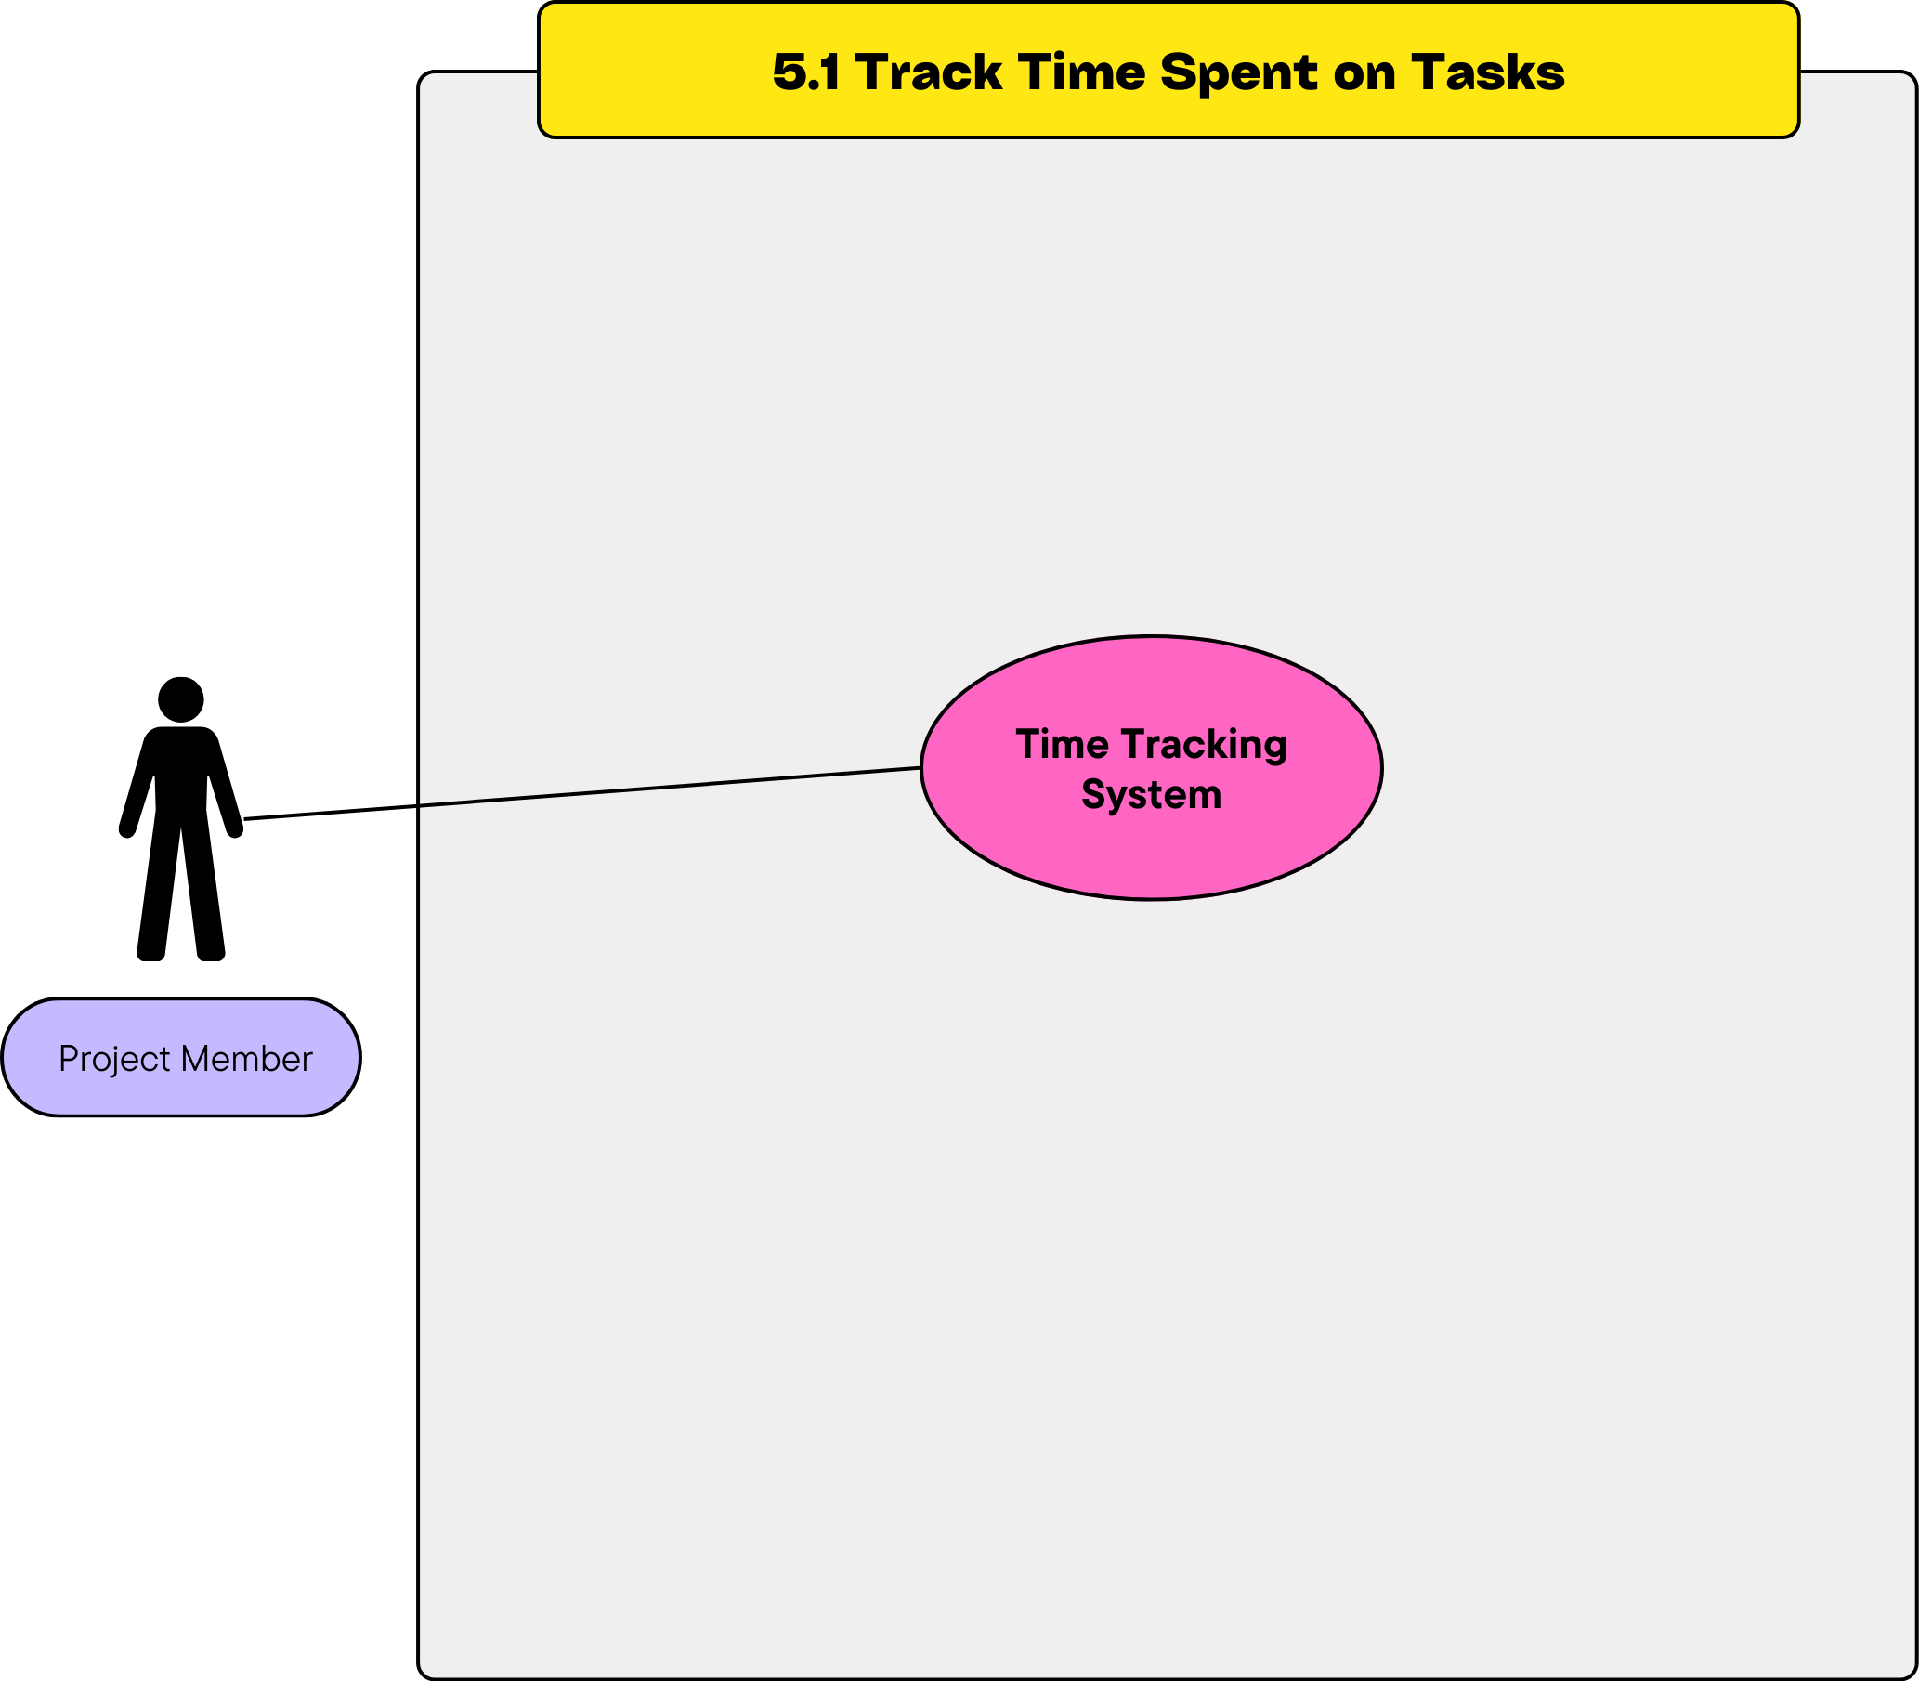
- Use Case Description
  - Primary Actor: Project Member
  - Stakeholders:
    - Project Member: Wants to track the time spent on their tasks accurately.
    - System: Records the time spent and displays it in the task details.
  - Preconditions:
    - User must be logged in.
    - Task status must be updated to 'In Progress'.
  - Postconditions:
    - Time spent is recorded and updated.
    - Task details reflect the time spent.
  - Main Flow:
    - User selects the task they are working on.
    - User updates the task status to 'In Progress'.
    - The system automatically starts the timer.
    - User pauses or stops the timer as needed.
    - System records and updates the time spent.
  - Alternative Flows:
    - Task Already Completed: System does not allow time tracking.
- Activity Diagram
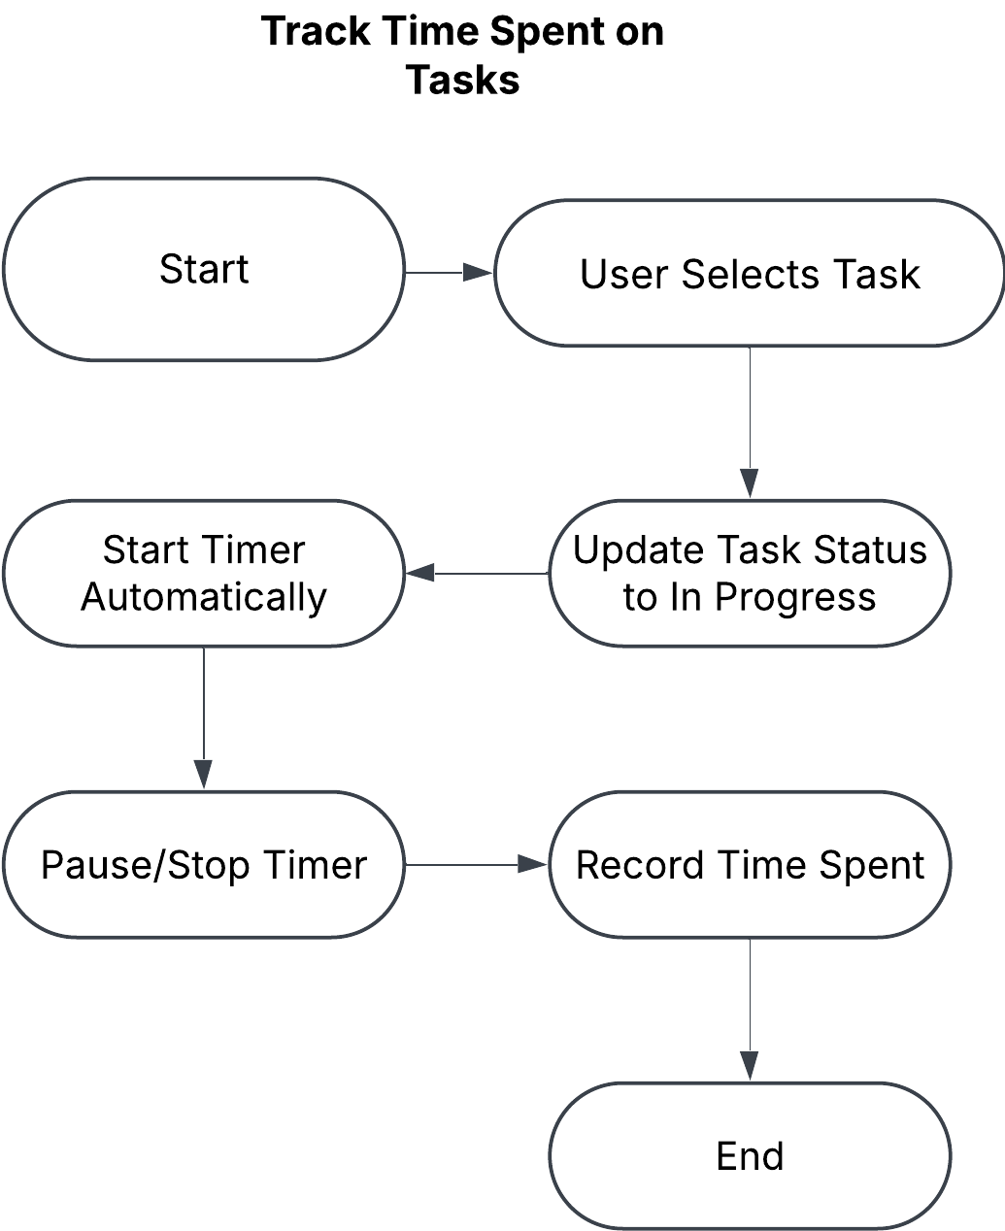

Wireframe

1.2 View Project Dashboard
- Use Case Diagram
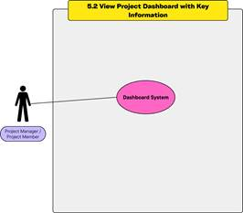
- Use Case Description
  - Primary Actor: Project Manager / Project Member
  - Stakeholders:
    - Project Manager: Wants to monitor project progress and performance.
    - Project Member: Wants to see overall project metrics.
    - System: Displays project data in visual formats.
  - Preconditions:
    - User must be logged in.
    - User must be part of the project.
  - Postconditions:
    - Project metrics are displayed visually on the dashboard.
  - Main Flow:
    - User navigates to the dashboard section.
    - The system retrieves key project metrics (e.g., tasks completed, time spent, progress percentages).
    - The system displays metrics in visual formats (e.g., charts, graphs).
  - Alternative Flows:
    - Available: System displays
- Activity Diagram
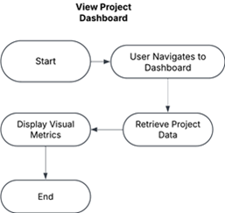
- Wireframe

Module 6 – Document management and file sharing

6.1 Upload project related files
- Use Case Diagram
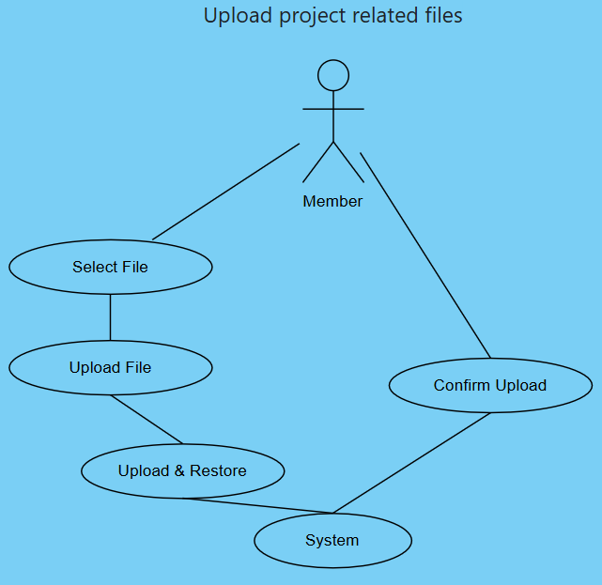
- Use Case Description
  - Actor(s): Project Member, System
  - Precondition: User is logged in.
  - Main Flow:
    - User selects a file.
    - System uploads and stores it.
    - Confirmation is displayed.
  - Postcondition: File is available in the system.
- Activity Diagram
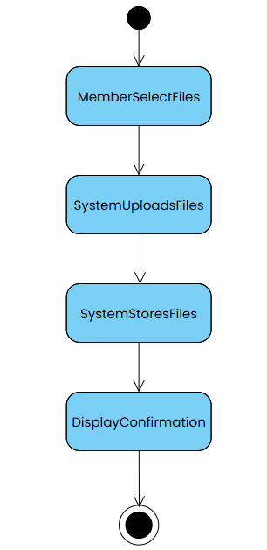
- Wireframe

6.2 Store documents
- Use Case Diagram
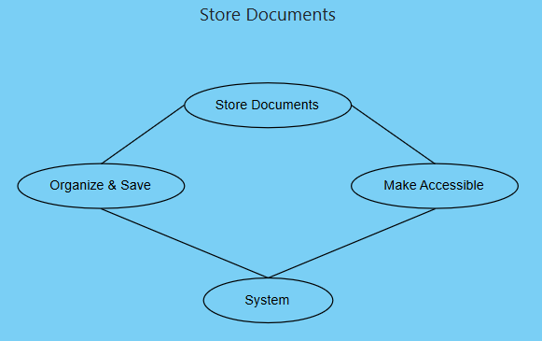
- Use Case Description
  - Actor(s): System
  - Precondition: File must be uploaded.
  - Main Flow: System organizes and saves documents in a structured way.
  - Postcondition: File is accessible for future use.
- Activity Diagram
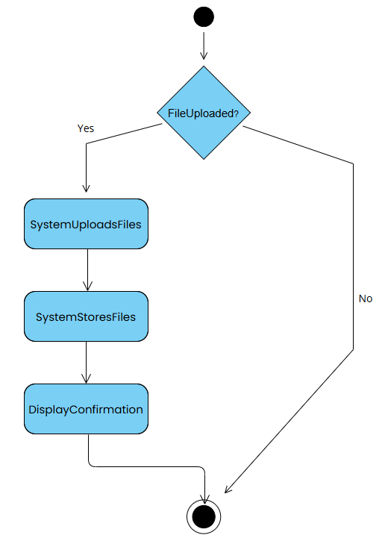
- Wireframe

6.3 Search specific files
- Use Case Diagram
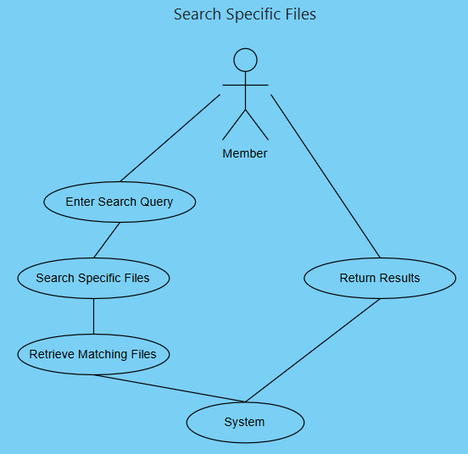
- Use Case Description
  - Actor(s): Project Member, System
  - Precondition: Files exist in the system.
  - Main Flow:
    - User enters search query.
    - System retrieves matching files.
  - Postcondition: User finds desired file.
- Activity Diagram
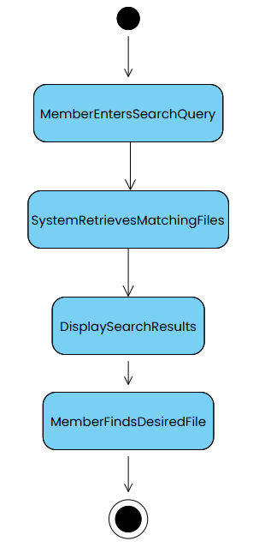
- Wireframe

6.4 Share files with team members
- Use Case Diagram
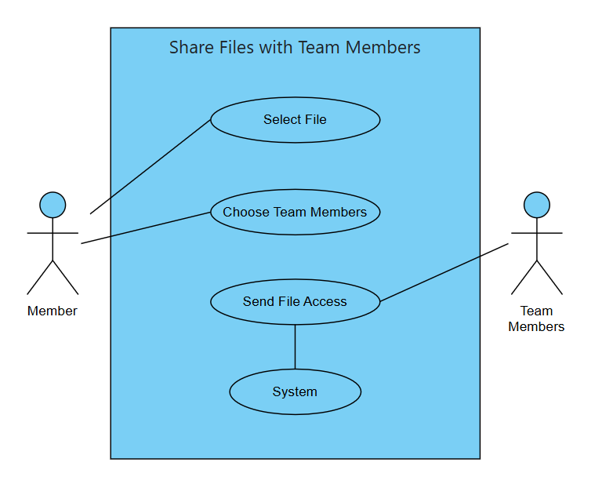
- Use Case Description
  - Actor(s): Project Member, Team Members, System
  - Precondition: File must exist in the system.
  - Main Flow:
    - User selects a file.
    - User chooses members to share with.
    - System sends file access notification.
  - Postcondition: Shared file is accessible.
- Activity Diagram
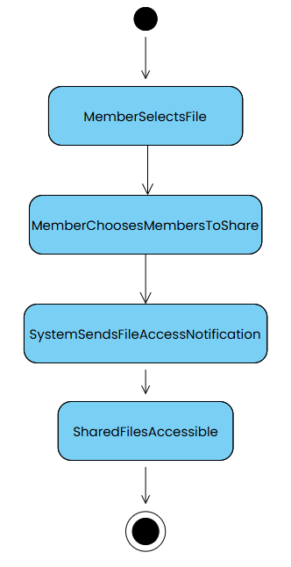
- Wireframe

Non-functional requirements

Performance

Details

Security

Details

Reliability

Details

