**Minutes of the Meeting**

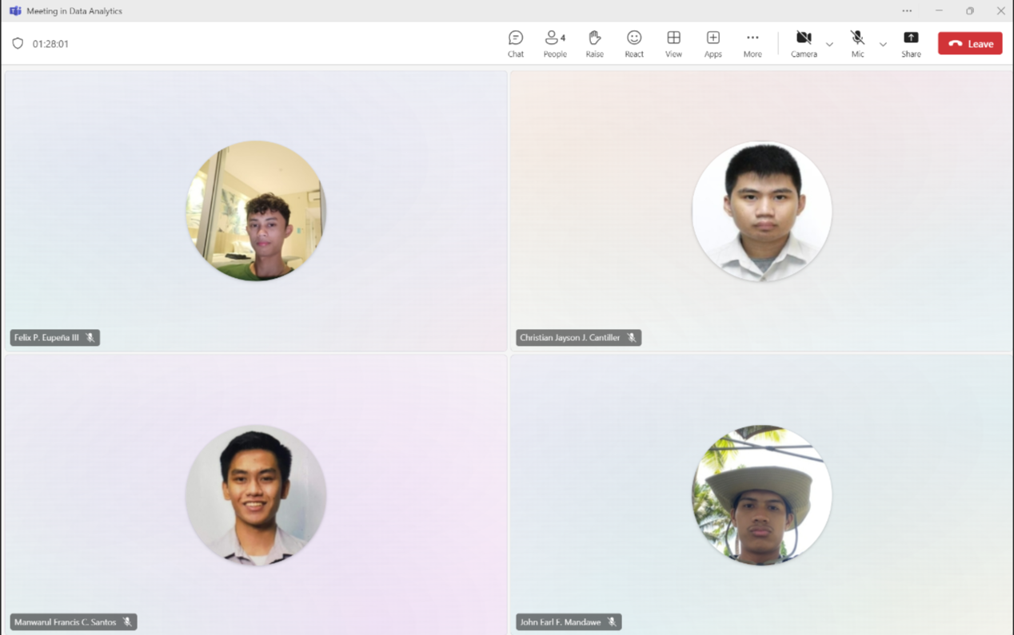

**Date:** November 11, 2024

Meeting Started - 6:00 PM

Making PowerPoint- 6:30 PM

Finished Making the PowerPoint - 9:40 PM

**Agenda**: Making PowerPoint Presentation for Pre-Final

**Group Members**:

1. Christian Jayson J. Cantiller

2. Manwarul Francis C. Santos

3. Felix P. Eupeña III

4. John Earl F. Mandawe