## Linux python and PyCharm:

export PYCHARM_JDK=/usr/local/share/Java-11/

/mnt/matylda1/hradis/temp/pycharm/bin/pycharm.sh

When creating new project, select` **Base interpreter** as /usr/local/bin/python3

## Windows

### Python

Install python from: <https://www.python.org/downloads/>

Steps:

1. Unselect “Install launcher for all users”
2. Select “Add Python to PATH”
3. Click “Customize installation” & “Next”
4. Change “Install location” to your “P:\<whatever>” folder

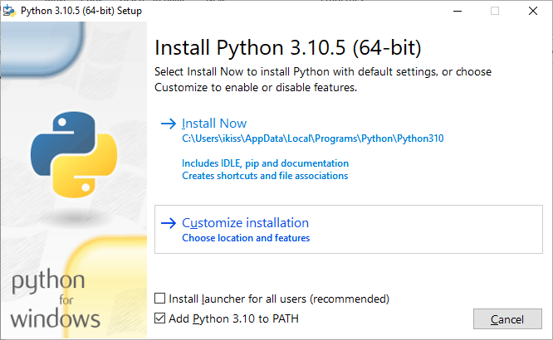

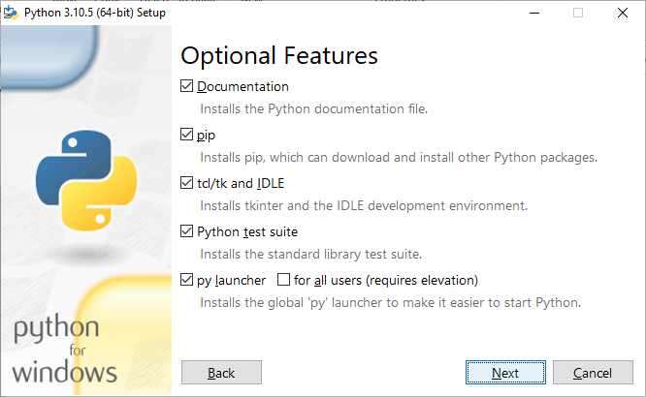

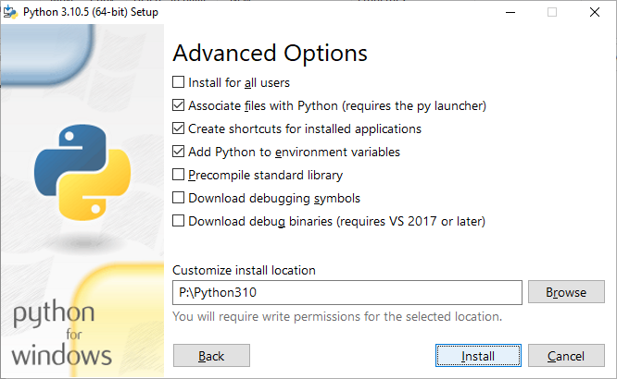

### PyCharm

Install Pycharm community edition from: <https://www.jetbrains.com/pycharm/download/download-thanks.html?platform=windows&code=PCC>

Steps:

1. On prompt to enter admin credentials click “No”
2. “Next”
3. Change “Destination folder” to “P:\<whatever>” & “Next”
4. Select:
   1. Update PATH variable
   2. Update context menu
   3. Create associations
5. Click “Install”

