**Profiler.xml format**

DX11 Server response to the following command:

http://localhost/78576/DX11/FP/Profiler.xml

<?xml version='1.0' encoding='ISO-8859-1'?><XML src='Profiler.xml'><frame><DrawCall><Index>1</Index><GPUTime>0.00637037</GPUTime><PSBusy>0</PSBusy></DrawCall><DrawCall><Index>2</Index><GPUTime>0.00488889</GPUTime><PSBusy>0</PSBusy></DrawCall><DrawCall><Index>3</Index><GPUTime>0.013037</GPUTime><PSBusy>52.9773</PSBusy></DrawCall><DrawCall><Index>4</Index><GPUTime>0.00162963</GPUTime><PSBusy>32.7697</PSBusy></DrawCall><DrawCall><Index>5</Index><GPUTime>0.004</GPUTime><PSBusy>36.8011</PSBusy></DrawCall><DrawCall><Index>6</Index><GPUTime>0.00325926</GPUTime><PSBusy>31.0201</PSBusy></DrawCall><DrawCall><Index>7</Index><GPUTime>0.00385185</GPUTime><PSBusy>29.6797</PSBusy></DrawCall><DrawCall><Index>8</Index><GPUTime>0.00296296</GPUTime><PSBusy>31.5402</PSBusy></DrawCall><DrawCall><Index>9</Index><GPUTime>0.00281481</GPUTime><PSBusy>29.4998</PSBusy></DrawCall><DrawCall><Index>10</Index><GPUTime>0.00296296</GPUTime><PSBusy>29.8676</PSBusy></DrawCall><DrawCall><Index>11</Index><GPUTime>0.00296296</GPUTime><PSBusy>31.0692</PSBusy></DrawCall><DrawCall><Index>12</Index><GPUTime>0.00311111</GPUTime><PSBusy>29.5243</PSBusy></DrawCall><DrawCall><Index>13</Index><GPUTime>0.00444444</GPUTime><PSBusy>28.4118</PSBusy></DrawCall><DrawCall><Index>14</Index><GPUTime>0.00340741</GPUTime><PSBusy>28.5114</PSBusy></DrawCall><DrawCall><Index>15</Index><GPUTime>0.00296296</GPUTime><PSBusy>29.3238</PSBusy></DrawCall></frame><drawcalllist><drawcall><index>1</index><call>ClearRenderTargetView</call><parameters>0x116CA9F8, Color( 0.000000, 0.250000, 0.250000, 0.550000 )</parameters><hash><RT><RT0>0x116C41F8</RT0><RT1>0x00000000</RT1><RT2>0x00000000</RT2><RT3>0x00000000</RT3><RT4>0x00000000</RT4><RT5>0x00000000</RT5><RT6>0x00000000</RT6><RT7>0x00000000</RT7></RT><Depth>0x00000000</Depth><Stencil>0x00000000</Stencil></hash></drawcall><drawcall><index>2</index><call>ClearDepthStencilView</call><parameters>0x116D0138, 1, 1.000000, 0</parameters><hash><RT><RT0>0x116C41F8</RT0><RT1>0x00000000</RT1><RT2>0x00000000</RT2><RT3>0x00000000</RT3><RT4>0x00000000</RT4><RT5>0x00000000</RT5><RT6>0x00000000</RT6><RT7>0x00000000</RT7></RT><Depth>0x00000000</Depth><Stencil>0x00000000</Stencil></hash></drawcall><drawcall><index>3</index><call>DrawIndexed</call><parameters>20523, 0, 0</parameters><hash><VS>0x116C0630</VS><HS>0x00000000</HS><DS>0x00000000</DS><GS>0x00000000</GS><PS>0x116C0C70</PS><RT><RT0>0x116C41F8</RT0><RT1>0x00000000</RT1><RT2>0x00000000</RT2><RT3>0x00000000</RT3><RT4>0x00000000</RT4><RT5>0x00000000</RT5><RT6>0x00000000</RT6><RT7>0x00000000</RT7></RT><Depth>0x00000000</Depth><Stencil>0x00000000</Stencil></hash></drawcall><drawcall><index>4</index><call>Draw</call><parameters>6, 0</parameters><hash><PerfMarker>HUD / Stats</PerfMarker><VS>0x116B45F0</VS><HS>0x00000000</HS><DS>0x00000000</DS><GS>0x00000000</GS><PS>0x116B4A70</PS><RT><RT0>0x116C41F8</RT0><RT1>0x00000000</RT1><RT2>0x00000000</RT2><RT3>0x00000000</RT3><RT4>0x00000000</RT4><RT5>0x00000000</RT5><RT6>0x00000000</RT6><RT7>0x00000000</RT7></RT><Depth>0x00000000</Depth><Stencil>0x00000000</Stencil></hash></drawcall><drawcall><index>5</index><call>Draw</call><parameters>108, 0</parameters><hash><PerfMarker>HUD / Stats</PerfMarker><VS>0x116B45F0</VS><HS>0x00000000</HS><DS>0x00000000</DS><GS>0x00000000</GS><PS>0x116B4A70</PS><RT><RT0>0x116C41F8</RT0><RT1>0x00000000</RT1><RT2>0x00000000</RT2><RT3>0x00000000</RT3><RT4>0x00000000</RT4><RT5>0x00000000</RT5><RT6>0x00000000</RT6><RT7>0x00000000</RT7></RT><Depth>0x00000000</Depth><Stencil>0x00000000</Stencil></hash></drawcall><drawcall><index>6</index><call>Draw</call><parameters>108, 0</parameters><hash><PerfMarker>HUD / Stats</PerfMarker><VS>0x116B45F0</VS><HS>0x00000000</HS><DS>0x00000000</DS><GS>0x00000000</GS><PS>0x116B4A70</PS><RT><RT0>0x116C41F8</RT0><RT1>0x00000000</RT1><RT2>0x00000000</RT2><RT3>0x00000000</RT3><RT4>0x00000000</RT4><RT5>0x00000000</RT5><RT6>0x00000000</RT6><RT7>0x00000000</RT7></RT><Depth>0x00000000</Depth><Stencil>0x00000000</Stencil></hash></drawcall><drawcall><index>7</index><call>Draw</call><parameters>6, 0</parameters><hash><PerfMarker>HUD / Stats</PerfMarker><VS>0x116B45F0</VS><HS>0x00000000</HS><DS>0x00000000</DS><GS>0x00000000</GS><PS>0x116B4A70</PS><RT><RT0>0x116C41F8</RT0><RT1>0x00000000</RT1><RT2>0x00000000</RT2><RT3>0x00000000</RT3><RT4>0x00000000</RT4><RT5>0x00000000</RT5><RT6>0x00000000</RT6><RT7>0x00000000</RT7></RT><Depth>0x00000000</Depth><Stencil>0x00000000</Stencil></hash></drawcall><drawcall><index>8</index><call>Draw</call><parameters>90, 0</parameters><hash><PerfMarker>HUD / Stats</PerfMarker><VS>0x116B45F0</VS><HS>0x00000000</HS><DS>0x00000000</DS><GS>0x00000000</GS><PS>0x116B4A70</PS><RT><RT0>0x116C41F8</RT0><RT1>0x00000000</RT1><RT2>0x00000000</RT2><RT3>0x00000000</RT3><RT4>0x00000000</RT4><RT5>0x00000000</RT5><RT6>0x00000000</RT6><RT7>0x00000000</RT7></RT><Depth>0x00000000</Depth><Stencil>0x00000000</Stencil></hash></drawcall><drawcall><index>9</index><call>Draw</call><parameters>90, 0</parameters><hash><PerfMarker>HUD / Stats</PerfMarker><VS>0x116B45F0</VS><HS>0x00000000</HS><DS>0x00000000</DS><GS>0x00000000</GS><PS>0x116B4A70</PS><RT><RT0>0x116C41F8</RT0><RT1>0x00000000</RT1><RT2>0x00000000</RT2><RT3>0x00000000</RT3><RT4>0x00000000</RT4><RT5>0x00000000</RT5><RT6>0x00000000</RT6><RT7>0x00000000</RT7></RT><Depth>0x00000000</Depth><Stencil>0x00000000</Stencil></hash></drawcall><drawcall><index>10</index><call>Draw</call><parameters>6, 0</parameters><hash><PerfMarker>HUD / Stats</PerfMarker><VS>0x116B45F0</VS><HS>0x00000000</HS><DS>0x00000000</DS><GS>0x00000000</GS><PS>0x116B4A70</PS><RT><RT0>0x116C41F8</RT0><RT1>0x00000000</RT1><RT2>0x00000000</RT2><RT3>0x00000000</RT3><RT4>0x00000000</RT4><RT5>0x00000000</RT5><RT6>0x00000000</RT6><RT7>0x00000000</RT7></RT><Depth>0x00000000</Depth><Stencil>0x00000000</Stencil></hash></drawcall><drawcall><index>11</index><call>Draw</call><parameters>108, 0</parameters><hash><PerfMarker>HUD / Stats</PerfMarker><VS>0x116B45F0</VS><HS>0x00000000</HS><DS>0x00000000</DS><GS>0x00000000</GS><PS>0x116B4A70</PS><RT><RT0>0x116C41F8</RT0><RT1>0x00000000</RT1><RT2>0x00000000</RT2><RT3>0x00000000</RT3><RT4>0x00000000</RT4><RT5>0x00000000</RT5><RT6>0x00000000</RT6><RT7>0x00000000</RT7></RT><Depth>0x00000000</Depth><Stencil>0x00000000</Stencil></hash></drawcall><drawcall><index>12</index><call>Draw</call><parameters>108, 0</parameters><hash><PerfMarker>HUD / Stats</PerfMarker><VS>0x116B45F0</VS><HS>0x00000000</HS><DS>0x00000000</DS><GS>0x00000000</GS><PS>0x116B4A70</PS><RT><RT0>0x116C41F8</RT0><RT1>0x00000000</RT1><RT2>0x00000000</RT2><RT3>0x00000000</RT3><RT4>0x00000000</RT4><RT5>0x00000000</RT5><RT6>0x00000000</RT6><RT7>0x00000000</RT7></RT><Depth>0x00000000</Depth><Stencil>0x00000000</Stencil></hash></drawcall><drawcall><index>13</index><call>Draw</call><parameters>396, 0</parameters><hash><PerfMarker>HUD / Stats</PerfMarker><VS>0x116B45F0</VS><HS>0x00000000</HS><DS>0x00000000</DS><GS>0x00000000</GS><PS>0x116B4A70</PS><RT><RT0>0x116C41F8</RT0><RT1>0x00000000</RT1><RT2>0x00000000</RT2><RT3>0x00000000</RT3><RT4>0x00000000</RT4><RT5>0x00000000</RT5><RT6>0x00000000</RT6><RT7>0x00000000</RT7></RT><Depth>0x00000000</Depth><Stencil>0x00000000</Stencil></hash></drawcall><drawcall><index>14</index><call>Draw</call><parameters>204, 0</parameters><hash><PerfMarker>HUD / Stats</PerfMarker><VS>0x116B45F0</VS><HS>0x00000000</HS><DS>0x00000000</DS><GS>0x00000000</GS><PS>0x116B4A70</PS><RT><RT0>0x116C41F8</RT0><RT1>0x00000000</RT1><RT2>0x00000000</RT2><RT3>0x00000000</RT3><RT4>0x00000000</RT4><RT5>0x00000000</RT5><RT6>0x00000000</RT6><RT7>0x00000000</RT7></RT><Depth>0x00000000</Depth><Stencil>0x00000000</Stencil></hash></drawcall><drawcall><index>15</index><call>Draw</call><parameters>102, 0</parameters><hash><PerfMarker>HUD / Stats</PerfMarker><VS>0x116B45F0</VS><HS>0x00000000</HS><DS>0x00000000</DS><GS>0x00000000</GS><PS>0x116B4A70</PS><RT><RT0>0x116C41F8</RT0><RT1>0x00000000</RT1><RT2>0x00000000</RT2><RT3>0x00000000</RT3><RT4>0x00000000</RT4><RT5>0x00000000</RT5><RT6>0x00000000</RT6><RT7>0x00000000</RT7></RT><Depth>0x00000000</Depth><Stencil>0x00000000</Stencil></hash></drawcall></drawcalllist></XML>

How the data looks in the Profiler results cell view

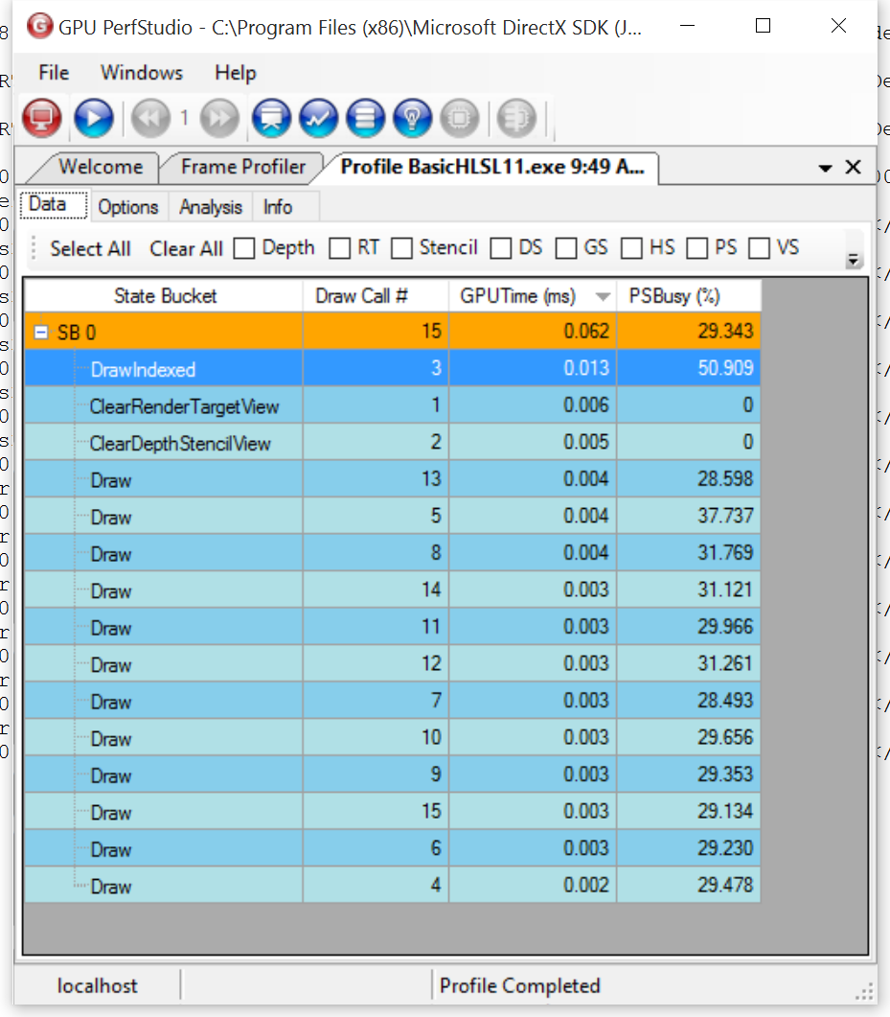

The counter selection for the above data

