

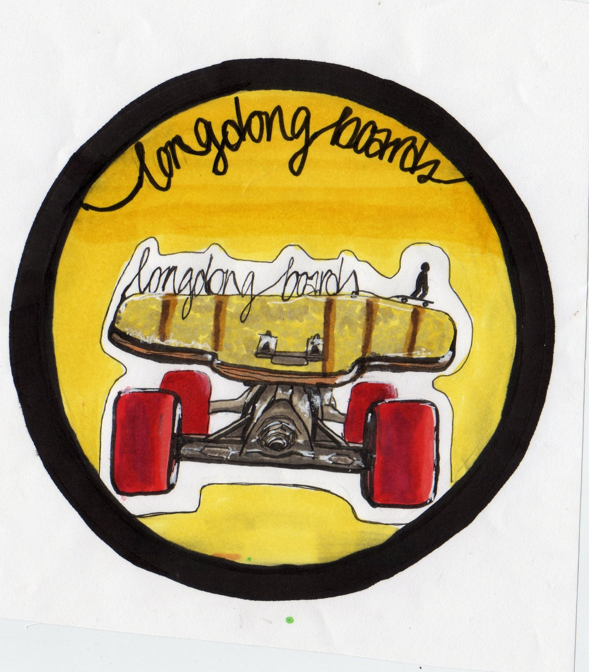

Entnehme aus deiner Eröffnungsbilanz die Anfangsbestände der Konten

* *Fuhrpark* und
* *Verbindlichkeiten gegenüber Sozialversicherungsträgern*

und trage sie in die notwendigen T-Konten ein.

Bilde anschließend die beiden Eröffnungsbuchungssätze.

S 0840 FP H S 4840 VSV H

|  |  |  |  |  |
| --- | --- | --- | --- | --- |
|  |  |  |  |  |

S 8000 EBK H

|  |  |  |  |  |
| --- | --- | --- | --- | --- |
|  |  |  |  |  |

|  |  |  |  |  |  |  |  |  |  |  |  |  |  |  |  |  |  |  |  |  |  |  |  |  |  |  |  |  |  |  |  |  |  |
| --- | --- | --- | --- | --- | --- | --- | --- | --- | --- | --- | --- | --- | --- | --- | --- | --- | --- | --- | --- | --- | --- | --- | --- | --- | --- | --- | --- | --- | --- | --- | --- | --- | --- |
|  |  |  |  |  |  |  |  |  |  |  |  |  |  |  |  |  |  |  |  |  |  |  |  |  |  |  |  |  |  |  |  |  |  |
|  |  |  |  |  |  |  |  |  |  |  |  |  |  |  |  |  |  |  |  |  |  |  |  |  |  |  |  |  |  |  |  |  |  |
|  |  |  |  |  |  |  |  |  |  |  |  |  |  |  |  |  |  |  |  |  |  |  |  |  |  |  |  |  |  |  |  |  |  |
|  |  |  |  |  |  |  |  |  |  |  |  |  |  |  |  |  |  |  |  |  |  |  |  |  |  |  |  |  |  |  |  |  |  |
|  |  |  |  |  |  |  |  |  |  |  |  |  |  |  |  |  |  |  |  |  |  |  |  |  |  |  |  |  |  |  |  |  |  |
|  |  |  |  |  |  |  |  |  |  |  |  |  |  |  |  |  |  |  |  |  |  |  |  |  |  |  |  |  |  |  |  |  |  |
|  |  |  |  |  |  |  |  |  |  |  |  |  |  |  |  |  |  |  |  |  |  |  |  |  |  |  |  |  |  |  |  |  |  |



**Hausaufgabe:**

1. Trage den folgenden Geschäftsfall in das Vorkontierungsblatt ein!

Geschäftsfall: Eröffnungsbuchung des Kontos 2880 KA.

Nimm deine Eröffnungsbilanz zur Hilfe!

|  |  |  |  |  |  |  |  |  |
| --- | --- | --- | --- | --- | --- | --- | --- | --- |
| BA | Datum | Soll | Haben | BNR | Text | Betrag (€)  B/N | | UCo |
| B |  |  |  | 23 |  | N |  | --- |

1. Bilde die Buchungssätze zu den beiden Eintragungen im Eröffnungsbilanzkonto!

S 8000 EBK H

|  |  |
| --- | --- |
| 1. 4250) 184.000,00 € | 2. 2020) 4.800,00 € |

|  |  |  |  |  |  |  |  |  |  |  |  |  |  |  |  |  |  |  |  |  |  |  |  |  |  |  |  |  |  |  |  |  |  |
| --- | --- | --- | --- | --- | --- | --- | --- | --- | --- | --- | --- | --- | --- | --- | --- | --- | --- | --- | --- | --- | --- | --- | --- | --- | --- | --- | --- | --- | --- | --- | --- | --- | --- |
|  |  |  |  |  |  |  |  |  |  |  |  |  |  |  |  |  |  |  |  |  |  |  |  |  |  |  |  |  |  |  |  |  |  |
|  |  |  |  |  |  |  |  |  |  |  |  |  |  |  |  |  |  |  |  |  |  |  |  |  |  |  |  |  |  |  |  |  |  |
|  |  |  |  |  |  |  |  |  |  |  |  |  |  |  |  |  |  |  |  |  |  |  |  |  |  |  |  |  |  |  |  |  |  |
|  |  |  |  |  |  |  |  |  |  |  |  |  |  |  |  |  |  |  |  |  |  |  |  |  |  |  |  |  |  |  |  |  |  |
|  |  |  |  |  |  |  |  |  |  |  |  |  |  |  |  |  |  |  |  |  |  |  |  |  |  |  |  |  |  |  |  |  |  |
|  |  |  |  |  |  |  |  |  |  |  |  |  |  |  |  |  |  |  |  |  |  |  |  |  |  |  |  |  |  |  |  |  |  |
|  |  |  |  |  |  |  |  |  |  |  |  |  |  |  |  |  |  |  |  |  |  |  |  |  |  |  |  |  |  |  |  |  |  |





Entnehme aus deiner Eröffnungsbilanz die Anfangsbestände der Konten

* *Fuhrpark* und
* *Verbindlichkeiten gegenüber Sozialversicherungsträgern*

und trage sie in die notwendigen T-Konten ein.

Bilde anschließend die beiden Eröffnungsbuchungssätze.

S 0840 FP H S 4840 VSV H

|  |  |  |  |  |
| --- | --- | --- | --- | --- |
| 8000) 32.000,00 |  |  |  | 8000) 18.000,00 |

S 8000 EBK H

|  |  |  |  |  |
| --- | --- | --- | --- | --- |
| 4840) 18.000,00 | 0840) 32.000,00 |  |  |  |

|  |  |  |  |  |  |  |  |  |  |  |  |  |  |  |  |  |  |  |  |  |  |  |  |  |  |  |  |  |  |  |  |  |  |
| --- | --- | --- | --- | --- | --- | --- | --- | --- | --- | --- | --- | --- | --- | --- | --- | --- | --- | --- | --- | --- | --- | --- | --- | --- | --- | --- | --- | --- | --- | --- | --- | --- | --- |
|  |  |  |  |  |  |  |  |  |  |  |  |  |  |  |  |  |  |  |  |  |  |  |  |  |  |  |  |  |  |  |  |  |  |
|  |  |  | 0840 FP an 8000 EBK 32.000,00 € |  |  |  |  |  |  |  |  |  |  |  |  |  |  |  |  |  |  |  |  |  |  |  |  |  |  |  |  |  |  |
|  |  |  |  |  |  |  |  |  |  |  |  |  |  |  |  |  |  |  |  |  |  |  |  |  |  |  |  |  |  |  |  |  |  |
|  |  |  |  |  |  |  |  |  |  |  |  |  |  |  |  |  |  |  |  |  |  |  |  |  |  |  |  |  |  |  |  |  |  |
|  |  |  | 8000 EBK an 4840 VSV 18.000,00 € |  |  |  |  |  |  |  |  |  |  |  |  |  |  |  |  |  |  |  |  |  |  |  |  |  |  |  |  |  |  |
|  |  |  |  |  |  |  |  |  |  |  |  |  |  |  |  |  |  |  |  |  |  |  |  |  |  |  |  |  |  |  |  |  |  |
|  |  |  |  |  |  |  |  |  |  |  |  |  |  |  |  |  |  |  |  |  |  |  |  |  |  |  |  |  |  |  |  |  |  |



**Hausaufgabe:**

1. Trage den folgenden Geschäftsfall in das Vorkontierungsblatt ein!

Geschäftsfall: Eröffnungsbuchung des Kontos 2880 KA.

Nimm deine Eröffnungsbilanz zur Hilfe!

|  |  |  |  |  |  |  |  |  |
| --- | --- | --- | --- | --- | --- | --- | --- | --- |
| BA | Datum | Soll | Haben | BNR | Text | Betrag (€)  B/N | | UCo |
| B | 01.01.2012 | 2880 | 8000 | 23 | Eröffnung Kasse | N | 700,00 | --- |

1. Bilde die Buchungssätze zu den beiden Eintragungen im Eröffnungsbilanzkonto!

S 8000 EBK H

|  |  |
| --- | --- |
| 1. 4250) 184.000,00 € | 2. 2020) 4.800,00 € |

|  |  |  |  |  |  |  |  |  |  |  |  |  |  |  |  |  |  |  |  |  |  |  |  |  |  |  |  |  |  |  |  |  |  |
| --- | --- | --- | --- | --- | --- | --- | --- | --- | --- | --- | --- | --- | --- | --- | --- | --- | --- | --- | --- | --- | --- | --- | --- | --- | --- | --- | --- | --- | --- | --- | --- | --- | --- |
|  |  |  |  |  |  |  |  |  |  |  |  |  |  |  |  |  |  |  |  |  |  |  |  |  |  |  |  |  |  |  |  |  |  |
|  |  |  |  | 1. 8000 EBK an 4250 LBKV 184.000,00 € |  |  |  |  |  |  |  |  |  |  |  |  |  |  |  |  |  |  |  |  |  |  |  |  |  |  |  |  |  |
|  |  |  |  |  |  |  |  |  |  |  |  |  |  |  |  |  |  |  |  |  |  |  |  |  |  |  |  |  |  |  |  |  |  |
|  |  |  |  |  |  |  |  |  |  |  |  |  |  |  |  |  |  |  |  |  |  |  |  |  |  |  |  |  |  |  |  |  |  |
|  |  |  |  | 1. 2020 H an 8000 EBK 4.800,00 € |  |  |  |  |  |  |  |  |  |  |  |  |  |  |  |  |  |  |  |  |  |  |  |  |  |  |  |  |  |
|  |  |  |  |  |  |  |  |  |  |  |  |  |  |  |  |  |  |  |  |  |  |  |  |  |  |  |  |  |  |  |  |  |  |
|  |  |  |  |  |  |  |  |  |  |  |  |  |  |  |  |  |  |  |  |  |  |  |  |  |  |  |  |  |  |  |  |  |  |