

**Der Jahresabschluss bei longdong boards**

1. Bilde die vorbereitende Abschlussbuchung des Bezugs-

kostenkontos Rohstoffe.

1. Nenne weitere Vorabschlussbuchungen!

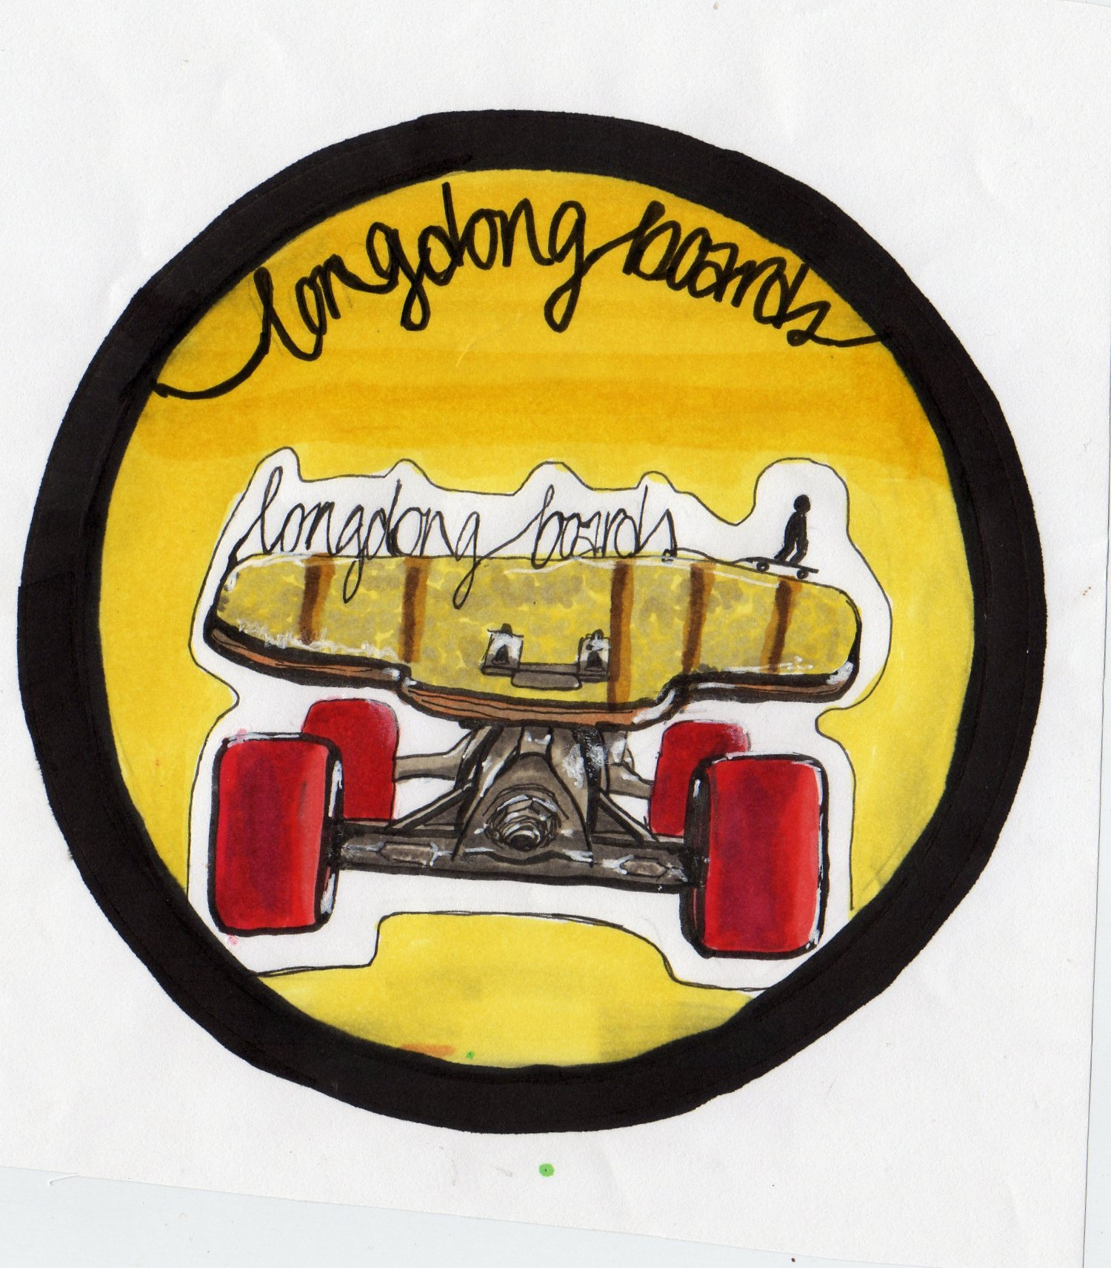

|  |  |  |  |  |  |  |  |  |  |  |  |  |  |  |  |  |  |  |  |  |  |  |  |  |  |  |  |  |  |  |  |  |  |
| --- | --- | --- | --- | --- | --- | --- | --- | --- | --- | --- | --- | --- | --- | --- | --- | --- | --- | --- | --- | --- | --- | --- | --- | --- | --- | --- | --- | --- | --- | --- | --- | --- | --- |
|  |  |  |  |  |  |  |  |  |  |  |  |  |  |  |  |  |  |  |  |  |  |  |  |  |  |  |  |  |  |  |  |  |  |
|  |  |  |  |  |  |  |  |  |  |  |  |  |  |  |  |  |  |  |  |  |  |  |  |  |  |  |  |  |  |  |  |  |  |
|  |  |  |  |  |  |  |  |  |  |  |  |  |  |  |  |  |  |  |  |  |  |  |  |  |  |  |  |  |  |  |  |  |  |
|  |  |  |  |  |  |  |  |  |  |  |  |  |  |  |  |  |  |  |  |  |  |  |  |  |  |  |  |  |  |  |  |  |  |
|  |  |  |  |  |  |  |  |  |  |  |  |  |  |  |  |  |  |  |  |  |  |  |  |  |  |  |  |  |  |  |  |  |  |
|  |  |  |  |  |  |  |  |  |  |  |  |  |  |  |  |  |  |  |  |  |  |  |  |  |  |  |  |  |  |  |  |  |  |
|  |  |  |  |  |  |  |  |  |  |  |  |  |  |  |  |  |  |  |  |  |  |  |  |  |  |  |  |  |  |  |  |  |  |
|  |  |  |  |  |  |  |  |  |  |  |  |  |  |  |  |  |  |  |  |  |  |  |  |  |  |  |  |  |  |  |  |  |  |
|  |  |  |  |  |  |  |  |  |  |  |  |  |  |  |  |  |  |  |  |  |  |  |  |  |  |  |  |  |  |  |  |  |  |

1. Trage die Abschlussbuchung des Kontos *Gehälter* und *Umsatzerlöse für eigene Erzeugnisse* in das Vorkontierungsblatt ein.

|  |  |  |  |  |  |  |  |  |
| --- | --- | --- | --- | --- | --- | --- | --- | --- |
| BA | Datum | Soll | Haben | BNR | Text | Betrag (€)  B/N | | UCo |
| B |  |  |  |  |  | N |  | --- |
| B |  |  |  |  |  | N |  | --- |

1. Trage die Abschlussbuchungen der Konten *Verbindlichkeiten* und *Zweifelhafte Forderungen* in das T-Konto ein und bilde die Buchungssätze dazu!

S 8010 SBK H

|  |  |
| --- | --- |
|  |  |

|  |  |  |  |  |  |  |  |  |  |  |  |  |  |  |  |  |  |  |  |  |  |  |  |  |  |  |  |  |  |  |  |  |  |
| --- | --- | --- | --- | --- | --- | --- | --- | --- | --- | --- | --- | --- | --- | --- | --- | --- | --- | --- | --- | --- | --- | --- | --- | --- | --- | --- | --- | --- | --- | --- | --- | --- | --- |
|  |  |  |  |  |  |  |  |  |  |  |  |  |  |  |  |  |  |  |  |  |  |  |  |  |  |  |  |  |  |  |  |  |  |
|  |  |  |  |  |  |  |  |  |  |  |  |  |  |  |  |  |  |  |  |  |  |  |  |  |  |  |  |  |  |  |  |  |  |
|  |  |  |  |  |  |  |  |  |  |  |  |  |  |  |  |  |  |  |  |  |  |  |  |  |  |  |  |  |  |  |  |  |  |
|  |  |  |  |  |  |  |  |  |  |  |  |  |  |  |  |  |  |  |  |  |  |  |  |  |  |  |  |  |  |  |  |  |  |
|  |  |  |  |  |  |  |  |  |  |  |  |  |  |  |  |  |  |  |  |  |  |  |  |  |  |  |  |  |  |  |  |  |  |
|  |  |  |  |  |  |  |  |  |  |  |  |  |  |  |  |  |  |  |  |  |  |  |  |  |  |  |  |  |  |  |  |  |  |
|  |  |  |  |  |  |  |  |  |  |  |  |  |  |  |  |  |  |  |  |  |  |  |  |  |  |  |  |  |  |  |  |  |  |



**Der Jahresabschluss bei longdong boards**

1. Bilde die vorbereitende Abschlussbuchung des Bezugs-

kostenkontos Rohstoffe.

1. Nenne weitere Vorabschlussbuchungen!



|  |  |  |  |  |  |  |  |  |  |  |  |  |  |  |  |  |  |  |  |  |  |  |  |  |  |  |  |  |  |  |  |  |  |
| --- | --- | --- | --- | --- | --- | --- | --- | --- | --- | --- | --- | --- | --- | --- | --- | --- | --- | --- | --- | --- | --- | --- | --- | --- | --- | --- | --- | --- | --- | --- | --- | --- | --- |
|  |  |  |  |  |  |  |  |  |  |  |  |  |  |  |  |  |  |  |  |  |  |  |  |  |  |  |  |  |  |  |  |  |  |
|  |  |  | 1. 6000 AWR an 6001 BZKR 140,00 € |  |  |  |  |  |  |  |  |  |  |  |  |  |  |  |  |  |  |  |  |  |  |  |  |  |  |  |  |  |  |
|  |  |  |  |  |  |  |  |  |  |  |  |  |  |  |  |  |  |  |  |  |  |  |  |  |  |  |  |  |  |  |  |  |  |
|  |  |  |  |  |  |  |  |  |  |  |  |  |  |  |  |  |  |  |  |  |  |  |  |  |  |  |  |  |  |  |  |  |  |
|  |  |  | 1. Abschluss Unterkonten, z.B. Nachlasskonten   Bestandsveränderungen |  |  |  |  |  |  |  |  |  |  |  |  |  |  |  |  |  |  |  |  |  |  |  |  |  |  |  |  |  |  |
|  |  |  |  |  |  |  |  |  |  |  |  |  |  |  |  |  |  |  |  |  |  |  |  |  |  |  |  |  |  |  |  |  |  |
|  |  |  |  |  |  |  |  |  |  |  |  |  |  |  |  |  |  |  |  |  |  |  |  |  |  |  |  |  |  |  |  |  |  |
|  |  |  |  |  |  |  |  |  |  |  |  |  |  |  |  |  |  |  |  |  |  |  |  |  |  |  |  |  |  |  |  |  |  |
|  |  |  |  |  |  |  |  |  |  |  |  |  |  |  |  |  |  |  |  |  |  |  |  |  |  |  |  |  |  |  |  |  |  |

1. Trage die Abschlussbuchung des Kontos *Gehälter* und *Umsatzerlöse für eigene Erzeugnisse* in das Vorkontierungsblatt ein.

|  |  |  |  |  |  |  |  |  |
| --- | --- | --- | --- | --- | --- | --- | --- | --- |
| BA | Datum | Soll | Haben | BNR | Text | Betrag (€)  B/N | | UCo |
| B | 31.12.12 | 8020 | 6300 |  | Abschluss Gehalt | N | 36.800,00 | --- |
| B | 31.12.12 | 5000 | 8020 |  | Abschluss UEFE | N | 46.150,00 | --- |

1. Trage die Abschlussbuchungen der Konten *Verbindlichkeiten* und *Zweifelhafte Forderungen* in das T-Konto ein und bilde die Buchungssätze dazu!

S 8010 SBK H

|  |  |
| --- | --- |
| 2. 2470) 35.937,00 | 1. 4400) 48.820,30 |

|  |  |  |  |  |  |  |  |  |  |  |  |  |  |  |  |  |  |  |  |  |  |  |  |  |  |  |  |  |  |  |  |  |  |
| --- | --- | --- | --- | --- | --- | --- | --- | --- | --- | --- | --- | --- | --- | --- | --- | --- | --- | --- | --- | --- | --- | --- | --- | --- | --- | --- | --- | --- | --- | --- | --- | --- | --- |
|  |  |  |  |  |  |  |  |  |  |  |  |  |  |  |  |  |  |  |  |  |  |  |  |  |  |  |  |  |  |  |  |  |  |
|  |  |  | 1. 4400 VE an 8010 SBK 48.820,30 € 2. 8010 SBK an 2470 ZWFO 35.937,00 € |  |  |  |  |  |  |  |  |  |  |  |  |  |  |  |  |  |  |  |  |  |  |  |  |  |  |  |  |  |  |
|  |  |  |  |  |  |  |  |  |  |  |  |  |  |  |  |  |  |  |  |  |  |  |  |  |  |  |  |  |  |  |  |  |  |
|  |  |  |  |  |  |  |  |  |  |  |  |  |  |  |  |  |  |  |  |  |  |  |  |  |  |  |  |  |  |  |  |  |  |
|  |  |  |  |  |  |  |  |  |  |  |  |  |  |  |  |  |  |  |  |  |  |  |  |  |  |  |  |  |  |  |  |  |  |
|  |  |  |  |  |  |  |  |  |  |  |  |  |  |  |  |  |  |  |  |  |  |  |  |  |  |  |  |  |  |  |  |  |  |
|  |  |  |  |  |  |  |  |  |  |  |  |  |  |  |  |  |  |  |  |  |  |  |  |  |  |  |  |  |  |  |  |  |  |