Міністерство науки і освіти України  
Львівський національний університет імені Івана Франка  
Факультет електроніки та комп’ютерних технологій

Лабораторна робота №1-3  
«Створення сучасної веб-сторінки за допомогою HTML5 та CSS3»

Підготував:  
студент ФЕІ-21  
Вибираний Владислав  
  
Перевірив:  
доц. Анохін В.Є.

Львів 2024

**Тема:** Створення сучасної веб-сторінки за допомогою HTML5 та CSS3

**Мета:**

* Навчитись створювати HTML документи
* Вивчити та навчитись використовувати теги для створення web-сторінок

**Код веб-сторінки**

<!DOCTYPE html>

<html lang="en">

<head>

<meta charset="UTF-8" />

<meta name="viewport" content="width=device-width, initial-scale=1.0" />

<title>Document</title>

<link rel="stylesheet" href="./style.css" />

<link rel="preconnect" href="https://fonts.googleapis.com" />

<link rel="preconnect" href="https://fonts.gstatic.com" crossorigin />

<link

href="https://fonts.googleapis.com/css2?family=Cormorant:ital@1&family=Poppins&display=swap"

rel="stylesheet"

/>

</head>

<body>

<header class="header">

<div class="container">

<div class="header__menu">

<a href="#!" class="header__logo">My Page</a>

<nav class="menu__list">

<ul class="menu__item">

<li class="menu__items">

<a href="" class="menu__link active">Home</a>

</li>

<li class="menu__items">

<a href="" class="menu__link">Works</a>

</li>

<li class="menu__items">

<a href="" class="menu__link">Services</a>

</li>

<li class="menu__items">

<a href="" class="menu__link">About</a>

</li>

<li class="menu__items">

<a href="" class="menu__link">Contact</a>

</li>

</ul>

</nav>

</div>

<div class="header__row">

<div class="header__content">

<h1 class="header__content-title">

Vlad Vybyranyi <br />

Data Scientist & Developer

</h1>

<div class="header__content-text">

I’m a Lviv National University student and a passionate Programmer Developer and Problem Solver. I’m

interested in all kinds of technology and software development.

</div>

</div>

<div >

<img class="header__image" src="./img/someguy.jpeg" alt="" />

</div>

</div>

</div>

</header>

<section class="services">

<div class="container">

<ul class="services__list">

<li class="services__item">

<img class="services__img" src="./img/graphic 1.jpg" alt="" />

<div class="services__title">Data Science</div>

<div class="services__text">

I am a beginner in the field of data science, but I am ready to learn and develop in this direction.

</div>

</li>

<li class="services__item">

<img class="services__img" src="./img/startup 1.jpg" alt="" />

<div class="services__title">Development</div>

<div class="services__text">

Also I am a beginner in the field of development, but I am ready to learn and develop in this direction.

</div>

</li>

<li class="services__item">

<img class="services__img" src="./img/browser 1.jpg" alt="" />

<div class="services__title">software development</div>

<div class="services__text">

I like to develop software in many laguages such as Rust, Python, C, C++ and others.

</div>

</li>

</ul>

</div>

</section>

<section class="table">

<div class="table__table">

<table>

<tr>

<th>Company</th>

<th>Contact</th>

<th>Country</th>

</tr>

<tr>

<td>Alfreds Futterkiste</td>

<td>Maria Anders</td>

<td>Germany</td>

</tr>

<tr>

<td>Centro comercial Moctezuma</td>

<td>Francisco Chang</td>

<td>Mexico</td>

</tr>

</table>

</div>

</section>

<section class="frame">

<iframe width="560" height="315" src="https://www.youtube.com/embed/JLD_Nl12oac?si=3bfQKixEYzSmu9iP" title="YouTube video player" frameborder="0" allow="accelerometer; autoplay; clipboard-write; encrypted-media; gyroscope; picture-in-picture; web-share" allowfullscreen></iframe>

</section>

<footer class="footer">

<div class="footer__body">

<h1 class="footer__title">Contacts</h1>

<div class="footer__text">

Want to know more about me? You are welcome!

</div>

<div class="form-div">

<form>

<div class="form-names">

<input type="text" name="fname" placeholder="First Name" class="fname">

<input type="text" name="lname" placeholder="Last Name" class="lname">

</div>

<div class="form-phone">

<input type="tel" name="phone" placeholder="Phone Number" minlength="10" maxlength="13"

class="phone">

</div>

<div class="form-select">

<select class="selection-menu">

<option disabled="disabled" selected="selected">Select Service:</option>

<option value="0">Option1</option>

<option value="1">Option2</option>

<option value="2">Option3</option>

</select>

</div>

<div class="form-area">

<textarea name="details" class="textarea" cols="54.5" rows="10"

placeholder="For details"></textarea>

</div>

<input type="reset" value="SUBMIT NOW" class="form-submit">

</form>

</div>

<a href="https://telegram.org/" class="footer__link">Send message ⌨</a>

</div>

</footer>

</body>

</html>

**style.css**

@keyframes slideInFromRight {

0% {

transform: translateX(100vw);

}

100% {

transform: translateX(0%);

}

}

* {

padding: 0;

margin: 0;

border: 0;

}

*,

*:before,

*:after {

-moz-box-sizing: border-box;

-webkit-box-sizing: border-box;

box-sizing: border-box;

}

:focus,

:active {

outline: none;

}

a:focus,

a:active {

outline: none;

}

nav,

footer,

header,

aside {

display: block;

}

html,

body {

height: 100%;

width: 100%;

font-size: 100%;

line-height: 1;

font-size: 14px;

-ms-text-size-adjust: 100%;

-moz-text-size-adjust: 100%;

-webkit-text-size-adjust: 100%;

}

input,

button,

textarea {

font-family: inherit;

}

input::-ms-clear {

display: none;

}

button {

cursor: pointer;

}

button::-moz-focus-inner {

padding: 0;

border: 0;

}

a,

a:visited {

text-decoration: none;

}

a:hover {

text-decoration: none;

}

ul li {

list-style: none;

}

img {

vertical-align: top;

}

h1,

h2,

h3,

h4,

h5,

h6 {

font-size: inherit;

font-weight: 400;

}

.container {

max-width: 1170px;

margin: 0 auto;

}

body {

font-family: "Poppins", sans-serif;

color: #000;

}

.header {

background: #f1f1f1;

}

.header__menu {

display: flex;

justify-content: space-between;

align-items: flex-end;

}

.header__logo {

position: relative;

font-size: 32px;

font-weight: 700;

line-height: 100%;

color: #000;

}

.header__logo::after {

content: "";

position: absolute;

width: 8px;

height: 8px;

bottom: -3px;

right: -12px;

background-color: #fda300;

border-radius: 50%;

}

.menu__list {

}

.menu__item {

display: flex;

gap: 0 50px;

}

.menu__link.active {

color: #606060;

}

.menu__link {

font-size: 14px;

font-weight: 500;

color: #000;

}

.menu__link:hover {

text-decoration: underline;

}

.header__content {

}

.header__content-title {

font-size: 44px;

font-weight: 600;

line-height: normal;

margin-top: 265px;

}

.header__content-text {

font-size: 14px;

font-weight: 400;

line-height: 200%;

width: 500px;

margin-top: 20px;

}

.header__row {

display: flex;

padding-bottom: 20px;

}

.header__image {

margin-top: 76px;

margin-left: 176px;

border-radius: 50px;

animation: 1.5s ease 0s 1 slideInFromRight;

}

.services {

padding: 90px 0;

}

.services__list {

display: flex;

}

@media (max-width: 1400px) {

.header__menu {

flex-direction: column;

align-items: center;

}

.menu__item {

margin-top: 20px;

}

.header__content-title {

font-size: 34px;

}

.header__content-text {

width: 100%;

text-align: center;

}

.header__image {

display: none;

}

.services__list {

flex-direction: column;

align-items: center;

}

.services__item {

margin-bottom: 40px;

}

.services__img {

margin-bottom: 20px;

}

.services__title {

font-size: 20px;

}

.services__text {

width: 100%;

text-align: center;

}

.footer__brows {

flex-direction: column;

gap: 0 40px;

}

.footer__copy {

text-align: center;

}

}

.services__item {

margin: 10px;

padding: 5px;

border: 2px solid #000000;

border-radius: 10px;

box-shadow: #bebebe 0px 0px 10px;

}

.services__img {

margin-bottom: 30px;

}

.services__title {

font-size: 24px;

font-weight: 600;

text-transform: uppercase;

margin-bottom: 10px;

}

.services__text {

width: 370px;

font-size: 14px;

font-weight: 400;

line-height: 2;

}

.footer {

padding: 90px 0;

}

.footer__body {

margin: 0 auto;

text-align: center;

color: #070707;

}

.footer__title {

font-size: 34px;

font-weight: 600;

margin-bottom: 40px;

}

.footer__text {

font-size: 18px;

font-weight: 400;

margin-bottom: 40px;

}

.footer__link {

padding: 7px 23px;

width: 180.5px;

height: 42px;

background-color: #070707;

color: #fff;

font-size: 18px;

font-weight: 400;

border-radius: 40px;

transition: all 0.3s linear;

}

.footer__link:hover {

background: #606060;

}

.footer__brows {

display: flex;

justify-content: center;

gap: 0 60px;

margin-top: 80px;

}

.footer__tiem {

}

.footer__img {

}

.footer__copy {

color: #828282;

font-size: 14px;

font-weight: 400;

margin-top: 41px;

line-height: normal;

}

.form-div{

margin: 20px;

display:flex;

justify-content: center;

}

.form-names{

display: flex;

gap: 0 20px;

margin-bottom: 20px;

padding: 2px;

border: 2px solid #000000;

border-radius: 5px;

}

.form-phone{

padding: 2px;

border: 2px solid #000000;

border-radius: 5px;

margin-bottom: 20px;

}

.form-select{

padding: 2px;

border: 2px solid #000000;

border-radius: 5px;

margin-bottom: 20px;

}

.form-area{

padding: 2px;

border: 2px solid #000000;

border-radius: 5px;

margin-bottom: 20px;

}

.form-submit{

padding: 7px 23px;

width: 180.5px;

height: 42px;

background-color: #070707;

color: #fff;

font-size: 18px;

font-weight: 400;

border-radius: 40px;

transition: all 0.3s linear;

}

.table__table{

margin: 20px;

display: flex;

justify-content: center;

}

table, tr, th, td{

border: 1px solid black;

border-collapse: collapse;

padding: 10px;

height: 50px

}

.frame{

margin: 20px;

display: flex;

justify-content: center;

}

**Веб-сторінка**

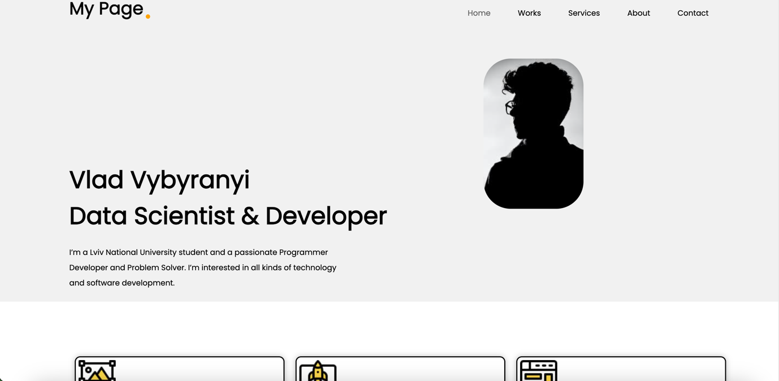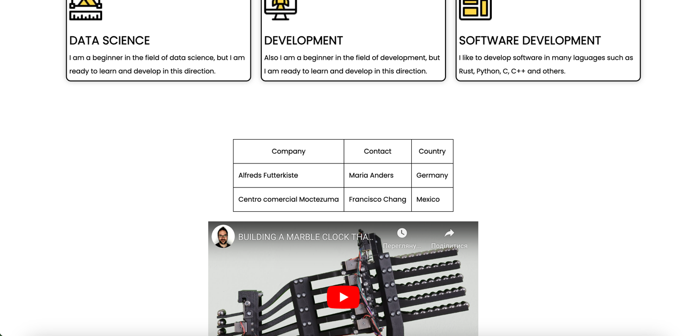

**Висновок:** під час виконання лабораторної роботи я навчився створювати веб-сторінки із сучасним дизайном за допомогою тегів HTML5 та каскадних стилів CSS3.