第一天工作记录

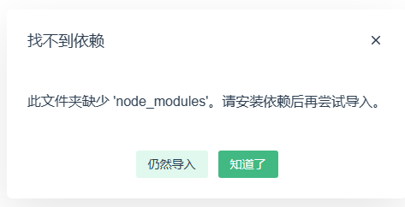

[【Vue】项目导入\_导入vue项目\_不大好不大好的博客-CSDN博客](https://blog.csdn.net/weixin_44707049/article/details/120762381?ops_request_misc=%7B%22request%5Fid%22%3A%22168836755016800213016288%22%2C%22scm%22%3A%2220140713.130102334..%22%7D&request_id=168836755016800213016288&biz_id=0&utm_medium=distribute.pc_search_result.none-task-blog-2~all~sobaiduend~default-1-120762381-null-null.142^v88^insert_down38v5,239^v2^insert_chatgpt&utm_term=vue%E9%A1%B9%E7%9B%AE%E5%A6%82%E4%BD%95%E5%AF%BC%E5%85%A5&spm=1018.2226.3001.4187)

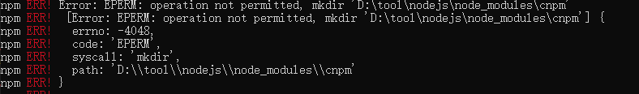

[Error: EPERM: operation not permitted, mkdir ‘D:\NodeJS\node\_global‘,‘-4048’的解决方法\_error: eperm: operation not permitted, mkdir 'd:\n\_是你达的博客-CSDN博客](https://blog.csdn.net/weixin_44047784/article/details/123459192?ops_request_misc=&request_id=&biz_id=102&utm_term=EPERM: operation not permitted&utm_medium=distribute.pc_search_result.none-task-blog-2~all~sobaiduweb~default-0-123459192.nonecase&spm=1018.2226.3001.4187)

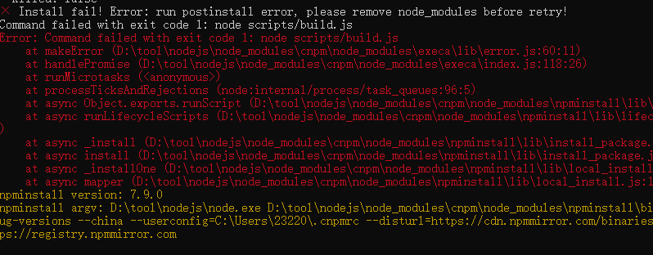

上面报错原因：node版本太高，是16版本，降低到14版本即可。