****

Arthur Cabral

Gabriel Rocha

Giovanna de Jesus

Mateus Gomes

Pedro Duó

*Cold Stock* 2020

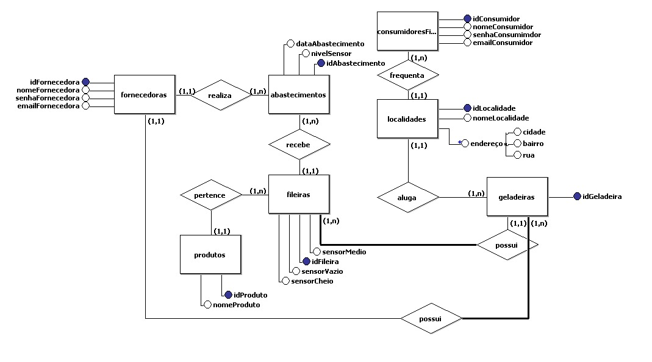MODELAGEM

