**DATA VISLUALIZATION EXPERIMENTS**

**6 (A) Create a first visualization with tableau software for data file formats**

Website to download: sandbox:/mnt/data/tableau _lab_ dataset.xlsx

The workbook contains these sheets (brief):

**Sales_TimeSeries** — date / region / product / sales / quantity / profit (time series, line & bar charts, dual-axis).

**Category_Summary** — category / subcategory / sales / profit (treemaps).

**Calculations_Data** — numeric rows to practice calculated fields (sum, avg, custom).

**PivotData** — employee / project / hours / date (pivoting practice).

**Filters_Data** — customer demographics and sales (filtering, sorting).

**DualAxis_Cyclical** — monthly cyclical metrics (dual axis, seasonal & cyclical analysis).

**CircularArea_Data** — segments & values (pie / circular area charts).

## 6 a) Create a first visualization with Tableau software for data file formats (open an Excel and make a simple line)

STEPS:

1. Open **Tableau Desktop** or **Tableau Public**.
2. On the Start page click **Microsoft Excel** under **Connect**.
3. In the file chooser navigate to and select **tableau_lab_dataset.xlsx** and click **Open**.
4. In the left pane click the sheet **Sales_TimeSeries** to load it (drag it to the canvas if prompted).
5. Switch to the **Sheet 1** tab at the bottom.
6. In the Data pane locate the field **Order Date** (Data type: Date). Drag **Order Date** to the **Columns** shelf.
7. In the Data pane locate **Sales** (Measure). Drag **Sales** to the **Rows** shelf.
8. On the **Marks** card set the mark type to **Line** (click the dropdown that may show Automatic and choose **Line**).
9. If Tableau aggregated by MONTH, and you want continuous dates, click the **Order Date** pill on Columns and choose **Month** → **Continuous** (DATEPART vs DATETRUNC options).
10. Confirm you see a line showing **SUM(Sales)** over time — that's your first visualization.

STEP 1 SCREENSHOT (Open **Tableau Desktop** or **Tableau Public)**

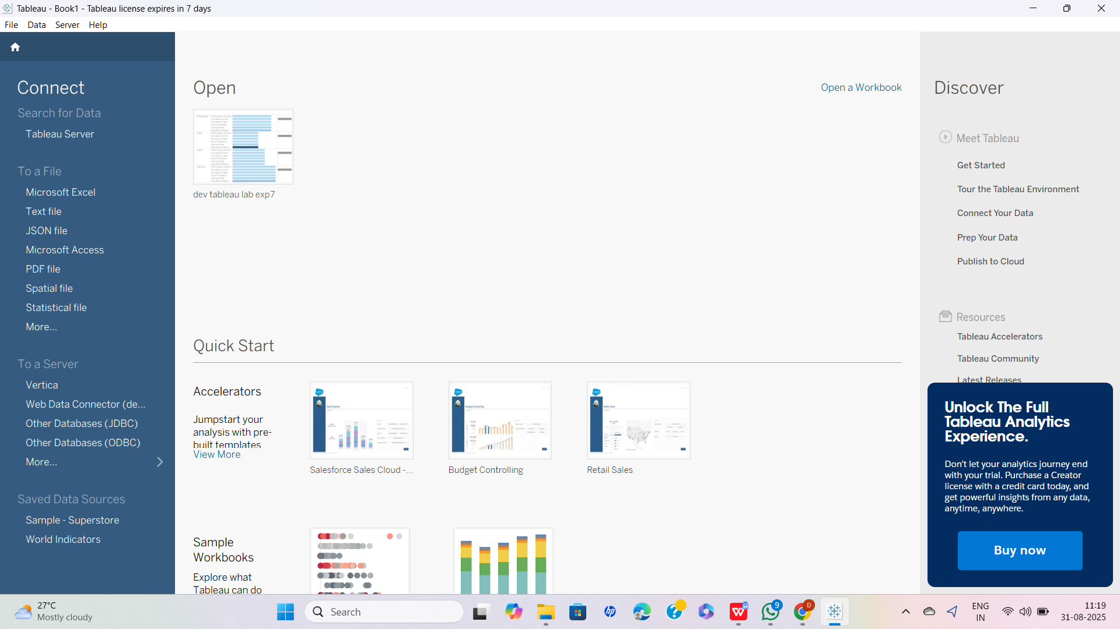

STEP 2 SCREENSHOT (On the Start page click **Microsoft Excel** under **Connect)**

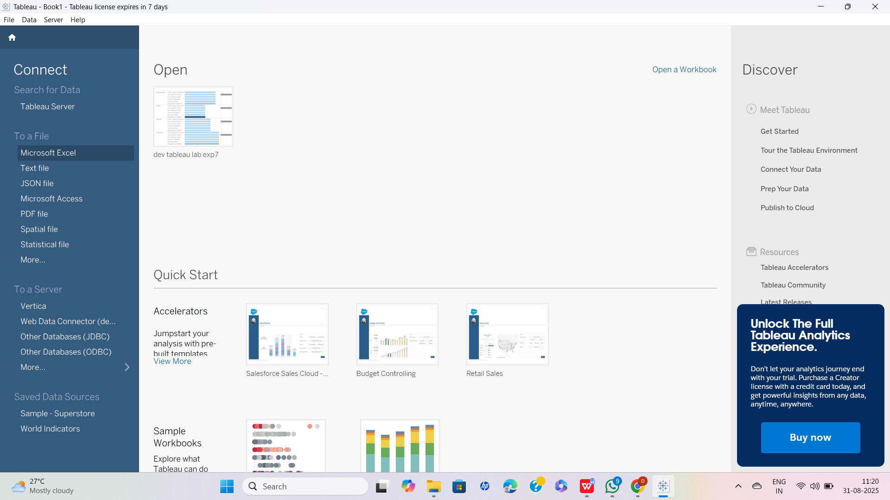

STEP 3 SCREENSHOT (In the file chooser navigate to and select **tableau_lab_dataset.xlsx** and click OPEN)

## 

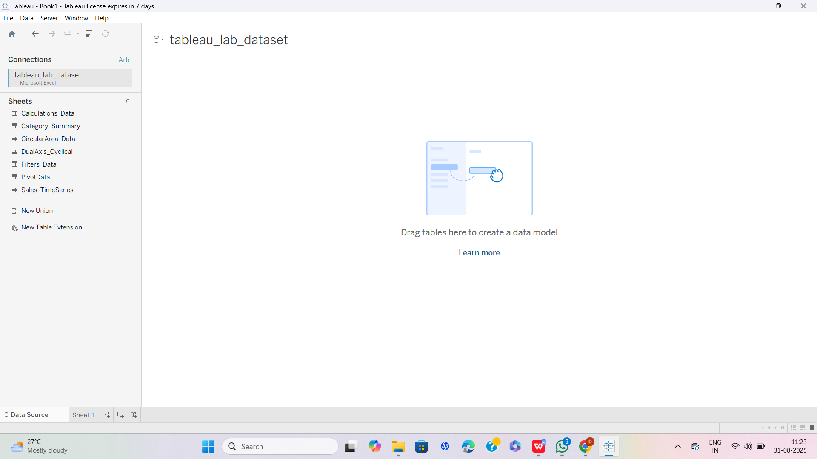

STEP 4 SCREENSHOT (In the left pane click the sheet **Sales_TimeSeries** to load it (drag it to the canvas if prompted).

## 

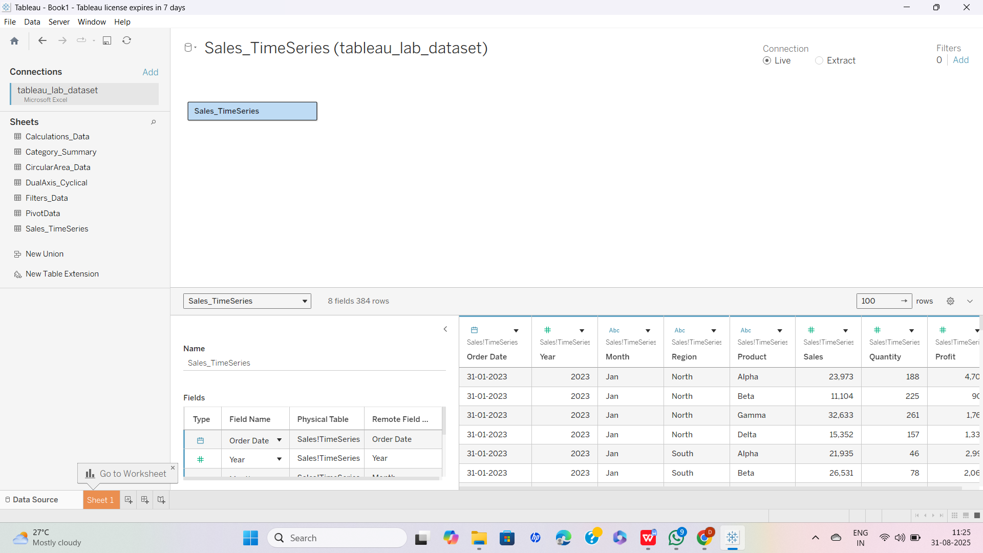

## STEP 5 SCREENSHOT (SWITCH TO SHEET 1 Tab at the bottom)

## 

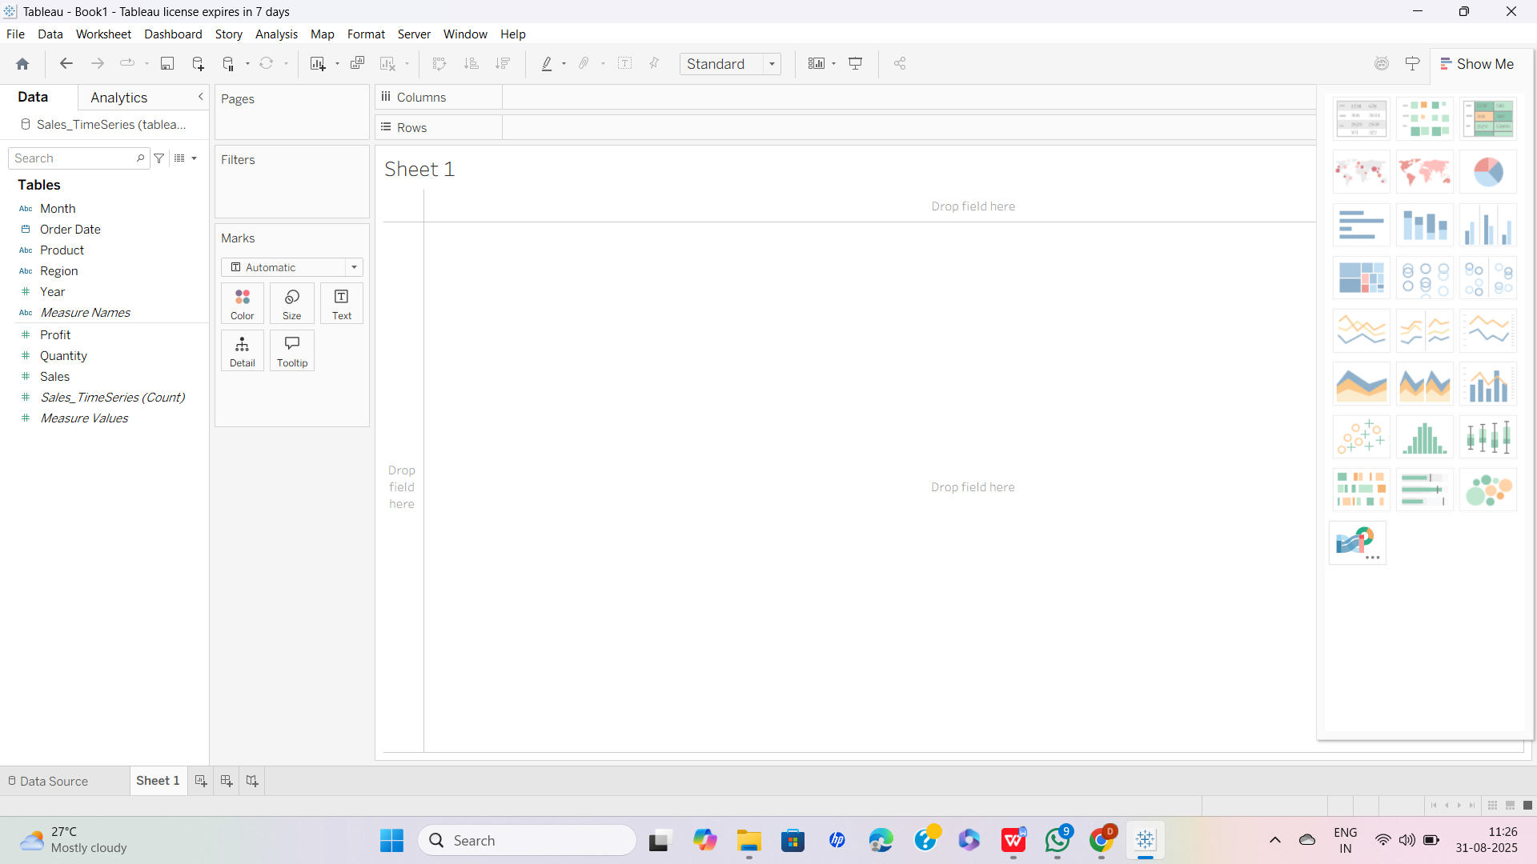

STEP 6 SCREENSHOT (In the Data pane locate the field **Order Date** (Data type: Date). Drag **Order Date** to the **Columns** shelf)

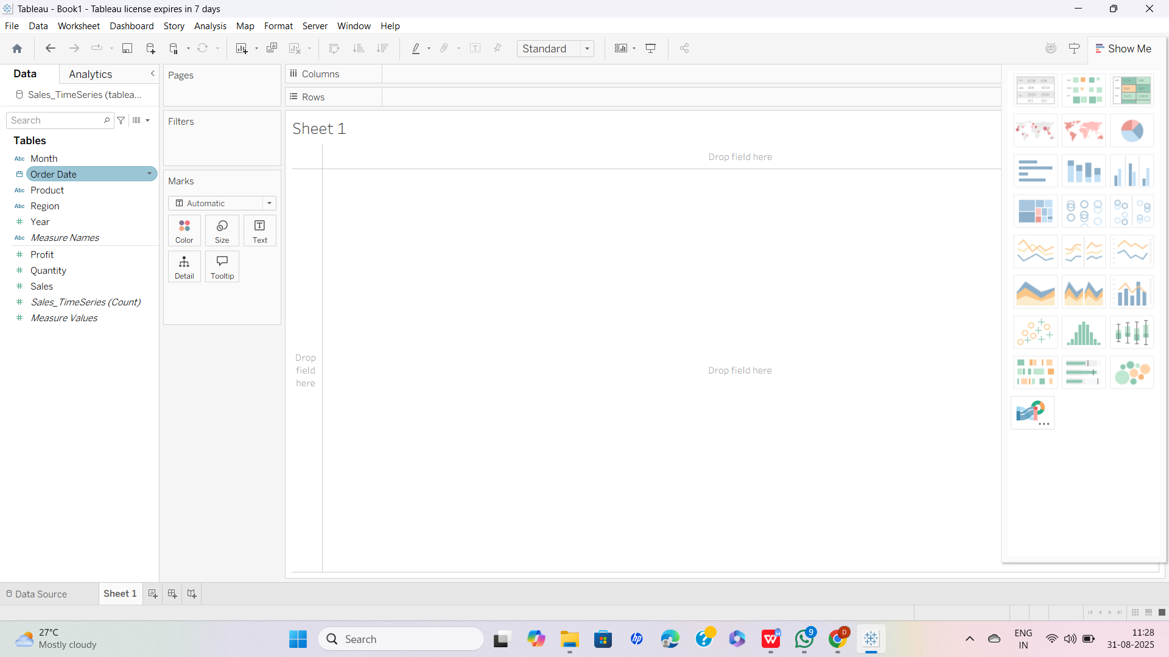

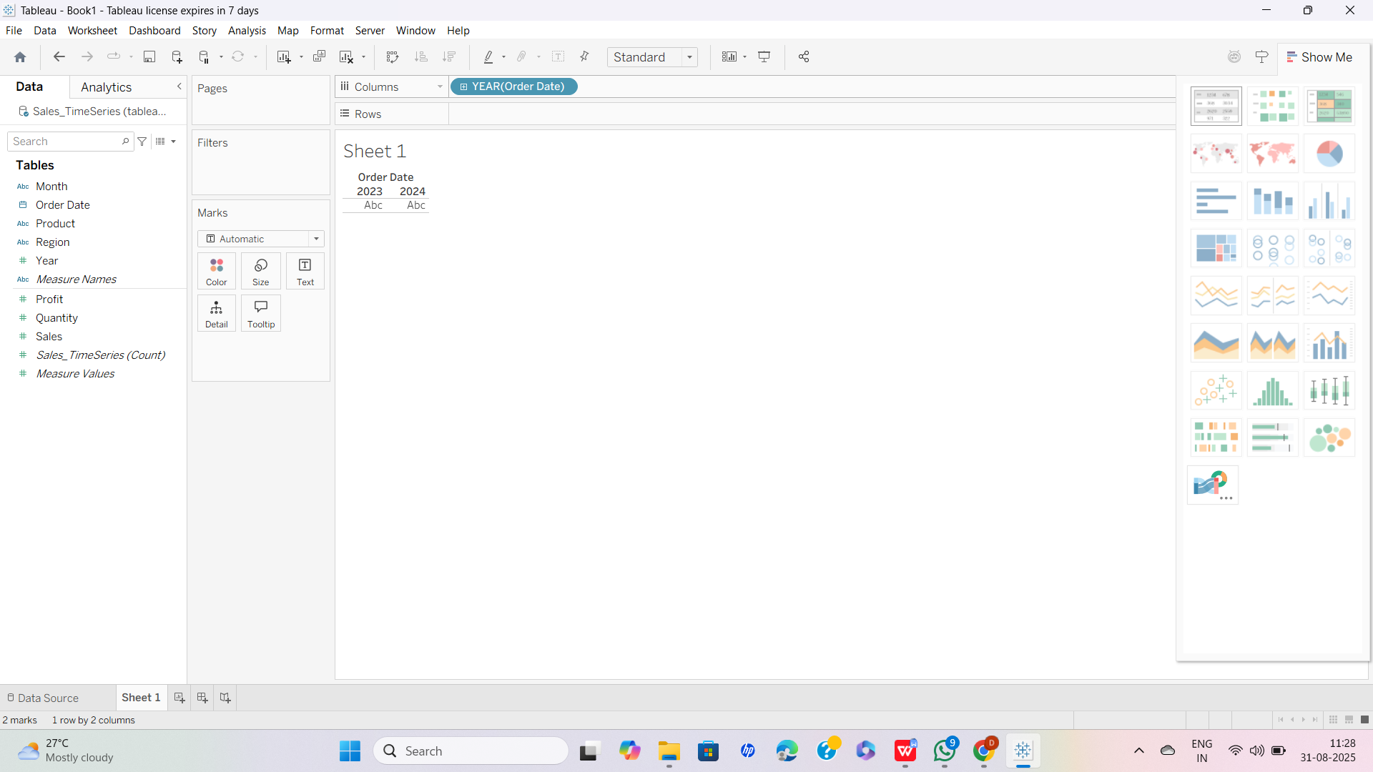

STEP 7 SCREENSHOT (In the Data pane locate **Sales** (Measure). Drag **Sales** to the **Rows** shelf)

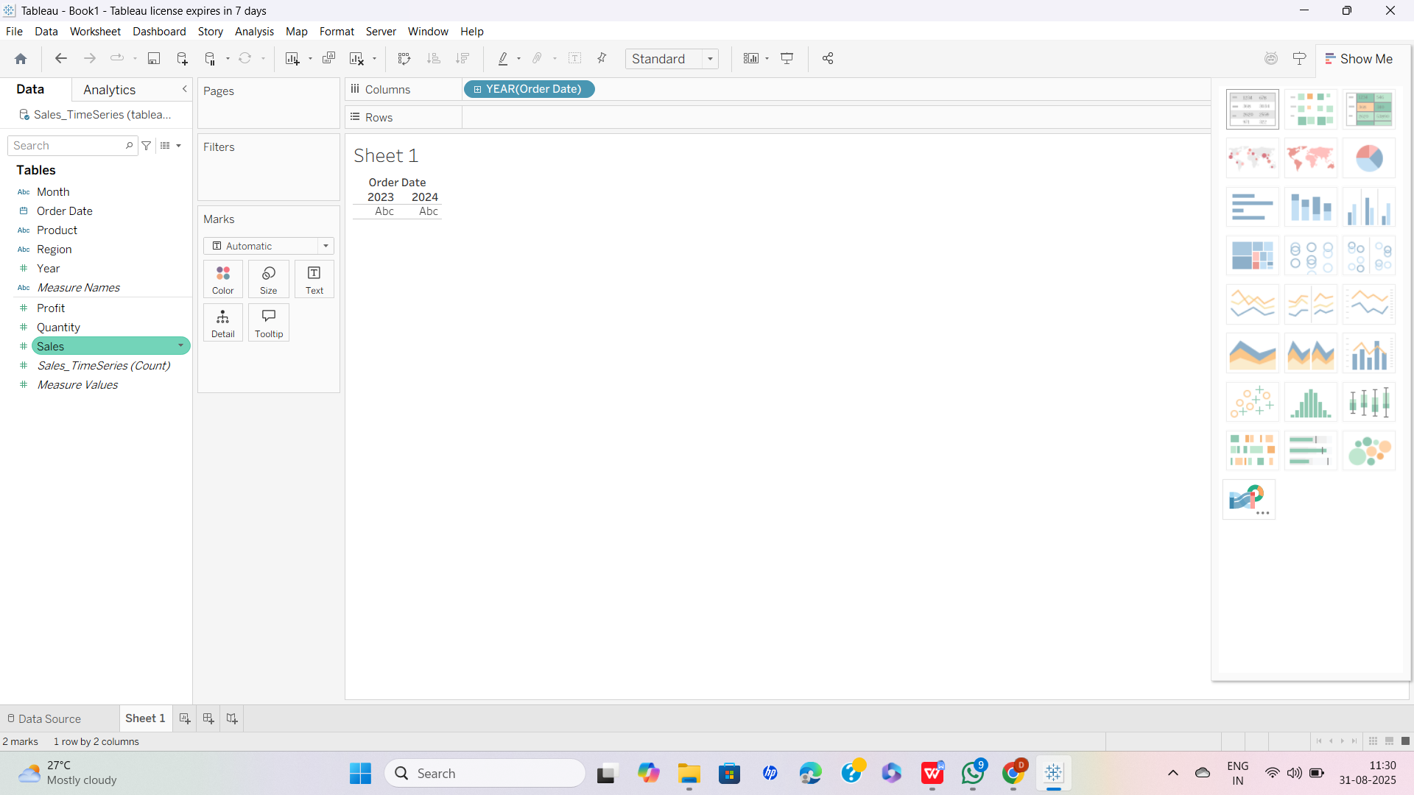

## 

STEP 8 SCREENSHOT (On the **Marks** card set the mark type to **Line** (click the dropdown that may show Automatic and choose **Line**).

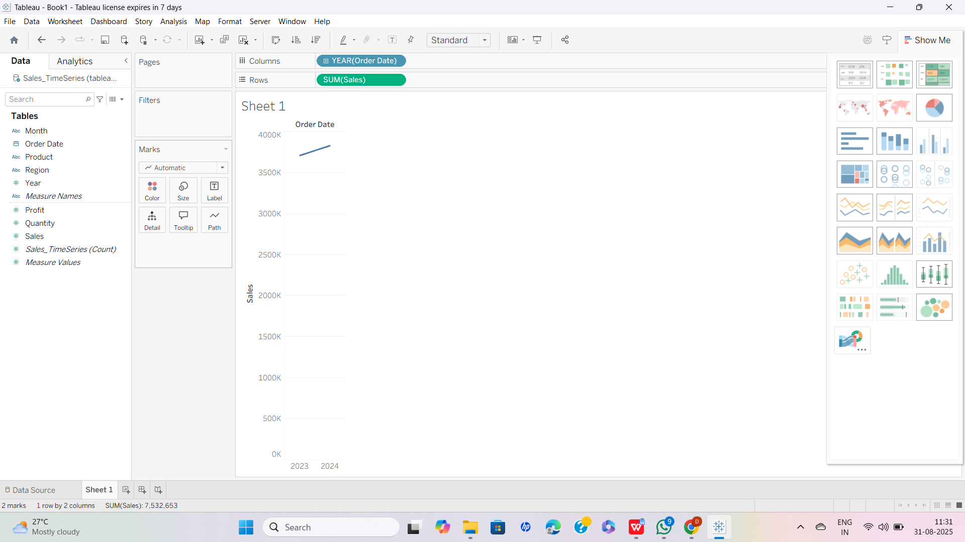

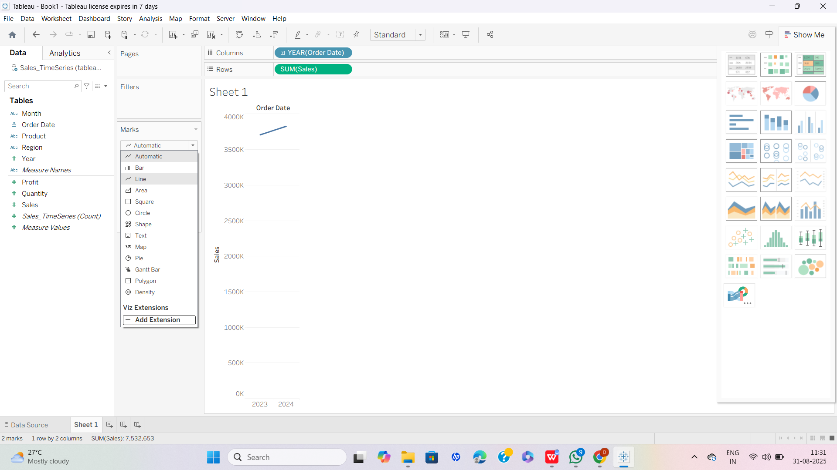

STEP 9 SCREENSHOT (If Tableau aggregated by MONTH, and you want continuous dates, click the **Order Date** pill on Columns and choose **Month** → **Continuous** (DATEPART vs DATETRUNC options).

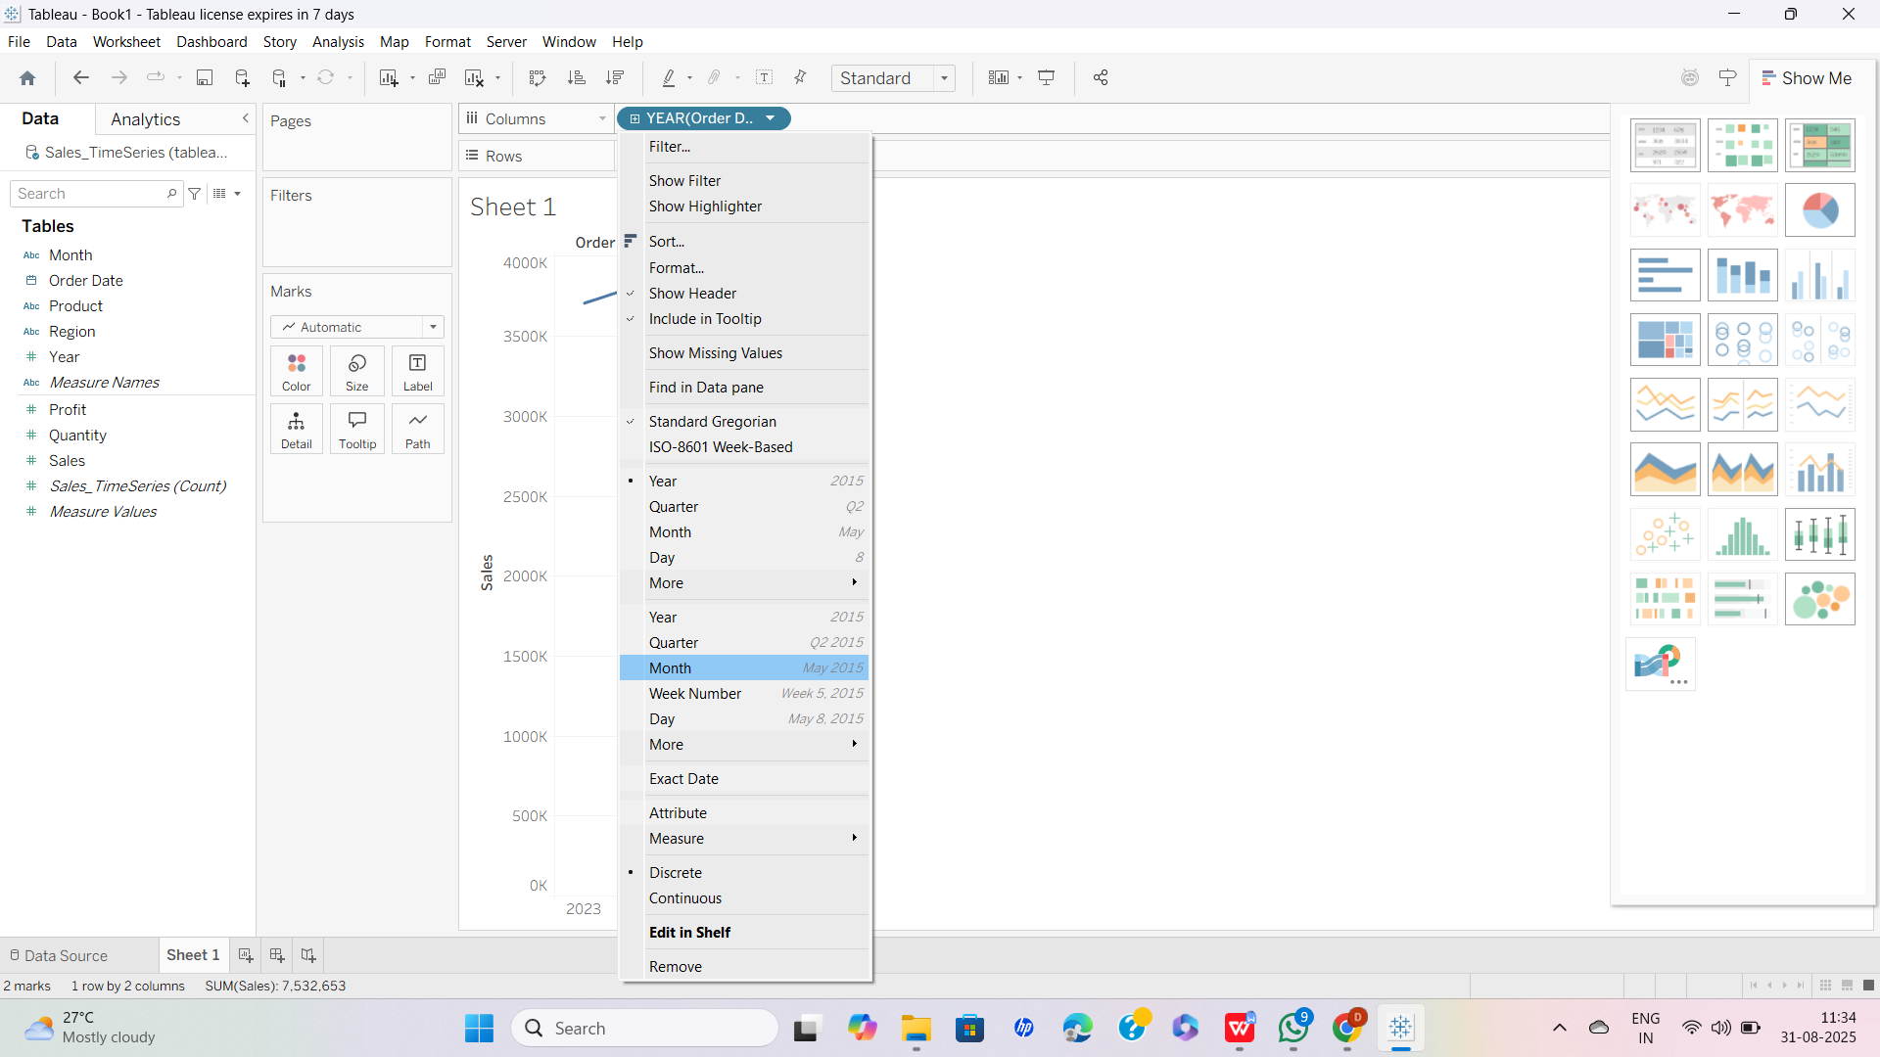

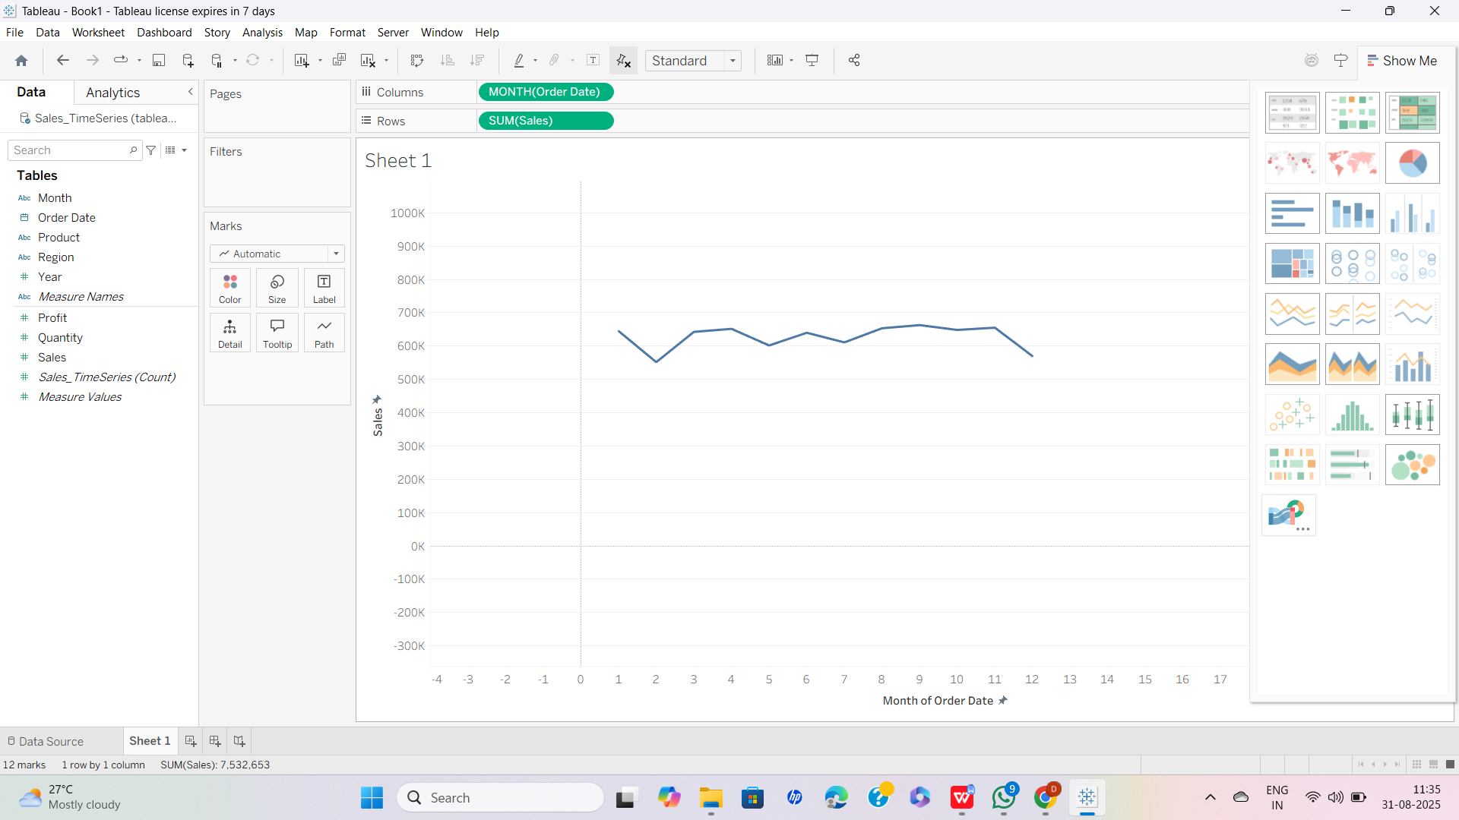

STEP 10 ( Confirm you see a line showing **SUM(Sales)** over time — that's your first visualization)

