**DATA VISLUALIZATION EXPERIMENTS**

## 6 b) Create basic charts (line, bar charts, tree maps) using the Show Me panel

**__________________________________________________________________**

**Line chart (quick, using Show Me):**

On a new sheet select **Order Date** in Data pane (single click).

Hold Ctrl (Cmd on Mac) and click **Sales**. Both fields should be highlighted.

Open the **Show Me** panel (right-hand side).

Click the **Lines** icon (the line-chart icon). Tableau builds a line chart.

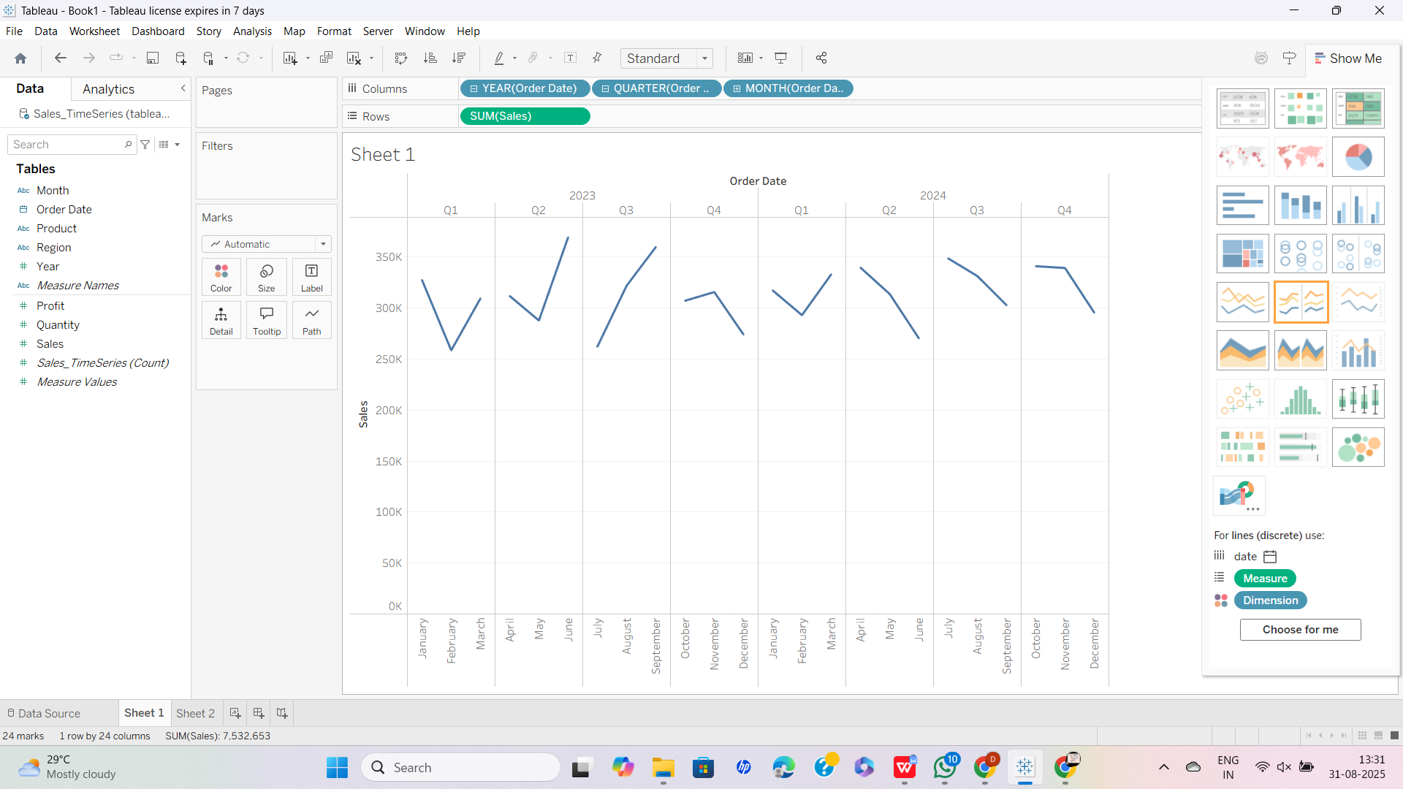

**______________________________________________________________________**

**Bar chart (category comparison):**

Open a new sheet.

Click **Region** (dimension) and **Sales** (measure) in the Data pane so they are both highlighted.

In **Show Me** click the **Horizontal Bars** icon.

Tableau will create SUM(Sales) per Region. If you want vertical bars, drag **Region** to Columns and **Sales** to Rows instead.

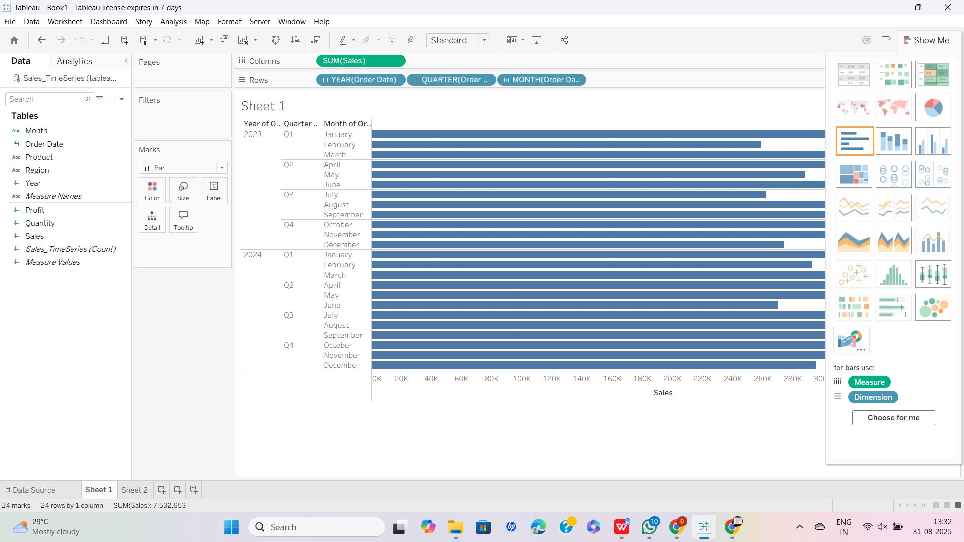

____________________________________________________________________________________________________

**Tree map (using Show Me):**

New sheet.

In Data pane click **Category** and **Subcategory** (if you want nesting) and **Sales**.

In **Show Me** click the **Tree Map** icon.

The tree map uses area to encode Sales; color will default to another measure — you can drag **Profit** to Color to color by profit.



