**DATA VISLUALIZATION EXPERIMENTS**

7 a) Tableau calculations: sum, avg, aggregate, create custom calculations and fields.

1. **Open the dataset**
2. Open **Tableau**.
3. Connect to the file **tableau_lab_dataset.xlsx**.
4. Drag **Sales_TimeSeries** sheet into the canvas → click **Sheet 1**.

**SUM Calculation (Total Sales)**

1. Drag **Sales** to **Rows**.
2. Drag **Region** to **Columns**.
3. By default, Tableau applies SUM(Sales) — meaning it is adding all sales for each region.
4. Formula internally: SUM([Sales]).
5. You see bars showing **total sales per region**.

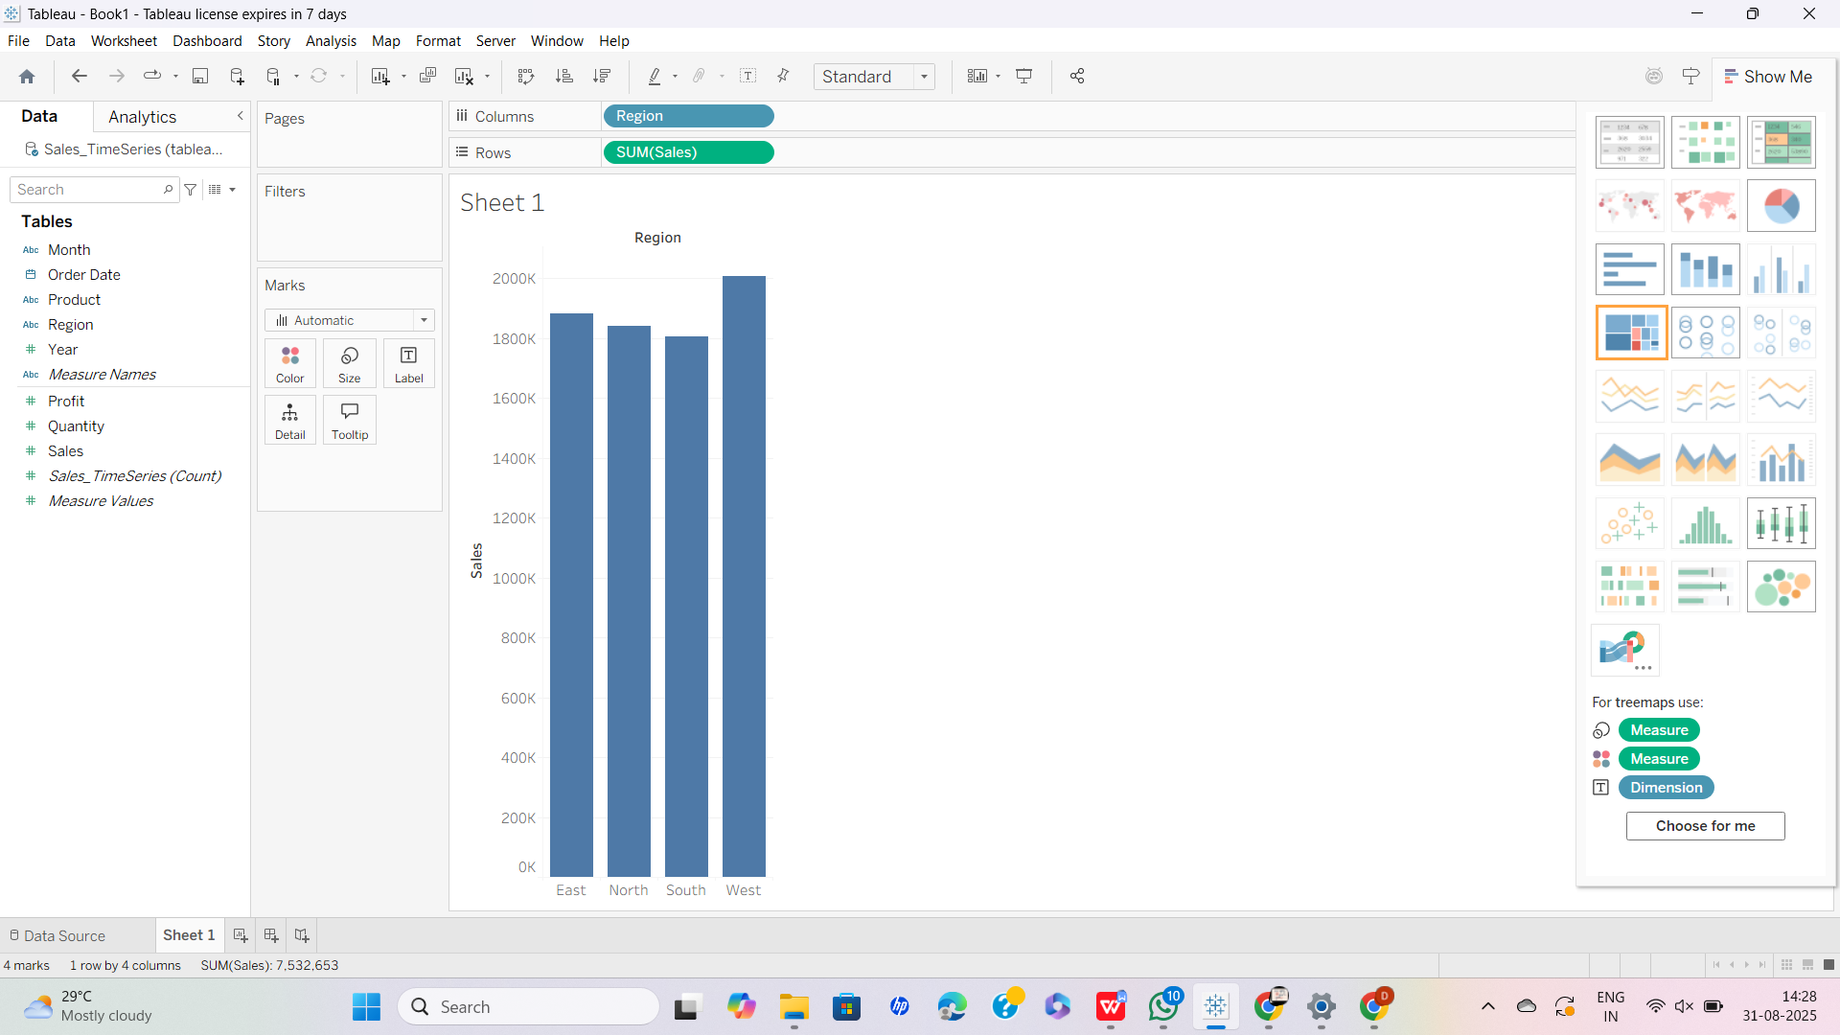

✅ This is the **SUM aggregate**.

### ****AVG Calculation (Average Sales per Product)****

### New sheet.

### Drag **Product** to **Columns**.

### Drag **Sales** to **Rows**.

### By default it shows SUM. Right-click the **Sales pill** → select **Measure (Sum)** → change to **Average**.

### Now the formula is AVG([Sales]) → average sales per product.

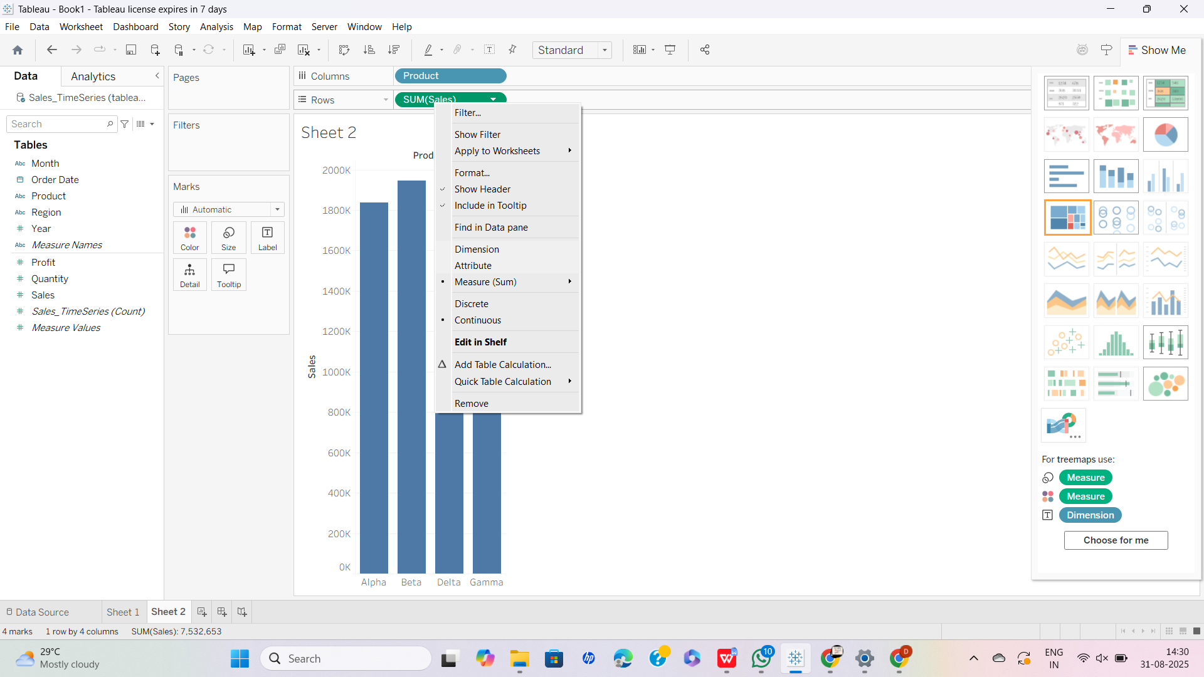

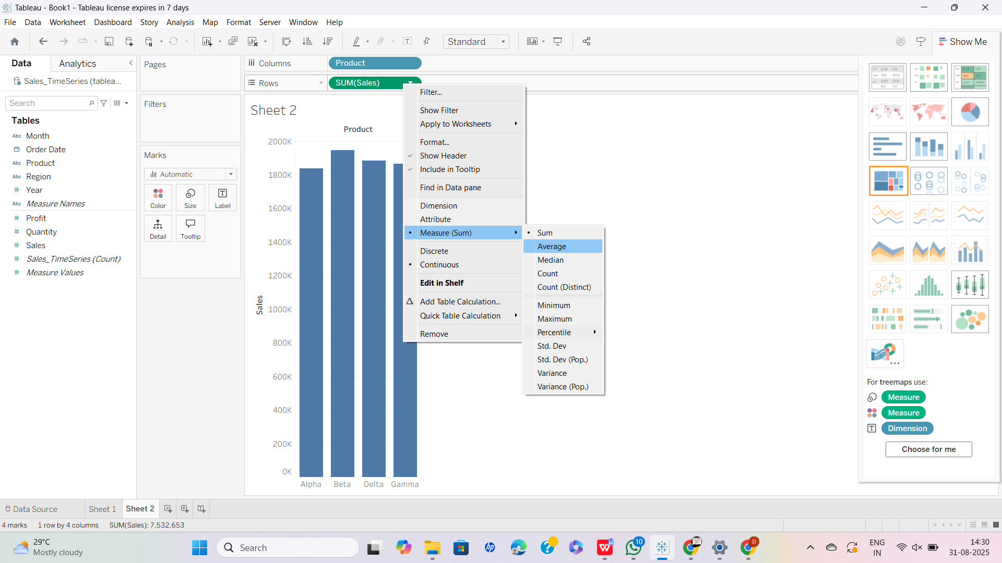

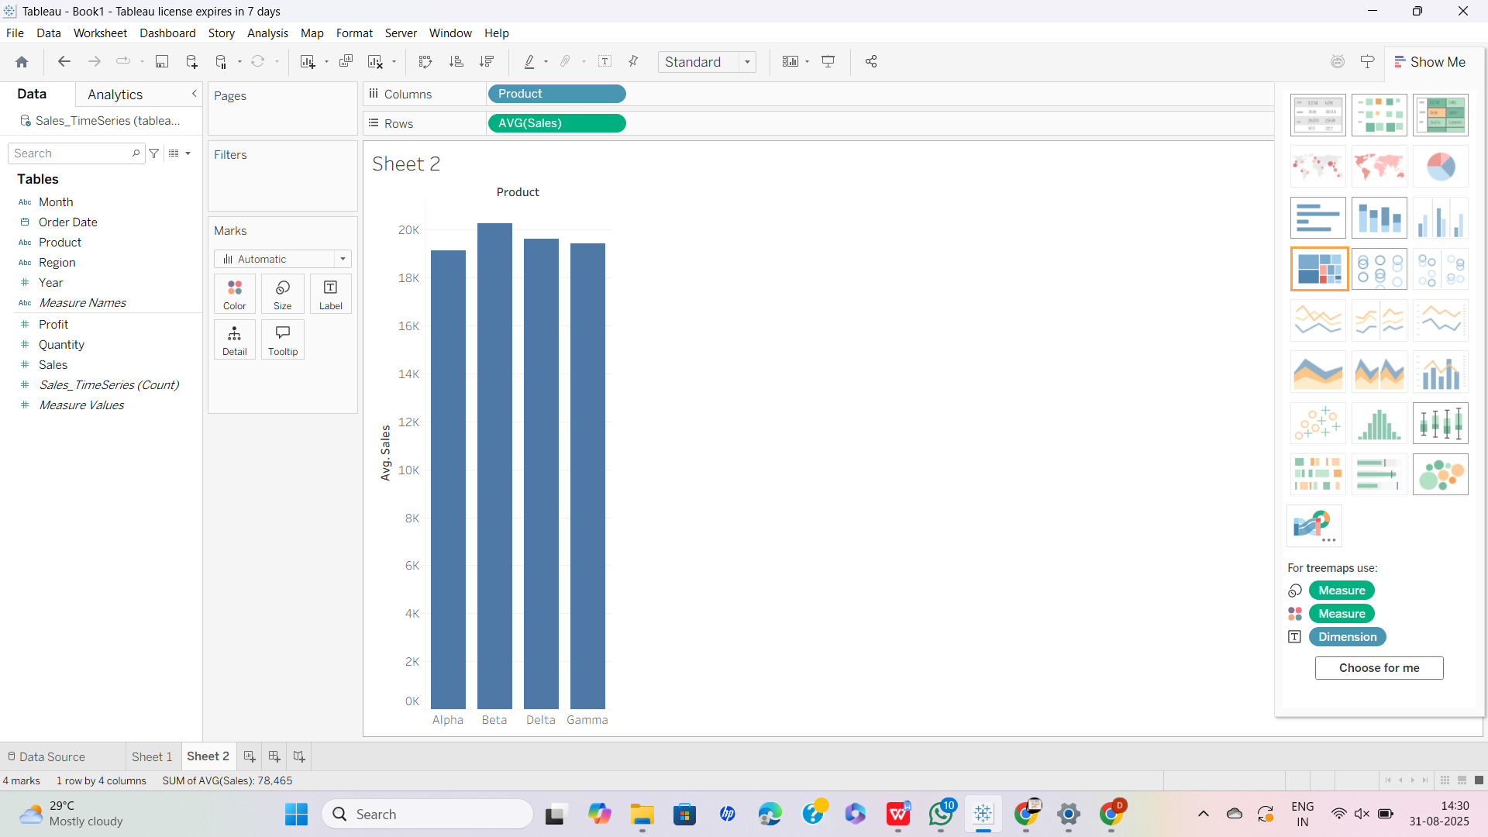

✅ This is the **AVG aggregate**.

### ****Aggregate Calculations (Profit Ratio example)****

1. We want to calculate **Profit Margin = Profit ÷ Sales**.
2. In the Data pane (left), right-click empty space → **Create Calculated Field…**
3. Name: Profit Margin.
4. Formula: SUM([Profit]) / SUM([Sales])

(We use SUM() because both Profit and Sales are aggregated at the visualization level).

1. Click **OK**.
2. Drag Profit Margin to **Rows** or **Label**.
3. Right-click → **Format** → set as **Percentage**.

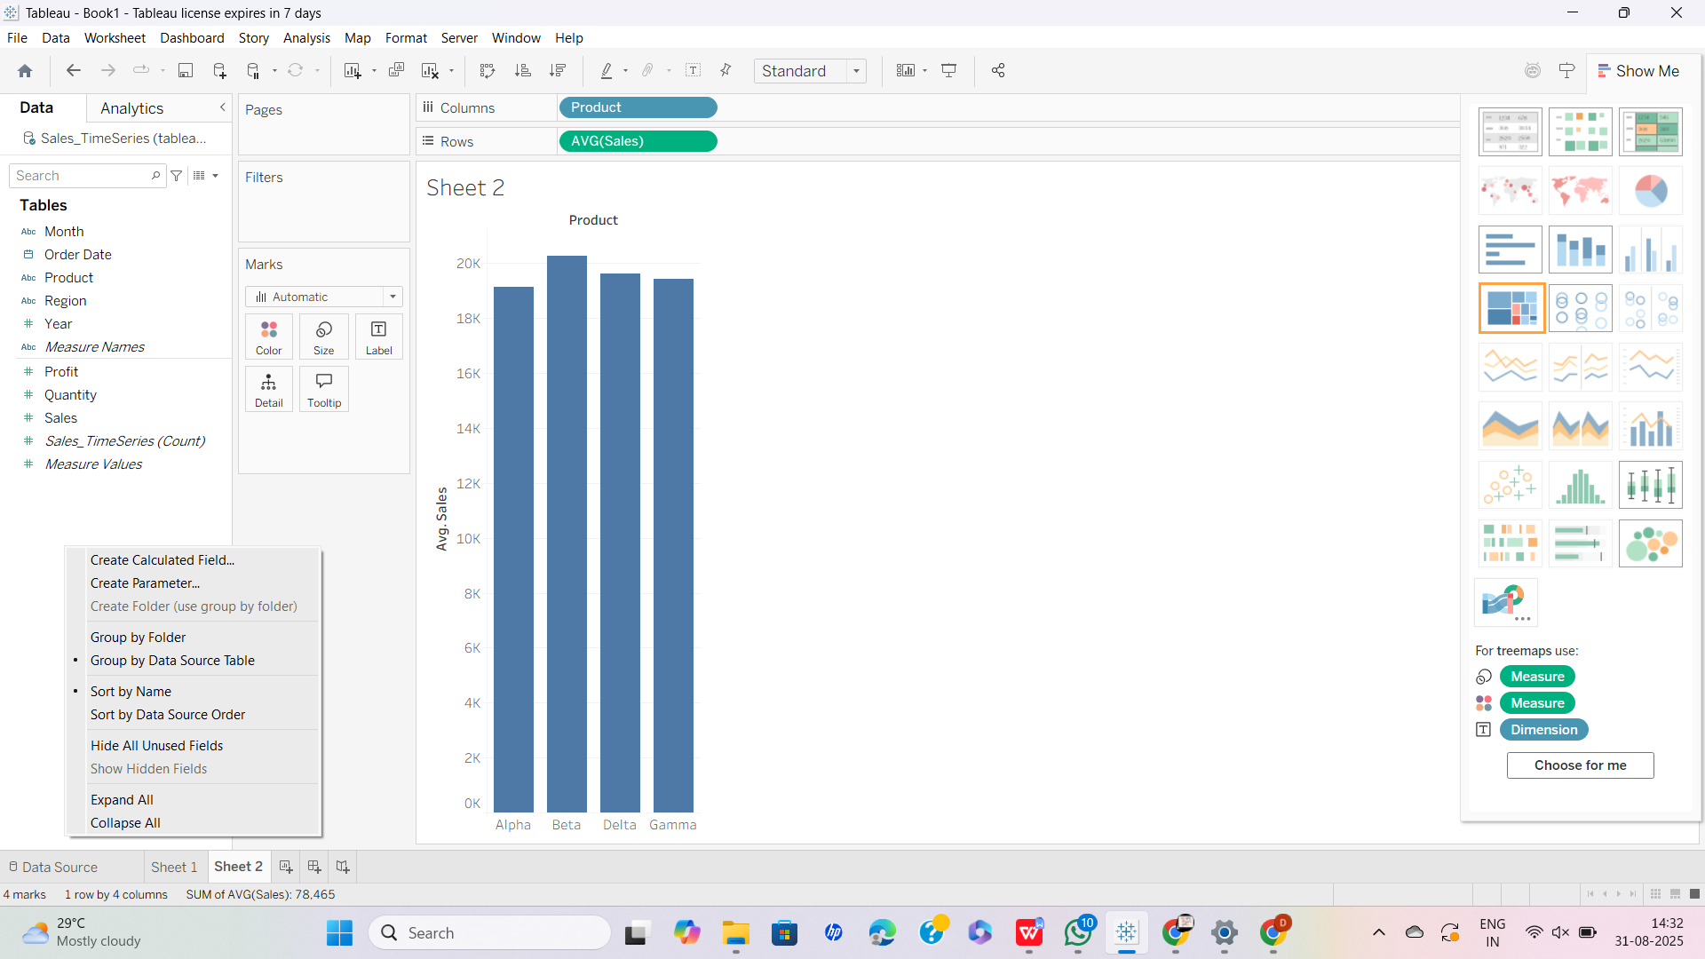

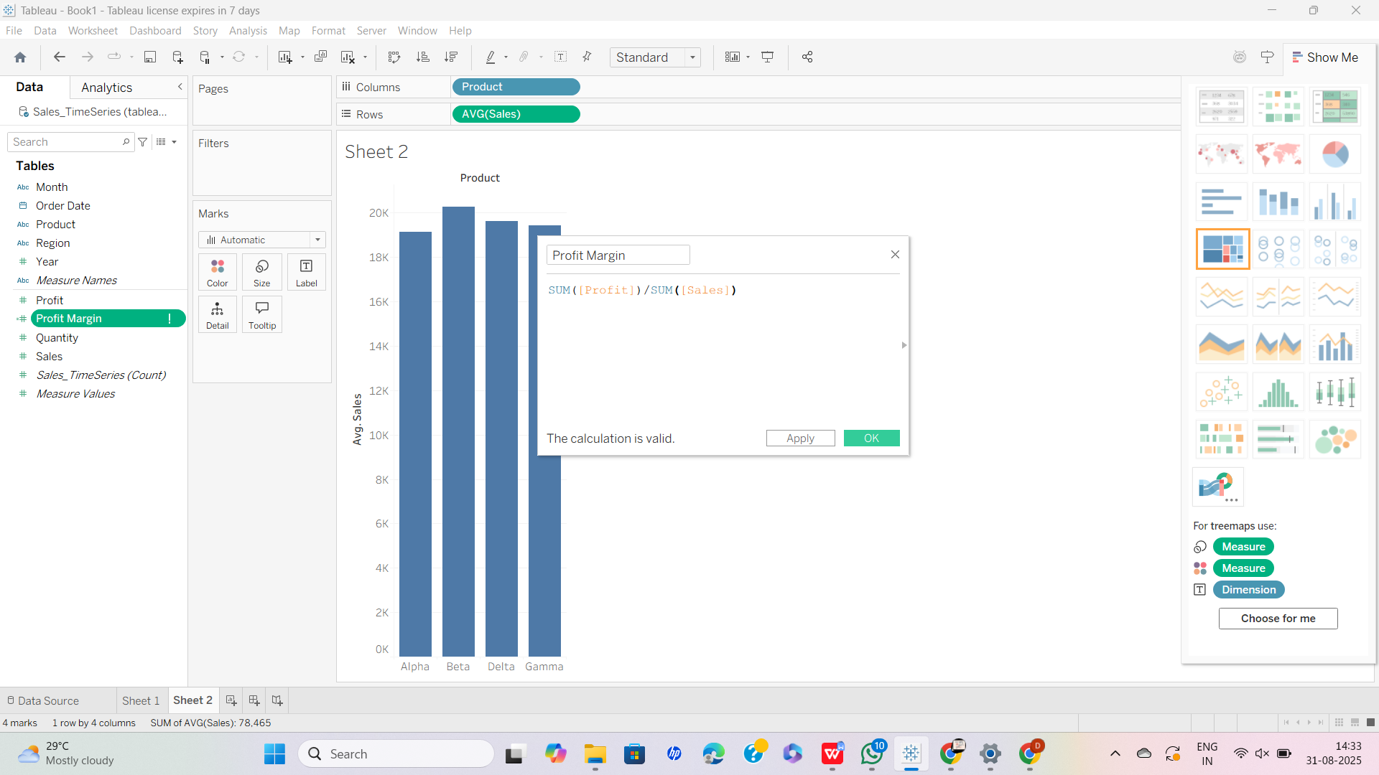

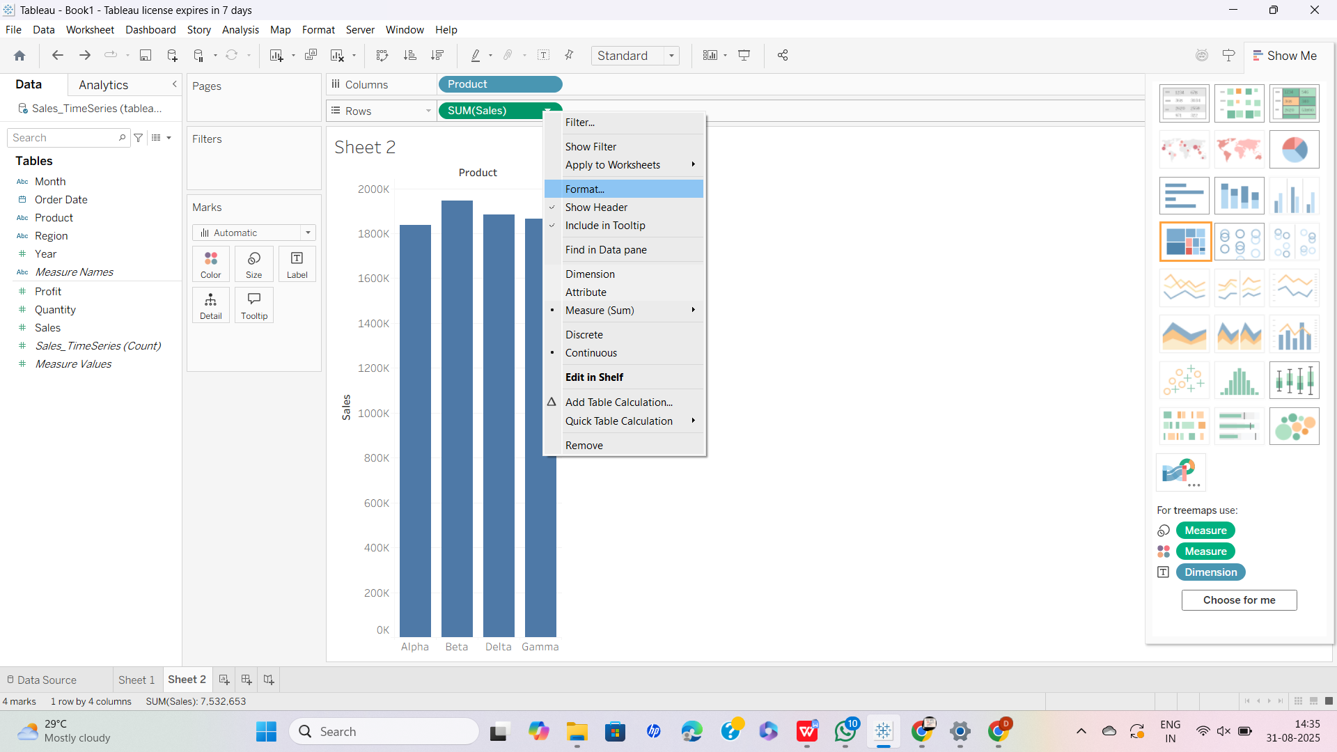

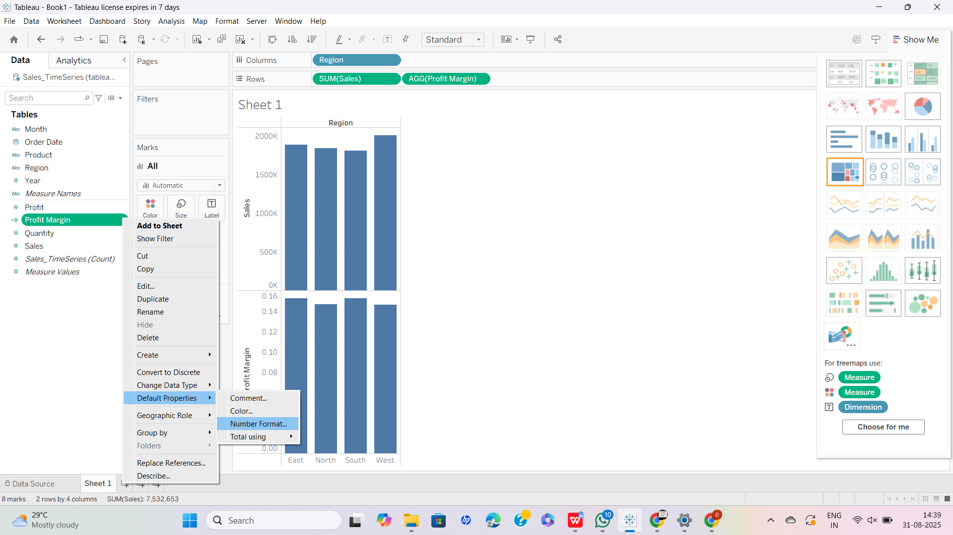

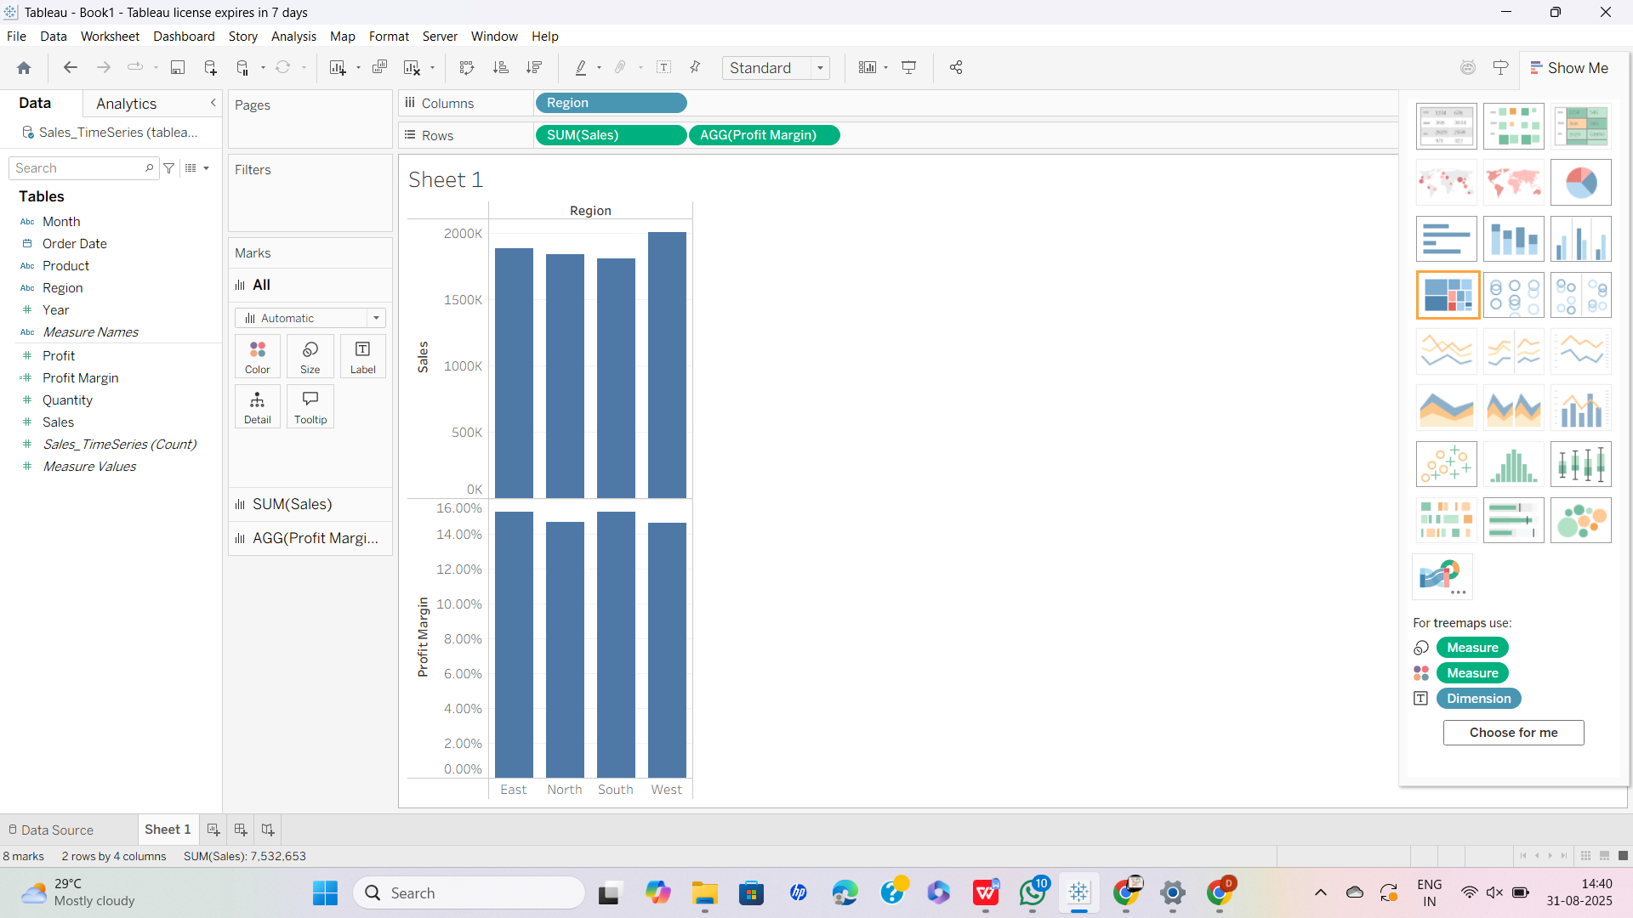

✅ Now you see Profit Margin % per category/region.

### ****Custom Calculations (Example: Average Selling Price)****

1. Let’s create a new field **Average Price per Unit = Sales ÷ Quantity**.
2. Right-click Data pane → **Create Calculated Field…**
3. Name: Avg Price per Unit.
4. Formula: SUM([Sales]) / SUM([Quantity])
5. Click **OK**.
6. Drag Avg Price per Unit to **Tooltip** in your bar/line chart.
7. Hover → You see calculated price shown in tooltips.

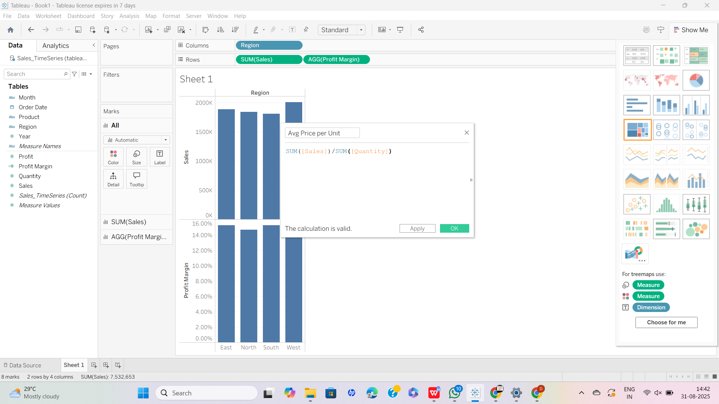

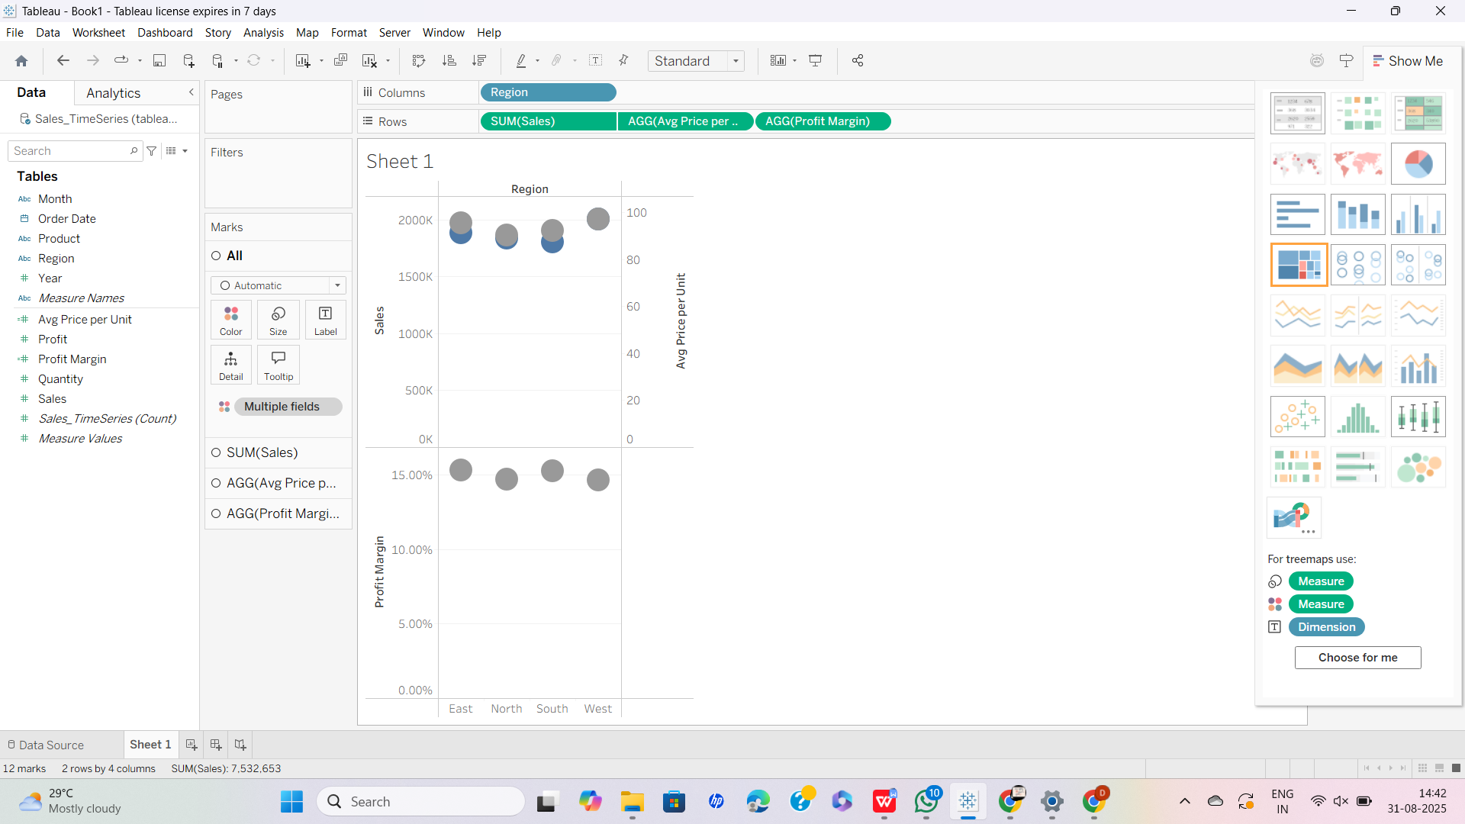

✅ This is a **custom calculation field**.

______________________________________________________________________