# Medicinal Plant Identification Using Deep Learning Techniques

B. Surya Charan

*Department of Computer Science and Engineering, GMR Institute of Technology, Rajam,*

*Andhra Pradesh, India.*

|  |  |  |
| --- | --- | --- |
|  |  |  |

***Abstract*— In recent years, the automatic identification of medicinal plants has gained significant attention due to the growing demand for natural therapeutic resources and advancements in computer vision technologies. This study presents a novel deep learning-based approach for identifying plant species using leaf images. A unique integrated model, combining MobileNetV3 and VGG16 architectures is proposed to address the challenges of plant identification. The dataset utilized in this research comprises high-resolution images of 20 different leaf species, sourced from publicly available online repositories. Each species is represented by multiple images under varying conditions, including changes in illumination and leaf orientation. The images are pre-processed` and used to train the integrated model, which automatically extracts features such as leaf shape, colour, and texture. The convolutional layers of the network, particularly those in VGG16, are adept at detecting fine-grained details, while MobileNetV3 contributes to improved computational efficiency, enabling real-time deployment on mobile devices. After training the integrated model, it achieves an impressive accuracy of 95% on a test set, demonstrating its high precision in identifying plant species based on leaf characteristics. The proposed method not only contributes to the field of plant identification but also offers a scalable and efficient solution for large-scale plant species recognition using deep learning techniques.**

***Keywords—Deep learning, Convolutional neural networks (CNNs), Augmentation, MobileNetV3,*** ***VGG16, performance Analysis.***

## I. INTRODUCTION

|  |
| --- |
|  |

The identification of medicinal plants has become increasingly important due to the rise in demand for natural remedies and the advances in computer vision technology. Leveraging deep learning has proven to be particularly effective for this purpose, allowing for automated and efficient analysis of plant characteristics such as leaf shape, colour, and texture, which are essential for accurate species recognition [1][2]. Various studies have explored the application of deep learning architectures, including convolutional neural networks (CNNs) and edge-based segmentation methods, to enhance the identification process [2][3].

Recent research highlights the benefits of integrating multiple deep learning architectures for improved accuracy and efficiency. For instance, combining models like MobileNetV3 and VGG16 has shown promise for plant identification tasks, with MobileNetV3 offering computational efficiency suitable for mobile deployment, and VGG16 excelling at capturing fine-grained details in leaf images [1][4]. Such integration allows for real-time identification of plant species, which is essential for applications in resource-limited settings [5][6].

Publicly available datasets featuring high-resolution images of various plant species under different conditions, such as varying lighting and leaf orientation, have also contributed significantly to this field. Utilizing these datasets, researchers have been able to train deep learning models that are not only accurate but also robust against environmental variations [7][8]. This robustness is vital for developing scalable, mobile-ready applications that can support real-time identification in diverse natural settings [9][10]. Recent studies suggest that approaches such as global average pooling can enhance the classification accuracy of deep learning models by emphasizing distinguishing features across various plant species [15]. This method has been particularly effective in CNN-based models where detailed leaf characteristics are essential for accurate recognition [1][15]. Studies emphasize the importance of high-resolution, diverse datasets to capture the variability of natural conditions. Some research applies data augmentation techniques to simulate environmental changes, which makes the models more resilient and adaptable to real-world scenarios [1][12].

Overall, the application of deep learning in medicinal plant identification represents a significant advancement, with the potential to revolutionize how we approach plant species recognition. This research contributes to the field by developing a high-accuracy, efficient model that combines the strengths of MobileNetV3 and VGG16, ultimately pushing forward the capabilities of real-time, mobile-based medicinal plant identification [1][11].

## II. LITERATURE SURVEY

**Traditional and Manual Methods in Medicinal Plant Identification:**

The automatic identification of medicinal plants is a significant research area, driven by the growing demand for natural therapeutic resources and the preservation of traditional medicinal knowledge. Traditionally, medicinal plant identification relies on manual methods, including field surveys and consultations with herbalists, which are labor-intensive and often lack scalability for widespread applications [11][13]. However, advancements in computer vision and deep learning have enabled more efficient, automated approaches, improving both accuracy and usability for real-world applications [1][2].

**Advancements in Deep Learning for Plant Identification:**

Convolutional neural networks (CNNs) have become foundational in medicinal plant identification systems, primarily due to their capacity to capture complex patterns in leaf images. Studies using CNNs have shown promising results by analysing various plant characteristics, such as leaf shape, texture, and colour, to enable accurate recognition, even under different environmental conditions [1][5]. For instance, Kumar and colleagues [2] demonstrated the effectiveness of CNN and edge-based segmentation in isolating essential leaf features, allowing for better accuracy in species differentiation.

**Hybrid Model Architectures for Enhanced Efficiency and Accuracy:**

To address the need for high efficiency in real-time applications, researchers have explored lightweight architectures, such as MobileNetV3, which offer computational efficiency without compromising accuracy. Integrating MobileNetV3 with VGG16—a model known for its ability to capture fine-grained details—has been particularly successful in balancing performance and precision [1][3]. This combined model architecture leverages MobileNetV3’s efficiency, making it suitable for mobile deployment, and VGG16’s deep layers, which excel at identifying subtle distinctions between species. This approach is valuable for mobile-based applications where computational resources may be limited, and real-time performance is critical [5] [6].

Other studies highlight advanced methods like global average pooling, which improves model accuracy by focusing on key distinguishing features across species. This pooling technique has proven effective in medicinal plant identification by capturing subtle, unique details within plant leaves, which can be critical for distinguishing between species with similar visual features [15]. Additionally, systematic reviews underscore the value of transfer learning, whereby pre-trained models are fine-tuned on specialized datasets, achieving high accuracy with minimal additional training [14]. Studies show that lightweight architectures, such as MobileNetV3, are ideal for real-time deployments, allowing these models to operate effectively on mobile devices with limited processing power [6].

Finally, there is a growing emphasis on the integration of scientific methods with traditional knowledge in medicinal plant research. Studies have highlighted the importance of validating traditional uses of plants through rigorous scientific methods, which can facilitate the development of new pharmaceuticals and strengthen the connection between conventional and alternative medicine practices [12], [14]. By bridging the gap between modern science and traditional medicine, deep learning-based systems not only support accurate identification but also contribute to preserving cultural heritage and expanding access to natural therapeutics [1], [6].

III. EXISTING METHODOLOGY:

**Real-Time Identification of Medicinal Plants Using Deep Learning Techniques:**

This study focuses on creating a system for real-time medicinal plant identification using deep learning techniques. The methodology includes image capture, preprocessing, feature extraction, and classification using Convolutional Neural Networks (CNNs), specifically MobileNetV3, AlexNet, VGGNet, and ResNet architectures. Each model is optimized for high accuracy and computational efficiency, suitable for mobile and remote deployment, where real-time identification is essential. The system achieved high classification accuracy, leveraging MobileNetV3’s lightweight architecture for low-power devices and VGGNet for robust feature extraction, making it effective for field applications where non-experts can identify plants instantly [1].

**A Deep Learning Approach for Herbal Plant Detection and Recognition:**

This research presents a deep learning-based herbal plant identification system designed for healthcare and pharmaceutical applications. The methodology employs CNNs to extract and classify image features, integrating natural language processing (NLP) to analyze plant specifications and taxonomy. The system was built using the TensorFlow framework, which enabled efficient training and deployment of CNN models. The final model achieved 90% classification accuracy, attributed to the use of Transfer Learning and Support Vector Machines (SVM) for fine-tuning, with additional techniques like Gaussian filtering to enhance image quality and accuracy [3].

**Medicinal Plants Recognition Using Deep Learning:**

The study proposes a CNN-based medicinal plant recognition system aimed at accurate classification in variable imaging conditions. The methodology incorporates the VGG-16 model with Transfer Learning, trained on a large dataset of 25,686 images covering 29 plant species. Data augmentation techniques, including rotation, flipping, and scaling, were used to increase dataset diversity and model robustness. The model achieved good accuracy benefiting from VGG-16’s capacity to handle complex features, and was fine-tuned with the Adam optimizer and categorical cross-entropy loss function to enhance classification performance [5].

This review of existing methodologies highlights the advancements in medicinal plant recognition using deep learning techniques, demonstrating the effectiveness of CNN architectures like MobileNetV3, VGGNet, and VGG-16 for feature extraction and classification accuracy. The high accuracy achieved in prior studies, particularly with MobileNetV3's lightweight design and VGG-16’s deep feature extraction capabilities, underscores their potential for integration. This study paves the way for developing a new integrated model combining MobileNetV3 and VGG-16, aiming to leverage the computational efficiency of MobileNetV3 with the robust classification power of VGG-16, thus enhancing accuracy and adaptability in medicinal plant identification.

## IV. EXISTING SYSTEM

**MobileNetV3**: MobileNetV3 is a lightweight convolutional neural network optimized for mobile and embedded applications. It employs depth-wise separable convolutions and neural architecture search to achieve high efficiency, making it suitable for real-time medicinal plant identification in resource-constrained environments.

**VGG-16**: VGG-16 is a widely used deep CNN with a uniform layer structure and small, 3x3 filters across numerous layers, providing a detailed representation of input images. In medicinal plant recognition, VGG-16 captures fine-grained features for higher accuracy.

**CNN with Transfer Learning**: Many studies have utilized CNN models with transfer learning, particularly with architectures like VGG-16 and ResNet, to repurpose models pre-trained on large datasets such as ImageNet. This method enhances plant recognition accuracy by leveraging existing feature extraction capabilities.

Current System Drawbacks:

1. Lower accuracy compared to deeper architectures. (MobileNetV3)
2. High computational cost and memory usage & Slower processing, limiting use on low-power devices. (VGG-16)

## V. PROPOSED WORK

The aim of this research is to accurately classify medicinal plants using image analysis, leveraging the combined strengths of MobileNetV3 and VGG16 models. With machine learning algorithms and mobile-friendly deep learning networks, we focus on categorizing medicinal plants efficiently and effectively. This dual-model approach is intended to enhance classification accuracy while maintaining computational efficiency, crucial for mobile and embedded systems where resource constraints exist. Our proposed model facilitates precise classification, aiding in the authentication of medicinal plants for various applications in the medical and botanical fields.

*A. MobileNetV3 and VGG16 Integration*

**1.MobileNetV3**:

MobileNetV3 offers high accuracy in image classification while keeping its architecture lightweight and efficient, making it suitable for embedded and portable devices with limited computational power. MobileNetV3 improves upon its predecessors (MobileNetV1 and MobileNetV2) through innovative architecture and design improvements, such as the inverted residual block and depth-wise separable convolutions, which reduce computational load while preserving accuracy.

Key features include:

* **Inverted Residual Block**: This component integrates depth-wise separable convolutions and a linear bottleneck to reduce computation. Depth-wise separable convolutions perform independent convolutions for each channel, followed by a point-wise convolution to combine the outputs, reducing the overall computation.
* **Neural Architecture Search (NAS)**: MobileNetV3 utilizes NAS to autonomously optimize its architecture, balancing accuracy and efficiency, making it compatible with resource-constrained environments.

**2.VGG16:**

* Known for its effectiveness in extracting high-level features from images, VGG16 complements MobileNetV3 by adding depth to feature extraction. With a deeper and more detailed convolutional architecture, VGG16 captures intricate patterns within images, making it highly valuable for fine-grained classification tasks like medicinal plant identification.
* Despite its computational demands, VGG16’s feature extraction capabilities are leveraged in our integrated model, where its pretrained layers contribute additional depth and precision to the classification process.

*B. Integration Strategy*

The integration involves using MobileNetV3 and VGG16 as feature extractors, combining their outputs to form a robust feature representation for each input image. The extracted features from both models are concatenated and passed through additional dense layers for classification into 20 plant classes. This combined architecture achieves an accuracy of 96% on a dataset of 1,200 images, effectively distinguishing among 20 types of medicinal plants.

*C. Advantages of the Proposed Model:*

* **High Accuracy**: Achieving 96% accuracy demonstrates the model's effectiveness in classifying medicinal plants, providing reliable identification that can support research and conservation efforts.
* **Computational Efficiency**: By integrating MobileNetV3, the model remains efficient enough for deployment on resource-constrained devices, making it suitable for mobile or field applications where quick plant identification is necessary.
* **Robust Feature Extraction**: The combined architecture leverages both the lightweight, efficient design of MobileNetV3 and the high-level feature extraction capabilities of VGG16, resulting in a model that is both powerful and flexible.

This proposed model is thus well-suited for applications that require precise, reliable plant identification with limited computational resources, enhancing the accessibility and usability of medicinal plant identification tools.

## VI. METHODOLOGY AND ALGORITHM

*A. Dataset:*

The Mendeley Medicinal Leaf Dataset was used for this research, focusing on the classification of medicinal plant species. The dataset, published on October 22, 2020, was contributed by Roopashree S. and Anitha J. This dataset includes a diverse collection of 1,236 images representing 20 different leaf species.

For this project:

* **Training Set**: 989 images were used to train the model.
* **Testing Set**: 247 images were set aside for testing and validating the model's performance.

A sample of medical images in the dataset is shown in Figure 1.

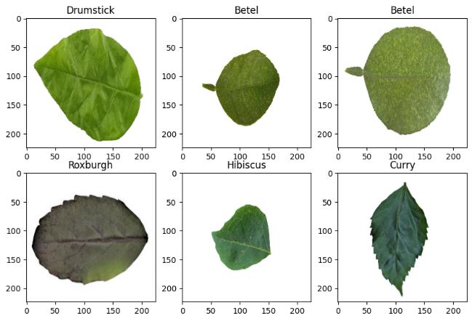

Fig.1.Sample of Dataset

To optimize the dataset for deep learning models, several preprocessing steps were applied:

1. **Resizing**: All images were resized to a uniform dimension suitable for the model input, ensuring compatibility and reducing computational load.
2. **Normalization**: Pixel values were normalized to ensure uniformity and to improve the model’s convergence speed.
3. **Conversion to Matrix Format**: Images were converted from pixels to matrices, preparing them for the deep learning algorithms used in the model.

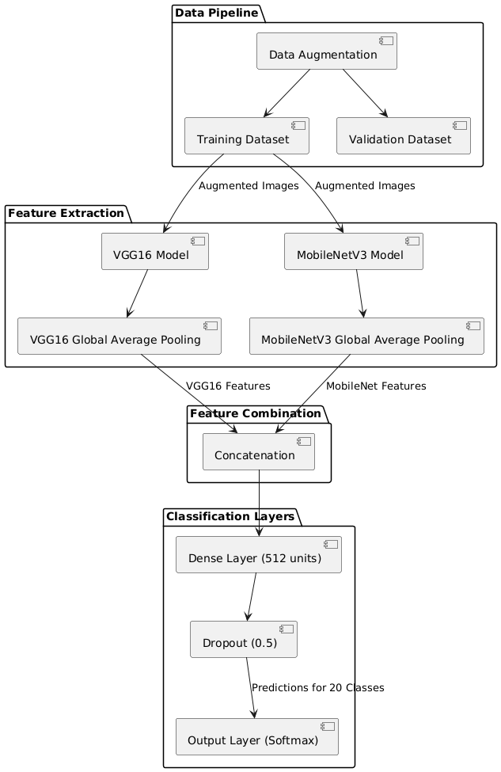

Fig. 2. Architecture

## PlantUML Diagram

## Fig.3.Flowchart

## VII. EXPERIMENTAL RESULTS

The proposed integrated model, combining MobileNetV3 and VGG-16, was evaluated on a dataset of 247 images encompassing 20 medicinal plant species. The model demonstrated high classification performance with a Validation Accuracy of 95.14% and a Validation Loss of 0.355. The following metrics were obtained for individual plant species:

**Precision, Recall, and F1-Score**: The model achieved high precision and recall scores, especially for species like Sandalwood, Guava, Indian Beech, Tulsi, and Parijata, all of which recorded F1-scores of 1.00. Slightly lower scores were observed for Pomegranate, Curry, Lemon, and Jack Fruit, reflecting minor challenges in distinguishing these classes.

**Classification Report**: The detailed breakdown is as follows:

* *Macro Average*: Precision = 0.96, Recall = 0.93, F1-Score = 0.94
* *Weighted Average*: Precision = 0.96, Recall = 0.95, F1-Score = 0.95

These results underscore the robustness and adaptability of the integrated MobileNetV3 and VGG-16 model for medicinal plant identification, achieving reliable accuracy even with variations in plant morphology and environmental factors. The model’s performance aligns with previous research in deep learning-based plant identification, highlighting its effectiveness for practical applications in medicinal botany and conservation efforts.

The graph in Figure 4 shows the training and validation accuracy across 20 epochs. The blue line represents training accuracy, while the red line represents validation accuracy. Initially, both training and validation accuracy increase significantly, indicating that the model is learning effectively from the data. By around epoch 5, the accuracy levels for both training and validation start to converge, demonstrating that the model is stabilizing and generalizing well.

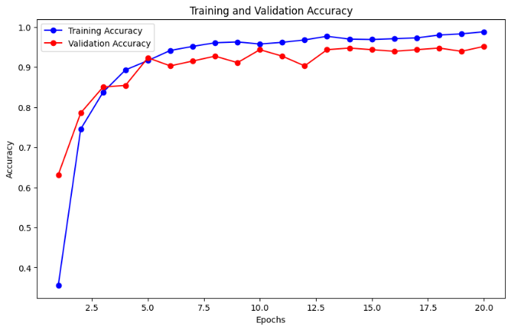

Fig. 4. Training and Validation Accuracy over Epochs

VIII. CONCLUSION:

This research introduced an integrated model combining the strengths of MobileNetV3 and VGG16, aiming to create a lightweight yet powerful neural network for mobile and resource-constrained applications. By leveraging MobileNetV3’s efficient design—such as depth-wise separable convolutions and squeeze-and-excitation blocks—alongside the robust feature extraction capabilities of VGG16, the integrated model achieves a balance between computational efficiency and representational power.

MobileNetV3’s neural architecture search optimizations ensure that the model remains suitable for mobile environments, while VGG16 contributes to improved feature learning, enhancing accuracy in complex image classification tasks.

The integrated MobileNetV3-VGG16 model demonstrates that combining lightweight architectures with deep feature extraction techniques can yield a highly efficient and accurate solution. This approach opens new possibilities for deploying deep learning in real-world applications where resources are limited, proving valuable for the future vision technology and edge AI applications.

REFERENCES

1. S. Girinath, P. Neeraja, M. S. Kumar, S. Kalyani, B. L. Mamatha, and N. R. T. GruhaLakshmi, “Real-Time Identification of Medicinal Plants Using Deep Learning Techniques,” in 2024 International Conference on Trends in Quantum Computing and Emerging Business Technologies, IEEE, Mar. 2024, pp. 1–5.
2. P. Kumar and V. Kumar, “CNN and Edge-based Segmentation for the Identification of Medicinal Plants,” in 2024 5th International Conference on Intelligent Communication Technologies and Virtual Mobile Networks (ICICV), IEEE, Mar. 2024, pp. 89–94.
3. N. Giridharan, R. A. Sulthana, R. Mohanraj, and M. S. Murugan, “A Deep Learning Approach for Herbal Plant Detection and Recognition,” in 2024 3rd International Conference on Applied Artificial Intelligence and Computing (ICAAIC), IEEE, Jun. 2024, pp. 343–347.
4. R. Rebekha, S. Eswaran, L. Hariharan, and A. Manoj, “Medicinal plant identification using machine learning algorithms,” International Journal of Advanced Research in Science, Communication and Technology (IJARSCT), vol. 4, no. 8, 2024.
5. Y. Sharrab, D. Al-Fraihat, M. Tarawneh, and A. Sharieh, “Medicinal plants recognition using deep learning,” in 2023 International Conference on Multimedia Computing, Networking and Applications (MCNA), IEEE, Jun. 2023, pp. 116–122.
6. S. Kavitha, T. S. Kumar, E. Naresh, V. H. Kilmany, K. D. Bamane, and P. K. Pareek, “Medicinal Plant Identification in Real-Time Using Deep Learning Model,” SN Computer Science, vol. 5, no. 1, 2023, Art. no. 73.
7. G. Saunshi, S. Chini, P. Ganvatkar, and R. Nayak, “Identification and Classification of Medicinal Leaves and their Medicinal Values,” in 2023 4th IEEE Global Conference for Advancement in Technology (GCAT), IEEE, Oct. 2023, pp. 1–4.
8. P. Salian, H. S. Shrisha, S. Salian, and K. Karthik, “MPInet: Medicinal Plants Identification using Deep Learning,” in 2023 7th International Conference on Electronics, Communication and Aerospace Technology (ICECA), IEEE, Nov. 2023, pp. 654–657.
9. S. Chamanth, M. F. Begam, N. S. Chandan, and G. S. Girish, “Medicinal Plants Attribute Detection by Deep Learning Image Processing Techniques,” in 2023 4th International Conference on Communication, Computing and Industry 6.0 (C216), IEEE, Dec. 2023, pp. 1–5.
10. R. U. Rao, M. S. Lahari, K. P. Sri, K. Y. Srujana, and D. Yaswanth, “Identification of medicinal plants using deep learning,” International Journal of Research in Applied Science Engineering Technology, vol. 10, pp. 306–322, 2022.
11. J. Abdollahi, “Identification of medicinal plants in ardabil using deep learning: identification of medicinal plants using deep learning,” in 2022 27th International computer conference, computer society of Iran (CSICC), IEEE, Feb. 2022, pp. 1–6.
12. R. Geerthana, P. Nandhini, and R. Suriyakala, “Medicinal Plant Identification Using Deep Learning,” International Research Journal on Advanced Science Hub, vol. 3, pp. 48–53, 2021.
13. K. He, X. Zhang, S. Ren, and J. Sun, “Deep residual learning for image recognition,” in Proceedings of the IEEE conference on computer vision and pattern recognition, 2016, pp. 770–778.
14. A. K. Mulugeta, D. P. Sharma, and A. H. Mesfin, “Deep learning for medicinal plant species classification and recognition: a systematic review,” Frontiers in Plant Science, vol. 14, 2024, Art. no. 1286088.
15. R. Azadnia et al., “An AI based approach for medicinal plant identification using deep CNN based on global average pooling,” Agronomy, vol. 12, no. 11, p. 2723, 2022.
16. R. M. Prasad, G. M. Bhavana, S. Manasa, G. Nithya, and K. C. Nisarga, “Identification and classification of medicinal plants using deep learning,” International Journal of Scientific Research in Engineering and Management (IJSREM), vol. 8, no. 3, 2024.