

**King Fahd University of Petroleum & Minerals**

**Department of Information and Computer Science**

**SWE363**

Term 193 Activity

Project Phase 01

**“CarPool”**

Version 1.6 15/06/2020

|  |  |  |
| --- | --- | --- |
|  | Group 5 |  |
| First Name | Last Name | ID |
| TARIQ | ALKHAMIS | 201639180 |
| BANDAR | ALBALAWI | 201657580 |

# Purpose

The purpose of this document is to provide details and information regarding the mobile-focused web app called “CarPool”.

CarPool is a new app designed to make transportation easier and cost effective. It mainly targets KFUPM students and faculty members and provides them with many benefits and services such as:  
-The ability to request a ride  
-The ability to view driver's details  
-The ability rate the driver  
…and many more features

It also provides the users the ability to pick their tier which provides a variety of car types (family car, luxury car, economy car) each for a specific price per KM and be given a list to pick the desired driver..

# Potential Users

* KFUPM Students
* KFUPM Faculty
* Admin

# Expected Functionalities/Services

1. Logging in
   1. Entering username
   2. Entering password
2. Registering a new account
   1. Inserting name
   2. Inserting username
   3. Inserting email
   4. Inserting phone number
   5. Inserting password
   6. Inserting date of birth
3. Editing personal details
   1. Uploading profile picture
   2. Editing username
   3. Editing bio
   4. Editing phone number
   5. Changing password
4. Viewing personal details
   1. Username
   2. Date of birth
   3. Profile picture
5. Requesting a ride
6. Cancel ride request
7. Viewing pickup details
   1. Driver name
   2. Driver profile picture
   3. Car model
8. Provide rating
9. Availability status
10. Calling driver/customer
11. Accept/deny a customer's request
12. Choosing ride cash amount
13. Banning a driver or a customer
14. Selecting driver and time
15. Selecting service tier (economy, luxury, etc…)
16. Viewing ride history
17. Viewing fare price
18. Checking pending driver requests
19. Approve/decline new driver

# Similar Systems Features

* Uber
* Careem
* Lyft

# Requirements

R1. The system shall allow users to log in

R2. The system shall allow users to create a new account

R3. The system shall allow users to view their personal details

R4. The system shall allow users to edit their personal details

R5. Customers shall be able to request a ride

R6. Customers shall be able to cancel a ride request they created

R7. Customers shall be able to view the pickup details of their ride request

R8. Customers shall be able to provide rating for a driver they previously have been picked up by

R9. Drivers shall be able to provide a rating for customer(s) they previously drove for

R10. Drivers shall be able to accept or deny ride requests made by customers

R11. Drivers shall be able to make a phone call with the customer who they accepted their ride request

R12. Customers shall be able to call the drivers who they successfully requested

R13. Drivers shall be able to choose the fare cash amount they desire for customers to pay

R14. Customers shall be able to view the estimated fare amount of the driver they requested

R15. Admins shall be able to ban user(s)

R16 Admins shall be able to view pending driver registrations forms

R17 Admins shall be able to approve or decline driver registration requests

R18. Customers shall be able to select the time and driver they desire

R19. Customers shall be able to select the service tier they desire

R20. The system shall let users view ride history

# Use Case Diagram

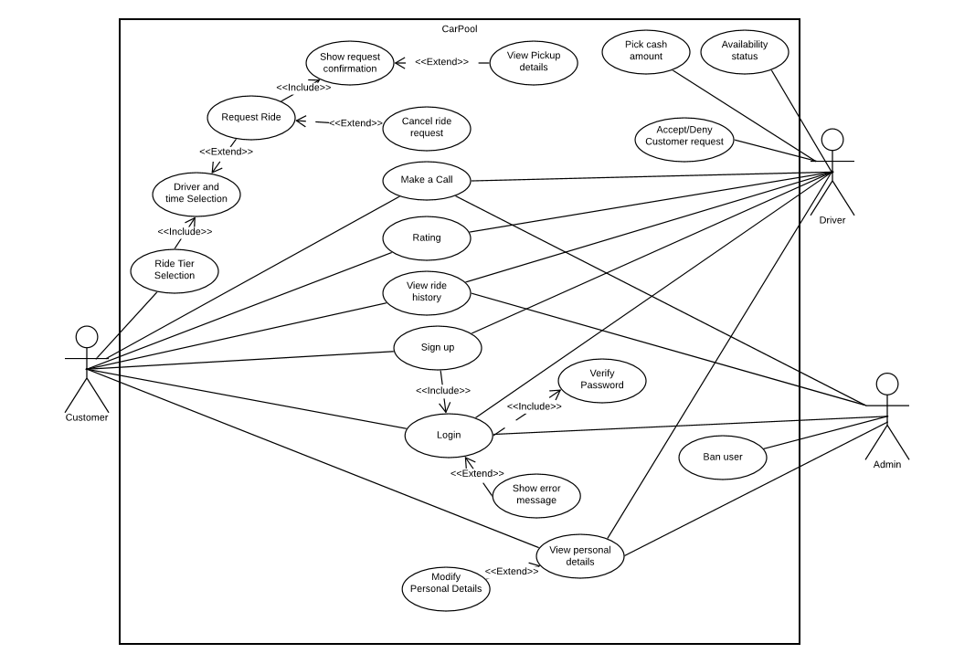

# Wireframes

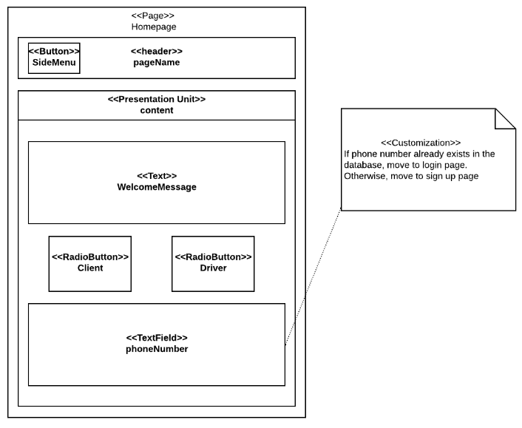

# 

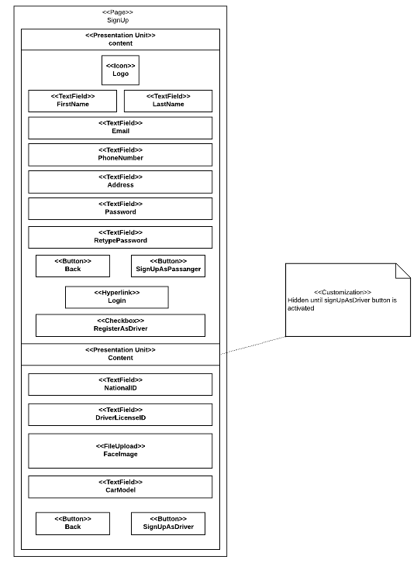

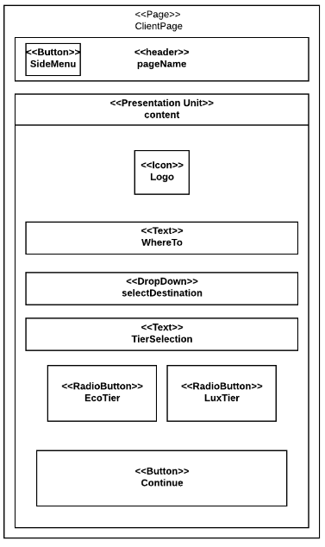

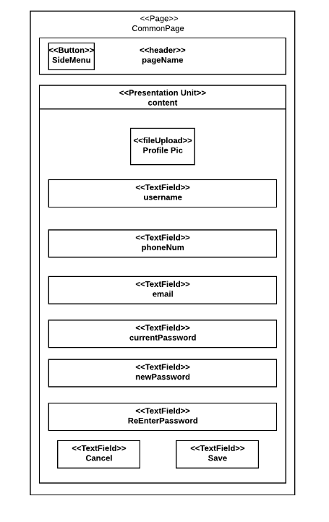

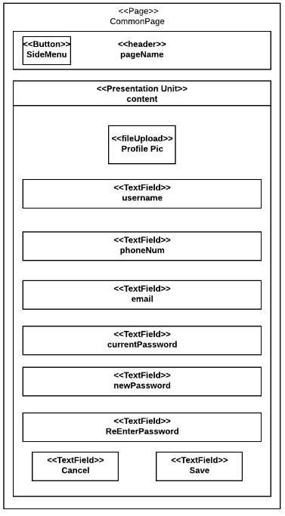

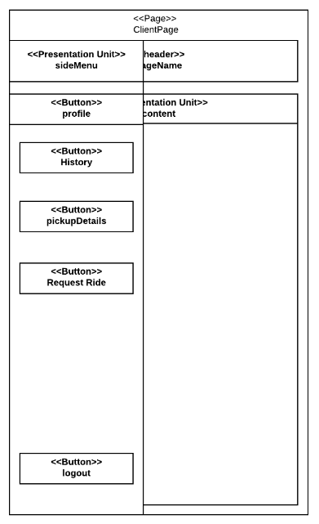

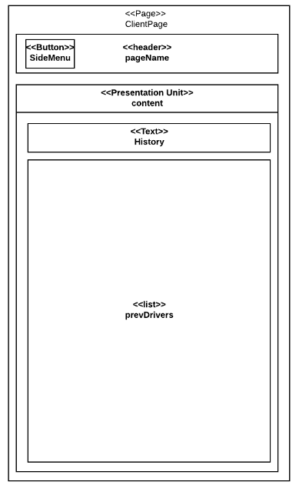

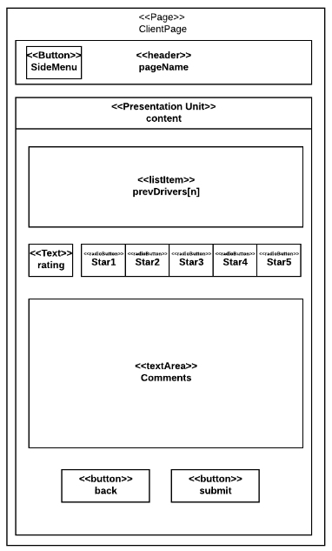

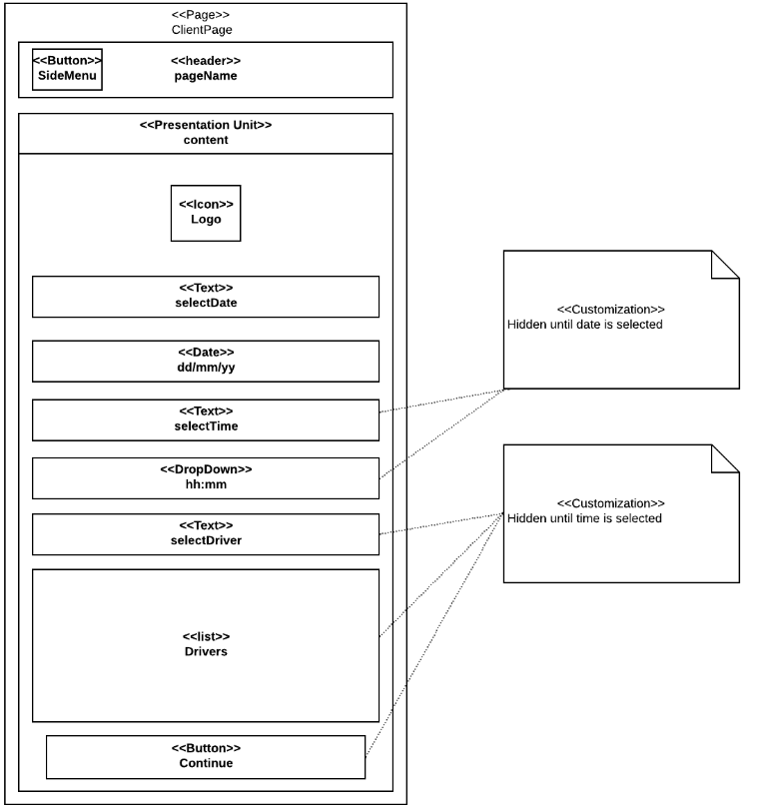

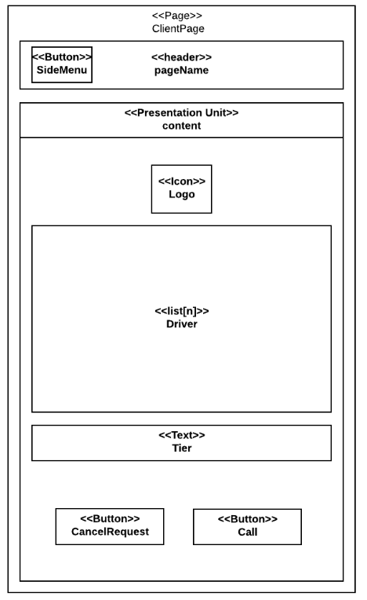

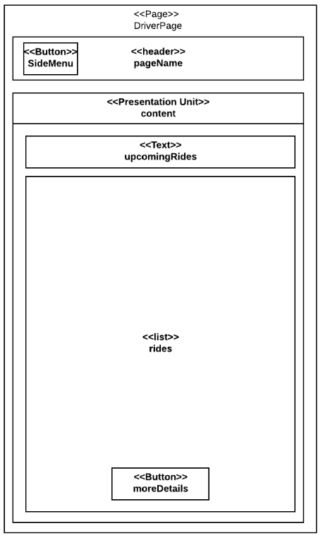

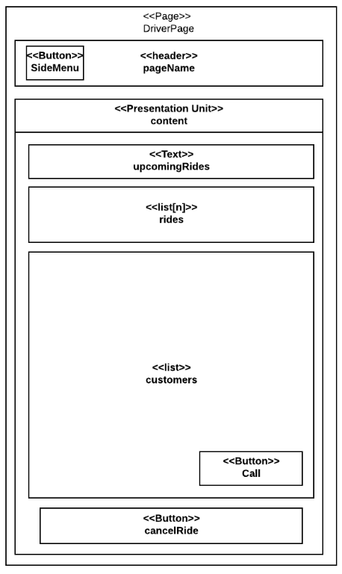

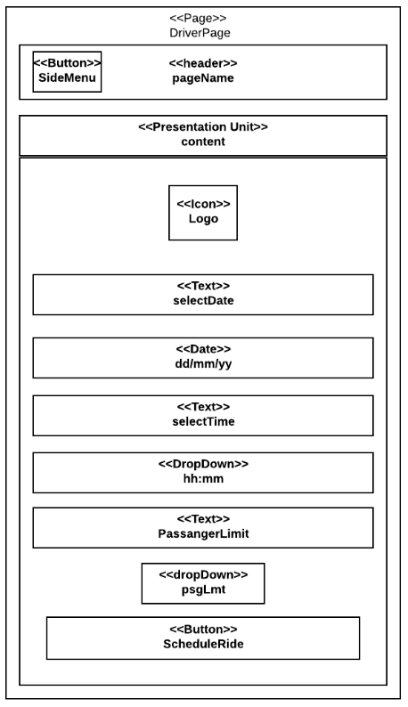

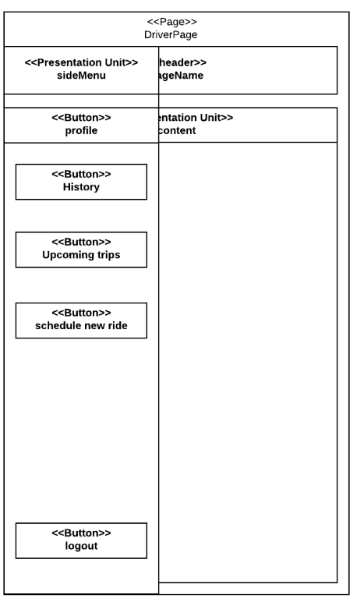

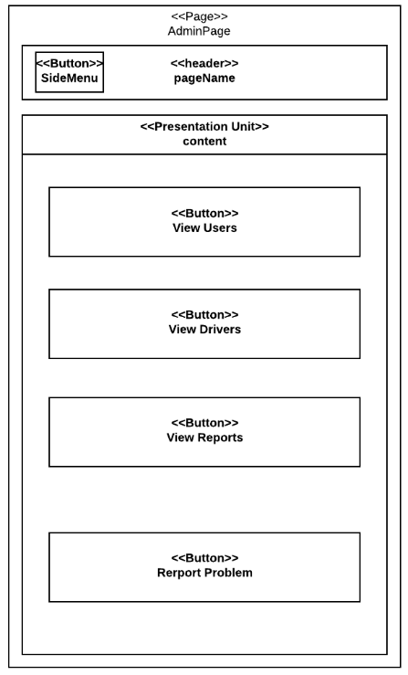

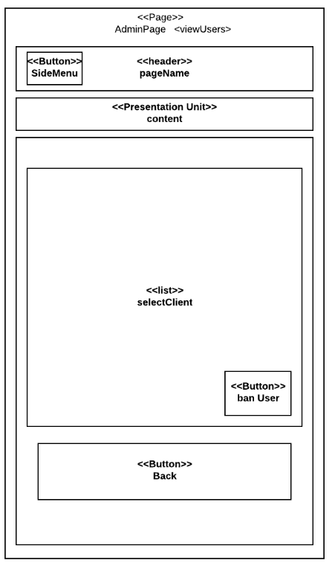

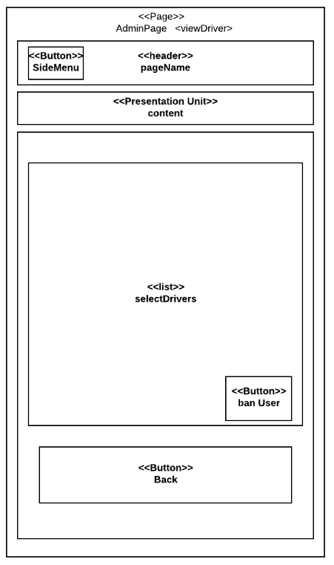

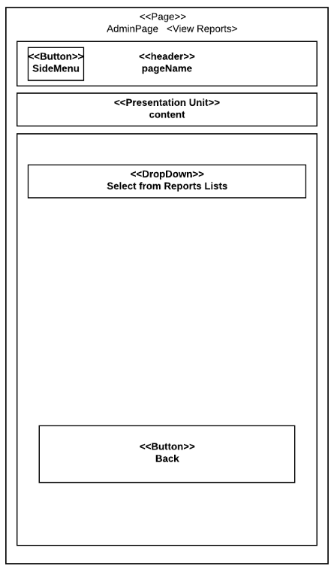

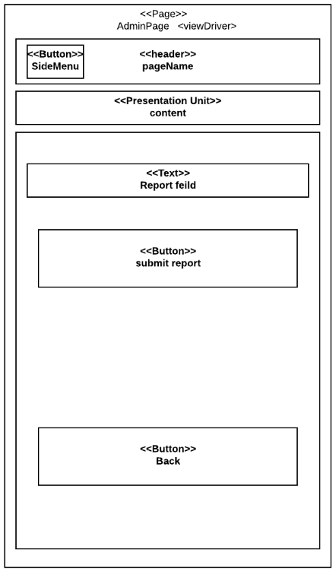

# Hypertext Structure Model

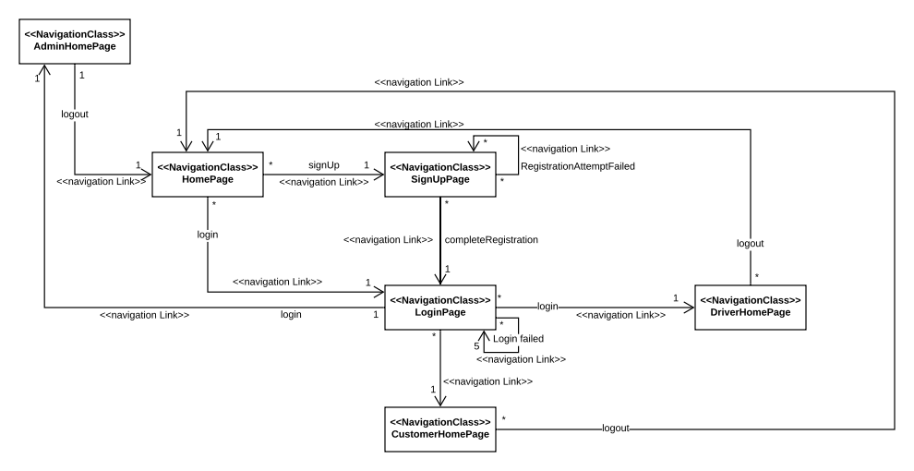

# UI Prototype Screenshots

Login Screens

## 

Customer Screens

## 

Driver Screens

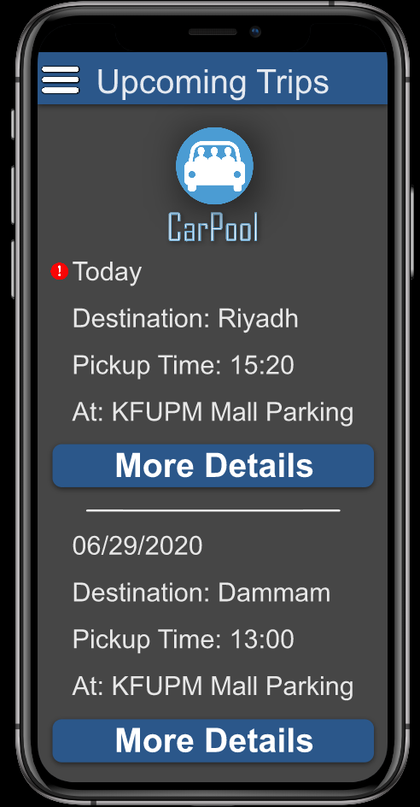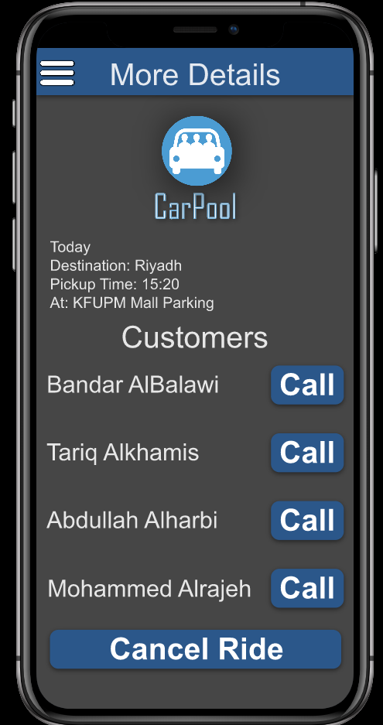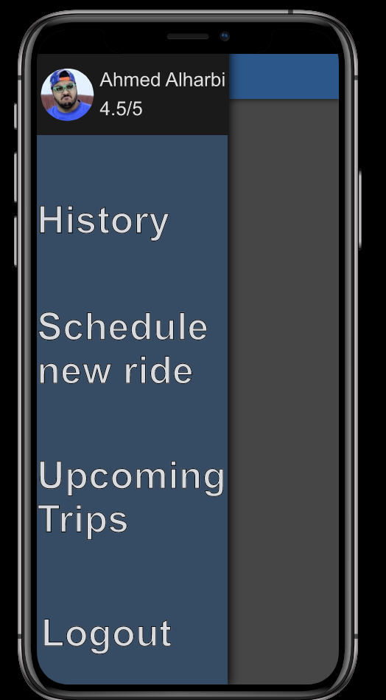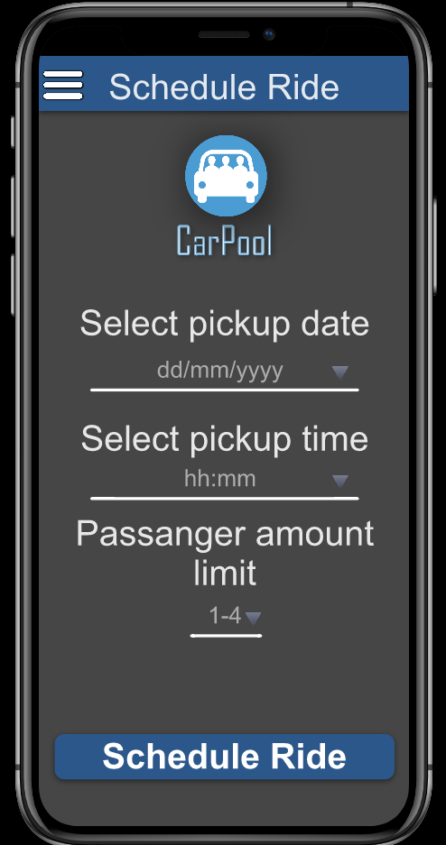

[**Click here for a fully dynamic prototype**](https://kfupm.invisionapp.com/prototype/ckbfbdrgk00m2ob01qcaav1t5/play)

# Assumptions

* The admin already has an account provided to him, no one can register an admin account
* All payments will be cash only