
SOFTWARE REQUIREMENTS SPECIFICATION (SRS)
CASHIER, FINANCE, AND STOCK MANAGEMENT SYSTEM
KHARISMART – TOKO KHARISMA
Android Mobile Application
Document Number | SRS-KM-2026-01
Revision | B (Credit / Pay Later)
Date | 3 November 2026
Project Status | Analysis and Design Stage
Course | IT Project Management (MPTI)
Study Program | Informatics

Prepared by Byteall Company Team
Anisa Eka Suraya — 244110601007
Bandar Qaid Ahmed Abdulrab — 244110601013
Gizha Dwi Arin Artiasindy — 244110601023
Syaharani Dwi Nuraini — 244110601049
Setia Sirajan Munawar — 244110601047

INFORMATICS STUDY PROGRAM
FACULTY OF SCIENCE AND TECHNOLOGY
STATE ISLAMIC UNIVERSITY PROF. K.H. SAIFUDDIN ZUHRI PURWOKERTO
2026

APPROVAL SHEET AND REVISION HISTORY
This SRS document was prepared as a continuation of the Byteall Company Case Study Report on the Kharismart Cashier, Finance, and Stock Management System for Toko Kharisma, and the Kharismart project proposal, and is used as a shared reference between the Development Team and the Owner of Toko Kharisma. Revision B updates the first version (Revision A) by adding Credit / Pay Later (utang) as a payment method at checkout: a credit sale reduces the stock, receives a receipt number, and automatically creates a linked debt note. Because the system is used by the owner (admin) and her helper (cashier) in a small mart, the requirements are kept compact: two roles, a single Android application, and ten data tables, with the technology set as a standalone Android (Kotlin) tablet application that keeps its data in a local SQLite (Room) database and is protected by an in-app backup and restore function.
Approval Sheet
Role | Name | Signature | Date
Prepared by | Gizha Dwi Arin Artiasindy (System Analyst)
Reviewed by | Bandar Qaid Ahmed Abdulrab (CEO / Project Manager)
Approved by | Ibu Sumarti (Owner/Admin of Toko Kharisma)
Evaluated by | Lecturer of the IT Project Management (MPTI) Course
Revision History
Revision | Date | Description of Changes | Author
A | 18/10/2026 | Initial preparation of the SRS based on the Kharismart project proposal, the Kharismart interface prototype, and the Case Study Report (Byteall Company, 2026). 18 functional requirements, 12 non-functional requirements, and 10 data tables. | Byteall Company Team
B | 03/11/2026 | Added Credit/Pay Later payment method at checkout, automatic inventory deduction on credit sales, linking transactions to debt notes, and updated schema/business rules. | Byteall Company Team
Summary of Scope (Revision B)
Area | Decision
Included | Barcode scanning and product search, cart with automatic total, payment via Cash, static QRIS, and Credit/Pay Later (where customer credit reduces inventory, generates an invoice/receipt, and creates an automatic linked debt record; for QRIS the customer scans the owner’s static QRIS and the cashier confirms the funds), receipt, transaction history, product and category management with cost price, stock management (automatic deduction, restock, adjustment, history, low-stock status), debt notes (created automatically from credit sales or entered manually), manual income and expenses, finance and sales reports, dashboard, store and QRIS settings, two user roles (admin and cashier), and backup and restore of all data.
Platform and technology | Native Android application (Kotlin, Android 8.0+) on one tablet at the counter (portrait and landscape) with a hardware barcode scanner (camera as fallback). Data is stored in a local SQLite (Room) database; there is no server and no network is needed. Data loss is prevented by in-app backup and restore (manual and daily automatic). Access control is trust-based: hashed PINs, role-based screens, and auto-lock.
Users | Two roles: the admin (the owner, Ibu Sumarti, with all features including the cashier’s and the management of users) and the cashier (for example the owner’s son, with the cashier features only; no cost prices, profit, or finance). Users are registered by the admin; there is no self-registration. Customers are not users of the system.
Not included | Online ordering by customers; dynamic payment gateways and digital payments other than the static QRIS; standalone/external supplier credit (debts of the store to suppliers); synchronization with other devices or a server; weighed or fractional quantities; transaction cancellation and returns; discounts and taxes; supplier management; multiple stores; special hardware integration; full accounting. (Customer credit at the point of sale is now supported.)
Changes in Revision B
Area | Change
Scope and constraints (1.2, 2.1, 2.2, 2.4) | Customer credit moved into scope: payment via Cash, static QRIS, and Credit/Pay Later. Supplier credit and dynamic payment gateways stay excluded.
Screens (3.1.1, Appendix A) | Screen 6: three-way payment selector with customer name and due date/note for credit; Screen 7: credit receipt; Screens 13–15: debt origin, receipt shortcut, and customer name in history; Figures 5, 7, 8, and 11 updated and Figure 12 added.
Functional requirements (3.2.1, 3.2.4) | F07, F08, F09, F10, F13, and F15 updated: a credit sale saves the transaction, items, stock movements, and a linked debt note in one all-or-nothing save.
Business rules (Table 9) | BR-04b added; BR-08, BR-13, BR-14, and BR-16 updated.
DFD and data (3.2.3, 3.3) | Flow P4 → D9 added; P6 handles POS and manual debts; transactions.method accepts credit; debts.transaction_id added with ON DELETE RESTRICT; ERD updated.
Traceability and appendices (Chapter 4, Appendix F) | Test scenarios F07, F08, F13, and F15 updated with a 3-item credit sale; Appendix F point 9 validated and approved; point 19 added.

TABLE OF CONTENTS
1. INTRODUCTION 5
1.1 Purpose of the Document 5
1.2 Problem Scope 5
1.3 Definitions, Abbreviations, and Acronyms 6
1.4 References 9
1.5 General Description of the Document 9
2. OVERALL DESCRIPTION OF THE SOFTWARE 11
2.1 Product Perspective 11
2.2 Main Product Functions 12
2.3 User Characteristics 13
2.4 Constraints 13
2.5 Assumptions and Dependencies 14
3. DETAILED REQUIREMENTS DESCRIPTION 15
3.1 External Interface Requirements 15
3.2 Functional Requirements 20
3.3 Data Description 35
3.4 Non-Functional Requirements 40
3.5 Software Quality Attributes 41
3.6 Design Constraints 42
4. TRACEABILITY MATRIX 44
4.1 Traceability of Problems to Requirements 44
4.2 Verification of Functional Requirements 44
4.3 Verification of Non-Functional Requirements 47
5. ADDITIONAL INFORMATION / APPENDICES 49
Appendix A. Interface Sketches (Mockups) 49
Appendix B. Concise DFD 52
Appendix C. Concise ERD 53
Appendix D. Initial System Data 53
Appendix E. Data to Be Prepared by the Management 54
Appendix F. Points to Be Validated 54
CLOSING 56

1. INTRODUCTION

1.1 Purpose of the Document
This Software Requirements Specification (SRS) document aims to define the functional and non-functional requirements for the development of the Kharismart Cashier, Finance, and Stock Management System for Toko Kharisma (hereinafter referred to as the Kharismart System). This document was prepared as a continuation of the Byteall Company Case Study Report, which identified the project’s problems, user, and stakeholders. In this document, those problems are translated into requirements that are clear, measurable, and verifiable. Because the system is used by the owner and one or two helpers of a small mart, the requirements are deliberately kept compact and easy to operate from a mobile phone.
The users of this document and their purposes are as follows.
Reader | Purpose of Use
Development Team (System Analyst, UI/UX Designer, Mobile App Developer, QA/Documentation) | As a reference for designing the interface and database and for building and testing the system.
Tester | As a basis for preparing test scenarios and verification through the Traceability Matrix (Chapter 4).
Owner of Toko Kharisma (Ibu Sumarti) | As material for re-review and validation that the requirements written match the needs of the mart’s business.
Lecturer of the IT Project Management (MPTI) Course | As material for evaluating the requirements analysis stage.

1.2 Problem Scope
Product Name | Kharismart Cashier, Finance, and Stock Management System (cashier, debt notes, stock, and sales/finance recap system)
System Type | A standalone native Android tablet application (Kotlin) that functions as a cashier, stock management, and sales and finance recap system. It stores its data in a local SQLite (Room) database and works without a network connection.
Business Location | Toko Kharisma, [address to be filled in according to the case study].
Owner and Users | Ibu Sumarti (owner and admin) and the owner’s son [name] (cashier); more cashiers can be registered by the admin.
Business Coverage | The system was developed for Toko Kharisma as a case study, but can be used by similar small marts by changing the products, categories, and settings (Section 3.6).
Project Status | Analysis and design stage. All features in this document are proposed requirements and are not yet a system that has been built.
Problem background. The project proposal and the discussion with the owner show that the daily operations of Toko Kharisma are still recorded manually or semi-digitally. This condition is prone to stock data that does not match the goods actually in the store, a long process of recapitulating reports, and a high potential for recording errors (human error). Therefore, Byteall Company intends to build an application that helps the owner record prices and stock, serve transactions at the counter, and recap sales and finances.
The follow-up study, based on the Kharismart interface prototype, added requirements for barcode scanning of goods, early warnings for low stock, credit (pay-later) sales that automatically create debt notes for customers who owe the shop, QRIS payment by the owner’s static QRIS code, and sales and finance summaries by day, week, month, and product category. Because the shop is run by the owner with the help of her son, the system has two roles (admin and cashier) so that the helper can serve customers without seeing cost prices, profit, and finances. Other complex requirements (transaction cancellation, discounts, taxes, supplier management) were left out so that the system is easy to build, learn, and use. All requirements still need to be validated with the owner (Appendix F).
Scope (included in the system). The Kharismart System covers:
- login for two roles, the admin (the owner) and the cashier, with access rights by role, and management of users by the admin;
- management of product categories and products (name, barcode, category, selling price, cost price, minimum stock, photo, status);
- searching and scanning products by barcode with the hardware scanner (or the tablet camera as a fallback), a cart with automatic subtotal and total calculation, and payment via Cash, static QRIS, and Credit/Pay Later (where customer credit reduces inventory, generates an invoice/receipt, and creates an automatic linked debt record);
- a Complete Transaction button with confirmation, a receipt number, and a receipt that can be shared or printed;
- stock management: automatic stock deduction on every sale, restocking, stock adjustment (physical count), stock history, and low-stock/out-of-stock status;
- debt notes of customers (created automatically from credit sales, or entered manually) together with debt payments in cash or QRIS;
- manual recording of other income and expenses, with sales revenue and goods purchases (restock) recorded automatically;
- transaction history, a dashboard, and finance and sales reports (revenue, gross profit, net profit, cash balance, outstanding debt, target progress, sales per category and per product) by day, week, month, or custom period;
- store settings (store identity, receipt footer, default minimum stock, QRIS account, revenue targets, auto-lock) and PIN change; and
- backup and restore of all data (manual and daily automatic) to a folder chosen by the admin.
Constraints (not included in the system). This system does not cover the following, which may be considered in a future version:
- online ordering and purchasing by customers (customers are not users of the system);
- dynamic payment gateways and digital payments other than the owner’s static QRIS (e-wallet or card integration, automatic payment verification); customer point-of-sale credit is supported, but standalone/external supplier credit is not;
- live access from other devices (the data stays on the counter tablet; reports leave it only as exported PDF/CSV files and backup files) and weighed or fractional quantities (only whole quantities);
- transaction cancellation, returns, discounts, and taxes;
- supplier management and the store’s own debts to suppliers (standalone supplier credit), and multiple stores; and
- push notifications, integration with special printer hardware (for example a Bluetooth thermal printer), database encryption, and full accounting.

1.3 Definitions, Abbreviations, and Acronyms
The following terms are used consistently throughout the document so that interpretation is accurate and uniform.
Term | Definition
SRS | Software Requirements Specification: a document that defines the functional and non-functional requirements of software.
Toko Kharisma | A small mart owned by Ibu Sumarti that sells daily-necessity goods (staples, snacks, cigarettes, and other daily needs).
Kharismart System | The Android tablet application and its local database that are specified in this document.
Admin | The owner of the mart (Ibu Sumarti), who has all features, including the cashier’s features and the management of users.
Cashier | A user with the cashier role (for example the owner’s son) who serves customers; cannot see cost prices, profit, finance, reports, users, and settings.
Role | A user’s role (admin or cashier) that determines the features the user can access.
QRIS | Quick Response Code Indonesian Standard. In this system, the owner’s static QRIS is used; the customer scans it with their own application, and the cashier confirms the incoming funds in the owner’s mobile banking.
Customer | A buyer at the mart. Customers are not users of the system; they buy and pay through the cashier.
Product (Barang) | An item sold in the mart, with a name, barcode (optional), category, selling price, cost price, stock, minimum stock, photo, and status.
Category | A group of products, initially Sembako (staples), Jajanan (snacks), Rokok (cigarettes), and Kebutuhan Harian (daily needs).
Barcode | A machine-readable code printed on the product packaging that identifies the product; read with the hardware scanner or the tablet camera.
Cost Price (Harga Modal) | The acquisition cost per unit of a product; used to calculate profit.
Stock | The number of units of a product that the system records as available in the mart.
Minimum Stock | The stock level at or below which a product is shown as low (Menipis); the default value is set in the settings and can be overridden per product.
Stock Status | Aman (safe): stock above the minimum; Menipis (low): stock above 0 and at or below the minimum; Habis (out): stock equal to 0.
Restock | Adding stock after purchasing goods from a supplier; recorded with a quantity and unit cost.
Stock Adjustment (Stock Opname) | Correcting the recorded stock to match a physical count, with a reason; the difference is saved as a stock movement.
Stock Movement | A record of every change in stock: initial, restock, sale, or adjustment, together with the stock after the change.
Transaction | A single sale to a customer, covering the receipt number, time, payment method, total, amount paid, change, cost, and gross profit.
Transaction Item | An item line on a transaction: the product, quantity, price and cost price at the time of the transaction, and subtotal.
Receipt Number | The sequential number per day in the format TRX-yyyymmdd-nnn that identifies a transaction and is printed on the receipt.
Cash Payment | Payment in cash; the amount paid must be at least the total and the system calculates the change.
QRIS Payment | Payment in which the customer scans the owner’s QRIS code; the amount paid equals the total and the cashier must confirm that the funds have arrived.
Credit / Pay Later (Utang) | A payment method at checkout in which the customer takes the goods now and pays later: the sale reduces the stock, receives a receipt number, and automatically creates a linked debt note (paid = 0, remaining = total).
Debt Note (Catatan Utang) | A record of money that a customer still owes the mart, with the customer name, total amount, amount paid, and status (unpaid/paid). It is created automatically by a credit sale at the point of sale (linked to the transaction) or entered manually as an ad-hoc IOU (no transaction).
Debt Payment | A payment (cash or QRIS) made by a customer toward a debt note; counted as money received on the payment date.
Revenue (Pendapatan) | The total of all sales transactions (cash, QRIS, and credit) in a period, calculated automatically.
Gross Profit (Keuntungan) | The difference between total sales and total cost price ((price − cost price) × quantity).
Net Profit | Gross profit plus other income minus operating expenses in a period.
Manual Income / Expense | Records of money coming in other than sales and of operating expenses (for example electricity and packaging) entered by the owner.
Cash Balance | Money received (cash and QRIS sales, and debt payments collected in cash or QRIS) plus other income minus operating expenses and goods purchases (restock) in a period; a credit sale adds to it only when its debt is paid.
Outstanding Debt | The sum of the remaining amounts of all unpaid debt notes at the time the report is viewed.
Target Progress | The percentage of the revenue target (daily, weekly, or monthly) that has been reached.
Dashboard | The home screen that summarizes low-stock products and outstanding debts and, for the admin, today’s revenue and profit.
Android | The mobile operating system on which the Kharismart application runs (version 8.0 or higher).
Kotlin | The programming language used to build the Android application.
SQLite / Room | SQLite is a lightweight relational database built into Android; Room is the Android library used to access it. All data of the system is stored in it locally on the tablet.
Hardware Barcode Scanner | A USB or Bluetooth scanner that behaves like a keyboard: it types the barcode digits into the focused field and presses Enter.
PIN | A secret number of 4–6 digits that identifies a user at the lock screen; it is stored only as a salted hash.
Recovery Code | A one-time code created at first setup and kept by the admin; it can be used to reset the admin’s PIN.
Auto-lock | The automatic return to the lock screen after a period without use (default 5 minutes).
Backup File | A .zip file containing a copy of the database, the product photos and the QRIS image, and an information file (date, application and database version); used to restore the data.
Storage Access Framework | The Android feature through which the user chooses a folder or file (for example on a USB drive or in a cloud drive) that the application may use for backups.
Database Transaction | A series of SQL commands that are either all saved or all rolled back (COMMIT/ROLLBACK).
DFD | Data Flow Diagram: a diagram of data flows between processes, data stores, and external entities.
ERD | Entity Relationship Diagram: a diagram of the structure of persistent data entities and their relationships.
PK / FK / UK | Primary Key / Foreign Key / Unique (values must not be duplicated).
Hash | Converting a PIN into a one-way random code (salted hash) so that it is not stored as plain text.
Backup / Restore | Backup: saving a copy of all data as a backup file. Restore: replacing the current data with the data of a backup file after the file has been checked.
Stakeholder | A party who is involved in, uses, or has an interest in the development and use of the system.

1.4 References
- IEEE Std 830-1993, IEEE Recommended Practice for Software Requirements Specifications.
- IEEE Std 610.12-1990, IEEE Standard Glossary of Software Engineering Terminology (ANSI).
- Guidelines for Completing a Process-Oriented Software Requirements Specification (SRS), Document Number GL01A, and the Guidelines for Completing an SRS with a Case Study Example (GL01A-EX).
- Byteall Company, IT Project Management (MPTI) Case Study Report: A Case Study on the Development of a Cashier, Finance, and Stock Management System for Toko Kharisma, Informatics Study Program, Faculty of Science and Technology, UIN Prof. K.H. Saifuddin Zuhri Purwokerto, 2026.
- Byteall Company, Project Proposal Kharismart: Application for Recording Prices and Stock of Toko Kharisma, 2026 (including the interface wireframe and prototype).
- Project Management Institute, A Guide to the Project Management Body of Knowledge (PMBOK Guide), 7th ed., 2021 (scope management: collecting requirements and defining the scope).
- Pressman, R. S., & Maxim, B. R., Software Engineering: A Practitioner’s Approach, 9th ed., McGraw-Hill Education, 2019.
- Official documentation of Android Developers (Room and SQLite, WorkManager, the Storage Access Framework, camera permission, and input devices) and of SQLite.

1.5 General Description of the Document
This document follows the structure of a process-oriented SRS (GL01A) adapted from IEEE Std 830-1993 and is divided into five chapters, ending with a closing.
Chapter | Contents
1. Introduction | Purpose, problem scope, definitions, references, and general description of the document.
2. Overall Description of the Software | Product perspective, main functions, user characteristics, constraints, and assumptions and dependencies.
3. Detailed Requirements Description | External interfaces, functional requirements (DFD, data flow dictionary, input-process-output specifications, validation and business rules, process descriptions), data description (ERD and data dictionary), non-functional requirements, quality attributes, and design constraints.
4. Traceability Matrix | The linkage of problems, requirements, and verification methods (Inspection, Analysis, Demonstration) along with test scenarios.
5. Additional Information | Appendices: interface sketches, concise DFD, concise ERD, initial system data, data to be prepared by the management, and points to be validated.
Notation used. Process analysis uses Data Flow Diagrams (Yourdon-DeMarco notation: circles for processes, rectangles for external entities, and boxes marked D for data stores), Entity Relationship Diagrams (crow’s foot notation), pseudo-code for the most detailed process level, and a traceability matrix.
Requirement numbering. Functional requirements are coded SRS-F01 to SRS-F18, non-functional requirements and quality attributes are coded SRS-NF01 to SRS-NF12, business rules are coded BR-01 to BR-18 (BR-04b is the credit payment rule), and data stores in the DFD are coded D1 to D10. In tables, codes may be written in short form (for example F01, NF01). The word “must” indicates a requirement that the system is obliged to fulfill.
Basis for requirements gathering. In accordance with the requirements analysis stages (problem identification, identification of users and functions, requirements gathering, SRS writing, and review/validation), this document rests on the following techniques.
Technique | Implementation | Status
Observation and interview | Observation of the sales and record-keeping process at Toko Kharisma and an interview with the owner (Ibu Sumarti) and her helper about the obstacles in recording prices, stock, and finances ([date to be filled in]). | To be confirmed by the team
Document study | Analysis of the Kharismart project proposal and the Byteall Company profile to determine the scope, the schedule, and the system team (the proposal assumes a single user; this was changed to the admin and cashier roles after discussion). | Carried out
Prototype review | Review of the Kharismart wireframe and interface prototype (dashboard, scan, product recording, debt notes, finance, and purchase history screens) to derive the functions and screens. | Carried out
Internal follow-up study | Analysis by the team that added stock rules, user roles, QRIS payment, finance formulas, and non-functional requirements. | Carried out
Review and validation | Review of Revision B together with Ibu Sumarti based on Appendix F; signature on the approval sheet. | Awaiting validation by the owner
Revision B change request | Decision of the owner that customers may buy on credit at the point of sale: the sale reduces the stock, issues a receipt, and creates a linked debt note (Appendix F, point 9). | Validated and approved

2. OVERALL DESCRIPTION OF THE SOFTWARE

2.1 Product Perspective
The Kharismart System is a standalone Android application installed on one tablet at the counter of Toko Kharisma (the “mart machine”). The application is built natively with Kotlin, requires Android 8.0 or higher, and adapts to both portrait and landscape orientation. All data is stored in a local SQLite database (accessed through the Room library) on the tablet; product photos and the QRIS image are kept in the application’s private storage. There is no server, so the system works without an internet connection or a Wi-Fi network.
A hardware barcode scanner (USB or Bluetooth) is attached to the tablet and works in keyboard mode: the scanned barcode is typed into the focused scan field and the product is added to the cart. The tablet’s camera is a fallback for scanning. The system is not connected to payment services or mobile banking applications: QRIS payment uses the owner’s static QRIS code displayed on the screen; the customer scans it with their own application, and the cashier confirms that the funds have been received through the notification in the owner’s mobile banking. The Android sharing and printing functions are used to share or print receipts and reports.
The application has two modules that share one database: (1) the Cashier Module for scanning products, accepting payment (cash/QRIS/credit), issuing receipts, viewing today’s history and the stock status, and noting debts; and (2) the Admin Module for managing products, prices, and cost prices, stock, users, manual income and expenses, reports, the store and QRIS settings, and backup and restore. The admin can also use all of the cashier’s features. Because the data exists only on the tablet, protection against loss relies on the Backup and Restore function (F18): the admin can back up all data at any time, the application makes a daily automatic backup to a folder chosen by the admin (for example a USB drive or a cloud-drive folder), and a backup can be restored on the same or another tablet after it has passed a validity check. The interconnection of the components is shown in the following figure.
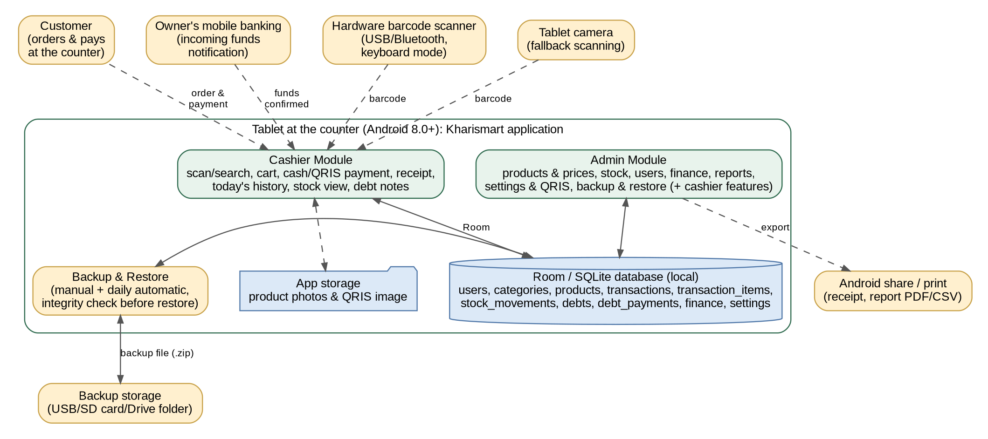
Figure 1. Block diagram of the product perspective of the Kharismart Cashier, Finance, and Stock Management System
The proposed system workflow is as follows.
- The user (cashier or admin) wakes the tablet, chooses their name on the lock screen, and enters their PIN; the menus shown depend on the role. The application locks again after a period without use.
- The customer brings the goods to the counter. The cashier scans each product’s barcode with the hardware scanner (or the camera, or searches for the product by name); the product is added to the cart and the system calculates the subtotal and total automatically.
- The cashier selects the payment method. For cash, the cashier enters the amount received and the system calculates the change. For QRIS, the system displays the owner’s QRIS code and the total, and the cashier then confirms that the funds have been received. For Credit/Pay Later, the cashier enters or selects the customer’s name (and, optionally, a due date or note); nothing is received at the time of sale and the total becomes a debt.
- The cashier presses Complete Transaction and answers the confirmation message.
- The system saves the transaction together with its items, reduces the stock of each product, records the stock movements, calculates the cost and gross profit, issues a receipt number, creates the linked debt note when the sale is on credit, and displays the receipt, which can be shared or printed.
- When goods arrive from a supplier, the admin records a restock (quantity and unit cost); when the physical count differs from the system, the admin records a stock adjustment with a reason.
- The dashboard shows the products whose stock is low or out and the outstanding debts (and, for the admin, today’s revenue and profit, and a backup reminder if needed). When a customer buys on credit, the debt note is created automatically; when a customer owes money from before or pays a debt, the cashier or the admin records it on the debt notes.
- The admin registers and manages users, records other income and expenses, views the finance and sales reports, configures the store and QRIS settings, and checks that the daily backup is made, restoring it when necessary.

2.2 Main Product Functions
The basic functions of the Kharismart System that address the problems in Section 1.2 are as follows.
- Users and access rights: the admin registers users and assigns the role of admin or cashier; each user signs in with a PIN and the screens are restricted by role.
- Product and price recording: the admin manages categories, products, barcodes, selling prices, and cost prices.
- Scanning and cart: products are found by hardware scanner, camera, or name search; the system calculates the subtotal, total, and change automatically.
- Payment: cash with change, QRIS with the owner’s QRIS code and the cashier’s confirmation, or Credit/Pay Later with the customer’s name (the sale reduces stock, issues a receipt, and creates a linked debt note), with validation and confirmation before the transaction is saved.
- Transaction saving and receipt: every transaction with its items is saved with the serving user, is given a receipt number, and can be shared or printed.
- Stock management: stock is reduced automatically on every sale, increased by restocking, corrected by stock adjustment, and shown with an Aman/Menipis/Habis status and a movement history.
- Debt notes: debts of customers are created automatically by credit sales (linked to the transaction) or recorded manually, and payments are tracked until the debt is paid.
- Financial recording: sales revenue and goods purchases are recorded automatically; the admin records other income and expenses manually.
- History, dashboard, and reports: transaction history, a dashboard according to the role, and finance and sales reports (revenue, gross and net profit, cash balance, outstanding debt, target progress, per category and per product) that can be exported.
- Settings and account: store identity, receipt footer, default minimum stock, QRIS account, revenue targets, auto-lock time, categories, and PIN change.
- Backup and restore: manual and daily automatic backup of all data, a reminder when no recent backup exists, and validated restore.

2.3 User Characteristics
Table 1. User characteristics of the Kharismart Cashier, Finance, and Stock Management System
User Category | Responsibilities | Access Rights | Qualifications / Skills
Cashier (the owner’s son or another helper) | Serves customers: scans or searches products, builds the cart, accepts cash, QRIS (confirming the funds), or credit payment, completes transactions, issues receipts, views today’s history, views products and stock status, and records debt notes and debt payments. | Cashier features only; does not see cost prices, profit, finance, reports, users, settings, and backup. | Can operate an Android tablet (touch screen, hardware scanner) and read the mobile banking notification; given a brief orientation.
Admin (Ibu Sumarti, the owner) | Manages users, categories, products, prices, and cost prices; records restock and stock adjustments; edits and deletes debt notes; records manual income and expenses; views the dashboard, full history, and reports; configures the store and QRIS; and performs backup and restore. Can serve transactions like a cashier. | All system features (including the cashier features). | Can operate an Android tablet and manage a small business’s records; keeps the recovery code and the backups safe.
Customer (not a user of the system) | Brings goods to the counter, pays in cash or by scanning the QRIS code, and receives a receipt if requested. | Has no account and does not access the system. | Has a mobile banking or e-wallet application if paying with QRIS.
Each user has one role (admin or cashier) and one PIN. The admin role automatically has all cashier access rights, so Ibu Sumarti, who serves transactions and also manages data, only needs one admin account, while her son uses a cashier account. Only one user is signed in on the tablet at a time; the application locks itself after a period without use (default 5 minutes), and users switch with their PIN. User registration and management are done only by the admin (there is no self-registration). If the admin forgets the PIN, it can be reset with the recovery code created at first setup. The detailed division of access rights needs to be validated with the owner (Appendix F).

2.4 Constraints
- The system functions as a cashier, stock management, debt note, and sales and finance recap system; it does not cover online ordering, digital payments other than the static QRIS, synchronization with other devices, or other features listed in Section 1.2.
- Customer credit has no credit limit, interest, or due-date reminder in this version; the due date or note entered at checkout is informational. Standalone supplier credit and dynamic payment gateways remain excluded.
- The application runs on an Android 8.0 (API level 26) or higher tablet in portrait and landscape orientation (it also runs on phones); iOS and a web interface are not provided.
- All data is stored only on the counter tablet in a local SQLite database. The data is not accessible from other devices; reports leave the tablet only as exported PDF/CSV files, and the whole data only as backup files.
- Data protection against loss depends on backups. The admin must keep backups in a place outside the tablet (for example a USB drive or a cloud-drive folder); a lost, broken, or reset tablet without a backup means lost data.
- Access control is trust-based. PINs are stored as salted hashes, the cashier’s screens hide cost prices, profit, and finance, and the application auto-locks; however, the database and backup files are not encrypted, so anyone who has the tablet or a backup file could read the data. This is accepted because all users are family members and the data is not highly sensitive.
- QRIS payment uses the owner’s static QRIS and a manual confirmation by the cashier; the system does not verify the payment automatically.
- Only whole quantities are supported; weighed or fractional quantities are not covered.
- All monetary values are in Rupiah and are stored as integers; all times use the WIB time zone (Asia/Jakarta).
- One installation (one database on one tablet) serves one store.
- Receipts and reports are shared or printed through the Android sharing and printing functions (any installed print service, or save as PDF); there is no integration with special printer hardware.

2.5 Assumptions and Dependencies
- The shop provides one Android tablet that meets the minimum specification, a USB or Bluetooth barcode scanner that works in keyboard mode, and a charger; the tablet stays at the counter and is kept charged during operating hours (a power bank or UPS is recommended).
- The tablet has a screen lock set by the owner, and a USB drive, SD card, or cloud-drive folder is available for backups.
- The admin chooses the backup folder, checks the backup reminder, and keeps the recovery code in a safe place; the admin also keeps an extra copy of the backup on another device from time to time.
- If the tablet fails, the shop uses manual record-keeping in a book until the last backup is restored on a repaired or replacement tablet (Section 3.4); transactions written in the book are entered afterward.
- The owner already has a QRIS from the mobile banking account of her choice and can upload the QRIS image and fill in the account data through the Settings menu; the cashier can see the incoming-funds notifications on the owner’s mobile banking (on the owner’s phone or another device).
- QRIS payment confirmation is done manually by the cashier; the reliability of the confirmation depends on the cashier’s carefulness and the mobile banking notification.
- Products have barcodes printed on their packaging that the scanner or camera can read; products without a barcode are found by name search.
- The admin enters the initial data: users, categories, products, barcodes, prices, cost prices, current stock, minimum stock, current customer debts, the QRIS account, and revenue targets (Appendices D and E). Products without a cost price are calculated with a cost of 0, so the profit is accurate only if cost prices are filled in.
- The owner decides which customers may buy on credit; the cashier selects the customer’s name from the previous debtors or types a new name carefully, because the name is used to group a customer’s debts.
- Stock accuracy depends on the admin recording restocks and adjustments; the system does not detect theft or loss by itself.
- Payment is received outside the system (cash in hand, or QRIS funds in the owner’s account); the system only records it.

3. DETAILED REQUIREMENTS DESCRIPTION

3.1 External Interface Requirements

3.1.1 User Interface
The application interface is designed for an Android tablet at the counter, in both portrait and landscape orientation (it also fits phone screens), in Indonesian, and kept simple so that it can be used quickly while serving a customer. In portrait orientation a bottom navigation bar provides the main destinations (Beranda, Pencatatan, Keuangan, History) and a central scan button, following the Kharismart prototype; in landscape orientation the same destinations appear in a side navigation, and the cashier screen shows the products on the left and the cart and payment on the right. The menus shown depend on the user’s role: the cashier sees only the cashier features, while the admin sees all features. Interface sketches are in Appendix A.
Table 2. List of user interface screens and components
No. | Screen | Main Components | Function / Purpose | Code
1 | Lock / Login | List of active users to choose from; PIN pad; Forgot admin PIN (recovery code); the application returns here after the idle time. | Signing in and switching users. | F01
2 | Header/Navigation | User name and role; bottom bar (portrait) or side navigation (landscape) with Beranda, Pencatatan, Keuangan, History and a central Scan button; menu items hidden according to the role; Lock now. | Navigation according to the role. | F01
3 | Dashboard (Beranda) | Search box; the Stok Menipis list; the Catatan Utang list; Lihat Semua links. Admin only: cards for today’s revenue and profit with the change from yesterday. | General overview according to the role. | F16
4 | Search and Product List | Search field (name or barcode), product cards (photo, name, price, stock), inactive products hidden, out-of-stock products marked. | Finding products. | F05
5 | Scan Product | Camera preview with a scan frame, the product found, and a Selesai button; the scan can be repeated for the next item. | Scanning barcodes. | F05
6 | Cart and Payment (Pembayaran) | List of items with quantity buttons (+/−) and delete; subtotal and total updated instantly; a three-way payment method selector [ Cash ] [ QRIS ] [ Credit / Utang ]. Cash: amount received and change. QRIS: the owner’s QRIS image, the total, and a “funds received” confirmation. Credit / Utang: a mandatory Customer Name field (search/dropdown of previous debtors, or a new name), an optional Due Date / Note field, Paid fixed at Rp0 (full credit), Change Due Rp0, and Remaining = Total. A prominent Complete Transaction button and a confirmation dialog; for credit: “Complete this sale on Credit to {Customer Name}? Total Rp{Total}. Stock will be deducted and a debt note will be generated.” | Calculating and completing a sale (cash, QRIS, or credit). | F06, F07, F08
7 | Receipt | Store name, receipt number, time, cashier, item details, total, method, paid, change, footer; for a credit sale also “Method: Credit (Utang)”, the customer name, “Paid: Rp0”, and “Remaining Debt: Rp{Total}”; Share and Print/PDF buttons. | Sharing or printing the receipt. | F09
8 | Product Recording (Pencatatan Barang) | Products grouped by category in tables (name, selling price, stock, status Aman/Menipis/Habis, edit and delete actions); Tambah Barang button per category; Download Data button. The cashier can only view products (without cost price). | Managing products (admin) and viewing stock status. | F04, F12
9 | Add/Edit Product | Barcode (typed or scanned), name, category, selling price, cost price, initial stock, minimum stock, photo; warning if price < cost price. Admin only. | Entering product data. | F04
10 | Manage Categories | Category list with add, rename, and activate/deactivate. Admin only. | Managing categories. | F03
11 | Stock | Current stock and status; restock form (quantity, unit cost, update cost price); stock adjustment form (counted stock, reason); stock history list. Admin only. | Updating stock. | F11
12 | Low-Stock List | All products with status Menipis or Habis, sorted by stock; a shortcut to the restock form (admin). | Monitoring low stock. | F12
13 | Debt Notes (Catatan Utang) | Debt table (name, total debt, remaining, status Belum lunas/Lunas, actions); every row shows its origin, “Origin: POS Sale (TRX-yyyymmdd-nnn)” or “Origin: Manual Entry”; Tambah Catatan button (manual notes); filter and search; total outstanding. The cashier can add manual notes and record payments; edit and delete of manual notes are for the admin; debts from POS sales cannot be edited or deleted. | Managing debts. | F13
14 | Debt Detail and Payment | Debt summary with its origin line; for a POS debt a clickable shortcut “View receipt” that opens the original sales receipt and its items; payment amount, payment method (Cash/QRIS), note, Save payment button, payment history. | Recording debt payments. | F13
15 | Transaction History (History Pembelian) | Transactions grouped by date with their items, totals, method (cash, QRIS, or credit with the customer name and the debt status), and cashier; filters (today, week, month, date range, method); sorting by heading; View receipt button. The cashier sees only today’s transactions. | Viewing past transactions. | F10, F09
16 | Finance (Keuangan) | Progress rings for day, week, and month (revenue vs target); category tiles (Sembako, Jajanan, Rokok, Kebutuhan Harian). Admin only. | Finance overview. | F15
17 | Report Detail | Period selection; summary cards (revenue, gross profit, expenses, net profit, cash balance, outstanding debt); cash balance details by method; sales per category and per product with sorting; Share PDF and Export CSV buttons. Admin only. | Viewing the sales and financial recap. | F15
18 | Manual Income/Expense Records | A form (date, type, category, amount, description); a records table with sorting and edit and delete buttons. Admin only. | Recording other income and expenses. | F14
19 | Manage Users | A user table; a form with name, username, initial PIN, role, and status; PIN reset. Admin only. | Managing accounts. | F02
20 | Settings | Store name, address, receipt footer, default minimum stock, auto-lock time, QRIS account (bank, owner name, upload image), revenue targets (admin only); change own PIN and Lock now (all users). | Configuring the system and the account. | F17, F01
21 | Backup and Restore | Last backup date and status; Back up now; choose the backup folder; automatic daily backup on/off; Restore from file with a warning and a validity check; backup reminder. Admin only. | Protecting the data against loss. | F18
General provisions for the user interface:
- Monetary values are displayed in Rupiah format (for example Rp15.000).
- The Complete Transaction button is easy to find, is distinguished from navigation buttons, and always opens a confirmation dialog before data is saved.
- Validation messages appear near the problematic field and explain how to correct it.
- Actions that cannot be undone (delete, complete transaction) ask for confirmation.
- Touch targets are at least 48 dp; history and report tables provide ascending/descending sorting on the main columns.
- Stock status uses both a label and a color (Aman green, Menipis yellow, Habis red) so that it does not depend on color alone.
- The cashier never sees cost prices, profit, finance, reports, users, or settings; these are hidden in the interface.
- The layout adapts to portrait and landscape orientation and to screen widths from 360 dp (phones) up to 10-inch tablets without hiding key information; the cart is kept when the screen is rotated.
- The scan field on the cashier screen keeps the focus so that the hardware scanner can type into it at any time.
Table 3. System messages displayed to the user
Condition | Message Displayed
Invalid item quantity | “Quantity must be an integer greater than 0.”
Insufficient stock | “Stock of {product} is only {n}. Reduce the quantity or ask the admin to update the stock.”
Inactive product | “{product} is inactive.”
Barcode not registered (admin) | “Barcode {code} is not registered. Register this product?”
Barcode not registered (cashier) | “Barcode {code} is not registered. Ask the admin to register this product.”
Empty cart | “Select at least one product before completing the transaction.”
Insufficient payment amount | “Payment is less than the transaction total.”
Invalid payment amount | “Payment amount must be a non-negative number.”
Customer name missing (credit) | “Customer name is required for a credit sale.”
QRIS not yet configured | “The QRIS account has not been configured. Contact the admin.”
QRIS confirmation | “Make sure the funds of Rp{total} have arrived in mobile banking before confirming.”
QRIS not confirmed | “Confirm that the funds have been received before completing the transaction.”
Complete transaction confirmation | “Complete this transaction? Total Rp{total}, paid Rp{paid}, change Rp{change}. The transaction cannot be changed after it is saved.”
Credit sale confirmation | “Complete this sale on Credit to {Customer Name}? Total Rp{Total}. Stock will be deducted and a debt note will be generated.”
Transaction successful | “Transaction saved successfully. Receipt No. {no}.”
Transaction failed to save | “The transaction failed to save. No data was saved, please try again.”
Backup failed | “The backup could not be saved. Check the chosen folder and the free space, then try again.”
Backup successful | “Backup saved: {file name}.”
Backup reminder | “No backup has been made for {n} days. Back up now?”
Restore confirmation | “Restoring will replace ALL current data with the data in {file} (dated {date}). A safety copy of the current data will be made first. Continue?”
Invalid backup file | “This file is not a valid Kharismart backup or it is damaged. The current data was not changed.”
Backup from a newer version | “This backup was made by a newer version of the application. Update the application first.”
Restore successful | “Data restored successfully. The application will restart.”
Incorrect PIN | “Incorrect PIN.”
Too many wrong PINs | “Too many wrong attempts. Try again in {n} seconds.”
Wrong recovery code | “The recovery code is incorrect.”
Inactive account | “This account is inactive. Contact the admin.”
Locked after inactivity | “The application was locked because it was not used for {n} minutes. Enter your PIN.”
No access | “You do not have access to this feature.”
Invalid PIN | “PIN must be 4–6 digits.”
Username already used | “This username is already used.”
Last admin cannot be deactivated | “The last active admin cannot be deactivated.”
Invalid price or cost price | “Selling price must be an integer greater than 0 and cost price must not be less than 0.”
Price below cost price | “Warning: the selling price is lower than the cost price.”
Duplicate barcode | “This barcode is already used by {product}.”
Category cannot be deactivated | “This category still has active products.”
Invalid restock | “Quantity must be an integer greater than 0 and unit cost must not be less than 0.”
Adjustment reason missing | “A reason is required for a stock adjustment.”
No stock difference | “The counted stock equals the recorded stock. Nothing to adjust.”
Low-stock notice | “{n} products are low or out of stock.”
Debt payment too high | “Payment cannot exceed the remaining debt of Rp{x}.”
Debt from POS sale protected | “This debt comes from a POS sale and cannot be edited or deleted. Ask the admin to reconcile it.”
Invalid financial record amount | “Amount must be an integer greater than 0.”
Empty category | “Category is required.”
Confirm deletion of financial record | “Delete this financial record? The reports will be recalculated.”
Confirm delete/deactivate | “Are you sure you want to delete/deactivate this data?”
Invalid target | “Targets must be whole numbers not less than 0.”
Camera permission | “Camera access is needed to scan barcodes. You can still search for products by name.”

3.1.2 Hardware Interface
Device | Minimum Specification | Purpose
Counter tablet | An Android 8.0 (API 26) or higher tablet of at least 7 inches (10 inches recommended) with at least 2 GB RAM (3 GB recommended) and 16 GB storage, supporting portrait and landscape orientation, USB OTG or Bluetooth, and a rear camera for fallback scanning. Wi-Fi and internet are not required. The tablet stays at the counter and is kept charged. | Running the Kharismart application and storing the data.
Owner’s mobile banking | The owner’s mobile banking application (on the owner’s phone or another device) that shows incoming-funds notifications for the owner’s QRIS account. | Confirming QRIS payments (outside the system).
Barcode scanner | A USB or Bluetooth barcode scanner that works in keyboard (HID) mode and ends each scan with the Enter key. | Scanning products at the counter (the camera is the fallback).
Printer (optional) | Any printer reachable through an Android print service, or save as PDF; Bluetooth thermal printers are not integrated. | Printing receipts and reports.
Backup storage | A USB drive or SD card (or a cloud-drive folder available through Android) of at least 4 GB, accessible through the Android Storage Access Framework. | Keeping backup files outside the tablet.

3.1.3 Software Interface
The system is a single standalone application: presentation (screens), application logic (the business rules), and data (a local database) all run on the counter tablet. The software used is as follows.
Layer | Specification | Purpose
Mobile application | Android (Kotlin), minimum Android 8.0 (API 26), with Material Design components and layouts that adapt to portrait and landscape; one application with a Cashier Module and an Admin Module selected by the signed-in user’s role. | Screens, cart calculation, business rules, and reports.
Database | SQLite accessed through the Room library, with ten tables: users, categories, products, transactions, transaction_items, stock_movements, debts, debt_payments, finance, and settings. Foreign keys are enabled, multi-table saves use Room transactions (all-or-nothing), and the schema has a version number with migrations. | Persistent data storage (Section 3.3).
Barcode input | A hardware scanner in keyboard (HID) mode typing into the focused scan field; as a fallback, the tablet camera (CameraX) with a barcode-scanning library (for example ML Kit or ZXing) for EAN/UPC and other common 1D barcodes. | Scanning products at the counter.
Local file storage | The application’s private storage on the tablet. | Product photos and the QRIS image.
Backup and restore | WorkManager for the daily automatic backup; the Android Storage Access Framework for choosing the backup folder and the restore file; zip files; the SQLite integrity check. | Backup copies of all data and validated restore.
PIN protection | A salted hash (for example PBKDF2 or bcrypt) for PINs and the recovery code; no plain PIN or code is stored. | Signing in.
Export and sharing | The Android share sheet and print framework; PDF and CSV generation. | Receipts and reports.

3.1.4 Communication and Data Exchange Interface
- The system does not need a network: during normal use no data is sent to other computers.
- Data leaves the tablet only as files that a user creates: backup files (.zip), exported reports (PDF/CSV), and receipts shared or printed through Android; the user chooses where they go (a USB drive, an SD card, a cloud-drive folder, or a messaging application).
- A backup file contains a copy of the database, the product photos and the QRIS image, and an information file (creation date, application version, database version); a restore is accepted only if the integrity check passes and the database version is not newer than the application.
- The hardware scanner is connected by USB (OTG) or Bluetooth and sends keystrokes; the application accepts a barcode in the scan field, and a barcode ends with the Enter key.
- Payment services are not accessed through any interface: QRIS uses the owner’s static QRIS image displayed in the application and the cashier’s manual confirmation of the incoming funds.

3.2 Functional Requirements
Functional requirements state the basic actions that the system must perform in processing input and producing output. This section consists of the list of requirements, the information flow (DFD levels 0 and 1 along with the data flow dictionary), input-process-output specifications and validation rules, business rules, and process descriptions (pseudo-code).

3.2.1 List of Functional Requirements
Table 4. List of functional requirements
Code | Feature Name | Actor | Requirement Specification
SRS-F01 | Login and access rights | All users | The system must show a lock screen where a user chooses their name and enters a PIN (4–6 digits); restrict the screens and functions according to the role (admin or cashier; the admin has all cashier access rights); lock again after a period without use (default 5 minutes) and on request; wait 30 seconds after 5 wrong PIN attempts; let users change their own PIN (the current PIN is required); and, at first setup, create the admin account and show a one-time recovery code that can reset the admin PIN.
SRS-F02 | Manage users | Admin | The system must allow the admin to register users (name, username, initial PIN, role), edit data and roles, activate/deactivate accounts, and reset PINs; users can change their own PIN. There is no self-registration and no deletion of users. The username must be unique, and the last active admin cannot be deactivated.
SRS-F03 | Manage categories | Admin | The system must provide the default categories (Sembako, Jajanan, Rokok, Kebutuhan Harian) and allow the admin to add, rename, and activate/deactivate categories. A category name must be unique, and a category that still has active products cannot be deactivated.
SRS-F04 | Manage products and prices | Admin, Cashier | The system must allow the admin to add and edit products (name, barcode, category, selling price, cost price, initial stock, minimum stock, photo, status) and activate/deactivate them. Price must be an integer > 0 and cost price an integer ≥ 0 (with a warning if price < cost price); a barcode must be unique; changes to price and cost price only apply to new transactions. The initial stock is saved as a stock movement. A product that has history is deactivated, not deleted. The Product Recording screen lists products per category with their stock and status. The cashier can only view products, selling prices, and stock (without cost prices).
SRS-F05 | Search and scan products | Cashier, Admin | The system must find a product by a barcode typed by the hardware scanner into the scan field, by scanning with the tablet camera as a fallback (asking for the camera permission when first used), or by searching its name or barcode. A found product can be added to the cart in one tap. If a scanned barcode is not registered, the admin is offered to register a new product, while the cashier is told to ask the admin. Inactive products must not be offered for sale.
SRS-F06 | Cart and automatic total | Cashier, Admin | The system must keep a cart in which the cashier can change quantities and delete items directly, while calculating the subtotal and total automatically and instantly on the tablet. Scanning the same product again increases its quantity by 1. Quantity must be an integer > 0 and not more than the recorded stock.
SRS-F07 | Payment, change, QRIS, and credit | Cashier, System | The system must allow the cashier to select the Cash, QRIS, or Credit / Pay Later method (a three-way selector). For cash, the system calculates the change and rejects an amount less than the total. For QRIS, the system displays the owner’s QRIS image and the total, and the transaction can only be completed after the cashier confirms that the funds have been received in the owner’s mobile banking. For Credit, the Customer Name is required and cannot be blank (chosen from previous debtors or typed as a new name), a due date or note is optional, the paid amount is Rp0, the change is Rp0, and the remaining debt equals the total; no cash or QRIS is received at the time of sale.
SRS-F08 | Complete transaction | Cashier, System | The system must provide a Complete Transaction button that displays a confirmation message; once confirmed, the system saves as a whole (all data is saved or none at all) the transaction, its items, the stock deduction and stock movements, the total cost and gross profit, the receipt number, and the user who served it. The price and cost price of each item are copied into the item rows so that later changes do not alter old transactions. The button is disabled while saving so that a double tap cannot create a second transaction; if the application is closed or the tablet loses power during saving, no partial data remains. When the method is credit, the same all-or-nothing save must simultaneously (1) save the transaction with method = ‘credit’, paid = 0, and change_due = 0; (2) write the line items to transaction_items; (3) decrement the stock in products and record the stock movements (type ‘sale’); and (4) insert a record into debts with the transaction_id, customer_name, total_amount = the transaction total, paid_amount = 0, and status = ‘unpaid’. If any step fails, nothing is saved. A credit sale receives a receipt number (TRX-yyyymmdd-nnn) like every other sale.
SRS-F09 | Receipt | Cashier, Admin | The system must display a receipt containing the store name, address, receipt number, time, cashier, item details, total, method, amount paid, change, and footer; the receipt can be shared or printed through Android, and can be viewed again from the history, where it is marked Copy. For a credit sale, the receipt shows “Method: Credit (Utang)”, the customer name, “Paid: Rp0”, and “Remaining Debt: Rp{Total}”.
SRS-F10 | Transaction history | Cashier, Admin | The system must display transactions grouped by date with their items, totals, method, and cashier, with filters by period (today, week, month, or date range) and payment method, and with sorting (date, receipt number, total, method). The cashier can only see today’s transactions; the admin can see all periods. Every transaction lists its items; a credit transaction also shows the customer name and the status of its linked debt.
SRS-F11 | Restock and stock adjustment | Admin | The system must allow the admin to record a restock (quantity, unit cost, and the option to update the cost price) that increases the stock, and a stock adjustment (counted stock and a required reason) that sets the stock to the counted value. Every change must be saved as a stock movement with the stock after the change and the user who recorded it, and the stock history of each product must be viewable.
SRS-F12 | Stock status and low-stock alert | Cashier, Admin, System | The system must show a status for every product (Aman, Menipis, Habis) based on the stock and the minimum stock, display low-stock and out-of-stock products on the dashboard and on a Low-Stock List sorted by stock, and show the number of such products as an in-app notice.
SRS-F13 | Debt notes | Cashier, Admin, System | The system must keep a ledger of customer debt notes. A debt note originates either (a) automatically from a POS credit sale, linked to its transaction, or (b) manually, as an ad-hoc IOU entry without a transaction (transaction_id is null) added by the cashier or the admin (customer name, amount, date, note). The cashier and the admin can record full or partial debt payments by cash or QRIS (QRIS needs the same confirmation as in F07), and the status (Belum lunas/Lunas) updates automatically. The list shows the origin of every note (“Origin: POS Sale (TRX-yyyymmdd-nnn)” or “Origin: Manual Entry”), can be filtered by status and searched by name, and a debt from a POS sale offers a shortcut to view its sales receipt. A debt created from a POS sale cannot be edited or deleted independently, because it is tied to a saved transaction; corrections are made by the admin through reconciliation (BR-13). Only the admin can edit or delete a manual debt note, and only if it has no payments (with confirmation).
SRS-F14 | Manual income and expense records | Admin | The system must allow the admin to record income other than sales and operating expenses (date, type, category, amount, description), and to edit and delete those records with confirmation. Sales revenue, debt payments, and goods purchases (restock) are recorded automatically and are not entered again.
SRS-F15 | Finance and sales reports | Admin | The system must display, for the selected period (day, week, month, or custom), the revenue, gross profit, other income, operating expenses, net profit, cash balance with its components (cash, QRIS, debt payments, restock purchases), outstanding debt, target progress (daily, weekly, monthly), sales per category, and quantity sold, sales, and profit per product; the results can be sorted, shared as a PDF, and exported as CSV. Credit sales count in the revenue and the gross profit, but they enter the cash balance only when their debts are paid.
SRS-F16 | Dashboard | Cashier, Admin | The system must display on the home screen the first low-stock or out-of-stock products, the first outstanding debts, and a product search box, each with a Lihat Semua link to the full list; for the admin, also today’s revenue and gross profit with the percentage change from yesterday, and a backup reminder when no backup has been made for 3 days. The cashier does not see revenue, profit, and the backup reminder.
SRS-F17 | Store and QRIS settings | Admin | The system must allow the admin to fill in the store name, address, receipt footer, default minimum stock, the auto-lock time, the QRIS account (bank, owner name, QRIS image), and the daily, weekly, and monthly revenue targets; changes take effect immediately and only for subsequent transactions.
SRS-F18 | Backup and restore | Admin, System | The system must allow the admin to (a) back up all data at any time to a folder or file chosen through Android; (b) choose a backup folder so that the system makes an automatic backup every day (keeping the last 30 files) and shows a reminder when no backup has been made for 3 days; and (c) restore from a backup file. A backup file contains the database, the photos and the QRIS image, and an information file. Before a restore replaces the data, the system must check that the file is a valid Kharismart backup (integrity check, database version not newer than the application) and make a safety copy of the current data; if the check fails, nothing is changed. A backup can be restored on another tablet.

3.2.2 Context DFD (Level 0)
The external entities are the Cashier and the Admin/Owner as the users of the system. The Customer is depicted as an external entity who interacts through the cashier (bringing goods, paying in cash or by scanning the QRIS code, and receiving the receipt), but is not a user of the system. The admin can also perform all cashier activities. The Backup storage (a USB drive, SD card, or cloud-drive folder) is an external storage that receives backup files and report exports and provides a backup file for a restore.
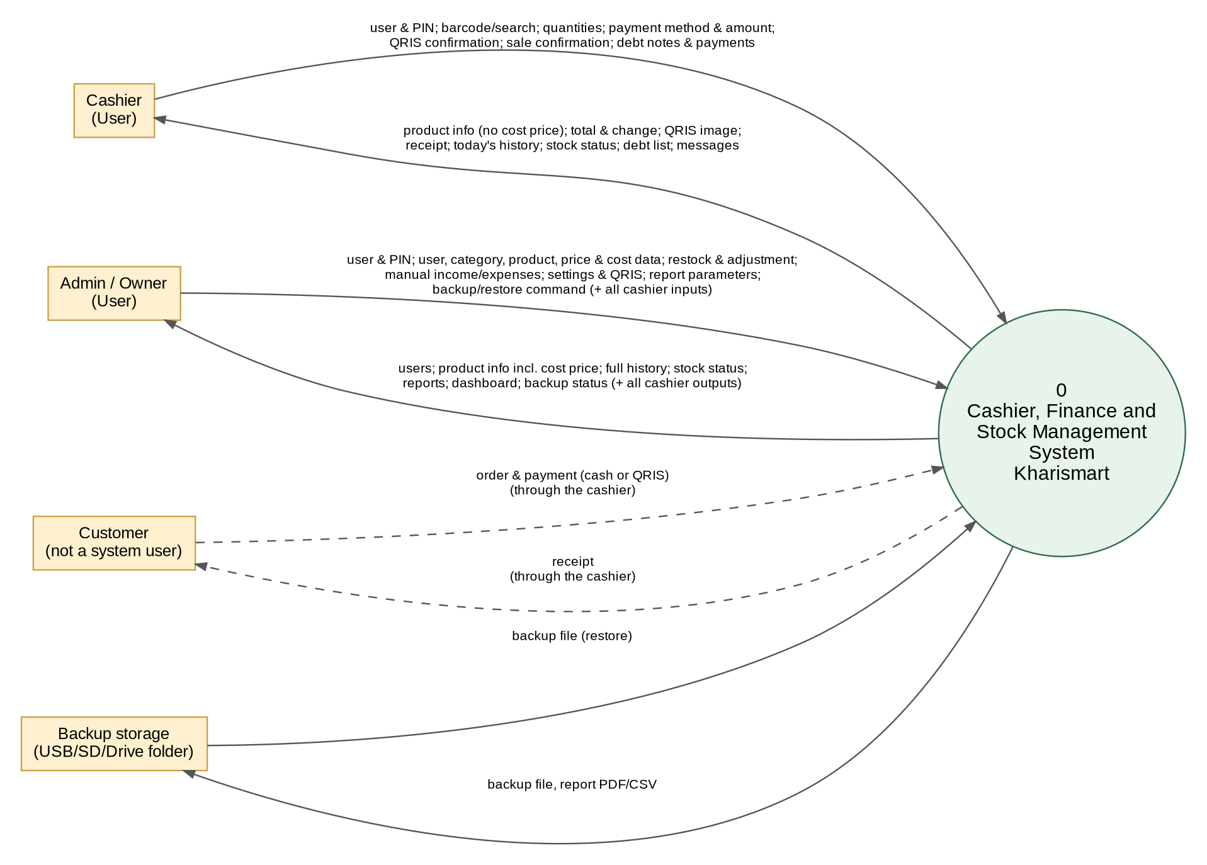
Figure 2. DFD Level 0 – Context diagram of the Kharismart Cashier, Finance, and Stock Management System
Table 5. Data flows of DFD Level 0
Entity | Data Flows into the System | Data Flows out of the System
Cashier (User) | User choice and PIN; barcode (from the scanner) or search text; cart quantities; payment method (cash, QRIS, or credit), amount, QRIS confirmation, and the customer name for a credit sale; sale confirmation; debt notes and debt payments. | Product information (without cost price); total and change; QRIS image; receipt; today’s transaction history; stock status and low-stock alerts; debt list; dashboard (without revenue and profit); validation messages.
Admin / Owner (User) | User choice and PIN; user data; category, product, price, and cost data; restock and stock adjustment; manual income and expenses; settings and QRIS image; report parameters; backup and restore commands; all cashier inputs. | User list; product information including cost price; full transaction history; stock status; sales and financial reports; dashboard with revenue, profit, and backup reminder; backup status; validation messages; all cashier outputs.
Backup storage (USB/SD/Drive folder) | A backup file to be restored. | Backup files and exported reports (PDF/CSV).
Customer (through the cashier) | Goods and payment (cash, scanning the QRIS code and transferring the funds, or taking the goods on credit and paying later). | Receipt containing the receipt number and items.

3.2.3 DFD Level 1
The system process is broken down into nine main processes, ten data stores, two user entities, and the backup storage. The customer is not drawn at this level because they interact only through the cashier. To keep the diagram readable, the admin’s use of the cashier processes (P4, P6, and P8) and the reads of D5 settings by processes P4, P5, and P8 are not drawn but are listed in Table 6; process P9 is connected to the whole database (D1–D10). Process 4.0 writes the debt note of a credit sale directly into D9 debts (the highlighted flow), and process 6.0 reads and updates these debts together with the manually entered debts.
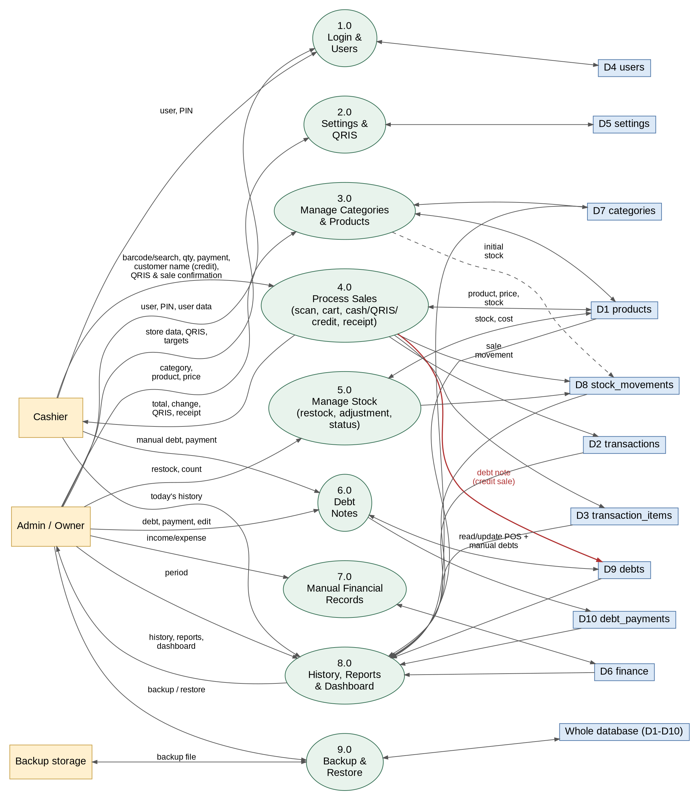
Figure 3. DFD Level 1 – Main processes of the Kharismart Cashier, Finance, and Stock Management System
Table 6. Processes in DFD Level 1
Process | Main Input | Data Store | Requirement
P1 Login and Users | User choice and PIN; new PIN; recovery code; user data (name, username, PIN, role, status). | D4 users | F01, F02
P2 Settings and QRIS | Store identity, receipt footer, default minimum stock, QRIS account and image, targets. | D5 settings | F17
P3 Manage Categories and Products | Category data; product data (barcode, name, category, price, cost price, initial stock, minimum stock, photo, status). | D7 categories, D1 products, D8 stock_movements (initial stock) | F03, F04
P4 Process Sales | Barcode or search text, quantity, method, amount paid, customer name and due note (credit), QRIS confirmation, sale confirmation. | D1 products, D2 transactions, D3 transaction_items, D8 stock_movements, D9 debts (debt note of a credit sale), D5 settings (read QRIS and footer) | F05–F09
P5 Manage Stock | Restock data; stock adjustment data. | D1 products, D8 stock_movements, D5 settings (read default minimum) | F11, F12
P6 Debt Notes | Manual debt data; debt payments (cash/QRIS); the debt notes generated by P4 are read here. | D9 debts (read/update, POS and manual), D10 debt_payments, D2 transactions (read, for the receipt shortcut) | F13
P7 Manual Financial Records | Manual income and expenses (date, type, category, amount). | D6 finance | F14
P8 History, Reports, and Dashboard | Period, filters, sort order; the cashier’s request for today’s history. | D1, D2, D3, D5, D6, D7, D8, D9, D10 (read) | F10, F15, F16
P9 Backup and Restore | Backup now; automatic daily backup; backup file to restore. | Whole database (D1–D10) and D5 settings (backup folder, last backup time) | F18
Data Flow Dictionary
Notation: “=” consists of; “+” and; “[ a | b ]” either one; “( )” optional; “{ }” repeated.
Table 7. Data flow dictionary
Data Flow | Composition
credentials | user_id + pin
pin_change | current_pin + new_pin
user_data | name + username + (pin) + role [ admin | cashier ] + status
category_data | name + status
product_data | (barcode) + name + category_id + price + cost_price + (initial_stock) + (min_stock) + (photo) + status
search_query | [ barcode | name_text ]
cart | { product_id + name + price + quantity + subtotal } + total
payment_data | method [ cash | qris | credit ] + (paid) + (qris_confirmation) + (customer_name) + (due_note)
receipt | store_name + address + receipt_no + date + cashier + { item } + total + method + paid + change_due + (customer_name) + (remaining_debt) + footer
restock_data | product_id + quantity + unit_cost + (update_cost_price)
adjustment_data | product_id + counted_stock + reason
stock_status | product_id + name + stock + min_stock + status [ aman | menipis | habis ]
debt_data | customer_name + total_amount + date + (note) + (transaction_id)
debt_payment_data | debt_id + amount + method [ cash | qris ] + (qris_confirmation) + (note)
manual_finance_data | date + type + category + amount + (description)
settings | store_name + store_address + receipt_footer + default_min_stock + auto_lock_minutes + qris_bank + qris_owner_name + (qris_image) + (target_daily) + (target_weekly) + (target_monthly) + (backup_folder)
backup_command | [ backup_now | choose_folder | restore ] + (backup_file)
backup_file | database + { photo } + qris_image + info (created_at + app_version + db_version)
recovery_code | code (shown once at first setup)
report_parameters | start_date + end_date + (method) + sort_by + direction
history | { receipt_no + date + method + total + cashier + { item } }
report | revenue + gross_profit + other_income + expenses + net_profit + cash_received + qris_received + debt_payments + restock_purchases + cash_balance + outstanding_debt + { target_progress } + { sales_per_category } + { sales_per_product }
dashboard | { low_stock_item } + { debt_summary } + (revenue_today + gross_profit_today + change_percent + backup_reminder ; admin only)

3.2.4 Input-Process-Output Specifications and Validation
Table 8. Input-process-output specifications and validation
Code | Input | Process | Output | Validation
F01 | User choice, PIN; new PIN; recovery code. | Verify the PIN against the salted hash; open the session in memory; check the role on every screen and function; lock after the idle time; change PIN; reset the admin PIN with the recovery code. | Access to the features of the role. | Active account; PIN matches; 30-second wait after 5 wrong attempts; the function is allowed for the role; new PIN is 4–6 digits and different from the current one.
F02 | Name, username, PIN, role, status; reset PIN. | Add/edit/activate/deactivate users; reset a PIN; hash the PIN. | User data saved. | Username unique; role admin/cashier; PIN 4–6 digits; the last active admin cannot be deactivated; admin only.
F03 | Category name, status. | Add, rename, activate/deactivate. | Category data saved. | Name required (≤ 50 characters) and unique; cannot deactivate a category with active products; admin only.
F04 | Barcode, name, category, price, cost price, initial stock, minimum stock, photo, status. | Add/edit/deactivate; save the initial stock movement; save the photo; cashier views without cost price. | Product data saved or displayed. | Name required; price integer > 0; cost integer ≥ 0 (warning if price < cost); barcode unique (≤ 30 characters); stock and minimum stock integers ≥ 0; photo png/jpg ≤ 1 MB; changes by admin only.
F05 | Barcode (camera) or search text. | Look up the product by barcode or name. | Product shown, or registration offer (admin) / message (cashier). | Product exists and is active; camera permission granted for scanning.
F06 | Product id, quantity. | Add/edit/delete cart items; calculate subtotal and total. | Cart and total. | Product active; quantity is an integer > 0 and ≤ stock.
F07 | Method, amount paid, QRIS confirmation, customer name, due date/note. | Calculate change (cash); display the QRIS image and total (QRIS); for credit set paid = 0, change = 0, and remaining = total; validate. | Change; QRIS image; credit summary (customer, remaining debt); payment passes or a validation message. | Cash: paid integer ≥ total. QRIS: QRIS already configured and the confirmation checked; paid = total. Credit: Customer Name required and not blank; paid = 0; change = 0.
F08 | Cashier confirmation. | Open a database transaction; recalculate totals and cost from the product prices; save the transaction, items, and stock movements; update stock; for credit also insert the linked debt note (transaction_id, customer_name, total_amount = total, paid_amount = 0, status unpaid). | Transaction saved; receipt number; linked debt note (credit). | All F06–F07 validations pass; stock sufficient at the time of saving; all-or-nothing saving (COMMIT/ROLLBACK), including the debt note of a credit sale; button disabled while saving.
F09 | Transaction id. | Compose the receipt for display, sharing, or printing. | Receipt. | Transaction exists (cashier: of today); a reprint is marked Copy.
F10 | Period, filters, sort column and direction. | Retrieve and sort transactions. | List and details of transactions. | Start date ≤ end date; sort column is in the permitted list; the cashier is limited to today.
F11 | Product id, quantity, unit cost, option; or counted stock, reason. | Increase stock (restock) or set stock to the count (adjustment); save the stock movement. | Stock updated; stock history. | Restock: quantity integer > 0, unit cost integer ≥ 0. Adjustment: counted stock integer ≥ 0, reason required, difference ≠ 0; admin only.
F12 | Stock, minimum stock. | Determine the status; list low and out-of-stock products. | Status labels; low-stock list; notice count. | Status according to BR-09.
F13 | Customer name, amount, date, note; payment amount, method. | Add a manual debt note; show the origin of each note; open the receipt of a POS debt; record a payment; update paid amount and status; admin edit/delete of manual notes. | Debt list and status. | Name required; amount integer > 0; payment integer > 0 and ≤ remaining; QRIS payment needs the confirmation; POS debts cannot be edited or deleted; edit/delete rules of BR-13.
F14 | Date, type, category, amount, description. | Save, edit, or delete a manual record. | Financial records and latest figures. | Type income/expense; category required; amount integer > 0; delete asks for confirmation; admin only.
F15 | Period, sort column and direction. | Calculate revenue, profit, cash balance, outstanding debt, target progress, and sales per category and product; export. | Finance and sales report; PDF; CSV. | Valid dates and start ≤ end; sort column permitted; admin only.
F16 | Signed-in user. | Retrieve the low-stock products and debts (and today’s summary and the backup reminder for the admin). | Dashboard according to the role. | Revenue, profit, and backup reminder only for the admin.
F17 | Store name, address, receipt footer, default minimum stock, auto-lock time, QRIS account and image, targets. | Save the settings and the QRIS image. | Active settings. | Store name required; default minimum stock integer ≥ 0; auto-lock 1–60 minutes; QRIS image png/jpg ≤ 1 MB; targets integers ≥ 0 or empty; admin only.
F18 | Backup command; backup folder; backup file to restore. | Create a zip of the database, photos, and QRIS image; write it to the folder; schedule a daily backup; check and restore a backup file after making a safety copy. | Backup file; backup status; restored data. | Folder accessible and writable; file is a valid zip with an information file; integrity check passes; database version not newer than the application; the admin confirms the restore.
Business Rules
Table 9. Business rules
Code | Business Rule
BR-01 | A product can only be added to the cart if its status is active, and the quantity in the cart may not exceed its recorded stock.
BR-02 | Subtotal = price × quantity; total = sum of all subtotals; item quantity must be an integer > 0.
BR-03 | Cash payment: the amount paid must be ≥ total; change = paid − total.
BR-04 | QRIS payment: the QRIS account must be configured; paid = total, change = 0, and the cashier must confirm that the funds have been received before the transaction can be completed.
BR-04b | Credit payment rule: Credit payment requires a valid Customer Name. paid is set to 0, change_due is 0. Completing a credit sale reduces stock identically to cash/QRIS sales, issues a unique receipt number (TRX-yyyymmdd-nnn), and automatically inserts a linked record in debts (transaction_id, customer_name, total_amount = total, paid_amount = 0, status = unpaid).
BR-05 | A transaction is only saved if there is at least one item, the payment is valid, and the cashier answers Yes at the confirmation. The Complete Transaction button is disabled while saving so that a double tap cannot create a duplicate transaction.
BR-06 | The price and cost price of each item are copied into the transaction items at the time of the transaction; later changes in the product do not change old transactions. Selling price is an integer > 0 and cost price an integer ≥ 0.
BR-07 | The receipt number has the format TRX-yyyymmdd-nnn, is sequential per day starting from 001, unique, and restarts at 001 at 00:00 WIB.
BR-08 | Every sale (cash, QRIS, or credit) reduces the product stock by the quantity sold; every change of stock (initial, restock, sale, adjustment) creates a stock movement with the signed change, the stock after, and the user; stock can never be less than 0.
BR-09 | Stock status: Habis if stock = 0; Menipis if 0 < stock ≤ minimum stock; Aman if stock > minimum stock. The minimum stock is the product’s own value or, if empty, the default in the settings (initial proposal 5).
BR-10 | Profit: total_cost = sum of (cost price × quantity) of all items; gross_profit = total − total_cost (may be negative if price < cost). Example: items total 49.000 with cost 44.000 give a gross profit of 5.000.
BR-11 | Restock: quantity is an integer > 0 and unit cost an integer ≥ 0; stock increases by the quantity; if the option is chosen the product’s cost price becomes the unit cost. The purchase cost (quantity × unit cost) is counted as a goods purchase in the cash balance and is not entered in the finance table, so no double counting occurs. The initial stock is not a purchase.
BR-12 | Stock adjustment: the counted stock is an integer ≥ 0 and a reason is required; the difference (counted − recorded) is saved as an adjustment movement; an adjustment is neither income nor expense.
BR-13 | Debt notes: a debt has a customer name and a total amount > 0 and originates either automatically from a POS credit sale (linked to its transaction through transaction_id; at most one debt per transaction; total_amount = the transaction total) or manually as an ad-hoc entry (transaction_id is null). A payment is an integer > 0, is made by cash or QRIS, and may not exceed the remaining debt; the status becomes Lunas when the remaining amount is 0; a payment is counted as money received on its date. Credit sales reduce the stock at the time of purchase because the goods have left the store; ad-hoc manual debts do not touch the stock. A debt created from a POS sale cannot be edited or deleted independently, because its transaction is saved and immutable; any correction is made by the admin through reconciliation (a note on the debt and, when goods are returned, a stock adjustment), and the transaction itself stays unchanged. Only the admin can edit or delete a manual debt note, and only if it has no payments.
BR-14 | Period figures: revenue = sum of the totals of cash, QRIS, and credit transactions; gross profit = revenue − the total cost of all items sold (sum of gross_profit, credit sales included); cash received = sum of (paid − change_due) of cash transactions + cash debt payments; QRIS received = sum of paid of QRIS transactions + QRIS debt payments. Credit sales have paid = 0, so they do not add to the cash received or the cash balance at the moment of sale; they add to the cash balance only when debt payments are collected in cash or QRIS. Net profit = gross profit + other income − operating expenses; cash balance = cash received + QRIS received + other income − operating expenses − goods purchases (restock); outstanding debt = sum of the remaining debts (POS and manual) at the time of viewing. A day is 00:00–23:59 WIB, a week is Monday–Sunday, and a month is a calendar month. Sales per category use the product’s current category.
BR-15 | Dashboard and targets: change from yesterday = (today − yesterday) / yesterday × 100, rounded to a whole percent, and shown as “—” if yesterday’s value is 0; target progress = revenue of the day/week/month ÷ target × 100, rounded, with the ring capped at 100%, and shown as “—” if no target is set.
BR-16 | Roles and access: the username is unique; each user has one role and one PIN of 4–6 digits that is stored only as a salted hash. Cashier access rights: scanning/search, cart, payment, receipt, today’s history, viewing products without cost price and stock status, debt notes (add and record payments), and the cashier dashboard; the cashier does not see cost prices, profit, finances, reports, users, settings, and backup. Admin access rights: all features including the cashier’s. The restrictions are applied by the screens and functions of the application (trust-based access control). After 5 wrong PIN attempts the lock screen waits 30 seconds, and the application locks after the idle time in the settings (default 5 minutes). A user who already has records is deactivated, not deleted; the last active admin cannot be deactivated. A saved transaction cannot be changed or deleted, and a debt created from a POS sale cannot be edited or deleted independently (BR-13); manual financial records can be edited or deleted by the admin with confirmation; products and categories that have history are deactivated, not deleted; a barcode is unique.
BR-17 | Monetary values are whole Rupiah integers (displayed as Rp15.000); all times use the WIB time zone with the dd/mm/yyyy format and a 24-hour clock.
BR-18 | Backup and restore: a backup contains the whole database, the product photos, and the QRIS image; the automatic backup runs once a day to the folder chosen by the admin and the last 30 files are kept; a reminder appears on the admin’s dashboard when no backup has been made for 3 days; a restore is accepted only if the file is a valid Kharismart backup (the integrity check passes and the database version is not newer than the application), and the current data is saved as a safety copy before it is replaced; a restore replaces all current data, including users and PINs.

3.2.5 Process Description
Table 10. Process description
Process | Description
P1 Login and Users | Verifies the PIN, opens and closes the session and the lock, applies the role, changes PINs and resets the admin PIN with the recovery code, and lets the admin register and manage users.
P2 Settings and QRIS | Stores the store identity, receipt footer, default minimum stock, QRIS account and image, and revenue targets used by other processes.
P3 Manage Categories and Products | The admin adds, edits, and deactivates categories and products; a new product with initial stock creates an initial stock movement.
P4 Process Sales | The cashier scans or searches products; the cart and total are updated on the tablet. After the payment has been filled in (the QRIS funds confirmed, or the customer name entered for a credit sale) and the sale confirmed, the application opens a database transaction, rechecks stock, recalculates totals, calculates cost and profit (P4c), generates the receipt number, saves the transaction, items, stock deduction, and stock movements (and, for a credit sale, the linked debt note), then performs a COMMIT and shows the receipt.
P5 Manage Stock | Records restocks and stock adjustments, saves stock movements, and determines the stock status of every product.
P6 Debt Notes | Lists debt notes (those generated by credit sales in P4 and the manual ones), shows the origin and the link to the sales receipt, adds and edits manual debt notes, and records debt payments until the debt is paid.
P7 Manual Financial Records | The admin records, edits, and deletes income other than sales and operating expenses.
P8 History, Reports, and Dashboard | Aggregates and sorts transaction, stock, debt, and finance data by period for the history, finance and sales reports, target progress, and the dashboard according to the role.
P9 Backup and Restore | Creates backup files manually and daily, shows the reminder, checks a chosen backup file, makes a safety copy, and restores the data.
The following are the process descriptions at the most detailed level in the form of pseudo-code.
P1a - Login and Lock (F01)
PROCESS P1a Login
DISPLAY the lock screen with the list of active users
RECEIVE user_id, pin FROM User
READ account FROM D4 WITH user_id
IF wrong_attempts >= 5 AND now < locked_until THEN DISPLAY "Too many wrong attempts. Try again in {n} seconds." ; EXIT
IF verify(pin, account.pin_hash) is false THEN
wrong_attempts <- wrong_attempts + 1 ; IF wrong_attempts = 5 THEN locked_until <- now + 30 seconds
DISPLAY "Incorrect PIN." ; EXIT
wrong_attempts <- 0 ; session <- (user_id, role) kept in memory
OPEN the home screen with the menus of account.role
; while the session is open: IF no use for auto_lock_minutes THEN session <- empty ; DISPLAY the lock screen
; every screen and function checks session.role: IF the function is not allowed for the role THEN
; DISPLAY "You do not have access to this feature."
; admin PIN recovery: RECEIVE recovery_code ; IF verify(recovery_code, recovery_hash) THEN allow a new admin PIN
END PROCESS
P1b - Manage Users (F02)
PROCESS P1b ManageUsers
RECEIVE name, username, pin, role, status FROM Admin
IF session.role <> "admin" THEN DISPLAY "You do not have access to this feature." ; EXIT
IF username already exists in D4 (other user) THEN DISPLAY "This username is already used." ; EXIT
IF pin is given AND pin is NOT 4-6 digits THEN DISPLAY "PIN must be 4-6 digits." ; EXIT
IF status becomes false AND the user is the last active admin THEN
DISPLAY "The last active admin cannot be deactivated." ; EXIT
WRITE or UPDATE D4 (name, username, role, status, pin_hash <- salted_hash(pin))
IF the user is deactivated AND is signed in THEN lock the application
END PROCESS
P4a - Add Item to Cart (F05, F06)
PROCESS P4a AddItem
RECEIVE barcode (hardware scanner or camera) OR name_text FROM Cashier
IF barcode THEN READ product FROM D1 WITH barcode ELSE SEARCH D1 BY name_text
IF barcode not found THEN
IF role = "admin" THEN DISPLAY "Barcode {code} is not registered. Register this product?"
ELSE DISPLAY "Barcode {code} is not registered. Ask the admin to register this product."
EXIT
IF product.status = false THEN DISPLAY "{name} is inactive." ; EXIT
new_quantity <- quantity in cart + 1 (or the quantity typed by the cashier)
IF new_quantity is NOT an integer > 0 THEN DISPLAY quantity message ; EXIT
IF new_quantity > product.stock THEN DISPLAY "Stock of {name} is only {stock}..." ; EXIT
ADD or EDIT item in the cart
FOR EACH item IN cart: subtotal <- price * quantity
total <- SUM(subtotal)
DISPLAY cart and total ; calculated on the tablet
END PROCESS
P4b - Payment and Completing the Transaction (F07, F08, F09)
PROCESS P4b PaymentAndCompletion
RECEIVE method, paid, qris_confirmation, customer_name, due_note FROM Cashier
IF cart is empty THEN DISPLAY "Select at least one product..." ; EXIT
IF method = "cash" THEN
IF paid is not a number >= 0 THEN DISPLAY amount message ; EXIT
IF paid < total THEN DISPLAY "Payment is less than the transaction total." ; EXIT
change_due <- paid - total
ELSE IF method = "qris" THEN
IF D5 qris_image is empty THEN DISPLAY "The QRIS account has not been configured. Contact the admin." ; EXIT
DISPLAY the QRIS image, the total, and "Make sure the funds of Rp{total} have arrived..."
IF qris_confirmation <> true THEN DISPLAY "Confirm that the funds have been received..." ; EXIT
paid <- total ; change_due <- 0
ELSE ; credit
IF customer_name is empty OR only spaces THEN DISPLAY "Customer name is required for a credit sale." ; EXIT
paid <- 0 ; change_due <- 0 ; remaining_debt <- total
DISPLAY total, paid, change_due
IF method = "credit" THEN REQUEST confirmation "Complete this sale on Credit to {customer_name}? Total Rp{total}.
Stock will be deducted and a debt note will be generated."
ELSE REQUEST confirmation "Complete this transaction?"
IF not confirmed THEN EXIT
DISABLE the Complete Transaction button
START DATABASE TRANSACTION ; START TRANSACTION (Room)
FOR EACH item: READ product FROM D1 ; IF quantity > product.stock THEN
ROLLBACK ; DISPLAY insufficient stock message ; EXIT
RECALCULATE total AND total_cost FROM the price and cost_price in D1
CALL P4c ProfitCalculation(total, total_cost)
receipt_no <- "TRX-" + today(yyyymmdd) + "-" + (count of today's rows in D2 + 1, 3 digits)
WRITE D2 (user_id, receipt_no, date <- now, method, total, paid, change_due,
total_cost, gross_profit)
FOR EACH item:
WRITE D3 (transaction_id, product_id, quantity, price, cost_price, subtotal)
UPDATE D1: stock <- stock - quantity
WRITE D8 (product_id, user_id, transaction_id, type "sale", quantity_change <- -quantity, stock_after)
IF method = "credit" THEN
WRITE D9 (transaction_id <- the new transaction, user_id, customer_name, date <- now,
total_amount <- total, paid_amount <- 0, status "unpaid", note <- due_note)
IF any SQL command fails THEN ROLLBACK ; DISPLAY "The transaction failed to save. No data was saved." ; EXIT
; nothing is kept: no transaction, items, stock change, or debt note
COMMIT
DISPLAY "Transaction saved successfully. Receipt No. n." ; DISPLAY receipt ; OFFER share/print
END PROCESS
P4c - Profit Calculation (F08)
PROCESS P4c ProfitCalculation(total, total_cost)
total_cost <- SUM(cost_price * quantity) OF all items
gross_profit <- total - total_cost
RETURN total_cost, gross_profit
END PROCESS
P5a - Restock (F11)
PROCESS P5a Restock
RECEIVE product_id, quantity, unit_cost, update_cost_price FROM Admin
IF quantity is NOT an integer > 0 OR unit_cost is NOT an integer >= 0 THEN DISPLAY restock message ; EXIT
START DATABASE TRANSACTION
READ product FROM D1 FOR UPDATE
UPDATE D1: stock <- stock + quantity ; IF update_cost_price THEN cost_price <- unit_cost
WRITE D8 (product_id, user_id, type "restock", quantity_change <- +quantity, stock_after, unit_cost,
total_cost <- quantity * unit_cost)
COMMIT ; DISPLAY updated stock and status
END PROCESS
P5b - Stock Adjustment (F11)
PROCESS P5b StockAdjustment
RECEIVE product_id, counted_stock, reason FROM Admin
IF counted_stock is NOT an integer >= 0 THEN DISPLAY message ; EXIT
IF reason is empty THEN DISPLAY "A reason is required for a stock adjustment." ; EXIT
START DATABASE TRANSACTION
READ product FROM D1 FOR UPDATE ; difference <- counted_stock - product.stock
IF difference = 0 THEN ROLLBACK ; DISPLAY "The counted stock equals the recorded stock..." ; EXIT
UPDATE D1: stock <- counted_stock
WRITE D8 (product_id, user_id, type "adjustment", quantity_change <- difference, stock_after <- counted_stock, note <- reason)
COMMIT ; DISPLAY updated stock and status
END PROCESS
P6 - Debt Payment (F13)
PROCESS P6 DebtPayment
RECEIVE debt_id, amount, method, qris_confirmation, note FROM User
; the debt comes either from a POS credit sale (transaction_id set; created by P4b) or from a manual note (transaction_id empty)
; the payment rules are the same; origin <- IF transaction_id is set THEN "POS Sale (" + receipt_no + ")" ELSE "Manual Entry"
READ debt FROM D9 ; remaining <- debt.total_amount - debt.paid_amount
IF amount is NOT an integer > 0 THEN DISPLAY amount message ; EXIT
IF amount > remaining THEN DISPLAY "Payment cannot exceed the remaining debt of Rp{remaining}." ; EXIT
IF method = "qris" AND qris_confirmation <> true THEN DISPLAY QRIS confirmation message ; EXIT
START DATABASE TRANSACTION
WRITE D10 (debt_id, user_id, date <- now, amount, method, note)
UPDATE D9: paid_amount <- paid_amount + amount ; IF paid_amount = total_amount THEN status <- "paid"
COMMIT ; DISPLAY the new remaining amount and status
END PROCESS
P7 - Manual Financial Records (F14)
PROCESS P7 RecordFinance
RECEIVE date, type, category, amount, description FROM Admin
IF type is NOT "income"/"expense" THEN DISPLAY message ; EXIT
IF category is empty THEN DISPLAY "Category is required." ; EXIT
IF amount is NOT an integer > 0 THEN DISPLAY amount message ; EXIT
WRITE or UPDATE D6 (user_id, date, type, category, amount, description)
; delete: REQUEST confirmation then DELETE the row from D6
DISPLAY records and the latest figures
END PROCESS
P8 - Finance and Sales Report (F15)
PROCESS P8 FinanceAndSalesReport
RECEIVE start_date, end_date, sort_column, direction FROM Admin
IF caller.role <> "admin" THEN DISPLAY "You do not have access to this feature." ; EXIT
IF start_date > end_date OR sort_column is not permitted THEN DISPLAY message ; EXIT
trx <- READ D2 IN period ; manual <- READ D6 IN period ; pay <- READ D10 IN period
revenue <- SUM(total) FROM trx ; gross_profit <- SUM(gross_profit) FROM trx
; revenue and gross_profit include credit sales (method = "credit")
cash_received <- SUM(paid - change_due) FROM trx WHERE method = "cash" + SUM(amount) FROM pay WHERE method = "cash"
qris_received <- SUM(paid) FROM trx WHERE method = "qris" + SUM(amount) FROM pay WHERE method = "qris"
; credit sales have paid = 0, so they add nothing to cash_received / qris_received until a debt payment is collected
other_income <- SUM(amount) FROM manual type "income" ; expenses <- SUM(amount) FROM manual type "expense"
restock_purchases <- SUM(total_cost) FROM D8 type "restock" IN period
net_profit <- gross_profit + other_income - expenses
cash_balance <- cash_received + qris_received + other_income - expenses - restock_purchases
outstanding_debt <- SUM(total_amount - paid_amount) FROM D9 WHERE status = "unpaid" ; as of now
FOR EACH range IN (today, this week, this month):
target_progress <- ROUND(SUM(total) IN range / target(range) * 100) ; "-" IF target is empty
per_category <- GROUP D3 (belonging to trx) BY product category: SUM(subtotal),
profit = SUM(subtotal - cost_price * quantity)
per_product <- GROUP D3 BY product_id: SUM(quantity), SUM(subtotal), profit
SORT per_product by sort_column AND direction
DISPLAY summary, cash balance details, outstanding_debt, target_progress, per_category, per_product
OFFER share as PDF / export as CSV
END PROCESS
P9a - Backup (F18)
PROCESS P9a Backup
RECEIVE command "backup now" FROM Admin OR the daily schedule
IF backup_folder is empty OR not accessible THEN DISPLAY "The backup could not be saved..." ; EXIT
WAIT until no transaction is being saved ; write all pending changes into the database file (checkpoint)
COPY the database file, the product photos, and the QRIS image INTO kharismart_yyyy-mm-dd_hhmm.zip
together with info (created_at, app_version, db_version)
WRITE the zip file TO backup_folder
IF writing failed THEN DISPLAY "The backup could not be saved..." ; EXIT
D5.last_backup_at <- now
IF scheduled THEN DELETE the oldest backup files so that only the last 30 remain
DISPLAY "Backup saved: {file name}."
; reminder: IF now - last_backup_at > 3 days THEN show "No backup has been made for {n} days. Back up now?" on the admin dashboard
END PROCESS
P9b - Restore (F18)
PROCESS P9b Restore
RECEIVE backup file FROM Admin (chosen through Android)
IF the file is not a valid zip OR has no info OR its database fails integrity_check THEN
DISPLAY "This file is not a valid Kharismart backup or it is damaged..." ; EXIT
IF info.db_version > current db_version THEN DISPLAY "This backup was made by a newer version..." ; EXIT
DISPLAY "Restoring will replace ALL current data... Continue?" ; IF not THEN EXIT
CREATE a safety copy of the current data in the application's private storage
REPLACE the database, the photos, and the QRIS image with those in the backup file
IF replacing failed THEN PUT BACK the safety copy ; DISPLAY failure message ; EXIT
RESTART the application ; DISPLAY the lock screen ; DISPLAY "Data restored successfully."
END PROCESS

3.3 Data Description

3.3.1 Entities and Relationships
Persistent data is stored in a local SQLite database on the counter tablet, accessed through the Room library, in ten tables. Products belong to categories; each transaction has many transaction items, and each product can appear in many transaction items. Every change of a product’s stock is saved as a stock movement, which may refer to the sale that caused it. A debt note is created automatically by a credit sale (linked to its transaction, at most one debt note per transaction) or entered manually (no transaction), and has many debt payments. The users table holds the accounts of the admin and the cashiers; every transaction, stock movement, debt note, debt payment, and financial record refers to the user who created it. The settings table stands alone and holds one configuration row, including the QRIS account, the auto-lock time, and the backup folder.
Table 11. Entities, primary keys, and data stores
Entity | Primary Key | Data Store | Relationship
users | user_id | D4 | Accounts with a role (admin/cashier); serves transactions and records stock movements, debt notes, debt payments, and financial records (1:N each).
categories | category_id | D7 | Has many products (1:N) through products.category_id.
products | product_id | D1 | Belongs to one category; sold in many transaction items (1:N); has many stock movements (1:N).
transactions | transaction_id | D2 | Served by one user (N:1); has many transaction items (1:N); may have many sale stock movements (1:N); has at most one debt note (1:0..1).
transaction_items | item_id | D3 | Item details: refers to one transaction and one product (N:1).
stock_movements | movement_id | D8 | Refers to one product and one user (N:1) and, for a sale, to one transaction (N:0..1).
debts | debt_id | D9 | Debt note of a customer; created automatically by a credit sale (linked to one transaction, 0..1) or entered manually (no transaction); refers to the user who recorded it; has many debt payments (1:N).
debt_payments | payment_id | D10 | Payment toward one debt note (N:1), received by one user.
finance | finance_id | D6 | Income other than sales and operating expenses entered manually by a user (N:1).
settings | settings_id | D5 | A single configuration row for the store, default minimum stock, QRIS account, targets, auto-lock time, and backup folder; stands alone.
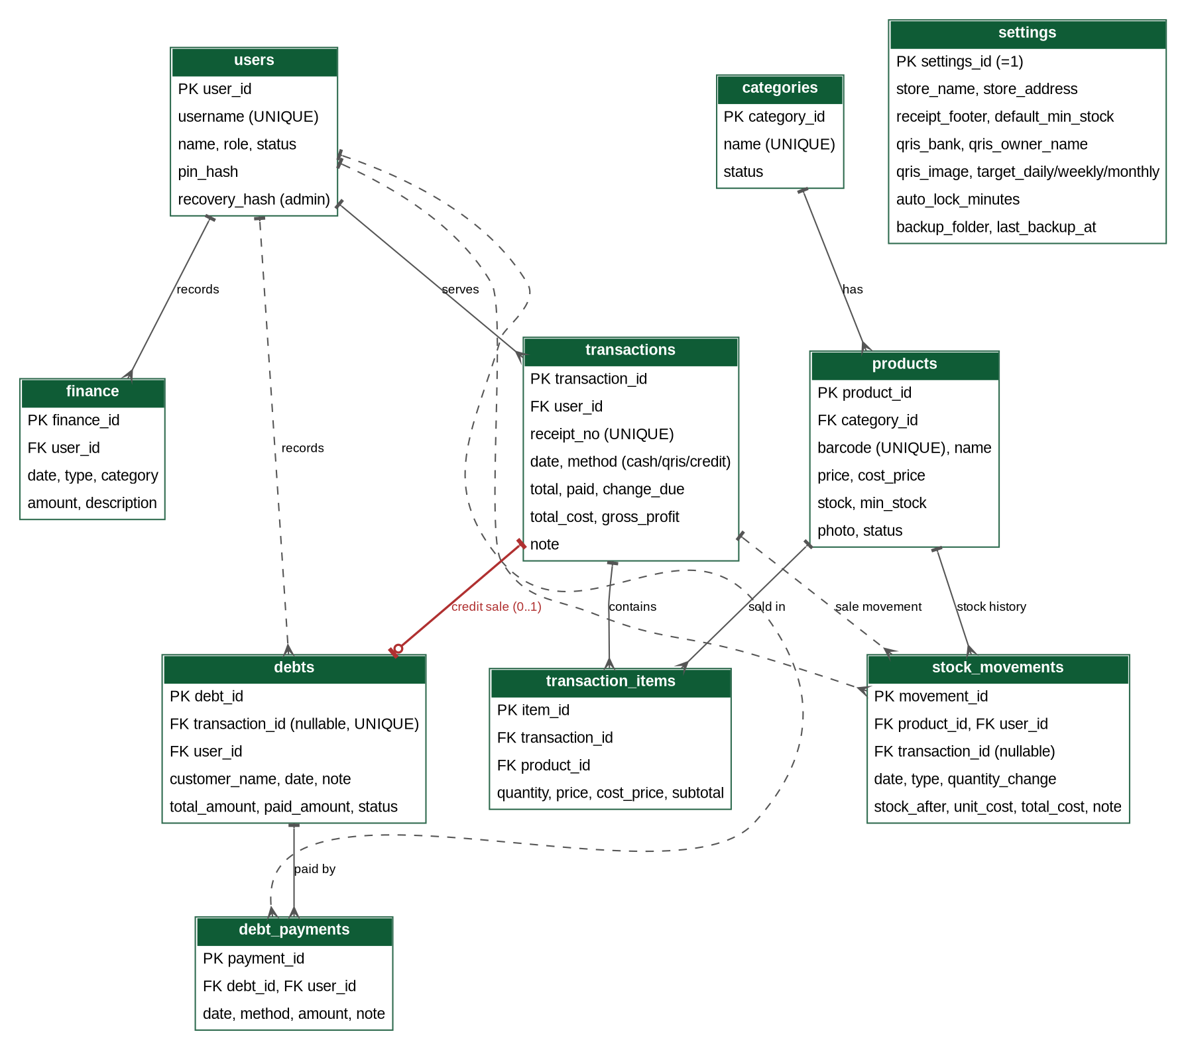
Figure 4. ERD of the Kharismart Cashier, Finance, and Stock Management System

3.3.2 Data Dictionary
The database is created by the application on first start (and updated through numbered Room migrations when the application is updated). Primary keys are autoincrement integers, foreign keys are enforced (PRAGMA foreign_keys = ON; ON UPDATE CASCADE, ON DELETE RESTRICT) so that data that is still referenced cannot be deleted. Monetary values and quantities are stored as whole integers (no decimals) to avoid rounding errors. SQLite has no separate boolean, date, or enumeration types: booleans are INTEGER (1 = yes, 0 = no), dates and times are TEXT in ISO 8601 format (yyyy-MM-dd HH:mm:ss, WIB), and restricted values are TEXT with a CHECK constraint. The stock column has a CHECK constraint (stock ≥ 0). Additional indexes: transactions(date), finance(date), stock_movements(product_id, date), transaction_items(transaction_id), products(category_id), and debts(status).
Table 12. users table (D4)
Field | Data Type (SQLite/Room) | Key | Required | Description
user_id | INTEGER (autoincrement) | PK | Yes | Unique user ID.
username | TEXT | UNIQUE | Yes | Account name for login.
pin_hash | TEXT | - | Yes | Salted hash of the user’s PIN (4–6 digits); the PIN itself is never stored.
name | TEXT | - | Yes | Full name of the user.
role | TEXT (CHECK: admin / cashier) | - | Yes | User role (admin has all cashier rights).
status | INTEGER (0/1) | - | Yes | 1 = active account (default 1).
recovery_hash | TEXT | - | No | Salted hash of the one-time recovery code (admin account only), used to reset the admin PIN.
Table 13. categories table (D7)
Field | Data Type (SQLite/Room) | Key | Required | Description
category_id | INTEGER (autoincrement) | PK | Yes | Unique category ID.
name | TEXT | UNIQUE | Yes | Category name (initially Sembako, Jajanan, Rokok, Kebutuhan Harian).
status | INTEGER (0/1) | - | Yes | 1 = active (default 1).
Table 14. products table (D1)
Field | Data Type (SQLite/Room) | Key | Required | Description
product_id | INTEGER (autoincrement) | PK | Yes | Unique product ID.
barcode | TEXT | UNIQUE | No | Barcode of the product; empty for products without a barcode.
name | TEXT | - | Yes | Name of the product.
category_id | INTEGER | FK | Yes | Refers to categories.category_id.
price | INTEGER | - | Yes | Unit selling price (Rupiah), > 0.
cost_price | INTEGER | - | Yes | Unit cost price (Rupiah), ≥ 0; never sent to the cashier.
stock | INTEGER | - | Yes | Current recorded stock, ≥ 0 (default 0).
min_stock | INTEGER | - | No | Minimum stock; empty = use settings.default_min_stock.
photo | TEXT | - | No | Name of the photo file in the application’s private storage.
status | INTEGER (0/1) | - | Yes | 1 = active/can be sold (default 1).
Table 15. transactions table (D2)
Field | Data Type (SQLite/Room) | Key | Required | Description
transaction_id | INTEGER (autoincrement) | PK | Yes | Unique transaction ID.
user_id | INTEGER | FK | Yes | Refers to users.user_id: the user who served the transaction.
receipt_no | TEXT | UNIQUE | Yes | Receipt number TRX-yyyymmdd-nnn (sequential per day).
date | TEXT (ISO 8601) | - | Yes | Time the transaction is saved.
method | TEXT (CHECK: method IN ('cash', 'qris', 'credit')) | - | Yes | Payment method: cash, QRIS, or credit (utang).
total | INTEGER | - | Yes | Transaction total (Rupiah).
paid | INTEGER | - | Yes | Amount paid (cash: amount received; QRIS: equal to total; credit: always 0).
change_due | INTEGER | - | Yes | Change returned (cash: paid − total; QRIS and credit: 0).
total_cost | INTEGER | - | Yes | Sum of (cost price × quantity) of all items.
gross_profit | INTEGER | - | Yes | total − total_cost (can be negative).
note | TEXT | - | No | Additional note.
Table 16. transaction_items table (D3)
Field | Data Type (SQLite/Room) | Key | Required | Description
item_id | INTEGER (autoincrement) | PK | Yes | ID of the item detail row.
transaction_id | INTEGER | FK | Yes | Refers to transactions.transaction_id.
product_id | INTEGER | FK | Yes | Refers to products.product_id.
quantity | INTEGER | - | Yes | Item quantity (> 0).
price | INTEGER | - | Yes | Selling price at the time of the transaction.
cost_price | INTEGER | - | Yes | Cost price at the time of the transaction.
subtotal | INTEGER | - | Yes | price × quantity.
Table 17. stock_movements table (D8)
Field | Data Type (SQLite/Room) | Key | Required | Description
movement_id | INTEGER (autoincrement) | PK | Yes | Unique movement ID.
product_id | INTEGER | FK | Yes | Refers to products.product_id.
user_id | INTEGER | FK | Yes | Refers to users.user_id: the user who caused or recorded the change.
transaction_id | INTEGER | FK | No | Refers to transactions.transaction_id for a sale movement.
date | TEXT (ISO 8601) | - | Yes | Time of the stock change.
type | TEXT (CHECK: initial / restock / sale / adjustment) | - | Yes | Type of stock change.
quantity_change | INTEGER | - | Yes | Signed change (+ increases, − decreases); never 0.
stock_after | INTEGER | - | Yes | Stock after this change.
unit_cost | INTEGER | - | No | Unit purchase cost (restock only).
total_cost | INTEGER | - | No | quantity × unit_cost (restock only); counted as a goods purchase.
note | TEXT | - | No | Reason or note (required for an adjustment).
Table 18. debts table (D9)
Field | Data Type (SQLite/Room) | Key | Required | Description
debt_id | INTEGER (autoincrement) | PK | Yes | Unique debt ID.
transaction_id | INTEGER | FK, UNIQUE | No | Refers to transactions.transaction_id: filled for a debt created by a POS credit sale (at most one debt per transaction); NULL for a manual debt note. Rule: FOREIGN KEY (transaction_id) REFERENCES transactions(transaction_id) ON DELETE RESTRICT.
user_id | INTEGER | FK | Yes | Refers to users.user_id: the user who recorded the debt note.
customer_name | TEXT | - | Yes | Name of the customer who owes (for a POS sale, taken from the sale).
date | TEXT (ISO 8601) | - | Yes | Date the debt arose (for a POS sale: the sale time).
total_amount | INTEGER | - | Yes | Total debt (Rupiah), > 0 (for a POS credit sale: equal to the transaction total).
paid_amount | INTEGER | - | Yes | Total paid through debt payments (default 0).
status | TEXT (CHECK: unpaid / paid) | - | Yes | unpaid = Belum lunas; paid = Lunas (default unpaid).
note | TEXT | - | No | Additional note (for a POS sale: the optional due date/note entered at checkout).
Table 19. debt_payments table (D10)
Field | Data Type (SQLite/Room) | Key | Required | Description
payment_id | INTEGER (autoincrement) | PK | Yes | Unique payment ID.
debt_id | INTEGER | FK | Yes | Refers to debts.debt_id.
user_id | INTEGER | FK | Yes | Refers to users.user_id: the user who received the payment.
date | TEXT (ISO 8601) | - | Yes | Time the payment is received.
method | TEXT (CHECK: cash / qris) | - | Yes | How the payment was received.
amount | INTEGER | - | Yes | Amount paid (Rupiah), > 0.
note | TEXT | - | No | Additional note.
Table 20. finance table (D6)
Field | Data Type (SQLite/Room) | Key | Required | Description
finance_id | INTEGER (autoincrement) | PK | Yes | Record ID.
user_id | INTEGER | FK | Yes | Refers to users.user_id: the user who recorded it.
date | TEXT (ISO 8601) | - | Yes | Date and time of the event.
type | TEXT (CHECK: income / expense) | - | Yes | Type of record.
category | TEXT | - | Yes | E.g. Electricity, Stall rental, Packaging, Salaries.
amount | INTEGER | - | Yes | Amount (Rupiah), > 0.
description | TEXT | - | No | Additional notes.
Table 21. settings table (D5)
Field | Data Type (SQLite/Room) | Key | Required | Description
settings_id | INTEGER | PK | Yes | Always has the value 1 (a single configuration row).
store_name | TEXT | - | Yes | Store name on the receipt.
store_address | TEXT | - | No | Address on the receipt.
receipt_footer | TEXT | - | No | Closing text of the receipt.
default_min_stock | INTEGER | - | Yes | Default minimum stock (initial proposal 5).
qris_bank | TEXT | - | No | Bank or m-banking application of the QRIS account.
qris_owner_name | TEXT | - | No | Account owner name shown with the QRIS.
qris_image | TEXT | - | No | Name of the QRIS image file in the application’s private storage; empty = QRIS not configured.
target_daily | INTEGER | - | No | Daily revenue target (Rupiah); empty = no target.
target_weekly | INTEGER | - | No | Weekly revenue target (Rupiah).
target_monthly | INTEGER | - | No | Monthly revenue target (Rupiah).
auto_lock_minutes | INTEGER | - | Yes | Idle minutes before the application locks (default 5).
backup_folder | TEXT | - | No | Android reference to the folder chosen for backups; empty = no automatic backup.
last_backup_at | TEXT (ISO 8601) | - | No | Time of the last successful backup.

3.4 Non-Functional Requirements
The following non-functional requirements are formulated with verifiable measures. Normal conditions are defined as: a tablet with Android 8.0 or higher and at least 3 GB RAM, in good condition and charged, one user signed in at a time, at most 1.000 active products, and at most 3.000 transactions, 1.000 financial records, and 5.000 stock movements in the report period.
Table 22. Non-functional requirements
Code | Category | Requirement (measurable)
NF01 | Performance | Under normal conditions, the product list is displayed in ≤ 1 second, a barcode typed by the hardware scanner puts its product in the cart in ≤ 1 second (≤ 2 seconds with the camera), and transaction saving (F08) completes with confirmation in ≤ 2 seconds, each in at least 95% of attempts; the subtotal, total, and change are updated in ≤ 0,5 seconds.
NF02 | Performance | A one-month report (≤ 3.000 transactions, ≤ 1.000 financial records, and ≤ 5.000 stock movements) is displayed in ≤ 5 seconds, also when the database holds three years of history (about 220.000 transactions).
NF03 | Capacity | The system stores at least 1.000 active products, 200 transactions per day, and three years of history (about 220.000 transactions) without errors, and the database file stays below 200 MB.
NF04 | Operating mode and location adaptation | The application works completely offline: no Wi-Fi or internet is needed for any function (internet is only used if the admin chooses a cloud-drive folder for backups or shares a report). If the tablet fails, the shop uses manual record-keeping in a book until the last backup is restored on a repaired or replacement tablet; the transactions in the book are entered afterward. All times use WIB (Asia/Jakarta), the currency is Rupiah, the language is Indonesian, and the date format is dd/mm/yyyy; the store name, address, receipt text, and QRIS account are taken from the settings.
NF05 | Usability | After an orientation of ≤ 30 minutes, a new cashier completes a 3-item cash sale using the hardware scanner in ≤ 45 seconds and ≤ 8 taps without help, in at least 4 of 5 test attempts. Touch targets are at least 48 dp, the Complete Transaction button is contrasting and separate from navigation, 100% of transaction completion and deletion actions ask for confirmation, and the scan field keeps the focus after each of 20 consecutive scans.
NF06 | Compatibility and responsiveness | The application runs on Android 8.0 (API 26) and higher on tablets of 7–11 inches and on phones from 360 dp wide, in portrait and in landscape orientation without hiding key information (totals, stock status, buttons); rotating the screen keeps the cart and unsaved input in 100% of test cases; it works with at least one USB and one Bluetooth barcode scanner in keyboard mode, and on at least three devices or emulators with different versions (for example Android 8, 11, and 14).

3.5 Software Quality Attributes
Table 23. Software quality attributes
Code | Attribute | Requirement (measurable)
NF07 | Basic data protection and access control | PINs and the recovery code are stored only as salted hashes (no plain PIN in the database or in a backup file). In the access test, 100% of the admin-only screens and functions are unavailable in the cashier role, and the cashier’s screens show no cost price, profit, or finance data. The application locks after the idle time set in the settings (default 5 minutes, tolerance ± 10 seconds) and on request, and waits 30 seconds after 5 wrong PIN attempts. Photos and the QRIS image are accepted only as png/jpg of at most 1 MB. The camera permission is requested only when scanning. The database and backup files are not encrypted and access control is trust-based; this is an accepted risk because all users are family members and the data is not highly sensitive (Sections 2.4 and 3.6).
NF08 | Reliability | Transaction saving (including the debt note of a credit sale), restock, adjustment, and debt payment saving use database transactions (COMMIT/ROLLBACK) so they are all-or-nothing, and the Complete Transaction button is disabled while saving. In a test of 100 transactions, with the application force-closed or the tablet powered off at random moments during saving, no transaction is duplicated or partially saved, stock never becomes negative, and for every product the stock equals the sum of its stock movements; in 100% of test transactions gross profit equals total minus total cost, and the cash balance in the report equals the components in BR-14.
NF09 | Backup, recovery, and availability | A manual backup of a database of 50 MB completes in ≤ 30 seconds; the automatic daily backup runs within one hour of its scheduled time while the tablet is on and keeps the last 30 files; a reminder appears after 3 days without a backup; a restore completes in ≤ 5 minutes, also on a different tablet; in 100% of tests a damaged or foreign file is rejected without changing the current data, and a restore that fails halfway puts the safety copy back. The maximum data loss is 24 hours (the interval between daily backups). Availability depends on the tablet and its power supply: at least 99% of the operating hours over a test period of 2 weeks with the tablet kept charged.
NF10 | Maintainability | The code separates the screens, the business logic, and the data access (Room) into separate packages; the database schema has a version number and numbered migrations, and an application update keeps all existing data (migration test); every F requirement has a screen or function listed in the traceability matrix.
NF11 | Portability (reuse) | The application can be installed on another tablet and the data restored from a backup in ≤ 1 hour; a different mart can be set up with the first-start setup and by changing the categories, products, users, and settings in ≤ 2 hours without changing the code.
NF12 | Learnability | The admin (not a programmer) can add a product, record a restock, register a cashier, view the daily report, and make and restore a backup (on a test tablet), and the cashier can complete a QRIS sale and a credit sale and record a debt payment, each without help after reading a brief guide, in at least 4 of 5 test attempts.

3.6 Design Constraints
Aspect | Constraint
Technology | Specified: a standalone Android application in Kotlin (minimum Android 8.0/API 26) with a local SQLite database accessed through Room; hardware barcode scanner in keyboard mode with camera scanning as a fallback. There is no server. The application is distributed as an installable APK; publication on Google Play is not required.
Hardware and installation | One tablet at the counter that stays charged during operating hours, a USB or Bluetooth barcode scanner, and a USB drive, SD card, or cloud-drive folder for backups. The tablet model and the scanner need to be validated by the owner (Appendix F).
Database | All tables use foreign keys, and multi-table saves use database transactions (COMMIT/ROLLBACK). Schema changes are made only through numbered Room migrations and are recorded in the documentation.
Payment | Cash, static QRIS, and Credit/Pay Later (utang) are supported. QRIS uses the owner’s static QRIS image and the cashier’s manual confirmation. A credit sale reduces the stock, issues a receipt, and creates a linked debt note; there is no credit limit, interest, or due-date reminder (the due date/note is informational). There is no payment gateway, e-wallet, or card integration, and no standalone supplier credit.
Finance and stock | Quantities are whole numbers. Stock is recorded per product with movements; a sale is rejected if the quantity exceeds the recorded stock. The system is not a replacement for bookkeeping or tax reporting, and discounts, taxes, returns, and supplier debts are not covered.
Data protection (accepted risk) | The data exists only on the tablet. Loss of the tablet or its data is mitigated only by backups, so backups must be kept outside the tablet. Access control is trust-based: PINs are hashed, the cashier’s screens hide cost prices, profit, and finance, and the application auto-locks, but the database and backups are not encrypted. This is accepted because all users are family members and the data is not highly sensitive.
Remote access | The owner cannot view live data from another device. Reports can be exported as PDF/CSV and shared, or a backup can be restored on another device to view the data; synchronization with other devices is not provided in this version.
Business coverage | The system is prioritized for one store, namely Toko Kharisma as a case study, but can be reused by similar small marts by changing the categories, products, users, and settings. One installation (one tablet) serves one store.
Language and format | The interface is in Indonesian; Rupiah format, dd/mm/yyyy dates, and the WIB time zone.

4. TRACEABILITY MATRIX
The traceability matrix links problems, requirements, and verification methods. Verification methods are grouped according to GL01A: Inspection (examination of documents/code/data), Analysis (calculation or tracing of logic/data), and Demonstration (operation of the system). The type of technical test is stated in the Test Type column.

4.1 Traceability of Problems to Requirements
Table 24. Traceability from problems to requirements
Problem Code | Identified Problem | Related Requirements
M01 | Order calculation and item entry at the counter are still manual, slow, and prone to human error. | F05, F06, F07, F08, NF01, NF05
M02 | Transaction recording and the recapitulation of reports are still manual and take a long time. | F08, F09, F10, F15
M03 | Stock data does not match the goods in the store, and low stock is not noticed early. | F04, F08, F11, F12, NF08
M04 | Selling prices and cost prices are not recorded and updated in one place. | F03, F04
M05 | Customer debts (utang) are not recorded systematically. | F07, F08, F13
M06 | Profit, expenses, and the cash position are hard to know by day, week, month, and category. | F04, F11, F14, F15, NF08
M07 | Digital payments by QRIS are not recorded per transaction. | F07, F08, F15, F17
M08 | Business data may only be accessed by authorized people, with different rights for the owner and the helper (derived requirement). | F01, F02, NF07
M09 | The owner needs a quick overview of today’s performance, low stock, and debts (derived from the prototype). | F12, F16
M10 | The business data exists only on the counter tablet and could be lost if the tablet fails (derived requirement). | F18, NF09

4.2 Verification of Functional Requirements
Table 25. Traceability matrix of functional requirements
Code | Feature | GL01A Category | Test Type | Test Scenario
F01 | Login and access rights | Demonstration | Security test | Correct and incorrect PIN; an inactive account is rejected; after 5 wrong PINs the lock screen waits 30 seconds; the application locks after the idle time and with Lock now; changing a PIN works only with the current PIN and the new PIN must be 4–6 digits; the recovery code resets the admin PIN; in the cashier role the admin-only screens and functions are not available and no cost price, profit, or finance data is shown; the PINs in the database and in a backup file are only hashes.
F02 | Manage users | Demonstration | Functional test | The admin registers a cashier (kasir1); a duplicate username and a 3-digit PIN are rejected; a reset PIN works at the next sign-in; a deactivated cashier cannot sign in; deactivating the last active admin is rejected; the user screens are not available to the cashier.
F03 | Manage categories | Demonstration | Functional test | Add a category; a duplicate name is rejected; rename; deactivating a category that still has active products is rejected.
F04 | Manage products and prices | Demonstration | Functional test | Add Indomie Goreng (price 3.500, cost 3.000, stock 40, with barcode); a duplicate barcode and price 0 are rejected; price 2.500 with cost 3.000 raises a warning; change Minyak Goreng price from 18.000 to 19.000: new transactions use 19.000, old ones remain 18.000; the initial stock creates an initial movement; a product with history can only be deactivated; the cashier sees products and stock but the cost price is not shown.
F05 | Search and scan products | Demonstration | Functional test | Scan the Indomie Goreng barcode with the hardware scanner: the product is added in ≤ 1 second and the scan field stays focused for 20 consecutive scans; scan with the camera as a fallback in ≤ 2 seconds; an unregistered barcode offers registration to the admin and shows the “ask the admin” message to the cashier; an inactive product is not offered; with the camera permission denied, the scanner and name search still work.
F06 | Cart and automatic total | Demonstration | Functional test | Add Indomie Goreng × 4, Minyak Goreng 1 L × 1, and Gula Pasir 1 kg × 1: total 49.000 appears instantly; edit and delete items; quantity 0 is rejected; a quantity above the stock is rejected; scanning the same product again adds 1.
F07 | Payment, change, QRIS, and credit | Demonstration | Negative test | Cash payment of 50.000 for a total of 49.000: change 1.000; payment of 45.000 is rejected. QRIS: with no QRIS image configured the message appears; with it configured the QRIS image and total are displayed; completing without the confirmation is rejected; after the confirmation paid = total and change = 0. Credit: with no (or a blank) customer name the sale is rejected; with the customer ‘Bu Hirah’ the 3-item sale (Indomie Goreng × 4, Minyak Goreng 1 L × 1, Gula Pasir 1 kg × 1, total 49.000) shows Paid Rp0, Change Rp0, Remaining Rp49.000, and the credit confirmation message.
F08 | Complete transaction | Demonstration | Integration test | The button raises a confirmation; after Yes, the transaction, items, stock deduction (Indomie Goreng 40 to 36), stock movements, total cost 44.000, gross profit 5.000, the serving user, and receipt number TRX-yyyymmdd-001 are saved; a double tap on the button creates one transaction; force-closing the application during saving leaves no partial data. Credit: the 3-item sale on credit to Bu Hirah saves the transaction with method credit (paid 0, change 0), deducts the stock (Indomie Goreng 40 to 36), issues a receipt TRX-yyyymmdd-nnn, lists the items in the history, and creates a debt note under Bu Hirah (total 49.000, paid 0, unpaid) linked to the transaction; the sale does not raise the cash balance until a settlement payment is logged (a cash payment of 10.000 then raises it by 10.000); a failure while writing the debt note leaves no transaction, no stock change, and no debt note.
F09 | Receipt | Inspection | Functional test | The receipt contains the receipt number, cashier, details, total, method, paid, and change; a reprint from history is marked Copy; sharing as PDF works.
F10 | Transaction history | Demonstration | Functional test | The admin filters by week and by method QRIS and sorts total descending and date ascending; transaction items are shown under each transaction; the cashier sees only today’s transactions, and earlier dates are not offered.
F11 | Restock and stock adjustment | Demonstration | Integration test | Restock Minyak Goreng +24 at unit cost 16.800 with the update option: stock 5 to 29, cost price 16.500 to 16.800, movement total cost 403.200; adjustment to a counted 27 with reason “Damaged”: movement −2 and stock 27; an adjustment without a reason and one with no difference are rejected; the stock history lists all movements; these screens are not available to the cashier.
F12 | Stock status and low-stock alert | Demonstration | Functional test | With the default minimum 5: stock 6 is Aman, 5 is Menipis, 0 is Habis; a product-specific minimum overrides the default; the Low-Stock List is sorted by stock ascending; the dashboard shows the first three products and the notice count, for both roles.
F13 | Debt notes | Demonstration | Functional test | The list shows the debt of Bu Hirah (49.000) with “Origin: POS Sale (TRX-yyyymmdd-nnn)” and a manual note of Pak Eko (20.000) with “Origin: Manual Entry”; the shortcut opens the receipt and items of the POS sale; a cash payment of 10.000 on Bu Hirah leaves 39.000 and the status stays Belum lunas; a QRIS payment without the confirmation is rejected; a payment of 39.000 sets Lunas; a payment above the remaining is rejected; the cashier cannot edit or delete (not offered); a POS debt cannot be deleted even by the admin (reconciliation only), while the admin can delete a manual note without payments but not one with payments.
F14 | Manual income and expense records | Demonstration | Functional test | Record a packaging expense of 10.000 and a stall rental income of 100.000: the net profit and cash balance change accordingly; amount 0 is rejected; edit and delete (with confirmation) recalculate the figures; these screens are not available to the cashier.
F15 | Finance and sales reports | Analysis | Integration test | In one period: a cash sale of 49.000 (cost 44.000), a QRIS sale of 30.000 (cost 26.000), a credit sale of 49.000 to Bu Hirah (cost 44.000), an existing manual debt note of 20.000 (Pak Eko), a cash debt payment of 10.000 on Bu Hirah’s debt, an expense of 10.000, and a restock purchase of 30.000: revenue 128.000, gross profit 14.000, cash received 59.000, QRIS received 30.000, net profit 4.000, cash balance 49.000 (the credit sale adds nothing until it is paid), outstanding debt 59.000. With a daily target of 500.000 and a revenue of 175.000 the progress is 35%. Sales per category and per product match the manual calculation; sorting by profit works; the PDF and CSV exports open correctly; the report screens are not available to the cashier.
F16 | Dashboard | Demonstration | Functional test | Admin: today’s revenue 110.000 against yesterday’s 100.000 shows +10%; yesterday 0 shows “—”. Cashier: the dashboard shows no revenue and profit. Both: the low-stock and debt lists show the first three entries with Lihat Semua.
F17 | Store and QRIS settings | Demonstration | Functional test | Change the store name and receipt footer: new receipts follow without changing code; upload a QRIS image (a file above 1 MB is rejected) and see it at the QRIS payment; the default minimum stock 5 to 10 changes the status of products that have no own minimum; the auto-lock time 5 to 2 minutes takes effect; a negative target is rejected; a change applies only to new transactions; the settings screens are not available to the cashier.
F18 | Backup and restore | Demonstration | Recovery test | Back up now to a USB folder: a .zip with the database, photos, QRIS image, and info file is created and the dashboard shows the last backup time; with the folder chosen, the automatic daily backup is created and only the last 30 files remain; with no backup for 3 days the reminder appears on the admin dashboard; delete some test data, then restore the file (also on a different tablet): all data returns, users and PINs included; a random file, a damaged zip, and a backup from a newer version are rejected with the current data unchanged; a restore that is interrupted puts the safety copy back; the backup screens are not available to the cashier.

4.3 Verification of Non-Functional Requirements
Table 26. Traceability matrix of non-functional requirements
Code | Attribute | GL01A Category | Test Type | Criteria / Scenario
NF01 | Performance | Demonstration | Performance test | Measure the product list load time, the scanner-to-cart time, the camera-to-cart time, and the transaction save time over 20 attempts each (at least 19 must comply); change an item quantity and measure the total update ≤ 0,5 seconds.
NF02 | Performance | Demonstration | Performance test | Load a one-month report with 3.000 test transactions, 1.000 test financial records, and 5.000 stock movements, in a database that also holds three years of test history; time ≤ 5 seconds.
NF03 | Capacity | Demonstration | Load test | Generate 220.000 test transactions (three years at 200 per day) with 1.000 active products; check that no errors occur, the database file stays below 200 MB, and the main screens still respond within the NF01 limits.
NF04 | Operating mode and location | Inspection | Inspection | Switch off Wi-Fi and mobile data and run all functions (all must work); check the written emergency procedure, the WIB time zone, the Rupiah/date format, and the receipt text and QRIS account from the settings.
NF05 | Usability | Demonstration | User test | Five testers complete a 3-item cash sale using the hardware scanner after a 30-minute orientation; at least 4 succeed in ≤ 45 seconds and ≤ 8 taps; measure that touch targets are ≥ 48 dp, all completion/delete actions ask for confirmation, and the scan field keeps the focus over 20 consecutive scans.
NF06 | Compatibility and responsiveness | Demonstration | Compatibility test | Install the application on tablets/emulators with Android 8, 11, and 14 and screen sizes from 360 dp wide to 11 inches; run the F05–F08 scenarios in portrait and landscape; rotate during a cart (the cart and input stay); test a USB and a Bluetooth scanner in keyboard mode.
NF07 | Basic data protection and access control | Demonstration | Security test | Open the database and a backup file and check that only PIN hashes exist; sign in as a cashier and try to reach every admin-only screen and function (all unavailable) and check that no cost price, profit, or finance data is shown; measure the auto-lock time (default 5 minutes ± 10 seconds) and the 30-second wait after 5 wrong PINs; upload a non-image file and an image above 1 MB (both rejected); check that the camera permission is requested only when scanning.
NF08 | Reliability | Demonstration | Integration test | Run 100 transactions, force-closing the application or switching the tablet off at random moments during saving: no duplicate or partial transaction; stock is never negative and equals the sum of the stock movements for every product; gross profit = total − total cost; the report’s cash balance matches BR-14.
NF09 | Backup, recovery, and availability | Demonstration | Recovery test | Time a manual backup of a 50 MB database (≤ 30 seconds) and a restore (≤ 5 minutes); check the daily automatic backup, the 30-file retention, and the 3-day reminder; restore on a different tablet; feed a random file, a damaged zip, and a backup from a newer version (all rejected with the data unchanged); interrupt a restore (the safety copy is put back); record the availability of the tablet over 2 weeks (≥ 99% of operating hours).
NF10 | Maintainability | Inspection | Code and document inspection | Check the separation of screens, logic, and Room data access; check that the schema has a version number and migrations; update the application to a newer test version and check that all data remains; check the mapping of F requirements to screens/functions.
NF11 | Reuse (reinstallation) | Demonstration | Installation test | Install the application on a second tablet and restore a backup (≤ 1 hour); on a clean tablet run the first-start setup and enter another mart’s categories, products, users, and settings; the system is ready to use in ≤ 2 hours without changing code.
NF12 | Learnability | Demonstration | User test | The admin adds a product, records a restock, registers a cashier, views the daily report, and makes and restores a backup on a test tablet; the cashier completes a QRIS sale and a credit sale and records a debt payment; each after reading a brief guide; at least 4 of 5 attempts succeed.

5. ADDITIONAL INFORMATION / APPENDICES

Appendix A. Interface Sketches (Mockups)
The following sketches are illustrative, to agree on the layout and flow; Figures 5–10 and 12 show the portrait layout and Figure 11 the landscape layout of the tablet; they follow the visual style of the Kharismart prototype, and the final visual design is determined at the design stage.
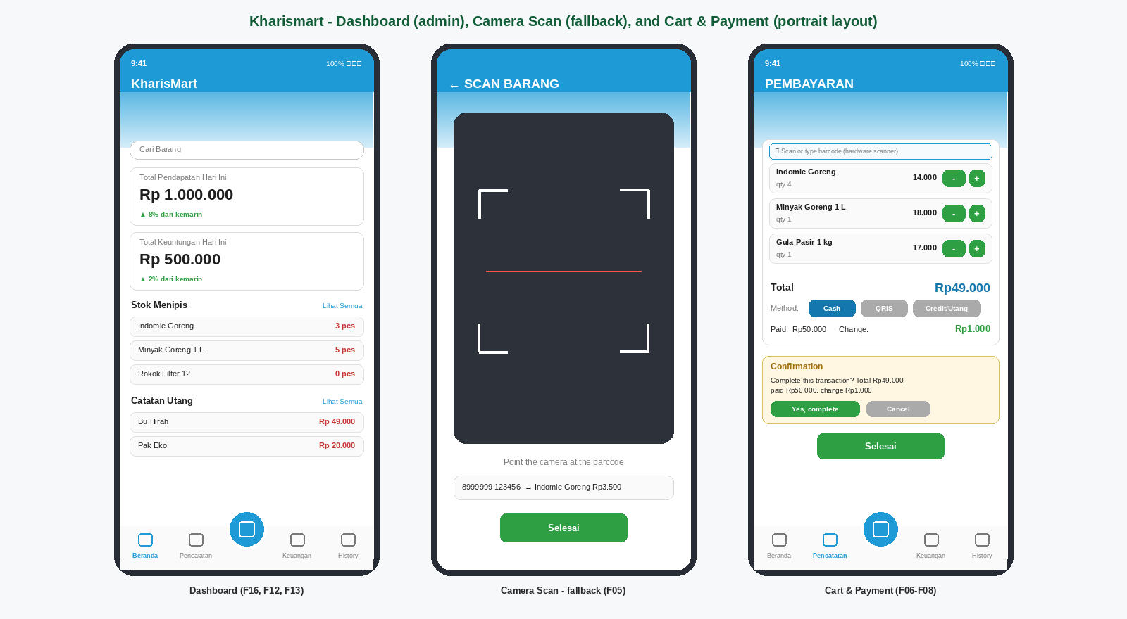
Figure 5. Sketch of the Dashboard (admin), Camera Scan (fallback), and Cart and Payment screens (portrait layout, with the Cash / QRIS / Credit selector and the confirmation dialog)
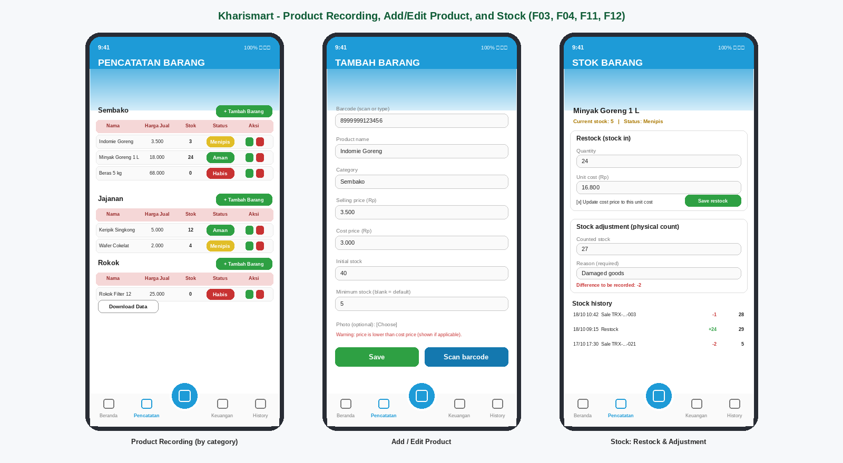
Figure 6. Sketch of the Product Recording, Add/Edit Product, and Stock (restock and adjustment) screens
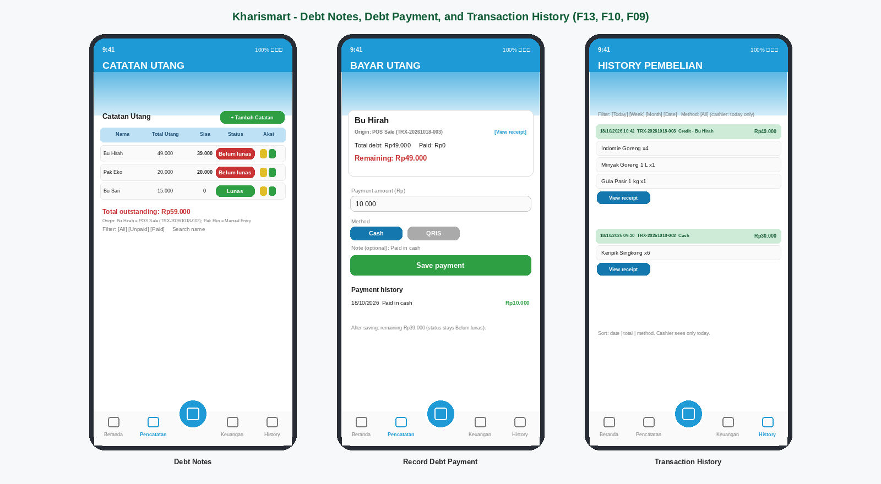
Figure 7. Sketch of the Debt Notes (with the origin of each debt), Debt Payment (with the receipt shortcut), and Transaction History (with a credit transaction) screens
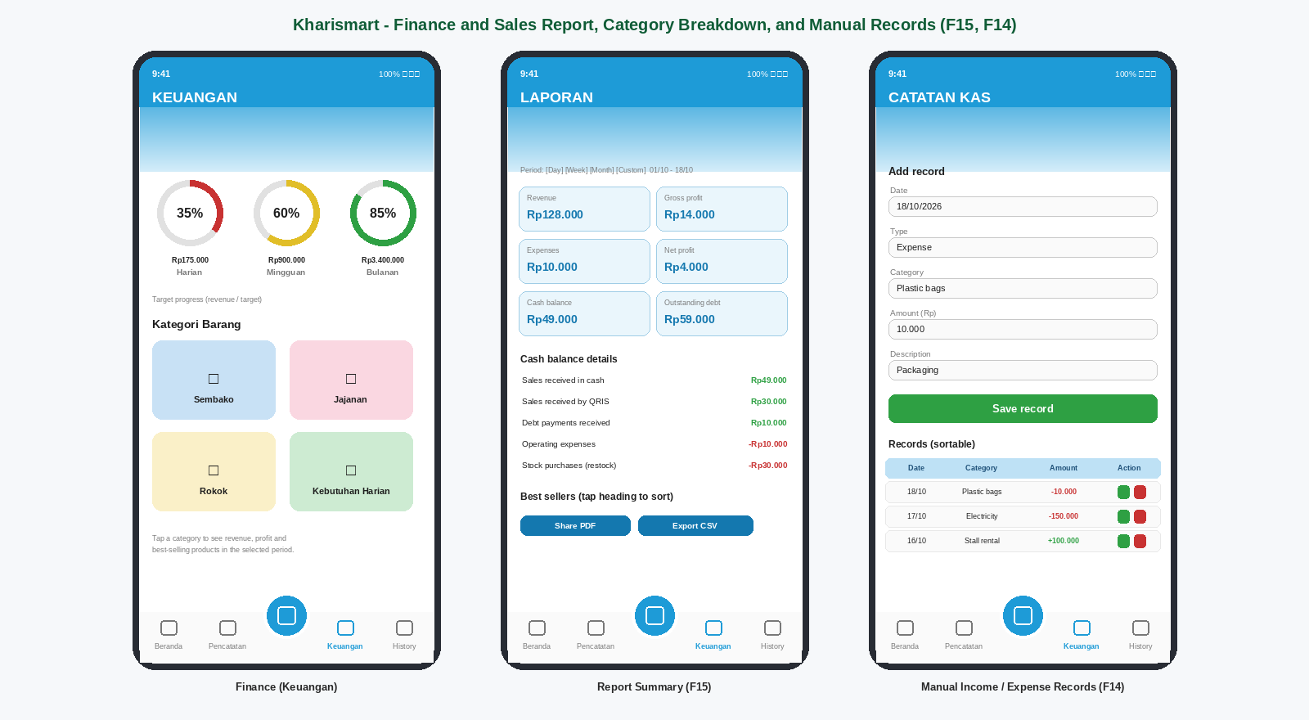
Figure 8. Sketch of the Finance, Report Summary, and Manual Income/Expense Records screens
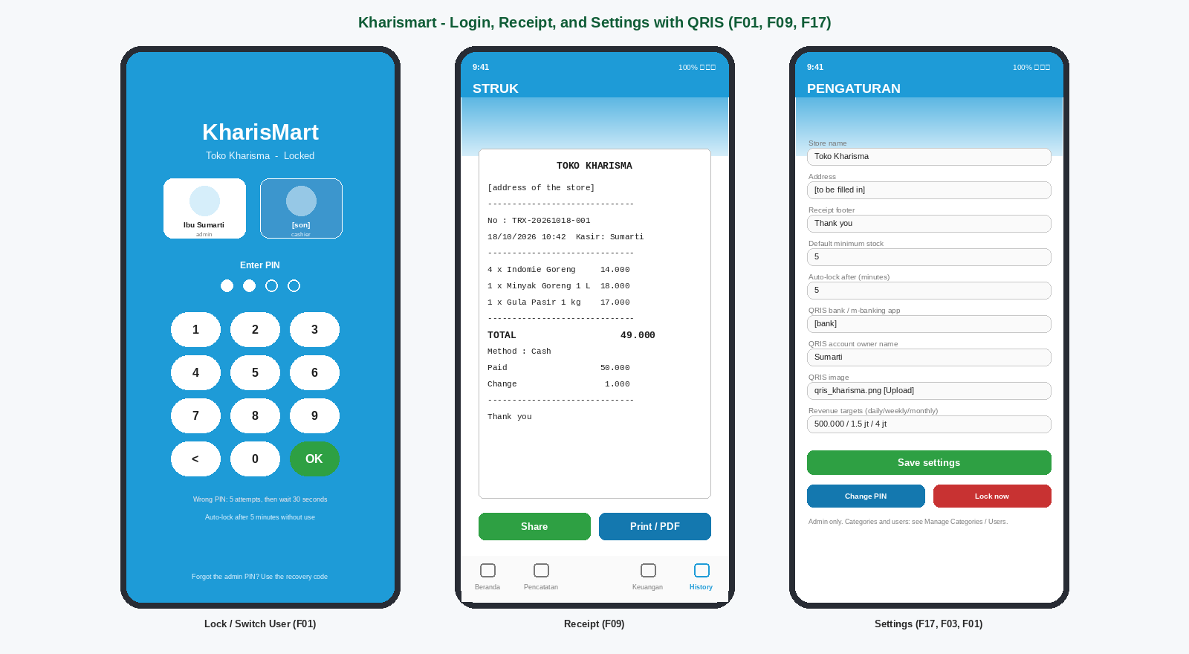
Figure 9. Sketch of the Lock/Switch User, Receipt, and Settings (with QRIS) screens
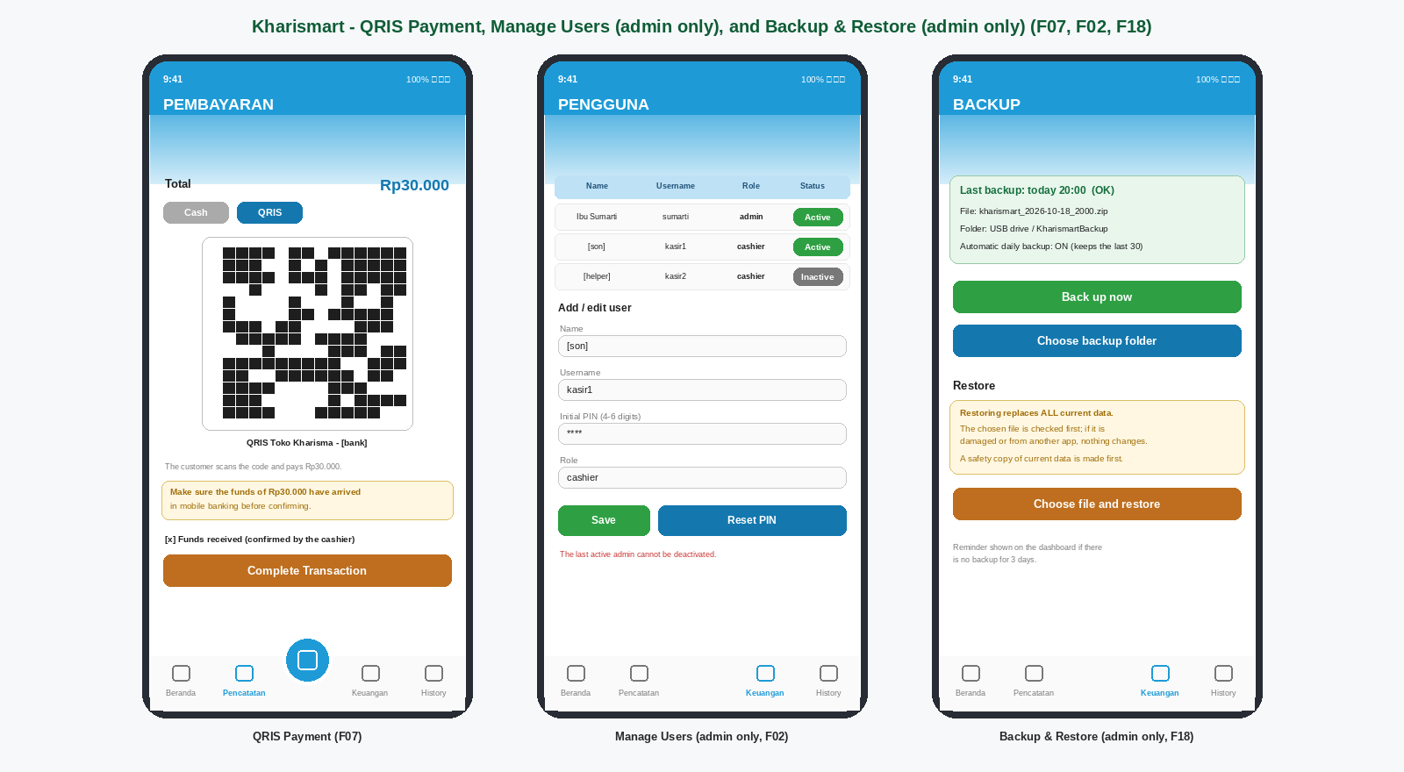
Figure 10. Sketch of the QRIS Payment, Manage Users, and Backup and Restore screens
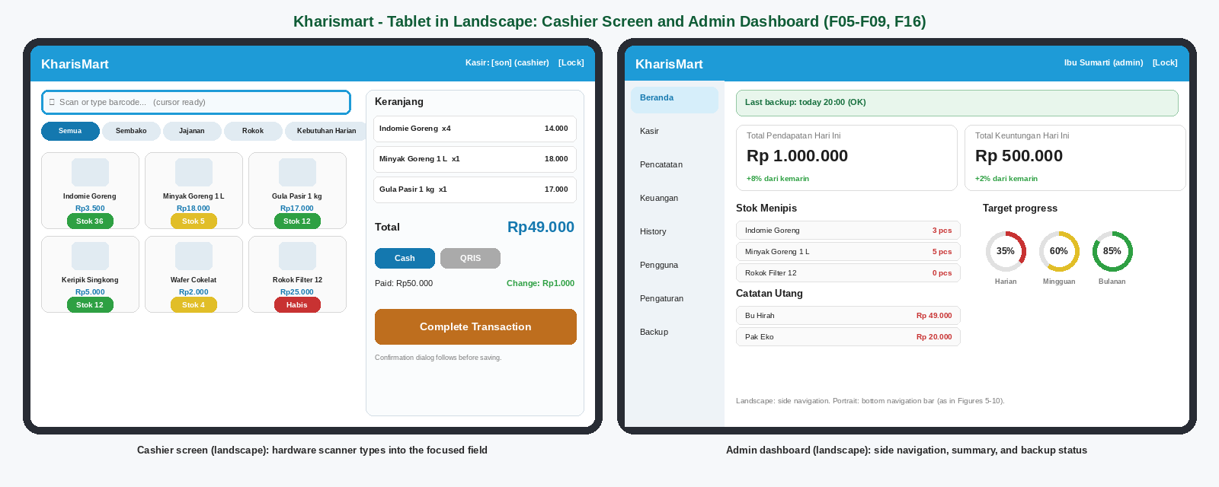
Figure 11. Sketch of the landscape tablet layout: Cashier screen with the hardware-scanner field and the Admin dashboard
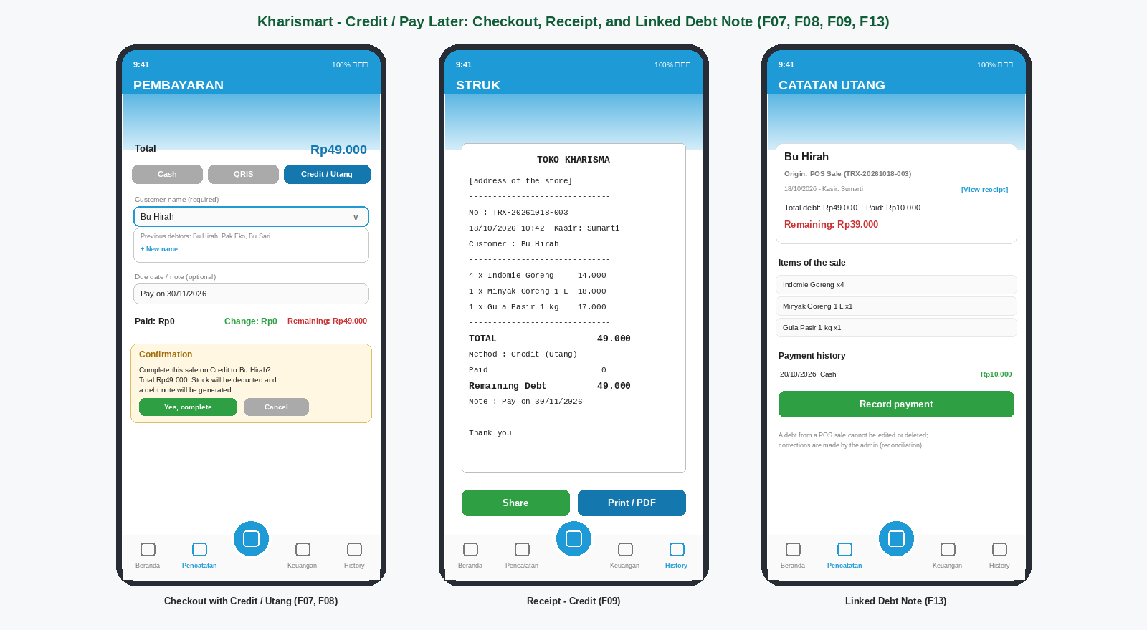
Figure 12. Sketch of the Credit / Pay Later checkout, the credit receipt, and the linked debt note

Appendix B. Concise DFD
Text representation of DFD Level 0:
[CASHIER] -> user choice and PIN, barcode (scanner) or search, quantities, payment method (cash/QRIS/credit)/amount,
customer name (credit), QRIS confirmation, sale confirmation, debt notes and payments -> (0 SYSTEM)
[ADMIN/OWNER] -> user choice and PIN, user/category/product/price/cost data, restock, stock adjustment,
manual income/expenses, settings and QRIS, report period, backup/restore commands
(+ all cashier inputs) -> (0 SYSTEM)

(0 SYSTEM) -> product info (no cost price), total, change, QRIS image, receipt, today's history,
stock status, debt list, cashier dashboard -> [CASHIER]
(0 SYSTEM) -> users, product info with cost price, full history, reports, admin dashboard,
backup status -> [ADMIN/OWNER]

[CUSTOMER] -> goods + payment, cash, QRIS, or credit (via the cashier) -> [CASHIER]
(0 SYSTEM) -> receipt (via the cashier) -> [CUSTOMER]
(0 SYSTEM) -> backup file, report PDF/CSV -> [BACKUP STORAGE] ; [BACKUP STORAGE] -> backup file (restore) -> (0 SYSTEM)
Internal data stores: D1 products, D2 transactions, D3 transaction_items, D4 users, D5 settings (single-row table), D6 finance, D7 categories, D8 stock_movements, D9 debts, D10 debt_payments.

Appendix C. Concise ERD
Main relationships:
CATEGORIES (1) ---< PRODUCTS (1) ---< TRANSACTION_ITEMS >--- (1) TRANSACTIONS
PRODUCTS (1) ---< STOCK_MOVEMENTS >--- (0..1) TRANSACTIONS
TRANSACTIONS (1) ---- (0..1) DEBTS (1) ---< DEBT_PAYMENTS
USERS (1) ---< TRANSACTIONS, STOCK_MOVEMENTS, DEBTS, DEBT_PAYMENTS, FINANCE
SETTINGS (stands alone)

users(user_id PK, username UK, name, role, status, pin_hash, recovery_hash)
categories(category_id PK, name UK, status)
products(product_id PK, barcode UK, name, category_id FK, price, cost_price, stock, min_stock, photo, status)
transactions(transaction_id PK, user_id FK, receipt_no UK, date, method, total, paid,
change_due, total_cost, gross_profit, note)
transaction_items(item_id PK, transaction_id FK, product_id FK, quantity, price, cost_price, subtotal)
stock_movements(movement_id PK, product_id FK, user_id FK, transaction_id FK, date, type,
quantity_change, stock_after, unit_cost, total_cost, note)
debts(debt_id PK, transaction_id FK UK nullable, user_id FK, customer_name, date, total_amount, paid_amount, status, note)
debt_payments(payment_id PK, debt_id FK, user_id FK, date, method, amount, note)
finance(finance_id PK, user_id FK, date, type, category, amount, description)
settings(settings_id PK=1, store_name, store_address, receipt_footer, default_min_stock, qris_bank,
qris_owner_name, qris_image, target_daily, target_weekly, target_monthly, auto_lock_minutes,
backup_folder, last_backup_at)

Appendix D. Initial System Data
Data | Example/Format | Status
Store name | Toko Kharisma | To be validated by the owner
Location | [address of Toko Kharisma] | To be filled in by the team
Categories | Sembako, Jajanan, Rokok, Kebutuhan Harian (can be added) | Based on the prototype; validated by the owner
Products, barcodes, prices, cost prices, stock | Name, barcode (optional), category, selling price and cost price in Rupiah, current stock, photo (optional) | To be prepared by the admin
Default minimum stock (proposed) | 5 units; can be overridden per product | Proposed; validated by the owner
QRIS account | Bank/m-banking app, account owner name, and the QRIS image | To be prepared by the owner
Revenue targets | Daily, weekly, and monthly targets in Rupiah (optional) | To be determined by the owner
Current customer debts | Customer name, amount, date | To be prepared by the owner
Expense categories | Electricity, Rent, Packaging, Salaries, Transport, Other | Can be adjusted
Receipt text | E.g. “Thank you” | Can be adjusted
User accounts | Ibu Sumarti (admin) and the owner’s son [name] (cashier), each with a PIN of 4–6 digits; more cashiers can be added by the admin; the admin’s recovery code is created at first setup | Created at first setup
Tablet and scanner | An Android tablet at the counter and a USB/Bluetooth barcode scanner in keyboard mode | To be validated by the owner
Backup folder | A folder on a USB drive, SD card, or cloud drive chosen by the admin | To be chosen by the admin

Appendix E. Data to Be Prepared by the Management
- A list of all products sold with barcodes (if available), the latest selling prices, cost prices, and current stock counts.
- Product photos (optional) and the product categories to be used.
- The minimum stock desired for the default and for important products.
- The QRIS image of the owner’s mobile banking account, the bank name, and the account owner name.
- A list of customers who currently owe the store, with the amounts owed.
- The list of expense categories commonly used and the revenue targets (if any).
- The store name, address, and the text desired on the receipt.
- The names of the people who will use the system (admin and cashiers) and the role of each.
- The Android tablet that will run the application, the USB/Bluetooth barcode scanner, a charger, and a USB drive, SD card, or cloud-drive folder for the backups.
- The PINs of the users and a safe place for the admin’s recovery code and for an extra copy of the backups.

Appendix F. Points to Be Validated
No | Validation Point | Party | Status | Date
1 | Store name and address, and ownership (Ibu Sumarti). | Owner | Not yet validated
2 | Product list, categories (are there more than Sembako, Jajanan, Rokok, Kebutuhan Harian?), barcodes, selling prices, cost prices, and current stock. | Owner | Not yet validated
3 | Division of access rights: the cashier cannot see cost prices, profit, finance, reports, users, settings, and backup, cannot manage products, restock, or edit/delete manual debt notes. Is this suitable (for example, may the cashier receive goods and record restocks)? | Owner | Not yet validated
4 | Users: the name of the owner’s son and any other cashier; the PINs; who keeps the admin recovery code. | Owner | Not yet validated
5 | Hardware: the tablet (model, Android version, 10 inches recommended) and the barcode scanner (USB or Bluetooth, keyboard mode) to be used at the counter. | Owner/Team | Not yet validated
6 | Backups: where the backup folder is (USB drive, SD card, or cloud drive), who checks the reminder, and where an extra copy is kept outside the shop. | Owner/Team | Not yet validated
7 | Accepted risks: the data exists only on the tablet and the database and backups are not encrypted (access is trust-based). Is this acceptable? Does the owner need to see live data on her own phone (excluded; only exported PDF/CSV or a restored backup)? | Owner | Not yet validated
8 | QRIS: the owner’s static QRIS, the bank, who checks the incoming-funds notification, and the manual confirmation by the cashier. | Owner | Not yet validated
9 | Decision: Credit payment method is enabled at POS; it decrements stock, issues a standard receipt, and generates an automatic linked debt entry. | Owner | Validated & Approved | 3 Nov 2026
10 | Stock rule: should a sale be rejected when the quantity exceeds the recorded stock, or should it be allowed with a warning? | Owner | Not yet validated
11 | Default minimum stock (5) and product-specific minimums; is an in-app alert enough, or are push notifications needed? | Owner | Not yet validated
12 | Meaning of the percentage rings on the Finance screen (assumed: revenue against a daily, weekly, and monthly target) and the target values. | Owner | Not yet validated
13 | The dashboard profit is the gross profit (price − cost price); the net profit in the report also subtracts expenses. Is this suitable? | Owner | Not yet validated
14 | Weighed or loose items (for example rice by the kilogram) are not supported; only whole quantities. Is this suitable? | Owner | Not yet validated
15 | Receipt: is sharing or saving as PDF enough, or is a Bluetooth thermal printer needed? Receipt format and text. | Owner | Not yet validated
16 | Features not included (transaction cancellation and returns, discounts, taxes, supplier management, multiple stores): are they indeed not needed? | Owner | Not yet validated
17 | The manual income and expense categories used. | Owner | Not yet validated
18 | Additional requirements not yet listed in the SRS. | Owner/Lecturer | Not yet validated
19 | Handling mistakes in POS credit sales (reconciliation): because a debt from a POS sale cannot be edited or deleted, how should a wrong customer name, a returned item, or an uncollectable debt be corrected? Are a credit limit, interest, or a due-date reminder needed? | Owner | Not yet validated

CLOSING
This SRS Revision B serves as the requirements reference for the design and development stages of the Kharismart Cashier, Finance, and Stock Management System for Toko Kharisma, an Android application for the owner (admin) and the cashier that covers the cashier with cash, QRIS, and credit (pay later) payment, debt notes, stock management, and sales and finance recap of a small mart. The requirements in this document and all points in Appendix F need to be reviewed and validated together with Ibu Sumarti before the document is approved. Any change to the requirements after the document is approved needs to be recorded as a revision so that the traceability of requirements and testing is maintained.

