
SOFTWARE REQUIREMENTS SPECIFICATION (SRS)
POINT-OF-SALE AND FINANCE SYSTEM
KEDAI PARADISE, PURBALINGGA
Document Number | SRS-KP-2026-01
Revision | D.2 (Clarifications: pagination, refunds, stale closing, printer, Tailwind)
Date | Early November 2026
Project Status | Analysis and Design Stage
Course | Software Development (PPL)
Study Program | Informatics

Prepared by Group 5 (Five)
Rio Alwi Syahputra — 244110601045
Abdulhamid Hilal Kabir — 244110601001
Aziz Febriyanto — 244110601011
Bandar Qaid Ahmed Abdulrab — 244110601013
Ariqoh Nahdif Febrians — 244110601008
Muhammad Faris Fadhilah — 244110601035

INFORMATICS STUDY PROGRAM
FACULTY OF SCIENCE AND TECHNOLOGY
STATE ISLAMIC UNIVERSITY PROF. K.H. SAIFUDDIN ZUHRI PURWOKERTO
2026

APPROVAL SHEET AND REVISION HISTORY
This SRS document was prepared as a continuation of the Group 5 PPL Case Study Report on the Kedai Paradise Point-of-Sale and Finance System, Purbalingga, and is used as a shared reference between the Development Team and the Management of Kedai Paradise. Revision D keeps the compact scope of Revision C (a small family-owned business) and integrates three changes: (1) the production environment is now strictly a hosted web cloud architecture accessed over HTTPS, while XAMPP/Laragon is retained only for development and offline staging; (2) transaction history, reports, and the manual ledger gain detailed ascending/descending sorting and dual export (Print/PDF and CSV); and (3) a menu modifiers and options engine (sizes, spice levels, toppings, and add-ons) with frozen price snapshots. The data model is expanded from six to nine tables in Revision D (and to eleven in Revision D.1), and the data flow diagrams, pseudo-code, interface sketches, and traceability matrices have been updated accordingly. Revision D.1 formally removes the mismatch between the specification and the database implementation: the persistent data model grows from nine to eleven tables (cash_closings and login_attempts); Admin-only full-order cancellation (void) with audit fields is added while partial refunds remain out of scope; a database-enforced unique daily order number is specified; login rate limiting protects the public login endpoint; and an end-of-day cash drawer closing audit is added. Revision D.2 adds the menu category with the cashier's filter pills, a stale-closing flag and a manual refund rule for voids, pagination of the history, and confirmed shop data (10 tables, operating hours 08:00 to 22:00 WIB), and refreshes the DFD, ERD, and interface figures.
Approval Sheet
Role | Name | Signature | Date
Prepared by | Abdulhamid Hilal Kabir (System Analyst)
Reviewed by | Rio Alwi Syahputra (Project Manager)
Approved by | Bapak Fajar (Owner/Admin of Kedai Paradise)
Approved by | Ibu Fitri (Admin of Kedai Paradise)
Evaluated by | Lecturer of the PPL Course
Revision History
Revision | Date | Description of Changes | Author
A | 28/09/2026 | Initial preparation of the SRS based on the observation results and the Case Study Report (23 September 2026). | Group 5
B | 13/10/2026 | Expanded scope (QRIS, order queue, stock, profit and fund allocation, business replication) and a Google Apps Script + Google Sheets architecture. | Group 5
C | 15/10/2026 | Simplification for a family business: 14 functional requirements (previously 26), 12 non-functional requirements (previously 20), and 6 data tables (previously 11); technology changed from Google Apps Script + Google Sheets to PHP, MySQL (phpMyAdmin), HTML, CSS, and JavaScript. The scope was carried forward into Revision D (see the Summary of Revision D Changes). | Group 5
D | Late Oct 2026 | Hosted cloud deployment over HTTPS (XAMPP/Laragon for development and offline staging only); detailed sorting and dual export (Print/PDF and CSV) for the history, reports, and manual ledger; menu modifiers and options engine; data model expanded from six to nine tables; new non-functional requirement SRS-NF13; new test cases (Section 4.4). | Group 5
D.1 | Early Nov 2026 | Persistent data model expanded from 9 to 11 tables (cash_closings, login_attempts); Admin-only full-order void with void_reason, voided_at, and voided_by (partial refunds out of scope); order sequence uniqueness enforced by order_date and UNIQUE(order_date, order_no); end-of-day cash closing (SRS-F15); login rate limiting; new BR-28 and BR-29; TC-D25 to TC-D28. | Group 5
D.2 | Early Nov 2026 | Clarifications aligning the SRS with the UI spec, schema and implementation plan: DFD data stores for P5 and P8, stale cash-closing flag (BR-31), manual refund policy (BR-30), history pagination, receipt paper width, Tailwind CDN allowance, traceability of NF03, NF06, NF10, NF12 (M15), CHECK constraint chk_trx_void, Indonesian seed names, TC-D29. Menu category (menu.category) added to F03, F04 and the filter pills. | Group 5
List of Changed Pages
Chapter | Revision | Chapter | Revision
1. Introduction | D.1 | 4. Traceability Matrix | D.2
2. Overall Description | D.2 | 5. Additional Information | D.2
3. Detailed Requirements Description | D.2 | - | -
Summary of Revision D.1 Changes
Area | Change
Data model (3.3) | Persistent data model expanded from 9 to 11 InnoDB tables (utf8mb4) by adding cash_closings (D10) and login_attempts (D11). The transactions table gains the status value 'void', the generated column order_date, void_reason, voided_at, voided_by, UNIQUE KEY uq_order_no_per_day (order_date, order_no), and KEY idx_transactions_order_date. DFD Level 1 now has data stores D1 to D11 and process 8.0.
Order void | Admin-only full-order cancellation (void) with a mandatory reason (3 to 255 characters) and audit fields void_reason, voided_at, and voided_by. A voided order keeps all rows, amounts, and snapshots, stays visible in the history (struck through, 'Dibatalkan' badge, 'DIBATALKAN' banner on reprints), and is excluded from every revenue, cost, profit, pool, dashboard, and report figure. Item-level partial refunds remain out of scope.
Order sequence | Order number uniqueness is enforced by the database through the stored generated column order_date = DATE(date) and UNIQUE(order_date, order_no); the save is retried on a collision and an order_no is never reused, even after a void (BR-06).
Cash closing | New SRS-F15 End-of-Day Cash Closing (Tutup Kasir): expected cash = opening cash + cash sales - cash out, compared with the counted cash and saved in cash_closings. It is an audit record only: cash_out never writes to the finance table (BR-28). Admins manage closings; cashiers view them read-only.
Login rate limiting | Rate limiting of the public login endpoint through login_attempts: 5 failed attempts per username or IP address within 15 minutes lock that username/IP for 15 minutes (SRS-F01, BR-29, NF07). Traceability updated: SRS-F15, void scenarios in F06/F09, and test cases TC-D25 to TC-D28 (Section 4.4).
Retained from Revision D | Hosted cloud over HTTPS, sorting and dual export (Print/PDF and CSV), the modifiers and options engine with frozen snapshots, and all Revision C scope. Partial refunds, stock, barcodes, discounts, and taxes remain excluded.
TABLE OF CONTENTS
1. INTRODUCTION 5
1.1 Purpose of the Document 5
1.2 Problem Scope 5
1.3 Definitions, Abbreviations, and Acronyms 7
1.4 References 9
1.5 General Description of the Document 10
2. OVERALL DESCRIPTION OF THE SOFTWARE 12
2.1 Product Perspective 12
2.2 Main Product Functions 14
2.3 User Characteristics 15
2.4 Constraints 15
2.5 Assumptions and Dependencies 16
3. DETAILED REQUIREMENTS DESCRIPTION 17
3.1 External Interface Requirements 17
3.2 Functional Requirements 23
3.3 Data Description 40
3.4 Non-Functional Requirements 47
3.5 Software Quality Attributes 48
3.6 Design Constraints 49
4. TRACEABILITY MATRIX 51
4.1 Traceability of Problems to Requirements 51
4.2 Verification of Functional Requirements 52
4.3 Verification of Non-Functional Requirements 54
4.4 Verification of Revision D Test Cases 55
5. ADDITIONAL INFORMATION / APPENDICES 61
Appendix A. Interface Sketches (Mockups) 61
Appendix B. Concise DFD 65
Appendix C. Concise ERD 65
Appendix D. Initial System Data 66
Appendix E. Data to Be Prepared by the Management 67
Appendix F. Points to Be Validated 67
CLOSING 69

1. INTRODUCTION

1.1 Purpose of the Document
This Software Requirements Specification (SRS) document aims to define the functional and non-functional requirements for the development of the Kedai Paradise Point-of-Sale and Finance System, Purbalingga (hereinafter referred to as the Paradise POS System). This document was prepared as a continuation of the Group 5 PPL Case Study Report, which identified the project's problems, users, and stakeholders. In this document, those problems are translated into requirements that are clear, measurable, and verifiable. Because the system is used by a small family-owned business, the requirements are deliberately kept compact and easy to operate. Revision D adds hosted cloud deployment, report export, and menu modifiers without changing that principle.
The users of this document and their purposes are as follows.
Reader | Purpose of Use
Development Team (System Analyst, UI/UX Designer, Programmer, Database) | As a reference for designing the interface and database and for building the system.
Tester | As a basis for preparing test scenarios and verification through the Traceability Matrix (Chapter 4).
Owner and Management of Kedai Paradise (Bapak Fajar and Ibu Fitri) | As material for re-review and validation that the requirements written match the needs of the shop's business.
Lecturer of the PPL Course | As material for evaluating the requirements analysis stage.

1.2 Problem Scope
Product Name | Kedai Paradise Point-of-Sale and Finance System (cashier service, order queue, and sales recap system)
System Type | A web-based application (web app) hosted in the cloud: a Hosted Web Cloud Architecture in production (PHP-MySQL web hosting/cPanel or a Linux VPS running Apache or Nginx, PHP 8.x, and MySQL 8.0/MariaDB), accessed through a public or protected web domain/subdomain over HTTPS. Local XAMPP/Laragon is used only for development and offline staging.
Business Location | Kedai Paradise, RT 01 RW 02, Kandang Gampang, Purbalingga, Central Java.
Owner and Manager | Bapak Fajar (owner and admin); Ibu Fitri (admin).
Business Coverage | The system was developed for Kedai Paradise as a case study, but can be used by similar businesses (shops or food stalls) by changing the menu and settings (Section 3.6).
Project Status | Analysis and design stage. All features in this document are proposed requirements and are not yet a system that has been built.
Problem background. The results of observation and interviews on 23 September 2026 showed that the cashier, Ibu Fitri, still processes transactions using the manual calculation method, so she often struggles when customers are crowding in, and needs to record income manually in a book as an income recap. Therefore, the group intends to build a system that can calculate orders and recap the cashier's sales for this Kedai Paradise.
The follow-up study added requirements for QRIS digital payment, order queue recording (order number, status, and order and completion times), as well as knowledge of profit and fund allocation (for example for restocking) along with recording of income and expenses. After reviewing that the system is used by a family business, other complex requirements (stock and restocking, barcodes, transaction cancellation, audit logs) were removed from Revision C; Revision D.1 re-introduces cancellation only as an Admin-only full-order void with audit fields (Section 1.2), and the financial requirements were made compact. Revision D adds three further needs: the owner must be able to open the system from outside the shop (hosted cloud over HTTPS); reports and ledgers must be sortable and exportable to paper/PDF and to spreadsheets (CSV); and menu items must support options such as size, spice level, and toppings with correct pricing and costing. All requirements still need to be validated with the Management (Appendix F).
Scope (included in the system). The Point-of-Sale and Finance System covers:
- order recording by the cashier (selecting menu items, quantities, and menu options such as size, spice level, toppings, and add-ons), total calculation, payment, and change calculation;
- cash and QRIS payment through the mobile banking account chosen by the owner and registered in the system;
- recording of the table number or TA (take away), order number, and receipt;
- a simple order queue: processing/completed status, order time, completion time, and processing duration;
- cost price for each menu item, profit calculation, and automatic fund allocation into three pools (Restock, Operating, Profit) on every transaction;
- manual recording of other income and expenses by the admin, with sales revenue recorded automatically;
- transaction history as well as sales and financial reports (total orders, revenue per method, profit, balances per fund pool, sales per menu item, a per-day breakdown, average fulfillment duration), with ascending/descending sorting on all main columns and export to Print/PDF and CSV;
- management of the menu list and prices, the menu modifier groups and items, user accounts (admin and cashier), as well as settings (business, QRIS, and allocation percentage);
- hosted cloud operation: access from the cashier counter (tablet/PC) and from the owner's mobile/laptop over HTTPS, automated daily database backups, and a manual-ledger contingency when the counter's internet is down;
- full-order cancellation (void) by the admin with a mandatory reason (3 to 255 characters), recorded with the time and the admin who voided the order; a voided order stays in the history, is excluded from all revenue, cost, profit, fund pool, dashboard, and report figures, and its order number is never reused (item-level partial refunds or cancellations remain excluded: the cashier voids the whole order and enters a corrected one);
- end-of-day cash drawer closing (Tutup Kasir): reconciliation of the counted cash in the drawer against the expected cash (opening cash + cash sales - cash out) as an audit record that does not modify the finance ledger or any financial report; and
- brute-force protection of the public login endpoint through login attempt tracking and a temporary lock (rate limiting).
Constraints (not included in the system). This system does not cover the following, which may be considered in a future version:
- online ordering and purchasing by customers (customers are not users of the system);
- digital payments other than static QRIS (payment gateway, e-wallet, card, transfer);
- stock and restocking (ingredient purchases are only recorded as manual expenses);
- barcodes, general audit logs (the only audit fields are those of void and cash closing), discounts and taxes;
- item-level partial refunds or partial cancellation of an order (only a full-order void by an admin is supported);
- customer monitoring, a public queue display, integration with special hardware;
- management of multiple branches in a single installation;
- an offline or queued transaction mode (during an internet outage the shop uses the manual ledger, Section 3.4); and
- server-side PDF generation or native Excel (.xlsx) export (PDF is produced by the browser's print function and Excel-compatible data by CSV).

1.3 Definitions, Abbreviations, and Acronyms
The following terms are used consistently throughout the document so that interpretation is accurate and uniform.
Term | Definition
SRS | Software Requirements Specification: a document that defines the functional and non-functional requirements of software.
Kedai Paradise | A food and beverage shop business owned by Bapak Fajar at RT 01 RW 02, Kandang Gampang, Purbalingga, Central Java, with a variety of menu items.
Kedai Paradise Point-of-Sale and Finance System | The web-based information system specified in this document.
Owner | The business owner (Bapak Fajar), who has admin access rights.
Cashier | A user with the cashier role who serves customers (selecting orders, accepting payment, completing transactions, and marking orders as completed).
Admin | A user with the admin role who has all features, including the cashier's features, and also manages the menu, users, settings, and reports. Bapak Fajar and Ibu Fitri act as admins.
Customer | A buyer at the shop. Customers are not users of the system; they order and pay through the cashier.
Role | A user's role (admin or cashier) that determines which features may be accessed. Each user has one role.
Menu | The list of food and drinks sold by the shop (name, category, price, cost price, photo, availability, status), optionally with modifier groups.
Modifier Group | A named set of options attached to one menu item (for example Size, Spice Level, Toppings / Additions) with a selection type (single_choice or multi_choice) and a requirement status (mandatory or optional).
Modifier Item (Option) | One choice inside a modifier group (for example Large, Level 3, Extra Egg) with an additional selling price and an additional cost price, both integers >= 0.
single_choice / multi_choice | Selection types of a modifier group: exactly one item may be chosen (for example sizes), or any number of items (for example extra toppings). Stored as ENUM 'single' / 'multiple'.
Mandatory / Optional | Requirement status of a modifier group: a mandatory group must be satisfied before the item can be added to the cart.
Effective Unit Price | Base price plus the sum of the extra prices of the selected modifier items; the effective unit cost is defined in the same way from cost prices.
Modifier Snapshot | The frozen copy of the chosen modifier names, prices, and cost prices stored with each order line at checkout, so later menu changes never alter past sales.
Cost Price | The acquisition cost per unit of a menu item; used to calculate profit and fund allocation.
Transaction | A single sales service to a customer, covering the order number, table or TA, payment method and amount, status, times, as well as profit and fund allocation.
Order (item details) | An item line on a transaction: the menu item, quantity, the frozen base price and base cost price, and the per-unit modifier totals; the chosen modifiers are stored in the modifier snapshot.
Order Number | The sequential order number per day that is printed on the receipt and used to call the customer; unique per day (enforced by the database) and never reused, even after the order is voided.
TA (Take Away) | Take-away service; the table number is filled in as TA.
Order Status | Processing of an order: Processing, Completed, or Void (cancelled by the admin).
Void / Pembatalan Pesanan | Admin-only cancellation of a whole order. The order keeps all its rows, amounts, and snapshots for audit, receives the status 'void' and the audit fields void_reason, voided_at, and voided_by, and is excluded from every revenue, cost, profit, pool, dashboard, and report figure.
Cash Closing / Tutup Kasir | The end-of-day reconciliation of the physical cash in the drawer (counted cash) against the expected cash (opening cash + cash sales - cash out); the result is saved as an audit record and never changes the finance ledger.
Rate Limiting | A limit on repeated failed login attempts: after 5 failed attempts for the same username or IP address within 15 minutes, further attempts are blocked for 15 minutes.
Processing Duration | The time difference between the order time and the completion time of an order, in seconds (also called fulfillment duration in report column headings).
Receipt | A print-ready proof of transaction (business name, order number, table/TA, time, item details with chosen modifiers, total, method, and status).
QRIS | Quick Response Code Indonesian Standard. In this system, the owner's static QRIS is used; the cashier confirms that the funds have been received through mobile banking.
Revenue | The total of all sales transactions in a period, calculated automatically from the transaction data.
Gross Profit | The difference between total sales and total cost, where total cost includes the cost price of the chosen modifiers (may be negative).
Fund Pool | Three groups for dividing funds on a record-keeping (virtual) basis: Restock, Operating, and Profit. Not a transfer between accounts.
Fund Allocation | The automatic division of the proceeds of every transaction into fund pools: Restock equal to the total cost price, Operating equal to a certain percentage of gross profit, and Profit equal to the remainder.
Net Profit (allocation) | The portion of gross profit allocated to the Profit pool after the Operating pool has been set aside.
Manual Income / Expenses | Records of money coming in other than sales and all money going out (for example ingredient purchases and electricity) that are entered by the admin.
Cash Balance | Sales revenue plus manual income minus expenses in a period; the pool balance is the allocation plus manual income minus expenses in that pool.
Recap / Report | A summary of orders, revenue, and sales per menu item for a particular period.
Dashboard | A summary page of today's transactions according to the user's role.
Responsive | A display that adjusts to the screen size of the device (smartphone, tablet, computer).
PHP | A server-side programming language that runs the application logic (validation, transactions, calculations, reports) on the web server.
MySQL | A relational database system (InnoDB engine) that stores the system's data.
phpMyAdmin | A web application for managing the MySQL database (viewing tables, importing the schema, manual export, and restore); in production it is reached only through the hosting control panel or a protected URL.
XAMPP / Laragon | A local web server package (Apache, PHP, MySQL, phpMyAdmin) installed on a PC; used strictly for local development and offline staging, never as the production environment.
HTML, CSS, JavaScript | Client-side technologies: HTML for page structure, CSS for the responsive display, and JavaScript for live cart calculation and data retrieval without reloading the page (fetch/AJAX).
PDO / Prepared Statement | A way for PHP to access MySQL with parameters kept separate from the SQL command, making it safe from SQL injection.
Database Transaction | A series of SQL commands that are either all saved or all rolled back (COMMIT/ROLLBACK).
DFD | Data Flow Diagram: a diagram of data flows between processes, data stores, and external entities.
ERD | Entity Relationship Diagram: a diagram of the structure of persistent data entities and their relationships.
PK / FK / UK | Primary Key / Foreign Key / Unique (values must not be duplicated).
HTTPS | Hypertext Transfer Protocol Secure: HTTP carried over TLS encryption; mandatory for all user access in production.
TLS | Transport Layer Security (TLS 1.2 or higher): the encryption protocol behind HTTPS.
Hash | Converting a password into a one-way random code (bcrypt, which already includes a salt) so that it is not stored as plain text.
Backup | A backup copy of the database (an SQL file produced by mysqldump, run daily by a remote cron job, or a phpMyAdmin export) that can be used to restore data.
Hosted Web Cloud Architecture | The production deployment model: the application and database run on an internet-hosted server (PHP-MySQL web hosting/cPanel or a Linux VPS) and are accessed from any device through a web domain/subdomain over HTTPS.
cPanel / VPS | cPanel: a web hosting control panel (files, databases, cron jobs, SSL). VPS: Virtual Private Server, a Linux virtual machine administered by the owner or team.
Remote cron | A scheduled job on the hosting server (cron) that runs mysqldump automatically every day.
CSV | Comma-Separated Values: a plain-text tabular file (RFC 4180) that spreadsheet applications such as Microsoft Excel can open.
UTF-8 BOM | A three-byte marker (EF BB BF) at the start of a CSV file so that Excel detects UTF-8 and displays characters correctly.
Print/PDF | Printing a page on paper or saving it as a PDF file through the browser's print dialog, using a CSS @media print layout.
CSV Formula Injection | An attack in which a text cell beginning with =, +, -, or @ is executed as a formula by a spreadsheet; prevented by sanitizing text cells on export.
Checkout Token | A single-use token issued with the cart and consumed when the transaction is saved, so a repeated submission cannot create a duplicate transaction.
Stakeholder | A party who is involved in, uses, or has an interest in the development and use of the system.

1.4 References
- IEEE Std 830-1993, IEEE Recommended Practice for Software Requirements Specifications.
- IEEE Std 610.12-1990, IEEE Standard Glossary of Software Engineering Terminology (ANSI).
- Guidelines for Completing a Process-Oriented Software Requirements Specification (SRS), Document Number GL01A, and the Guidelines for Completing an SRS with a Case Study Example (GL01A-EX).
- Group 5, Software Development (PPL) Case Study Report: A Case Study on the Development of a Point-of-Sale and Finance System for Kedai Paradise in Purbalingga, Informatics Study Program, Faculty of Science and Technology, UIN Prof. K.H. Saifuddin Zuhri Purwokerto, 2026.
- Lecture Material, Meeting 6: Analyzing User Requirements in Software Development.
- Official documentation of PHP (PDO, sessions, password_hash, fputcsv), the MySQL Reference Manual, and the phpMyAdmin manual.
- IETF RFC 4180, Common Format and MIME Type for Comma-Separated Values (CSV) Files.
- IETF RFC 8446, The Transport Layer Security (TLS) Protocol Version 1.3, and RFC 6797, HTTP Strict Transport Security (HSTS).
- W3C CSS Paged Media Module (the @page rule and @media print) for print and PDF layouts.
- OWASP guidance on CSV Injection, Cross-Site Request Forgery (CSRF) prevention, and SQL Injection prevention.

1.5 General Description of the Document
This document follows the structure of a process-oriented SRS (GL01A) adapted from IEEE Std 830 and is divided into five chapters, ending with a closing.
Chapter | Contents
1. Introduction | Purpose, problem scope, definitions, references, and general description of the document.
2. Overall Description of the Software | Product perspective, main functions, user characteristics, constraints, and assumptions and dependencies.
3. Detailed Requirements Description | External interfaces (user, hardware, software, communication), functional requirements, data flow diagrams, input-process-output specifications, business rules, pseudo-code, the data description (eleven tables), the CSV/print export specification, and non-functional requirements, software quality attributes, and design constraints.
4. Traceability Matrix | The linkage of problems, requirements, and verification methods (Inspection, Analysis, Demonstration) along with test scenarios.
5. Additional Information | Appendices: interface sketches, concise DFD, concise ERD, initial system data, data to be prepared by the management, and points to be validated.
Notation used. Process analysis uses Data Flow Diagrams (Yourdon-DeMarco notation: circles for processes, rectangles for external entities, and boxes marked D for data stores), Entity Relationship Diagrams (crow's foot notation), pseudo-code for the most detailed process level, and a traceability matrix.
Requirement numbering. Functional requirements are coded SRS-F01 to SRS-F15, non-functional requirements and quality attributes are coded SRS-NF01 to SRS-NF13, business rules are coded BR-01 to BR-31, and data stores in the DFD are coded D1 to D11. In tables, codes may be written in short form (for example F01, NF01). The word "must" indicates a requirement that the system is obliged to fulfill.
Basis for requirements gathering. In accordance with the requirements analysis stages (problem identification, identification of users and functions, requirements gathering, SRS writing, and review/validation), this document rests on the following techniques.
Technique | Implementation | Status
Observation | Observation of the transaction and record-keeping process at Kedai Paradise (23 September 2026). | Carried out
Interview | Interview with the cashier (Ibu Fitri) about the obstacles of manual calculation and record-keeping (23 September 2026). | Carried out
Internal follow-up study | Re-review of the scope and simplification by Group 5, which produced Revision B and Revision C, followed by the architecture, export, and modifier changes of Revision D. Revision D.1 then aligned the specification with the database (void, cash closing, rate limiting, order sequence, and the 11-table schema). | Carried out
Document study | Analysis of the manual income recap book to determine the format of sales and financial reports and the expense categories. | Planned; attach as evidence
Review and validation | Review of Revision D.1 together with Bapak Fajar and Ibu Fitri based on Appendix F; signatures on the approval sheet. | Awaiting validation by the management

2. OVERALL DESCRIPTION OF THE SOFTWARE

2.1 Product Perspective
The Kedai Paradise Point-of-Sale and Finance System is an independent web-based system that is accessed through a web browser without installing any application on the user's device. The application is built with PHP (server logic), MySQL (database, managed through phpMyAdmin), and HTML, CSS, and JavaScript (display and interaction). In production the system follows a Hosted Web Cloud Architecture: it is deployed on PHP-MySQL web hosting (cPanel) or a Linux VPS running Apache or Nginx with PHP 8.x and MySQL 8.0/MariaDB, and is reached through a public or protected domain or subdomain. All access, from the cashier's counter tablet/PC as well as from the owner's mobile phone or laptop at home, is carried over HTTPS (TLS encryption). Menu photos and QRIS images are stored in the uploads/ folder on the hosting server, while all other data is stored in MySQL. XAMPP/Laragon on a local counter PC is retained strictly for development and offline staging and is not a production environment.
The system is not programmatically connected to payment services or mobile banking applications. QRIS payment uses the owner's static QRIS code displayed on the cashier's screen; the customer scans it with their own application, and the cashier confirms that the funds have been received through the owner's mobile banking notification. Online ordering by customers is outside the scope (Section 1.2).
The system consists of two modules that share one database: (1) the Cashier Module for selecting orders and their options (modifiers), accepting payment (cash/QRIS), printing receipts, managing the order queue, viewing transaction history, and viewing the cash closing records (read-only); and (2) the Admin Module for managing the menu, prices, cost prices, and modifier groups and items, recording manual income and expenses, viewing, sorting, printing, and exporting sales and financial reports, voiding wrongly entered orders, closing the cash drawer at the end of the day, managing users, and configuring the business, QRIS, and fund allocation. The admin can also use all of the cashier's features. The interconnection of the components is shown in the following figure and the deployment environments are summarized in the table that follows the figure.
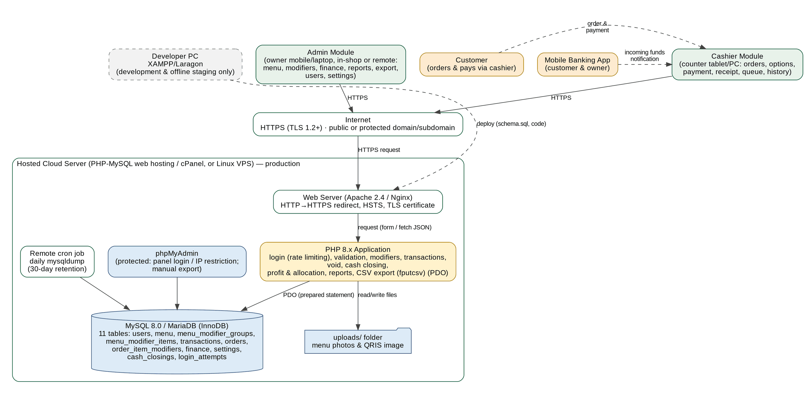
Figure 1. Block diagram of the product perspective (hosted cloud architecture) of the Kedai Paradise Point-of-Sale and Finance System
Table 1. Deployment environments of the system
Environment | Platform | Purpose | Access
Production (hosted cloud) | PHP-MySQL web hosting/cPanel or Linux VPS; Apache 2.4 or Nginx; PHP 8.x; MySQL 8.0/MariaDB; TLS certificate; remote cron. | Live operation of the shop: orders, payment, queue, history, reports, finance. | Cashier counter tablet/PC and owner mobile/laptop over HTTPS through a public or protected domain/subdomain.
Development and offline staging | XAMPP or Laragon on a local counter PC or developer laptop. | Coding, schema.sql changes, offline demonstration and testing before deployment. Strictly not for production data. | Local PC only (http://localhost); not exposed to the internet.
Backup | Remote cron mysqldump on the hosting server; phpMyAdmin manual export. | Daily database copies kept for 30 days; manual export before changes. | Owner/Team through the hosting control panel.

The proposed system workflow is as follows.
- The user (cashier or admin) opens the system's web address in a browser on the counter tablet/PC or, for the owner, on a mobile phone or laptop; the connection is encrypted with HTTPS, and the user logs in with a username and password (after 5 failed attempts within 15 minutes the login is locked for 15 minutes).
- The customer arrives and gives the order to the cashier.
- The cashier selects the menu items and quantities. For an item that has modifier groups, an option selection modal opens (size, spice level, toppings, add-ons); the item is added only when all mandatory groups are chosen. The system calculates the effective unit price, the subtotal, and the total instantly.
- The cashier selects the payment method. For cash, the cashier enters the amount and the system calculates the change. For QRIS, the system displays the owner's QRIS code and the total, and the cashier then confirms that the funds have been received.
- The cashier presses Complete Transaction and answers the confirmation message.
- The system saves the transaction with a status of processing along with the order time, calculates cost (including modifier costs), profit, and fund allocation automatically, freezes the chosen modifiers in the order details, generates the order number, and displays the receipt, which lists the chosen options under each item.
- The customer waits near the cashier or sits at their table until the order is handed over.
- After the order is handed over, the cashier marks the order as completed; the system saves the completion time and calculates the processing duration.
- The admin manages the menu, prices, cost prices, and modifier groups and items when there are changes, records other income and expenses, voids a wrongly entered order (with a reason) when necessary, views, sorts, prints (Print/PDF), or exports (CSV) the history and the sales and financial reports, from the shop or remotely, and closes the cash drawer at the end of the day. If the counter's internet connection is lost for more than 5 minutes, the shop uses the manual ledger until the connection is restored.

2.2 Main Product Functions
The basic functions of the Kedai Paradise Point-of-Sale and Finance System that address the problems in Section 1.2 are as follows.
- Order calculation: the system calculates the effective unit price (base price plus selected modifier extra prices), the subtotal of each item, the total, and the change instantly as the cashier chooses items, options, and quantities.
- Payment: cash or QRIS, with amount validation and confirmation before the transaction is saved.
- Transaction saving and receipt: every transaction along with its item details and frozen modifier snapshot is saved, is given an order number that is unique per day (enforced by the database), and can be printed or saved as a receipt that lists the chosen options under each item; the receipt of a voided order carries a DIBATALKAN banner.
- Order queue: the processing/completed status, order time, completion time, and processing duration of every order, with the chosen options shown on each queue card so the order can be prepared correctly; voided orders leave the queue.
- Automatic profit and fund allocation: every transaction calculates gross profit (including modifier revenues and costs) and divides it into three fixed pools (Restock, Operating, Profit).
- Financial recording: sales revenue is recorded automatically; the admin records other income and expenses manually.
- History and reports: transaction history and sales and financial reports per period (total orders, revenue per method, profit, cash balance, balance per pool, sales per menu item, per-day breakdown, average duration) with sorting on all main columns; voided orders stay visible in the history but are excluded from every figure.
- Menu and modifier management: the admin adds, edits, and activates/deactivates menu items, changes prices and cost prices, and defines modifier groups and modifier items; the cashier can mark menu items as available or sold out.
- User and settings management: the admin registers users, sets roles, and fills in the QRIS account and business identity.
- Remote hosted access: the same system is available over HTTPS to the cashier at the counter and to the owner from outside the shop.
- Report export: the transaction history, the sales and financial summary, menu item sales performance, and the manual ledger can each be printed or saved as PDF (Print/PDF) and downloaded as CSV for spreadsheets.
- Void management: the admin cancels a whole order with a mandatory reason; the order is kept for audit (void_reason, voided_at, voided_by), excluded from all totals, and its order number is never reused. Cashiers cannot void; item-level partial refunds are not supported.
- End-of-day cash drawer closing: the admin reconciles the counted cash with the expected cash (opening cash + cash sales - cash out) and saves the variance in cash_closings as an audit record; the cashier can view the closings read-only.
- Login protection: failed logins are tracked per username and IP address; 5 failures within 15 minutes lock that username/IP for 15 minutes.

2.3 User Characteristics
Table 2. User characteristics of the Kedai Paradise Point-of-Sale and Finance System
User Category | Responsibilities | Access Rights | Qualifications / Skills
Cashier | Selects menu items, options, and quantities, accepts cash/QRIS payment, completes transactions, prints receipts, marks orders as completed, marks menu items as available or sold out, and views, prints, and exports the current day's transaction history (without cost and profit columns). Views the cash closing records (read-only). Cannot void orders. | Cashier features: orders, queue, menu availability, current-day history, and a compact dashboard. Cannot access admin functions. | Can operate a tablet, computer/laptop, or smartphone and a web browser; given a brief orientation.
Admin (Bapak Fajar as the owner; Ibu Fitri) | Manages the menu, prices, cost prices, and modifier groups and items; records manual income and expenses; views, sorts, prints, and exports sales, profit, and balance reports and the full history; manages users; and configures the business, QRIS, and fund allocation. Can serve transactions like a cashier and may work remotely over HTTPS. Voids orders (mandatory reason) and creates or corrects cash closings. | All system features (including cashier features). | Can operate a computer/laptop or smartphone and a web browser.
Customer (not a user of the system) | Gives the order and pays through the cashier, receives a receipt, and waits for the order. | Has no account and does not access the system. | Has a mobile banking application if paying with QRIS.
Each user has one role (admin or cashier). The admin role automatically has all cashier access rights, so Ibu Fitri, who serves transactions and also manages data, only needs one admin account. The cashier role is available in case other staff are added later. User registration and management are done only by the admin (there is no self-registration). The detailed division of access rights needs to be validated with the Management (Appendix F). Only users with the admin role (Ibu Fitri and Bapak Fajar) can void an order; cashiers have no void action. Cashiers can view the cash closing records in read-only mode, whereas admins can create and correct them.

2.4 Constraints
- The system functions as a point-of-sale, a simple order queue, and a sales recap; it does not cover online ordering, digital payments other than static QRIS, stock and restocking, or other features listed in Section 1.2.
- The system is accessed through a modern web browser (Google Chrome, Mozilla Firefox, Microsoft Edge, Safari), the last two stable versions.
- The system is built with PHP, MySQL (phpMyAdmin), HTML, CSS, and JavaScript, and in production runs on a hosted server (PHP-MySQL hosting/cPanel or a Linux VPS) with Apache or Nginx, PHP 8.x, and MySQL 8.0 or MariaDB 10.x (Section 3.6). XAMPP/Laragon is permitted only for development and offline staging.
- The production system requires an internet connection at all times and is accessed over HTTPS only. There is no offline or queued transaction mode: if the counter's internet connectivity fails for more than 5 minutes, the shop falls back to manual ledger bookkeeping in a book until connectivity is restored (Section 3.4).
- All monetary values are in Rupiah and are stored as integers; all times use the WIB time zone (Asia/Jakarta).
- One installation (one database and one copy of the application) serves one business.
- Receipt, history, report, and ledger printing uses the browser's print function (any printer installed on the device, or Save as PDF), formatted by a CSS @media print stylesheet. PDF files are produced by the browser and not by the server; tabular data export uses CSV (no native .xlsx).
- A menu item can have at most 5 modifier groups, and a modifier group can have at most 10 modifier items; modifier extra prices and extra costs are integers >= 0.
- The persistent data model is limited to eleven InnoDB tables: users, menu, menu_modifier_groups, menu_modifier_items, transactions, orders, order_item_modifiers, finance, settings, cash_closings, and login_attempts.

2.5 Assumptions and Dependencies
- The owner has a hosting account (PHP-MySQL hosting/cPanel) or a Linux VPS and a domain or subdomain, keeps the TLS certificate valid (for example free AutoSSL or Let's Encrypt), and is responsible for securing the hosting control panel, phpMyAdmin, and the database credentials (including passwords).
- The cashier's counter device (tablet or PC) and the owner's remote devices (mobile phone or laptop) are available with a modern browser and an internet connection; the counter has a stable internet connection (a mobile-data hotspot is recommended as a spare).
- The owner already has a QRIS from the mobile banking account of their choice and can upload the QRIS image and fill in the account data through the Settings menu; the cashier can see incoming-funds notifications on the owner's mobile banking.
- QRIS payment confirmation is done manually by the cashier; the reliability of the confirmation depends on the cashier's carefulness and the mobile banking notification.
- The hosting provider keeps the web server and database running during operating hours (the provider's uptime guarantee). If the counter's internet connection is down for more than 5 minutes, the shop uses manual ledger bookkeeping in a book as before until connectivity is restored (Section 3.4).
- The cashier informs the customer of the order number and table verbally; the system does not send notifications to customers.
- Fund allocation is record-keeping only; the owner moves the actual money outside the system.
- The admin prepares the initial data: the menu list, prices, cost prices, photos (optional), number of tables, QRIS account, and the operating allocation percentage (Appendices D and E). The cost price of each menu item needs to be filled in so that profit and allocation are accurate; menu items without a cost price are calculated with a cost of 0. Menu availability is updated manually by the admin or cashier.
- The admin prepares the modifier groups and items (for example Size, Spice Level, Toppings / Additions) with their extra prices and extra costs together with the initial menu data.
- The hosting provider supports PHP 8.x, MySQL 8.0 or MariaDB, cron jobs, a TLS certificate, and preferably a server located in Indonesia or Southeast Asia so that latency stays low.
- The admin counts the physical cash in the drawer at the end of each operating day and enters the opening cash, cash out, and counted cash on the Cash Closing page; cash taken out of the drawer that is an expense is also recorded separately as a manual expense.

3. DETAILED REQUIREMENTS DESCRIPTION

3.1 External Interface Requirements

3.1.1 User Interface
The system interface is designed for tablet, desktop/laptop, and smartphone (responsive), in Indonesian, and kept simple so that it is easy to use when customers are crowding in. The cashier's main page displays the menu list and the details of the current order side by side so that the cashier does not need to switch pages; menu items with options open an option selection modal or drawer. Every history, report, and ledger view has Export CSV and Print/PDF buttons. Interface sketches are in Appendix A.
Table 3. List of user interface pages and components
No. | Part | Main Components | Function / Purpose | Code
1 | Login | Username and password fields; Log In button. After 5 failed attempts within 15 minutes the form shows the rate-limit message and does not verify the password. | Log in to the system. | F01
2 | Header/Navigation | User name and role, menu according to access rights, Logout button. Clicking the user name opens Akun Saya (change own password, F02). | Navigation and logging out. | F01, F11
3 | Menu List | Menu cards (photo, name, base price); items that have modifier groups carry an Options badge and open the option selection modal when clicked; inactive or sold-out menu items are marked and cannot be selected. Category pills (All plus each distinct category) and a name search box above the menu cards. | Selecting items. | F04
4 | Cart / Order | A list of items, the chosen modifiers shown indented under each item (for example [Level 3, Extra Egg]), quantity, effective unit price, subtotal, and total that are updated instantly; change quantities, re-open the options of a line, and delete items in place. Lines with the same item and the same modifier set are merged. There is no separate order review step before payment. | Displaying the current order. | F04
5 | Option Selection Modal / Drawer | Opens when a menu item with modifier groups is clicked: the groups with their rule badge (Mandatory/Optional, choose 1 or choose any), radio buttons for single_choice groups and checkboxes for multi_choice groups, extra price beside each item (unavailable items disabled), a quantity stepper, the live effective unit price and subtotal, and an Add to Cart button that stays disabled until all mandatory groups are satisfied. | Choosing options before adding an item to the cart. | F04
6 | Service and Payment | Table number field or TA option, Cash/QRIS method, payment amount (cash), change; for QRIS the QRIS image and total are displayed along with a Confirm funds received button. | Determining the service type and paying. | F05
7 | Complete Transaction Button and Confirmation Dialog | A prominent action button (contrasting color, separate from navigation buttons) that opens a confirmation message containing the total, payment, and change with Yes and Cancel buttons. | Completing the transaction safely. | F06
8 | Receipt | A print-ready display: business name, order number, table/TA, time, item details with the chosen modifiers listed indented under each item, total, method, and status. | Printing or saving as PDF. | F07
9 | Order Queue | A list of processing orders (number, table/TA, order time, elapsed time, item summary with the chosen modifiers listed under each item), a Complete button, and a list of orders completed today along with their durations. | Managing the queue. | F08
10 | Transaction History | A list and details of transactions (including chosen modifiers), filters by date/status (processing, completed, void)/method, ascending/descending sorting by clicking any main column heading (date, order number, table/TA, method, total, status, fulfillment duration; admin also cost and profit), Export CSV and Print/PDF buttons, and, for admins only, a Void button per non-void order. Voided orders are shown struck through with a Dibatalkan badge. The list is paginated on the server (50 rows per page). | Viewing past transactions. | F09
11 | Void Action and Modal (in Transaction History) | A Void button (admin only) per non-void order opens a modal showing the order summary, a mandatory cancellation reason field (3 to 255 characters, character counter), an explicit warning that the whole order is cancelled, excluded from all totals, never reuses its number, and cannot be undone, and the buttons Yes, void order and Back. | Cancelling a whole order with an audit reason. | F06, F09
12 | Cash Closing View (cash_close.php / Tutup Kasir) | A form with closing date, opening cash, automatic cash sales (void excluded), cash out, expected cash, counted cash, an optional note, and a live variance (counted - expected); a table of past closings (date, opening, cash sales, cash out, expected, counted, difference). Cashiers see the page read-only (no form or save button). | Reconciling the cash drawer at the end of the day (admin) and viewing closings (cashier). | F15
13 | Sales and Financial Reports | Period selection, a summary (total orders, revenue, gross profit, net profit, expenses, cash balance, average fulfillment duration), revenue per method, balance per fund pool, a per-day breakdown, and a menu item sales performance table, each sortable on all main columns, with Export CSV and Print/PDF buttons. | Viewing, sorting, exporting, and printing the reports. | F10
14 | Manual Financial Records | A form with date, type (income/expense), category, fund pool, amount, and description; a list of records with filters (period, type, pool, category), sorting on all main columns (date, type, category, fund pool, amount, recorded by), edit/delete buttons, and Export CSV and Print/PDF buttons. | Recording other income and expenses. | F14
15 | Manage Menu | A menu table (name, price, cost price, photo, availability, number of option groups, status), an add/edit form with a warning if price < cost price, and a Manage Options button. The cashier can only view the menu (without cost price) and change availability. The form and table include the category; the table has a category filter. | Managing the menu, prices, and cost prices. | F03
16 | Manage Modifiers | For a selected menu item: its modifier groups (name, selection type single_choice/multi_choice, mandatory/optional) and, in each group, a table of modifier items (name, extra price, extra cost, available) with add, edit, and delete buttons; a warning if extra price < extra cost; limits of 5 groups per item and 10 items per group. | Managing menu options, extra prices, and extra costs (admin only). | F03
17 | Manage Users | A user table; a form with name, username, initial password, role, and status; password reset. There is no last-login column. | Managing accounts. | F02
18 | Settings | QRIS account (bank, owner name, upload image), business name, address, number of tables, receipt text, and operating allocation percentage. | Configuring the system. | F12, F13
19 | Dashboard | A summary of today according to the role. | General overview. | F11
General provisions for the user interface:
- Monetary values are displayed in Rupiah format (for example Rp15.000).
- Transaction action buttons (for example "Complete Transaction") are easy to find and are distinguished from navigation buttons, and are always accompanied by a confirmation button/message before data is saved.
- Validation messages appear near the problematic field and explain how to correct it.
- Actions that cannot be undone (delete, complete transaction) ask for confirmation. Voiding an order also requires a reason of 3 to 255 characters and an explicit confirmation warning.
- History, report, and ledger tables provide ascending/descending sorting on all main columns (a click toggles the direction and a ▲/▼ indicator shows the active column); each such view shows Export CSV and Print/PDF buttons that follow the active filters, period, and sort order.
- The Add to Cart button of the option selection modal stays disabled, and the missing mandatory group is highlighted, until every mandatory modifier group is satisfied.
- The display is responsive for screen widths from 360 px and does not require horizontal scrolling on the main pages.
Table 4. System messages displayed to the user
Condition | Message Displayed
Invalid item quantity | "Quantity must be an integer greater than 0."
Menu item unavailable | "{menu name} is currently sold out or inactive."
Empty cart | "Select at least one menu item before completing the transaction."
Invalid table number | "Table number must be between 1 and {table count}, or select TA."
Insufficient payment amount | "Payment is less than the transaction total."
Invalid payment amount | "Payment amount must be a non-negative number."
QRIS not yet configured | "The QRIS account has not been configured. Contact the admin."
QRIS confirmation | "Make sure the funds of Rp{total} have arrived in mobile banking before confirming."
Complete transaction confirmation | "Complete this transaction? Total Rp{total}, paid Rp{paid}, change Rp{change}. The transaction cannot be changed after it is saved."
Transaction successful | "Transaction saved successfully. Order number {n}."
Transaction failed to save | "The transaction failed to save. No data was saved, please try again."
Order marked as completed | "Order No. {n} completed. Processing duration {mm:ss}."
Login failed | "Incorrect username or password."
Session expired | "Session expired. Please log in again."
Invalid price or cost price | "Price and cost price must be numbers not less than 0."
Price below cost price | "Warning: the selling price is lower than the cost price."
Invalid allocation percentage | "The operating allocation percentage must be between 0 and 100."
Invalid financial record amount | "Amount must be an integer greater than 0."
Empty category or pool | "Category and fund pool are required."
Confirm deletion of financial record | "Delete this financial record? Balances will be recalculated."
Confirm delete/deactivate | "Are you sure you want to delete/deactivate this data?"
Insufficient access rights | "You do not have access to this feature."
Mandatory option not selected | "Select an option for {group name} before adding to the cart."
Modifier unavailable | "{modifier name} is currently unavailable."
Invalid modifier price or cost | "Additional price and additional cost must be integers not less than 0."
Modifier extra price below extra cost | "Warning: the additional selling price is lower than the additional cost price."
Modifier limit exceeded | "A menu item can have at most 5 modifier groups and a group at most 10 modifier items."
Duplicate submission (token already used) | "This transaction was already saved as Order No. {n}."
Connection lost | "The connection to the server was lost. Do not press Complete again; check the history first. If it is not restored within 5 minutes, record the order in the manual ledger."
No data to export | "There is no data in the selected period to export."
Export failed or invalid parameters | "Export failed. Check the period, sort, and delimiter options, then try again."
Insecure connection (HTTP) | "Redirecting to a secure (HTTPS) connection."
Rate limited (login) | "Terlalu banyak percobaan masuk. Coba lagi dalam 15 menit." (too many login attempts; try again in 15 minutes)
Void reason invalid | "Alasan pembatalan wajib diisi (minimal 3 karakter)." (also shown when the reason is longer than 255 characters)
Void success | "Pesanan #X berhasil dibatalkan."
Order already void | "Order #X has already been voided."
Invalid cash closing amount | "Opening cash, cash out, and counted cash must be integers not less than 0."
Cash closing saved | "Cash closing for {date} saved. Variance: {amount}."
Invalid menu category | Category is required and may have at most 30 characters.

3.1.2 Hardware Interface
Device | Minimum Specification | Purpose
User device | Cashier: a tablet or PC at the counter with a modern browser. Owner/admin: a mobile phone or laptop (in the shop or remote) with a modern browser. Screen width from 360 px. | Operating the cashier and admin modules over HTTPS.
Network | A stable internet connection at the counter (at least 2 Mbps and a round-trip time of <= 150 ms to the server; a mobile-data hotspot is recommended as a spare) and an internet connection for the owner's remote device. | Connecting the counter and remote devices to the hosted server over HTTPS.
Printer (optional) | Any printer installed on the device, or the browser's Save as PDF. Receipts use a CSS print layout for 58 mm (default) or 80 mm roll printers; history, reports and ledgers print on A4. | Printing receipts, history, reports, and ledgers (Print/PDF).
Hosted server (production) | PHP-MySQL web hosting (cPanel) or a Linux VPS (recommended at least 1 vCPU, 1 GB RAM, 10 GB SSD) with Apache 2.4 or Nginx, PHP 8.x, MySQL 8.0/MariaDB 10.x, a TLS certificate, cron, and a server located in Indonesia or Southeast Asia. | Running the application and the database 24 hours a day.
Development / staging PC | A PC or laptop with XAMPP or Laragon (Apache, PHP, MySQL, phpMyAdmin). | Local development and offline staging only; never production.

3.1.3 Software Interface
The system is built with the technologies PHP, MySQL (managed through phpMyAdmin), HTML, CSS, and JavaScript in a simple three-tier web architecture: presentation (HTML/CSS/JavaScript), application logic (PHP), and data (MySQL), deployed as a hosted web cloud application. The software used is as follows.
Layer | Specification | Purpose
Database | MySQL 8.0 or MariaDB 10.x (InnoDB engine, utf8mb4 charset) with eleven tables: users, menu, menu_modifier_groups, menu_modifier_items, transactions, orders, order_item_modifiers, finance, settings, cash_closings, and login_attempts. The schema is created through the schema.sql file. | Persistent data storage (Section 3.3).
Database administration | phpMyAdmin through the hosting control panel (cPanel) or a protected URL. | Viewing tables, importing the schema, manual export, and restore.
Web server | Apache 2.4 or Nginx 1.18+ on the hosting or VPS, with PHP 8.x (PHP-FPM or mod_php) and a valid TLS certificate. | Serving pages over HTTPS and running PHP.
Backend | PHP 8.x using PDO (prepared statements), sessions, password_hash/password_verify, and fputcsv() for CSV export. | Authentication, access rights, validation, transactions, profit and fund allocation, reports.
Interface | HTML5 (semantic) and CSS3 (responsive, with an @media print stylesheet for receipts, history, reports and ledgers). Tailwind CSS may be loaded through its CDN script (cdn.tailwindcss.com, allowed by the Content-Security-Policy) together with the custom print stylesheet; replacing it with a precompiled CSS file is a later hardening step, not a requirement. | Responsive layout of the cashier and admin dashboard.
Client interaction | JavaScript (ES6, no required library) with fetch/AJAX in JSON format. | Real-time calculation of subtotals and totals, the option selection modal, sorting controls, and the export buttons.
File storage | The uploads/ folder on the hosting server (outside PHP execution). | Menu photos and QRIS images.
Backup | A remote cron job that runs mysqldump every day (automated daily cloud database backup), retained for 30 days; manual export through phpMyAdmin. | Database backup copies.
Transport security | TLS 1.2 or higher with a certificate from the hosting (AutoSSL) or Let's Encrypt; HTTP is redirected to HTTPS (301) and HSTS is enabled. | Encrypting all communication between devices and the server.
CSV export engine | PHP fputcsv() writing to php://output with streaming HTTP headers (Table below). | CSV export of history, reports, and the ledger.
Print/PDF | CSS @media print stylesheet and the browser's print dialog (Save as PDF). | Paper and PDF archival of receipts, history, reports, and ledgers.
Table 5. CSV and Print/PDF export technical specification
Item | Specification
Generation | CSV files are generated natively in PHP with fputcsv() writing row by row to php://output (streamed, no temporary file on the server), using an explicit empty escape parameter for RFC 4180 style quoting: fputcsv($out, $row, $delimiter, '"', '').
HTTP response headers | Content-Type: text/csv; charset=UTF-8. Content-Disposition: attachment; filename="kedai-paradise_{report}_{yyyymmdd}-{yyyymmdd}.csv". Cache-Control: no-store. X-Content-Type-Options: nosniff.
Encoding | UTF-8 with a BOM (bytes EF BB BF) written once before the header row so that Microsoft Excel detects UTF-8; lines end with CRLF.
Delimiter | Comma (default) or semicolon, chosen with the delimiter parameter (comma|semicolon) in the export dialog; the semicolon option is for Excel installations whose regional setting uses a semicolon list separator. fputcsv() quotes any value that contains the delimiter, a double quote, or a line break.
Header and values | The first row contains fixed column names (Table in Section 3.2.4). Rupiah values are plain integers without Rp or thousand separators; dates are dd/mm/yyyy hh:mm (WIB); duration is in seconds (duration_seconds). Values equal those on screen.
Formula injection protection | A text cell (menu name, modifier name, category, description, username) whose first character is =, +, -, @, a tab, or a carriage return is prefixed with a single quote (') so that spreadsheets read it as text; numeric columns are never altered.
Scope and request | The export contains the whole filtered result set (not only the visible page) in the on-screen sort order. Request: GET export.php?report=&from=&to=&sort=&dir=&delimiter=&filters=; read-only, requires a valid session and role check; sort columns come from a whitelist and every parameter is validated.
Print/PDF layout | CSS @media print hides navigation, buttons, and filter forms; a print header shows the business name, report title, period, printed by, and print time; @page uses A4 (landscape for wide tables); table headers repeat on each page (thead as table-header-group) and rows do not split across pages; PDF is produced by the browser's Save as PDF.

3.1.4 Communication Interface
- All browser-server communication uses HTTPS (TLS 1.2 or higher) only, through a public or protected domain/subdomain: HTTP requests are redirected to HTTPS (301), HSTS is enabled, and session cookies are marked Secure, HttpOnly, and SameSite. This applies to the cashier's counter tablet/PC and to the owner's mobile/laptop alike.
- Pages are loaded through ordinary HTTPS requests (form POST) and dynamic data (for example the option selection modal's modifier list) is retrieved through fetch/AJAX in JSON format to PHP endpoints. The client sets a request timeout and never resubmits Complete Transaction automatically; a lost connection shows the Connection lost message.
- The server re-validates all input (numbers, ranges, formats, access rights), uses prepared statements, and escapes output. For every cart line the server recomputes prices and costs from the database, rejects modifier ids that do not belong to the menu item or are unavailable, and does not trust any price sent by the browser.
- Every request that changes data (including the new modifier group and item endpoints) carries a CSRF token that is checked by the server; the Complete Transaction request additionally carries a single-use checkout token.
- QRIS does not use a payment API; the system only displays the owner's QRIS image and records the cashier's confirmation.
- CSV downloads are streamed with the headers in the CSV specification table; export endpoints are read-only (GET) but require an authenticated session and a role check.
- The login endpoint is rate limited: the server counts failed attempts in login_attempts per username and per IP address and, after 5 failed attempts within 15 minutes, answers with the rate-limit message for 15 minutes without verifying the password. The void endpoint requires the admin role and a CSRF token; a cashier calling it directly receives HTTP 403.

3.2 Functional Requirements
Functional requirements state the basic actions that the system must perform in processing input and producing output. This section consists of the list of requirements, the information flow (DFD levels 0 and 1 along with the data flow dictionary), input-process-output specifications and validation rules, business rules, and process descriptions (pseudo-code).

3.2.1 List of Functional Requirements
Table 6. List of functional requirements
Code | Feature Name | Actor | Requirement Specification
SRS-F01 | Login and access rights | All users | The system must require login with a username and password, apply access rights by role (admin or cashier), end the session after 30 minutes of inactivity, and provide logout. Access is over HTTPS only: HTTP is redirected to HTTPS and session cookies are Secure, HttpOnly, and SameSite. The public login endpoint must be rate limited: after 5 failed login attempts for the same username or the same IP address within 15 minutes, that username/IP is locked for 15 minutes and the system answers "Terlalu banyak percobaan masuk. Coba lagi dalam 15 menit." without verifying the password. Every failed attempt (username, IP address, time) is logged in login_attempts; a successful login clears that username's attempts from the same IP.
SRS-F02 | Manage users | Admin | The system must allow the admin to register users (name, username, initial password, role), edit data and roles, deactivate accounts, and reset passwords; users can change their own password. There is no self-registration.
SRS-F03 | Manage menu, prices, and modifiers | Admin, Cashier | The system must allow the admin to add and edit menu items (name, price, cost price, photo, availability, status) and activate/deactivate them. Price and cost price must be integers >= 0 (with a warning if price < cost price); changes only apply to new transactions. The cashier can only change menu availability. In addition, the admin must be able to define for each menu item Modifier Groups (for example Size, Spice Level, Toppings / Additions) with a selection type (single_choice, for example sizes, or multi_choice, for example extra toppings) and a requirement status (mandatory or optional), and Modifier Items under each group with an item name, an additional selling price (integer >= 0), and an additional cost price (integer >= 0), and may edit, make unavailable, or delete them. At most 5 groups per menu item and 10 items per group are allowed. Each menu item also has a category (free text, required, up to 30 characters, default Lainnya) chosen by the admin.
SRS-F04 | Select order and options | Cashier | The system must let the cashier select menu items and quantities and add them to the cart. When the cashier clicks a menu item that has modifier groups, the system must open an Option Selection Modal/Drawer; the item cannot be added to the cart until all mandatory groups are satisfied. The live cart must show the chosen modifiers under each item and update the price: Effective Unit Price = Base Price + sum(selected modifier extra prices); subtotal = effective unit price x quantity. Lines with the same item and modifier set are merged, and the cashier can edit options, change quantity, or delete lines. The cashier's menu list can be filtered by category pills (one pill per distinct category of the active menu items, plus All) and by a name search, both client-side.
SRS-F05 | Payment and change | Cashier, System | The system must allow the cashier to enter the table number or TA and select the Cash or QRIS method. For cash, the system calculates the change and rejects an amount less than the total. For QRIS, the system displays the owner's QRIS image and the total, and the transaction can only be completed after the cashier confirms that the funds have been received.
SRS-F06 | Complete transaction | Cashier, System | After the cashier confirms, the system must save the transaction with the order number, status processing, and the order time, and freeze the selected modifier names, prices, and cost prices into the transaction's order lines at checkout so that later menu or modifier updates never alter past sales. The save is a single database transaction (all or nothing). The request carries a single-use checkout token so that a repeated submission (for example after a flaky connection) cannot create a duplicate transaction. The order number is unique per day, enforced by the database (stored generated column order_date = DATE(date) and UNIQUE(order_date, order_no)); the number is taken inside the saving transaction and the save is retried if a collision occurs. A saved transaction cannot be edited or deleted; it can only be voided as described in SRS-F09.
SRS-F07 | Print receipt | Cashier | The system must display and print a receipt (business name, order number, table/TA, time, item details, total, method, paid, change, status). The chosen modifiers must be listed indented under each menu item line (for example Fried Noodles [Level 3, Extra Egg]), using the frozen snapshot, so reprints are identical. Printing uses the browser's print function (@media print) or Save as PDF.
SRS-F08 | Order queue | Cashier, System | The system must show processing orders as queue cards (order number, table/TA, order time, elapsed time), listing the chosen modifiers indented under each menu item so the order is prepared correctly, and allow the cashier to mark an order completed; the completion time and the processing duration are then saved.
SRS-F09 | Transaction history | Cashier, Admin | The system must display the transaction history with details (including chosen modifiers) and filters by date, status, and method (cashier: current day only, without cost and profit). Every main column must be sortable ascending/descending: date, order number, table/TA, method, total, status, fulfillment duration (admin also total cost, gross profit, and net profit). The history must offer two export mechanisms: Print/PDF (a formatted CSS @media print layout for paper and PDF archival) and CSV export, both following the active filters and sort order. Void workflow: only the admin may void an order, from a Void button in the history; the system asks for a mandatory reason (3 to 255 characters) with an explicit confirmation warning, then sets the status to void and stamps void_reason, voided_at, and voided_by. A voided transaction permanently retains its rows, amounts, and modifier snapshots for audit, remains visible in the history (struck through with a Dibatalkan badge; receipt reprints show a DIBATALKAN banner), keeps its order number, and cannot be restored. Cashiers have no void action and direct requests return HTTP 403. Only whole orders can be voided; item-level partial refunds are not supported. The history list is paginated on the server (default 50 rows per page); totals, Print/PDF and CSV always cover the whole filtered result, not only the visible page. Any cash refund to the customer after a void is handled manually at the counter (BR-30).
SRS-F10 | Sales and financial recap and reports | Admin | The system must provide, per period, the Sales and Financial Summary Report (total orders, revenue total and per method, gross profit, net profit, manual income, expenses, cash balance, balance per fund pool, average fulfillment duration, and a per-day breakdown) and the Menu Item Sales Performance Report (quantity sold, gross sales, modifier sales, total cost, and gross profit per menu item). Every table must be sortable ascending/descending on all main columns (for example date, gross sales, quantity sold, net profit, fulfillment duration). Each report must offer Print/PDF and CSV export, generated natively with PHP fputcsv() (UTF-8 BOM, comma/semicolon delimiter), whose figures equal the screen. Voided orders are excluded from every aggregate (status <> 'void'): revenue, cost, gross and net profit, pool allocations, per-day and per-menu tables, and exports. The report additionally shows an informational count and value of the voided orders of the period.
SRS-F11 | Dashboard | Cashier, Admin | The system must display a summary of today according to the role: the cashier sees the number of orders and orders being processed; the admin additionally sees total revenue, profit, cash balance, and best-selling menu items. Voided orders are excluded from every dashboard metric. The cash balance shown to the admin is revenue + manual income - expenses of the current day (BR-11); the counted drawer cash of today's closing may be shown as a separate card labelled Kas Laci Terhitung and is not the cash balance.
SRS-F12 | Business and QRIS settings | Admin | The system must allow the admin to fill in the QRIS payment account chosen by the owner (bank/application name, owner name, QRIS image) as well as the business name, address, number of tables, receipt text, and operating allocation percentage; changes take effect immediately and only for subsequent transactions.
SRS-F13 | Profit and fund allocation | System | The system must automatically calculate, for every transaction, total_cost = sum( (Base Cost + sum of Modifier Costs) x Quantity ), gross_profit = total - total_cost, and the allocation into three pools: Restock = total_cost; Operating = round(operating_percent/100 x gross_profit); Profit = gross_profit - Operating. Modifier revenues and modifier costs must therefore be reflected automatically in gross profit and in the three pools.
SRS-F14 | Manual income and expense records | Admin | The system must let the admin add, edit, and delete manual income (other than sales) and expense records (date, type, category, fund pool, amount, description), list them with filters (period, type, pool, category), sort them ascending/descending on all main columns (date, type, category, fund pool, amount, recorded by), and provide Print/PDF and CSV export of the filtered ledger.
SRS-F15 | End-of-day cash closing (Tutup Kasir) | Admin (manage), Cashier (view) | The system must let the admin close the cash drawer for a date. It must compute cash_sales as the sum of the totals of the non-void cash transactions of that date, take opening_cash and cash_out as entered, compute expected_cash = opening_cash + cash_sales - cash_out, take the physical counted_cash, and record difference = counted_cash - expected_cash with an optional note (up to 255 characters) in cash_closings. There is one closing per date; an admin corrects a closing by saving that date again. The page must show the variance live and the history of past closings. Cashiers can only view the closings (read-only). Cash closing is an audit record only: cash_out is not written to the finance table and no revenue, profit, pool, or cash balance report changes. The closing history marks a closing as stale (Perlu disimpan ulang) when its stored cash_sales differs from the current sum of non-void cash totals of that date, for example after a later void (BR-31); an admin corrects it by saving that date again.

3.2.2 Context DFD (Level 0)
The main external entities are the Cashier and the Admin/Owner as users, reaching the system over HTTPS. The Customer is depicted as an external entity who interacts through the cashier (giving the order and paying, receiving the receipt), but is not a user of the system.
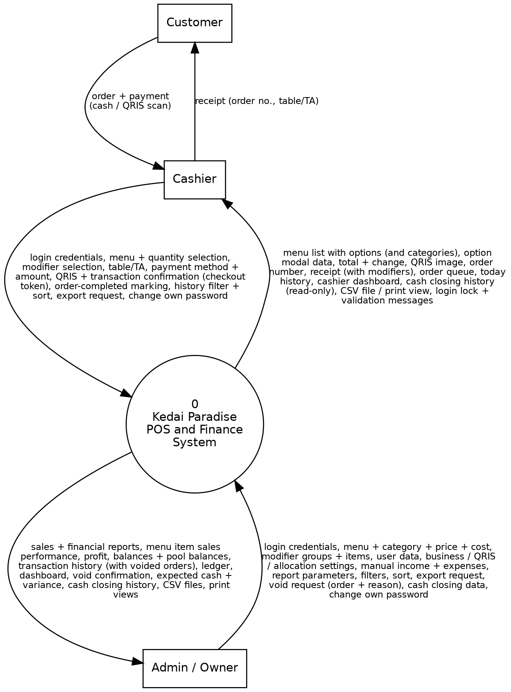
Figure 2. DFD Level 0 - Context diagram of the Kedai Paradise Point-of-Sale and Finance System
Table 7. Data flows of DFD Level 0
Entity | Data Flows into the System | Data Flows out of the System
Cashier | Login credentials, menu and quantity selections, modifier selections, service (table/TA), payment method and amount, QRIS and transaction confirmation (with checkout token), order-completed marking, history filters and sort, export request. | Menu list with options, option selection modal data, total and change, QRIS image, order number, receipt (with modifiers), order queue (with modifiers), today's history, CSV file or print view, validation messages, cash closing history (read-only).
Admin / Owner | Login credentials, menu data, prices, and costs, modifier group and item data, user data, business, QRIS, and allocation settings, manual income/expenses, report parameters, filters, sort, export request. Void request with reason, cash closing data (opening cash, cash out, counted cash, note). | Sales and financial reports, menu item sales performance, profit, balances and fund pool balances, transaction history, ledger, dashboard, CSV files, print/PDF views, void confirmation, cash closing result (expected cash and variance).
Customer (through the cashier) | Order and payment (cash or QRIS scan). | Receipt containing the order number and table number/TA.

3.2.3 DFD Level 1
The system process is broken down into eight main processes, eleven data stores (D1 to D11, including the modifier tables, cash_closings, and login_attempts), and two user entities. The customer is not drawn at this level because they interact only through the cashier.
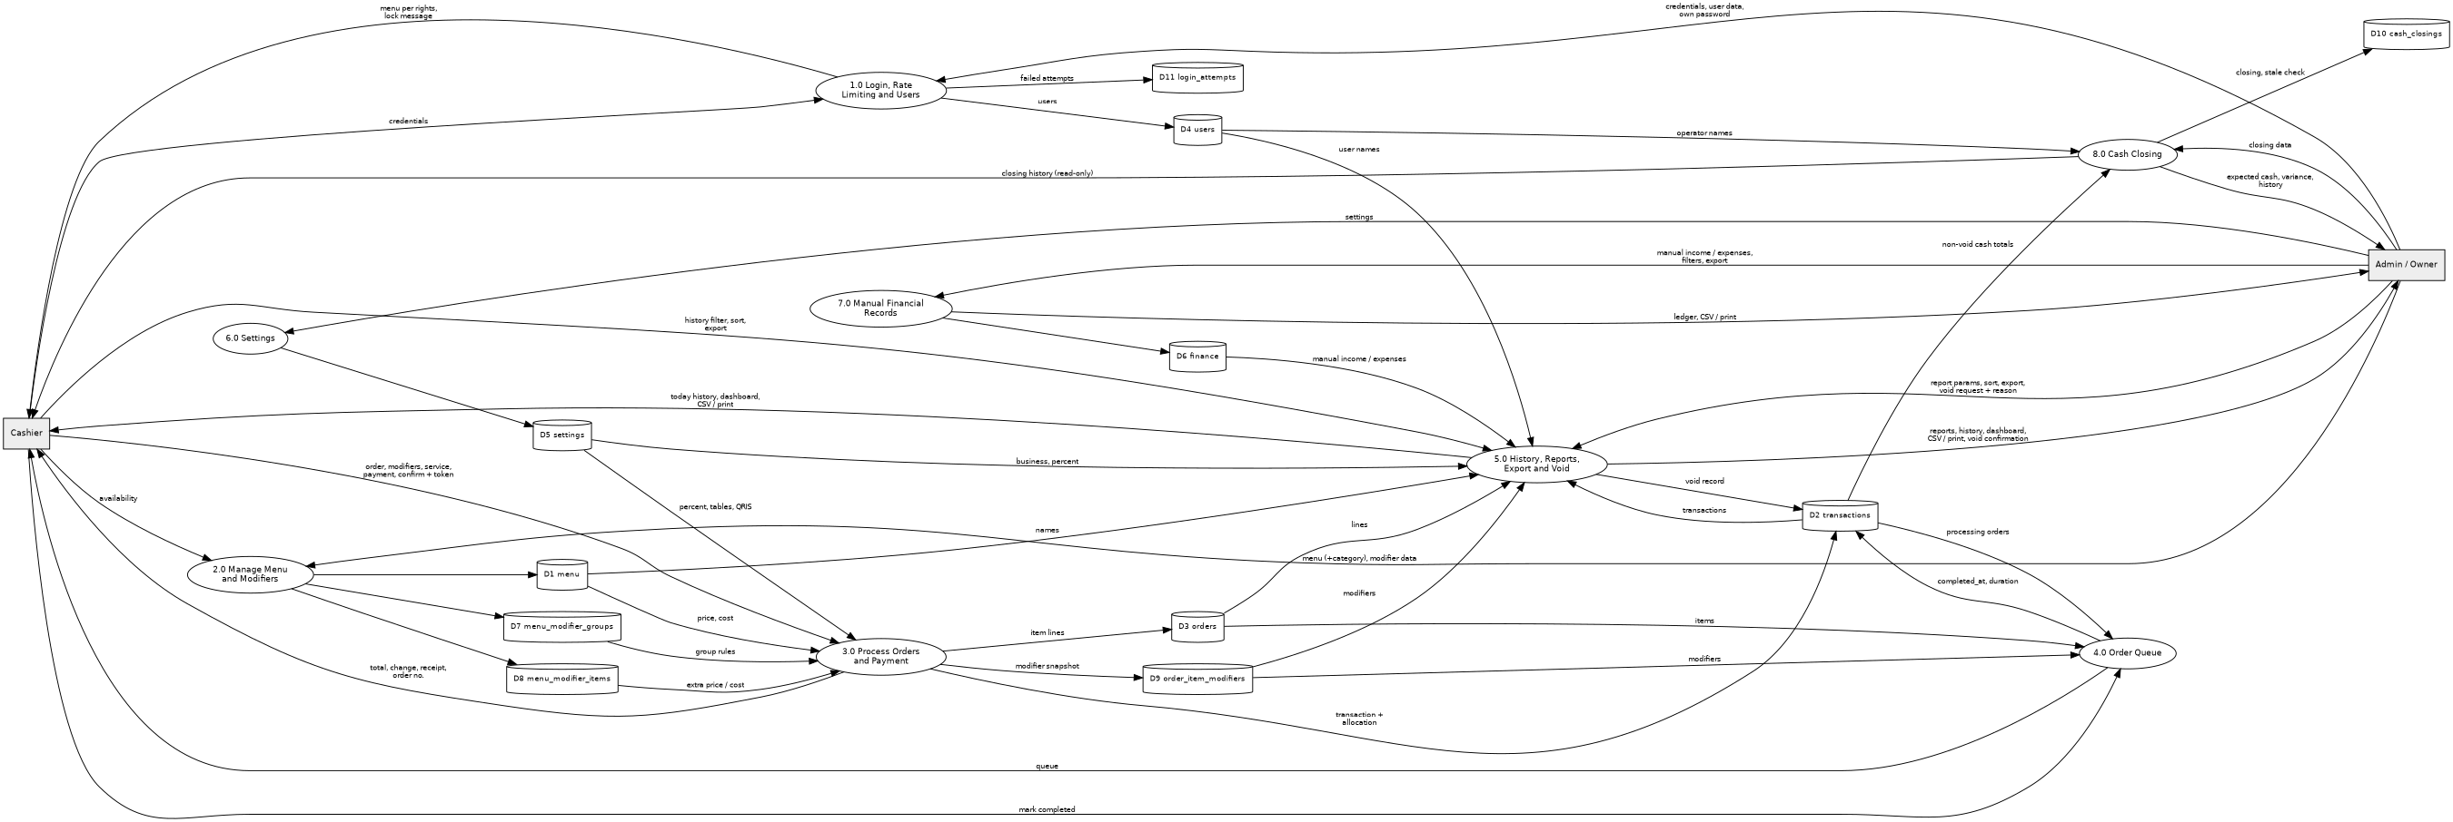
Figure 3. DFD Level 1 - Main processes of the Kedai Paradise Point-of-Sale and Finance System
Table 8. Processes in DFD Level 1
Process | Main Input | Data Store | Requirement
P1 Login, Rate Limiting and Users | Credentials; user data. | D4 users, D11 login_attempts (read/write) | F01, F02
P2 Manage Menu and Modifiers | Menu data, price, cost, photo, status, availability; modifier group and item data. | D1 menu, D7 menu_modifier_groups, D8 menu_modifier_items | F03
P3 Process Orders and Payment | Menu, quantity, modifier selection, service, method, amount, confirmation, checkout token. | D1 menu, D7, D8 (read); D2 transactions, D3 orders, D9 order_item_modifiers (write); D5 settings (read) | F04-F07, F13
P4 Order Queue | Completed marking. | D2 transactions, D3 orders (read), D9 order_item_modifiers (read) | F08
P5 History, Reports, Export and Void | Date/period, filters, sort order, export request; void request (order id and reason). | D1 menu, D3 orders, D9 order_item_modifiers, D6 finance, D4 users (cashier and voider names), D5 settings (business name, receipt text, operating percent) (read); D2 transactions (read; update for void) | F09, F10, F11
P6 Settings | QRIS account, business identity, number of tables, allocation percentage. | D5 settings | F12
P7 Manual Financial Records | Manual income/expenses (date, type, category, pool, amount, description); filters, sort order, export request. | D6 finance | F14
P8 Cash Closing | Closing date, opening cash, cash out, counted cash, note. | D2 transactions (read), D4 users (operator name, read), D10 cash_closings (read/write) | F15
Data Flow Dictionary
Notation: "=" consists of; "+" and; "[ a | b ]" either one; "( )" optional; "{ }" repeated.
Table 9. Data flow dictionary
Data Flow | Composition
credentials | username + password
order_item | menu_id + quantity + { modifier_id }
cart | { menu_id + name + base_price + { modifier_name + extra_price } + unit_price + quantity + subtotal } + total + checkout_token
service_data | table_no [ table number | "TA" ]
payment_data | method [ cash | qris ] + (paid) + (qris_confirmation)
receipt | business_name + address + order_no + table_no + date + cashier_name + { item + { modifier_name } } + total + method + paid + change_due + status
menu_data | name + category + price + cost_price + (photo) + available + status
manual_finance_data | date + type + category + pool + amount + (description)
user_data | name + username + (password) + role + status
settings | business_name + address + table_count + receipt_text + qris_bank + qris_owner_name + qris_image + operating_percent
report_parameters | start_date + end_date + sort_column + direction + (filters)
report | total_orders + revenue + { revenue_per_method } + gross_profit + net_profit + expenses + cash_balance + { pool_balance } + { daily_breakdown } + { sales_per_menu + modifier_sales } + voided_summary (count + value) + avg_duration
queue | { order_no + table_no + date + elapsed + { item + { modifier_name } } }
completion_marking | transaction_id
modifier_group_data | menu_id + name + type [ single | multiple ] + is_required
modifier_item_data | group_id + name + extra_price + extra_cost + available
modifier_selection | menu_id + { modifier_id } ; valid only if every mandatory group is satisfied
export_request | report + start_date + end_date + sort_column + direction + format [ csv | print ] + (delimiter [ comma | semicolon ]) + (filters)
export_file | [ csv_file = BOM + header_row + { data_row } | print_view = formatted page ]
void_request | transaction_id + void_reason ; 3 to 255 characters
void_record | status [ "void" ] + void_reason + voided_at + voided_by
login_attempt | username + ip_address + attempted_at
cash_closing_data | closing_date + opening_cash + cash_out + counted_cash + (note)
cash_closing | closing_date + user_id + opening_cash + cash_sales + cash_out + expected_cash + counted_cash + difference + (note)

3.2.4 Input-Process-Output Specifications and Validation
Table 10. Input-process-output specifications and validation
Code | Input | Process | Output | Validation
F01 | Username, password, client IP address. | Delete login_attempts older than 24 hours; check the 5 most recent failed attempts of the username or IP (D11) before password verification; verify with password_verify; on failure record the attempt; on success clear the attempts of that username and IP and create a session (Secure, HttpOnly, SameSite cookie over HTTPS); apply access rights. | Dashboard or the cashier page according to role; or the rate-limit message. | Both fields are required; HTTP requests are redirected to HTTPS; a failed login shows one generic message; 5 failures within 15 minutes lock the username/IP for 15 minutes and show "Terlalu banyak percobaan masuk. Coba lagi dalam 15 menit."
F02 | Name, username, password, role, status. | Add/edit/deactivate; reset password; change own password. | User data saved. | Unique username; role cashier/admin; password at least 8 characters; may not deactivate oneself or the last active admin.
F03 | Name, price, cost price, photo, availability, status; modifier group (menu_id, name, type, is_required); modifier item (group_id, name, extra_price, extra_cost, available). Menu category. | Add/edit menu items; change availability (cashier); add/edit/delete modifier groups and items (admin). | Menu and modifier data saved. | Name required; price and cost are integers >= 0 (warning if price < cost); photo png/jpg <= 1 MB (optional); group type single or multiple; <= 5 groups per item; <= 10 items per group; extra price and extra cost integers >= 0 (warning if extra price < extra cost); name <= 50 characters. Category required, up to 30 characters (default Lainnya).
F04 | Menu id, quantity, modifier ids. | Open the option modal when the item has groups; validate mandatory groups; add/edit/delete cart lines; compute unit price, subtotal, and total. | Cart (with chosen modifiers) and total. | Menu active and available; quantity is an integer > 0; each modifier belongs to the item and is available; single_choice groups have at most one item; mandatory groups are satisfied.
F05 | Table no. or TA, method, payment amount, QRIS confirmation. | Calculate change (cash); display QRIS (QRIS); validate. | Change; payment passes or a validation message. | Table 1..table count or TA; cash: paid >= total and number >= 0; QRIS: confirmation required and QRIS already configured.
F06 | Cashier confirmation, checkout token. | Open a database transaction; recompute prices and costs from the database; save the transaction, order lines, and modifier snapshot; COMMIT; consume the checkout token. The order number is taken for order_date = CURDATE() and written with UNIQUE(order_date, order_no); on a duplicate-key error the save is retried with a new number (at most 3 times). | Order number and receipt. | Cart not empty; payment valid; token valid and unused; the whole save succeeds or nothing is saved (ROLLBACK). The (order_date, order_no) pair is unique; the status starts as processing.
F07 | Transaction id. | Compose a print-ready receipt from the frozen snapshot, with the modifiers listed indented under each item. | Receipt for print/PDF. | The transaction exists; the user may view it.
F08 | Transaction id (completion marking). | Completion time = now; duration = completion time - order time; show the queue cards with the chosen modifiers. | Updated queue. | The status must still be processing.
F09 | Date range, filters, sort column and direction, export format (csv|print), delimiter. Void: transaction id and reason (admin only). | Retrieve and sort transactions (cashier: current day, without cost and profit); generate the print view or stream the CSV. Void: validate the admin role and the reason, lock the row, refuse an already void order, set status = void with void_reason, voided_at, voided_by, keeping all rows and amounts. All aggregates use status <> 'void'. | List and details of transactions; CSV file or print view. Voided orders shown struck through with a Dibatalkan badge; success message. | Start date <= end date; sort column is in the whitelist; direction asc|desc; delimiter comma|semicolon; admin-only columns are never exported for a cashier. Reason 3 to 255 characters; the order exists and is not already void; the cashier gets HTTP 403.
F10 | Period, sort column and direction, export format, delimiter. | Calculate the number of orders, revenue (total and per method), gross profit and net profit, manual income, expenses, cash balance, balance per pool, per-day breakdown, sales per menu item (quantity, gross sales, modifier sales, cost, profit), average duration; sort; export. Aggregates exclude voided orders; the voided count and value are reported separately. | Sales and financial report, menu performance report; CSV file or print view. | Valid dates and start <= end; sort column in the whitelist; direction asc|desc; delimiter comma|semicolon.
F11 | User session. | Retrieve today's summary according to the role. | Dashboard. | Summary according to access rights.
F12 | Bank name, owner name, QRIS image, business name, address, number of tables, receipt text, operating percentage. | Save the settings; save the QRIS image to the uploads/ folder. | Active settings. | Image png/jpg <= 2 MB; number of tables is an integer >= 1; business name required; operating percentage 0 to 100.
F13 | The transaction to be saved (order lines with base cost and modifier costs), operating_percent. | Calculate total_cost = sum((base cost + modifier costs) x quantity), gross_profit, and the three allocations. | Cost, profit, and allocation saved with the transaction. | The allocation sum equals total; operating_percent 0-100.
F14 | Date, type, category, pool, amount, description; filters, sort, export format, delimiter. | Save, edit, or delete a manual record; list, sort, and filter; generate the print view or stream the CSV. | The saved record; the ledger; CSV file or print view. | Amount is an integer > 0; category and pool are required; sort column in the whitelist.
F15 | Closing date, opening cash, cash out, counted cash, note (admin); view request (cashier). | Sum the non-void cash totals of the date (D2); expected_cash = opening_cash + cash_sales - cash_out; difference = counted_cash - expected_cash; save or update the closing of that date in D10; do not write to D6. Compare the stored cash_sales with the current non-void cash total and flag a stale closing. | The saved closing with the variance; the closing history. | Admin role for writing (cashier read-only); amounts are integers >= 0; the date is not in the future; the note is at most 255 characters.
Report Sorting and Export Specification
Table 11. Report sorting and export specification
Report | Sortable columns (ascending/descending) | Filters | CSV columns and print content
Transaction History Ledger (F09) | Date/time (default, descending), order number, table/TA, method, total, status, fulfillment duration; admin only: total cost, gross profit, net profit (alloc_profit), cashier. | Date range, status, method (cashier: current day only). | Summary mode (one row per transaction): order_no, date, table_no, method, total, paid, change_due, status, completed_at, duration_seconds, items (for example "2 x Fried Noodles [Level 3, Extra Egg]; 1 x Iced Tea"), cashier; admin adds total_cost, gross_profit, alloc_restock, alloc_operating, alloc_profit. Lines mode (one row per item line): order_no, date, menu_name, modifiers, quantity, unit_price, subtotal; admin adds unit_cost and line_cost. Print: filtered table with the print header. Admin adds void_reason, voided_at, and voided_by to both modes; voided orders are exported with status void.
Sales and Financial Summary Report (F10) | Daily breakdown: date (default, descending), orders, gross sales, total cost, gross profit, net profit, average fulfillment duration. Pool table: pool, allocation, expenses, balance. Method table: method, amount. | Period (start and end date). | Sectioned CSV: each section has a title row and a header row, separated by one blank row: SUMMARY (metric, value), REVENUE_PER_METHOD, POOL_BALANCE, DAILY_BREAKDOWN. Print: summary cards and all tables. The SUMMARY section also lists voided_orders and voided_value (informational; not included in the totals).
Menu Item Sales Performance Report (F10) | Menu name, quantity sold, gross sales (default, descending), modifier sales, total cost, gross profit. | Period (start and end date). | menu_name, quantity_sold, gross_sales, modifier_sales, total_cost, gross_profit. Print: the table with totals.
Manual Income and Expense Ledger (F14) | Date (default, descending), type, category, fund pool, amount, recorded by. | Period, type, fund pool, category. | finance_id, date, type, category, pool, amount, description, recorded_by. Print: the table with total income and total expenses.

Business Rules
Table 12. Business rules
Code | Business Rule
BR-01 | A menu item can only be selected if its status is active and its availability is true (available).
BR-02 | Effective unit price = base price + sum of the extra prices of the selected modifier items; subtotal = effective unit price x quantity; total = sum of all subtotals; item quantity must be an integer > 0.
BR-03 | Cash payment: the amount paid must be >= total; change = paid - total. QRIS payment: paid = total, change = 0, and the cashier must confirm that the funds have been received.
BR-04 | A transaction is only saved if there is at least one item, the payment is valid, and the cashier answers Yes at the confirmation.
BR-05 | The base price and base cost price of each item, and the name, extra price, and extra cost of each selected modifier, are copied into the order details and the modifier snapshot at the time of the transaction; later changes in the menu or modifiers do not change old transactions. Price, cost price, extra price, and extra cost >= 0 (0 is allowed).
BR-06 | Dine-in service requires a table number 1..table count; take-away service fills the table number with "TA". The order number is sequential per day starting from 1 and resets to 1 at 00:00 WIB. Uniqueness is enforced at the database level by the stored generated column order_date = DATE(date) and the constraint UNIQUE(order_date, order_no); the number is taken inside the saving transaction and, if a duplicate-key collision still occurs, the save is retried (at most 3 times) with a new number. An order_no is never reused or reassigned, including after the order is voided.
BR-07 | Transaction status has three values: 'processing' (default when saved), 'completed' (marked by the cashier; processing duration = completion time - order time), and 'void' (cancelled by an admin, BR-14). A voided order is excluded from every revenue total, cost, gross and net profit, fund pool allocation, dashboard metric, cash closing, queue, and report table (WHERE status <> 'void'). It remains visible in the Transaction History (struck through with a "Dibatalkan" badge) and its receipt reprint shows a prominent "DIBATALKAN" banner. A voided order cannot be completed, edited, or restored.
BR-08 | Profit: total_cost = sum of ((base cost + sum of modifier costs) x quantity) of all items; gross_profit = total - total_cost (may be negative if price < cost).
BR-09 | Fund allocation per transaction (three fixed pools): alloc_restock = total_cost; alloc_operating = round (operating_percent/100 x gross_profit); alloc_profit = gross_profit - alloc_operating. The sum of the three always equals total, and modifier revenue and cost are included automatically. Example: price 10.000, cost 8.000, percentage 50%: gross profit 2.000, Restock 8.000, Operating 1.000, Profit 1.000.
BR-10 | Sales revenue is calculated from the transactions table and is not recorded again in the finance table, so no double counting occurs. The finance table only contains income other than sales and all expenses; each record refers to one pool (restock, operating, or profit) and its amount is an integer > 0.
BR-11 | Cash balance = revenue + manual income - expenses. Pool balance = the pool's allocation on transactions + the pool's manual income - the pool's expenses (may be negative as a sign that expenses exceed the allocation). Net profit for the period = the sum of alloc_profit of transactions in the period. Ingredient purchases are recorded as restock pool expenses.
BR-12 | Cashier access rights: orders and options, queue, menu availability, current-day history (print and CSV without cost, profit, and allocation columns), compact dashboard; the cashier does not see cost prices, modifier costs, profit, and finances. Admin access rights: all features including cashier features, modifier management, reports, and all exports. Restrictions are enforced on the server on every function call. Only admins may void orders and create or correct cash closings; cashiers may view cash closings read-only.
BR-13 | Unique username; each user has one role; a user who already has transactions is not permanently deleted but deactivated; the last active admin cannot be deactivated.
BR-14 | A saved transaction cannot be edited or deleted. The only correction is a full-order void by an admin with a mandatory reason of 3 to 255 characters; it sets status = 'void' and stamps void_reason, voided_at, and voided_by, while the transaction, its order rows, modifier snapshots, and amounts are kept permanently for audit. Cashiers cannot void (the server returns HTTP 403). Partial (item-level) refunds or cancellations are not supported: the admin voids the whole order and the cashier enters a corrected one. A void is irreversible.
BR-15 | Monetary values are whole Rupiah integers (displayed as Rp15.000); all times use the WIB time zone with the dd/mm/yyyy format and a 24-hour clock.
BR-16 | A modifier group belongs to exactly one menu item and has a name, a selection type (single_choice = ENUM 'single'; multi_choice = ENUM 'multiple'), and a requirement status (mandatory = is_required 1). A menu item has at most 5 groups and a group at most 10 modifier items.
BR-17 | Selection rules: mandatory single_choice = exactly 1 item; optional single_choice = 0 or 1; mandatory multi_choice = at least 1; optional multi_choice = 0 or more. An item cannot be added to the cart until all its mandatory groups are satisfied.
BR-18 | A modifier item has a name (<= 50 characters), an extra price and an extra cost that are integers >= 0, and an availability flag. Only available items can be selected; the server rejects any modifier id that does not belong to the item's groups or is unavailable. A warning is shown if extra price < extra cost.
BR-19 | Effective unit cost = base cost + sum of the extra costs of the selected modifier items. orders.modifier_price and orders.modifier_cost store the per-unit sums; orders.subtotal = (price + modifier_price) x quantity.
BR-20 | Cart lines merge (quantities add up) only when the menu item and the set of selected modifier items are identical; otherwise they remain separate lines.
BR-21 | At checkout the server recomputes all prices and costs from the database (client values are not trusted) and stores one order_item_modifiers row per selected modifier. The snapshot has no foreign key to the modifier tables, so modifier items can later be changed or deleted without affecting past sales.
BR-22 | Changes to modifier groups and items only apply to new transactions. Receipts, queue cards, history, and reports always display the frozen snapshot.
BR-23 | Every history, report, and ledger table can be sorted ascending or descending on the columns listed in Table 11; the sort column and direction are validated against a whitelist on the server and a stable secondary key (record id) is used.
BR-24 | Exports (Print/PDF and CSV) contain the whole filtered result in the on-screen sort order. CSV: UTF-8 with BOM; comma delimiter by default or semicolon on request; fputcsv() quoting; integer Rupiah without symbols; dates dd/mm/yyyy hh:mm; text cells that begin with =, +, -, or @ are escaped with a leading single quote; filename kedai-paradise_{report}_{yyyymmdd}-{yyyymmdd}.csv.
BR-25 | Export access: the admin may export and print all four reports; the cashier may print and export only the current day's transaction history, without cost, profit, and allocation columns. This is enforced on the server.
BR-26 | All access is over HTTPS: HTTP is redirected (301), HSTS is enabled, and session cookies are Secure, HttpOnly, and SameSite. The Complete Transaction request carries a single-use checkout token; a second submission with the same token is rejected and shows the existing order number.
BR-27 | Contingency and backup: if the counter's internet connection fails for more than 5 minutes, the shop records sales in the manual ledger (a book) until connectivity is restored. The database is backed up automatically every day by a remote cron mysqldump (kept 30 days) and can also be exported manually through phpMyAdmin.
BR-28 | Cash closing independence: cash closing is strictly an internal cash drawer audit. expected_cash = opening_cash + cash_sales - cash_out, where cash_sales counts only non-void cash transactions of the closing date, and difference = counted_cash - expected_cash. The cash_out field does NOT write to the finance table and does not change sales revenue, pool balances, or the cash balance report (preventing double-counting); an expense paid from the drawer is recorded separately as a manual expense. There is one closing per date.
BR-29 | Login rate limiting: 5 consecutive failed login attempts for the same username or the same IP address within 15 minutes lock that username/IP for 15 minutes. While locked, the password is not verified and further attempts are not recorded; a successful login clears the attempts of that username and IP; records older than 24 hours are purged.
BR-30 | Void and money: voiding an order does not move money in the system. Any cash refund to the customer is done manually at the counter. Only whole orders can be voided; to correct an order the admin voids it and the cashier enters a corrected one (BR-14).
BR-31 | Stale cash closing: when a void (or any change to the cash totals of a closed date) makes the stored cash_sales differ from the current non-void cash total of that date, the cash closing history shows a Perlu disimpan ulang flag until the admin saves the date again. The flag never changes finance records or reports (BR-28).

3.2.5 Process Description
Table 13. Process description
Process | Description
P1 Login and Users | Verifies credentials, creates a session, determines access rights by role, and manages user accounts by the admin. Before the password is verified, the system checks login_attempts (D11); after 5 failed attempts within 15 minutes the username/IP is locked for 15 minutes. Failed attempts are recorded and a successful login clears them.
P2 Manage Menu and Modifiers | The admin adds/edits menu items and prices and defines the modifier groups and items of each item; the cashier only changes menu availability.
P3 Process Orders and Payment | The cashier selects menu items and quantities; items with modifier groups open the option selection modal, and the system updates the cart and total in real time. After the service and payment have been filled in and confirmed, the server checks the checkout token, opens a database transaction, recomputes the prices and the total, generates the order number, calculates cost (including modifier costs), profit, and fund allocation (P3c), saves the transaction, the item details, and the modifier snapshot, then performs a COMMIT and issues the receipt.
P4 Order Queue | Displays processing orders with their chosen modifiers; the cashier marks an order completed and the system saves the completion time and duration.
P5 History, Reports, Export and Void | Aggregates and sorts transaction, order, modifier, and finance data by period for the history, the sales and financial reports, the menu item sales performance report, and the dashboard, always excluding voided orders (status <> 'void') and reporting their count and value separately; generates the Print/PDF view or the CSV download; and lets an admin void a whole order with a mandatory reason (P5v).
P6 Settings | Stores the QRIS account, business identity, number of tables, and allocation percentage used by other processes.
P7 Manual Financial Records | The admin records, edits, and deletes manual income and expenses, filters and sorts the ledger, and prints or exports it as CSV.
P8 Cash Closing | The admin enters the opening cash, cash out, and counted cash of a date; the system sums the non-void cash sales, computes the expected cash and the variance, and saves the closing in cash_closings without touching the finance records; cashiers only view the closings.
The following are the process descriptions at the most detailed level in the form of pseudo-code.
P1 - Login, Rate Limiting and Access Rights (F01)
PROCESS P1 Login
IF the request is NOT over HTTPS THEN REDIRECT (301) TO https:// ; EXIT
RECEIVE username, password FROM User ; ip <- connection address
DELETE FROM D11 WHERE attempted_at < now - 24 hours ; housekeeping
READ the 5 most recent failed attempts (f1 newest ... f5) FROM D11
WHERE username = username OR ip_address = ip
IF 5 rows exist AND f1 - f5 <= 15 minutes AND now < f1 + 15 minutes THEN
DISPLAY "Terlalu banyak percobaan masuk. Coba lagi dalam 15 menit." ; EXIT
; the password is not verified and this attempt is not recorded
READ account FROM D4 WITH username
IF account does not exist OR status = false OR password_verify(password, password_hash) is
false THEN
WRITE D11 (username, ip_address <- ip, attempted_at <- now)
DISPLAY "Incorrect username or password." ; EXIT
DELETE FROM D11 WHERE username = username AND ip_address = ip ; success resets the counter
CREATE PHP session (session_regenerate_id; Secure, HttpOnly, SameSite cookie; expires 30
minutes after last activity)
IF role = "admin" THEN access_rights <- admin features + cashier features
ELSE access_rights <- cashier features
DISPLAY menu according to access_rights
END PROCESS

P2 - Manage Menu and Modifiers (F03)
PROCESS P2 ManageMenuAndModifiers
RECEIVE action, data FROM Admin ; menu item, modifier group, or modifier item ; CSRF token
IF role <> "admin" OR CSRF token is invalid THEN DISPLAY "You do not have access to this
feature." ; EXIT
IF action concerns a menu item THEN apply the F03 menu rules (price, cost_price integers >= 0
;
warning if price < cost_price) ; WRITE D1 ; EXIT
IF action = ADD/EDIT group THEN
IF name is empty OR type NOT IN ("single", "multiple") THEN DISPLAY message ; EXIT
IF action = ADD AND COUNT(D7 WITH menu_id) >= 5 THEN DISPLAY limit message ; EXIT
WRITE D7 (menu_id, name, type, is_required)
IF action = ADD/EDIT item THEN
IF name is empty OR longer than 50 OR extra_price OR extra_cost is NOT an integer >= 0
THEN
DISPLAY "Additional price and additional cost must be integers not less than 0." ;
EXIT
IF action = ADD AND COUNT(D8 WITH group_id) >= 10 THEN DISPLAY limit message ; EXIT
IF extra_price < extra_cost THEN DISPLAY warning
WRITE D8 (group_id, name, extra_price, extra_cost, available)
IF action = DELETE group THEN REQUEST confirmation ; DELETE FROM D7 ; its items in D8 are
removed (ON DELETE CASCADE)
IF action = DELETE item THEN REQUEST confirmation ; DELETE FROM D8
; past sales are unaffected: D9 holds a frozen copy without a foreign key to D7/D8
DISPLAY the menu and modifiers ; changes apply to new transactions only
END PROCESS

P3a - Select Order and Options (F04)
PROCESS P3a SelectOrder
RECEIVE menu_id, quantity FROM Cashier
READ menu FROM D1 WITH menu_id
IF menu.status = false OR menu.available = false THEN
DISPLAY "{name} is currently sold out or inactive." ; EXIT
IF quantity is NOT an integer > 0 THEN DISPLAY quantity message ; EXIT
READ groups FROM D7 WITH menu_id ; READ available items FROM D8 FOR EACH group
IF groups exist THEN
OPEN the option selection modal ; RECEIVE modifier_ids FROM Cashier
FOR EACH group IN groups:
chosen <- modifier_ids that belong to group
IF group.type = "single" AND COUNT(chosen) > 1 THEN DISPLAY message ; EXIT
IF group.is_required = 1 AND COUNT(chosen) = 0 THEN
DISPLAY "Select an option for {group name} before adding to the cart." ; EXIT
; the Add to Cart button stays disabled
IF any chosen id is NOT available OR NOT in the groups of menu_id THEN
DISPLAY "{modifier name} is currently unavailable." ; EXIT
unit_price <- menu.price + SUM(extra_price OF chosen)
ADD or EDIT item in the cart (merge only if menu_id AND the set of modifier_ids are identical)
FOR EACH item IN cart: subtotal <- unit_price * quantity
total <- SUM(subtotal)
DISPLAY cart (modifiers shown under each item) and total ; calculated reactively on the
client (JavaScript)
END PROCESS

P3b - Payment and Completing the Transaction (F05, F06, F07)
PROCESS P3b PaymentAndCompletion
RECEIVE table_no, method, paid, checkout_token FROM Cashier
IF checkout_token is missing OR already consumed THEN
DISPLAY "This transaction was already saved as Order No. n." ; EXIT
IF cart is empty THEN DISPLAY "Select at least one menu item..." ; EXIT
IF table_no <> "TA" AND outside 1..table_count THEN DISPLAY table message ; EXIT
IF method = "qris" THEN
IF QRIS is not configured (D5) THEN DISPLAY "The QRIS account has not been configured." ;
EXIT
DISPLAY QRIS image and total ; paid <- total ; change_due <- 0
REQUEST cashier confirmation "funds have been received" ; IF not THEN EXIT
ELSE ; cash
IF paid is not a number >= 0 THEN DISPLAY amount message ; EXIT
IF paid < total THEN DISPLAY "Payment is less than the total." ; EXIT
change_due <- paid - total
DISPLAY total, paid, change_due
REQUEST confirmation "Complete this transaction?" ; IF not THEN EXIT
START DATABASE TRANSACTION ; START TRANSACTION (InnoDB)
FOR EACH cart line: RELOAD menu FROM D1 AND chosen modifiers FROM D7/D8 ; REJECT IF
inactive/unavailable/invalid
unit_price <- price + SUM(extra_price) ; unit_cost <- cost_price + SUM(extra_cost) ;
from the database
RECALCULATE total <- SUM(unit_price * quantity) AND total_cost <- SUM(unit_cost * quantity) ON
THE SERVER
CALL P3c ProfitAllocation(total, total_cost)
; result: gross_profit, alloc_restock, alloc_operating, alloc_profit
attempts <- 0
REPEAT ; at most 3 attempts
today <- CURDATE() ; the stored column order_date = DATE(date) follows the same date
order_no <- (SELECT COALESCE(MAX(order_no), 0) + 1 FROM D2 WHERE order_date = today FOR
UPDATE)
; voided orders are counted, so a voided order_no is never reused
WRITE D2 (transaction_id, order_no, date <- now, table_no, method, total, paid,
change_due,
status "processing", total_cost, gross_profit, alloc_restock, alloc_operating,
alloc_profit, user_id) ; the database enforces UNIQUE(order_date, order_no)
IF duplicate-key error on uq_order_no_per_day THEN attempts <- attempts + 1 ; RETRY
UNTIL the write succeeds OR attempts = 3
IF the write failed THEN ROLLBACK ; DISPLAY "The transaction failed to save. No data was
saved." ; EXIT
FOR EACH item: WRITE D3 (transaction_id, menu_id, quantity, price, cost_price,
modifier_price, modifier_cost, subtotal) ; order_id <- generated id
FOR EACH selected modifier: WRITE D9 (order_id, modifier_name, price <- extra_price,
cost_price <- extra_cost) ; frozen snapshot
IF any SQL command fails THEN
ROLLBACK ; DISPLAY "The transaction failed to save. No data was saved." ; EXIT
COMMIT ; CONSUME checkout_token (remember order_no)
DISPLAY "Transaction saved successfully. Order number n." ; OFFER to print receipt (modifiers
listed under each item)
END PROCESS

P3c - Profit and Fund Allocation (F13)
PROCESS P3c ProfitAllocation(total, total_cost)
; total_cost = SUM( (cost_price + SUM(modifier extra_cost)) * quantity ) over all items
READ operating_percent FROM D5
gross_profit <- total - total_cost
alloc_restock <- total_cost
alloc_operating <- ROUND(operating_percent / 100 * gross_profit)
alloc_profit <- gross_profit - alloc_operating
; invariant: alloc_restock + alloc_operating + alloc_profit = total ; modifier revenue and
cost included
END PROCESS

P4 - Order Queue (F08)
PROCESS P4 MarkCompleted
READ processing transactions FROM D2 ; FOR EACH: READ items FROM D3 AND chosen modifiers FROM
D9
DISPLAY queue cards (order no., table/TA, time, elapsed, items with the modifiers listed
indented under each)
RECEIVE transaction_id FROM Cashier
READ transaction FROM D2
IF status <> "processing" THEN DISPLAY "This order is not in processing status." ; EXIT
completed_at <- now
duration_seconds <- DIFFERENCE(completed_at, date)
UPDATE D2: status <- "completed", completed_at, duration_seconds
DISPLAY "Order No. n completed. Processing duration mm:ss."
END PROCESS

P5 - History, Reports, and Export (F09, F10, F11)
PROCESS P5 HistoryReportsAndExport
RECEIVE start_date, end_date, report, sort_column, direction, format, delimiter, filters FROM
Admin
; the cashier may only request the current day's history
IF start_date > end_date OR sort_column NOT IN whitelist(report) OR direction NOT IN
("asc","desc")
OR delimiter NOT IN ("comma","semicolon") THEN DISPLAY message ; EXIT
all_trx <- READ D2 IN period ; used only by the history list (voided rows are shown struck
through)
trx <- READ D2 IN period WHERE status <> "void" ; the ONLY set used by every aggregate below
voided_count <- COUNT(D2 WHERE status = "void") ; voided_value <- SUM(total) OF the same rows
; informational
manual <- READ D6 IN period
total_orders <- COUNT(trx) ; revenue <- SUM(total) FROM trx
per_method <- GROUP trx BY method: SUM(total)
gross_profit <- SUM(gross_profit) FROM trx ; net_profit <- SUM(alloc_profit) FROM trx
manual_income <- SUM(amount) FROM manual type "income"
expenses <- SUM(amount) FROM manual type "expense"
cash_balance <- revenue + manual_income - expenses
FOR EACH pool IN (restock, operating, profit):
pool_balance <- SUM(alloc_pool FROM trx) + manual_income(pool) - expenses(pool)
per_menu <- GROUP D3 (belonging to trx) BY menu_id:
quantity_sold = SUM(quantity), gross_sales = SUM(subtotal),
modifier_sales = SUM(modifier_price * quantity),
total_cost = SUM((cost_price + modifier_cost) * quantity),
gross_profit = gross_sales - total_cost
per_day <- GROUP trx BY order_date: COUNT, SUM(total), SUM(total_cost), SUM(gross_profit),
SUM(alloc_profit), AVERAGE(duration_seconds)
avg_duration <- AVERAGE(duration_seconds) FROM trx with status "completed"
SORT the requested table BY sort_column AND direction (whitelisted name -> SQL column, then
record id)
IF format = "print" THEN DISPLAY the print view (@media print: header, tables, totals) ; EXIT
IF format = "csv" THEN CALL P5e ExportCsv(report, rows, columns, delimiter) ; EXIT
DISPLAY summary, per_method, pool_balance, per_day, per_menu, avg_duration, voided_count,
voided_value
with the Export CSV and Print/PDF buttons ; in the history list show Void buttons to
admins only
END PROCESS

P5v - Void Order (F06, F09)
PROCESS P5v VoidOrder
RECEIVE transaction_id, void_reason FROM Admin ; CSRF token
IF CSRF token is invalid THEN DISPLAY "Invalid request." ; EXIT
IF role <> "admin" THEN RESPOND HTTP 403 ; DISPLAY "You do not have access to this feature." ;
EXIT
reason <- TRIM(void_reason)
IF LENGTH(reason) < 3 OR LENGTH(reason) > 255 THEN
DISPLAY "Alasan pembatalan wajib diisi (minimal 3 karakter)." ; EXIT
REQUEST confirmation (warning: the whole order is cancelled and cannot be restored) ; IF not
THEN EXIT
START DATABASE TRANSACTION
READ transaction FROM D2 WITH transaction_id FOR UPDATE
IF the transaction does not exist THEN ROLLBACK ; DISPLAY "Order not found." ; EXIT
IF status = "void" THEN ROLLBACK ; DISPLAY "Order #X has already been voided." ; EXIT
UPDATE D2: status <- "void", void_reason <- reason, voided_at <- now, voided_by <- user_id
; the rows in D3 and D9 and all amounts stay unchanged ; order_no stays reserved
IF the update fails THEN ROLLBACK ; DISPLAY "The order could not be voided." ; EXIT
COMMIT
DISPLAY "Pesanan #X berhasil dibatalkan."
; from now on the order is excluded from reports, dashboard, queue, and cash closing
END PROCESS

P5e - CSV Export (F09, F10, F14)
PROCESS P5e ExportCsv(report, rows, columns, delimiter)
IF COUNT(rows) = 0 THEN DISPLAY "There is no data in the selected period to export." ; EXIT
IF role = "cashier" THEN restrict period to the current day AND remove cost, profit, and
allocation columns
IF role = "admin" AND report = "history" THEN columns <- columns + void_reason, voided_at,
voided_by
SEND HEADERS Content-Type: text/csv; charset=UTF-8
Content-Disposition: attachment;
filename="kedai-paradise_{report}_{from}-{to}.csv"
Cache-Control: no-store
out <- OPEN php://output ; WRITE BOM (EF BB BF) TO out
sep <- IF delimiter = "semicolon" THEN ";" ELSE ","
fputcsv(out, header_names, sep, '"', '')
FOR EACH row IN rows (streamed, in the on-screen sort order):
FOR EACH text cell: IF first character IN ("=", "+", "-", "@", TAB, CR) THEN cell <- "'" +
cell
numbers <- plain integers (no Rp, no thousand separators) ; dates <- dd/mm/yyyy hh:mm
fputcsv(out, row, sep, '"', '')
CLOSE out
END PROCESS

P7 - Manual Financial Records (F14)
PROCESS P7 RecordFinance
RECEIVE date, type, category, pool, amount, description FROM Admin
IF type is NOT "income"/"expense" OR pool is NOT restock/operating/profit THEN
DISPLAY message ; EXIT
IF category is empty OR pool is empty THEN
DISPLAY "Category and fund pool are required." ; EXIT
IF amount is NOT an integer > 0 THEN DISPLAY amount message ; EXIT
WRITE or UPDATE D6 (date, type, category, pool, amount, description, user_id)
; delete: REQUEST confirmation then DELETE the row from D6
RECEIVE filters (period, type, pool, category), sort_column, direction, format FROM Admin
IF sort_column NOT IN (date, type, category, pool, amount, recorded_by) OR direction NOT IN
("asc","desc") THEN
DISPLAY message ; EXIT
IF format = "print" THEN DISPLAY the print view (with total income and total expenses) ; EXIT
IF format = "csv" THEN CALL P5e ExportCsv("ledger", rows, columns, delimiter) ; EXIT
DISPLAY records and the latest balances
END PROCESS

P8 - Cash Closing (F15)
PROCESS P8 CashClosing
RECEIVE closing_date, opening_cash, cash_out, counted_cash, note FROM Admin ; CSRF token
IF role = "cashier" THEN DISPLAY the closing history FROM D10 (read-only) ; EXIT
IF role <> "admin" OR CSRF token is invalid THEN RESPOND HTTP 403 ; EXIT
IF opening_cash, cash_out, or counted_cash is NOT an integer >= 0 OR closing_date is in the
future
OR LENGTH(note) > 255 THEN DISPLAY the invalid cash closing amount message ; EXIT
cash_sales <- SUM(total) FROM D2 WHERE order_date = closing_date AND method = "cash" AND
status <> "void"
expected_cash <- opening_cash + cash_sales - cash_out
difference <- counted_cash - expected_cash ; negative = shortage, positive = surplus
WRITE D10 (closing_date, user_id, opening_cash, cash_sales, cash_out, expected_cash,
counted_cash, difference, note) ; UPDATE the row instead if closing_date already
exists
; D6 finance is NOT written: cash_out never creates a finance record or changes any report
DISPLAY "Cash closing for {date} saved. Variance: {difference}." and the closing history
END PROCESS

3.3 Data Description

3.3.1 Entities and Relationships
Persistent data is stored in a MySQL database (InnoDB engine, utf8mb4) in eleven tables managed through phpMyAdmin on the hosted server. One user (cashier/admin) serves many transactions and, as an admin, may void many transactions (transactions.voided_by); each transaction has many order rows (item details); each menu item can appear in many order rows; and the admin records many manual financial records and many cash closings (one per date). Each menu item can have many modifier groups, and each modifier group has many modifier items; when a transaction is saved, the chosen modifiers of each order row are copied (frozen) into order_item_modifiers, which belongs to one order row and deliberately has no foreign key to the modifier tables. Profit and the fund allocation to three pools (Restock, Operating, Profit) are saved directly on each transaction. A voided transaction keeps all its data and is only stamped with the void audit fields. The login_attempts table is a log without foreign keys (it also records attempts for unknown usernames), and the settings table contains only one configuration row and has no relationship with the other tables.
Table 14. Entities, primary keys, and data stores
Entity | Primary Key | Data Store | Relationship
users | user_id | D4 | Serves many transactions (1:N through transactions.user_id) and may void many transactions (1:N through transactions.voided_by); records many financial records (1:N) and many cash closings (1:N through cash_closings.user_id).
menu | menu_id | D1 | Ordered in many order rows (1:N) through orders.menu_id; has many modifier groups (1:N) through menu_modifier_groups.menu_id.
menu_modifier_groups | group_id | D7 | An option group (Size, Spice Level, Toppings / Additions) of one menu item (N:1 to menu).
menu_modifier_items | modifier_id | D8 | A choice inside a group with an extra price and extra cost (N:1 to menu_modifier_groups).
transactions | transaction_id | D2 | Has many order rows (1:N); belongs to the cashier/admin who served it and optionally to the admin who voided it; status processing, completed, or void; order_no unique per order_date.
orders | order_id | D3 | Item details: refers to one transaction and one menu item (N:1); has many frozen modifier rows (1:N) in order_item_modifiers.
order_item_modifiers | order_modifier_id | D9 | Frozen modifier snapshot of one order row (N:1 to orders); no foreign key to the modifier tables.
finance | finance_id | D6 | Income other than sales and manual expenses; recorded by one user (N:1).
settings | settings_id | D5 | A single configuration row for the business, QRIS, and allocation percentage; stands alone.
cash_closings | closing_id | D10 | One end-of-day cash drawer reconciliation per date (N:1 to users); an audit record independent of finance.
login_attempts | attempt_id | D11 | Log of failed login attempts (username, IP address, time) used for rate limiting; no foreign keys.
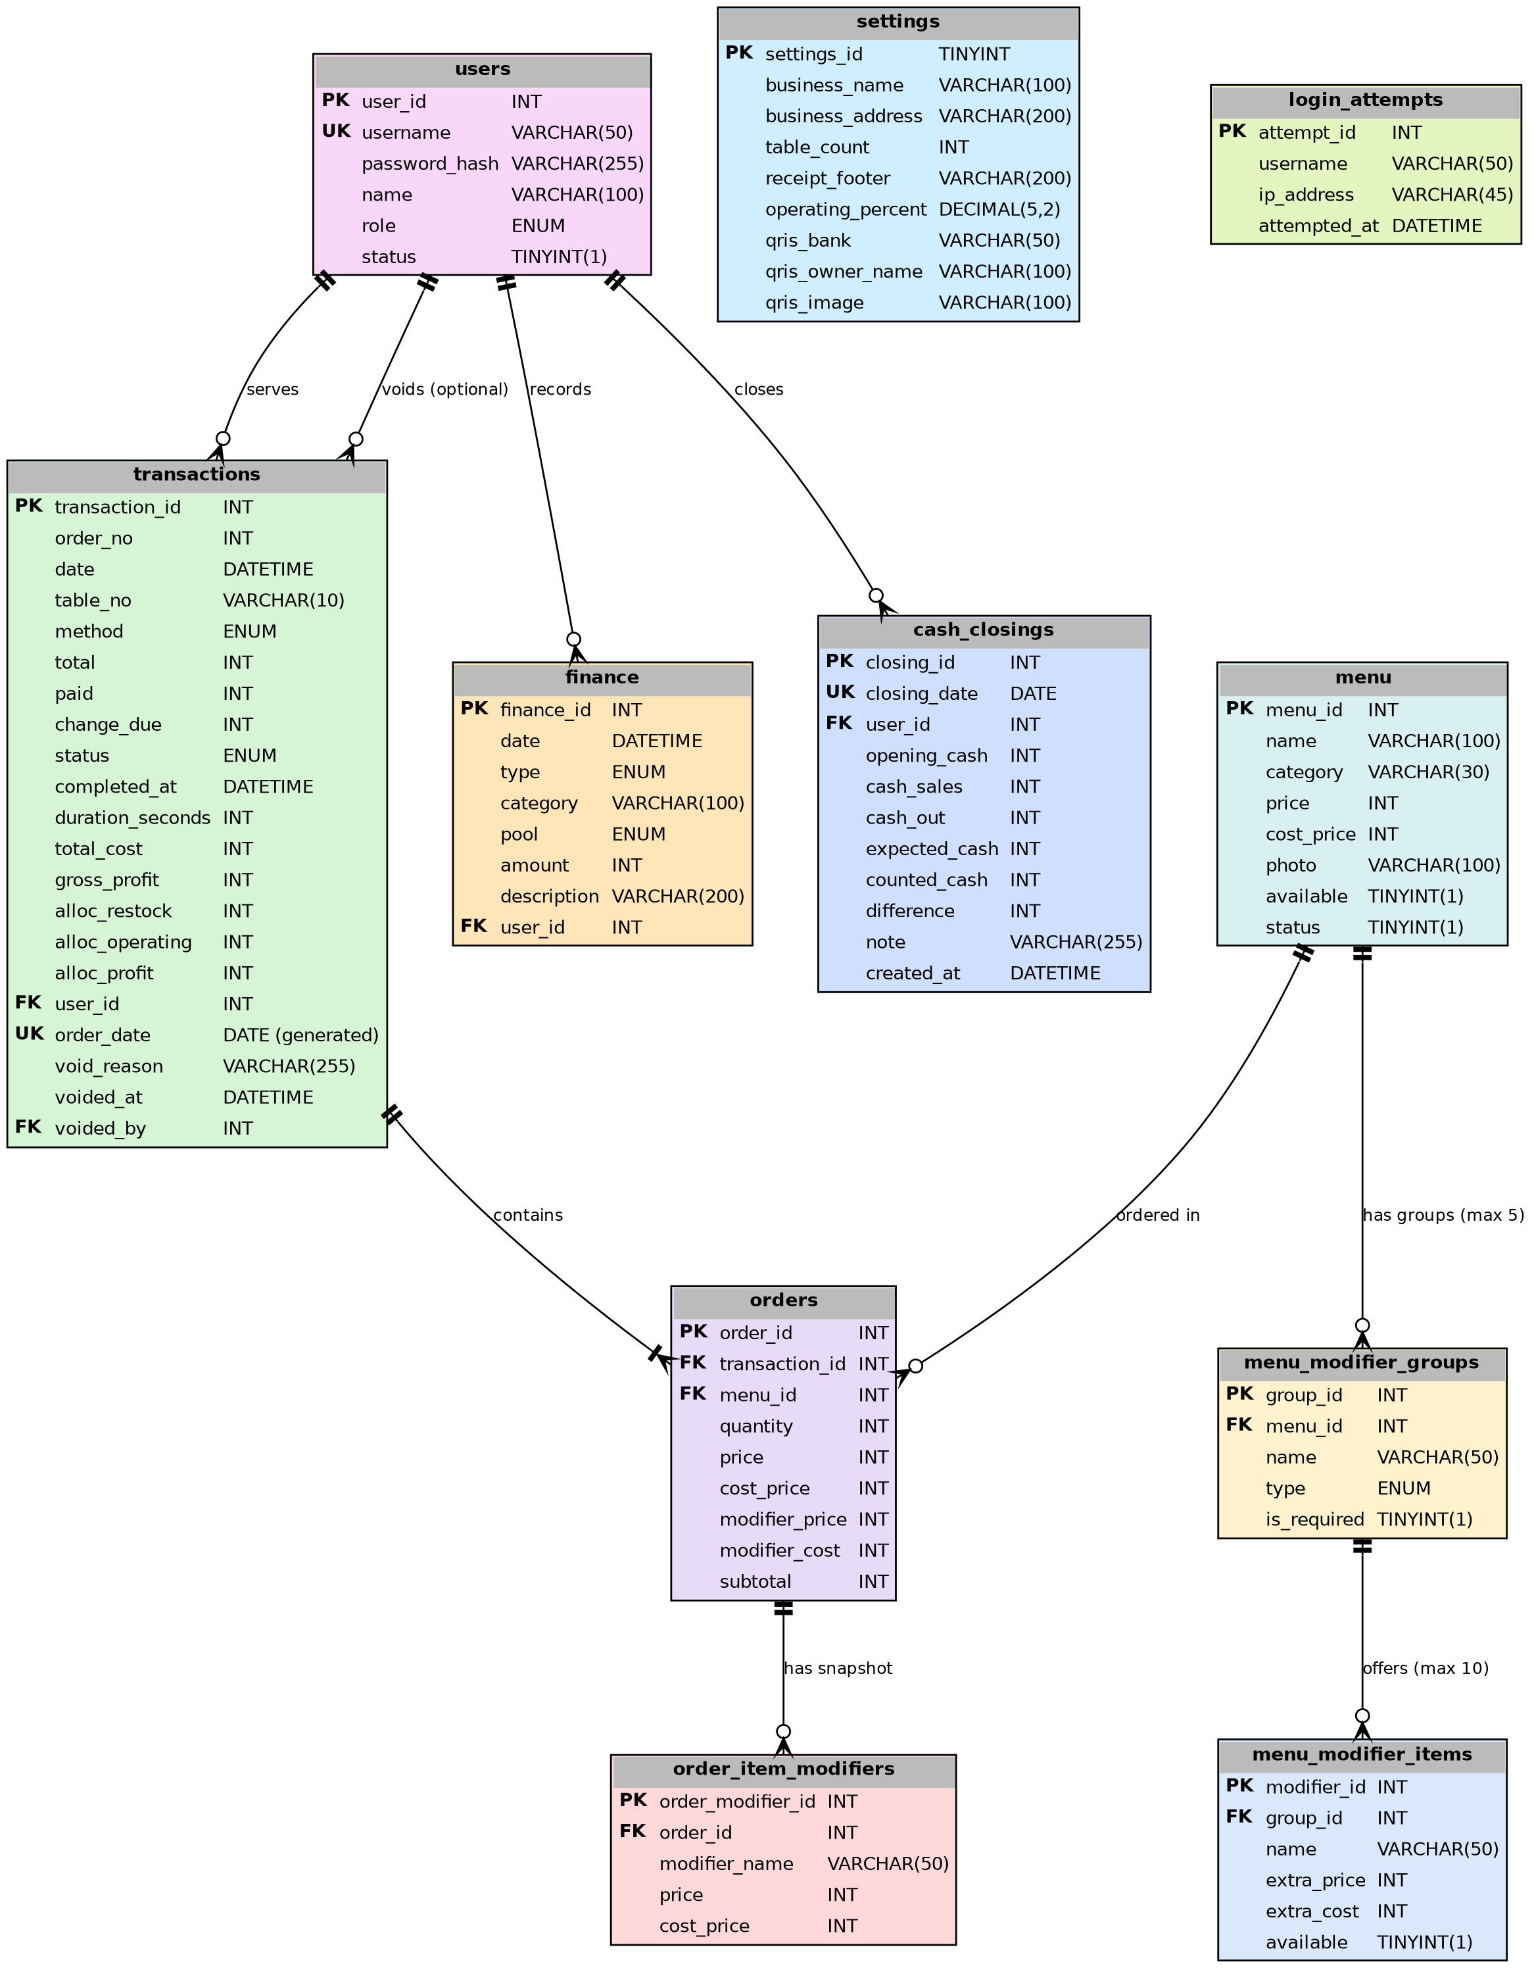
Figure 4. ERD of the Kedai Paradise Point-of-Sale and Finance System (eleven tables, crow's foot notation)

3.3.2 Data Dictionary
The schema is created on MySQL 8.0 or MariaDB 10.x with the InnoDB engine and the utf8mb4 charset through the schema.sql script file, which can be imported via phpMyAdmin; the design is in third normal form. Primary keys are AUTO_INCREMENT, and all foreign keys are enforced by MySQL (ON UPDATE CASCADE, ON DELETE RESTRICT, including transactions.voided_by and cash_closings.user_id) so that data that is still referenced cannot be deleted, with one exception: menu_modifier_items.group_id uses ON DELETE CASCADE because modifier configuration is not historical data. Monetary values are stored as whole Rupiah integers (INT, no decimals) to avoid rounding errors. Boolean values use TINYINT(1) (1 = yes, 0 = no), and restricted values use ENUM. Additional keys and indexes: UNIQUE KEY uq_order_no_per_day (order_date, order_no) and KEY idx_transactions_order_date (order_date) on transactions; transactions(date), finance(date), orders(transaction_id), menu_modifier_groups(menu_id), menu_modifier_items(group_id), and order_item_modifiers(order_id); UNIQUE(closing_date) on cash_closings; and KEY idx_login_user (username, attempted_at) and KEY idx_login_ip (ip_address, attempted_at) on login_attempts.
Table 15. users table (D4)
Field | Data Type (MySQL) | Key | Required | Description
user_id | INT AUTO_INCREMENT | PK | Yes | Unique user ID.
username | VARCHAR(50) | UNIQUE | Yes | Account name for login.
password_hash | VARCHAR(255) | - | Yes | The result of PHP's password_hash() (bcrypt, already includes a salt); the original password is never stored.
name | VARCHAR(100) | - | Yes | Full name.
role | ENUM('admin','cashier') | - | Yes | The admin automatically has cashier rights.
status | TINYINT(1) | - | Yes | 1 = active account (default 1).
Table 16. menu table (D1)
Field | Data Type (MySQL) | Key | Required | Description
menu_id | INT AUTO_INCREMENT | PK | Yes | Unique menu ID.
name | VARCHAR(100) | - | Yes | Name of the food/drink.
category | VARCHAR(30) DEFAULT 'Lainnya' | - | Yes | Menu category (free text, for example Makanan, Minuman, Snack) used for the cashier's category filter pills; default Lainnya.
price | INT | - | Yes | Unit selling price (Rupiah), >= 0.
cost_price | INT | - | Yes | Unit cost price (Rupiah), >= 0.
photo | VARCHAR(100) | - | No | Name of the photo file in the uploads/ folder.
available | TINYINT(1) | - | Yes | 1 = available, 0 = sold out (changed manually; default 1).
status | TINYINT(1) | - | Yes | 1 = active/shown at the cashier (default 1).
Table 17. menu_modifier_groups table (D7)
Field | Data Type (MySQL) | Key | Required | Description
group_id | INT AUTO_INCREMENT | PK | Yes | ID of the modifier group.
menu_id | INT | FK | Yes | Refers to menu.menu_id (the menu item that owns the group).
name | VARCHAR(50) | - | Yes | Group name, for example Size, Spice Level, Toppings / Additions.
type | ENUM('single','multiple') | - | Yes | single = single_choice (exactly one item, for example sizes); multiple = multi_choice (any number of items, for example extra toppings).
is_required | TINYINT(1) | - | Yes | 1 = mandatory (must be satisfied before adding to the cart); 0 = optional.
Table 18. menu_modifier_items table (D8)
Field | Data Type (MySQL) | Key | Required | Description
modifier_id | INT AUTO_INCREMENT | PK | Yes | ID of the modifier item.
group_id | INT | FK | Yes | Refers to menu_modifier_groups.group_id (ON DELETE CASCADE).
name | VARCHAR(50) | - | Yes | Item name, for example Large, Level 3, Extra Egg.
extra_price | INT | - | Yes | Additional selling price per unit (integer >= 0).
extra_cost | INT | - | Yes | Additional cost price per unit (integer >= 0).
available | TINYINT(1) | - | Yes | 1 = can be selected; 0 = unavailable.
Table 19. transactions table (D2)
Field | Data Type (MySQL) | Key | Required | Description
transaction_id | INT AUTO_INCREMENT | PK | Yes | Unique transaction ID.
order_no | INT | - | Yes | Sequential order number per day (resets to 1 at 00:00 WIB); unique together with order_date and never reused, also after a void.
date | DATETIME | - | Yes | Order time (when the transaction is saved).
table_no | VARCHAR(10) | - | Yes | Table number or "TA".
method | ENUM('cash','qris') | - | Yes | Payment method.
total | INT | - | Yes | Transaction total (Rupiah).
paid | INT | - | Yes | Amount paid (QRIS: equal to total).
change_due | INT | - | Yes | paid - total (derived; stored for the receipt).
status | ENUM('processing','completed','void') DEFAULT 'processing' | - | Yes | Order status: processing (default), completed, or void (cancelled by an admin).
completed_at | DATETIME | - | No | Time the order was marked as completed.
duration_seconds | INT | - | No | completed_at - date (seconds).
total_cost | INT | - | Yes | Sum of ((base cost price + modifier costs) x quantity) of all items.
gross_profit | INT | - | Yes | total - total_cost (can be negative).
alloc_restock | INT | - | Yes | Allocation to the Restock pool (= total_cost).
alloc_operating | INT | - | Yes | Allocation to the Operating pool (percent x gross_profit).
alloc_profit | INT | - | Yes | Allocation to the Profit pool (gross_profit - alloc_operating).
user_id | INT | FK | Yes | The cashier who created the transaction (refers to users.user_id).
order_date | DATE GENERATED ALWAYS AS (DATE(date)) STORED | UK | Yes (generated) | Order date derived from date; with order_no forms UNIQUE KEY uq_order_no_per_day (order_date, order_no); also KEY idx_transactions_order_date.
void_reason | VARCHAR(255) | - | No | Mandatory reason (3 to 255 characters) when the order is voided; NULL otherwise. Enforced by CHECK chk_trx_void: when status is void, void_reason (3 to 255 characters) and voided_at must be set; voided_by is enforced by the application because MySQL forbids a CHECK on a column with a foreign key ON UPDATE CASCADE.
voided_at | DATETIME | - | No | Time of the void; NULL if not voided.
voided_by | INT | FK | No | Refers to users.user_id: the admin who voided the order (ON UPDATE CASCADE, ON DELETE RESTRICT); NULL if not voided.
Table 20. orders table (D3)
Field | Data Type (MySQL) | Key | Required | Description
order_id | INT AUTO_INCREMENT | PK | Yes | ID of the item detail row.
transaction_id | INT | FK | Yes | Refers to transactions.transaction_id.
menu_id | INT | FK | Yes | Refers to menu.menu_id.
quantity | INT | - | Yes | Item quantity (> 0).
price | INT | - | Yes | Base selling price at the time of the transaction (without modifiers).
cost_price | INT | - | Yes | Base cost price at the time of the transaction (without modifiers).
modifier_price | INT | - | Yes | Sum of the extra prices of the selected modifiers per unit (0 if none); equals the sum of order_item_modifiers.price of this row.
modifier_cost | INT | - | Yes | Sum of the extra costs of the selected modifiers per unit (0 if none); equals the sum of order_item_modifiers.cost_price of this row.
subtotal | INT | - | Yes | (price + modifier_price) x quantity.
Table 21. order_item_modifiers table (D9) - frozen modifier snapshot
Field | Data Type (MySQL) | Key | Required | Description
order_modifier_id | INT AUTO_INCREMENT | PK | Yes | ID of the snapshot row.
order_id | INT | FK | Yes | Refers to orders.order_id (the order row that carries the modifier).
modifier_name | VARCHAR(50) | - | Yes | Modifier name at the time of the transaction.
price | INT | - | Yes | Extra selling price per unit at the time of the transaction (>= 0).
cost_price | INT | - | Yes | Extra cost price per unit at the time of the transaction (>= 0).
Table 22. finance table (D6)
Field | Data Type (MySQL) | Key | Required | Description
finance_id | INT AUTO_INCREMENT | PK | Yes | Record ID.
date | DATETIME | - | Yes | Date and time of the event.
type | ENUM('income','expense') | - | Yes | Type of record.
category | VARCHAR(100) | - | Yes | E.g. Ingredient restocking, Electricity, Stall rental.
pool | ENUM('restock','operating','profit') | - | Yes | The pool that is charged/targeted.
amount | INT | - | Yes | Amount (Rupiah), > 0.
description | VARCHAR(200) | - | No | Additional notes.
user_id | INT | FK | Yes | The admin who recorded it (refers to users.user_id).
Table 23. settings table (D5)
Field | Data Type (MySQL) | Key | Required | Description
settings_id | TINYINT | PK | Yes | Always has the value 1 (a single configuration row).
business_name | VARCHAR(100) | - | Yes | Business name on the receipt.
business_address | VARCHAR(200) | - | No | Address on the receipt.
table_count | INT | - | Yes | Number of tables, >= 1.
receipt_footer | VARCHAR(200) | - | No | Closing text of the receipt.
operating_percent | DECIMAL(5,2) | - | Yes | Percentage of gross profit for the Operating pool, 0 to 100 (initial proposal 50.00).
qris_bank | VARCHAR(50) | - | No | Name of the bank/m-banking application chosen by the owner.
qris_owner_name | VARCHAR(100) | - | No | Name of the account/merchant owner.
qris_image | VARCHAR(100) | - | No | Name of the QRIS image file in the uploads/ folder.
Table 24. cash_closings table (D10)
Field | Data Type (MySQL) | Key | Required | Description
closing_id | INT AUTO_INCREMENT | PK | Yes | ID of the closing.
closing_date | DATE | UK | Yes | Closing date; UNIQUE (one closing per date).
user_id | INT | FK | Yes | Refers to users.user_id: the admin who saved the closing (ON UPDATE CASCADE, ON DELETE RESTRICT).
opening_cash | INT DEFAULT 0 | - | Yes | Cash in the drawer at the start of the day (Rupiah, >= 0).
cash_sales | INT DEFAULT 0 | - | Yes | Sum of the totals of the non-void cash transactions of closing_date, computed by the system.
cash_out | INT DEFAULT 0 | - | Yes | Cash taken out of the drawer during the day (>= 0); does not write to finance.
expected_cash | INT DEFAULT 0 | - | Yes | opening_cash + cash_sales - cash_out.
counted_cash | INT DEFAULT 0 | - | Yes | Physical cash counted in the drawer (>= 0).
difference | INT DEFAULT 0 | - | Yes | counted_cash - expected_cash (negative = shortage).
note | VARCHAR(255) | - | No | Optional note.
created_at | DATETIME DEFAULT CURRENT_TIMESTAMP | - | Yes | Time the closing was recorded.
Table 25. login_attempts table (D11)
Field | Data Type (MySQL) | Key | Required | Description
attempt_id | INT AUTO_INCREMENT | PK | Yes | ID of the failed attempt.
username | VARCHAR(50) | - | Yes | Username that was entered (also if it does not exist). KEY idx_login_user (username, attempted_at).
ip_address | VARCHAR(45) | - | Yes | Client IP address (IPv4 or IPv6). KEY idx_login_ip (ip_address, attempted_at).
attempted_at | DATETIME DEFAULT CURRENT_TIMESTAMP | - | Yes | Time of the failed attempt; rows older than 24 hours are purged.

3.4 Non-Functional Requirements
The following non-functional requirements are formulated with verifiable measures. Normal conditions are defined as: a stable internet connection at the counter and for remote users (at least 2 Mbps and a round-trip time of <= 150 ms to the server), a hosted server with at least 1 vCPU and 1 GB RAM, at most 3 simultaneous active users, at most 100 active menu items (each with at most 5 modifier groups and 10 modifier items per group), and at most 3.000 transactions and 1.000 financial records in the report period.
Table 26. Non-functional requirements
Code | Category | Requirement (measurable)
NF01 | Performance | Under normal conditions, the cashier page (menu list) is displayed in <= 3 seconds, the option selection modal opens in <= 1 second, and transaction saving (F06) completes with confirmation in <= 4 seconds in at least 95% of attempts; the effective unit price, subtotal, total, and change are updated on the client side with JavaScript in <= 0,5 seconds without a server round trip.
NF02 | Performance | A one-month report (<= 3.000 transactions and <= 1.000 financial records) is displayed in <= 6 seconds when accessed remotely over HTTPS; its CSV export starts downloading in <= 5 seconds and completes in <= 15 seconds (streamed); sorting a table completes in <= 2 seconds.
NF03 | Capacity | The system serves at least 3 simultaneous active users and 150 transactions per day without losing or duplicating data.
NF04 | Operating mode and location adaptation | In production the system operates interactively as a hosted web cloud application over HTTPS, from the cashier counter and from remote devices; XAMPP/Laragon is used only for development and offline staging. An internet connection is required. If the counter's connection fails for more than 5 minutes, the cashier uses manual ledger bookkeeping in a book until connectivity is restored. All times use WIB (the PHP and MySQL time zones are set to Asia/Jakarta even if the server is located elsewhere), the currency is Rupiah, the language is Indonesian, and the date format is dd/mm/yyyy; the name, address, and receipt text are taken from the settings table.
NF05 | Usability | After an orientation of <= 30 minutes, a new cashier completes a 3-item cash transaction in <= 60 seconds and <= 10 taps/clicks without help, in at least 4 of 5 test attempts. Transaction action buttons are at least 44 px in size, contrasting, and separate from navigation; 100% of transaction completion and deletion actions ask for confirmation. A 3-item cash transaction in which one item has a mandatory single_choice group and one optional topping is completed in <= 90 seconds and <= 15 taps.
NF06 | Responsiveness and compatibility | The display is usable from a 360 px screen width up to desktop without horizontal scrolling on the main pages, and works on Chrome, Firefox, Edge, Chrome Android, and Safari iOS (the last two stable versions). The option selection modal and the export buttons are usable from 360 px width without horizontal scrolling.

3.5 Software Quality Attributes
Table 27. Software quality attributes
Code | Attribute | Requirement (measurable)
NF07 | Security | All SQL commands (including the modifier group, modifier item, export, and checkout endpoints) use prepared statements (PDO) so they are not vulnerable to SQL injection; sort columns, directions, and delimiters are whitelisted; all output to pages is escaped (htmlspecialchars) so it is not vulnerable to XSS; every request that changes data checks a CSRF token. All user access uses HTTPS (TLS 1.2 or higher, valid certificate): HTTP is redirected to HTTPS (301), HSTS is enabled, and session cookies are Secure, HttpOnly, and SameSite. Passwords are stored with password_hash() (bcrypt), never as plain text, with at least 8 characters; PHP sessions end after 30 minutes of inactivity; access-rights checks are performed on the server so that 100% of admin functions (including modifier management and full exports) reject users with the cashier role in the access test. CSV text cells are sanitized against formula injection. The uploads/ folder cannot execute PHP; phpMyAdmin is reachable only through the hosting control panel or a protected URL; database credentials are kept outside the web root; error display is off in production. Failed logins are rate limited (login_attempts): 5 failed attempts per username or IP address within 15 minutes lock that username/IP for 15 minutes without verifying the password; the void and cash closing endpoints are admin-only (HTTP 403 for cashiers) and CSRF-protected.
NF08 | Reliability | Transaction saving uses InnoDB database transactions (COMMIT/ROLLBACK) so it is all-or-nothing; in a test of 3 simultaneous users x 50 transactions there are no duplicate order numbers or partially saved transactions. Monetary values are whole Rupiah integers; in 100% of test transactions the sum of alloc_restock, alloc_operating, and alloc_profit equals total sales, and revenue + manual income - expenses equals the cash balance in the report. The order lines, the modifier snapshot, and the transaction are saved atomically, and a repeated submission with a used checkout token never creates a duplicate transaction. Order numbers are unique per day at database level (UNIQUE(order_date, order_no)) even with simultaneous checkouts, and a void never deletes data.
NF09 | Availability and backup | Availability of at least 99% during the shop's operating hours, measured over a test period of at least 2 weeks (depending on the hosting provider and the counter's internet connection). Database backups are made automatically every day by a remote cron job running mysqldump on the hosting server, kept for 30 days (a copy on another storage and of the uploads/ folder is recommended), and can be exported manually through phpMyAdmin; maximum data loss of 24 hours and recovery through a phpMyAdmin import in <= 1 hour. If the counter's internet connection fails for more than 5 minutes, manual ledger bookkeeping is used until it is restored.
NF10 | Maintainability | The code separates the presentation (HTML/CSS/JavaScript), application logic (PHP), and data access (PDO) into separate files/folders; the database schema is documented in schema.sql, and every F requirement has a file or marker function in the traceability matrix.
NF11 | Portability (reuse) | The system can be deployed on another hosting account or VPS (or on a local PC for staging) by importing schema.sql, filling in the database connection configuration, installing the TLS certificate, and changing the menu, modifiers, and settings, in <= 2 hours without changing the code, so that it can be used by similar businesses.
NF12 | Learnability | The manager (not a programmer) can add a new user, change a price, add a modifier group with items, record one expense, export a report as CSV, and save the QRIS account without help after reading a brief guide, in at least 4 of 5 test attempts.
NF13 | Export quality and interoperability | Every CSV export opens correctly in Microsoft Excel and LibreOffice Calc (UTF-8 BOM, correct columns with both comma and semicolon delimiters, no garbled characters), has the specified header row, and contains values equal to the on-screen report in 100% of tested rows; text cells starting with =, +, -, or @ are escaped so they are never executed as formulas; the Print/PDF layout fits A4 without cut-off columns, hides navigation and buttons, and repeats table headers on every page.

3.6 Design Constraints
Aspect | Constraint
Technology | Specified: MySQL (managed through phpMyAdmin), PHP, HTML, CSS, and JavaScript. Minimum versions: PHP 8.0, MySQL 8.0 or MariaDB 10.4, Apache 2.4 or Nginx 1.18. The UI is built with HTML5 and CSS3 (Tailwind CSS via CDN allowed, see 3.1.3) and JavaScript ES6; CSV is generated with PHP's native fputcsv() and PDF through the browser's print function; additional libraries or frameworks are not required.
Server environment | Production is strictly a hosted web cloud (PHP-MySQL hosting/cPanel or a Linux VPS) reached through a public or protected domain/subdomain over HTTPS. XAMPP/Laragon on a local counter PC is limited to development and offline staging. Configuration (database credentials) is stored outside the web root. The hosting choice needs to be validated by the management (Appendix F).
Database | All eleven tables use the InnoDB engine with foreign keys and database transactions (COMMIT/ROLLBACK), in third normal form; the modifier snapshot is a normalized table, not a text or JSON field. Order number uniqueness and the void status are enforced by the database (generated column order_date, UNIQUE(order_date, order_no), ENUM status). Schema changes are made only through the schema.sql file/phpMyAdmin and are recorded in the documentation.
Payment | Only static QRIS from the mobile banking account chosen by the owner; confirmation is done manually by the cashier. There is no payment gateway or dynamic QRIS.
Finance | The fund allocation (three fixed pools) is record-keeping and does not move money; modifier revenues and costs flow into the same pools. The system does not record stock; ingredient purchases are recorded as manual expenses. The system is not a replacement for bookkeeping or tax reporting, and discounts and taxes are not covered. Cash closing is an audit record only: it does not change the finance records or any financial report, and voided orders are excluded from all figures.
Business coverage | The system is prioritized for one business, namely Kedai Paradise as a case study, but can be reused by similar businesses (shops or food stalls) by changing the menu, modifiers, and settings (name, address, receipt text, number of tables, QRIS account). One installation serves one business.
Data security | The business data is stored on a hosted server. The owner is responsible for the hosting account and control panel, TLS certificate renewal, the phpMyAdmin/MySQL passwords, and the backup copies; the hosting provider is responsible for the physical server. The cashier and admin only access data through the application over HTTPS.
Language and format | The interface is in Indonesian; Rupiah format, dd/mm/yyyy dates, and the WIB time zone.

4. TRACEABILITY MATRIX
The traceability matrix links problems, requirements, and verification methods. Verification methods are grouped according to GL01A: Inspection (examination of documents/code/data), Analysis (calculation or tracing of logic/data), and Demonstration (operation of the system). The type of technical test is stated in the Test Type column.

4.1 Traceability of Problems to Requirements
Table 28. Traceability from problems to requirements
Problem Code | Identified Problem | Related Requirements
M01 | Order calculation is still manual and makes things difficult when it is busy. | F04, F05, F06, NF01, NF05
M02 | Transaction recording and income recap are still manual in a book. | F06, F07, F09, F10
M03 | Prices/menu need to be managed so that transaction information matches the shop's condition. | F03
M04 | The management needs a summary of transactions, sales, and finances. | F09, F10, F11
M05 | Transaction data may only be accessed by authorized users (derived requirement). | F01, F02, NF07
M06 | Non-cash payment (QRIS) is not yet accommodated. | F05, F12
M07 | Order status and processing time (queue) are not yet recorded. | F06, F07, F08, F10
M08 | The owner needs to know the profit and fund allocation (restock, operating, profit), and to record other income and expenses so that finances can be recapped. | F03, F06, F10, F12, F13, F14, NF08
M09 | Menu items come in variants (size, spice level, toppings, add-ons) with different prices and costs that a single menu price cannot record correctly (Revision D request). | F03, F04, F06, F07, F08, F13, NF08
M10 | The owner needs history, reports, and ledgers that can be sorted flexibly and kept on paper/PDF and in spreadsheets (CSV) (Revision D request). | F09, F10, F14, NF02, NF13
M11 | The owner needs to reach the system from outside the shop with encrypted communication, safe backups, and a fallback when the counter's internet fails (Revision D request). | F01, NF01, NF04, NF07, NF09, NF11
M12 | A wrongly entered order cannot be cancelled, so revenue and profit become wrong; the owner needs a safe full-order cancellation with an audit trail (Revision D.1 request). | F06, F09, F10, F11, BR-07, BR-14
M13 | The cash in the drawer cannot be reconciled with the day's cash sales at closing time (Revision D.1 request). | F15, BR-28
M14 | The public login endpoint is exposed to brute-force password guessing (Revision D.1 request). | F01, NF07, BR-29
M15 | The system must stay maintainable, installable by another business, and learnable by non-programmers; it must work on tablets and phones and serve several users at once (derived requirement). | NF03, NF06, NF10, NF11, NF12

4.2 Verification of Functional Requirements
Table 29. Traceability matrix of functional requirements
Code | Feature | GL01A Category | Test Type | Test Scenario
F01 | Login and access rights | Demonstration | Security test | Correct and incorrect login; a cashier user accessing admin functions is rejected; the admin can use cashier features; the session ends after 30 minutes of inactivity; logout works. Open the site over HTTP: it is redirected to HTTPS; the session cookie carries the Secure, HttpOnly, and SameSite flags. Enter 5 wrong passwords for one username within 15 minutes: the 6th attempt shows the rate-limit message for 15 minutes (TC-D27).
F02 | Manage users | Demonstration | Functional test | Add a cashier user; a duplicate username is rejected; password reset; an account with transactions is only deactivated; the last active admin cannot be deactivated.
F03 | Manage menu, prices, and modifiers | Demonstration | Functional test | Add a menu item with price 0 (accepted) and price -1 (rejected); cost 8.000 with price 7.000 raises a warning; change the Milk Coffee price from 18.000 to 20.000: new transactions use 20.000, old ones remain 18.000; the cashier can only change availability and does not see the cost. Create the group Spice Level (single_choice, mandatory) with Level 1-3 and the group Toppings / Additions (multi_choice, optional) with Extra Egg 3.000/2.000 and Sausage 4.000/2.500: extra price -1 is rejected and 0 is accepted; a sixth group or an eleventh item is rejected. Save a menu item with category Minuman and one with an empty or 31-character category (rejected); the cashier's pills show the distinct categories (TC-D30).
F04 | Select order and options | Demonstration | Functional test | Select Milk Coffee (Regular) quantity 2, Toasted Bread 1, Iced Tea 1: total 53.000 appears instantly; edit and delete items; quantity 0 is rejected; a sold-out menu item cannot be selected. Fried Noodles opens the option modal; Add to Cart is disabled until Spice Level is chosen; Level 3 + Extra Egg + Sausage gives unit price 21.000 (14.000 + 3.000 + 4.000) and quantity 2 gives 42.000; an identical selection merges into the same line and a different one makes a new line. Selecting a category pill shows only the items of that category; combined with a name search both filters apply (TC-D30).
F05 | Payment and change | Demonstration | Negative test | Cash payment of 60.000 for a total of 53.000: change 7.000; payment of 50.000 is rejected; table 99 is rejected; QRIS shows the image and total, and cannot be completed without confirmation.
F06 | Complete transaction | Demonstration | Integration test | The button raises a confirmation; after Yes, the transaction (including profit and allocation) and the order rows are saved with a sequential order number and processing status; simulating a write failure leaves no partial data. After saving, change Extra Egg to 3.500: the saved transaction and its receipt still show 3.000; submitting the same checkout token twice creates only one transaction. Insert two transactions with the same (order_date, order_no) directly in the database: the second is rejected (duplicate key); two simultaneous checkouts receive different numbers; after voiding the latest order the next order does not reuse its number.
F07 | Print receipt | Inspection | Functional test | The receipt contains the order number, table/TA, details, total, method, and status; a reprint from history is marked Copy. The receipt of an order with Fried Noodles [Level 3, Extra Egg] lists the modifiers indented under the item; a reprint after a price change is identical.
F08 | Order queue | Demonstration | Integration test | A transaction at 10:42:00 is marked completed at 10:48:10: duration 370 seconds (06:10), status completed, disappears from the processing list. Queue cards list the chosen modifiers under each item.
F09 | Transaction history | Demonstration | Functional test | Filter by date and method; sort total descending and date ascending; the cashier only sees today's transactions. Sort by each main column ascending and descending; Export CSV and Print/PDF reproduce the filtered rows in the same order; the cashier's CSV has no cost or profit columns. Void as admin (reason shorter than 3 characters refused); the voided order stays in the history, struck through, and its reprint shows DIBATALKAN; a cashier has no Void button and a direct call returns HTTP 403 (TC-D25, TC-D26). Load 120 transactions: page 1 shows 50 rows while totals and exports cover all 120 (TC-D29).
F10 | Sales and financial recap and reports | Analysis | Integration test | 10 transactions in the period (6 cash, 4 QRIS) plus 1 manual income of 100.000 and 1 expense of 250.000: total orders 10; revenue, profit, cash balance, and balance per pool match the manual calculation; quantity sold per menu item matches; average duration matches; sort sales per menu item by profit. Sort every table on every column; Export CSV (summary and menu performance) and Print/PDF match the screen; the per-day breakdown sums to the summary totals. Compare the report before and after a void: revenue, cost, profit, pools, and tables exclude the voided order, and the void count and value are shown.
F11 | Dashboard | Demonstration | Functional test | Compare the cashier's and admin's summaries with today's data; total revenue is not shown to the cashier. The dashboard excludes voided orders.
F12 | Business and QRIS settings | Demonstration | Functional test | Fill in the QRIS account and upload the image; change the business name and number of tables: the receipt and table options follow without changing code; operating percentage 101 is rejected; a percentage change only applies to new transactions.
F13 | Profit and fund allocation | Analysis | Unit test | Sell 1 item at price 10.000, cost 8.000, operating percentage 50%: gross profit 2.000, Restock 8.000, Operating 1.000, Profit 1.000 (sum 10.000); price 7.000 cost 8.000: gross profit -1.000 and the allocation sum remains 7.000. Multi-modifier order (TC-D17): total 61.000, total cost 35.500, gross profit 25.500, Restock 35.500, Operating 12.750, Profit 12.750.
F14 | Manual income and expense records | Demonstration | Functional test | Record an electricity expense of 180.000 in the operating pool and stall rental income of 100.000 in the profit pool: the cash balance and pool balances change accordingly; amount 0 is rejected; edit and delete (with confirmation) recalculate balances. Filter and sort the ledger on every column; Export CSV and Print/PDF match the screen.
F15 | End-of-day cash closing | Demonstration | Functional test | Opening cash 200.000, cash sales 350.000 (a voided cash order is excluded), cash out 50.000, counted cash 495.000: expected cash 500.000 and difference -5.000 are shown live and saved once per date; the cashier sees the closing read-only; the finance table and all reports stay unchanged (TC-D28). Void a cash order of a closed date: the closing shows Perlu disimpan ulang; saving the date again clears it and the finance table is unchanged (TC-D29).

4.3 Verification of Non-Functional Requirements
Table 30. Traceability matrix of non-functional requirements
Code | Attribute | GL01A Category | Test Type | Criteria / Scenario
NF01 | Performance | Demonstration | Performance test | Measure the cashier page load time, the option modal opening time, and the transaction save time over 20 attempts from the counter and 20 from a remote home connection (at least 19 of each must comply: page <= 3 s, modal <= 1 s, save <= 4 s); change the item quantity and an option and measure the total update <= 0,5 seconds.
NF02 | Performance | Demonstration | Performance test | Load a one-month report with 3.000 test transactions and 1.000 test financial records remotely over HTTPS: displayed in <= 6 seconds; download its CSV: starts in <= 5 seconds and completes in <= 15 seconds; sort a table: <= 2 seconds.
NF03 | Capacity | Demonstration | Load test | 3 simultaneous users create 150 transactions; check that no data is lost or duplicated.
NF04 | Operating mode and location | Inspection | Inspection | Check the production deployment over HTTPS from the counter and from a remote device and confirm that XAMPP/Laragon is not used for production; disconnect the counter's internet for more than 5 minutes and follow the manual ledger procedure; check the Asia/Jakarta (WIB) time zone on a server in another time zone, the Rupiah/date format, and the receipt text from the settings table.
NF05 | Usability | Demonstration | User test | Five testers complete a 3-item cash transaction after a 30-minute orientation; at least 4 succeed in <= 60 seconds and <= 10 taps; measure that buttons are >= 44 px and all completion/delete actions ask for confirmation.
NF06 | Responsiveness and compatibility | Demonstration | Display test | Open the main pages at 360 px, tablet, and desktop without horizontal scrolling; run the F04-F06 scenarios on Chrome, Firefox, Edge, Chrome Android, and Safari iOS.
NF07 | Security | Demonstration | Security test | Call every admin function (including the modifier endpoints and full exports) with a cashier session (all rejected); try SQL injection (for example username ' OR 1=1 -- and the group name, item name, extra price, sort, direction, and delimiter parameters): rejected with no effect; enter the menu or modifier name <script>alert(1)</script>: displayed as text; submit a modifier form or a checkout without a CSRF token: rejected; try uploading a .php file to the uploads/ folder: rejected or not executable; check that password_hash only contains bcrypt hashes; test the 30-minute session; open the site over HTTP: redirected to HTTPS with HSTS; check the TLS version (1.2 or higher), certificate, and cookie flags; check that phpMyAdmin is not publicly reachable without protection. Also: 5 failed logins lock the username/IP for 15 minutes (TC-D27); a cashier's direct void request returns HTTP 403 (TC-D26).
NF08 | Reliability | Demonstration | Integration test | 3 users x 50 simultaneous transactions: no duplicate order numbers; in all test transactions the allocation sum = total and the report's cash balance = revenue + manual income - expenses; cut the database connection mid-save: ROLLBACK leaves no partial data in either the transactions or orders tables.
NF09 | Availability and backup | Analysis | Monitoring and recovery test | Record server disruptions during a test period of >= 2 weeks (availability >= 99%); check that the remote cron job creates the daily mysqldump file and that files are kept for 30 days; export manually through phpMyAdmin; delete the test data then restore from the SQL file through a phpMyAdmin import in <= 1 hour.
NF10 | Maintainability | Inspection | Code and document inspection | Check the separation of presentation (HTML/CSS/JavaScript), PHP logic, and PDO data access in separate folders; schema.sql is documented; and the mapping of F requirements to files/functions.
NF11 | Reuse (reinstallation) | Demonstration | Installation test | Deploy the application on a test hosting account/VPS (and a local PC for staging): import schema.sql, fill in the database connection configuration, install the TLS certificate, then change only the menu, modifiers, and settings for another business; the system is ready to use in <= 2 hours without changing code.
NF12 | Learnability | Demonstration | User test | The manager adds a user, changes a price, and saves the QRIS account after reading a brief guide; at least 4 of 5 attempts succeed. Add a modifier group with items and export a report as CSV.
NF13 | Export quality and interoperability | Demonstration | Compatibility test | Export each report as CSV with comma and with semicolon and open it in Excel and LibreOffice: no garbled characters, correct columns, the specified header row, and values equal to the screen in 100% of rows; a menu name beginning with = is shown as text; print each view to PDF on A4: no cut-off columns, no buttons, headers repeated.

4.4 Verification of Revision D Test Cases
This section lists the detailed test cases added in Revisions D and D.1 for CSV export and printing, modifiers, profit allocation arithmetic, the hosted cloud security and performance requirements (TC-D01 to TC-D24), and the void order, cashier restriction, login rate limiting, and cash closing requirements (TC-D25 to TC-D28). The sample data are those of Appendix D (for example Fried Noodles 14.000, cost 9.000; Extra Egg +3.000, cost +2.000; Milk Coffee 18.000, cost 10.000; Large +4.000, cost +1.500; Iced Tea 5.000, cost 2.000).
Table 31. Revision D and D.1 detailed test cases
Test ID | Requirement | Objective | Steps / Input | Expected Result
TC-D01 | F09, NF13 | CSV headers and encoding | Export the transaction history (summary mode) for 01-30/10/2026. | The file starts with the bytes EF BB BF; Content-Type is text/csv; charset=UTF-8; Content-Disposition is attachment with the kedai-paradise_{report}_{yyyymmdd}-{yyyymmdd}.csv pattern; the first row has the specified column names; lines end with CRLF.
TC-D02 | F09, F10 | CSV accuracy against the screen | Compare the exported rows with the on-screen history and summary for the same period and filters. | Row count, total, paid, change_due, status, and duration_seconds equal the screen (mm:ss = seconds); the sum of the total column equals the Revenue figure.
TC-D03 | NF13, F10 | Delimiter handling | Export with delimiter=comma and delimiter=semicolon; open both in Excel and LibreOffice; use the menu name "Nasi, Telur" and a description containing a line break. | Both files open in the correct columns with no garbled characters; the values containing the delimiter, a quote, or a line break are quoted correctly; no extra columns.
TC-D04 | NF13, F14 | Formula injection | Create the ledger description =1+1 and the menu name @SUM(A1); export the ledger and the history. | The cells start with a single quote and Excel shows them as text; no formula is executed; numeric columns (including a negative gross profit) remain numeric.
TC-D05 | F09, F10, F14 | Sorting and filtering in exports | Sort each main column ascending and descending with a filter active; export; request sort=1;DROP and delimiter=tab. | The CSV and print view contain only the filtered rows (the whole set, not only the visible page) in the on-screen order; the invalid sort column and delimiter are rejected.
TC-D06 | F10 | Sectioned summary and menu performance CSV | Export the Sales and Financial Summary and the Menu Item Sales Performance reports for one period. | The summary has the SUMMARY, REVENUE_PER_METHOD, POOL_BALANCE, and DAILY_BREAKDOWN sections, each with a title row and a header row, separated by a blank row; the daily rows add up to the summary totals; the menu CSV contains modifier_sales.
TC-D07 | F09, BR-25 | Export access rights | As a cashier, export the history; then request another day, the cost columns, and a report through the URL. | Only the current day is exported, without cost, profit, and allocation columns; the other requests are rejected with the access-rights message (HTTP 403).
TC-D08 | F09, F10, F14, NF13 | Print/PDF layout | Print the history, the summary, the menu performance, and the ledger views to PDF on A4. | Navigation, buttons, and filter forms are hidden; the print header shows the business name, title, period, printed by, and time; table headers repeat on each page; no column is cut off; the content equals the screen.
TC-D09 | F03 | Modifier configuration validation | Create the sample groups and items; try extra price -1, 1.5, and abc, an item name of 51 characters, a sixth group, and an eleventh item; save Cheese with extra price 1.000 and extra cost 1.500. | Valid data are saved (type stored as single/multiple, is_required as 1/0); invalid data are rejected with the messages; the Cheese item is saved with the price-below-cost warning.
TC-D10 | F04 | Mandatory option validation | Click Fried Noodles and press Add to Cart without choosing a Spice Level. | Add to Cart is disabled and the message "Select an option for Spice Level before adding to the cart." is shown; after choosing Level 3 the button is enabled.
TC-D11 | F04 | Single and multi choice rules | Choose Level 1 then Level 2; choose Extra Egg and Sausage; try the unavailable Cheese. | Only one Spice Level stays selected; both toppings can be selected; the unavailable item cannot be selected.
TC-D12 | F04 | Cart recalculation | Add Fried Noodles Level 3 + Extra Egg + Sausage quantity 2; edit the options to Level 2 + Extra Egg; add the same selection again and then a different selection. | Unit price 21.000 and subtotal 42.000, then unit price 17.000; the total updates in <= 0,5 s; identical selections merge into one line and a different selection is a separate line.
TC-D13 | F04, F06 | Server-side price integrity | Tamper with the checkout request: a unit price of 1, a modifier id of another menu item, and an unavailable modifier. | The server recomputes all prices from the database; the invalid and unavailable modifiers are rejected; the saved totals use database prices.
TC-D14 | F06 | Frozen modifier snapshot | Complete the order of TC-D17; then change Extra Egg to 3.500/2.200, delete Sausage, and rename Large to Jumbo; reopen the history, the receipt, and the reports. | The old transaction still shows Extra Egg 3.000/2.000 and Large +4.000; the order_item_modifiers rows are unchanged; the receipt reprint is identical; modifier_price and modifier_cost equal the sums of the snapshot rows.
TC-D15 | F06 | Duplicate submission and atomicity | Press Complete Transaction twice quickly and replay the request; then simulate a write failure on the order_item_modifiers insert. | Only one transaction exists and the second attempt shows "already saved as Order No. n"; the failure leaves no transaction, order, or modifier rows (ROLLBACK).
TC-D16 | F07, F08 | Modifiers on receipt and queue card | Open the receipt and the queue card of the TC-D17 order, and an order with an item without modifiers. | The modifiers are listed indented under the item, for example [Level 3, Extra Egg] and [Large]; an item without modifiers shows no empty brackets.
TC-D17 | F13 | Allocation arithmetic with multiple modifiers | Order 2 x Fried Noodles [Level 3, Extra Egg] (price 14.000 + 3.000, cost 9.000 + 2.000), 1 x Milk Coffee [Large] (18.000 + 4.000, cost 10.000 + 1.500), and 1 x Iced Tea (5.000, cost 2.000); operating percentage 50%. | Total 61.000; total_cost 22.000 + 11.500 + 2.000 = 35.500; gross profit 25.500; Restock 35.500; Operating 12.750; Profit 12.750; the sum is 61.000.
TC-D18 | F13 | Percentage variation and loss-making modifier | Repeat TC-D17 at 40%; add a modifier with extra price 1.000 and extra cost 1.500 to an item. | At 40%: Operating 10.200, Profit 15.300, sum 61.000; the loss-making modifier lowers the gross profit by 500 per unit and the allocation sum still equals the total.
TC-D19 | F10 | Reports reflect modifiers | Display the report of the day of TC-D17 and sort the menu performance table by modifier sales. | Revenue includes the modifier revenue; Fried Noodles: quantity 2, gross sales 34.000, modifier_sales 6.000, total_cost 22.000, gross profit 12.000; Milk Coffee modifier_sales 4.000.
TC-D20 | NF07 | HTTPS enforcement | Open the HTTP address; inspect the response headers, certificate, and cookies. | A 301 redirect to HTTPS; the HSTS header is present; TLS 1.2 or higher with a valid certificate chain; cookies are Secure, HttpOnly, and SameSite; no mixed-content warnings; no login is accepted over HTTP.
TC-D21 | NF01, NF02 | Remote cloud access latency | From the counter and from a home connection, 20 attempts each: page load, option modal, transaction save, one-month report, and CSV download. | Page <= 3 s; modal <= 1 s; save <= 4 s (at least 19 of 20); report <= 6 s; CSV starts <= 5 s and completes <= 15 s.
TC-D22 | NF07 | CSRF on modifier and checkout endpoints | Submit create, edit, and delete of a group and an item, and a checkout, without a token and with another session's token. | All are rejected (HTTP 403) and no data changes; with a valid token they succeed.
TC-D23 | NF07 | SQL injection on modifier and export endpoints | Send ' OR 1=1 -- and 1; DROP TABLE menu; in the group name, item name, extra price, group id, sort, direction, and delimiter parameters. | Input is rejected or stored as plain text; all tables stay intact; sort, direction, and delimiter are whitelisted.
TC-D24 | NF04, NF09 | Backup and outage contingency | Check the remote cron mysqldump files for 3 days and the 30-day retention; export manually through phpMyAdmin; restore a dump; disconnect the counter's internet for more than 5 minutes and apply the manual ledger procedure. | The daily files exist and restore in <= 1 hour with all eleven tables and their data; the outage procedure is followed; after the connection returns the system resumes without duplicate transactions.
TC-D25 | F06, F09, F10, F11, BR-07, BR-14 | Void order and audit integrity | Complete the TC-D17 order (61.000) and a second cash order. As admin, press Void on the first order; try an empty reason and a 2-character reason; then enter "Customer changed the order" and confirm. Check the reports, dashboard, pools, queue, and cash closing, reprint the receipt, and inspect the database; then enter a new order. | Short reasons are refused with "Alasan pembatalan wajib diisi (minimal 3 karakter)."; success shows "Pesanan #X berhasil dibatalkan."; status = void with void_reason, voided_at, and voided_by filled while the order rows, snapshot rows, and amounts are unchanged; the order stays in the history, struck through with the Dibatalkan badge; revenue (down by 61.000), cost, gross and net profit, the three pools, dashboard, and cash closing exclude it, and the report shows 1 voided order worth 61.000; the reprint shows the DIBATALKAN banner; voiding again is refused; the new order gets a new order_no (the voided number is not reused).
TC-D26 | F06, F09, BR-12, BR-14 | Cashier void restriction | Log in as a cashier and look for the Void action in the history; call the void endpoint directly with a valid session and CSRF token, and without them. | No Void button is shown; direct calls return HTTP 403 Forbidden and the transaction is unchanged (nothing is written to D2).
TC-D27 | F01, NF07, BR-29 | Login rate limiting | Enter a wrong password 5 times for one username within 15 minutes; then try the 6th attempt with the correct password; try another username from the same IP; wait 15 minutes and log in correctly. | Attempts 1 to 5 show "Incorrect username or password." and create 5 rows in login_attempts; the 6th attempt, even with the correct password, shows "Terlalu banyak percobaan masuk. Coba lagi dalam 15 menit." and is not recorded; the same IP is blocked for other usernames; the lock survives a reload and a new session; after 15 minutes the login succeeds and the attempts of that username and IP are cleared.
TC-D28 | F15, BR-28 | Cash drawer closing and variance | On a day with 350.000 of non-void cash sales (plus one voided cash order), enter opening cash 200.000, cash out 50.000, and counted cash 495.000; save; save the same date again with another counted cash; then log in as a cashier; compare the finance table and the reports before and after. | cash_sales 350.000 (void excluded); expected cash 500.000; difference -5.000 (shortage) shown live and saved in cash_closings; saving the same date again updates the single row; the history lists the closing; the cashier sees it read-only without a save button; the finance table, revenue, pool balances, and cash balance are unchanged.
TC-D29 | F09, F15, BR-30, BR-31 | Pagination and stale cash closing | Load 120 transactions and view the history; export CSV. Complete and close a day with cash sales, then void one cash order of that date; open the cash closing history; save the date again. | The history shows 50 rows per page while the totals and the CSV cover all 120 rows; after the void the closing shows Perlu disimpan ulang; saving again clears the flag; the finance table and all reports are unchanged by the closing.
TC-D30 | F03, F04 | Menu category and filter pills | As admin create the items Kopi Susu (Minuman), Mie Goreng (Makanan) and a new item with category Dessert; try an empty and a 31-character category; as cashier open the order page and click each pill and combine a pill with a search. | The empty and the too-long category are rejected with the category message; pills show All, Makanan, Minuman, Dessert (and Lainnya if used); a pill shows only its items; the search narrows inside the selected pill; inactive items never create a pill.

5. ADDITIONAL INFORMATION / APPENDICES

Appendix A. Interface Sketches (Mockups)
The following sketches are illustrative, to agree on the layout and flow; the final visual design is determined at the design stage.
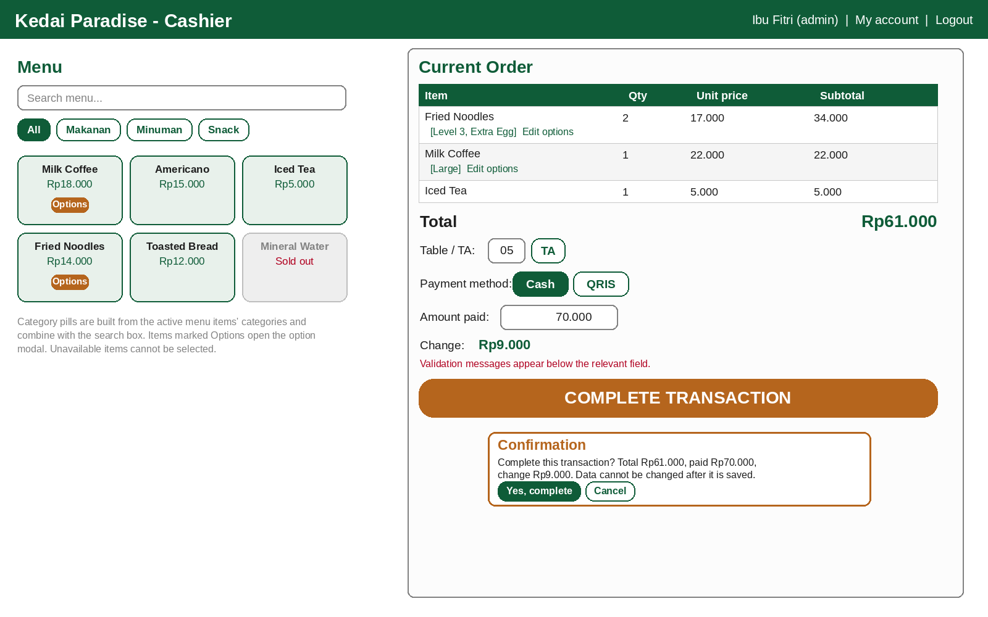
Figure 5. Sketch of the Cashier page: menu with category pills, search and Options badge, current order with the modifiers shown under each item, table/TA, payment method, Complete Transaction button, and confirmation message
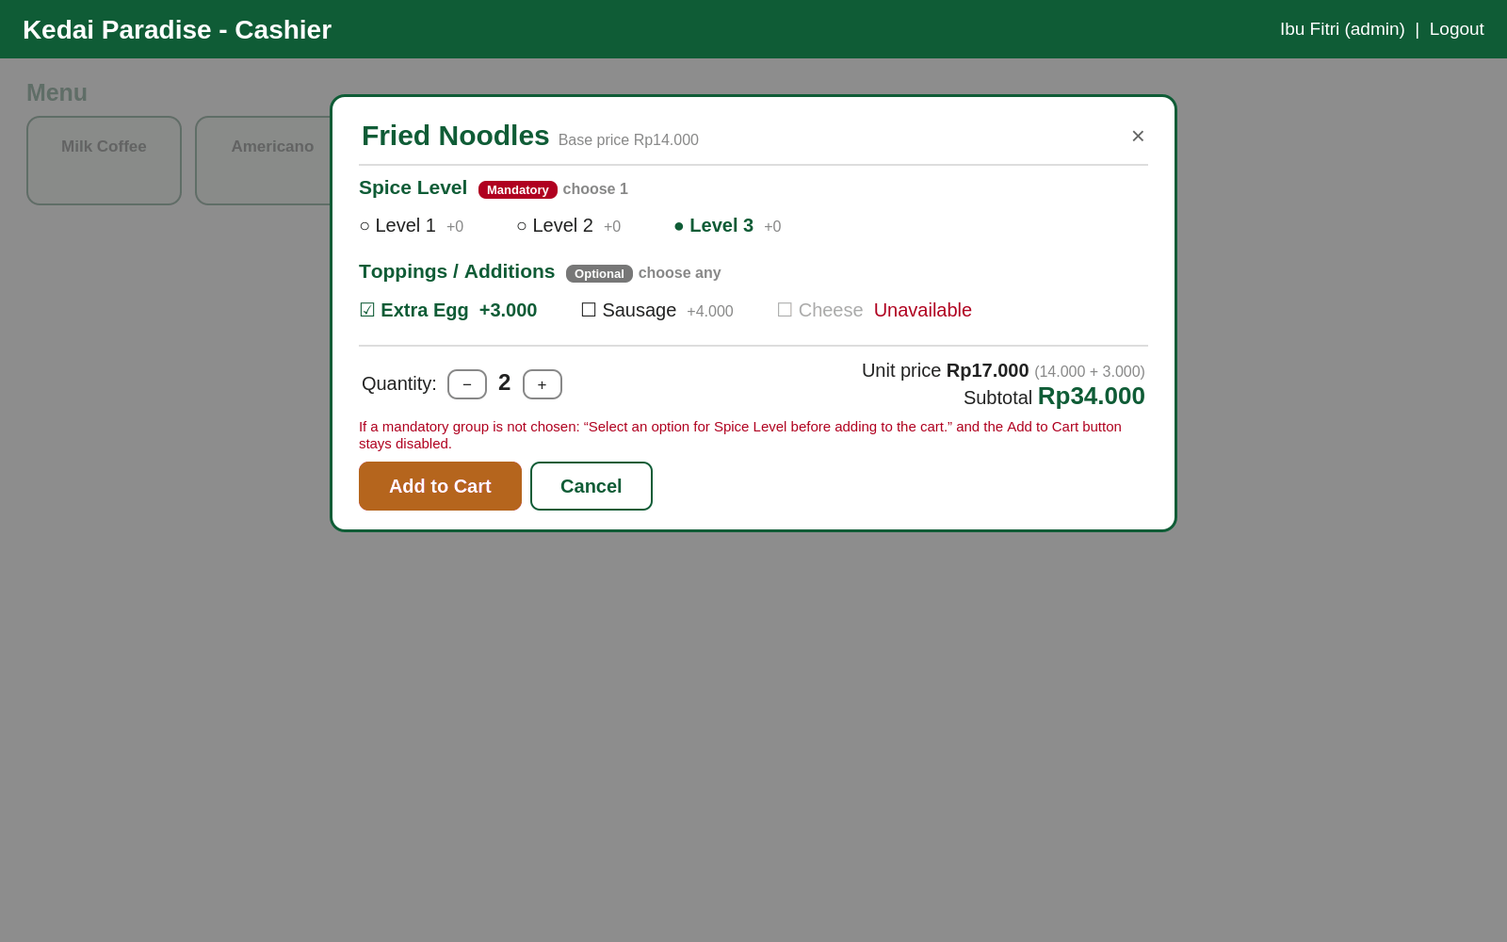
Figure 6. Sketch of the Option Selection Modal: mandatory and optional modifier groups, extra prices, quantity, live effective unit price, and the Add to Cart button
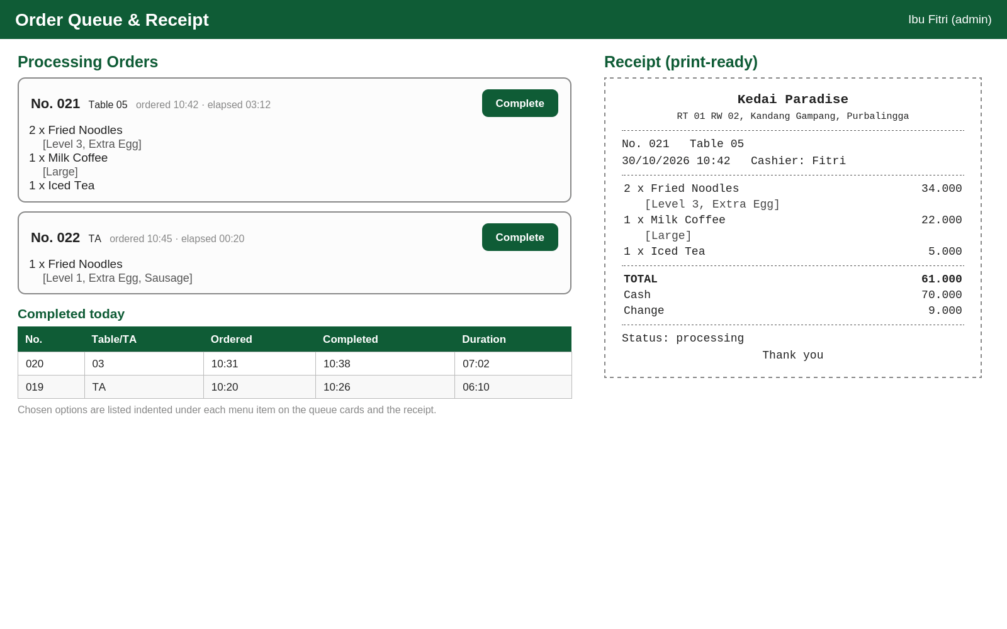
Figure 7. Sketch of the Order Queue (status, time, duration, modifiers under each item) and a sample Receipt with order number, table/TA, and the chosen modifiers
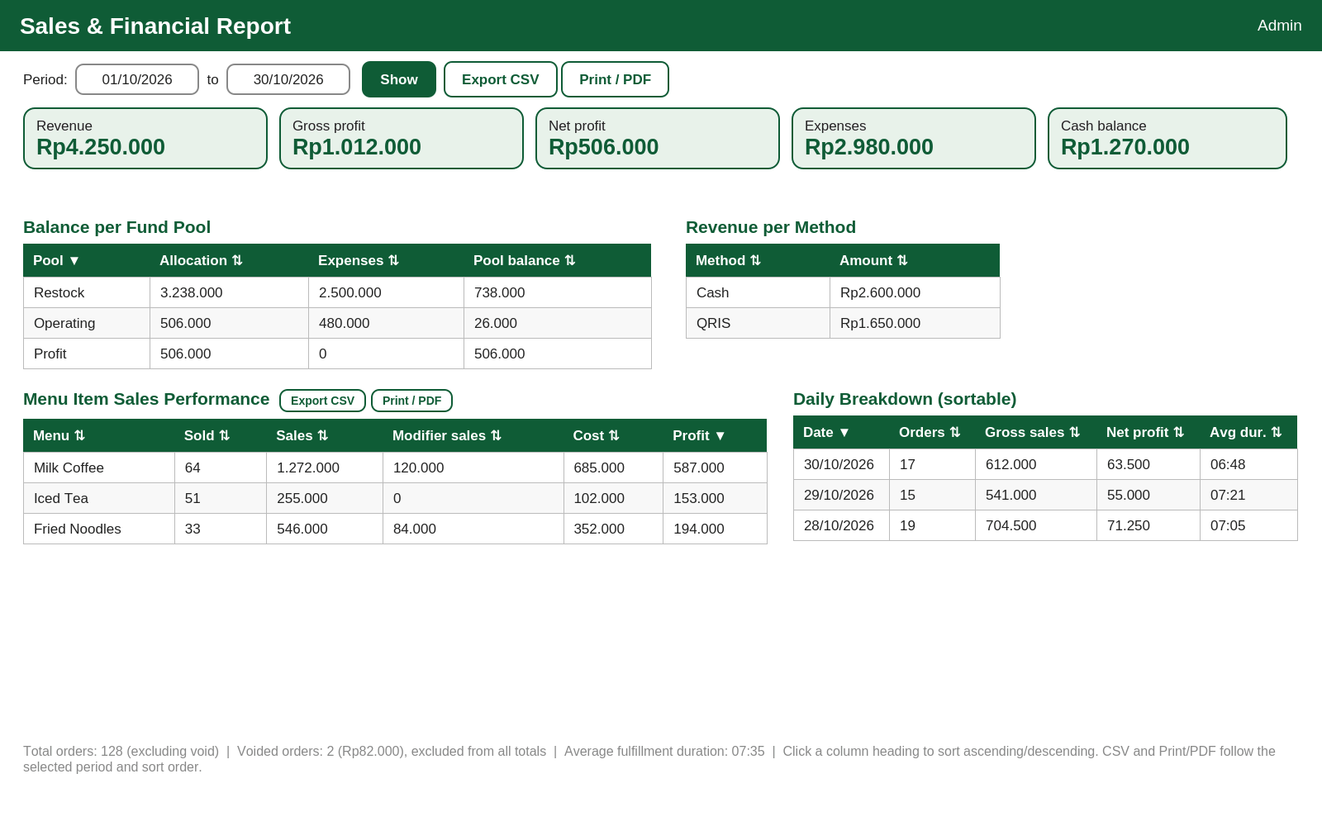
Figure 8. Sketch of the Sales and Financial Reports page: summary, balance per fund pool, revenue per method, menu item sales performance, per-day breakdown, sortable columns, the voided-orders note, and the Export CSV and Print/PDF buttons
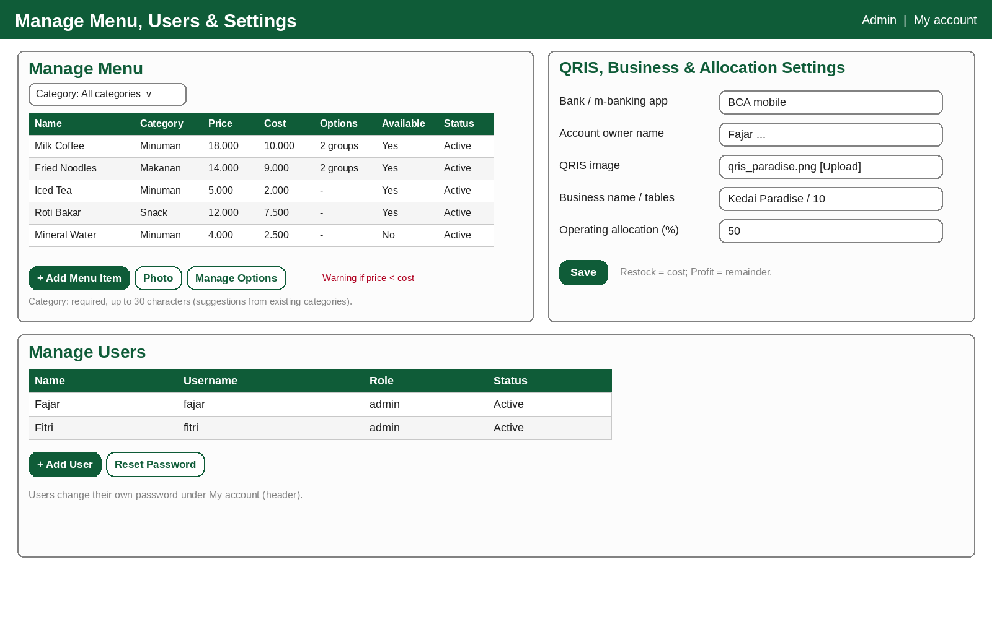
Figure 9. Sketch of the Manage Menu page (with category, cost price and the number of option groups), QRIS, Business and Allocation Settings, and Manage Users
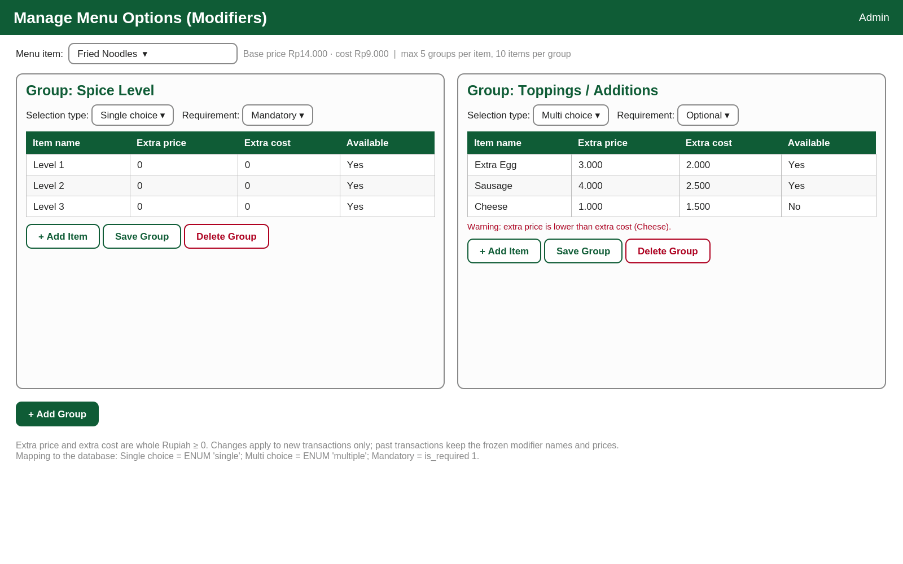
Figure 10. Sketch of the Manage Modifiers page: modifier groups (single_choice/multi_choice, mandatory/optional) and modifier items with extra price and extra cost
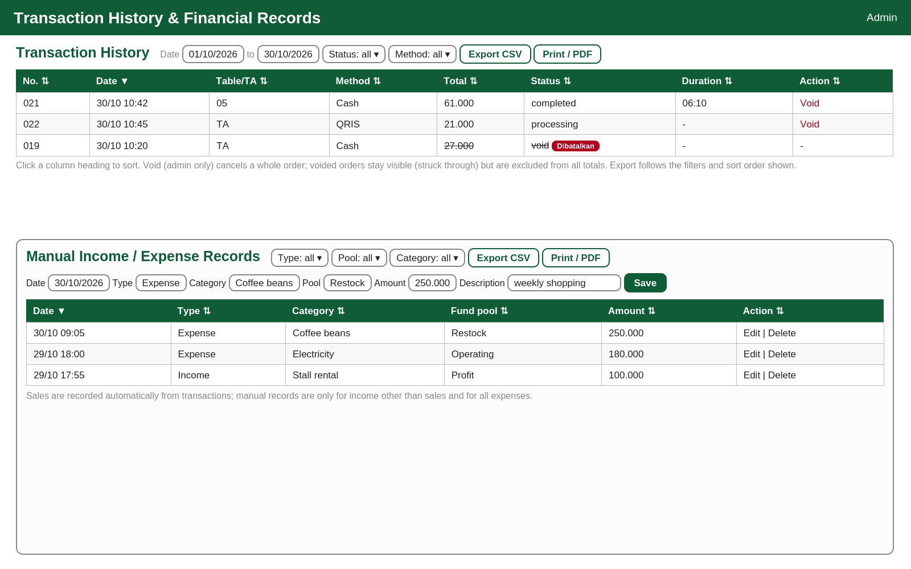
Figure 11. Sketch of the Transaction History (with the admin-only Void action and a voided order) and Manual Income/Expense Records page with filters, sortable columns, and the Export CSV and Print/PDF buttons
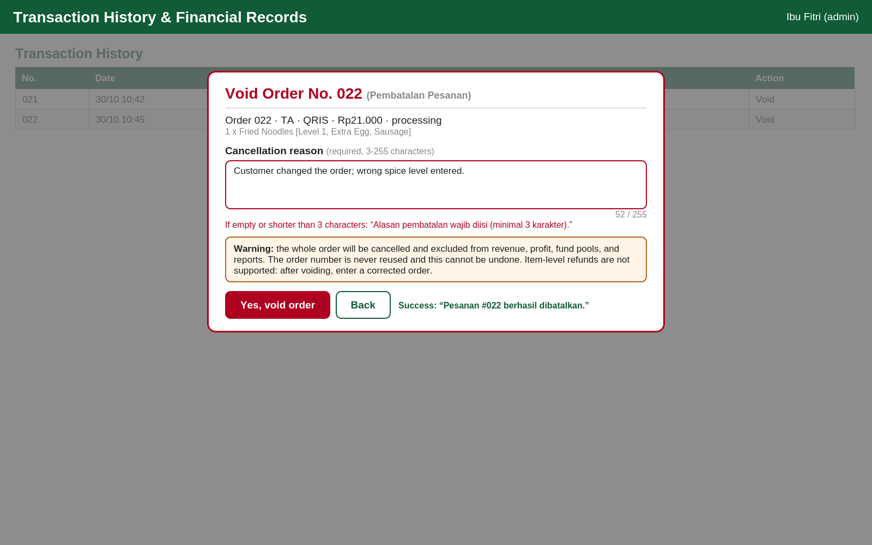
Figure 12. Sketch of the Void Order modal: order summary, mandatory reason (3 to 255 characters), confirmation warning, and the validation and success messages
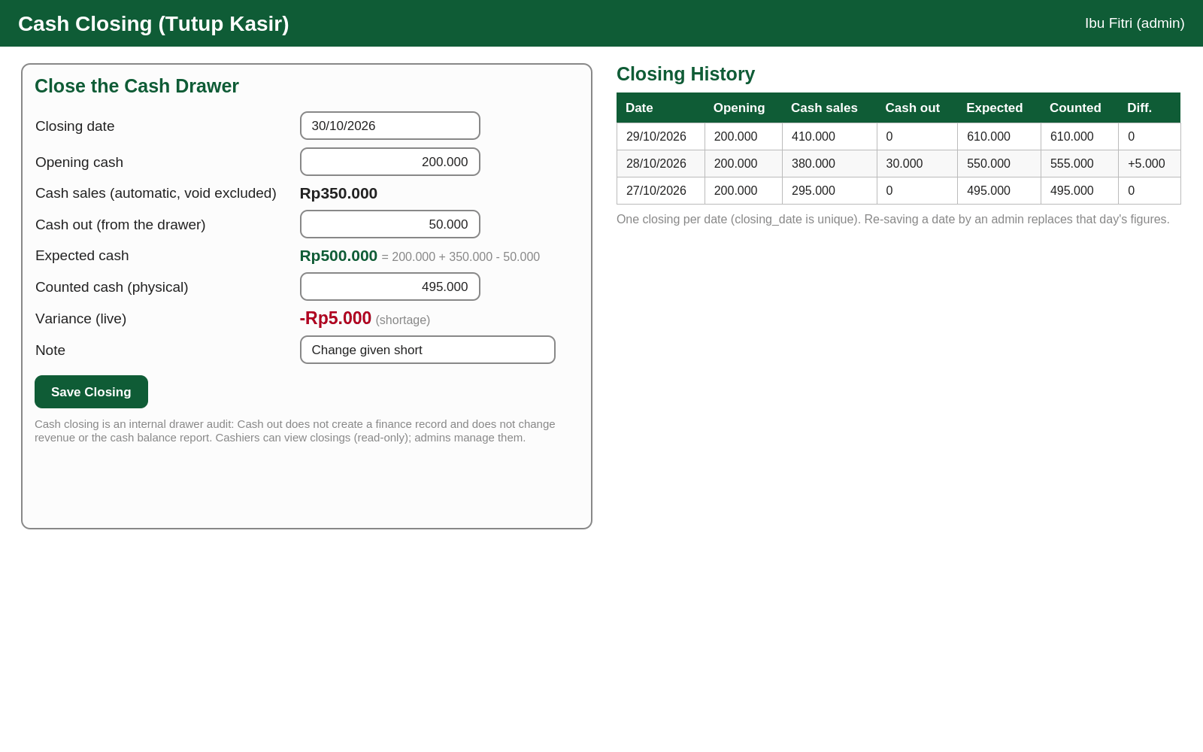
Figure 13. Sketch of the Cash Closing (Tutup Kasir) page: opening cash, automatic cash sales, cash out, expected cash, counted cash, live variance, and the history of past closings

Appendix B. Concise DFD
Text representation of DFD Level 0:
[CASHIER] -> login, menu+quantity+modifier selection, table/TA, method+payment,
confirmation + checkout token, mark completed, history filter/sort,
export request -> (0 SYSTEM)
(0 SYSTEM) -> menu list with options, total, change, QRIS, order number,
receipt (with modifiers), queue (with modifiers), today's history,
cash closing history (read-only), CSV file / print view -> [CASHIER]
[ADMIN] -> login, menu+price+cost, modifier groups+items, users, settings,
manual income/expenses, report period, filters, sort,
export request, void request + reason,
cash closing data -> (0 SYSTEM)
(0 SYSTEM) -> sales+financial report, menu performance, profit, balances,
history, ledger, dashboard, CSV file / print view,
void confirmation, cash closing result -> [ADMIN]
[CUSTOMER] -> order + payment (via cashier) -> [CASHIER]
(0 SYSTEM) -> receipt (order no., table/TA, modifiers) -> [CUSTOMER]
Internal data stores: D1 menu, D2 transactions, D3 orders, D4 users, D5 settings (single-row table), D6 finance, D7 menu_modifier_groups, D8 menu_modifier_items, D9 order_item_modifiers, D10 cash_closings, D11 login_attempts.

Appendix C. Concise ERD
Main relationships:
USERS (1) ---< TRANSACTIONS (1) ---< ORDERS >--- (1) MENU
USERS (1) ---< TRANSACTIONS ; through voided_by (optional, the admin who voided)
ORDERS (1) ---< ORDER_ITEM_MODIFIERS ; frozen snapshot, no FK to the modifier tables
MENU (1) ---< MENU_MODIFIER_GROUPS (1) ---< MENU_MODIFIER_ITEMS
USERS (1) ---< FINANCE
USERS (1) ---< CASH_CLOSINGS
SETTINGS (single row) and LOGIN_ATTEMPTS (log, no FK) stand alone

users(user_id PK, username UK, password_hash, name, role, status)
menu(menu_id PK, name, category, price, cost_price, photo, available, status)
menu_modifier_groups(group_id PK, menu_id FK, name, type ENUM('single','multiple'), is_required)
menu_modifier_items(modifier_id PK, group_id FK, name, extra_price, extra_cost, available)
transactions(transaction_id PK, order_no, date, order_date GENERATED STORED DATE(date),
table_no, method, total, paid, change_due,
status ENUM('processing','completed','void'), completed_at, duration_seconds,
total_cost, gross_profit, alloc_restock, alloc_operating, alloc_profit,
void_reason, voided_at, voided_by FK, user_id FK,
UNIQUE(order_date, order_no), KEY(order_date))
orders(order_id PK, transaction_id FK, menu_id FK, quantity, price, cost_price,
modifier_price, modifier_cost, subtotal)
order_item_modifiers(order_modifier_id PK, order_id FK, modifier_name, price, cost_price)
finance(finance_id PK, date, type, category, pool, amount, description, user_id FK)
cash_closings(closing_id PK, closing_date UK, user_id FK, opening_cash, cash_sales,
cash_out, expected_cash, counted_cash, difference, note, created_at)
login_attempts(attempt_id PK, username, ip_address, attempted_at,
KEY(username, attempted_at), KEY(ip_address, attempted_at))
settings(settings_id PK=1, business_name, business_address, table_count, receipt_footer,
operating_percent, qris_bank, qris_owner_name, qris_image)

Appendix D. Initial System Data
Data | Example/Format | Status
Shop name | Kedai Paradise | To be validated by the management
Location | RT 01 RW 02, Kandang Gampang, Purbalingga | Based on the case study
Operating hours | 08:00 to 22:00 WIB, every operating day | Confirmed by the management
Number of tables | 10 tables (Meja 01 to Meja 10) | Confirmed by the management
Menu, prices, and cost prices | Name, selling price in Rupiah, cost price in Rupiah, photo (optional) Category (for example Makanan, Minuman, Snack). | To be prepared by the management
Modifier groups and items (sample) | Fried Noodles: Spice Level (single_choice, mandatory) Level 1/2/3 +0/+0; Toppings / Additions (multi_choice, optional) Extra Egg +3.000/+2.000, Sausage +4.000/+2.500, Cheese +3.000/+1.500. Milk Coffee: Size (single_choice, mandatory) Regular +0/+0, Large +4.000/+1.500 The shop UI is Indonesian, so the seed script (schema.sql) uses Indonesian sample names (Kopi Susu, Mie Goreng, Es Teh, Roti Bakar; Tingkat Pedas, Toppings / Tambahan, Ukuran; Telur Tambahan, Sosis, Keju, Reguler, Large); the English names in this SRS are translations of the same data. | Sample for testing; to be prepared by the management
Sample menu prices/costs for tests | Milk Coffee 18.000/10.000; Fried Noodles 14.000/9.000; Iced Tea 5.000/2.000; Toasted Bread 12.000/7.500 (price/cost) | Sample for testing
Operating allocation percentage (proposed) | 50% of gross profit; the remainder to the Profit pool; Restock = total cost | Proposed; validated by the owner
Void reasons (examples) | Wrong item entered; customer changed the order; duplicate order | Examples only; the reason is free text (3 to 255 characters)
Opening cash (drawer float) | Rp200.000 per day (sample) | To be decided by the management
Expense categories | Ingredient restocking, Operating, Electricity/Water, Salaries, Other | Can be adjusted
QRIS account | Bank/application, owner name, QRIS image | To be prepared by the owner
Receipt text | E.g. "Thank you" | Can be adjusted
User accounts | Bapak Fajar (admin); Ibu Fitri (admin) | Created at implementation (schema.sql/seed)
Server | Production: PHP-MySQL hosting (cPanel) or a Linux VPS with Apache/Nginx, PHP 8.x, MySQL 8.0/MariaDB, HTTPS, and a domain/subdomain; XAMPP/Laragon only for development and offline staging | To be validated by the management
Backup schedule | Remote cron mysqldump every day (outside operating hours), kept for 30 days; manual phpMyAdmin export Suggested time: 23:30 WIB, after the shop closes at 22:00. | Proposed; validated by the owner

Appendix E. Data to Be Prepared by the Management
- A list of all food and drinks sold along with their categories (for example Makanan, Minuman, Snack), the latest selling prices and cost prices.
- The modifier groups and items (sizes, spice levels, toppings, add-ons) of each menu item with their extra selling prices and extra cost prices.
- Menu photos (optional).
- The desired fund allocation rule (operating percentage) and the list of expense categories commonly used.
- Menu availability status (available/sold out).
- The QRIS image and the mobile banking account data chosen by the owner.
- Data of the users who will use the system (admin and, if any, cashiers).
- The number of tables and the text desired on the receipt.
- The opening cash amount (float) of the drawer, the procedure and time for counting the cash at the end of the day, and the names of the admins who may void orders and close the cash drawer.
- A hosting account (PHP-MySQL hosting/cPanel) or a Linux VPS, a domain or subdomain with a TLS certificate, and a stable internet connection at the counter (with a spare mobile-data hotspot).
- Passwords for the hosting control panel and phpMyAdmin/MySQL, and the storage location of backup copies (including the remote cron backup schedule).

Appendix F. Points to Be Validated
No | Validation Point | Party | Status | Date
1 | Business name and address, as well as ownership (Bapak Fajar) and Ibu Fitri's role as admin. | Management | Not yet validated
2 | Menu list, selling prices, and cost prices. | Management | Not yet validated
3 | Access rights: the admin includes cashier features, one role per user, the cashier only sees the current day's history and does not see cost prices and finances. | Management/Team | Not yet validated
4 | Static QRIS payment with manual confirmation by the cashier: is it suitable, or is dynamic QRIS/another method needed? | Owner | Not yet validated
5 | The mobile banking account for QRIS and who is entitled to change it. | Owner | Not yet validated
6 | Who marks orders as completed (the cashier or kitchen staff) and the device used. | Management | Not yet validated
7 | Receipt format (58/80 mm paper, closing text) and the printers available. 58 mm is the default. | Management | Not yet validated
8 | Number of tables and table numbering. | Management | Not yet validated
9 | Production hosting: PHP-MySQL hosting (cPanel) or Linux VPS, domain/subdomain, and HTTPS; who secures the hosting control panel and phpMyAdmin and stores backups (XAMPP/Laragon only for development and staging). | Owner/Team | Not yet validated
10 | Emergency procedure when the counter's internet connection fails for more than 5 minutes (manual ledger bookkeeping until connectivity is restored). | Management/Team | Not yet validated
11 | Features removed in Revision C (stock and restocking, barcodes, discounts, taxes, general audit logs): are they indeed not needed? Note: transaction cancellation has been re-introduced in Revision D.1 as an Admin-only full-order void with audit logging (void_reason, voided_at, voided_by); partial (item-level) refunds remain out of scope. | Owner | Not yet validated
12 | Fund allocation into three fixed pools (Restock = cost, Operating = percentage of gross profit, Profit = remainder) and the initial percentage of 50%: is it suitable, or are other pools needed? | Owner | Not yet validated
13 | The manual income and expense categories used, and who may edit and delete records. | Owner | Not yet validated
14 | Modifier snapshot design: stored in the normalized order_item_modifiers table (eleven-table schema) instead of a JSON field in orders; limits of 5 groups per item and 10 items per group. | Owner/Team | Not yet validated
15 | After an outage, are the sales written in the manual ledger entered into the system (for example as a summary) or kept only on paper? | Management/Owner | Not yet validated
16 | Login protection on a public domain: resolved in Revision D.1 through rate limiting with the login_attempts table (5 failed attempts per username or IP within 15 minutes lock it for 15 minutes; BR-29). | Owner/Team | Resolved (Revision D.1)
17 | Export: default CSV delimiter (comma or semicolon) for the owner's Excel settings; whether the cashier may export the current-day history; additional columns needed. | Owner | Not yet validated
18 | Hosting choice and cost (shared hosting/cPanel or VPS), server region, domain name, who renews the TLS certificate, and whether the uploads/ folder is also backed up. | Owner | Not yet validated
19 | Cash closing (Tutup Kasir) procedure: who counts the drawer, at what time each day, how the opening cash (float) is set, how shortages and surpluses are handled, and that cash_out for expenses is also entered as a manual expense (BR-28). | Management/Owner | Not yet validated
20 | Void policy: which admins may void, whether a completed order of an earlier day may still be voided after that day's cash closing (the closing must then be saved again), and the wording of the reason examples. | Management/Owner | Not yet validated
21 | Rate limiting side effect: all devices of the shop may share one public IP address; confirm that 5 failed attempts per IP within 15 minutes (BR-29) is acceptable and who unlocks a user in an emergency. | Owner/Team | Not yet validated
22 | Additional requirements not yet listed in the SRS. | Management/Lecturer | Not yet validated
23 | Is the Perlu disimpan ulang flag (BR-31) sufficient, or must a void after a cash closing be blocked? | Management/Owner | Not yet validated

CLOSING
This SRS Revision D.1 serves as the requirements reference for the design and development stages of the Kedai Paradise Point-of-Sale and Finance System, which remains compact enough for a family business while covering hosted cloud deployment over HTTPS, sorted and exportable reports (Print/PDF and CSV), menu modifiers with frozen price snapshots, an eleven-table data model, Admin-only full-order void with audit logging, a database-enforced unique daily order number, login rate limiting, and end-of-day cash drawer closing, together with cost price, profit, fund allocation, and manual financial recording. The requirements in this document and all points in Appendix F need to be reviewed and validated together with Bapak Fajar and Ibu Fitri before the document is approved. Any change to the requirements after the document is approved needs to be recorded as a revision so that the traceability of requirements and testing is maintained.

