Fake News Detection in Social Media
(Using ML & NLP)
Submitted in partial fulfilment of requirements to CSE (Data Science)
Project -I (CD – 363)
III/IV B. Tech CSE (DS) (VI Semester)
Submitted by
Bhukya Harsha Vardhan (Y23CD019)
Dodda Venkata Sai(Y23CD048)
Bandaru Likhith Sai (Y23CD014)



MARCH 2026
R.V.R. & J.C. COLLEGE OF ENGINEERING
(Autonomous)
(NAAC A+ Grade) (Approved by A.I.C.T.E.)
(Affiliated to Acharya Nagarjuna University)
Chandramoulipuram : : Chowdavaram
Guntur – 522 019
R. V. R. & J. C. COLLEGE OF ENGINEERING
DEPARTMENT OF
COMPUTER SCIENCE AND ENGINEERING (DATA SCIENCE)



CERTIFICATE
This is to certify that this project report “Fake news Detection” is the Bonafide work of “Bhukya Harsha Vardhan (Y23CD019), Bandaru Likhith Sai (Y23CD014) and Dodda Venkata Sai(Y23CD048)” who has carried out the work under my supervision and submitted in partial fulfilment for the award of Project - I (CD-363) during the year 2025- 2026.

Mr. R. Ch S N P Sairam  Project Guide | Dr. K. Subramanyam  Project In-charge | Dr. M.V.P.Chandra Sekhara Rao  Prof. & HOD, CSD

ACKNOWLEDGEMENT

We would like to express our sincere gratitude to these dignitaries, who are with us in the journey of our project “Fake News Detection in Social Media”.
First and foremost, we extend our heartfelt thanks to Dr. Kolla Srinivas, principal of R. V. R. & J. C. College of Engineering, Guntur, for providing us with such overwhelming environment to undertake this project.
We are utmost grateful to Dr. M. V. P. Chandra Shekar Rao, Head of the Department of Computer Science and Engineering (Data Science) for paving a path for us and assisting us to meet the requirements that are needed to complete this project.
We extend our gratitude to the in-charge Mr. R. Ch S N P Sairam for his ecstatic guidance and feedback throughout the project. His constant support and constructive criticism have helped us in completing the project.
We would also like to express our sincere thanks to our friends and family for their moral support though out our journey.
Finally, I would like to express my heartfelt thanks to my friends and family for their continuous encouragement and moral support throughout this journey.

Bhukya Harsha Vardhan (Y23CD019)
Dodda Venkata Sai(Y23CD048)
Bandaru Likhith Sai (Y23CD014)
ABSTRACT

This project aims to develop a machine learning–based system capable of identifying news sources that are likely to produce fake news. Rather than focusing solely on individual articles, the proposed model evaluates multiple articles originating from the same source to determine whether the source itself can be classified as a fake news producer. Once a source is identified and labeled as unreliable, the system can predict with high confidence that future articles published by that source are also likely to contain fake news. This source-oriented approach allows for greater tolerance toward individual article misclassification, as the decision is supported by multiple data samples associated with each source.
Fake news detection in this study is carried out using the Passive Aggressive Classifier (PAC) in combination with Natural Language Processing (NLP) techniques. NLP methods are employed to analyze textual characteristics of news articles, including linguistic patterns, word frequency distributions, sentiment cues, satire indicators, irony, and topical relevance. The Passive Aggressive Classifier, an online learning algorithm designed for binary classification tasks, is particularly well suited for this application due to its ability to update the model incrementally as new data becomes available. This adaptive learning capability enables efficient real-time classification while maintaining strong predictive performance, making the proposed approach effective for handling continuously evolving news content in dynamic online environments.

Table of Contents
Title | Page No.
CHAPTER–1: INTRODUCTION
1.1 Introduction of the Project | 1
1.2 Existing System | 1
1.3 Proposed System | 1
1.4 Potential Users | 2
1 .5 Unique features of the System | 2
1.6 Demand for the product | 2
1.7 Protection of Idea | 2
CHAPTER-2: LITERATURE SURVEY / RELATED WORK & SRS
2.1 Literature Review | 3
2.1.1. Review Findings | 3
2.1.2 Objectives of the System | 3
2.2 Requirements Analysis | 3
2.2.1 Functional Requirements Analysis | 3
2.2.2 User Requirements | 3
2.2.3 Non-Functional Requirements | 4
2.2.4 System Requirements | 4
2.3 Modules Description | 4
2.4 Feasibility Study | 4
2.4.1 Technical Feasibility | 4
2.4.2 Operational Feasibility | 4
2.4.3 Behavioral Feasibility | 4
2.5 Process Model used | 5
2.6 Hardware and Software Requirements | 5
2.7 SRS Specification | 5
2.8 Financial Plan for the Development of Product (optional) | 5
CHAPTER-3: DESIGN PHASE / SYSTEM DESIGN
3.1 Design concepts & Constraints | 6
3.2 Design Diagram of the System | 6
3.3 Conceptual Design | 6
3.4 Logical Design (Logical Tools/Logical Diagrams) | 7
3.5 Database Design | 8
CHAPTER-4: PROPOSED SYSTEM
4.1 Introduction to the Proposed System | 9
4.2 System Architecture / Block Diagram | 9
4.3 Algorithms Design | 10
4.4 Modules and Functionalities with outcomes | 11
4.5 Advantages over Existing System | 12
4.6 Limitations (Optional but Recommended) | 13
CHAPTER-5: IMLEMENTATION / CODING
5.1 Implementation Introduction | 14
5.2 Sample Coding | 15
5.3 Implementation procedure & Steps | 20
CHAPTER-6: TESTING  6.1 Introduction to Testing | 22
6.2 Types of Testing | 22
6.3 Test cases and Test Reports | 23
CHAPTER-7: RESULTS / OUTPUT SCREENS
7.1 Output Screens | 25
7.2 Screen Reports | 27
CHAPTER-8 CONCLUSION AND FUTURE ENHANCEMENTS
8.1 Conclusion | 28
8.2 Future Enhancements | 29
CHAPTER-9: BIBLIOGRAPHY
9.1 Books Referred | 30
9.2 Websites visited | 30
9.3 References | 30

CHAPTER - 1
INTRODUCTION
1.1 Introduction of the Project
The rapid growth of social media has made it easy for information to spread quickly among people.
However, this has also increased the spread of fake news and misinformation online.
Fake news can mislead people, create confusion, and influence public opinion.
Traditional methods of detecting fake news mainly rely on manual fact-checking.
Manual verification takes a lot of time and effort and is not suitable for large amounts of data.
To solve this problem, Machine Learning and Natural Language Processing techniques can be used.
These technologies help computers analyse and understand textual information.
In this project, we developed a Fake News Detection system using machine learning algorithms.
The system analyses news articles and predicts whether the news is real or fake.
The model is trained using a dataset containing both real and fake news articles.
A simple web interface allows users to enter news text and get instant results.
This system helps reduce misinformation and supports users in verifying news content
1.2 Existing System
1.Existing fake news detection systems mainly rely on manual fact-checking.
2.Experts or journalists verify news by checking different sources.
3.This process takes a lot of time and human effort.
4.Some systems use rule-based methods to detect fake news.
5.These methods check for specific keywords or patterns in the text.
6.Many existing models work only in offline research environments.
7.Users do not have a simple system to instantly verify news online
1.3 Proposed System
The proposed system is a machine learning-based Fake News Detection system. It automatically analyses news text and predicts whether it is real or fake.
The system uses Natural Language Processing (NLP) techniques to understand the news content. A machine learning algorithm is trained using a dataset containing real and fake news articles.
The trained model learns patterns and features from the dataset. A user-friendly web interface allows users to enter news text easily. The system processes the input and provides an instant prediction result. This helps users quickly verify news and reduces the spread of misinformation.

1.4 Potential Users
The proposed system is intended for a wide range of users, including:
- Social Media Users
- Journalists and News Agencies
- Researchers and Analysts
- Government Organizations
- Educational Institutions and Students
1.5 Unique Features of the System
- User-Friendly Web Interface
- Machine Learning–Based Prediction
- Natural Language Processing (NLP) Analysis
- Easy to use
- Fast and Accurate News Classification
- Dataset-Based Model Training
1.6 Demand for the Product
The demand for fake news detection systems is increasing due to the rapid growth of social media and online news platforms. Large amounts of information are shared daily, making it difficult to identify whether news is real or fake. Fake news can mislead people and spread misinformation quickly. Therefore, automated systems are needed to verify news content efficiently. Such systems help users and organizations prevent the spread of false information.
1.7 Protection of Idea
The project idea can be protected through:
- Copyright for source code
- API key security and access control
- Institutional project ownership
- Possible future patent for adaptive learning workflow

CHAPTER - 2
LITERATURE SURVEY / RELATED WORK and SRS
2.1 Literature Review
The literature review focuses on various research studies related to fake news detection.
Many researchers have used machine learning and natural language processing techniques to identify fake news. Some studies used algorithms like Naïve Bayes, Logistic Regression, and Passive Aggressive Classifier for classification. These approaches analyse textual patterns and features in news articles to detect misinformation. The review of these studies helped in designing and developing an effective fake news detection system.
2.1.1 Review Findings
• Machine Learning improves accuracy in fake news detection
• NLP techniques help analyze textual patterns in news
• Manual fact-checking is time-consuming and inefficient
2.1.2 Objectives of the System
• Detect fake news automatically using Machine Learning
• Analyze news text using Natural Language Processing
• Provide instant prediction for user-entered news
• Reduce the spread of misinformation online

2.2 Requirements Analysis
2.2.1 Functional Requirements Analysis
• Accept news text input from the user
• Process and clean the input data
• Analyze text using trained ML model
• Predict whether the news is real or fake
• Display prediction results to the user
2.2.2 User Requirements
• Simple and user-friendly interface
• Fast prediction results
• Easy news input system
• Clear display of real or fake result

2.2.3 Non-Functional Requirements
• High system performance
• Accurate prediction results
• Secure and reliable system
• Easy accessibility through web interface
2.2.4 System Requirements
• Web browser with internet access
• Python programming environment
• Required ML libraries (Scikit-learn, Pandas, NumPy)
• Web framework support (Flask or similar)

2.3 Modules Description
• User Interface Module: Allows users to enter news text
• Text Processing Module: Cleans and prepares input text
• Feature Extraction Module: Converts text into numerical features using TF-IDF
• Machine Learning Module: Uses Passive Aggressive Classifier for prediction
• Prediction Module: Classifies news as real or fake
• Result Display Module: Shows prediction results on the web page

2.4 Feasibility Study

2.4.1 Technical Feasibility
The system uses widely available technologies such as Python, HTML, CSS, and Machine Learning libraries, making it technically feasible.

2.4.2 Operational Feasibility
The system is simple to operate and users can easily verify news by entering text in the web interface.

2.4.3 Behavioural Feasibility
People are increasingly aware of fake news and are willing to use tools that help verify news authenticity.

2.5 Process Model Used
The Agile Development Model is used for this project, allowing continuous improvements, testing, and incremental development of features.
2.6 Hardware and Software Requirements
Hardware Requirements
• Processor: Intel i3 or above
• RAM: Minimum 4 GB
• Storage: 5 GB free space
Software Requirements
• Frontend: HTML, CSS
• Backend: Python (Flask)
• Machine Learning Libraries: Scikit-learn, Pandas, NumPy
• Development Tools: Git & GitHub
• Operating System: Windows / Linux / MacOS

2.7 SRS Specification
The Software Requirements Specification (SRS) defines the functional requirements, non-functional requirements, system architecture, constraints, and future improvements of the fake news detection system.

2.8 Financial Plan for Development
• Development Cost: RS.0/-
• Dataset: Free public dataset
• Deployment Cost: Depends on hosting platform

CHAPTER – 3
DESIGN PHASE / SYSTEM DESIGN
3.1 Design Concepts & Constraints
The Fake News Detection system is designed to automatically classify news articles as real or fake using Machine Learning techniques. The system uses Natural Language Processing (NLP) to analyse the textual content of news articles Modular architecture
• The system mainly works with text-based news content.
• The model accuracy depends on the quality and size of the training dataset
3.2 Design Diagram of the System
The system follows a client-server architecture with microservices for NLP and AI integration.
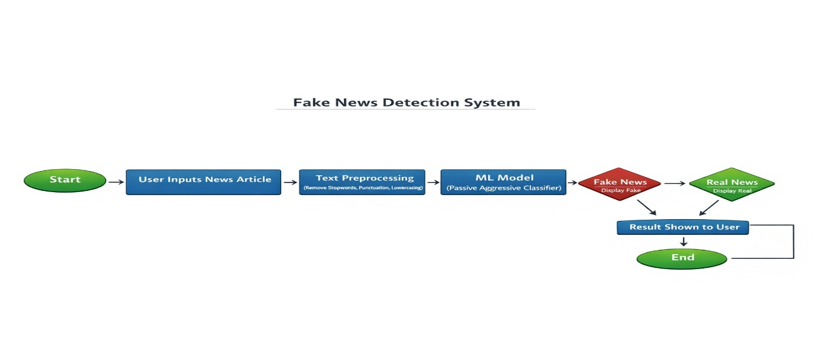
Fig-1: Design System Diagram
3.3 Conceptual Design
• The user enters a news article or statement in the web interface.
• The system receives the input and sends it to the preprocessing module.
• The text is cleaned by removing stopwords, punctuation, and unnecessary characters.
• The cleaned text is converted into numerical features using TF-IDF vectorization.
• The machine learning model analyzes these features.
• The model predicts whether the news is real or fake.
• The result is displayed to the user on the website.

3.4 Logical Design (Logical Tools / Diagrams)
- Use Case Diagram

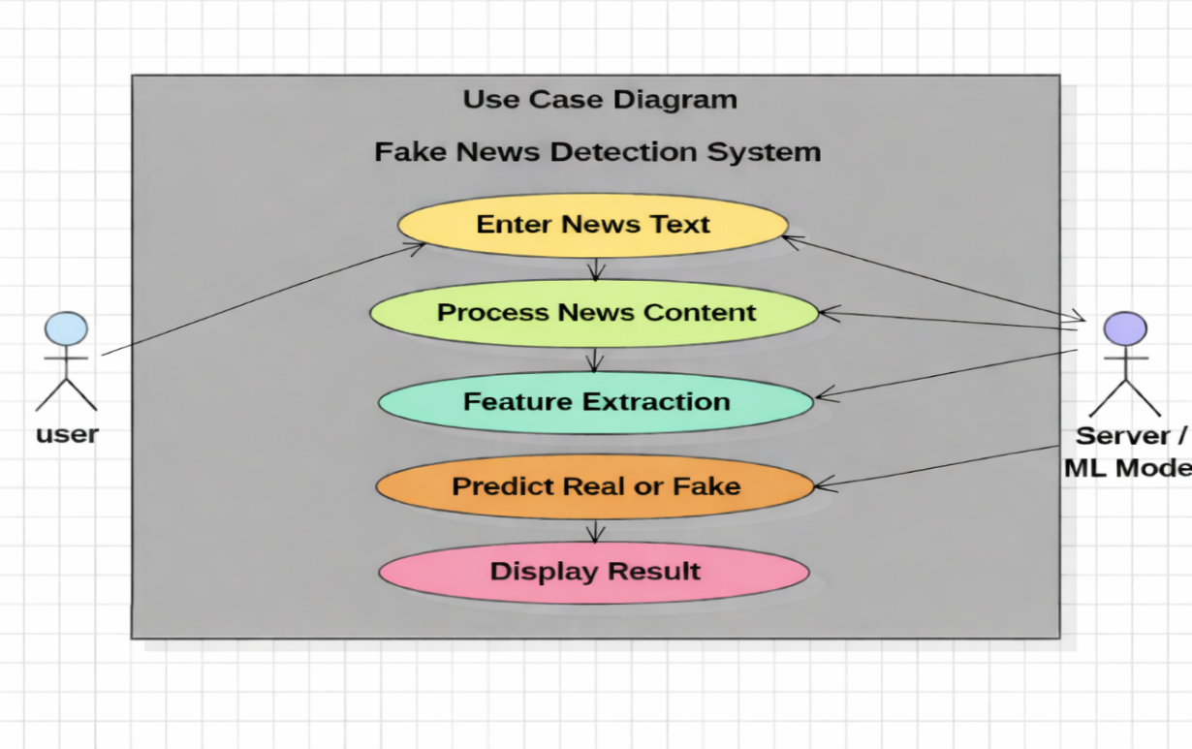
Fig-2 Use case diagram
- Data Flow Diagram (DFD)
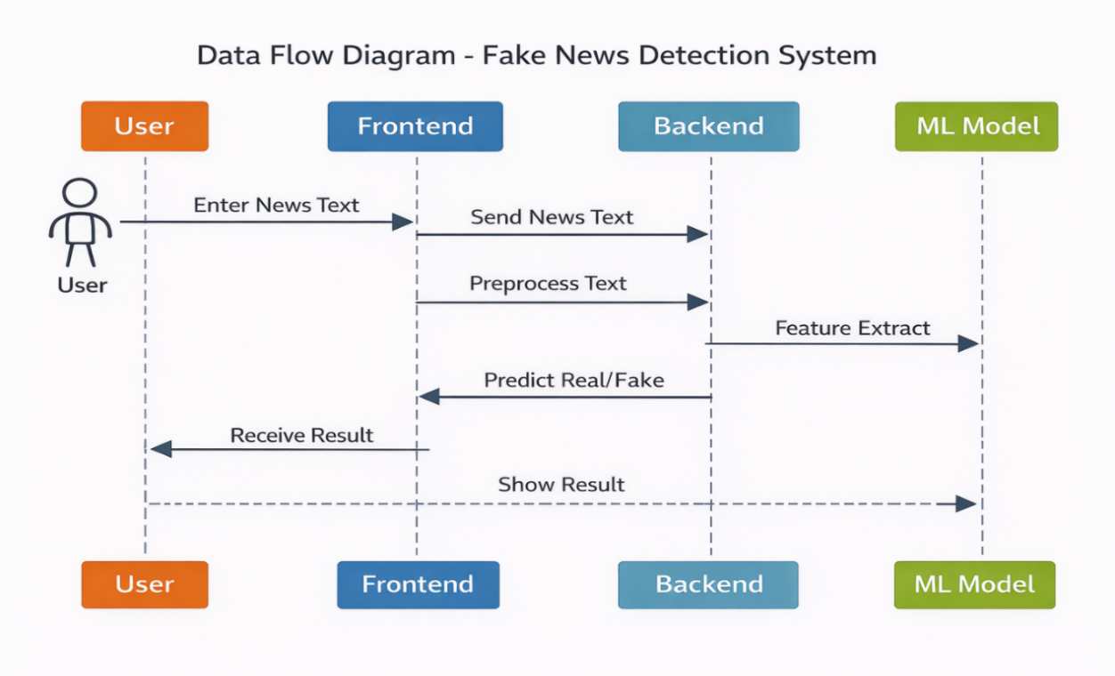
Fig-3: Data Flow Diagram

3.5 Database Design
The Fake News Detection system mainly relies on a dataset used for training the machine learning model. Instead of a traditional relational database, the system uses structured datasets.
Dataset Components
• Text Column – Contains news article or statement.
• Label Column – Indicates whether the news is real or fake.
The dataset is processed using Pandas for data handling and analysis. After training, the model is saved and used for predicting new news inputs.

CHAPTER – 4
PROPOSED SYSTEM
4.1 Introduction to the Proposed System
The proposed system is a machine learning-based Fake News Detection system designed to identify whether a given news article is real or fake. With the rapid growth of social media and online news platforms, misinformation spreads quickly and creates confusion among people. To address this issue, the system uses Natural Language Processing (NLP) and Machine Learning algorithms to analyze news content and predict its authenticity.
The user enters a news statement through a web-based interface, and the system processes the text by cleaning and converting it into numerical features using TF-IDF vectorization. The processed data is then passed to a trained Passive Aggressive Classifier model, which predicts whether the news is real or fake. The prediction result is displayed to the user instantly.
This system helps users verify news quickly and reduces the spread of misinformation by providing an automated and easy-to-use fake news detection solution.

4.2 System Architecture
The system architecture of the Fake News Detection System describes how different components interact to process user input and generate prediction results. The architecture consists of four main components: User Interface, Frontend, Backend Processing, and Machine Learning Model. These components work together to analyze news text and determine whether it is real or fake.
First, the User enters the news text through a web-based interface. The Frontend collects this input and sends it to the Backend server for processing. In the backend, the text undergoes preprocessing, which includes cleaning the text, removing unnecessary characters, and preparing the data for analysis.
After preprocessing, the system performs feature extraction using TF-IDF (Term Frequency–Inverse Document Frequency) to convert text into numerical vectors that can be understood by the machine learning model. These features are then passed to the Passive Aggressive Classifier, which analyzes the patterns in the text and predicts whether the news is real or fake.
Finally, the prediction result is sent back to the Frontend, where it is displayed to the user. This architecture ensures that the system processes data efficiently and provides quick and accurate fake news detection

4.3 Algorithms Design
The Fake News Detection system uses Machine Learning algorithms to classify news articles as real or fake. The main algorithm used in this system is the Passive Aggressive Classifier
# Passive Aggressive Classifier Algorithm
Input: Training dataset (X, y)
w = 0
for each training example (xi, yi):
# Predict label
y_pred = sign(w · xi)
# Calculate hinge loss
loss = max(0, 1 - yi * (w · xi))
# Update rule (if prediction is wrong)
if loss > 0:
tau = loss / (||xi||^2)
w = w + tau * yi * xi
# Model prediction
def predict(x_new):
result = sign(w · x_new)
return result
TF-IDF vectorization
# TF-IDF Feature Extraction Algorithm
Input: Collection of documents D = {d1, d2, d3 ... dn}
# Preprocess documents
for document in D:
document = document.lower()
document = remove_punctuation(document)
document = remove_stopwords(document)
# Calculate Term Frequency (TF)
def compute_tf(word, document):
return document.count(word) / len(document.split())
# Calculate Inverse Document Frequency (IDF)
def compute_idf(word, D):
doc_count = sum(1 for doc in D if word in doc)
return log(len(D) / (1 + doc_count))
# Calculate TF-IDF
def compute_tfidf(word, document, D):
tf = compute_tf(word, document)
idf = compute_idf(word, D)
return tf * idf
# Generate TF-IDF vector for each document
tfidf_vectors = []
for document in D:
vector = []
for word in vocabulary:
vector.append(compute_tfidf(word, document, D))
tfidf_vectors.append(vector)
4.4 Modules and Functionalities with outcomes
User-Interface-Module:
The user interface module provides a simple web-based interface that allows users to interact with the system. It contains an input text box where users can enter the news article or statement they want to verify. The interface also includes a submit button to send the input to the system for analysis. The outcome of this module is that users can easily access the system and submit news text for verification.
Data-Input-Module:
The data input module is responsible for receiving the news text entered by the user. It collects the input data from the web interface and sends it to the backend for processing. This module ensures that the system accepts user input correctly without errors. The outcome is that the system successfully captures the news content that needs to be analyzed.
Text-Preprocessing-Module:
The text preprocessing module prepares the input text for machine learning analysis. In this stage, unnecessary characters, punctuation marks, and stop words are removed from the text. The text is also converted into a suitable format for further processing. The outcome of this module is that the cleaned and structured text becomes ready for feature extraction.
Feature-Extraction-Module:
The feature extraction module converts the processed text into numerical form using TF-IDF vectorization. This step helps transform textual data into numerical features that can be understood by the machine learning model. The outcome is that the news text is represented as feature vectors for classification.
Machine-Learning-Model-Module:
This module uses the Passive Aggressive Classifier algorithm to analyze the extracted features and identify patterns in the news content. The trained model compares the input data with patterns learned during training. The outcome is that the system predicts whether the given news is real or fake.
Result-Display-Module:
The result display module shows the final prediction result to the user on the web interface. After the model processes the input, the system displays whether the news is real or fake. The outcome of this module is that users receive instant feedback about the authenticity of the news content.

4.5 Advantages over Existing System
The proposed Fake News Detection system provides several improvements over existing systems. Traditional fake news detection methods mainly depend on manual fact-checking, which is time-consuming and requires significant human effort. In contrast, the proposed system uses machine learning techniques to automatically analyze and classify news content. This reduces the need for manual verification and speeds up the detection process.
The system provides real-time prediction, allowing users to quickly check whether a news article is real or fake. It also includes a simple and user-friendly web interface, which makes the system accessible to both technical and non-technical users. The use of Natural Language Processing (NLP) techniques helps the system understand and analyze textual information effectively.
Additionally, the system uses TF-IDF feature extraction and the Passive Aggressive Classifier, which improves the accuracy and efficiency of fake news detection. Compared to earlier research-based models, this system is designed as a practical application that users can interact with directly through a website.
Overall, the proposed system helps reduce the spread of misinformation, improves news verification speed, and provides a reliable solution for identifying fake news online

4.6 Limitations
Although the Fake News Detection system provides useful predictions, it still has some limitations. The accuracy of the system mainly depends on the quality and size of the training dataset. If the dataset does not contain enough diverse examples, the model may not perform well on new or unseen news articles.
The system mainly works with text-based news content, so it may not detect fake news that spreads through images, videos, or multimedia content. Another limitation is that the model may sometimes misclassify complex or ambiguous news statements due to language variations and sarcasm.
In addition, the system does not directly analyze real-time social media streams but instead predicts based on the trained dataset. Despite these limitations, the system still provides a helpful tool for quickly identifying potentially fake news.

CHAPTER-5:
IMLEMENTATION / CODING

5.1 Implementation Introduction
The implementation of the Fake News Detection System involves developing a web-based application that can automatically identify whether a given news article is real or fake using machine learning techniques. The system is designed to provide a simple and efficient way for users to verify news content through an easy-to-use interface.
The system is implemented using Python for backend processing and HTML and CSS for the frontend interface. Python libraries such as Pandas and NumPy are used for data handling and analysis, while Scikit-learn is used to build and train the machine learning model. The dataset used for training contains both real and fake news articles, which helps the model learn patterns and differences between authentic and misleading news.
During implementation, the news text first goes through a data preprocessing stage, where unnecessary characters, punctuation, and stop words are removed. The cleaned text is then converted into numerical features using TF-IDF vectorization, which allows the machine learning model to understand and analyze the text.
After feature extraction, the data is given to the Passive Aggressive Classifier, which is trained to classify news articles based on patterns learned from the dataset. Once the model is trained, it is integrated with the web application so that users can input news text and instantly receive prediction results.
The final system allows users to enter news text, process the input through the trained model, and display the prediction result (Real or Fake). This implementation helps provide a practical and efficient solution for detecting fake news and reducing the spread of misinformation online.

4.2 Sample Coding
Sample Python code
import pandas as pd
import pickle

from sklearn.feature_extraction.text import TfidfVectorizer
from sklearn.linear_model import LogisticRegression
from sklearn.model_selection import train_test_split
from sklearn.metrics import accuracy_score

# helper for building the vectorizer (does not remove the word 'not')
def build_vectorizer():
from sklearn.feature_extraction import text as sktext
stop_words = set(sktext.ENGLISH_STOP_WORDS) - {'not'}
return TfidfVectorizer(stop_words=list(stop_words), ngram_range=(1,2), max_df=0.85)

def train(save=True):
"""Train the model and optionally save artifacts."""
print('Loading dataset...')
data = pd.read_csv('news.csv')
data['label'] = data['label'].str.upper()
X = data['text']; y = data['label']

tfidf = build_vectorizer()
X_tfidf = tfidf.fit_transform(X)
print('TF-IDF completed')

X_train, X_test, y_train, y_test = train_test_split(
X_tfidf, y, test_size=0.25, random_state=42, stratify=y
)

model = LogisticRegression(class_weight='balanced', solver='liblinear')
model.fit(X_train, y_train)
print('Model trained successfully')

y_pred = model.predict(X_test)
accuracy = accuracy_score(y_test, y_pred)
accuracy_percent = round(accuracy * 100, 2)
print('Model Accuracy:', accuracy_percent, '%')

if save:
pickle.dump(model, open('model.pkl','wb'))
pickle.dump(tfidf, open('tfidf.pkl','wb'))
pickle.dump(accuracy_percent, open('accuracy.pkl','wb'))
print('Saved model + tfidf + accuracy')

return model, tfidf, accuracy_percent

if __name__ == '__main__':
train(save=True)

Sample HTML code
<!DOCTYPE html>
<html lang="en">
<head>
<meta charset="UTF-8">
<meta name="viewport" content="width=device-width, initial-scale=1.0">
<title>Truthify - About</title>

<!-- CSS -->
<link rel="stylesheet" href="{{ url_for('static', filename='style.css') }}">
</head>

<body>

<!-- HEADER -->
<header class="navbar">
<div class="logo">🛡️ Truthify</div>

<nav>
<a href="/">Home</a>
<a href="/detect">Detect</a>
<a href="/about">About</a>
</nav>
</header>

<!-- ABOUT SECTION -->
<section class="about-work">

<h1>How FakeGuard Works</h1>
<p class="subtitle">
Understanding the machine learning pipeline behind our fake news detection system
</p>

<div class="work-container">

<div class="work-card">
<h3>1. Text Preprocessing</h3>
<p>
The raw text is cleaned and normalized. This includes converting to lowercase,
removing stopwords and tokenization.
</p>
</div>

<div class="work-card">
<h3>2. TF-IDF Vectorization</h3>
<p>
TF-IDF converts text into numerical vectors capturing word importance.
</p>
</div>

<div class="work-card">
<h3>3. Classification Model</h3>
<p>
Passive Aggressive classifier analyzes patterns to classify news.
</p>
</div>

<div class="work-card">
<h3>4. Prediction Output</h3>
<p>
System predicts REAL or FAKE with confidence score.
</p>
</div>

</div>

</section>

<!-- DETECTION FLOW -->
<section class="flow">
<h2>Detection Flow</h2>

<div class="flow-steps">
<span class="step">Input Text</span>
<span class="arrow">→</span>
<span class="step">Preprocessing</span>
<span class="arrow">→</span>
<span class="step">Tokenization</span>
<span class="arrow">→</span>
<span class="step">TF-IDF</span>
<span class="arrow">→</span>
<span class="step">Classifier</span>
<span class="arrow">→</span>
<span class="step">Prediction</span>
</div>
</section>

<!-- SIGNALS
<section class="signals">

<h2>Signals We Analyze</h2>

<div class="signals-container">

<div class="signals-col">
<h4>Sensational Language</h4>
<p>Clickbait phrases, shocking claims, emotional manipulation</p>

<h4>Writing Quality</h4>
<p>ALL CAPS usage, excessive punctuation, text length</p>

<h4>Data & Statistics</h4>
<p>Presence of numbers, percentages, and data points</p>
</div>

<div class="signals-col">
<h4>Source Attribution</h4>
<p>References to studies, officials, credible organizations</p>

<h4>Emotional Tactics</h4>
<p>Urgency appeals, fear-mongering, share pressure</p>

<h4>Source Reliability</h4>
<p>Unverifiable claims, anonymous sources, rumor patterns</p>
</div>
</div>
</section>-->
<!-- DISCLAIMER -->
<section class="disclaimer">
<p>
<strong>Disclaimer:</strong> Truthify is an educational demonstration tool.
</p>
</section>

<!-- CTA -->

<section class="cta">

<button class="start" onclick="window.location.href='/detect'">

Try the Detector →

</button>
</section>

<!-- FOOTER -->

<footer class="footer">

Truthify — A demonstration tool for fake news awareness

</footer>

<script src="{{ url_for('static', filename='script.js') }}"></script>
</body>
</html>
5.3 Implementation procedure & Steps
The implementation of the Fake News Detection System was carried out through several steps to ensure proper development and functionality of the system.
First, a fake news dataset containing both real and fake news articles was collected. This dataset was used to train the machine learning model. The data was then loaded using Python libraries such as Pandas for further processing.
Next, the data preprocessing step was performed, where unnecessary characters, punctuation, and stop words were removed from the text to clean the data. After cleaning, the text data was converted into numerical form using TF-IDF vectorization, which helps the machine learning model understand the textual information.
The dataset was then split into training and testing sets to train and evaluate the model. The Passive Aggressive Classifier algorithm was used to train the model on the training data. After training, the model was tested to check its prediction accuracy.
Once the model was successfully trained, it was integrated into a web application. The frontend was developed using HTML and CSS, while the backend was implemented using Python to connect the machine learning model with the user interface.
Finally, the system was tested by entering different news statements through the web interface, and the system provided predictions indicating whether the news was real or fake.

CHAPTER-6
TESTING
6.1 Introduction to Testing
Testing is an important phase in software development that ensures the system works correctly and meets the required specifications. It helps identify errors, bugs, and issues in the system before it is used by users. Proper testing improves the reliability, performance, and quality of the software.
In the Fake News Detection System, testing is performed to verify whether the system correctly processes user input and accurately predicts whether the news is real or fake. The testing process checks different components of the system, including the user interface, backend processing, machine learning model, and result display.
Various types of testing are carried out to ensure the system functions properly under different conditions. Through testing, the system’s performance, accuracy, and functionality are evaluated to ensure that it provides reliable fake news detection results.
6.2 Types of Testing
In the Fake News Detection System, several testing methods were used to ensure that the system works correctly, provides accurate predictions, and performs efficiently. Testing helps identify errors in different parts of the system and ensures that the application functions as expected.
1.Unit_Testing:
Unit testing was performed to test individual components of the system separately. Modules such as text preprocessing, TF-IDF feature extraction, dataset loading, and the Passive Aggressive Classifier model were tested individually to verify that each function works correctly.
2.Integration_Testing:
Integration testing was used to check whether different modules of the system work together properly. In this project, the frontend interface, backend processing, and machine learning model were integrated and tested to ensure smooth communication between these components.
3.System_Testing:
System testing was performed on the entire application to verify that the complete system functions correctly. This includes testing the process where a user enters news text, the system processes the input, and the model predicts whether the news is real or fake.
4.User_Interface_Testing:
User interface testing ensured that the web interface is simple and easy to use. The input text field, buttons, and result display were tested to confirm that users can easily interact with the system without any confusion or errors.
5.Performance_Testing:
Performance testing was conducted to evaluate how quickly the system processes user input and generates prediction results. The system was tested with multiple news inputs to ensure that it provides fast and reliable responses.
6.Model_Accuracy_Testing:
The machine learning model was also tested to measure its prediction accuracy using testing data. This testing helped evaluate how well the model can classify unseen news articles as real or fake.

6.3 Test cases and Test Reports
Test cases are used to verify whether the system functions correctly for different inputs and scenarios. Each test case includes the input provided by the user, the expected output, and the actual result produced by the system. Test reports help evaluate the performance and correctness of the Fake News Detection System.
Test Case Table
TC1:
This test case verifies the system using real news text. The input provided is “Government announces new policy for farmers.” The expected output is Real News, and the system correctly classifies it as Real News, resulting in a Pass.
TC2:
This test case verifies the system using fake news text. The input provided is “Celebrity secretly owns a flying car factory.” The expected output is Fake News, and the system correctly identifies it as Fake News, resulting in a Pass.
TC3:
This test case checks the system using a random sentence entered by the user. The input is a random sentence, and the expected output is a Real/Fake prediction. The system successfully provides a Real/Fake prediction, resulting in a Pass.
TC4:
This test case checks the system behavior when the input field is empty. The input is no text entered, and the expected output is an error message or warning. The system correctly displays an error message, resulting in a Pass.
TC5:
This test case checks the system response time when a news text is entered. The input is news text, and the expected output is a fast prediction result. The system provides the prediction quickly, resulting in a Pass.
TC6:
This test case verifies the system using a long news article paragraph as input. The expected output is a Real/Fake prediction. The system successfully generates the prediction, resulting in a Pass.

Test Report
The testing results show that the Fake News Detection System successfully processes user inputs and provides predictions for news authenticity. The system correctly identifies real and fake news based on the trained machine learning model. The web interface functions properly, and the prediction results are displayed without errors. Overall, the testing process confirms that the system performs reliably and meets the required functional requirements.

CHAPTER-7:
RESULTS / OUTPUT SCREENS

7.1 Output Screens











7.2 Screen Reports
Home-Page-Screen:
The home page screen is the main interface of the Fake News Detection System. It displays the system title and provides a text input box where users can enter the news content they want to verify. The page also includes a submit button to start the prediction process. This screen allows users to easily interact with the system.
Input-Screen:
The input screen allows users to enter the news article or statement into the text field. After entering the news text, users can submit the input for analysis. This screen ensures that the news content is properly received by the system for further processing.
Processing-Screen:
The processing screen represents the stage where the system analyzes the input news text. During this step, the system performs text preprocessing, feature extraction using TF-IDF, and prediction using the Passive Aggressive Classifier model. This screen indicates that the system is processing the data.
Result-Screen:
The result screen displays the final prediction generated by the system. After analyzing the news content, the system shows whether the news is Real or Fake. This screen provides clear output to the user, helping them verify the authenticity of the news quickly.

CHAPTER-8
CONCLUSION AND FUTURE ENHANCEMENTS

8.1 Conclusion
The Fake News Detection System was developed to identify whether a news article is real or fake using machine learning techniques. The rapid growth of social media has increased the spread of misinformation and misleading content. Many people find it difficult to verify whether the news they see online is authentic. This project aims to provide a simple and effective solution to address this problem. The system helps users verify news content quickly and easily.
The system uses Natural Language Processing and machine learning algorithms to analyze textual information. TF-IDF feature extraction is used to convert news text into numerical features. These features are then processed using the Passive Aggressive Classifier to detect patterns in the data. The model is trained using a dataset containing both real and fake news articles. This training helps the system classify news content accurately.
A user-friendly web interface was developed to make the system easy to use. Users can enter any news text through the input field on the webpage. The system processes the text using preprocessing and feature extraction techniques. After processing, the machine learning model predicts whether the news is real or fake. The final result is displayed instantly on the screen.
Overall, the project demonstrates how machine learning can be used to reduce the spread of fake news. The system provides a fast and reliable method for verifying news content. It also shows the importance of technology in solving real-world problems. The project can be further improved with larger datasets and advanced algorithms. This system helps promote responsible sharing of information online.

8.2 Future Enhancements
The Fake News Detection System can be further improved by adding more advanced features and technologies. One possible enhancement is using larger and more diverse datasets to improve the accuracy of the machine learning model. With more training data, the system can learn better patterns and detect fake news more effectively.
Another improvement is the integration of deep learning models, such as neural networks, which can analyze complex language patterns and provide more accurate predictions. The system can also be extended to analyze multimedia content, including images and videos, which are commonly used in fake news.
In the future, the system can be connected directly to social media platforms to detect and filter fake news in real time. Additionally, developing a mobile application for the system would make it easier for users to verify news quickly from their smartphones. These enhancements would make the system more powerful and useful in controlling the spread of misinformation.

CHAPTER-9:
BIBLIOGRAPHY
9.1 Books Referred
- Tom M. Mitchell, Machine Learning, McGraw-Hill Education.
- Christopher D. Manning, Prabhakar Raghavan, and Hinrich Schütze, Introduction to Information Retrieval, Cambridge University Press.
- Ian Goodfellow, Yoshua Bengio, and Aaron Courville, Deep Learning, MIT Press.
- Ethem Alpaydin, Introduction to Machine Learning, MIT Press.
- Peter Harrington, Machine Learning in Action, Manning Publications.

9.2 Websites visited
- https://www.kaggle.com
- https://scikit-learn.org
- https://www.tensorflow.org
- https://www.geeksforgeeks.org
- https://www.w3schools.com
- https://towardsdatascience.com
- https://github.com

9.3 References
- M. Park and S. Chai, “Constructing a User-Cantered Fake News Detection Model by Using Classification Algorithms in Machine Learning Techniques,” IEEE Access, vol. 11, pp. 71517–71526, 2023, Doi: 10.1109/ACCESS.2023.3294613.
Constructing a User Centered Fake News Detection Model
This includes:
- Authors: Minjung Park, Sangma Chai
- Journal: IEEE Access
- Year: 2023
- Volume: 11
- Pages: 71517–71526
- DOI: 10.1109/ACCESS.2023.3294613

