DEEP LEARNING AND COMPUTER VISION
Abstract
Agriculture is an important contributor to food production and plant diseases have a major impact on the quality and production of food. Identification of rice diseases at an early stage will enable farmers to take preventive measures to minimise losses. In this paper, we propose a deep learning model for the classification of rice leaf diseases using convolutional networks (CNN), transfer learning methods, and classification algorithms. In this work, a publicly available dataset, RIPE diseases, was employed with a dataset of four classes of rice diseases. Two models, namely a custom Convolutional Neural Network (CNN) and ResNet50 were implemented and evaluated. The images were augmented and preprocessed for training the models. The CNN model had an accuracy of 41.26% and ResNet50 model had an accuracy of 25.00% through the experimental results. The achieved performance was limited but the study shows the difficulties of the image-based disease classification and emphasizes the need for tuning the model and enough training. From the results, it is observed that there is need to optimize more and computational power to enhance the classification performance.
Introduction
Rice is one of the major food crops globally. Rice diseases can have a negative impact on agricultural productivity and on the farmers' economy. Traditional diseases identification systems rely on human observation and agricultural specialists and may be lengthy and unreliable. Recent advances in AI and deep learning have offered automated solutions for image classification. CNNs have been found to be effective in computer vision applications. Another advantage of transfer learning models like ResNet50 is that they can be trained to capture intricate visual details. The goal of this project is to categorize the rice diseases with deep learning techniques and to compare the performance of a customized CNN model with the transfer learning approach.
Literature Review
Deep learning methods have been used in several studies for plant disease identification. CNN-based models are effective in disease detection because they can automatically extract image features and have been used with good performance. Other techniques like transfer learning using ResNet, VGG and MobileNet have also been applied to agriculture image classification problems (LeCun, Bengio and Hinton, 2015). These models are trained beforehand and are more accurate in numerous applications, saving training time. Several classification accuracy rates of over 90% have been reported for some plant disease datasets. The performance can be affected by the quality of the data sets, class imbalance, the resolution of the images and the computational capacity (Mohanty, Hughes and Salathé, 2016).
Dataset Description
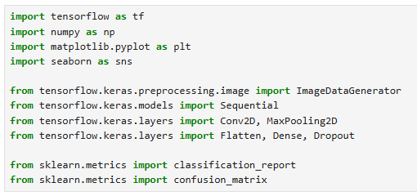
Figure 1: Import Required Package
(Source: Self-created)
This study uses the Rice Disease Image Dataset from Kaggle. The dataset contains images belonging to four different categories:
- Brown Spot
- Healthy
- Hispa
- Leaf Blast
The pictures depict various types of diseases in rice leaves. The data set was split into train and validation data set for model development and testing.
Data Preprocessing
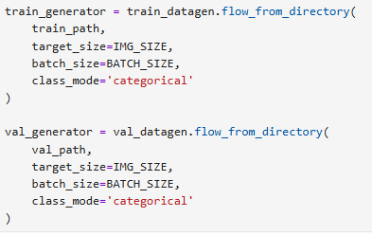
Figure 2: Data Loading
(Source: Self-created)
In order to enhance the performance of the model, the image processing is essential. The following pre-processing steps were carried out:
- Resizing images to 224 x 224 pixels.
- Normalizing pixels by rescaling the data.
Data augmentation techniques used are:
- Rotation
- Zoom
- Horizontal flipping
These techniques are used to make the data more diverse and to prevent overfitting.
CNN Model
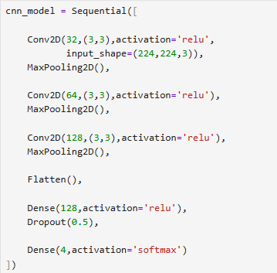
Figure 3: CNN Model
(Source: Self-created)
A Customized Convolutional Neural Network (CNN) was created for image classification. The model is comprised of the following:
- Convolutional layers
- Max-pooling layers
- Flatten layer
- Dense layers
- Dropout layer
- Softmax output layer
The CNN model was trained with categorical cross-entropy loss function and Adam optimizer.
ResNet50 Model
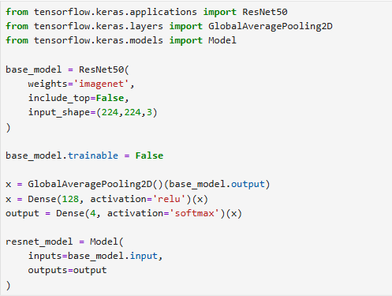
Figure 4: ResNet50 Model
(Source: Self-created)
ResNet50 is a pre-trained deep learning model with the Residual Learning approach. In this project, the transfer learning was used with ImageNet pre-trained weights. All of the top classification layers have been removed, and custom dense layers have been added for the four-class classification problem. The model has been compiled using the Adam optimizer with categorical cross-entropy loss function.
Experimental Results
The CNN model was found to be more effective than ResNet50. The ResNet50 model performed worse, possibly because of lower number of epochs, insufficient fine-tuning and computational constraints. As shown in the accuracy and loss charts, both models exhibited fluctuations in their performance throughout the training process, suggesting they had difficulties in identifying good features from the data. The model predictions were analyzed by using the confusion matrices and classification reports.
Model | Accuracy
CNN | 41.26%
ResNet50 | 25.00%
Discussion
The results obtained show that both of the models developed had problems in the classification of rice diseases. The reduced accuracy may have been due to the following:
- Limited training epochs.
- When the ResNet50 is not tuned for fine-tuning.
- Class imbalance.
- Computational limitations.
- Insufficient hyperparameter optimization.
The overall image classification performance was not as good as expected but the project successfully proved the entire image classification process with deep learning. Some of the things that could be done in the future are:
- Increasing training epochs.
- Fine-tuning pretrained layers.
- Using sophisticated augmentation methods.
- Using larger datasets.
- Experiment with different architecture like MobileNet or EfficientNet.
Computational Analysis
Experiments were carried out in Jupyter Notebook and using TensorFlow. The CNN model was found to have fewer parameters and computational time. The ResNet50 model had more parameters than the other one, making it more expensive to calculate. The training has been carried out on a typical computing environment without any high-end GPU acceleration. This restriction had an impact on the efficiency of the training and the overall performance. CNN achieved higher computational efficiency than ResNet50 in the hardware setting.
Ethical Considerations
Before implementing artificial intelligence systems in agriculture, they need to be carefully evaluated. The wrong prediction can result in:
- Improper treatment decisions.
- Losses to be incurred by farmers.
- Reduced crop productivity.
Prediction performance can also be influenced by the dataset bias. The model might give incorrect predictions if there are not as many images in some of the disease classes. So, the disease detection system based on AI should not be the end-all and be-all, but rather a decision support tool for agricultural experts.
Conclusion
In this study, deep learning techniques for rice disease classification were studied. Two models (CNN and ResNet50) were implemented and evaluated. The CNN model performance was 41.26% and ResNet50 was 25.00% accurate. The project did not achieve the desired results but it proved to be a successful demonstration of image preprocessing, development of deep learning models, evaluation, and comparative analysis. Hyperparameter tuning, more data and optimizing transfer learning may make a big difference for future improvements.
Limitations of the Study
In the study, it is found that although deep learning models were successfully applied in the classification of rice diseases, there are still some limitations to be addressed. The first limitation is the limited amount of training data. In general, deep learning models need a massive amount of data to be accurate. The images collected into the dataset were of four disease categories, but the amount of images was relatively small for each class (He et al., 2016). Another restriction was the computing environment. The experiments were performed with a standard computer system, where GPU support was not used. Inference with deep neural networks on CPU takes longer and possibly results in degradation of the entire system performance. Frozen layers were used with ResNet50 model. Because fine-tuning was not conducted this model can not adapt to the characteristic of rice leaf image completely. This made a considerable impact on the accuracy of the final product. Limited number of training epochs was also used. More epochs and hyperparameter optimization techniques may help the model achieve better results. Finally, the classification results may have been influenced by the environmental factors, like ambient lighting, various background conditions, image quality etc.
Future Scope
This study could be expanded in a number of ways to increase the accuracy of disease classification and usability in practice. A potential enhancement is the ability to gather more and varied data sets. Images from various geographical areas and environmental conditions would enhance the robustness of the model. Advanced data augmentation methods like brightening, random crop and color transformation can also help increase the generalization performance. The following are some possible deep learning architectures that can be explored in future studies:
- EfficientNet
- MobileNetV2
- DenseNet
- Vision Transformers
The models have been shown to perform well in different image classification tasks. Grid search and Bayesian optimization are two hyperparameter tuning methods that can also enhance the accuracy of the models (Shorten and Khoshgoftaar, 2019). Cloud-based GPU platforms such as Google Colab or Kaggle Notebook can provide faster training and enable larger experiments. The model could be incorporated into mobile apps for farmers to upload pictures of leaves and get immediate predictions of the diseases. AI-driven agricultural systems can play a crucial role in precision farming and sustainable agriculture.
Reflection
This project gave great hands-on experience in the field of Artificial Intelligence and Computer Vision. Several challenges occurred while implementing this process, such as the dataset preparation, dataset preprocessing, training the model and testing the accuracy of the model. The project contributed to the learning of the Python programming language, TensorFlow, Keras, and deep learning methods. The ability to understand and know the difference between traditional CNN and transfer learning models was very useful.

References
Brahimi, M., Boukhalfa, K. and Moussaoui, A. (2017) ‘Deep Learning for Tomato Diseases: Classification and Symptoms Visualization’, Applied Artificial Intelligence, 31(4), pp. 299–315.
Chollet, F. (2021) Deep Learning with Python. 2nd edn. New York: Manning Publications.
Goodfellow, I., Bengio, Y. and Courville, A. (2016) Deep Learning. Cambridge, MA: MIT Press.
He, K., Zhang, X., Ren, S. and Sun, J. (2016) ‘Deep Residual Learning for Image Recognition’, Proceedings of the IEEE Conference on Computer Vision and Pattern Recognition (CVPR), pp. 770–778.
Kaggle (2025) Rice Diseases Image Dataset. Available at: https://www.kaggle.com/datasets/minhhuy2810/rice-diseases-image-dataset (Accessed: 24 June 2026).
Keras (2025) Keras Documentation. Available at: https://keras.io/ (Accessed: 24 June 2026).
LeCun, Y., Bengio, Y. and Hinton, G. (2015) ‘Deep learning’, Nature, 521(7553), pp. 436–444.
Mohanty, S.P., Hughes, D.P. and Salathé, M. (2016) ‘Using Deep Learning for Image-Based Plant Disease Detection’, Frontiers in Plant Science, 7, p. 1419.
Russakovsky, O. et al. (2015) ‘ImageNet Large Scale Visual Recognition Challenge’, International Journal of Computer Vision, 115(3), pp. 211–252.
Shorten, C. and Khoshgoftaar, T.M. (2019) ‘A survey on Image Data Augmentation for Deep Learning’, Journal of Big Data, 6(60), pp. 1–48.
TensorFlow (2025) TensorFlow Documentation. Available at: https://www.tensorflow.org/ (Accessed: 24 June 2026).

