Architecture

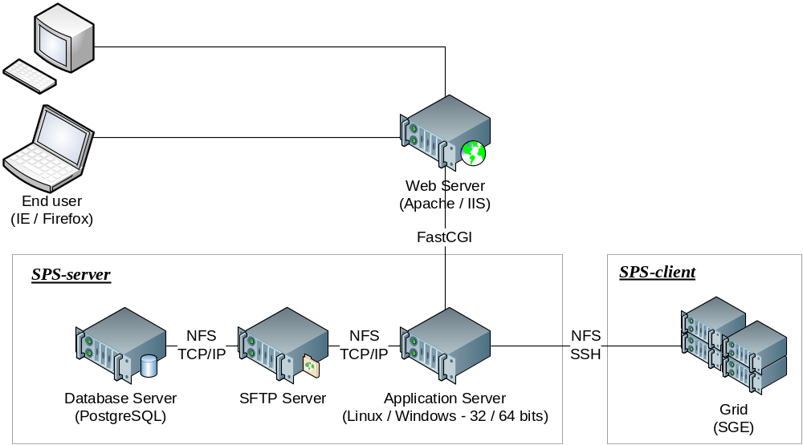

SPS architecture diagram

End user system
Implements the interfaces to the Input, Annotation and Reports modules, including some client-side processing of filtration options.

System and technical requirements:
- Recent internet browser:
  - Mozilla Firefox 3.5 or higher
  - Microsoft Internet Explorer 8.0 or higher
- Javascript version 1.8 (included with browser)
- Support for Flash version 9.0.45 (available free of charge from: http://get.adobe.com/flashplayer/)
- Support for Thermo .RAW files further requires
  - Windows OS compatible with Thermo DLLs and ReAdW
  - Proprietary Thermo DLLs compatible with the .RAW files
  - ReAdW version 4.2.1 or higher

SPS-client
Collection of command line tools used to distribute the execution of compute-intensive algorithms over a grid or compute cluster.

System and technical requirements:
- Recommended hardware configuration
  - Intel Xeon or AMD Opteron (Dual or Quad Core)
  - 24 Gb RAM
  - 1.5 Tb hard drive
  - 1 Gbps Full Duplex network connections to web server and grid
- x86 or x86_64 compute nodes running Redhat or CentOS 4.4 with preinstalled packages:
  - glibc-2.3.4
  - libgcc-3.4.6
  - libstdc++-3.4.6
  - gd-2.0.28
  - libjpeg-6b
  - freetype-2.1.9
  - libpng-1.2.7
  - xorg-x11-libs-6.8.2
  - openssl-0.9.7a
- Sun Grid Engine (SGE) version 6.1 scheduler for distribution of compute jobs on the grid
- NFS access to SPS-server files: grid front-end and compute nodes

SPS-server
Multi-process services and servers implementing Shotgun Protein Sequencing. As described below, most tasks assigned to SPS-server are administrative or related to the web services and control of compute-intensive tasks executed on the grid;

SPS-server modules and functionality:

- Shotgun Protein Sequencing; to minimize network overload, short-lived compute-intensive and/or memory-intensive parts of the Shotgun Protein Sequencing and Comparative SPS algorithms may be executed directly by SPS-server.

- Distributed execution; controls the execution of SPS-client modules on the grid, depending on current load, user/project quotas, etc.

- Web application; all application-related requests for dynamic content (from End users) are relayed by the Web server to SPS-server via a FastCGI interface.

- Data storage and management; files are transferred to SPS-server via SFTP and either stored in a database or on the file system under a predetermined directory structure:
  - Database storage is used for all administrative data related to user accounts, file ownership and sharing properties, project parameters and results, etc.
  - File system storage is used for input spectrum files (e.g., mzXML files) and for project results required for generating reports and implementing the interactive user interface.

- Generation of reports; requests for the generation of PDF reports are handled directly by SPS-server.

- Multi-user environment; allows end users to change their username/password, manage projects data and remove/share input spectrum files.

- Administration; implementation of the administrative interface for management of user accounts, grid parameters and quotas, file management, configuration of SPS parameters and location of third-party modules (e.g., libraries).

System and technical requirements:
- x86 or x86_64 compute nodes running Redhat or CentOS 4.4 with preinstalled packages:
  - glibc-2.3.4
  - libgcc-3.4.6
  - libstdc++-3.4.6
  - openssl-0.9.7a
  - proftpd-1.3.3rc2
- Recommended hardware configuration
  - Intel Nehalem (Quad Core Hyperthreaded)
  - 24 Gb RAM
  - 1.5 Tb hard drive
  - 1 Gbps Full Duplex network connections to web server and grid
- Xerces C++ XML library version 3.0.1 or higher
- PostgreSQL 8.4 or higher
- Apache FOA version 0.6
- Java SE Runtime Environment JRE 6

