Shotgun  Protein  Sequencing
   | Project Status
  Create Project | Run Project | Project Status | Reports
  Project
  abrf_olc
  aHerceptin_gtabOboth
  aMRSA_HC
  Next
  Protein
  gi|124487419
  gi|71043961
  gi|22507367
  Next
  Contig
  18
  19
  20
  Next
  Input File
  Ab_LC_DTT_NIPIA_ArgC
  Ab_LC_DTT_NIPIA_AspN
  Ab_LC_DTT_NIPIA_GluC
  Next
  Project | abrf_olc 1. Name of the project
  User | pbouchard 2. Username executing the job
  Status | 100 % 3. Percentage of completion
  Elapsed | 1:13 4. Elapsed and remaining time
  Data | Group by Contig 5. All spectra sorted by contig
  Data | Group by Protein 6. All contig sorted by protein with statistics
  Cluster Data | All Clusters (txt)  Group by ABRF_Ab_LC_DTT_NIPIA_ArgC_37C_On_102909.mgf 7. All spectra sorted by input  Group by ABRF_Ab_LC_DTT_NIPIA_AspN_37C_ON_102909.mgf  Group by ABRF_Ab_LC_DTT_NIPIA_GluC_37C_ON_102909.mgf  Group by ABRF_Ab_LC_DTT_NIPIA_LysC_37C_ON_102909.mgf  Group by ABRF_Ab_LC_DTT_NIPIA_chymotrypsin_37C_ON_102909.mgf  Group by ABRF_Ab_LC_DTT_NIPIA_pepsin_37C_1h_102809.mgf  Group by ABRF_Ab_LC_DTT_NIPIA_trypsin_37C_ON_102909.mgf

Shotgun  Protein  Sequencing
  Proteins
  Create Project | Run Project | Project Status | Reports
  Project
  abrf_olc
  aHerceptin_gtabOboth
  aMRSA_HC
  Next
  Protein
  gi|124487419
  gi|71043961
  gi|22507367
  Next
  Contig
  18
  19
  20
  Next
  Input File
  Ab_LC_DTT_NIPIA_ArgC
  Ab_LC_DTT_NIPIA_AspN
  Ab_LC_DTT_NIPIA_GluC
  Next
  Protein | Description | Contigs | Spectra | Amino Acids | Coverage (%)
  gi|124487419|ref|NP_034798.2| | keratin complex 2, basic, gene 17 [Mus musculus] | 9 | 27 | 71 | 100
  gi|71043961|ref|NP_075822.3| | trypsinogen 7 [Mus musculus] | 4 | 375 | 35 | 141
  gi|22507367|ref|NP_683761.1| | oxysterol-binding protein-like protein 10 [Mus musculus] | 2 | 5 | 17 | 28
  gi|16716569|ref|NP_444473.1| | protease, serine, 1 [Mus musculus] | 5 | 18 | 48 | 195
  gi|31980626|ref|NP_058038.2| | regulator of G-protein signaling 14 [Mus musculus] | 2 | 5 | 13 | 23
  gi|121040|sp|P01868.1|IGHG1_MOUSE | Ig gamma-1 chain C region secreted form | 2 | 15 | 11 | 33
  gi|3212688|pdb|2JEL|L | Chain L, Jel42 FabHPR COMPLEX | 50 | 272 | 141 | 649
  gi|148667160|gb|EDK99576.1| | hypothetical protein C630010N09 [Mus musculus] | 2 | 6 | 16 | 118
  gi|6978717|ref|NP_036668.1| | Chymotrypsinogen B [Rattus norvegicus] | 1 | 4 | 12 | 45
  gi|149044187|gb|EDL97569.1| | echinoderm microtubule associated protein like 1, isoform CRA_b [Rattus norvegicus] | 4 | 11 | 22 | 35

Shotgun  Protein  Sequencing
  Protein
  Create Project | Run Project | Project Status | Reports
  Project
  abrf_olc
  aHerceptin_gtabOboth
  aMRSA_HC
  Next
  Protein
  gi|124487419
  gi|71043961
  gi|22507367
  Next
  Contig
  18
  19
  20
  Next
  Input File
  Ab_LC_DTT_NIPIA_ArgC
  Ab_LC_DTT_NIPIA_AspN
  Ab_LC_DTT_NIPIA_GluC
  Next
  GI 71043961 REF NP_075822.3 1. Name of the protein
  4 contigs, 375 spectra, 35 amino acids, 14.1% coverage 2. General statistics
  1  51  101  151  201 | MKTLIFLAFL GAAVALPLDD DDDKIVGGYT CQRNALPYQV SLNSGYHFCG 3. Common amino acids  GSLINSQWVV SAAHCYKSRI QVRLGEHNID ALEGGEQFID AAKIIRHPNY  NANTYNNDIM LIKLKTAATL NSRVSTVALP RSCPSAGTRC LVSGWGNTLS  SGTNYPSLLQ CLDAPVLSDS SCTSSYPGKI TSNMFCLGFL EGGKDSCQGD  SGGPVVCNGQ LQGVVSWGYG CAQRGKPGVY TKVCKYVNWI QQTIAAN
  Index | Spectra | Contig | Contig Sequence | Protein
  18 | 2 | 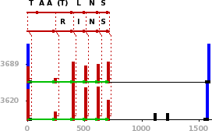 |  | gi|71043961|ref|NP_075822.3|  trypsinogen 7 [Mus musculus]
    Homolog
    TAA(T,55.0)LNS
    De Novo
    [243.1]RINS
  23 | 5 | 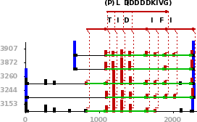 |  | gi|71043961|ref|NP_075822.3|  trypsinogen 7 [Mus musculus]
    Homolog
    (P,4.0)LD(DDDDKIVG,-368.2)
    De Novo
    [275.2]TID[229.1]IFI[255.2]

Shotgun  Protein  Sequencing
  Contig
  Create Project | Run Project | Project Status | Reports
  Project
  abrf_olc
  aHerceptin_gtabOboth
  aMRSA_HC
  Next
  Protein
  gi|124487419
  gi|71043961
  gi|22507367
  Next
  Contig
  18
  19
  20
  Next
  Input File
  Ab_LC_DTT_NIPIA_ArgC
  Ab_LC_DTT_NIPIA_AspN
  Ab_LC_DTT_NIPIA_GluC
  Next
  2. Reference peptide  3. Database peptide  4. De Novo peptide | 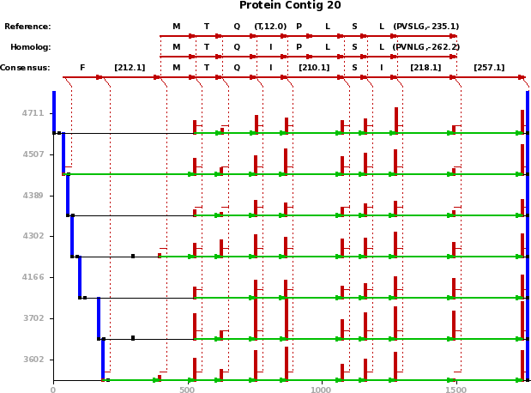 | 1. Contig index  5. Spectra alignment
  Index | Spectrum | Peptide | Mass (m) | Charge (z) | B (%) | Y (%) | BY Intensity (%)
  3602 |  |  | 795.5 | 0 | 81 | 109 | 46
    Reference
    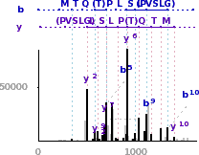
    6. Link to associated cluster
    Reference 2.
    [212.1]MTQ(T,12.0)PLSL(PVSLG,-235.1)[257.1]
    Homolog 3.
    [212.1]MTQIPLSL(PVNLG,-262.1)[257.1]
    De Novo 4.
    [212.1]MTQI[210.1]SI[218.1][257.1]

Shotgun  Protein  Sequencing
  Cluster
  Create Project | Run Project | Project Status | Reports
  Project
  abrf_olc
  aHerceptin_gtabOboth
  aMRSA_HC
  Next
  Protein
  gi|124487419
  gi|71043961
  gi|22507367
  Next
  Contig
  18
  19
  20
  Next
  Input File
  Ab_LC_DTT_NIPIA_ArgC
  Ab_LC_DTT_NIPIA_AspN
  Ab_LC_DTT_NIPIA_GluC
  Next
   | 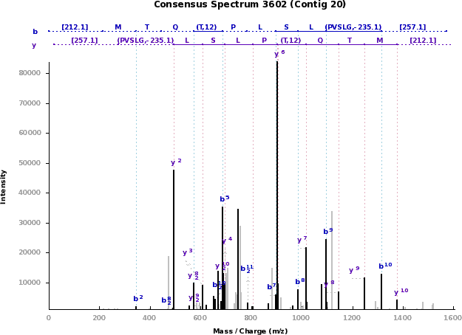 | 1. Consensus spectrum of the cluster
  Scan | Spectrum | Peptide | Mass (m) | Charge (z) | B (%) | Y (%) | BY Intensity (%)
  3235 |  |  | 1589.9 | 2 | 81 | 109 | 45
    Reference
    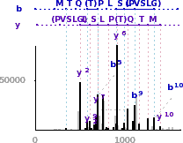
    Reference
    [212.1]MTQ(T,12.0)PLSL(PVSLG,-235.1)[257.1]
    Homolog
    [212.1]MTQIPLSL(PVNLG,-262.1)[257.1]
    De Novo
    [212.1]MTQI[210.1]SI[218.1][257.1]
  3235
     | ABRF_Ab_LC_DTT_NIPIA_AspN_37C_ON_102909.mgf | 2. Input filename

Shotgun  Protein  Sequencing
  Input File
  Create Project | Run Project | Project Status | Reports
 | 2. Pagination  [40-1205] [1258-1556] [1583-1790] [1795-1914] [1920-2130] [2140-2420] [2432-2693]
  Project
  abrf_olc
  aHerceptin_gtabOboth
  aMRSA_HC
  Next
  Protein
  gi|124487419
  gi|71043961
  gi|22507367
  Next
  Contig
  18
  19
  20
  Next
  Input File
  Ab_LC_DTT_NIPIA_ArgC
  Ab_LC_DTT_NIPIA_AspN
  Ab_LC_DTT_NIPIA_GluC
  Next
  ABRF_Ab_LC_DTT_NIPIA_ArgC_37C_On_102909.mgf 1. Input filename
  Scan | Spectrum | Peptide | Mass (m) | Charge (z) | B (%) | Y (%) | BY Intensity (%)
  620  (54) |  |  | 1256.6 | 2 | 111 | 111 | 55
    Homolog
    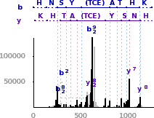
    Homolog
    HNSY(TCE,-91.0)ATHK
    De Novo
    [251.1]SY[299.1]ATHQ
  620  (54)
     | gi|3212688|pdb|2JEL|L | 3. Protein name
  633  (54) |  |  | 1268.6 | 2 | 80 | 40 | 44
    Homolog
    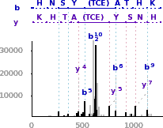
    Homolog
    [12.0]HNSY(TCE,-91.0)ATHK
    De Novo
    [12.0][251.1]SY[299.1]ATHQ
  633  (54) | gi|3212688|pdb|2JEL|L

