Report elements

Spectrum
- Filename
- Scan number
- Assigned peptide (empty if unknown)
- Peptide propagation level (empty if unknown)
- Percentage of explained PRM score (empty if unknown)
- Percentage of explained MS/MS intensity (empty if unknown)
- Percentage of b/y breaks present in the spectrum (empty if unknown)
- Length of the longest series of consecutive b-ion or y-ion matches (tag length)
- Annotated-spectrum image (like Label.py, empty if unknown)

Protein match
Box with the following elements
- Protein ID + name at the top (name not shown below)
- Do not show match statistics like below
- Protein sequence with matched regions highlighted in black, non-matched regions shown in gray

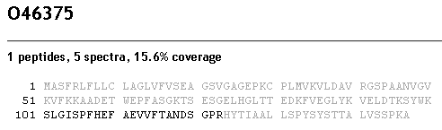

Report views

Spectral network list view
List of the following:
- Spectral Network index
- Covered sequence (including all peptides for all grouped spectra)
- Number of grouped spectra
- Number of modifications
- Clicking on a spectral network leads to Spectral network detail view

Spectral network detail view
- Show peptide spectral network at the top, side-by-side with a protein match element highlighting the region covered by this network in red
- Spectral-network element
- List of Spectrum elements displayed like shown below

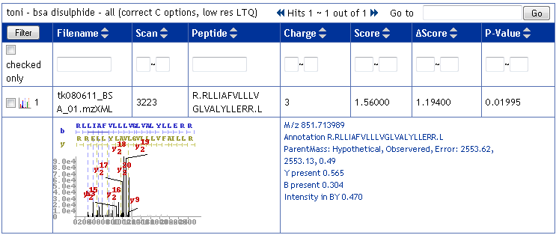

Protein list view
List of proteins selected from DB by at least one spectrum/network match, sorted by decreasing number of matched spectra
- Protein ID
- Protein name
- Coverage: percentage of protein sequence matched spectra
- Number of matched networks
- Number of matched spectra
- Number of modifications/sites
- Clicking on a protein leads to Protein detail view

Protein detail view
- Show Protein match element at the top
- Reuse Spectral network list view, selecting only networks matched to selected protein
- Clicking on a spectral network leads to Spectral network detail view

Graphical elements
- Export in scalable vector format: Encapsulated PostScript (.eps)
- Export in portable raster format: Portable Network Graphics (.png)
- Generate network graphs using graphviz or java/cpp library providing equivalent functionality

Spectral network
- Nodes: spectra in the network, labels of the form “P (N)”, where P is the peptide sequence assigned to the spectrum and N is the propagation level (empty if not available)
- Edges: significant spectral alignments contained in the network
- As generated by graphviz only

Spectrum
- X-axis: m/z
- Y-axis: peak intensities (scores for PRM spectra)
- Peaks shown in
  - Thick blue/red lines for matched b/y ions
  - Black lines for other matched ions (-H2O, -NH3, isotopic, doubly-charged)
  - Gray lines for unmatched peaks
- B/y-ion series in blue/red at the top
- b/y/b2/y2 brownish-green labels for most-intense peaks (optional)

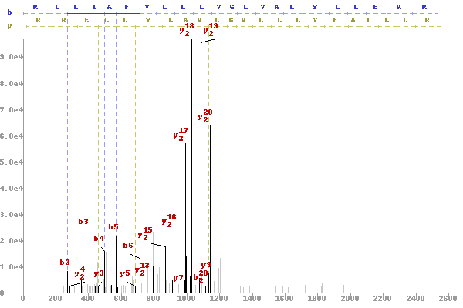

Peptide spectral network
- Simplified spectral network with multiple nodes annotated with the same peptide collapsed into a single peptide-node
- Peptide-nodes: unique peptides in the network, labeled with the sequence of the unique peptide
- Peptide-edges between peptide-nodes P/P’ if there is at least one edge between spectra annotated with P and P’. Label peptide-edges (P,P’) with the number of spectral network edges between spectra annotated with P/P’

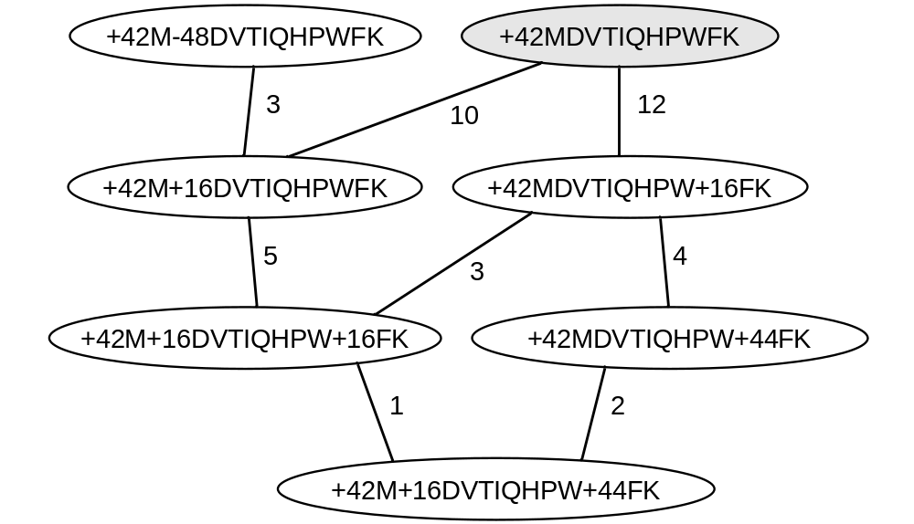

Spectral alignment
- Shows two spectra, one above the other
- Matched b/y-ions shown in thicker gold/red peaks in each spectrum, connected by dashed blue/red lines

