Levels of spectrum grouping:
- Raw MS/MS spectra supplied by end user
- Clustered MS/MS spectra group ‘repeated’ spectra from the same peptide
- SPS contigs grouping related spectra from overlapping peptides
- CSPS sequences from groups of SPS contigs that match to the same protein regions (the reference protein may contain multiple CSPS sequences)

Reports should be created in <project_dir>/report; images should be under <project_dir>/report/images
- One main report per SPS project (contig list)
- As many Contig Detail reports as the number of assembled contigs
- As many Cluster Detail reports as the number of assembled cluster-consensus spectra

Test files for implementation of Protein-match reports:
- Target sequence database: usa.ucsd.edu://home/nbandeira/data/testsets/aBTLA/rat_mouse_all.fasta
- Main SPS project: usa.ucsd.edu://home/nbandeira/data/testsets/aBTLA/sps_LTQ
  - FILE_INDEX=<sps>/spectra/input_index.txt – filenames for each MS/MS input file
  - FILE_CLUSTERMS=<sps>/spectra/specs_ms_*.pklbin – pklbin version of each MS/MS input file
  - FILE_CLUSTERSCAN=<sps>/spectra/specs_ms_*.bin – scan-number/ms-level information for each MS/MS input file
  - FILE_CLUSTER=<sps>/spectra/out/clusters_0_*.clust.txt – indicates which MS/MS spectra were grouped in each cluster (MS-Cluster) and used to generate the consensus spectra in specs_ms.pklbin.
  - FILE_MS=<sps>/spectra/specs_ms.pklbin –MS/MS spectra used for sequencing (may be a clustered and filtered version of all input spectra)
  - FILE_STARS=<sps>/spectra/stars.pklbin – star-spectra used to render spectra in contig images
  - FILE_SEQS=<sps>/assembly/sps_seqs.pklbin – contig sequences as spectra
  - FILE_COMP=<sps>/assembly/component_info.bin – ABruijn graphs for assembled contigs
- Main CSPS project: usa.ucsd.edu://home/nbandeira/data/testsets/aBTLA/csps
  - FILE_FASTA = <csps>/protid.fasta – protein sequences selected and used by CSPS
  - FILE_MP = <csps>/homology/matchma_sps_LTQ_mp.bin – Matched proteins: index, # mods, direct(0)/reversed(1) match (3 cols per row, best match per contig)
  - FILE_MIDX = <csps>/homology/matchma_sps_LTQ_midx.pklbin – Peak indices for matched contig/protein mass pairs (best match per contig); zero index indicates first contig mass and before-first-aa protein match. For contig peaks mass difference M matched to a protein string P, the following string is generated:
    - “P” if M=mass(P)
    - “[M,P,M-mass(P)]” if M!=mass(P)
    - “{M}” if M is not matched to a protein string P (only happens at the start/end of a contig)
  - FILE_REFMP = <csps>/homology/homglue_ref_mp.bin – Matched proteins after mapping contigs to the best reference protein; contig/protein assignments may differ from those in matchma_sps_LTQ_mp.bin. File format is as above: protein index (zero-based), # mods, direct(0)/reversed(1) match (3 cols per row, best match per contig)
  - FILE_REFMIDX = <csps>/homology/homglue_ref_midx.pklbin – Peak indices for matched contig/protein mass pairs (best match per contig) after mapping contigs to the best reference protein; zero index indicates first contig mass and before-first-aa protein match.
  - FILE_REFINDEX = <csps>/homology/ref_sps_names.txt – text file indicating the correspondence between indices of contigs matched to the reference protein and the overall contig indices. Each line corresponds to one contig in FILE_REFMP/FILE_REFMIDX and each contig’s correspondence is indicated by the leftmost string of the form “<sps_project_name>:<1-based_sps_contig_index>”.

How to identify the REFERENCE protein:
  - Find all contigs in $FILE_REFMP whose assigned protein differs from that in $FILE_MP. All the contigs that changed should have changed to the same protein - this is defined as the REFERENCE protein.
  - Only contigs mapped to the REFERENCE protein should have a "Reference" sequence assigned to the contig.

Report elements

Spectrum
- Filename and Scan number (from spectra/specs_ms.txt)
- Assigned peptide(s):
  - De novo: directly extracted from the ABruijn component
  - Homolog: best database match; from matchma_* outputs (CSPS)
  - Reference: reference-protein database match (CSPS)
  - Each peptide links to a different annotation figure for the same spectrum
- Position of first/last aa matched to protein sequence (CSPS only)
- Percentage of explained MS/MS intensity (empty if unknown)
- Percentage of b/y breaks present in the spectrum (empty if unknown)
- Length of the longest series of consecutive b-ion or y-ion matches (tag length)
- Percentage of explained PRM score (empty if unknown)
- Annotated-spectrum image (see Spectrum graphics details below, empty if unknown)

Protein match
Box with the following elements
- Protein ID + name at the top (name not shown below)
- Match statistics: # contigs, # spectra, #aa covered, % coverage
- Protein sequence with matched regions highlighted in black, non-matched regions shown in gray, modified aa shown underlined

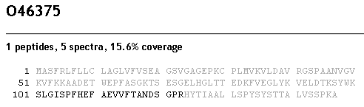

- The protein coverage graphical element should be updated as illustrated in coverage_mtABTLA_LC.pdf; coverage is automatically updated if the user adds/changes the User sequences assigned to the contigs.

Report views

Contig list view
List of the following:
- Contig index
- Protein contig sequences:
  - De novo: directly extracted from the protein contig spectrum
  - Homolog: best database match; from matchma output (CSPS)
  - Reference: reference-protein database match (CSPS)
  - User: sequence provided by end user for either a spectrum or a contig; mass matches to the spectrum/contig-spectrum are directly derived from prefix masses of the User sequence.
  - Each peptide links to a different annotation figure for the same spectrum
  - Include link for clustalw Homolog/Reference alignment
- Number of assembled spectra
- Total number of modifications
- Selecting a contig leads to Contig detail view

Contig detail view
- Show contig graphical element at the top, below a protein match element highlighting only the region covered by this contig
- Allow user to specify:
  - A User contig sequence to be added at the top of the contig graphical element.
  - UserLeft and UserRight contig sequences to be added to the left/right of the sequence assigned to the contig.
  - All User sequences automatically update and coverage map
  - Should contig/assembled-spectrum mass matches be automatically updated based on the assigned sequences? Similar procedure to that needed for spectral networks; changes to the putative sequence could then also be automatically linked to contig sequences.
- User can enter text notes per contig
- List of Spectrum elements displayed like shown below
  - Clicking on a spectrum shows the additional table line below, including a graphical spectrum element
  - If spectrum is a cluster consensus, there should be an additional option to lead to cluster detail view
  - User can enter text notes per spectrum

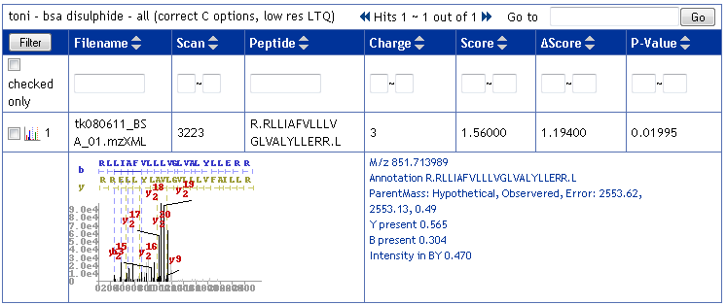

Cluster detail view
- Show image of annotated consensus spectrum at the top, contig graphical element at the top, above a protein match element highlighting only the region covered by this cluster
- Show clustered spectra as a list of Spectrum elements displayed as in Contig detail view
  - Clicking on a spectrum shows an additional table line as in Contig detail view
- Correspondence between clusters and clustered MS/MS spectra is determined by:
  - spectra/specs_ms_*.pklbin – input MS/MS data
  - spectra/input_index.txt – filenames of input MS/MS files
  - spectra/out/clusters_*.clust.txt – each cluster header is followed by a set of lines with two numbers per line:
    - input MS/MS file index (zero-based)
    - spectrum index in MS/MS file (zero-based)
- User can enter text notes per spectrum

Protein list view (CSPS only)
List of proteins selected from DB by at least one matched contig, sorted by decreasing number of matched contigs
- Protein ID
- Protein name
- Coverage: number of aa and percentage of protein sequence matched to contigs
- Number of matched contigs
- Number of matched spectra
- Number of modifications/sites
- Selecting a protein leads to Protein detail view

Protein detail view (CSPS only)
- Show Protein match element at the top
- Reuse Contig list view, selecting only contigs matched to selected protein
- Clicking on a contig leads to Contig detail view

Graphical elements
- Export in scalable vector formats: Encapsulated PostScript (.eps), PDF
- Export in portable raster format: Portable Network Graphics (.png)

Spectrum
- X-axis: m/z
- Y-axis: peak intensities (scores for PRM spectra)
- Peaks shown in
  - Thick blue/red lines for matched b/y ions
  - Black lines for other matched ions (-H2O, -NH3, isotopic, doubly-charged)
  - Gray lines for unmatched peaks
- B/y-ion series in blue/red at the top
- b/y/b2/y2 brownish-green labels for most-intense peaks (optional)

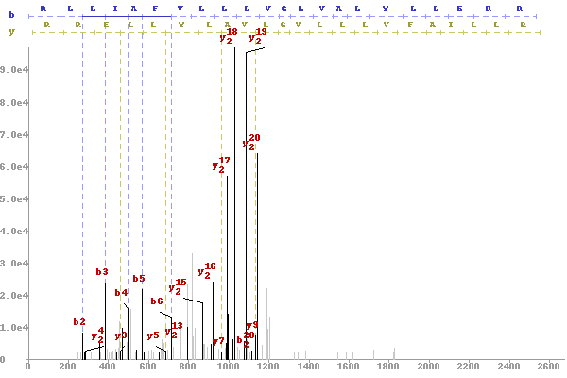

Spectral alignment
- Shows two spectra, one above the other
- Matched b/y-ions shown in thicker gold/red peaks in each spectrum, connected by dashed blue/red lines

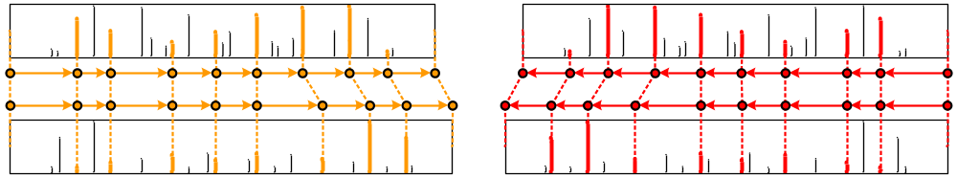

Contig
- Shows assembled spectra, separated vertically and ordered horizontally by 1) increasing absolute shift and 2) by spectrum parent mass
- Spectrum peaks matched to contig sequence should be shown in bold
- Spectrum peaks glued in an A-Bruijn vertex in the consensus path (protein contig sequence) are shown connected by dashed lines

Advanced manual editing of CSPS sequences

 |  |  |  |  | 1 |  |  |  |  |  |  | 2
Final sequence |  | P |  | E |  | G |  | T |  | N |  | NA |  | E
Putative sequence |  | P |  | GE |  |  |  | T |  | N |  | [NG,+14] |  | E
Reference sequence |  | P |  | W |  |  |  | Q |  | GG |  | NG |  | E
 |  |  |  | Merged aa |  |  |  | Substitution |  | Split aa
Contig sequences |  | P |  | GE³ |  |  |  | T
 |  |  |  | E | ⁴ | G |  | T |  | N
 |  |  |  | W |  |  |  | [TN]⁵ |  |  |  | [NG,+14] |  | E

Manual editing
- Displayed sequences
  - Final sequence – manually annotated sequence; initialized with Putative sequence
  - Putative sequence – final de novo sequence returned by CSPS
  - Reference sequence – sequence of the best homologous (reference) protein used by CSPS to order/glue SPS contigs
  - Contig sequences – de novo sequences from the matched contigs; shown sorted by the indices of the first/last matched masses.
  - The table width should be adjustable to fit on at least a 1024x768 display by changing the number of columns; sequences should be wrapped as necessary to show all complete sequences.
- Clicking on a sequence cell allows changing the sequence to a longer/shorter/different non-empty sequence
- Notes:
- Green bars between amino acids indicate matched masses (to at least one contig). Clicking on a green bar removes the matched mass and merges the adjacent sequences; new green bars are added whenever a putative sequence mass matches a mass on at least one contig sequence.
- The location of the +14 mass difference is initially unknown (no matched masses) and ambiguous since N+14=Q/K and G+14=A. In this case, manual annotation selects the latter choice.
- Contig sequence GE was matched to reference sequence W and thus has no matched mass (green bar) between G and E.
- The matched mass (green bar) between E and G is automatically added when the final sequence is changed to EG (because it matches the contig sequence).
- [TN] indicates that the contig sequence had a mass gap of mass 215 Da = TN

