Nic Bander

Grade 11-12

In my classroom, I commit to:

* Utilize a 3 before me question system to encourage participation with each other.
  + https://www.google.com/url?sa=i&url=https%3A%2F%2Fwww.pinterest.com%2Fpin%2F126523070767870961%2F&psig=AOvVaw1_1psDZsazEBy6OeEFRfFj&ust=1600290758906000&source=images&cd=vfe&ved=0CAIQjRxqFwoTCLDGueaJ7OsCFQAAAAAdAAAAABAD
* Utilize Slack and message boards
  + https://slack.com/
* Group presentations requiring students to touch on each of the topics in the computer
  + Not sure how to share a picture or video around this one.

In my school, I commit to:

* Grow the FIRST Robotics club in the school and hopefully corporation
  + 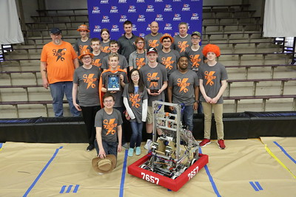
* Use cross-curricular activities to involved my students with the digital electronic course.
  + We do not have any pictures yet about this, but our DE course has drones that we are looking at building with them. They require Python programming.