PBL: Local Restaurant App

* Trade-off Triangle:
  + Time to Market: 3 weeks
  + Quality: Needs to be able to run without any run time errors and be able to see the menu, order, and contact
  + Low Cost: Utilize free cloud based services and IDE
* User Story:
  + Customers need to be able to customize their order
* WBS

|  |  |  |
| --- | --- | --- |
| Task | Duration (in hours) | Notes |
| App Menu for Navigation | 4 |  |
| Display Food Menu | 6 | Pull info from Backendless |
| Ordering System | 12 |  |
| Contact Screen | 8 |  |
| Welcome Screen | 6 | Pictures and Ads |
| Connect to Cloud Server | 6 | Ordering menu and update price |
| Combo and Coupons | 2 |  |

Network Diagram

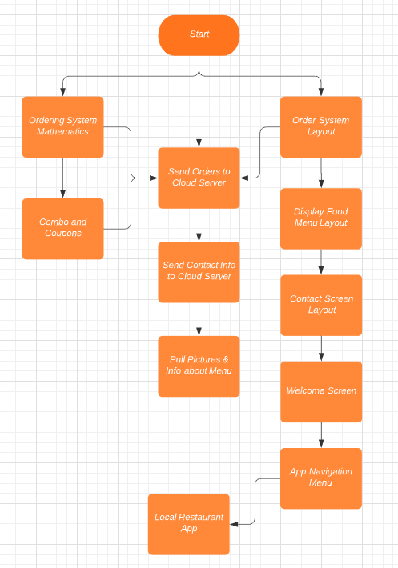

Test Plan:

* System – Be able to send any size order to the system
* Unit Testing - Switch in between different screens without losing information in the cart or in the menus
* Field Testing – run through full orders

Reflecting:

When they have a plan that incorporates feedback and tests frequently. I look for their ability to also have great documentations on who is assigned to what backlog item. Checking to see which backlog item is needed before another is completed.