Этот словарь тупо для меня, и для тех микрочеликов, которые хотят знать, что учить

Software – computer instructions that tell the computer how to work.

Software engineer – someone who develop software.

Hardware – physical parts of computer.

Hardware engineer – someone who develop hardware.

Personel – people who use software or design, control it.

Input – entering data.

Output – results.

Processing – data changing process or data manipulation**.**

Communication – process of sending and receiving information.

Feedback – information about reactions to a product.

Memory – storage of data.

ITC – information and communication technologies

Test – to operate something to see if it works correctly.

Design – to plan the way that something will be created.

Develop – to bring something from conception to action.

Evaluate - calculate the quality, amount, or value of something.

Investigate – to get more information about something.

Focus on – to give full attention to something.

Mastery – good skills in something.

Efficient – able to do something quickly and competently.

Dedicated – something that created to do a specific task.

Innovate – something new and creative.

Detail-oriented – able to pay attention to small, specific parts of something.

Traits - черты

Pay close attention – уделять внимание

Elaborate – уточнить

Computer – is an electronic device, that manipulates data.

Desktop computer – there is a personal computer on the desk

Mainframe – main workstation

Workstation – fast computer that is used by one person and has more memory than an ordinary personal computer

PDA – mobile personal computer with personal assistiant functions.

Cell phone – device that can makes and receives calls.

Laptop – portable personal computer

Disposal- в нашем расположении

Motherboard – board with ports and socket uses to putting together a computer

Case – to protect components of PC

Processor – a part that completes task for the computer

Fan – a part used to cool the computer

RAM - Random Access Memory

Power supply – part of computer used to deliver electrify to all part of a computer

Hard drive – a part used to store large amount of data

Heat sink – радиатор – a part used to cool the processor

Expansion card – a part used to increase a computer functions

Disk drive – part of computer used to read CD/DVD drive.

Socket – разъём

ROM – read only memory

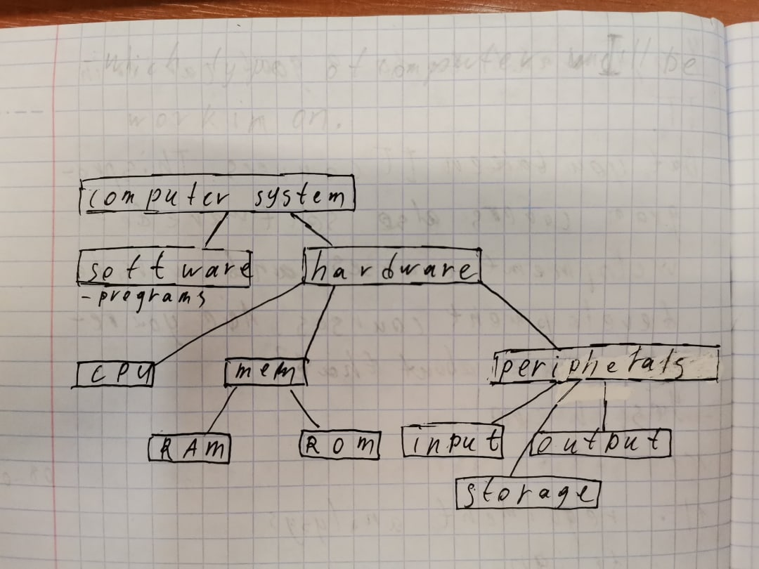

Usb flash device – флеха

cd-r – диск

magnetic tape – магнитная лента

array – сервер

zip drive – касеты

floppy disk – мягкотельный накопитель

RAID – База данных

Failure – неудача

SATA – интерфейс подключения

Graphic User Interface (GUI) – is an part of operating system that uses icoтs to represent programs and files allow users to access to them.

Represent – представлять

Icons – shortcut to something in desktop

Pointer – something that you can use, to manipulate icons

Shortcuts – special icons. You can use it to open programs

Folders – file that store files

Windows – visual areas on a computer screen

Minimize – hide windows

Maximize – Extend windows to full size

Menu – part of gui

System tray – notification area

Desktop – screen that displays icons and folders

Menu bar – row of words that open up menus when selected

Drop-down (pull-down) menu – menu, that appears below a menu item when selected

Scroll bar – horizontal or vertical menu

Dock – bar that users using to quick start

-----------------------------------

Test:

A:

1 – new input devices

2 – they want to made computers more social and more easy to use

3 – In more intuitive ways they to view ??? content within a single browser interface

4 – Speech will second

5 – Mouth useful in text redactor

6 – Handwriting information internet

7 – Camera

8 – Very much information internet

9 – retrieving and delivering information and delivering automation repetitive task

B:

1)

A – 3

b- 5

c – 1

d – 2

e – 4

2)

A – false

B – false

C – false

D – false

E – true

F - true

-----------------

**Structure of OS:**

Hardware -> OS -> System Program -> Application program

|  |  |  |
| --- | --- | --- |
| Action | VMS | UNIX |
| List all Files | directory | Ls |
| Delete | Delete | Rm |
| Rename | Rename | Mv |
| Copy | Copy | Cp |
| Sent to a printer | Print | Lrp |
| Help | Help | Man |
| Create a dir | Create/directory | Mkdir |
| Show date | Show time | Date |
| Show users | Show users | Rwho |
| Talk to other users | Phone | Write |
| Seathing | Search | Grep |

------------------------------------------------------------------------------

U4,5,6:

U5:

(2):

1 – B

2 – D

3 – A

(3):

1 – A

2 – D

3 – C

4 – E

5 – G

6 – H

7 – B

8 – F

(4):

1 – B

2 – B

U4:

(2):

1 – C

2 – C

3 – D

(3):

1 – f

2 – E

3 – C

4 – B

5 – a

6 – D

(4):

1 – TIMECARD, DATABASE

2 – BUDGET, WORKBOOK

(6):

1-t

2-t

3-f

(7):

1-Do you like

2 – tracks

3 – have any

4 – company database

5 –

6 - transparent

U6:

(2):

1 – B

2 – D

3 – A

(3):

1 – G

2 – A

3 – E

4 - C

5 – H

6 – D

7 – F

8 – B

(4):

1 – B

2 – A

-------------------------

Database – array of information in a computer;

Queries – запрос – try to requesting information.

Charts – диаграмма

Word processing

Word processing – program to write in computers.

Edit – redacting;

Format – formating;

Erase – delete;

Spellcheck –

Memos – заметка;

Agendas – повестка дня;

Assemply language – instructions that not been converted to a binary language

Hacker -a person who uses computers to gain unauthorized access to data.

A virus – is a type of computer program that, when executed, replicates itself by modifying other computer programs and inserting its own code

Trojan virus – is a computer program that appears to be beneficial but is actually malicious/

A worm – a type of virus that replicates itself through emails.

Anti-virus software -searches a computer system for a computer system for viruses.

Pharming – a process wherein thieves reroute people to a fake website that appears to be a legitimate in order to trick them to giving away their personal information.

Phishing - a process wherein thieves trick people into giving away their personal information through email.

Pretexting - a process wherein thieves trick people into giving away their personal information through email.

Form to: Stats.

By: OlegZig.

Subject: About computer security.

Hi Stats. I’m very worrying about our security and safety.  
 About 3-4 hours ago, I heard from our security-specialist about new type of trojan viruses. It’s very important to our company, because we have a big server for user data, and information on it is very confidential. We must avoid contaminating this server. If our boss finds it out (or hackers break our defense and make data breach), we get a lot of problems.

Afterwards, I think we need to upgrade Anti-malware software and update virus base and our LAN-hardware. And ask out security manager how we can upgrade our defense against viruses.

P.S. try to convince workers under your control to change passwords. (or login with passwords.)

Bye, with best regards Oleg.

2) A – 3; b – 1; c – 2; d – 4.

3)1 – f; 2 – f; 3 – t; 4 – t.

4) 1 – user name; 2 – domain name; 3- at; 4 – domain.

5) 1 – a; 2 – b; 3 – a; 4 – b.

6) 1 –stands for; 2- client; 3 – deals with; 4 – server.

7) online; stand alone; outgoing; send; same.

8) .at – Austria; .be – Belgium; .bg – Bulgarium; .de – Germany; .dk – Denmark; .es – Spain; .fr – France; .gr – Greece; .hu – Hungary; .it – Italy; .lu – Luxembourg; .nl – Netherlands; .pt – Portugal; .ro – Romaina; .si – Slovenia; .uk - United Kingdom

Hyperlink – a word/image that you can click on to navigate;

Website – a collection of internet pages;

HTML – Language that’s allows programmers to makes websites;

Web host – company that provides space for a website;

Web browser – program that allows you to use internet.