System Capacity & Care Load Analytics
for Unaccompanied Children
Bandham Raju
B.Sc Mathematics, Electronics and Computer Science
Bhavan's Vivekananda Degree College
Secunderabad, Telangana, India
bandhamraju2@gmail.com

Abstract — Healthcare capacity management is essential for ensuring timely and effective care delivery for vulnerable populations. This study presents a data-driven healthcare analytics framework for analyzing system capacity and care load trends for Unaccompanied Children (UC) under the U.S. Department of Health and Human Services (HHS). Using historical healthcare capacity data from January 2023 to December 2025, the study examines care load patterns, CBP custody trends, healthcare demand fluctuations, and net intake pressure across the healthcare system. Exploratory data analysis, trend analysis, and time-series forecasting techniques are employed to identify operational patterns and estimate short-term healthcare demand. A 90-day forecasting model is utilized to support capacity planning and resource allocation decisions. The findings indicate significant variations in healthcare demand over time and demonstrate the importance of data-driven forecasting for improving operational preparedness and healthcare resource utilization. The proposed framework provides actionable insights for supporting strategic and operational decision-making in healthcare capacity management.
Keywords—Healthcare Analytics, Healthcare Capacity Management, Unaccompanied Children, Time-Series Forecasting, Data Science, Exploratory Data Analysis, Streamlit Dashboard, Resource Planning)

Introduction
Healthcare capacity management plays an important role in ensuring timely and effective care delivery for vulnerable populations. Unaccompanied Children (UC) entering the United States are temporarily placed under the care of the U.S. Department of Health and Human Services (HHS), which is responsible for monitoring healthcare capacity and providing appropriate services. Variations in care demand and resource utilization highlight the need for data-driven approaches to support operational planning and capacity management.
Healthcare analytics enables organizations to transform operational data into actionable insights through trend analysis, forecasting, and interactive visualization techniques. These approaches support healthcare demand assessment and improve decision-making related to resource allocation and capacity planning.
This study presents a healthcare analytics framework for analyzing system capacity and care load trends for Unaccompanied Children using historical healthcare capacity data from January 2023 to December 2025. The proposed framework integrates exploratory data analysis, key performance indicators (KPIs), time-series forecasting, and an interactive Streamlit dashboard to evaluate healthcare demand patterns and support evidence-based healthcare capacity planning.

LITERATURE REVIEW
Recent studies have demonstrated the value of healthcare analytics and forecasting techniques in supporting healthcare capacity planning and operational decision-making [1]-[4]. Data-driven approaches have been widely used to analyze healthcare demand, resource utilization [5]-[7], and temporal trends across healthcare systems. Interactive dashboards and forecasting models further enhance the ability to monitor system performance and support evidence-based planning.
Existing research primarily focuses on hospital resource management and healthcare demand forecasting. However, limited studies integrate exploratory data analysis, operational indicators, forecasting, and interactive analytics specifically for healthcare capacity management involving Unaccompanied Children[8]-[11]. This study addresses this gap by presenting a unified healthcare analytics framework for monitoring care load patterns and supporting capacity planning.

RESEARCH GAP
Existing healthcare analytics research has made significant contributions to healthcare demand forecasting, resource utilization analysis, and hospital capacity management. However, most studies focus on specific aspects of healthcare operations rather than providing an integrated framework for healthcare capacity planning. Limited research combines exploratory data analysis, operational indicators, forecasting techniques, and interactive visualization within a single decision-support system [3],[5],[8].
Furthermore, there is comparatively limited work addressing healthcare capacity management for vulnerable populations such as Unaccompanied Children, where care demand may fluctuate over time and requires continuous operational monitoring [9]-[11]. Existing approaches often emphasize descriptive analysis or forecasting independently without integrating both analytical and visualization capabilities for real-time capacity assessment.
This study addresses these limitations by proposing a unified healthcare analytics framework that combines healthcare capacity monitoring, key performance indicators, time-series forecasting, and an interactive Streamlit dashboard to support evidence-based healthcare capacity planning and operational decision-making.

PROPOSED FRAMEWORK AND METHODOLOGY
This study proposes a healthcare analytics framework for monitoring system capacity and care load trends among Unaccompanied Children under the care of the U.S. Department of Health and Human Services (HHS). The framework combines exploratory data analysis, key performance indicator (KPI) assessment, time-series forecasting, and interactive dashboard visualization to support healthcare capacity planning.
Healthcare demand forecasting and healthcare capacity management have become increasingly important for resource allocation and operational planning across healthcare systems [1],[2],[6].
Historical healthcare data spanning January 2023 to December 2025 were analyzed to evaluate changes in total children under care, CBP custody populations, HHS care populations, and net intake pressure. Data preprocessing techniques were employed to ensure consistency in date formatting and operational indicators prior to analysis.
Exploratory data analysis was used to identify temporal patterns and variations in healthcare demand. A 90-day time-series forecasting model was utilized to estimate short-term healthcare capacity requirements. Furthermore, an interactive Streamlit dashboard was developed to provide real-time visualization of healthcare trends and support evidence-based operational decision-making.

V. RESULTS AND DISCUSSION
The analytical results indicate that healthcare demand exhibits significant temporal variations across the study period. Healthcare capacity indicators demonstrate noticeable changes in the number of children under care and net intake pressure, emphasizing the importance of continuous operational monitoring. Trend analysis revealed periods of increased healthcare demand followed by declining care load patterns, highlighting the dynamic nature of healthcare capacity requirements.
The analytical findings emphasize the importance of continuous healthcare capacity monitoring and proactive resource planning during periods of fluctuating healthcare demand

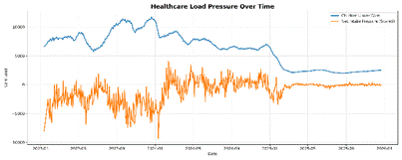
Healthcare Load Pressure Analysis
Fig.1. Healthcare Load Pressure Analysis illustrating temporal variations in healthcare demand and care-load patterns across the study period.
Time-series decomposition identified both trend and seasonal components within the dataset, supporting the applicability of forecasting techniques for healthcare capacity planning. The 90-day forecasting model provides short-term estimates of healthcare demand that can assist stakeholders in anticipating resource requirements and improving operational preparedness. Forecasting results further emphasize the need for proactive capacity management during periods of fluctuating healthcare demand.
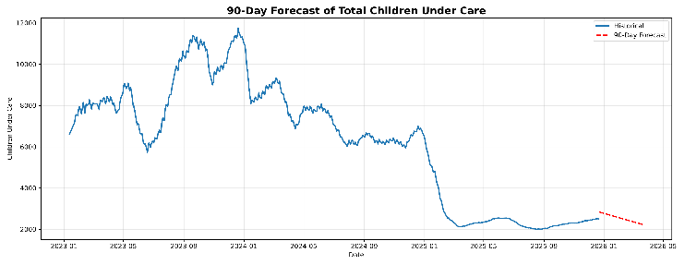
Forecast graph.
Fig. 2. 90-Day Healthcare Demand Forecast illustrating projected short-term healthcare demand patterns and capacity requirements over the forecast period.
The Streamlit dashboard enables interactive monitoring of key healthcare indicators through integrated visualizations and KPI-based assessment. By combining exploratory analysis, forecasting, and dashboard-based analytics, the proposed framework provides actionable insights for supporting evidence-based healthcare capacity planning and informed operational decision-making.
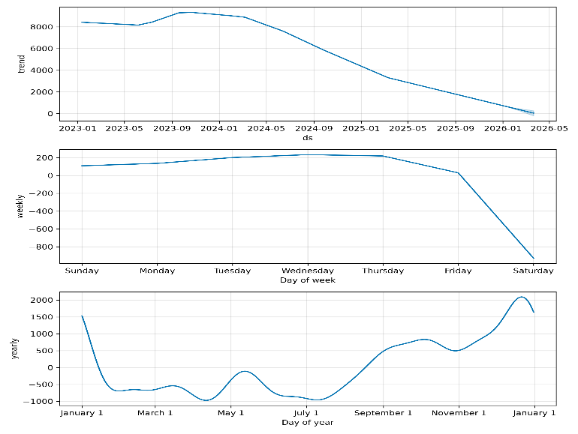
Trend and Seasonal Components Graph
Fig. 3. Trend and Seasonal Components of Healthcare Demand illustrating underlying temporal patterns and seasonal variations within the historical healthcare dataset.

VI RECOMMENDATIONS AND LIMITATIONS
The findings of this study highlight the importance of continuous healthcare capacity monitoring for supporting operational and strategic decision-making. Integrating forecasting techniques with healthcare analytics can assist stakeholders in anticipating short-term demand fluctuations and improving resource allocation strategies. The adoption of interactive dashboard-based monitoring systems may further enhance the accessibility and interpretation of healthcare capacity indicators.
Despite its contributions, this study has certain limitations. The analysis is based on historical healthcare data collected for a specific time period and does not incorporate external factors that may influence healthcare demand patterns. Additionally, the forecasting component focuses on short-term demand estimation and may benefit from incorporating additional explanatory variables in future studies. Future work may explore advanced forecasting approaches and extended healthcare datasets to further improve capacity planning capabilities.
VII. CONCLUSION
This study presents a healthcare analytics framework for monitoring system capacity and care load trends among Unaccompanied Children using historical healthcare data from the U.S. Department of Health and Human Services. By integrating exploratory data analysis, key performance indicator assessment, time-series forecasting, and interactive dashboard visualization, the proposed framework provides meaningful insights into healthcare demand patterns and operational capacity requirements.
The analytical findings demonstrate the value of data-driven approaches for supporting healthcare capacity planning and resource management. The proposed framework contributes toward improving operational preparedness by enabling continuous monitoring of healthcare indicators and facilitating evidence-based decision-making for healthcare capacity management.

REFERENCES

[1] Forecasting Hospital Resource Demand Using Time Series and Machine Learning Models, 2025.

[2] Large Language Models for Healthcare Forecasting, arXiv:2311.07283, 2023.

[3] Healthcare Forecasting Research,

arXiv:2403.15634v3, 2024.

[4] Healthcare Demand Forecasting Review,

PubMed, 2022.

[5] Healthcare Information Systems Research,

BMC Medical Informatics and Decision Making.

[6] Hospital Capacity and Healthcare Analytics,

Applied Sciences (MDPI).

[7] Method Selection for Demand Forecasting,

Healthcare Analytics Research.

[8] Congressional Research Service Report:

Unaccompanied Children (R43599).

[9] Modernizing Child Welfare Technologies and

Tools, U.S. Department of Health and Human Services.

[10] Predictive Analytics in Child Welfare,

Administration for Children and Families.

[11] Child Welfare Workload Model Report,

2024–2025.

[12] Official U.S. Department of Health and Human

Services Dataset Source (HealthData.gov).

