**Project : Pizza Sales Analysis**

**Problem Statement**

**KPI’s REQUIREMENT**

We need to analyze key indicators for our pizza sales data to gain insights into our business performance. Specifically, we want to calculate the following metrics:

1. Total Revenue: The sum of the total price of all pizza orders.
2. Average Order Value: The average amount spent per order, calculated by dividing the total revenue by the total number of orders.
3. Total Pizzas Sold: The sum of the quantities of all pizzas sold.
4. Total Orders: The total number of orders placed.
5. Average Pizzas Per Order: The average number of pizzas sold per order, calculated by dividing the total number of pizzas sold by the total number of orders.

**CHARTS REQUIREMENT**

We would like to visualize various aspects of our pizza sales data to gain insights and understand key trends. We have identified the following requirements for creating charts:

**1. Hourly Trend for Total Pizzas Sold:** Create a stacked bar chart that displays the hourly trend of total orders over a specific time period. This chart will help us identify any patterns or fluctuations in order volumes on a hourly basis.

**2. Weekly Trend for Total Orders:** Create a line chart that illustrates the weekly trend of total orders throughout the year. This chart will allow us to identify peak weeks or periods of high order activity.

**3. Percentage of Sales by Pizza Category:** Create a pie chart that shows the distribution of sales across different pizza categories. This chart will provide insights into the popularity of various pizza categories and their contribution to overall sales.

**4. Percentage of Sales by Pizza Size:** Generate a pie chart that represents the percentage of sales attributed to different pizza sizes. This chart will help us understand customer preferences for pizza sizes and their impact on sales.

**5. Total Pizzas Sold by Pizza Category:** Create a funnel chart that presents the total number of pizzas sold for each pizza category. This chart will allow us to compare the sales performance of different pizza categories.

**6. Top 5 Best Sellers by Revenue, Total Quantity and Total Orders:** Create a bar chart highlighting the top 5 best-selling pizzas based on the Revenue, Total Quantity, Total Orders. This chart will help us identify the most popular pizza options.

**7. Bottom 5 Best Sellers by Revenue, Total Quantity and Total Orders:** Create a bar chart showcasing the bottom 5 worst-selling pizzas based on the Revenue, Total Quantity, Total Orders. This chart will enable us to identify underperforming or less popular pizza options.

**Data Analysis using MySQL**

Utilized MySQL for data extraction and calculation of key metrics such as Total Revenue, Average Order Value, Total Pizzas Sold, Total Orders, and Average Pizzas Per Order.

**DATA IMPORT**

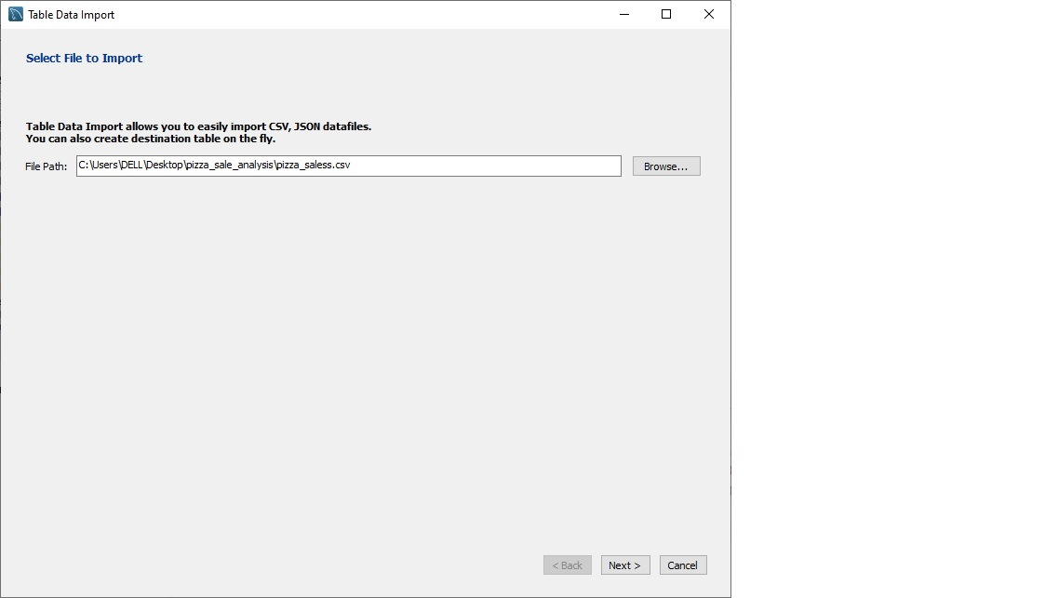

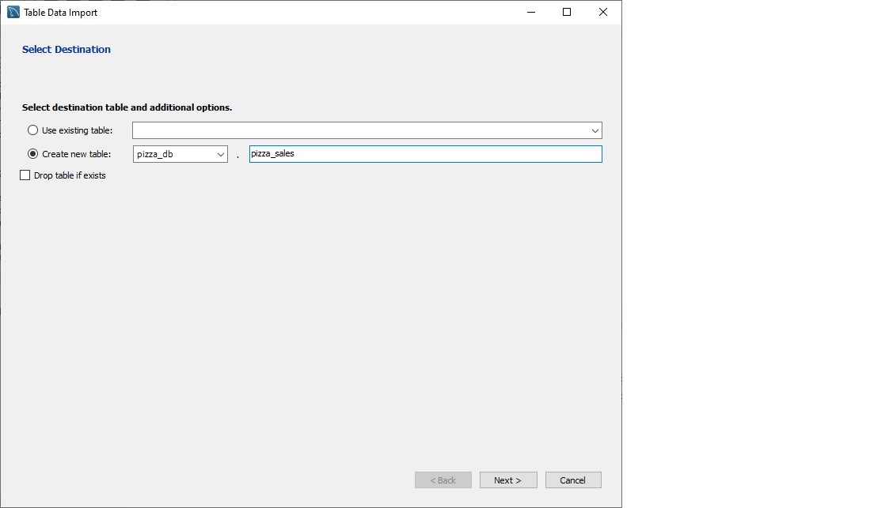

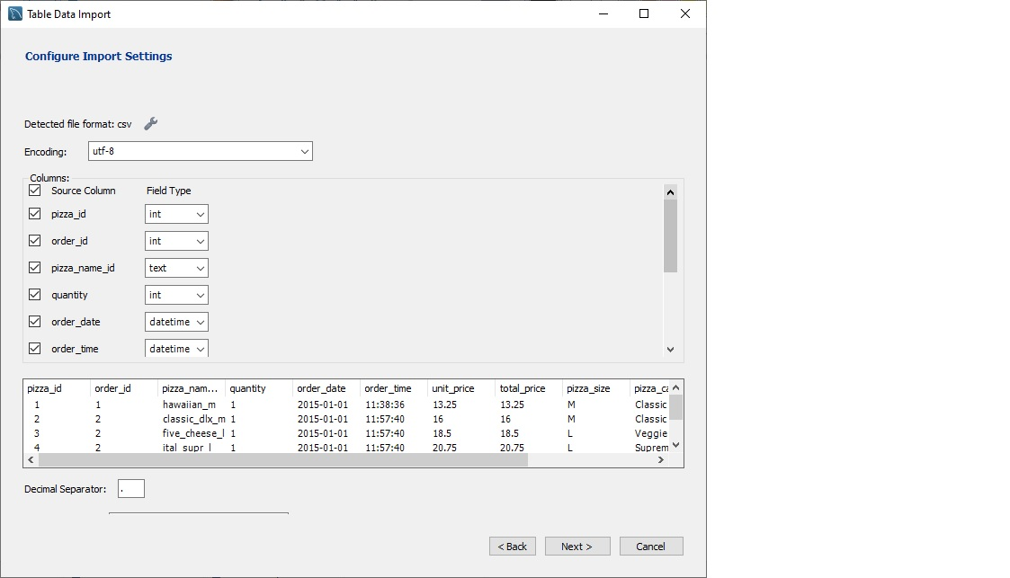

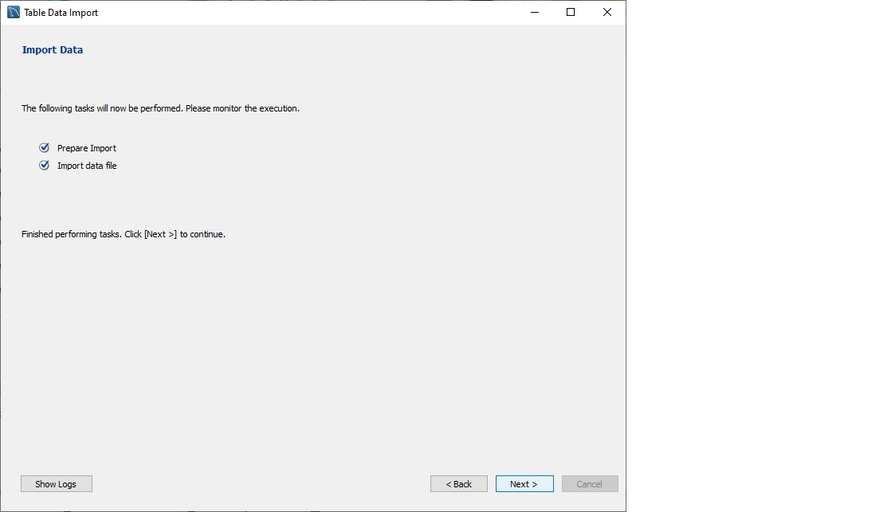

ANALYSIS OF DIFFERENT SQL STATEMENT ON DATA BASE

1. **KPI’s**
2. **Total Revenue:**

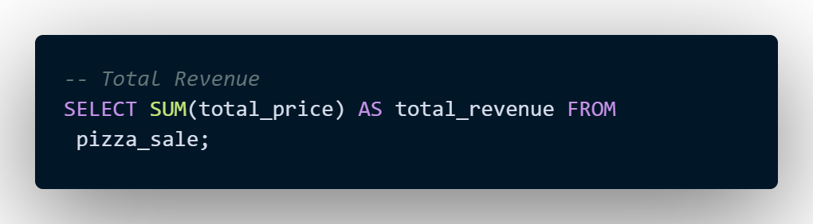

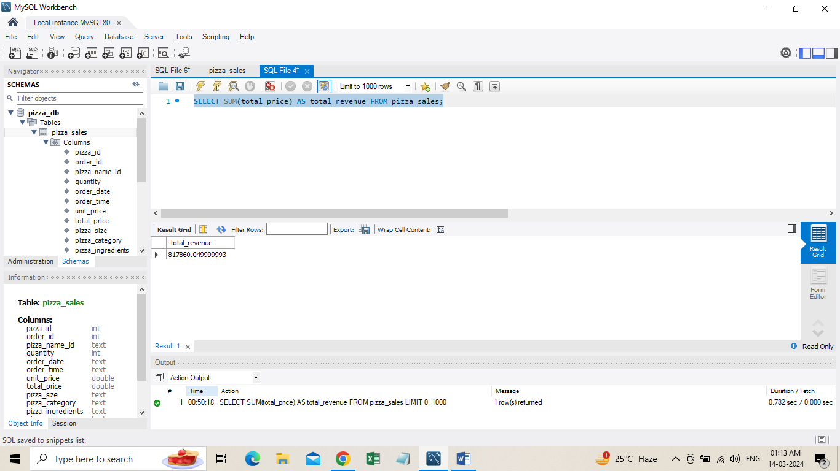

**2**. **Average Order Value:**

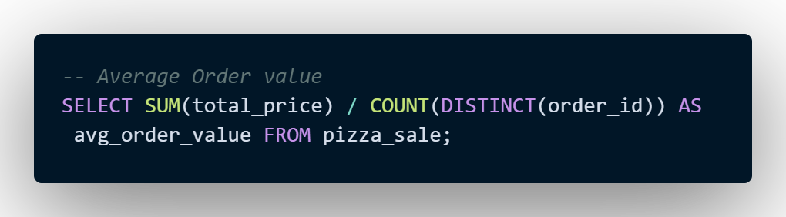

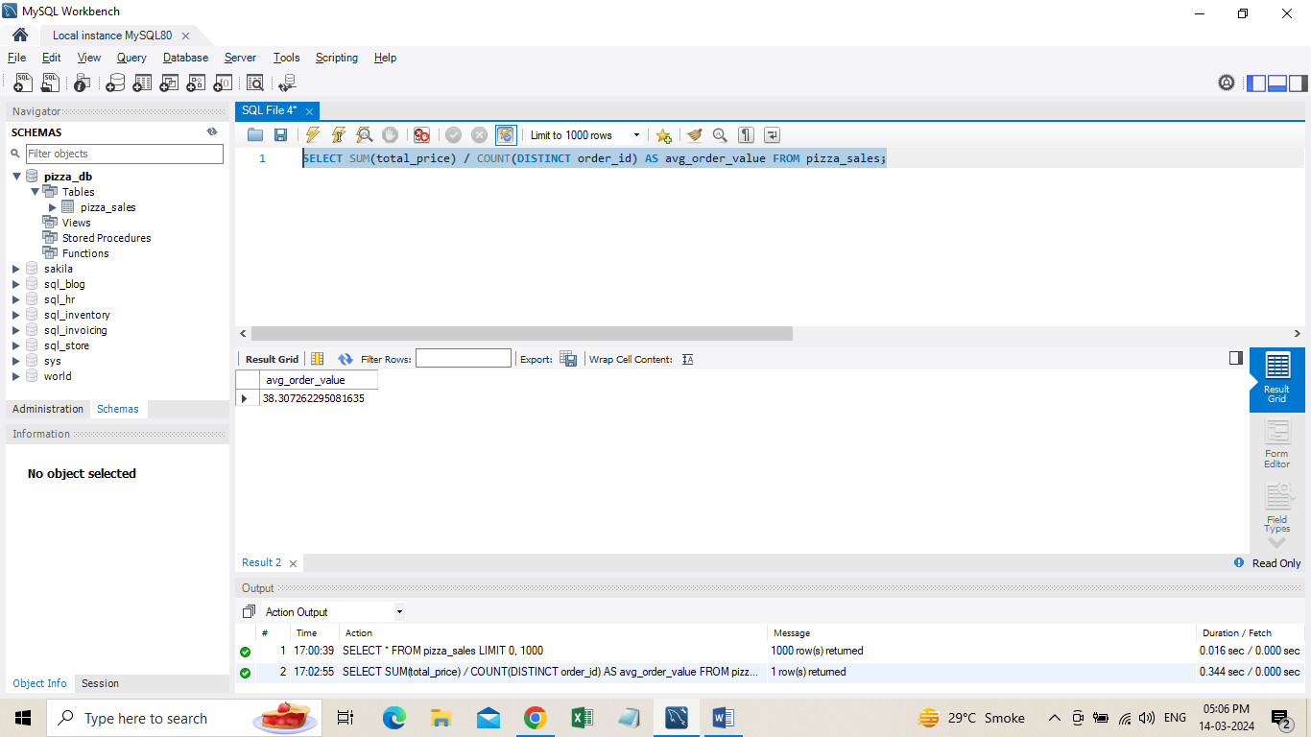

1. **Total Pizza Sold**

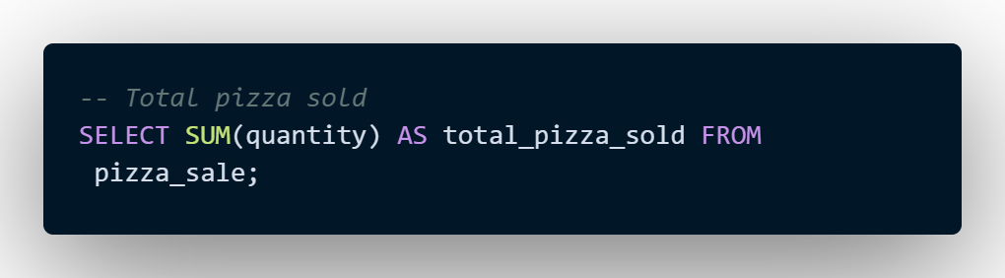

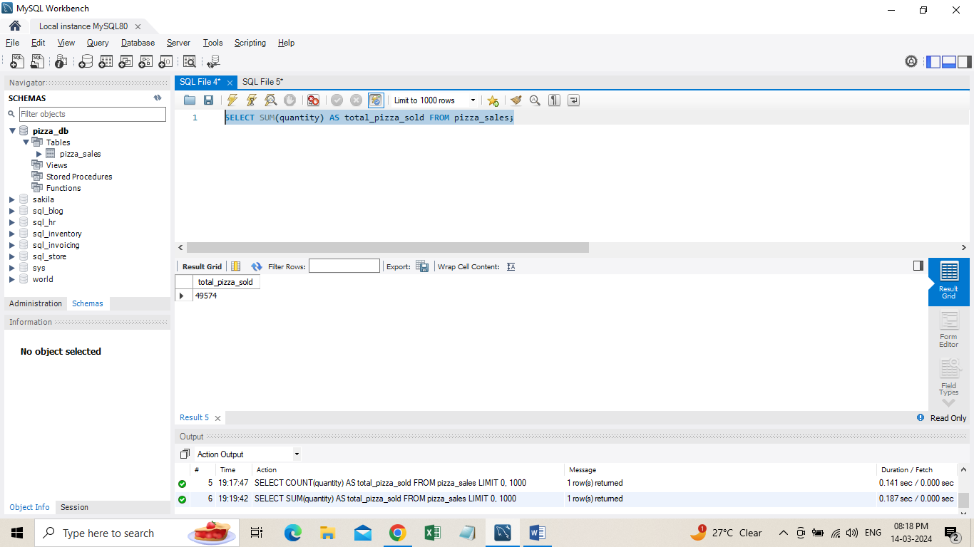

1. **Total Orders**

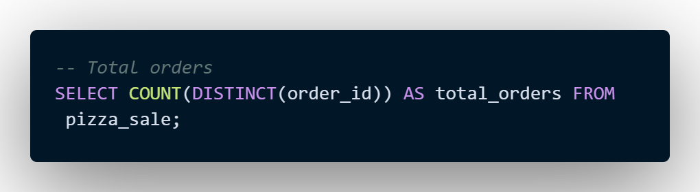

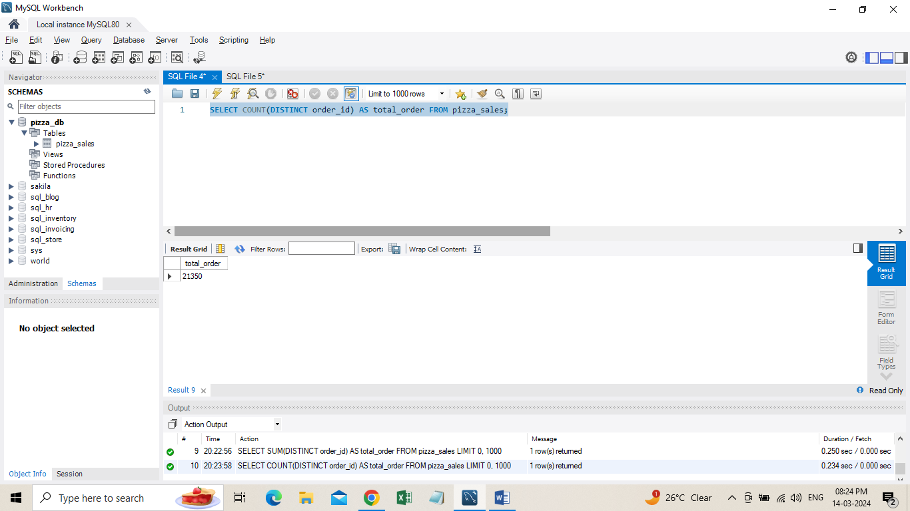

1. **Average Pizzas Per Order**

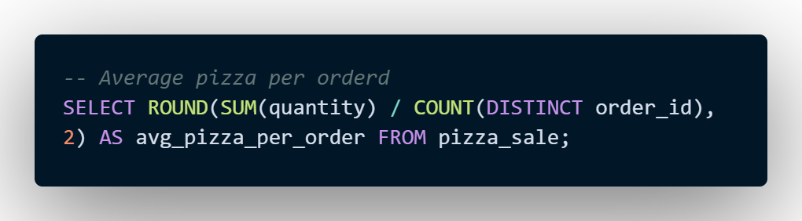

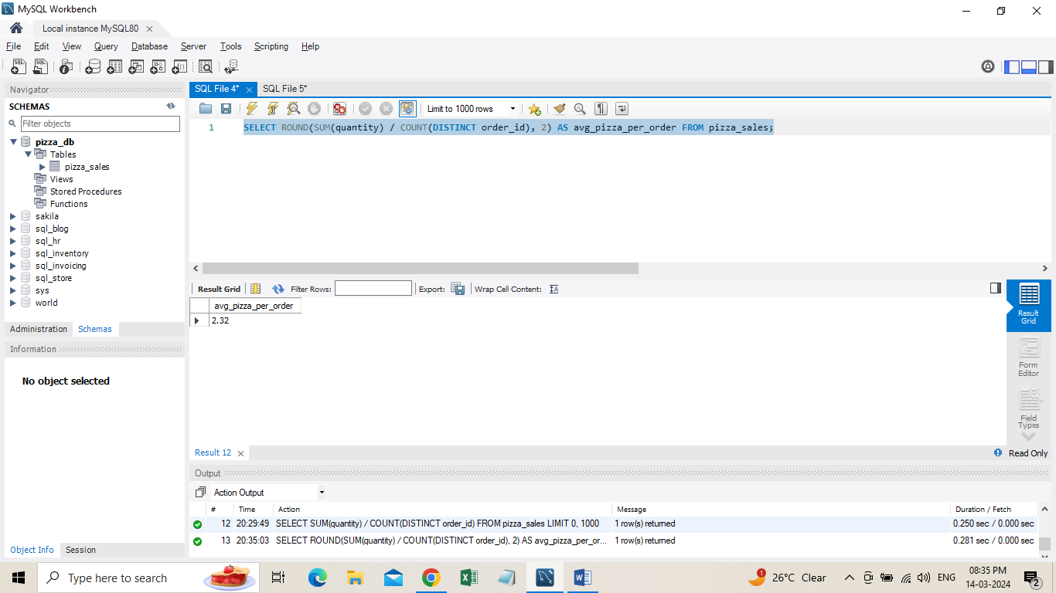

**B. Hourly Trend for Total Pizzas Sold**

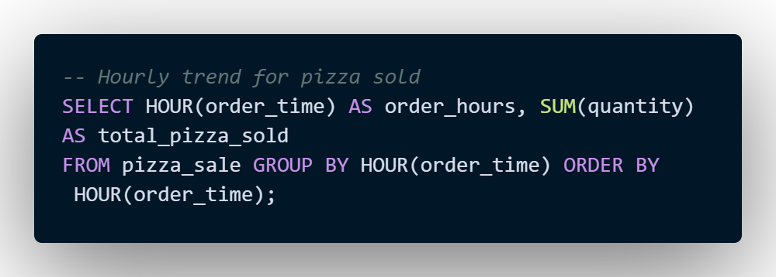

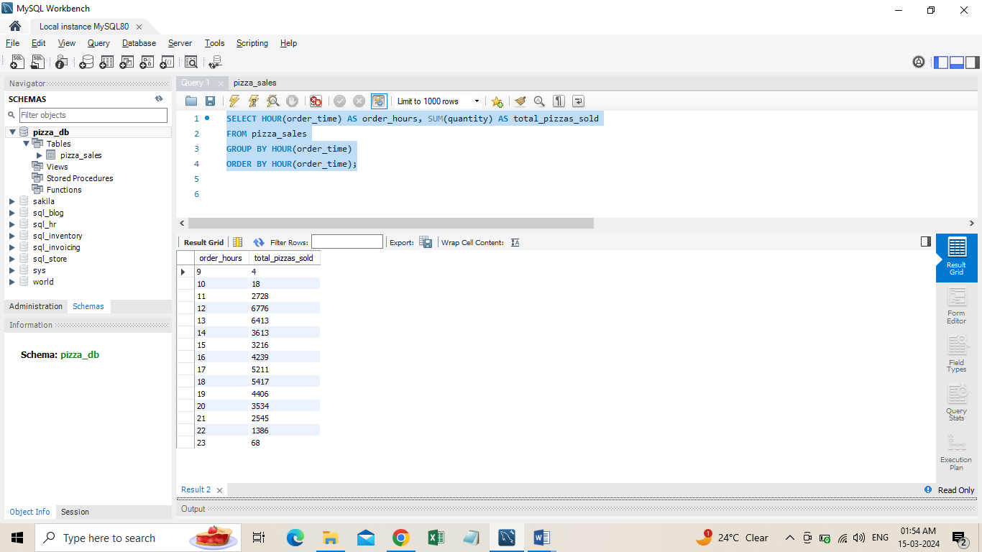

1. **Weekly Trend for Orders**

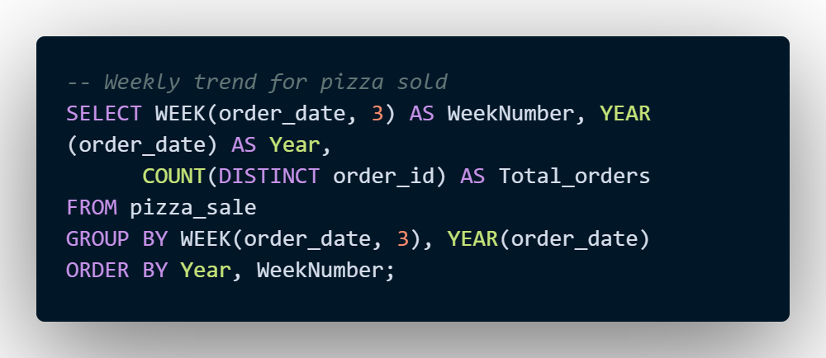

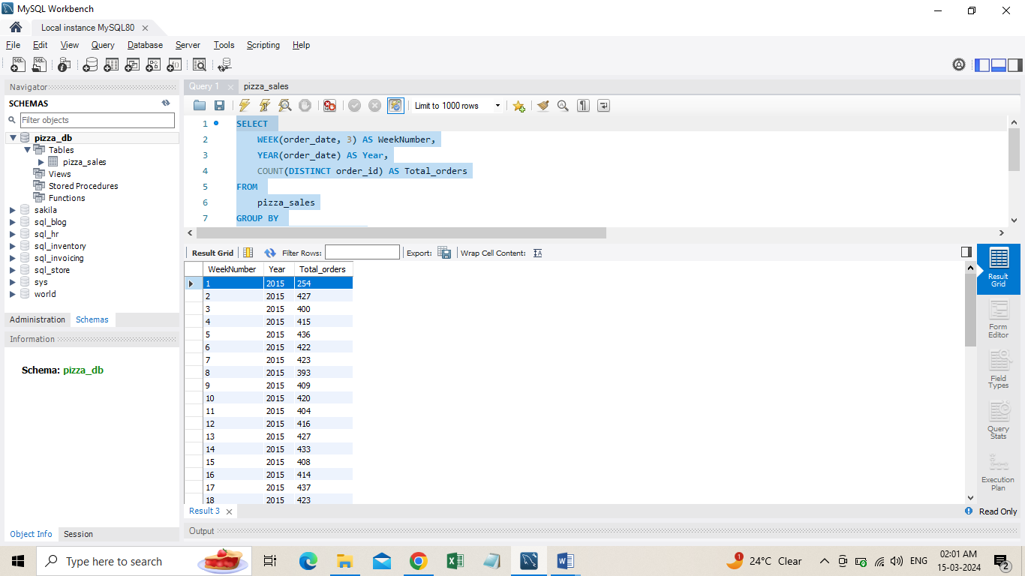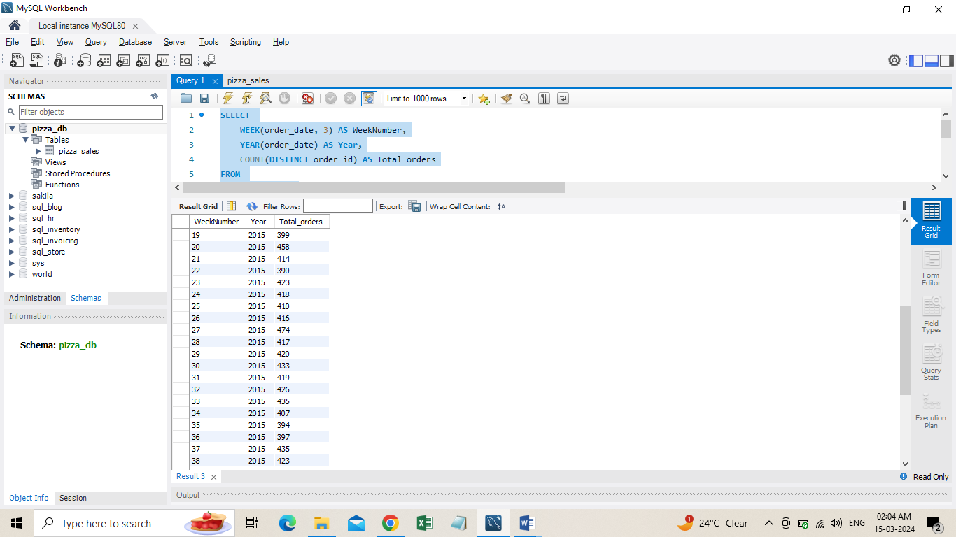

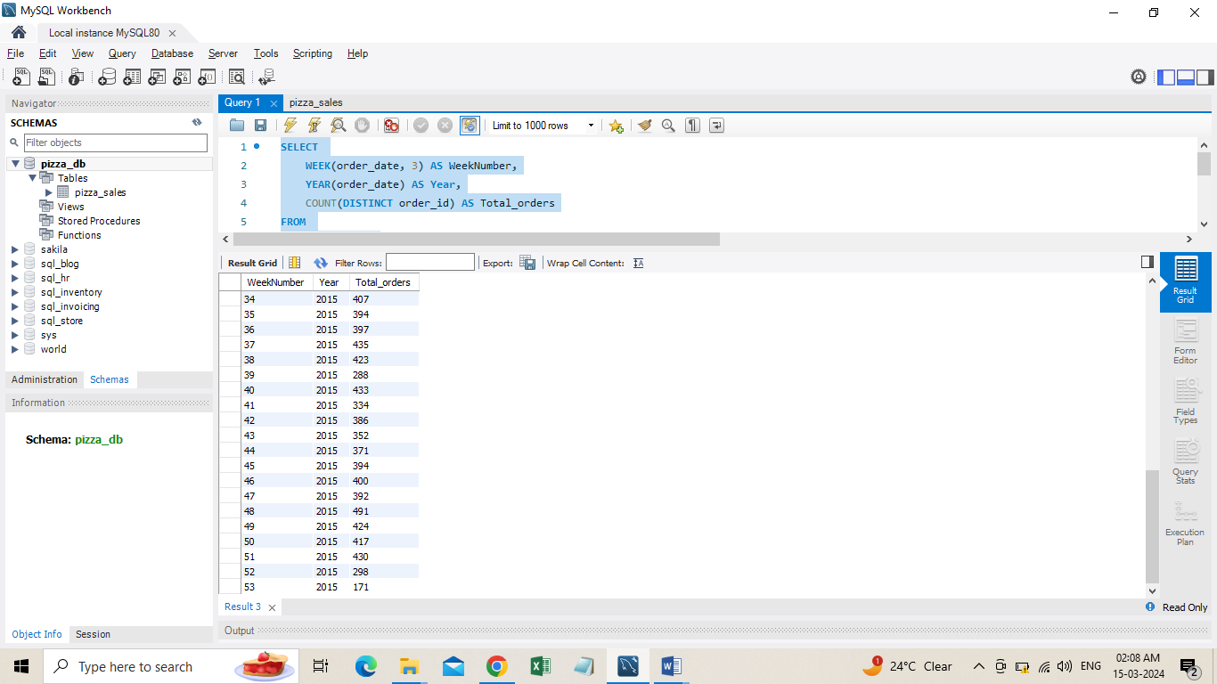

1. **% of Sales by Pizza Category**

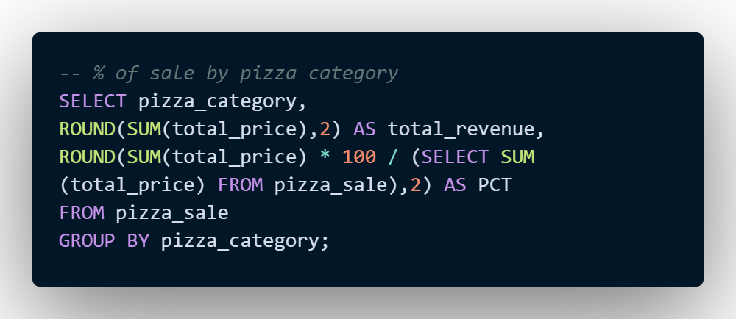

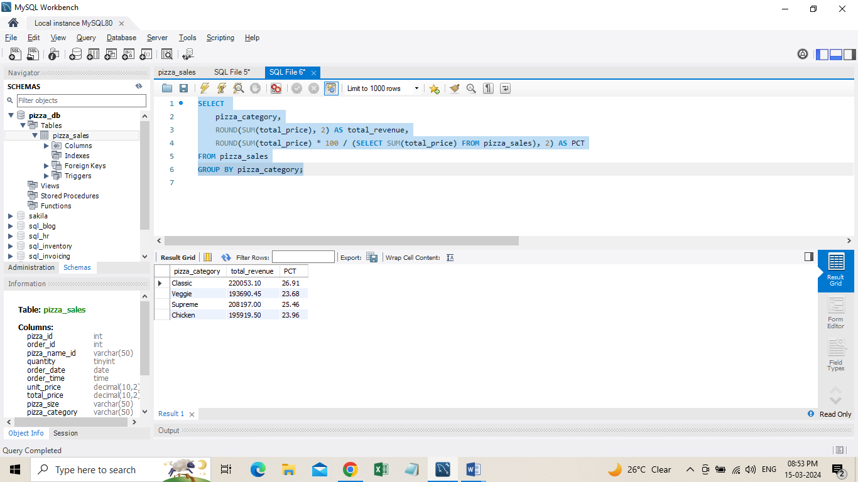

1. **% of Sales by Pizza Size**

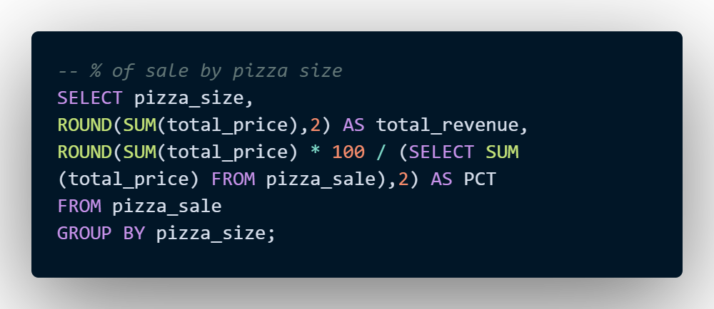

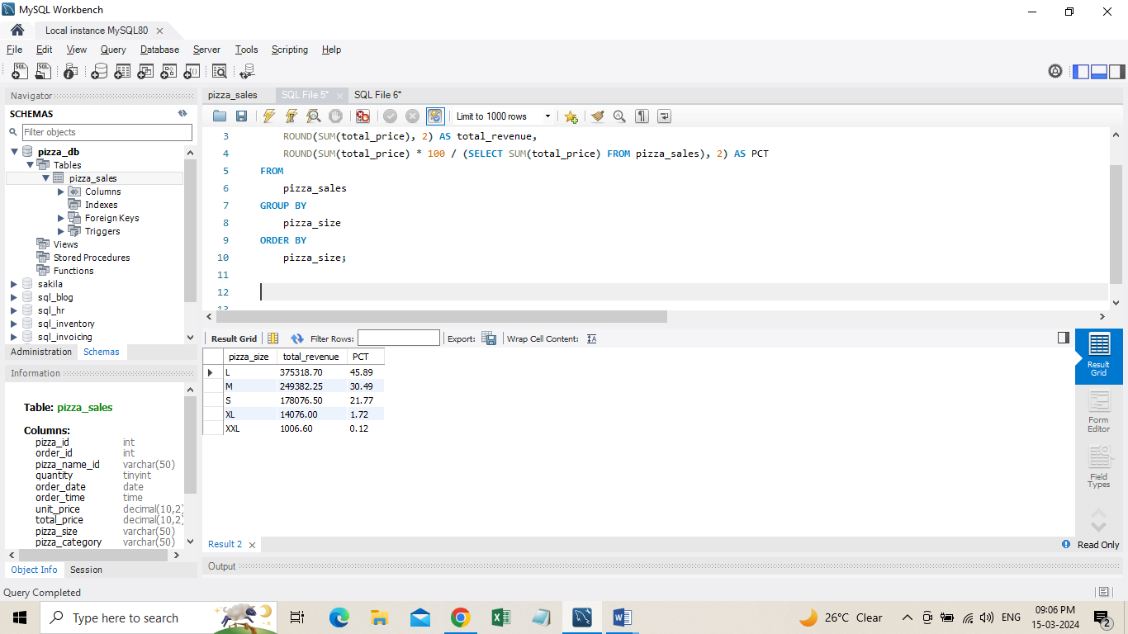

1. **Total Pizzas Sold by Pizza Category**

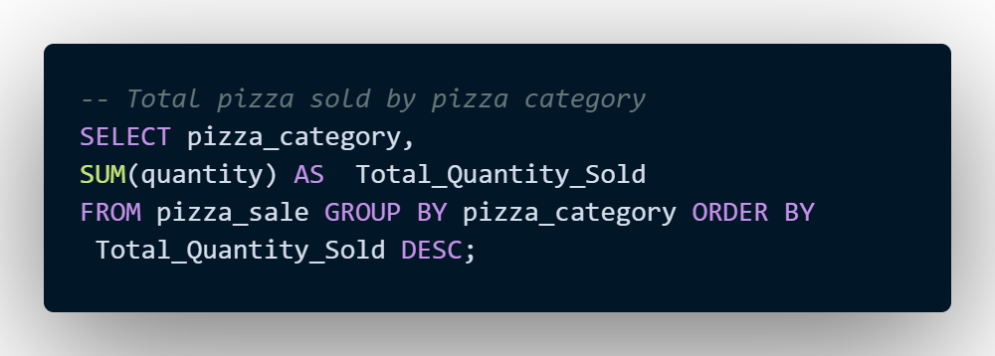

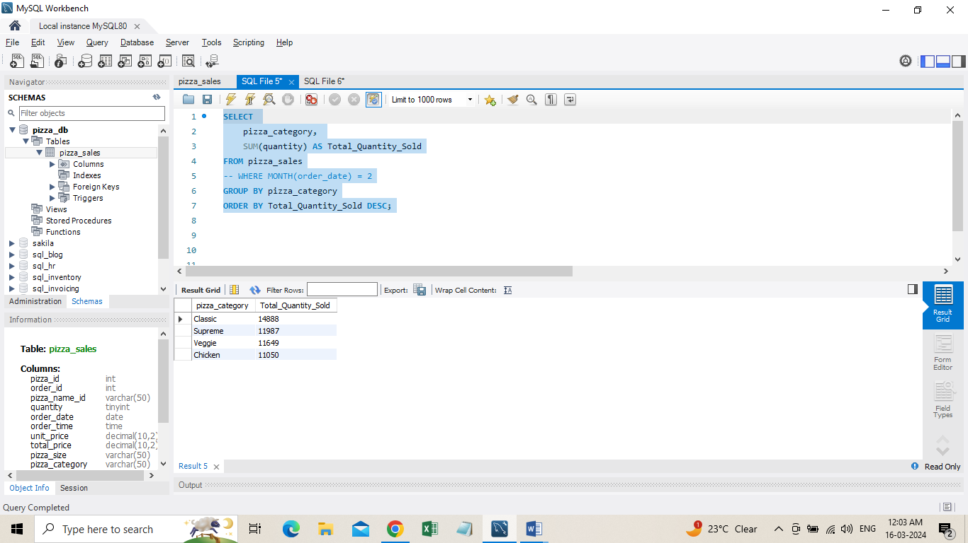

1. **Top 5 Pizzas by Revenue**

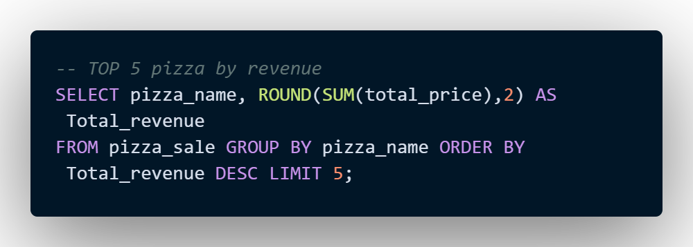

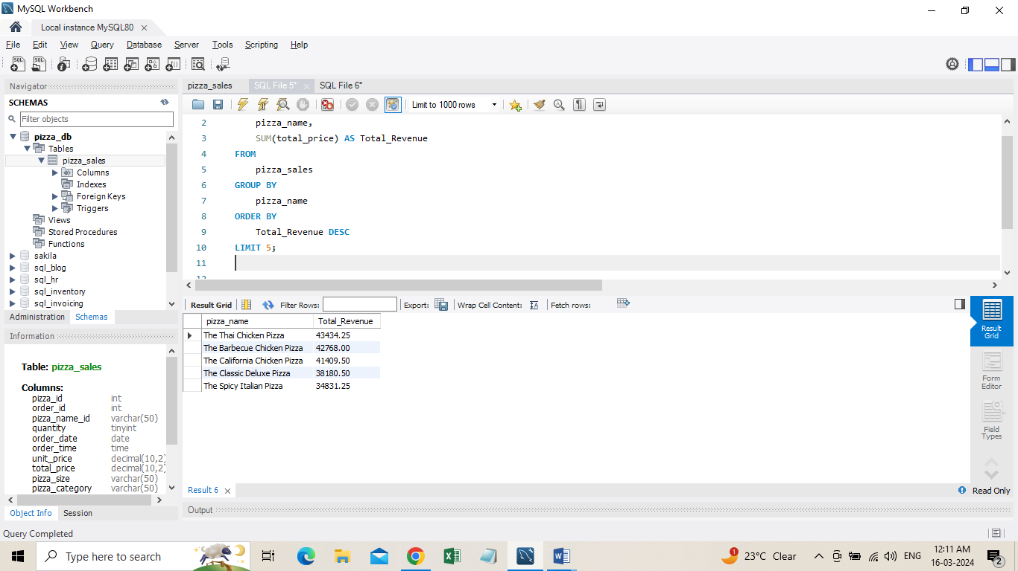

**H. Bottom 5 Pizzas by Revenue**

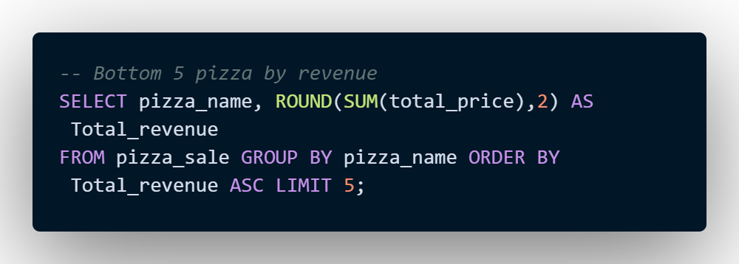

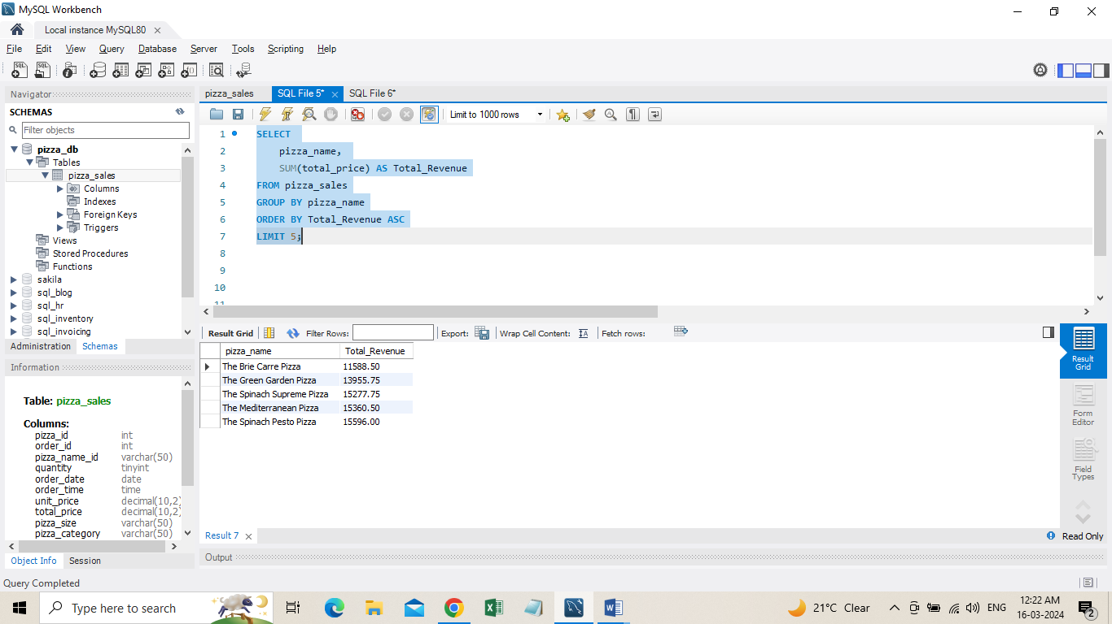

1. **Top 5 Pizzas by Quantity**

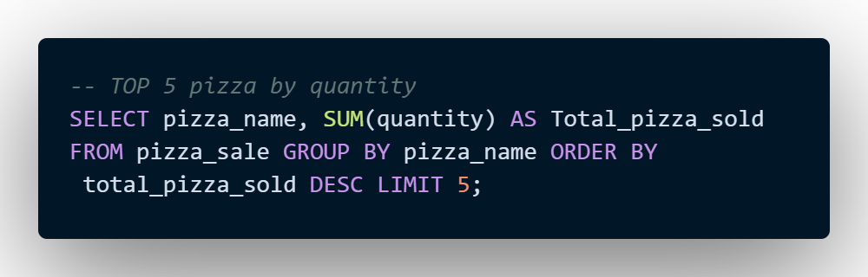

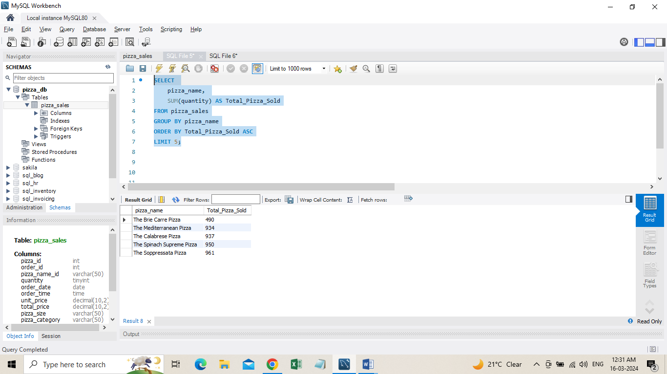

**K. Top 5 Pizzas by Total Orders**

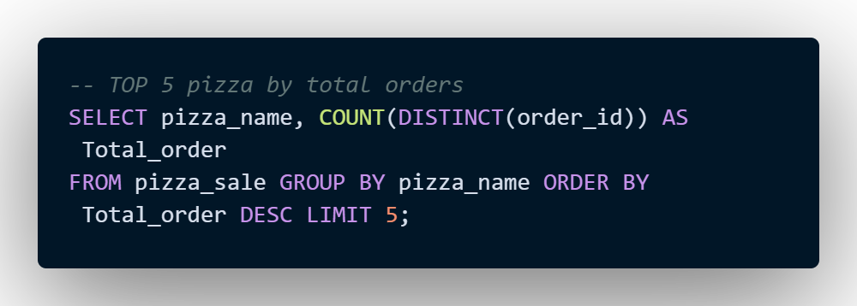

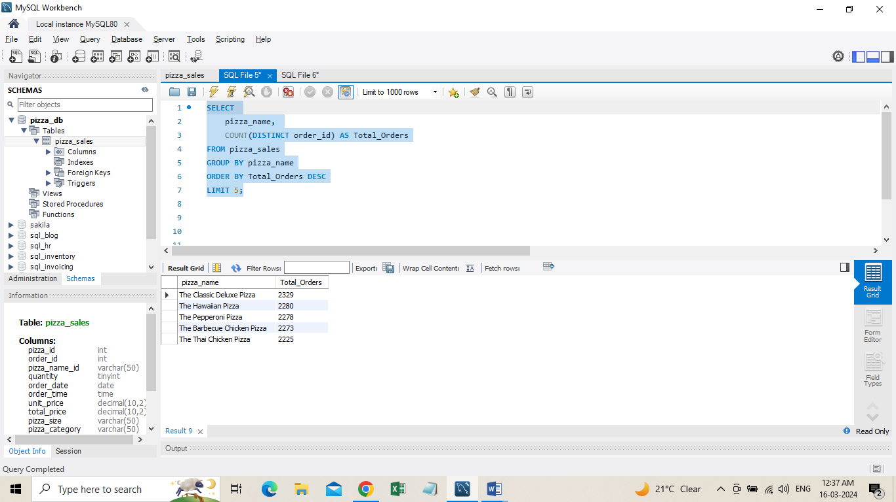

**L. Bottom 5 Pizzas by Total Orders**

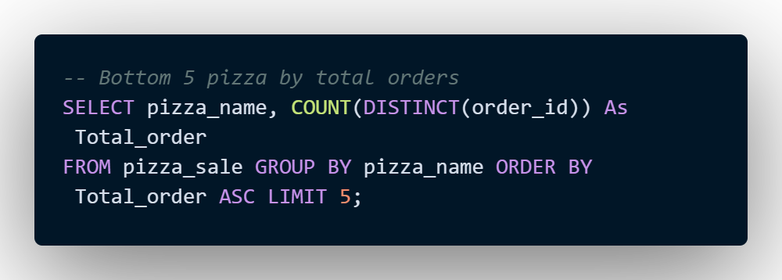

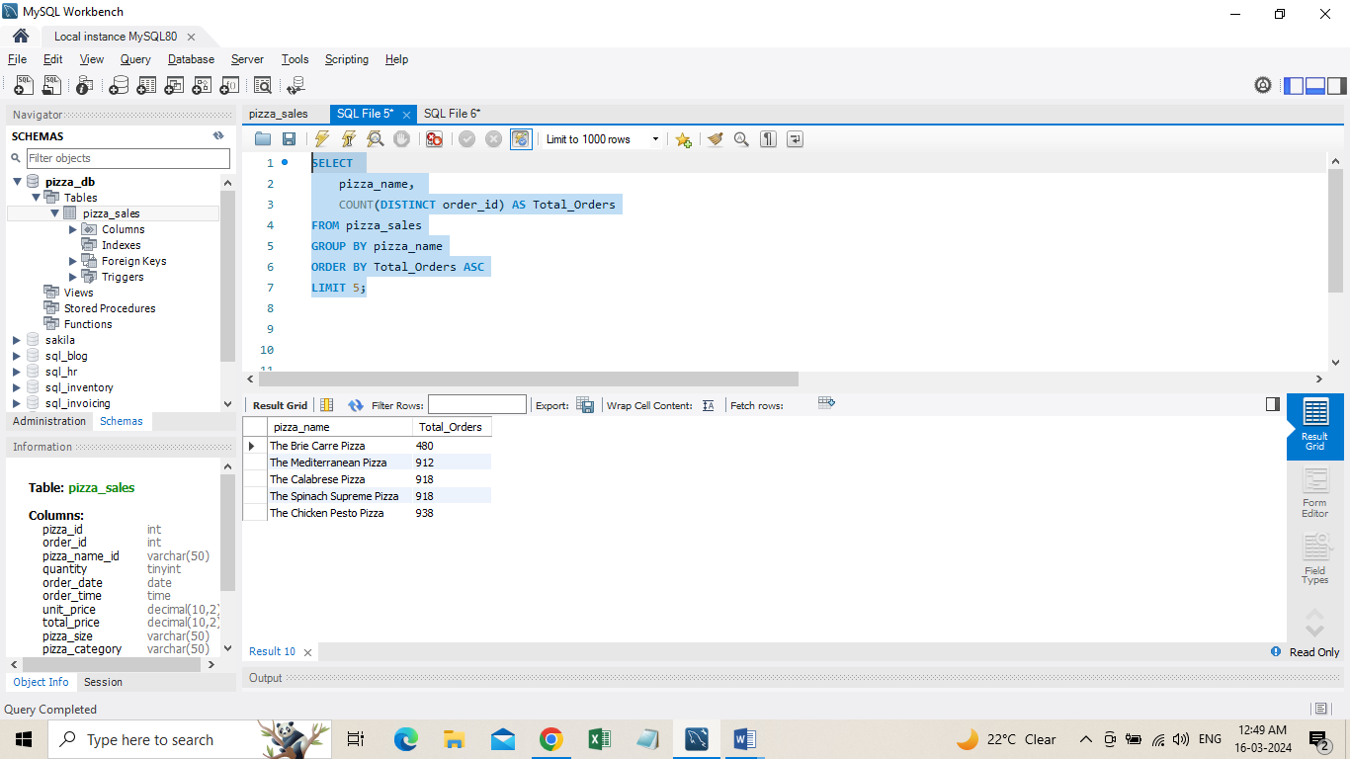

***NOTE***

If you want to apply the pizza_category or pizza_size filters to the above queries you can use WHERE clause. Follow some of below examples

SELECT pizza_name, COUNT(DISTINCT order_id) AS Total_Orders FROM pizza_sales

WHERE pizza_category = 'Classic' GROUP BY pizza_name ORDER BY Total_Orders ASC LIMIT 5;

**Data Cleaning**

Pizza size category we have in our database is abbreviated and for dashboard we need it in full expanded form. For eg. L= large, M= medium etc, so we will create an alias to temporary change its name in required format.

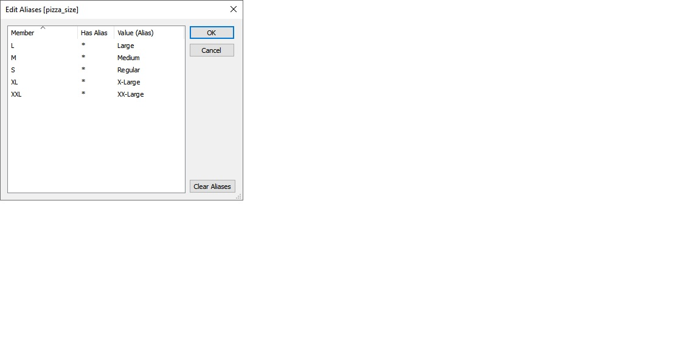

**Build Dashboard or a Report using Tableau**

Created a comprehensive dashboard in Tableau featuring key metrics and charts, including Hourly Trend, Weekly Trend, Sales by Category, Sales by Size, Total Pizzas Sold by Category, Top 5 Best Sellers, and Bottom 5 Worst Sellers.

KPI’S

* **Total Revenue** SUM([order id])
* **Total Orders** COUNTD([order id])
* **Average Order Value** [total revenue] / [total orders]
* **Total Pizzas Sold** SUM([quantity])
* **Average Pizzas Per Order** [total pizzas sold] / [total orders]

DASHBOARD

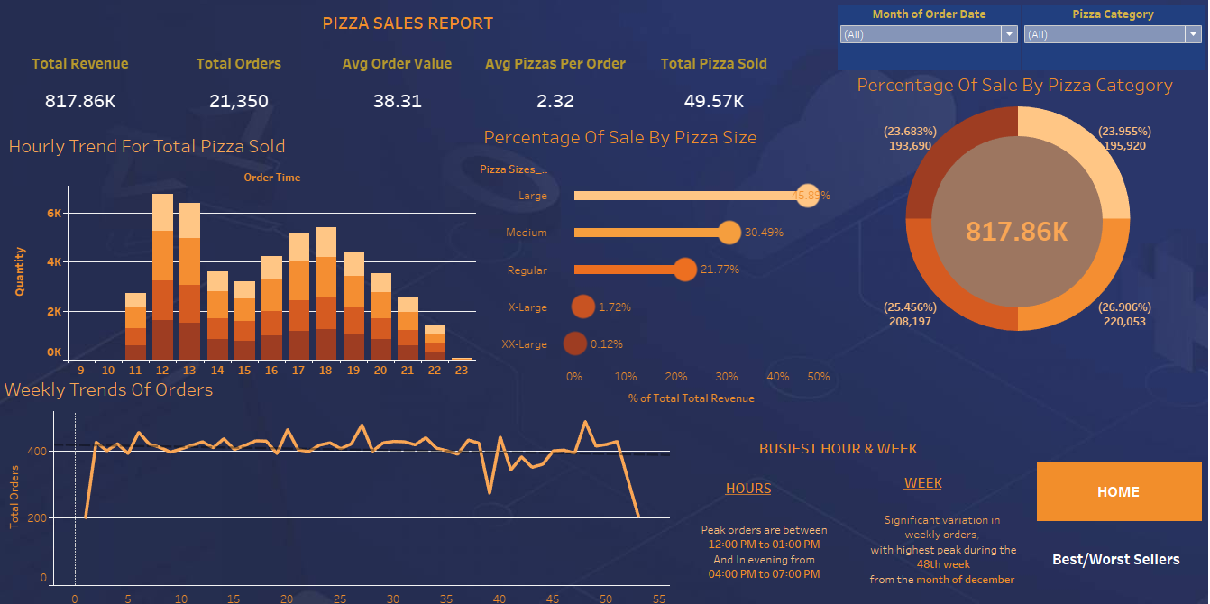

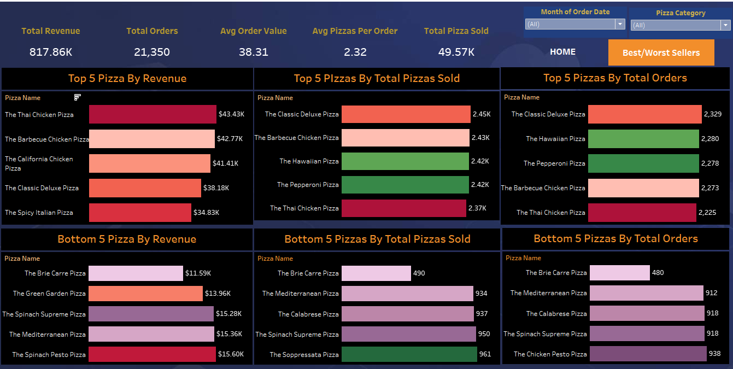

**Tools, Software, and Libraries**

* **MySQL Workbench8.0.36**

for data analysis and storage

* **Tableau2024.1.0**

for dashboard creation and visualization

* **Excelversion 2021**  
  for initial data exploration and manipulation