**Software Requirements Specification**

**for**

**Sports Inventory Management System**

**Version 1.0 approved**

**Prepared by**

* 21ucs003(Abhinav Midha)
* 21ucs019(Ananya Khadria)
* 21ucs049(Chandandeep Singh)
* 21ucs065(Dhruv Bandi)
* 21ucs074(Divyanshi Agarwal)

**LNMIIT**

**21 Oct 2023**

**Table of Contents**

**Table of Contents**

**Revision History**

**1. Introduction**

1.1 Purpose

1.2 Document Conventions

1.3 Intended Audience and Reading Suggestions

1.4 Product Scope

1.5 References

**2. Overall Description**

2.1 Product Perspective

2.2 Product Functions

2.3 User Classes and Characteristics

2.4 Operating Environment

2.5 Design and Implementation Constraints

2.6 User Documentation

2.7 Assumptions and Dependencies

**3. External Interface Requirements**

3.1 User Interfaces

3.2 Hardware Interfaces

3.3 Software Interfaces

3.4 Communications Interfaces

**4. System Features**

4.1 System Feature 1

4.2 System Feature 2 (and so on)

**5. Other Nonfunctional Requirements**

5.1 Performance Requirements

5.2 Safety Requirements

5.3 Security Requirements

5.4 Software Quality Attributes

5.5 Business Rules

**6. Other Requirements**

**Appendix A: Glossary**

**Appendix B: Analysis Models**

**Appendix C: To Be Determined List**

**Revision History**

|  |  |  |  |
| --- | --- | --- | --- |
| **Name** | **Date** | **Reason For Changes** | **Version** |
| **Sports Inventory Management System** | **21 Oct 2023** |  | **1.0** |
|  |  |  |  |

**1. Introduction**

1.1 Purpose

The Sport Inventory Management project's primary objective is to make it easier for educational institutions, sporting facilities, and other organizations to reserve and manage sports equipment. This document is to provide the complete description of Sports Inventory Management. It would give students access to an easy-to-use platform where they may reserve sports equipment for their activities. By doing away with manual or in-person reservations, this method makes the procedure more streamlined and available. It will also include assumptions, requirement, and system constraints. This document is meant mainly for Administration of the institute as well as for the other developers who may be interested in leading the project further.

1.2 Document Conventions

**Title:** Give the document a simple, informative title like "Sports Inventory Management Project”.

**Document Identification:** Include a section that lists the title, version, creation date, and authors of the document.

* Title: Sports Inventory Management Project
* Date: 21/10/23
* Author(s): Abhinav Middha, Ananya Khadria, Chandandeep Singh, Divyanshi Agarwal, Dhruv Bandi

**Bullet Points and Numbering:** Use bullet points and numbers to list each section's items, and when necessary, use numbering for sub-items.

**Font and Styling:** Use a unified typeface and layout throughout the entire document. Use a standard typeface (like Calibri (Body)) and a constant font size, like 15 points, for instance.

**Text formatting:** To make headings and subheadings stand out, use bold text. For instance, the words "Purpose" and "Objectives" ought to be bold.

**Capitalization:** Use sentence case for normal text and title case for headings (such as "Purpose").

**Spacing:** Maintain a standard line spacing for reading (e.g., 1.5 or double-spaced).

**Margin**: Use regular margins on all sides of the page.

**Page numbering**: Consistently number each page of the document, usually at the top or bottom.

1.3 Intended Audience and Reading Suggestions

The "Sports Inventory Management" project's Software Requirements Specification (SRS) document is written with a variety of readers in mind, each with different roles and responsibilities. The reader kinds are described below, along with a suggested order for reading the document.

**Developers**:

Developers are in charge of constructing the system. They must have a thorough understanding of the technical specifications and functional needs.

**Project Manager**:

Project managers are in charge of the project, thus they must make sure that it adheres to the project's objectives, schedule, and resource allocation.

**Users (Students):**

Students will be the system's users in this instance, utilizing it to reserve sporting goods.

**Testers:**

Based on the functional requirements and anticipated behavior of the system, testers must develop test cases and scenarios.

**Documentation Writers:**

User manuals, how-to manuals, and other types of user-facing documentation are produced by documentation writers. To give correct information, they must comprehend the system.

**Suggested Sequence for Reading:**

Developers: Overview, Functional Requirements, Technical Specifications.

Project Managers: Overview, Project Constraints, Dependencies, Timeline and Milestones.

Users (Students): User Guide.

Testers: Functional Requirements, Testing Guidelines.

Documentation Writers: Overview, User Guide, Documentation Guidelines.

**Organization of the SRS:**

The SRS is organized in a structured manner to facilitate readability and accessibility for different reader types. Here is a typical organization of the SRS:

**Title Page and Document Identification:**

Includes the title, version, date, and author information.

**Table of Contents:**

Lists the sections and subsections of the document for quick navigation.

**Overview:**

Describes the purpose of the project.

Provides a high-level project summary.

**Functional Requirements:**

Details the system's features and functionalities.

Includes use cases, user interactions, and requirements specifications.

**Technical Specifications:**

Describes the technical architecture, hardware, software, and data requirements.

May include data models, system diagrams, and integration details.

**Project Constraints:**

Outlines any limitations or restrictions that affect the project.

**Dependencies:**

Identifies external factors or dependencies that the project relies on.

**Timeline and Milestones:**

Provides a project schedule with key milestones.

**User Guide (or User Manual):**

Offers instructions for end-users on how to interact with the system.

**Testing Guidelines:**

Provides instructions for testers on how to create test cases and scenarios.

1.4 Product Scope

This software system is designed to increase the efficiency and performance of the administration for proper allocation and management of the sports equipment. This software can be used by any institute to manage the sports equipment.

Administration can use the software to allocate sports equipment to students, for personal

use, as well as to sports society, for any sports competition. The software will check the availability

of the required sports equipment whenever any issue request is made. Student can also check the availability of the equipment and can also make a special request to the management to add some more equipment to the inventory. Software will also keep a deadline for the return of the sports equipment. Student can submit any equipment he/she is possessing through the software; software will update the equipment availability accordingly so as to make equipment available for other students. If the equipment is found damaged than the software will keep this particular equipment in the category of damaged equipment, and concerned authority will be informed so that further action can be taken.

Also, all the issuing and submitting processes will be done under the surveillance of the

security worker for the better security of equipment, so a password with be required to complete

any of the above two processes to complete, which will be available with the security worker.

1.5 References

## IEEE. IEEE std 830-1998 IEEE Recommended Practice for Software Requirements Specifications. IEEE Computer Society, 1998

* [CSS: Cascading Style Sheets | MDN (mozilla.org)](https://developer.mozilla.org/en-US/docs/Web/CSS)
* [React Tutorial (w3schools.com)](https://www.w3schools.com/react/)

[588+ Free HTML CSS Website Templates by TemplateMo](https://templatemo.com/)



* <https://nodejs.org/en/docs>

**2. Overall Description**

2.1 Product Perspective

The Sports Inventory Management System (SIMS) is an independent software solution designed to address the specific needs of sports equipment management within our college. SIMS operates as a standalone application, not linked to any existing system or part of a product family. Its primary purpose is to streamline the management of sports equipment on campus.

**Interfaces and Interactions:**

SIMS is designed to integrate seamlessly with the college's existing IT infrastructure, enabling a smooth user experience. This includes interfacing with the college's authentication system for user identity verification.

2.2 Product Functions

SIMS offers a range of essential functions to support effective sports equipment management:

**Equipment Request**

• Description: The system enables students to make requests for sports equipment tailored to their specific game requirements.

• Details: Students can utilize SIMS to specify the type and quantity of equipment they need, the game they require it for, as well as the date and time of their request.

**Approval**

• Description: The Main Head possesses administrative authority to approve or reject equipment requests.

• Details: Main Head users have access to the system for reviewing incoming equipment requests, granting or denying them based on criteria like equipment availability.

**Inventory Management**

• Description: SIMS maintains a comprehensive record of equipment inventory, tracking its status in real-time.

• Details: Equipment Managers are tasked with updating the status of equipment, which includes marking equipment as "ordered" when requested, as "left" when it's distributed to students, and conducting damage assessments when equipment is returned.

2.3 User Classes and Characteristics

SIMS caters to various user classes, each exhibiting distinct characteristics:

**Students**

• Description: Students represent the primary user group, actively engaging in equipment request and return processes.

• Characteristics: Within this group, users may possess varying levels of technical expertise, educational backgrounds, and familiarity with the system.

**Main Head**

• Description: The Main Head plays a crucial role in the system, possessing administrative privileges to oversee equipment request approvals.

• Characteristics: Main Head users require a comprehensive understanding of the system's functionalities, including higher-level access rights.

**Equipment Managers**

• Description: Equipment Managers are responsible for the upkeep and management of the equipment inventory.

• Characteristics: This group must have a profound understanding of the system, particularly in areas concerning inventory management and equipment maintenance.

2.4 Operating Environment

SIMS functions within a specific technological and environmental context:

**Hardware Platform**

• Description: The back-end components of SIMS operate on a Windows Server environment.

• Details: This ensures a robust and reliable foundation for hosting the system's back-end components.

**Software Components**

• Description: SIMS relies on various software components to fulfill its functionality.

• Details: These include a Database Management System (such as MongoDB(NOSQL)) for data storage, as well as a web server (such as Vercel) for hosting the front-end application.

**Dependencies**

• Description: SIMS is dependent on the stability and availability of the college's IT infrastructure.

• Details: The system's operational efficiency relies on the reliability and stability of the college's IT infrastructure, including network connectivity and server resources.

2.5 Design and Implementation Constraints

The design and implementation of SIMS are subject to specific constraints:

**Corporate Policies**

• Description: The system must adhere to the college's IT policies, encompassing data security and privacy regulations.

• Details: SIMS is mandated to uphold stringent data security and privacy standards and ensure compliance with college-specific IT policies.

**Hardware Limitations**

• Description: The system must operate efficiently within the constraints of the available server hardware resources.

• Details: SIMS is engineered to perform optimally within the available hardware resources to prevent system strain and resource contention.

**Interfaces**

• Description: SIMS must facilitate smooth integration with other college systems.

• Details: The system is designed to seamlessly integrate with other college systems, such as the user authentication system, ensuring a consistent and hassle-free user experience.

**Security**

• Description: Security is a paramount concern for SIMS.

• Details: The system places a strong emphasis on robust security measures to safeguard user data and maintain the system's integrity. These measures encompass protection against unauthorized access and data breaches.

**Technology and Tools**

• Description: The development team must operate within specific technology and tool constraints.

• Details: The development team is mandated to adhere to specific programming languages and development tools in accordance with college-defined development standards.

Parallel Operations

• Description: SIMS must efficiently handle multiple concurrent operations.

• Details: The system is engineered to support concurrent requests from multiple users without compromising performance or responsiveness.

2.6 User Documentation

User documentation for SIMS includes several vital components:

• **User Manuals**: These comprehensive guides are designed to assist users in understanding the system, making equipment requests, and navigating the approval process.

• **Online Help**: Contextual guidance within the system offers users real-time assistance while interacting with SIMS.

2.7 Assumptions and Dependencies

Several assumptions and dependencies are integral to SIMS:

• Third-party Components: The system may incorporate third-party components for user authentication and (not decided yet) email services. Assumptions revolve around the availability and reliability of these components.

• Operating Environment: The system's operational effectiveness depends on the stable and available resources within the college's IT infrastructure, including server resources and network connectivity.

• Data Availability: SIMS assumes that essential data regarding sports equipment and user information is accessible and up-to-date for the system to function optimally.

**3. External Interface Requirements**

3.1 User Interface

(i) User Interface:

* Components:
  + **Homepage :** Display a list of sport categories.
  + **Sport Specific Page :** Show Detailed Inventory for the selected sport on the sport-specific page.
* Layout and Design:
  + **Consistency :** Use a uniform color palette and design style throughout the entire website.
  + **Navigation :** Simple and clear menus and buttons for navigating between pages.
  + **Responsive Design :** Make sure the interface is responsive and adjusts to various screen sizes (desktop and mobile).
  + **Images :** Use crisp, high-quality photos of sporting goods to improve the customer experience.
* Standard Functions:
  + **Reserve Button :** Typical button design for requesting a reservation.
  + **Login/Register /Logout:** Clear alternatives for users to log in, register for an account, or log out of an account.

(ii) Admin/Producer Interface:

* Components:
  + **Login Panel :** Allow admin/producer to safely enter credentials in the login panel.
  + **Dashboard :** Shows inventory management tools and pending reservation requests.
  + **Inventory Management :** Tools for adding, modifying, or removing equipment items and their amounts are available in inventory management.
  + **Reservation Management :** Options to accept or reject reservation requests.
* Layout and Design:
  + **Dashboard Overview :** Overview of the dashboard with information on the total inventory and pending reservations.
  + **Quick Actions :** Quick Access buttons for common tasks like confirming reservations or adding new equipment.
* Standard Functions:
  + **Error Handling :** Clear error messages for wrong login attempts or unsuccessful inventory adjustments.
  + **Data Validation :** Data validation should be done to ensure that the admin or producer's data is accurate.
  + **Logout :** Secure logout from the administrator/producer interface option.

3.2 Hardware Interfaces

(i) Web Interface:

* Logical Characteristics :
  + **Supported Devices :** Chrome, Firefox, Safari, and Edge-compatible desktop, laptop, tablet, and smartphone web browsers.
  + **Data Interactions :** HTTP/HTTPS protocols are used to process user requests for inventory data, reservation activities, and admin actions.
  + **Control Interactions :** Users can navigate the website by clicking, touching it, or typing. Utilizing the website's admin interface, administrators and producers can confirm or cancel reservations and manage inventories.
* Physical Characteristics :
  + **Server :** The website hosting the application for keeping track of sporting goods.
  + **Database Server :** Database server that keeps track of user and inventory information.
  + **Communication Protocols :** HTTP/HTTPS communication protocols are used for data transmission between client devices and the web server.

(ii) Database Interface:

* Logical Characteristics :
  + **Data – Interactions :** For handling inventory items, user accounts, and reservation information, CRUD operations (Create, Read, Update, Delete) are used.
  + **Control – Interactions :** SQL instructions and queries are used for database activities under control.
* Physical Characteristics :
  + **Database Server :** Database server software that controls the inventory database for sporting goods.
  + **Storage :** Persistent storage for keeping track of reservation information, user data, and inventory information.
  + **Communication Protocol :** Database-specific protocols for updating and retrieving data (for instance, the PostgreSQL and MySQL protocols).

3.3 Software Interfaces

(i) Frontend Technology :

* **Software Components :** Software components include HTML, CSS, JavaScript, and React (or another frontend framework; version to be determined).
* **Purpose :** Frontend development makes use of HTML, CSS, and JavaScript to create responsive and interactive user interfaces. The user experience is improved by React (or another frontend framework) through dynamic content rendering and seamless interactions.

(ii) Backend Technology :

* **Software Components:** Node.js (JavaScript Framework).
* **Purpose:** Respond to frontend requests, manage business logic, interact with the database, and handle frontend requests.
* **Data Interaction:** Uses CRUD operations to interact with MongoDB.

(iii) Database Management System :

* **Software Components:** MongoDB (NoSQL Database).
* **Purpose:** Software components include MongoDB, a NoSQL database.

(iv) Implementation Constraints:

* **Security Measures:** Implementation must follow security best practices, which include user authentication/authorization procedures, secure API endpoints, and data encryption (both in transit and at rest).
* **Data Consistency:** Use transaction mechanisms in MongoDB to ensure data consistency, particularly when reading and writing data simultaneously.
* **Scalability:** As data volumes and user traffic rise over time, make sure the MongoDB architecture is horizontally scalable.

3.4 Communications Interfaces

(i) Web Browser Communication:

* **Requirements :** On a variety of platforms (desktop, tablet, and mobile), the system should be accessible through common web browsers (Chrome, Firefox, Safari, and Edge).
* **Message Formatting :** Web pages should be responsive and properly formatted for various screen sizes and resolutions.
* **Communication Protocol :** HTTP/HTTPS protocols are used to transfer data between client devices and web servers.
* **Security :** In order to encrypt data while it is being transmitted between users' browsers and the web server, HTTPS should be made mandatory.

(ii) API Communication(For Backend Operations):

* **Requirements:** For inventory retrieval, reservation requests, and update requests, the frontend (React) must interface with the backend (Node.js) using API calls.
* **Message Formatting:** or simple parsing and processing, API endpoints should take and return data in JSON format.
* **Communication Protocol:** RESTful API connection between frontend and backend components via HTTP/HTTPS protocols.
* **Security:** To avoid unauthorized access, API endpoints should be protected with authentication tokens. SSL/TLS should be used to encrypt any transferred data.

(iii) Communication Security and Encryption :

* **Requirements:** To guarantee data security and prevent unwanted access, all communications, including emails, API requests, and WebSocket connections, should be encrypted.
* **Security Measures:** Use SSL/TLS encryption for all lines of communication. Emails should be sent securely via encrypted connections, and API endpoints should require authentication credentials before access is granted.

**4. System Features**

4.1 Equipment Reservation System

**4.1.1 Description and Priority:**

(i) **Description:**

Users can use this function to check the availability of particular sports equipment by viewing the inventory that is currently available for various sports. By clicking on the desired piece of equipment, users can request reservations, which is sent to the administrator or producer. Depending on whether the equipment is available, the administrator or producer can then confirm, change, or cancel the reservation.

(ii) **Priority:** Medium

Priority Components:

* Benefit: (8)

By enabling users to simple verify equipment availability and reserve goods, this functionality dramatically improves user experience.

* Penalty: (2)

If this feature is not implemented, users may have trouble locating equipment that is available, which could cause annoyance and unhappiness.

* Cost: (3)

The design of the user interface, the backend logic for managing reservations, and the interaction between users and admins/producers all need moderate development and maintenance expenditures.

* Risk:(6)

The intricacy of the reservation system, potential bugs, and ensuring a smooth flow of communication between users and admins/producers all pose a moderate risk.

**4.1.2 Stimulus / Response Sequences:**

**Use Case 1:** User Checking Inventory

(i) User Action: The user chooses a specific sport (e.g.basketball) from the website.

System Response: The system presents a list of the basketball-related gear that is at your disposal, along with information on how many basketballs, jerseys, and shoes are available in each category.

(ii) User Action: The user clicks on a specific piece of equipment (such as a basketball) to see if it is still available.

System Response: The system displays comprehensive details about the chosen basketball, including its status as "Available," "Reserved," or "Out of Stock."

**Use Case 2:** User Making a Reservation

(i) User Action: The user selects a piece of equipment (such as a basketball) by clicking the "Reserve" button next to it.

System Response: If the user doesn't already have an account, the system prompts them to do so. If logged in, the system verifies the reservation request and notifies the administrator or producer.

(ii) User Action: Admin/Producer receives a notification of a reservation request.

System Response: The system emails the administrator or producer to inform them of the reservation request and provide information on the equipment being sought as well as the user who is making the reservation.

**Use Case 3:** Admin /Producer Managing Reservations

(i) User Action: The administrator or producer logs into the dashboard and browses the list of pending reservation requests.

System Response: The system displays a list of pending reservation requests, together with information on the equipment sought, the user who submitted the request, and the date and time of the request.

(ii) User Action: The producer or administrator confirms the reservation request.

System Response: The system responds by updating the inventory status and designating the reserved equipment as "Reserved." The user receives an email or message that confirms the reservation and contains pickup or delivery instructions.

(iii) User Action: The reservation request is cancelled by the administrator or producer.

System Response: The system updates the inventory status, marking the equipment as "Available" again. An email or notification is sent to the user, informing them that the reservation has been cancelled.

**4.1.3 Functional Requirements:**

**REQ-1:** User Inventory Viewing

Requirement: Users must be able to choose a particular sport.

Description: When a sport is selected from a list on the website, the inventory for that sport, including equipment names, quantities, and descriptions, should be displayed.

Requirement: Users must be able to view detailed information for a specific equipment item.

Description: When a user clicks on a piece of equipment, the system ought to show the item's status (e.g., "Available," "Reserved," or "Out of Stock") and any relevant annotations.

**REQ-2:** Reservation Management

Requirement: Users must be able to start a reservation request for equipment that is available.

Description: There should be a "Reserve" button next to every piece of equipment that is accessible. Users should be asked to log in or establish an account after clicking. The system ought to save the reservation request after login.

Requirement: New reservation requests must be notified to the admin or producer.

Description: When a user requests a reservation, the system should notify the administrator or producer (via email), providing information about the required equipment and the user who made the request.

Requirement: The administrator or producer must have access to the list of active reservation requests.

Description: The administrator or producer should have access to a dashboard that lists all open reservations along with information on the equipment being requested, the user requesting the reservation, and the date and time of the reservation.

Requirement: Reserving requests must be able to be confirmed or cancelled by the administrator or producer.

Description: The administrator or producer should have the ability to confirm reservations and mark equipment as "Reserved." They should also be able to revoke a reservation if necessary, resetting the equipment to "Available". Users and the administrator/producer should be notified when the reservation status changes.

# 5. Other Nonfunctional Requirements

5.1 Performance Requirements

A software system's performance criteria are essential in establishing how it should operate in different scenarios. They aid programmers in comprehending the standards for the system's responsiveness, reliability and efficiency. To make sure that the system can handle various scenarios in the "Sports Inventory Management" project, performance requirements should be set. Here are some illustrations of performance criteria together with their justifications:

**Performance Requirement 1:** Equipment Reservation Response Time

The system must react to student requests for equipment reservations within three seconds.

**Rationale:** When making a sports equipment reservation, students anticipate a quick and responsive system. An efficient user experience is guaranteed and frustration is avoided with a speedy response time.

**Performance Requirement 2:** Concurrent User Handling

The system must be able to handle at least 100 concurrent users without experiencing performance deterioration.

**Rationale:** To accommodate usage during peak periods, like the beginning of the sports season, the system must be able to handle a sizeable number of concurrent user interactions without slowing down.

**Performance Requirement 3:** Mobile Responsiveness

On mobile devices with a range of screen sizes and resolutions, the user interface must load and run without any issues.

**Rationale:** It's crucial to ensure responsive design and performance in order to accommodate consumers who use the system on mobile devices.

## 5.2 Safety Requirements

Any software system that involves user interactions or even indirectly potentially hazardous situations must adhere to strict safety regulations. There may be needs to take into account in the "Sports Inventory Management" project that are safety-related:

**Safety Requirement 1:** Data Security and Privacy

The system must guarantee the security and privacy of user data, especially sensitive personal data. It is necessary to prevent unauthorized access, loss, or damage to sensitive data.

**Safety Requirement 2:** User Authentication

User authentication is a requirement to prevent equipment reservations from being used improperly or being tampered with.

**Safety Requirement 3:** Equipment Condition

To prevent potential harm during use, the system must flag equipment that is reported as being broken, unsafe, or in need of maintenance.

**Safeguards:** Create a system for reporting broken equipment. Make sure that any equipment that is flagged is automatically marked as being out of commission.

**Safety Requirement 4:** Safety Certifications

The system must get any relevant safety certifications that apply to the equipment or facilities it maintains if it is intended for use in educational institutions, sporting venues, or organizations.

**Safety Requirement 5:** User Authorization

It involves ensuring that user authorization is performed securely and reliably using JWT.

5.3 Security Requirements

Any software product, including the "Sports Inventory Management" system, must meet strict security and privacy criteria. Here are some needs for security and privacy:

**Security Requirement 1:** User Identity Authentication

To prevent unwanted access, the system must guarantee secure user identity authentication.

**Details:** Users (administrators and students alike) must have special login credentials.

**Details:**

Users (administrators and students alike) must have special login credentials.

Passwords should follow strict password guidelines.

Administrator accounts must use MFA, or multi-factor authentication.

**Rationale:**

Strong authentication procedures shield the system from unauthorized access and data breaches.

**Security Requirement 2:** Role-Based Access Control

Role-based access control must be used by the system to limit users to approved functionalities and data.

**Details:**

Define roles for administrators and students with specified access rights.

Database and equipment management features are accessible to administrators.

**Rationale:**

Utilizing role-based access control, users can only carry out approved actions, limiting access to sensitive capabilities.

**Security Requirement 3:** Logging and Monitoring

For security and auditing purposes, the system must record and keep track of all user actions and system occurrences.

**Details:**

Logs must document login attempts, modifications to user roles, equipment reservations, and equipment upkeep.

There should be in place alerts and notifications for unauthorized or questionable activity.

**Rationale:**

Logging and monitoring help detect and respond to security incidents and unauthorized access.

**Security Requirement 4:** Password Encryption

Passwords are Encrypted using HASH-FUNCTION using Blowfish algorithm.

**Details:** For data transfer to and from the system, use HTTPS. Use robust encryption methods to encrypt data while it is at rest.

**Privacy Requirement 1:** Data Protection

The system must safeguard user data privacy, especially sensitive personal data.

**Details:**

Users' informed consent is required for data gathering. Only the intended uses of data should be made.

**Rationale:**

By safeguarding user data and assuring privacy compliance, the system can win users' trust and better abide by pertinent data protection laws.

**Privacy Requirement 2:** Compliance with Data Protection Regulations

The system must abide by all relevant data protection laws, including GDPR, HIPAA, and any others that may apply.

**Details:**

Enable users to exercise their data protection rights, such as data access, rectification, and erasure, by implementing features and procedures. Verify that data retention rules adhere to statutory standards.

**Rationale:**

Adherence to data protection laws is necessary to safeguard user privacy and avert legal repercussions.

**Security and Privacy Certifications**

Specific security or privacy certifications must be acquired and kept up to date if the system is meant to be used in settings that do.

**Details:**

Coordination with pertinent authorities and adherence to certification standards are detailed.

**Rationale:**

Products utilized in highly regulated or sensitive environments, including healthcare or banking, frequently need security and privacy certifications.

5.4 Software Quality Attributes

The "Sports Inventory Management" product's success as a whole depends on its quality attributes. The simplicity of creation and maintenance as well as customer satisfaction may be strongly impacted by these qualities. Here are some additional qualities to take into account:

**1. Usability:**

The system must have this quality of being simple to use and intuitive.

Specifics: It should take users under 2 minutes on average to reserve sports equipment.

Justification: User-friendliness is essential to ensuring that administrators and students can effectively complete tasks within the system.

**2. Availability:**

The system must have the property of being accessible constantly with little downtime.

Specifics: Over the course of any given month, the system shall have an uptime of at least 99.9%.

Justification: High availability makes that users can access the system whenever they need to, especially for last-minute equipment reservations.

**3. Reliability:**

The system must have the property of being continually error-free.

Specifics: The system shouldn't crash or encounter unanticipated outages.

Justification: Reliability is essential to avoiding hiccups in equipment management and reservations.

**4. Adaptability:**

The system should have the ability to adapt to various contexts or organizations.

Specifics: The system should support customizing logos, branding, and other user interface components to reflect the identity of the organization.

Justification: Adaptability guarantees that the system can be customized to the unique requirements and branding of many enterprises.

**5. Interoperability:**

The system should have the following property in order to be interoperable with other regularly used systems and tools in sporting or educational organizations.

Specifics: The solution should enable integration with popular office productivity programs like Google Workspace and Microsoft Office.

The functionality of the system is increased and data interchange is streamlined thanks to interoperability.

**6. Maintainability:**

The system should have the property of being simple to update and maintain.

Details: A system update or patch should not take longer than an hour to apply.

Justification: Maintainability guarantees that the system can be kept secure and up to date without suffering from frequent outages.

**7. Testability:**

The system should have the following features for efficient testing and quality assurance.

Details: Test plans must cover 95 percent of the system's code.

Justification: Good testing aids in finding and fixing problems before they affect users.

**8. Portability:**

The system should have the property of being easily adaptable to various hosting environments.

Details: The system must be able to be installed on different cloud hosting platforms, including AWS, Azure, and Google Cloud.

Justification: The system's portability enables it to be hosted in settings that are compatible with an organization's preferences or infrastructure.

**9. Correctness:**

The system should have the following feature: accurate outcomes and error prevention.

Details: The system's equipment reservation and availability data should contain errors at a rate of less than 0.1%.

Justification: Accuracy is necessary to avoid inaccurate information and operational mistakes.

**10. Flexibility:**

The system should have the ability to change to accommodate new needs as they arise.

Details: The architecture of the system should make it possible to add new features or modules without significantly altering the existing code.

Justification: System flexibility allows it to adapt to changing user needs and business requirements.

**Usability vs. Ease of Learning:**

While both are essential, priority should be given to usability. The system should be designed to be user-friendly for efficient, error-free equipment reservations. Learning may require initial effort but should not impede usability.

5.5 Business Rules

Here are some operating guidelines for the "Sports Inventory Management" product, which outline the responsibilities and situations in which people can carry out certain tasks. Even though they are not in and of themselves functional needs, the following set the stage for specifying those that do:

**1. Role-Based Access Control:**

Principle: Within the system, users (students and administrators) will have different roles and responsibilities, and their access levels will change according to those roles.

Implication:

This principle suggests the necessity for functional specifications that outline the tasks and data that each role is capable of accessing and performing. For instance, while administrators may have access to equipment maintenance, students may be able to reserve equipment.

**2. User Authentication:**

Principle:

To access the system, all users must go through user authentication.

Implication:

This idea suggests that user authentication functional requirements are necessary. Login pages are a part of these specifications for roles like administrators.

**3. Reserving Policies:**

Principle:

Students can reserve sporting goods for particular dates and times.

Implication:

This concept suggests that the reservation process must meet certain functional requirements, such as the ability to choose dates and times, confirm reservations, and cancel reservations.

**4. Equipment Maintenance Rules:**

Principle:

When maintenance or repairs are necessary, administrators are accountable for labeling equipment as unavailable.

Implication:

The functional requirements for equipment management by administrators are implied by this principle. Features for identifying equipment as unavailable and tracking maintenance are examples of functional requirements.

**5. Data Consent and Privacy:**

Principle:

Users' data should be protected and collected only with their explicit agreement.

Implication:

The need for functional requirements pertaining to user data privacy is implied by this premise. Data gathering methods, user consent features, and data protection systems are just a few examples of functional needs.

**6. Rules for Equipment Availability:**

Principle:

To avoid double bookings, the system should offer real-time information about equipment availability.

Implication:

This notion involves functional specifications for in-the-moment equipment availability checks. Ensuring that users receive correct and current information about equipment availability may be a functional necessity.

**6.** **Other Requirements**

* User Training and Adaptation:
  + Prior to system completion and delivery, several user training sessions will be conducted to familiarize users with the system's capabilities.
  + Users will require a reasonable adaptation period to become proficient in using the system effectively.
* Post-Implementation Bug Hunting:
  + A development team member must allocate a predetermined amount of time to actively monitor the system post-implementation.
  + The objective during this phase is to identify and address any newly discovered bugs that were not detected in previous development stages.

**Appendix A: Glossary**

* Registered-User:
  + Users with valid login credentials generally Students.
* Administrator/Admin:
  + Authorized individual from the college administration to monitor and oversee the inventory . It can also be the Security guard with apt technical knowledge.
* SIMS:
  + Acronym for our site name Sports Inventory Management System.
* HTTPS:
  + Hypertext Transfer Protocol Secure: A secure version of the HTTP protocol, often used for secure data transfer over the internet.

**DESIGN**

ER DIAGRAM

Use Case Diagram

DFD Level 0 Diagram

Class Diagram

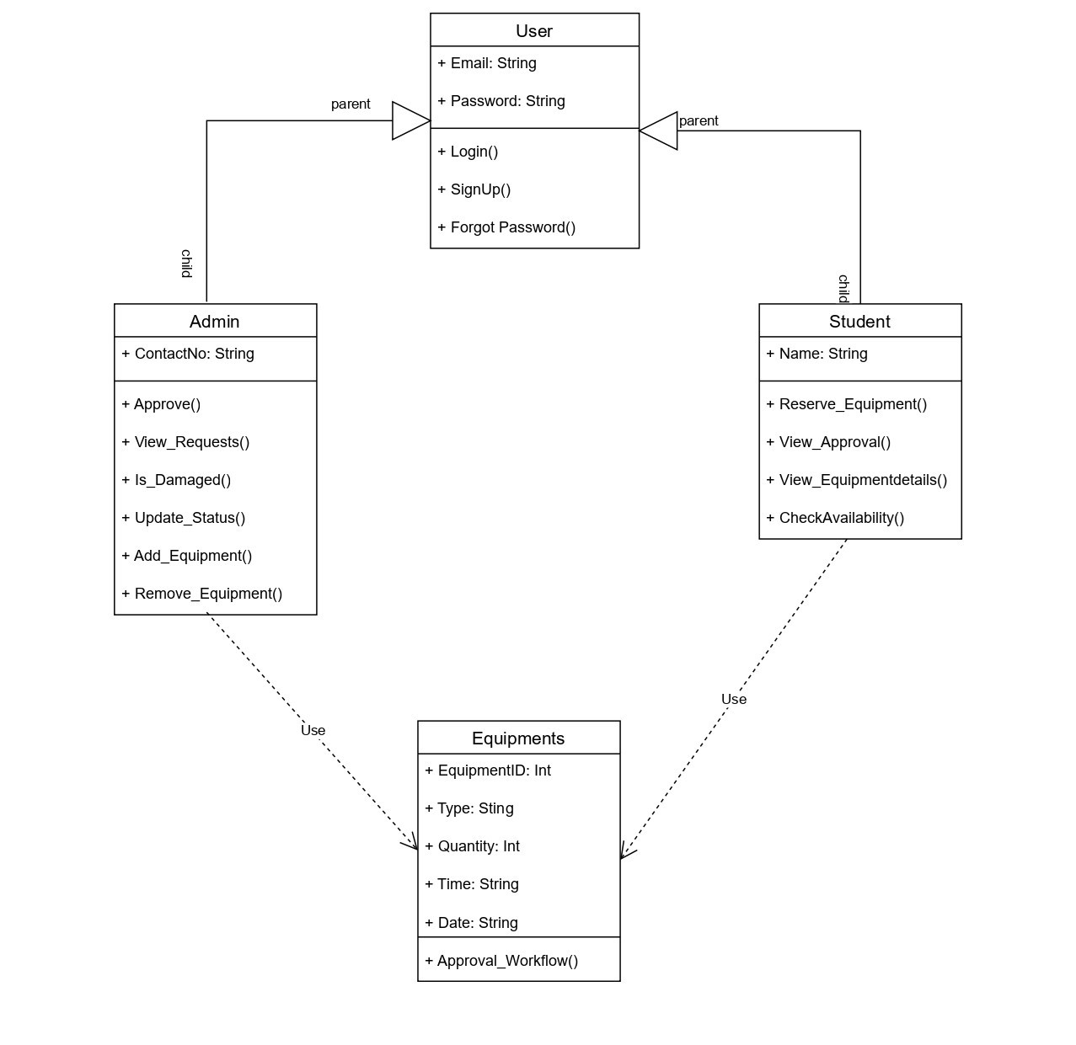

Sequence Diagram for reservation of Equipment

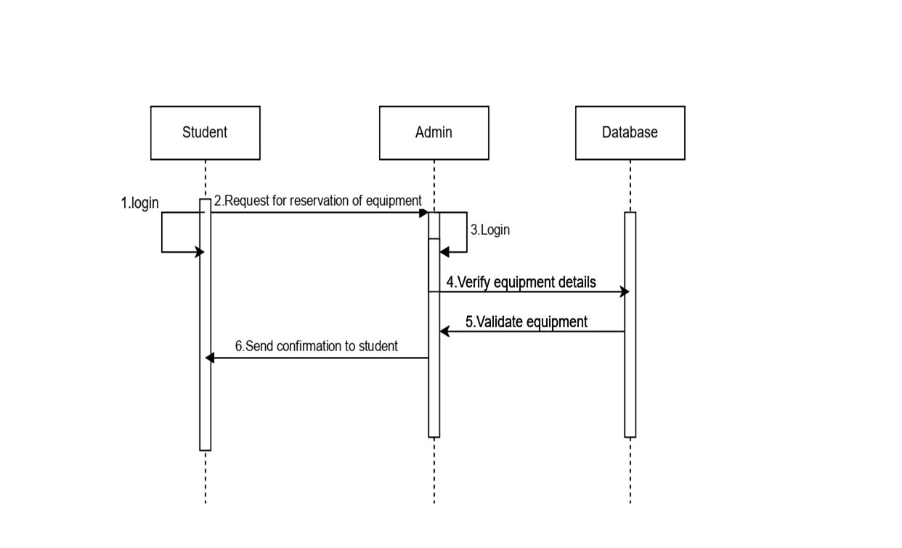

Sequence Diagram for return of Equipment

