# **WhatNext Vision Motors: Shaping the Future of Mobility with Innovation and Excellence**

# **Abstract**

**WhatsNext Vision Motors,** a pioneering force in the automotive industry, has initiated an ambitious Salesforce project aimed at revolutionizing the customer ordering process. The project introduces innovative features such as automatic dealer location suggestions based on customer address,

real-time stock availability validation, and automated order status updates for bulk records. These enhancements are designed to improve customer satisfaction, streamline operations, and boost organizational efficiency by reducing errors, administrative burdens, and delays.

# **Objective**

The primary objective of this project is to enhance the customer experience and operational efficiency by streamlining the vehicle ordering process. Specifically, it seeks to:

* Suggest the nearest dealer location to customers based on their address.
* Prevent orders for vehicles that are out of stock.
* Automate the update of order statuses in bulk, ensuring transparency and accuracy.
* Reduce manual administrative workload and enable employees to focus on strategic tasks.

# **Technology Description**

# **Salesforce**:- Salesforce is a cloud-based Customer Relationship Management (CRM) platform that helps businesses manage customer data, automate processes, and improve service, marketing, and sales operations. It provides both point-and-click tools and programmatic capabilities (like Apex, Flows, and Triggers) to build custom business solutions.

**Custom Objects:-**

Objects in Salesforce are similar to tables in a database. Custom Objects are created to store project-specific data.

**Examples for this project:**

* **Customer** – Stores customer information, including address details used for dealer suggestions.
* **Product (Vehicle)** – Stores vehicle details and availability status.
* **Order** – Stores customer orders and their status (Pending/Confirmed).
* **Dealer** – Stores information about dealer locations and stock.

**Tabs**

Tabs are used to display object data in the Salesforce UI. They allow users to easily view and manage information.

**Examples:**

* A **Product Tab** for managing vehicles.
* An **Order Tab** for tracking customer orders.
* A **Dealer Tab** for viewing dealer locations.

**Custom App**

An App in Salesforce is a collection of tabs grouped together for a specific business purpose.

**Example for this project:**  
A **Vehicle Ordering App** that includes tabs for Customer, Product, Order, and Dealer. This app allows sales teams and customers to manage the complete ordering process in one place.

**Automation Tools**

* **Flows & Process Builder** – Automate order creation, stock validation, and dealer suggestions.
* **Scheduled Jobs** – Automatically update bulk order statuses (Pending/Confirmed) based on stock availability.
* **Validation Rules** – Prevent customers from placing orders for out-of-stock vehicles.

**Profiles**

Profiles define what users can do in Salesforce, such as create, view, edit, or delete records. They control object permissions and field-level security.

**Example in this project:**

* **Sales Rep Profile** – Can create and track orders.
* **Inventory Manager Profile** – Can update stock availability.

**Roles**

Roles control data visibility in Salesforce’s role hierarchy. They are used for sharing settings and reporting.

**Example in this project:**

* **Sales Manager Role** – Can view orders created by all sales reps under them.
* **Dealer Role** – Can only see data related to their own dealership.

**Permission Sets**

Permission Sets grant additional permissions to users without changing their profile.

**Example in this project:**

* A permission set to allow certain sales reps to **override order restrictions** or access special reports.

**Validation Rules**

Validation Rules ensure data accuracy by preventing users from saving records that don’t meet certain conditions.

**Examples in this project:**

* Prevent customers from placing an order if the **vehicle stock is 0**.
* Ensure a **valid customer address** is entered before suggesting the nearest dealer.
* Require the **Order Status field** to be updated before closing an order.

**Email Templates**

Email Templates are predefined formats used for sending consistent communication to customers and internal teams.

**Examples in this project:**

* **Order Confirmation Template** – Sent when an order is successfully placed and stock is available.
* **Pending Order Template** – Sent when the order is pending due to stock unavailability.
* **Dealer Information Template** – Sent to customers with details of their nearest dealer.

**Email**

Email functionality in Salesforce is used to automatically notify customers and staff about important updates. It integrates with workflow rules, process builder, or flows to trigger messages.

**Examples in this project:**

* Automatically send an **order confirmation email** to customers when status = Confirmed.
* Notify customers with a **pending stock email** when status = Pending.
* Send an **internal notification email** to dealers whenever a new order is assigned to them.

**Flows**

Flows in Salesforce are powerful automation tools that allow complex business processes to be automated without coding. They use a point-and-click interface to define logic, collect data, and perform actions.

**Examples in this project:**

* **Dealer Suggestion Flow** – Automatically fetches the nearest dealer based on the customer’s address.
* **Order Validation Flow** – Checks vehicle stock before allowing an order to be submitted.
* **Bulk Order Update Flow** – Updates order statuses (Pending/Confirmed) in scheduled batches based on stock availability.

**Apex**

Apex is Salesforce’s object-oriented programming language that allows developers to write custom business logic when declarative tools (like Flows) are not enough.

**Examples in this project:**

* **Custom Apex Trigger** – Prevents order creation if the stock is out of stock (additional safeguard beyond validation rules).
* **Apex Batch Class** – Handles scheduled bulk order status updates efficiently for large volumes of records.
* **Apex Integration Logic** – Connects with external systems (e.g., inventory system) to fetch real-time stock availability.

**Detailed Execution of Project Phases**

**1.Deveoper Org Setup**

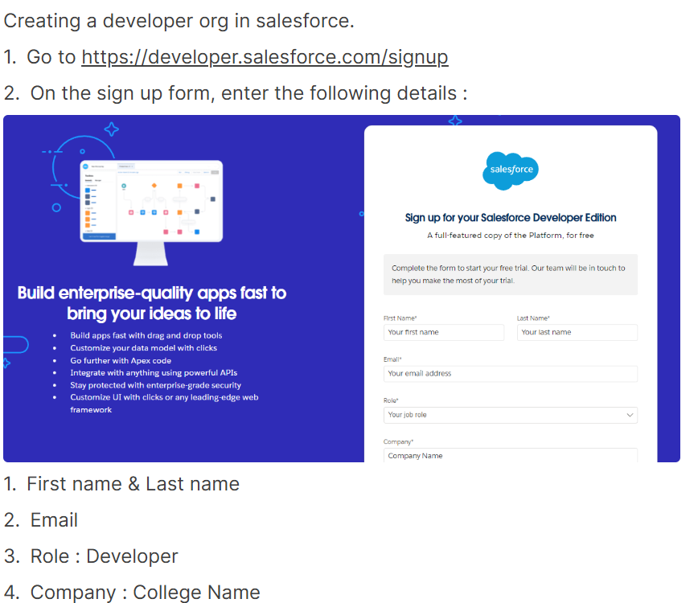

**2. Custom Object Creation**

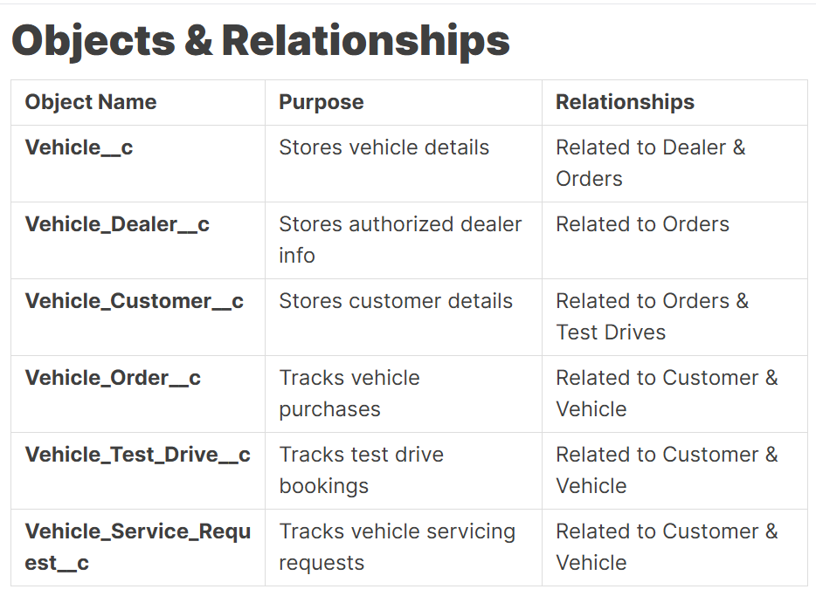

**3. Creating the Lightning App**

* The Lightning App groups together project-specific tabs (Customer, Product, Order, Dealer) into a single unified workspace.
* It provides a customized interface for different roles (Sales Reps, Managers, Dealers) to manage vehicle orders efficiently.
* The app enhances user experience and productivity by simplifying navigation and showing only relevant features to each user.

**4. Validation Rules**

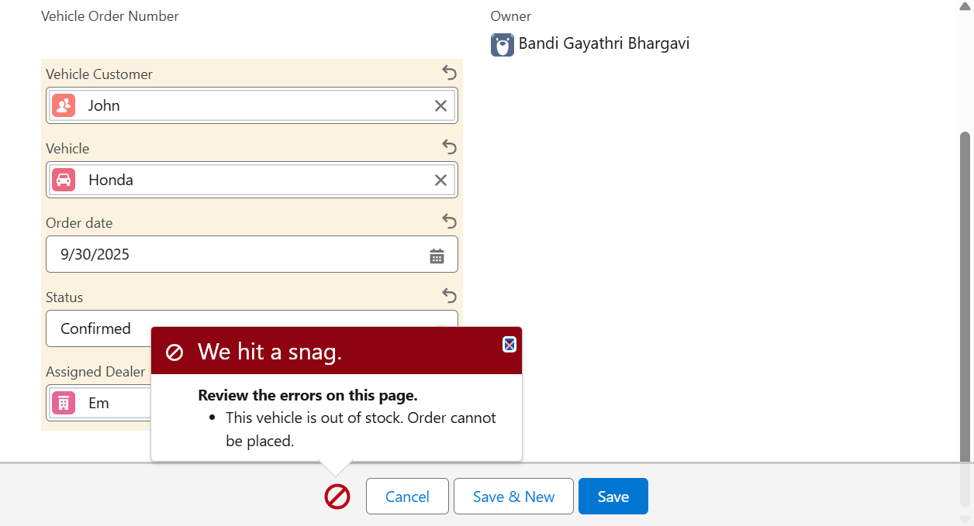

**5. User Role & Profile Setup**

* Profiles define what users can do in Salesforce, such as create, view, edit, or delete records, and control object/field-level access.
* Roles determine data visibility in the hierarchy, ensuring managers see their team’s records while users see only their own.

**6. User Creation**

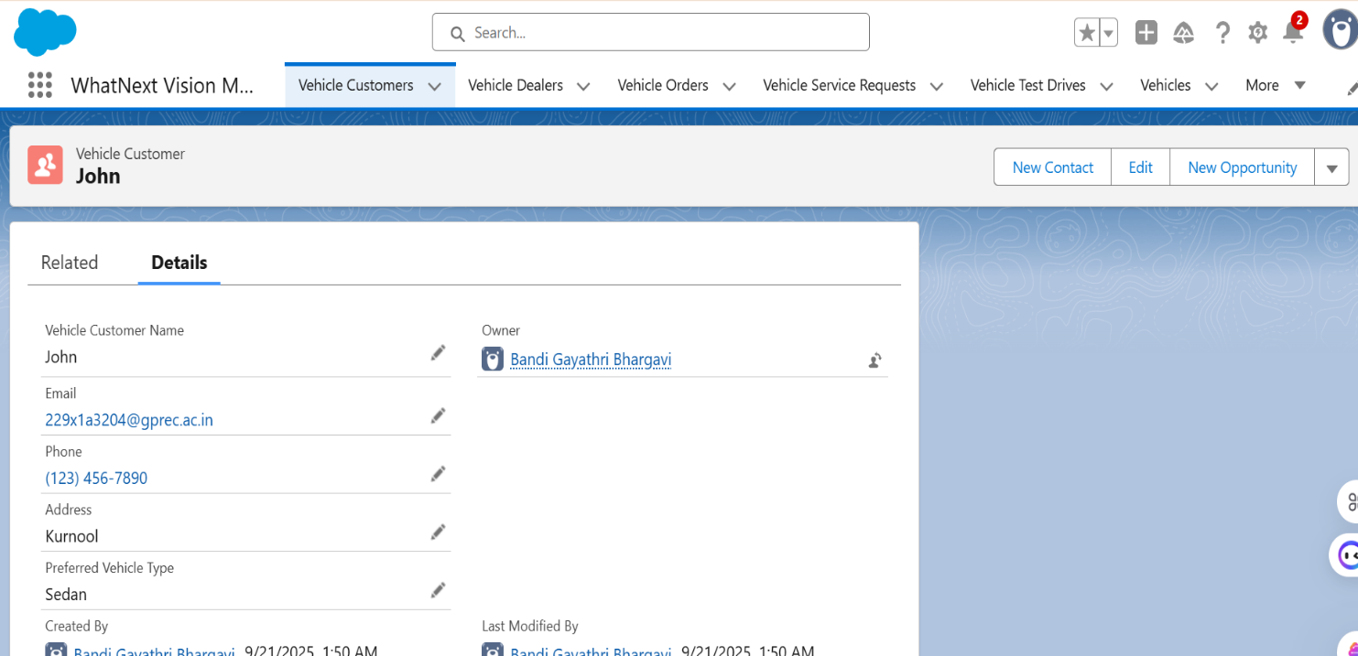

**7. Email Template & Alerts**

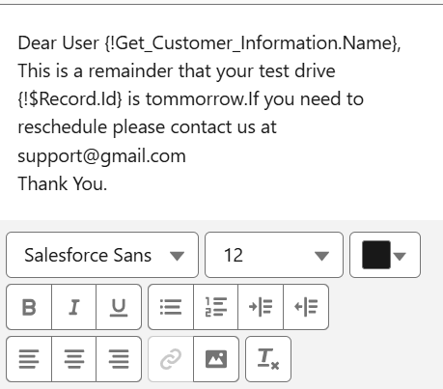

**8. Flow Implementation**

**a.**

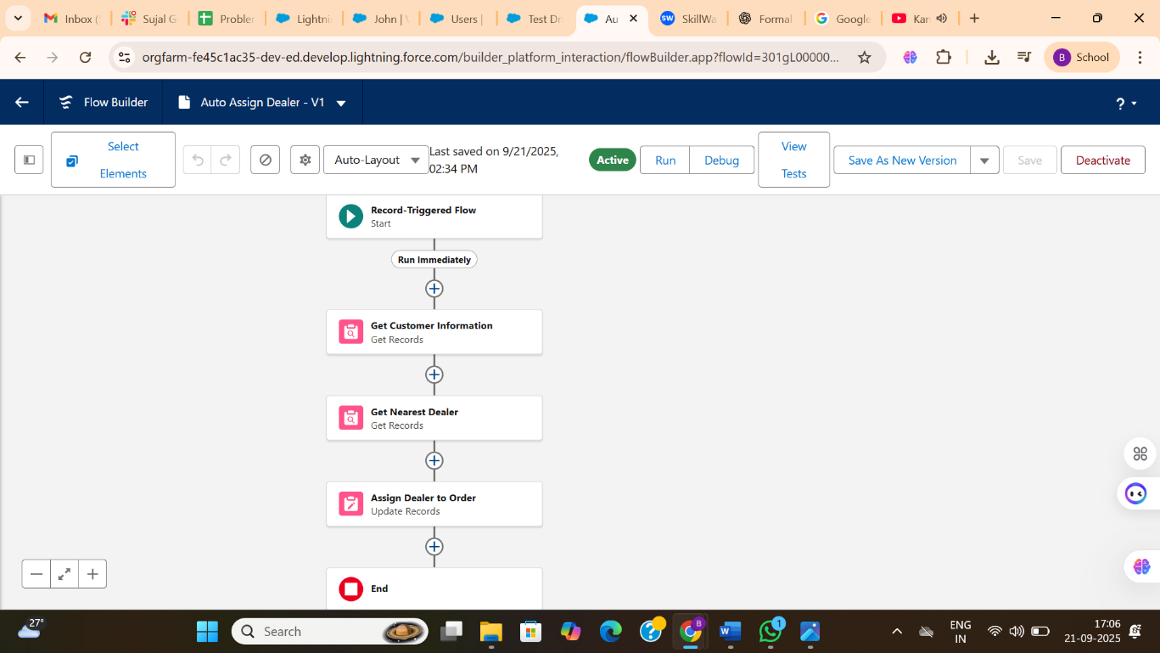

**b.**

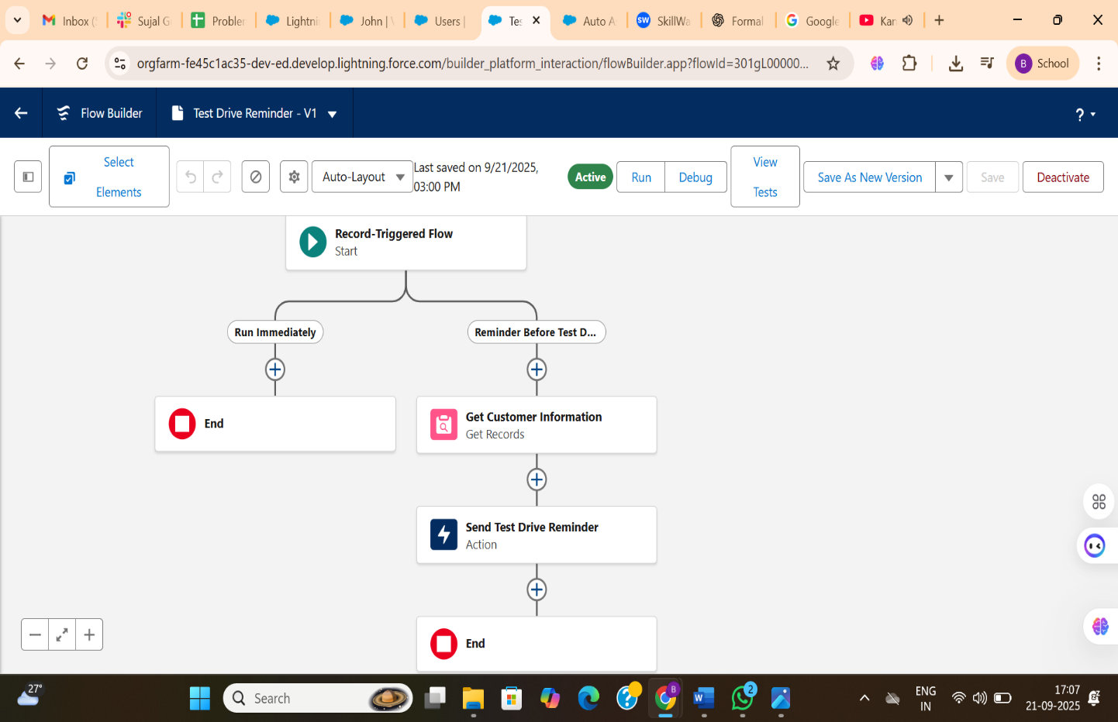

**7. Apex Triggers**

**VehicleOrderTriggerhandler**

**VehicleOrderTrigger**

**VehicleOrderBatch**

**VehicleOrderBatchScheduler**

**Project Explanation With Real-World Example**

1. **Customer Registration**

* Customers can register by providing details such as name, contact information, and address.
* The system uses the address to suggest the nearest dealer automatically.

1. **Product Setup**

* Vehicles are stored as Products in Salesforce with details like model, price, and availability.
* Stock levels are maintained to ensure customers can only order available vehicles.

1. **Order Placement**

* Customers place an order through Salesforce, selecting their desired vehicle.
* Validation rules ensure orders are only confirmed if stock is available.

1. **Inventory Update**

* Inventory managers update stock availability in real time.
* Scheduled processes automatically update order statuses (Pending/Confirmed) based on stock.

1. **Loyalty Program**

* Returning customers are rewarded with loyalty points for each purchase.
* Loyalty points can be tracked in Salesforce and redeemed for future discounts.

1. **Email Notifications**

* Customers receive automated order confirmation or pending emails.
* Dealers are notified instantly when a new order is assigned to them.

1. **Users and Roles**

* Profiles define what actions users (Sales Rep, Manager, Dealer) can perform.
* Roles control data visibility, allowing managers to see their team’s orders while dealers see only their own.

**Screenshots**

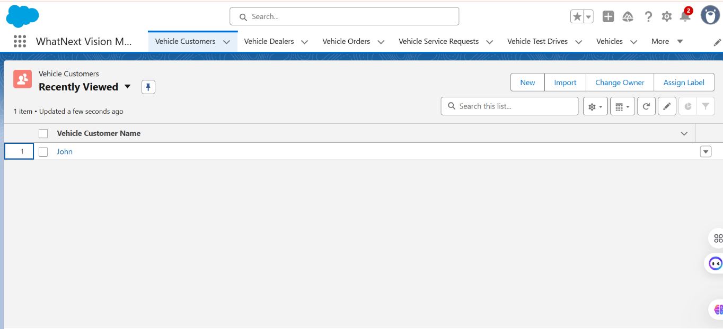

**Fig: Custom App for WhatNextVisionMotors**

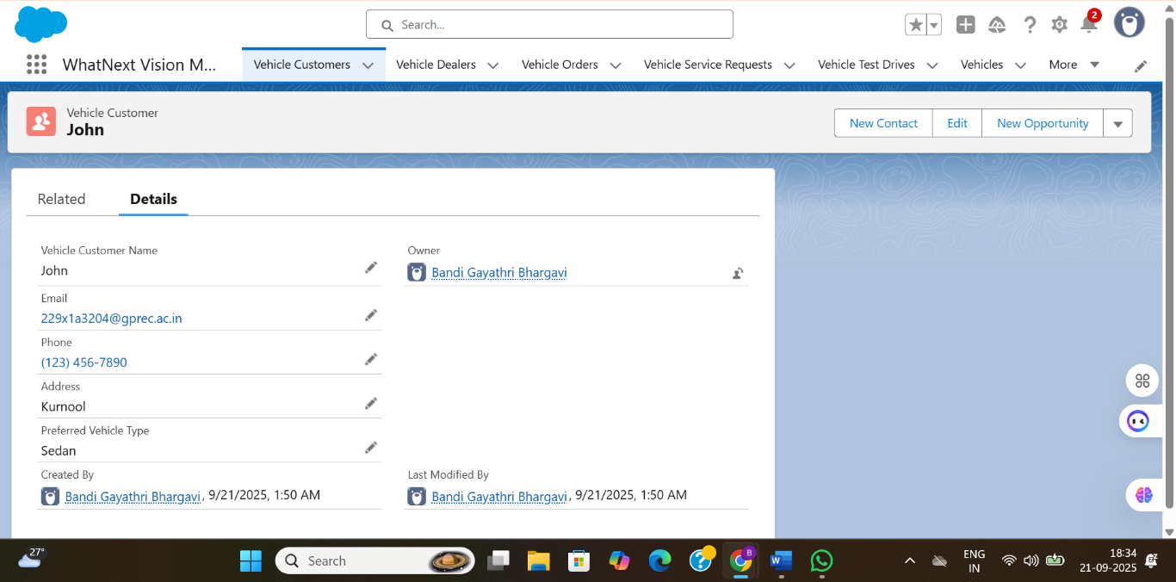

**Fig: Customer Creation for WhatNext Vision Motors**

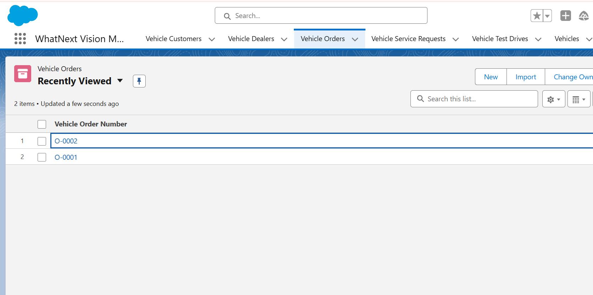

**Fig: Order Confirmation**

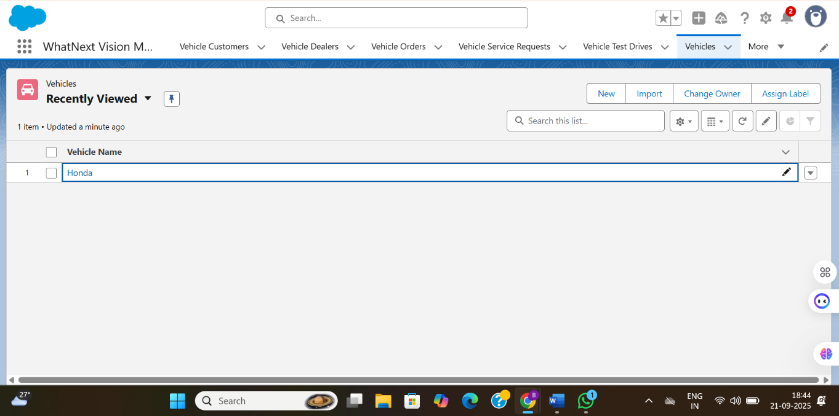

**Fig: Vehicles**

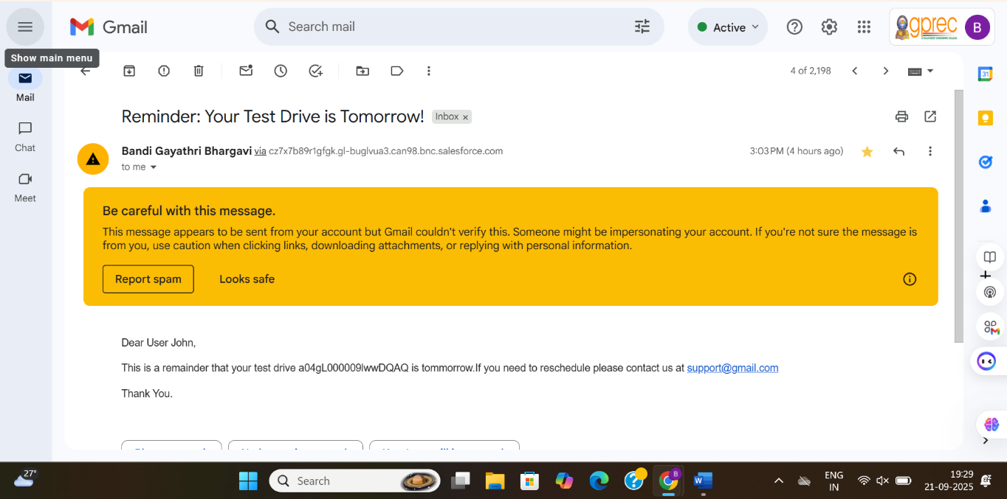

**Fig: Test Drive Email**

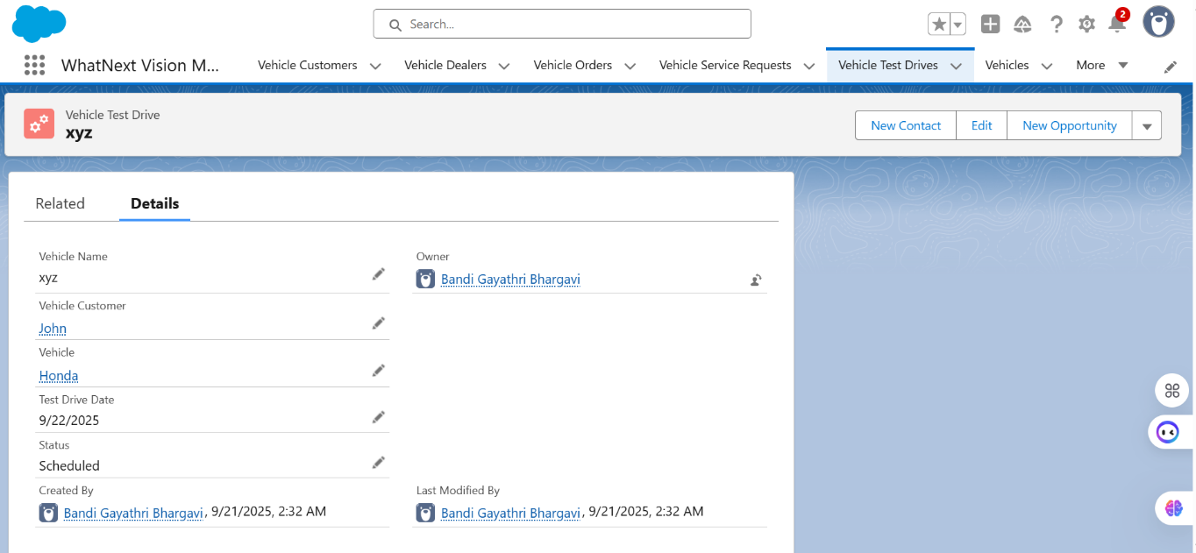

**Fig: Test Drive Requests**

**Conclusion**

The implementation of the Salesforce project at WhatsNext Vision Motors has successfully streamlined the vehicle ordering process, enhancing both customer experience and operational efficiency. By automating dealer suggestions, stock validations, and order status updates, the system reduces errors and administrative workload while ensuring transparency and accuracy.

This project demonstrates how technology can be leveraged to create a customer-friendly, efficient, and scalable solution, benefiting customers, dealers, and the company alike. The use of Salesforce tools such as Flows, Apex, Validation Rules, and Email Notifications ensures that processes are automated, reliable, and adaptable to future business needs.

**Future Scope:-**

1. **Integration with AI and Predictive Analytics** – Use AI to predictcustomer preferences, recommend vehicles, and forecast stock requirements, enhancing personalization and sales efficiency.
2. **Mobile App Integration** – Extend the system to a mobile platform, allowing customers to place orders, track deliveries, and receive notifications on-the-go.
3. **Enhanced Loyalty Programs** – Introduce advanced rewards and gamification to increase customer retention and engagement.
4. **Integration with IoT and Vehicle Telematics** – Real-time tracking of vehicle production, delivery, and inventory to optimize operations further.
5. **Expansion to Multi-Channel Sales** – Incorporate online marketplaces and third-party platforms, enabling a seamless omnichannel ordering experience.
6. **Advanced Reporting and Dashboards** – Use Salesforce analytics to provide actionable insights for sales trends, inventory management, and dealer performance.