EMS-ENKONIX

An Employee Management System (EMS) is a comprehensive digital solution designed to streamline and automate organizational processes related to workforce management. It enables businesses to efficiently handle employee data, attendance, payroll, leave requests, performance tracking, and communication within a centralized platform. By integrating various HR functions, EMS minimizes manual effort, reduces errors, and enhances transparency across departments. It supports data-driven decision-making, ensuring compliance with organizational policies and labor regulations. With real-time access and reporting features, EMS empowers HR professionals and management to improve productivity, foster employee engagement, and create a structured, efficient, and collaborative workplace environment.
Login Page
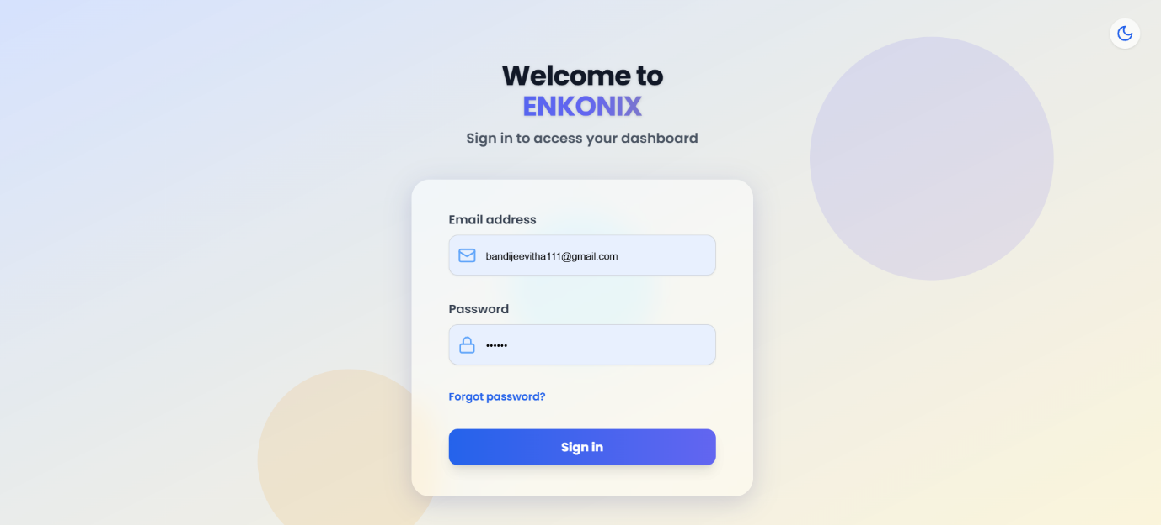
The first screenshot shows the login screen for the EMS system. Its key functionalities are:
- Welcome Message:
Displays a greeting with the company name (ENKONIX) and prompts the user to sign in to access their dashboard.
- Login Credentials:
  - Email Address Field → The user enters their registered email ID.
  - Password Field → The user enters their secure password.
- Forgot Password Option:
Provides a link to reset the password in case the user forgets it.
- Sign In Button:
On clicking this, the system validates the entered credentials against the database.
- Theme Toggle:
A small icon in the top-right corner allows switching between light mode and dark mode for better user experience.
✅ Purpose: Secure authentication and controlled access to the EMS dashboard.

Shift Status Checker Page
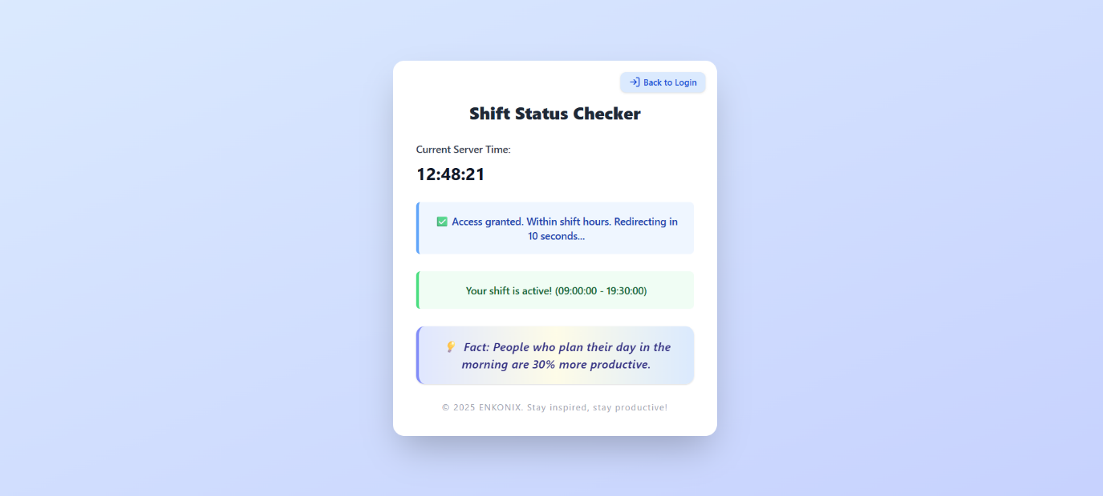
Once a user successfully logs in, they are redirected to the Shift Status Checker page. This acts as an access gate that verifies whether the login is within assigned working hours.
- CurrentServerTime:
Displays the exact time from the server to ensure accuracy.
- Access Validation:
  - If login time is within assigned shift hours, access is granted.
  - If outside the shift, access would be denied with a message.
- ShiftStatus:
Example shown: Your shift is active (09:00:00 – 19:30:00) → indicates the employee is logging in during valid working hours.
- Auto-Redirection:
The page shows a success message like:
“Access granted. Within shift hours. Redirecting in 10 seconds…”
After this countdown, the user is automatically redirected to their main dashboard.
- Productivity Tips:
The system also shows a motivational fact/quote, e.g.:
“People who plan their day in the morning are 30% more productive.”
→ This encourages positive work habits.
✅ Purpose: To ensure employees log in only during their authorized working hours, improving security, discipline, and monitoring.

Overall Flow
- User enters credentials on the Login Page.
- System validates login → redirects to Shift Status Checker.
- Shift validation:
  - If within shift hours → grants access and redirects to dashboard.
  - If outside shift hours → denies access, preventing unauthorized login.
- Dashboard access is granted only after successful shift verification.
Left Sidebar (Navigation Menu)
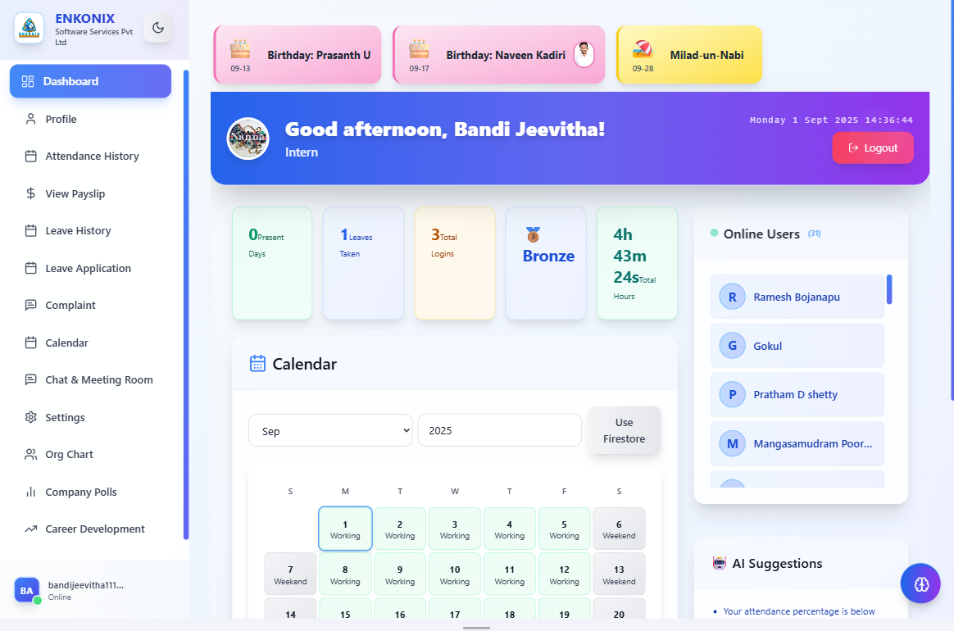
- Logo & Company Name ("ENKONIX Software Services Pvt Ltd") → Branding of the HR system.
- Dashboard → Main overview page (attendance, tasks, announcements).
- Profile → Employee personal details, contact info, job info.
- Attendance History → Detailed log of check-ins/outs, late marks, overtime.
- View Payslip → Monthly salary breakdown (earnings, deductions, net pay).
- Leave History → (Current Page) Shows employee’s past leaves, status, balance.
- Leave Application → Apply for new leave.
- Complaint → File grievances/issues to HR/admin.
- Calendar → Organization-wide events, holidays, leave mapping.
- Chat & Meeting Room → Internal messaging & meetings (like MS Teams/Slack).
- Settings → Personal and system preferences (password, theme, notifications).
- Org Chart → Visual company hierarchy.
- Company Polls → Vote in company-related surveys/polls.
- Career Development → Training, promotions, skill development modules.

Dashboard Overview 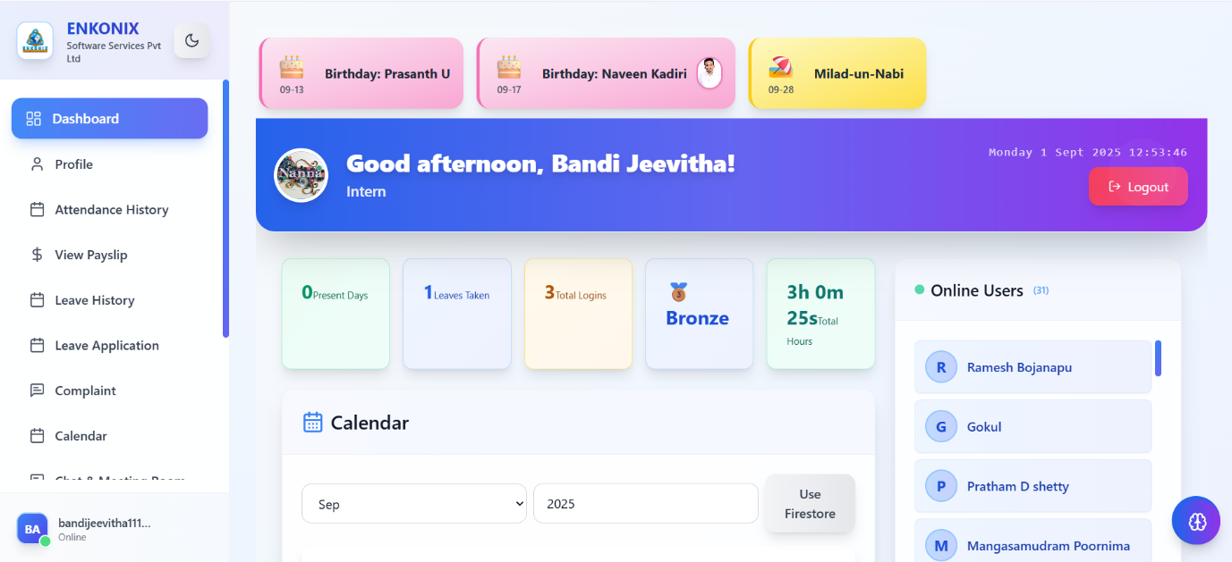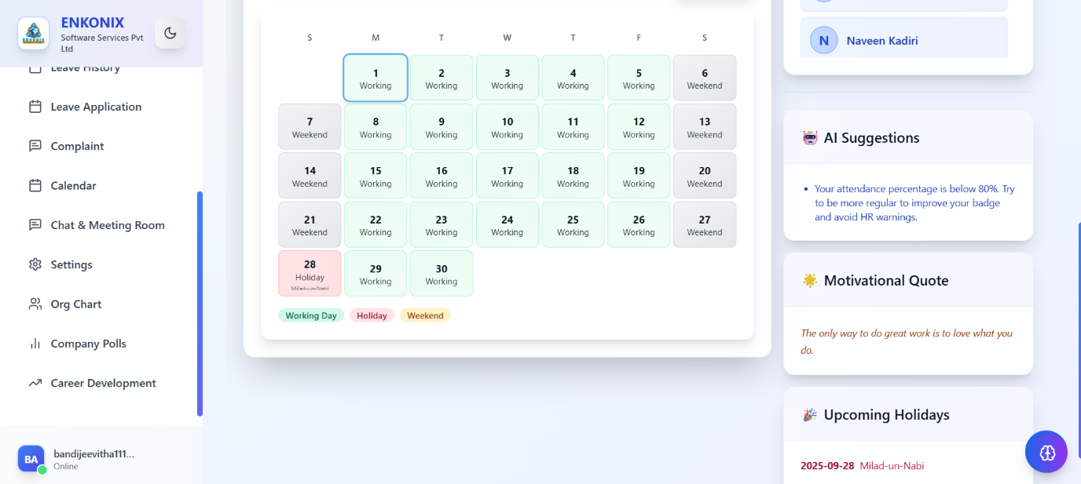
- Greeting Section: Personalized welcome message with user’s role (e.g., Intern).
- Quick Stats:
  - Present Days – Total number of working days attended.
  - Leaves Taken – Number of approved leave days.
  - Total Logins – Count of successful logins.
  - Badge System (Bronze/Silver/Gold) – Gamified performance tracking.
  - Total Hours – Sum of working hours logged.
- Reminders & Events:
  - Shows Birthdays and Holidays for easy tracking.
- Calendar: Displays month-wise schedule and allows navigation between months.
- Online Users: Shows a list of currently active employees (real-time).
- Logout Button: Securely ends the session.
Calendar & AI Assistance
- Calendar View:
  - Marks Working Days, Weekends, and Holidays.
  - Example: 28th Sept = Milad-un-Nabi holiday.
- AI Suggestions:
  - Provides smart recommendations, e.g., “Your attendance percentage is below 80%...”.
  - Helps employees improve performance and avoid HR warnings.
- Motivational Quotes:
  - Boosts morale with daily motivational messages.
- Upcoming Holidays:
  - Lists company-declared holidays in advance for planning.
✅ In summary:
The Dashboard module is a central hub where employees can:
- Track attendance, leaves, and work hours.
- Access company-wide events, birthdays, holidays.
- Get AI-based suggestions for performance improvement.
- Stay connected with colleagues (via online users, chat, polls).
- Manage personal and professional information.
Profile Module 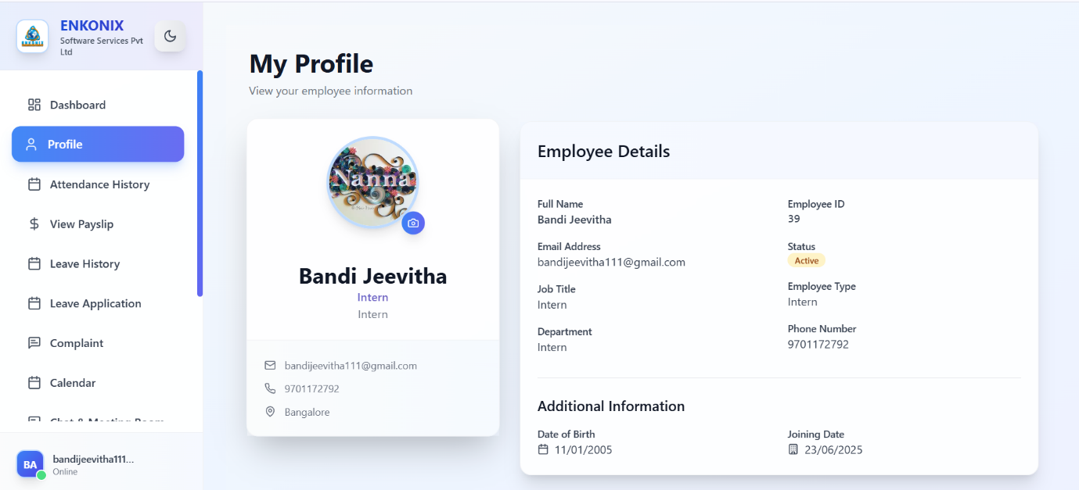
📌 Purpose: Stores and displays employee personal and professional information.
- Profile Picture → Employee can upload/change their profile photo.
- Employee Name & Role → Shows Bandi Jeevitha – Intern.
- Contact Details → Email ID, phone number, location (Bangalore).
- Employee Details:
  - Employee ID → Unique identifier (39).
  - Status → Active/Inactive status of employee.
  - Employee Type → Intern, Full-time, Contract, etc.
  - Department → Associated department (Intern in this case).
- Additional Information:
  - Date of Birth → 11/01/2005.
  - Joining Date → 23/06/2025.
👉 This helps HR and employees track identity, status, and employment details.

Attendance History 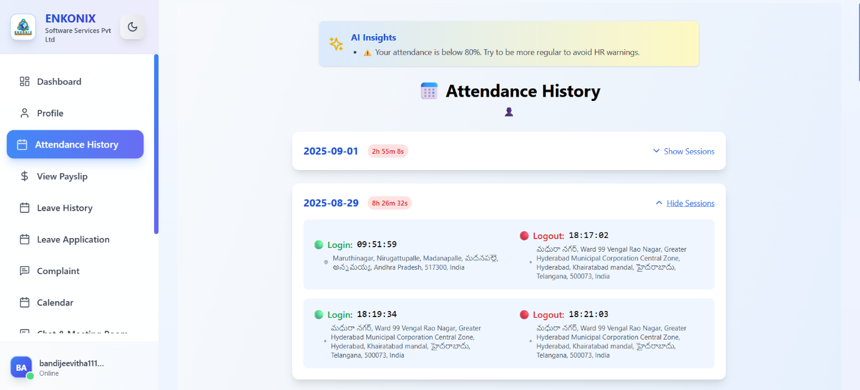
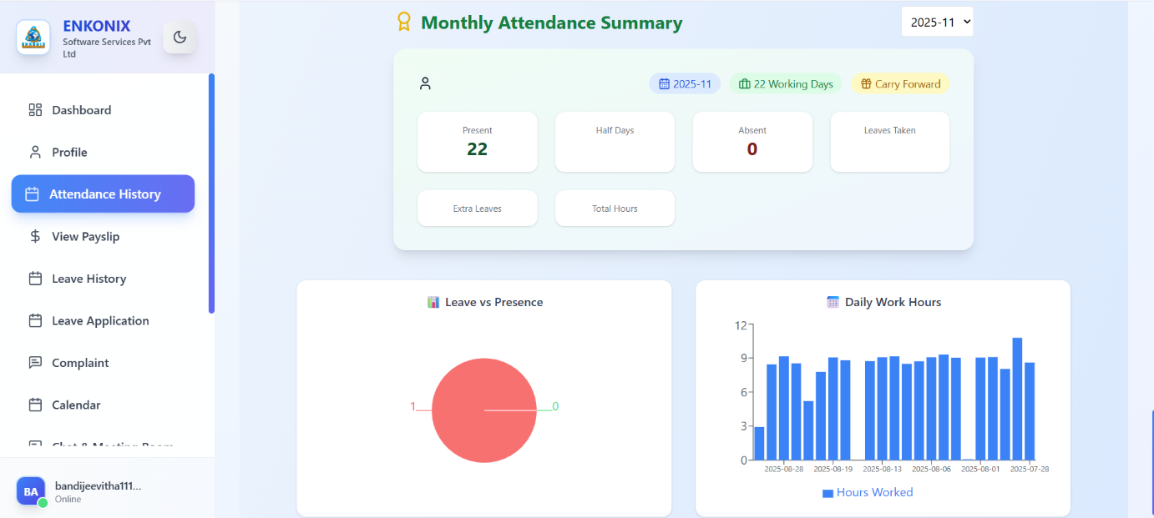
📌 Purpose: Tracks daily login/logout sessions, locations, and total hours worked.
Daily Log Records (Screenshot 2)
- Date-wise Records: Example → 2025-09-01 worked 2h 55m 8s.
- Login/Logout Times: Exact timestamps (e.g., 09:51:59 login, 18:17:02 logout).
- Geo-location: Captures login/logout location for compliance & security.
- AI Insights: Smart warnings (e.g., “Attendance below 80%...”).
Monthly Attendance Summary
- Summary Cards:
  - Present Days → Count of attended days (22).
  - Half Days → Tracked if employee logged half-day work.
  - Absent Days → Zero in this case.
  - Leaves Taken → Official leaves applied/approved.
  - Extra Leaves → Leaves beyond allowed quota.
  - Total Hours → Accumulated working hours for the month.
- Graphs & Charts:
  - Leave vs Presence → Pie chart comparing leaves with attended days.
  - Daily Work Hours → Bar chart of logged working hours (e.g., 3–12 hrs range).
👉 This helps in performance analysis, payroll processing, and HR compliance.

Payslip Module
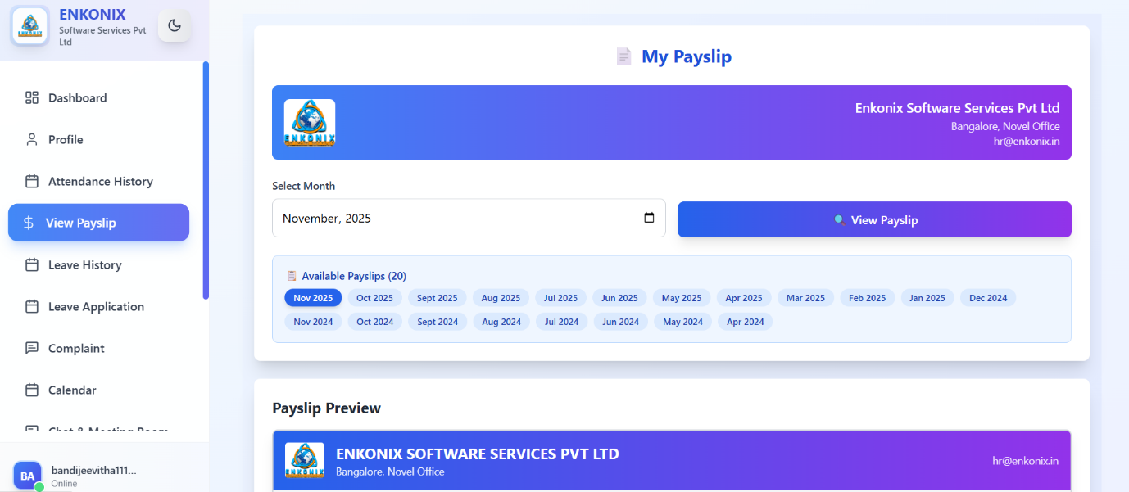
📌 Purpose: Provides digital salary slips month-wise for employees.
- Select Month Dropdown → Choose a specific month (e.g., November 2025).
- Available Payslips List → All downloadable payslips (20 months available: Nov 2025 to Apr 2024).
- Payslip Preview:
  - Displays company details (Enkonix Software Services Pvt Ltd).
  - Employee salary details (basic, allowances, deductions, net pay).
  - HR contact (hr@enkonix.in).
👉 Ensures easy salary transparency & record-keeping.

Key Functionalities Across All Screens
✅ Profile → Manage personal/employee details.
✅ Attendance History → Track daily login/logout and monthly stats.
✅ Monthly Attendance Summary → Get performance and presence insights.
✅ Payslip → Secure, month-wise salary management.
Leave History
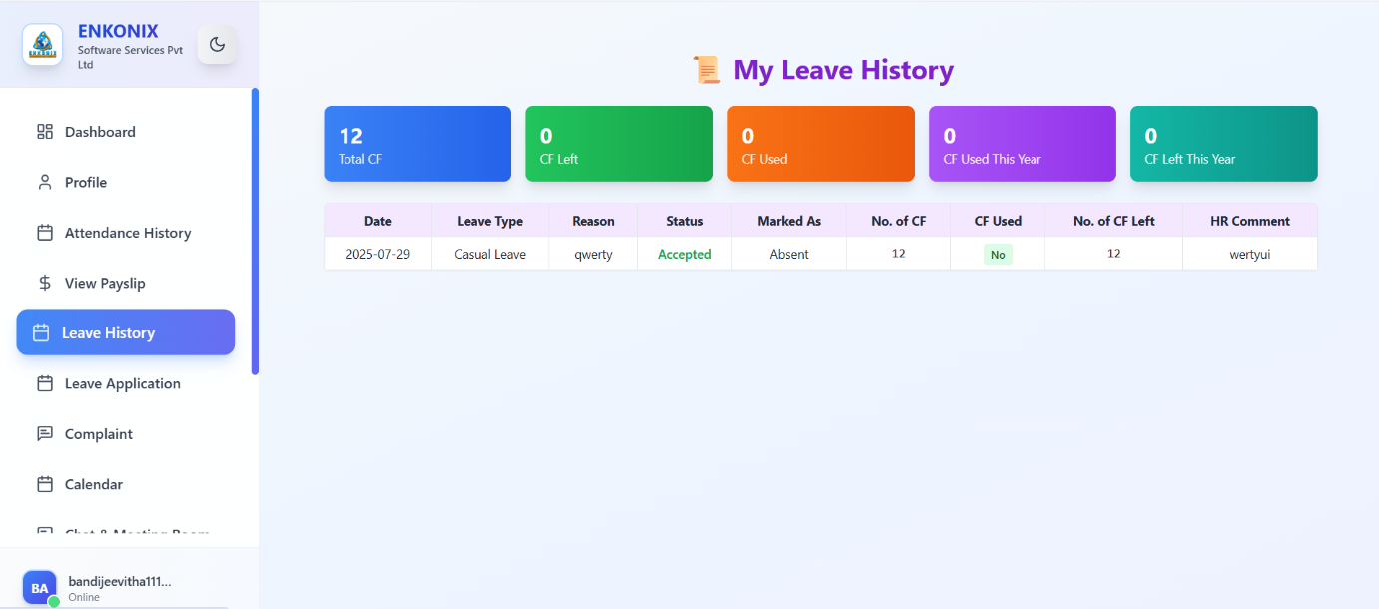
Main Panel (Leave History Section)
- Header: "My Leave History" → Title of the section.
- Colored Cards (Summary of Leave Balance)
  - 12 Total CF → Total Casual/Compensatory/Carry Forward leaves assigned.
  - 0 CF Left → Remaining balance (currently none).
  - 0 CF Used → No carry forward leave used yet.
  - 0 CF Used This Year → Zero used in the current year.
  - 0 CF Left This Year → Zero left for this year.
- Leave Records Table
  - Date → Leave date (e.g., 2025-07-29).
  - Leave Type → Casual Leave (CL, usually limited to a few days).
  - Reason → Employee’s justification ("qwerty" in test case).
  - Status → Accepted (approved by manager/HR).
  - Marked As → Absent (system marks attendance accordingly).
  - No. of CF → Total casual/compensatory leaves allocated (12).
  - CF Used → Shows if leave was adjusted from carry forward (here → "No").
  - No. of CF Left → Balance after applying (12 left here).
  - HR Comment → HR’s note/remark ("wertyui" in demo).
✅ Functionality: This page is a leave ledger – employees can track approvals, balances, and HR comments.

Leave Application Portal
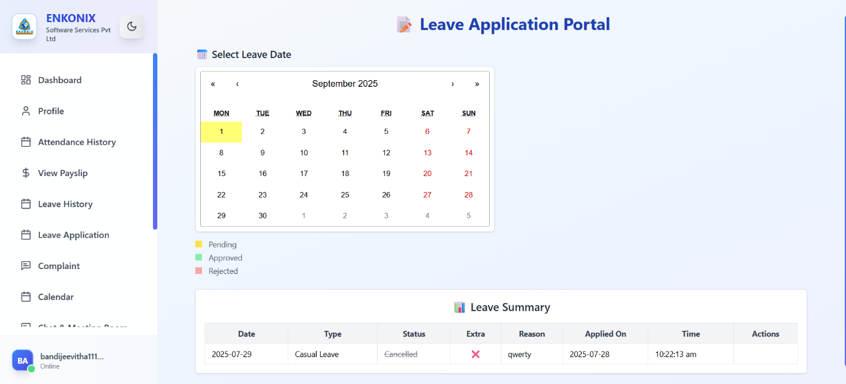
Calendar Section
- Calendar (September 2025) → Select leave date(s).
  - Highlight Colors:
    - Yellow → Pending approval.
    - Green → Approved.
    - Red → Rejected.
Leave Summary Table
- Date → 2025-07-29 (leave date).
- Type → Casual Leave.
- Status → Cancelled (employee/HR cancelled after request).
- Extra → Indicates if it was additional beyond quota (❌ = not extra).
- Reason → "qwerty".
- Applied On → 2025-07-28 (application submission date).
- Time → 10:22:13 am (time of application).
- Actions → Usually buttons (Edit/Delete/View) – blank in screenshot.
✅ Functionality: This page allows employees to apply for leave, track status (pending/approved/rejected/cancelled), and check application logs.

Complaint Module
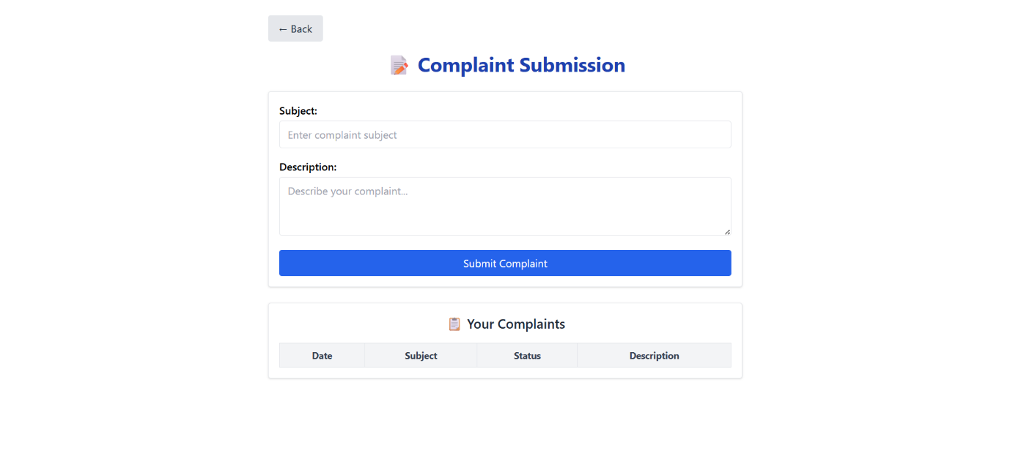
- Employees can submit complaints by filling in:
  - Subject → Short title of the complaint.
  - Description → Full details of the issue.
- After clicking Submit Complaint:
  - The complaint is saved in the system.
  - It shows up in the Your Complaints list below.
- In the Your Complaints section, employees can see:
  - Date – when it was submitted.
  - Subject – title of the complaint.
  - Status – Pending, In Progress, Resolved, or Rejected.
  - Description – details of the issue.
- The Back button takes the user to the previous page.
👉 In short: Employees raise issues here, track their status, and HR/Admin updates the resolution.
Attendance Calendar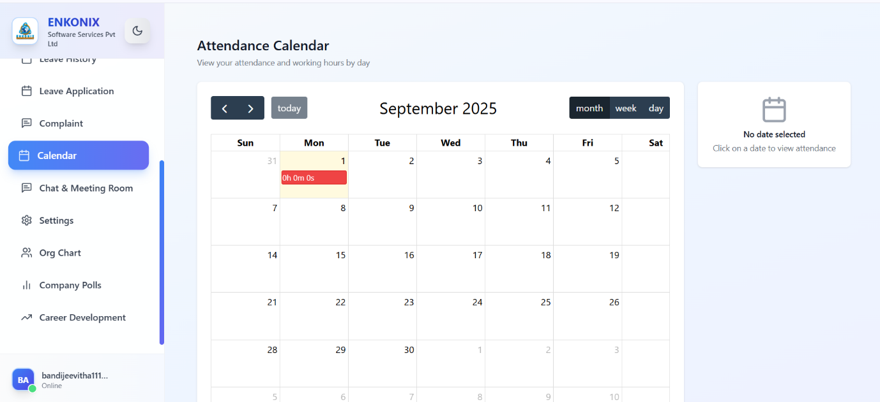
This tracks daily attendance & working hours.
- Month/Week/Day View Toggle – Switch calendar display.
- Today Button – Jump back to the current day.
- Calendar View (Sept 2025 Example):
  - Each date shows logged working hours.
  - On 1st September, it shows 0h 0m 0s (meaning no attendance recorded).
- Right-side panel: Shows details for the selected date (currently “No date selected”).
- Helps employees/managers monitor punctuality & productivity.

Chat & Meeting Room
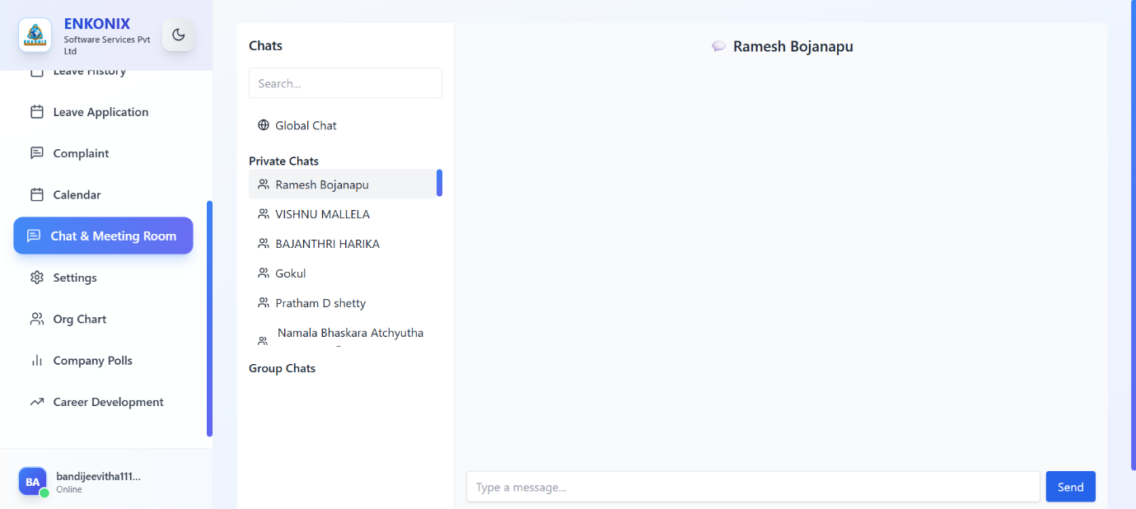
Main Panel
- Chats Section
  - Search Box → Find colleagues by name.
  - Global Chat → Company-wide chat (everyone can see).
  - Private Chats → One-on-one chats with employees (list shown: Ramesh, Vishnu, Harika, Gokul, etc.).
  - Group Chats → Teams/project groups (not shown here, but supported).
- Chat Window
  - Selected Chat (Ramesh Bojanapu) → Active conversation.
  - Typing Box → Input field ("Type a message…").
  - Send Button → Sends text to selected person.
✅ Functionality: Works like Slack/MS Teams/Workplace Chat – real-time messaging, meetings, and collaboration.

Settings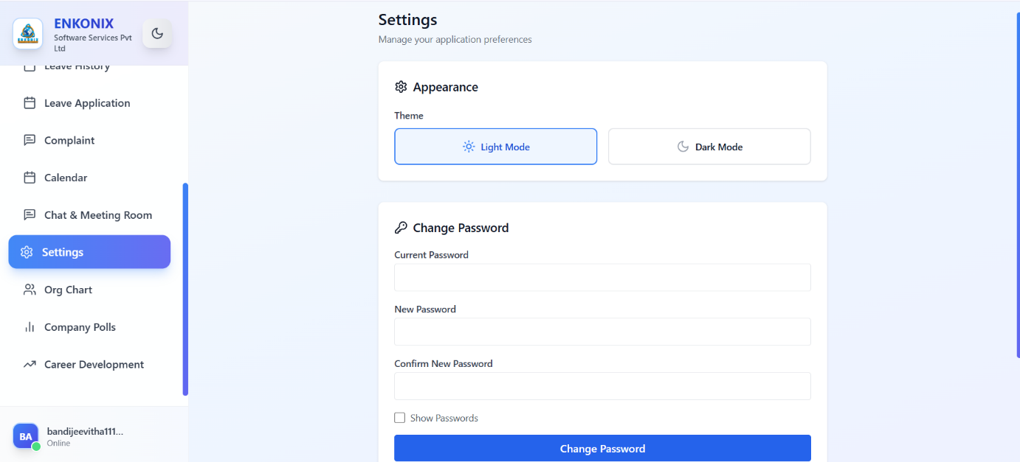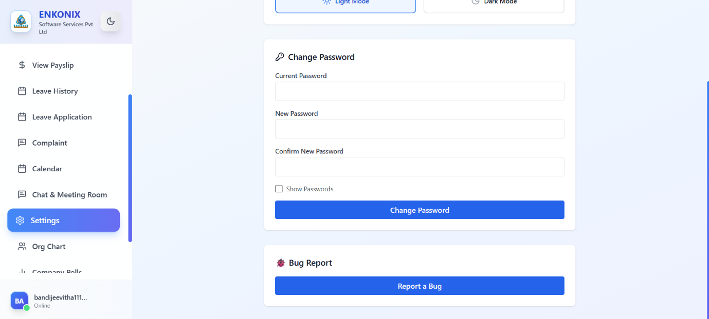
Customize preferences & security.
Features:
- Appearance:
  - Switch between Light Mode 🌞 and Dark Mode 🌙.
- Change Password:
  - Enter current password.
  - Set new password.
  - Confirm it.
  - Option to “Show Passwords” before saving.
- Bug Report :
  - Report system issues directly to IT/Admins.

Bug Report
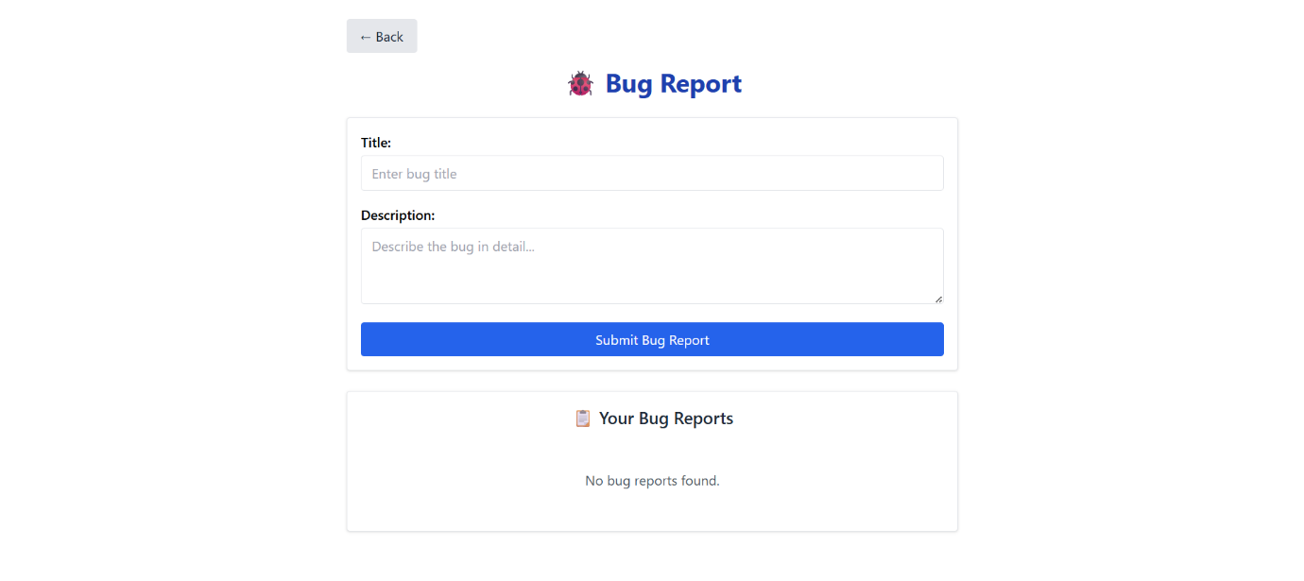
- Allows users to report software glitches or issues.
- Form:
  - Title → Short description of the bug.
  - Description → Detailed explanation.
  - Submit Bug Report button.
- Bug History Section:
  - Shows previously reported bugs (currently none).

Company Org Chart
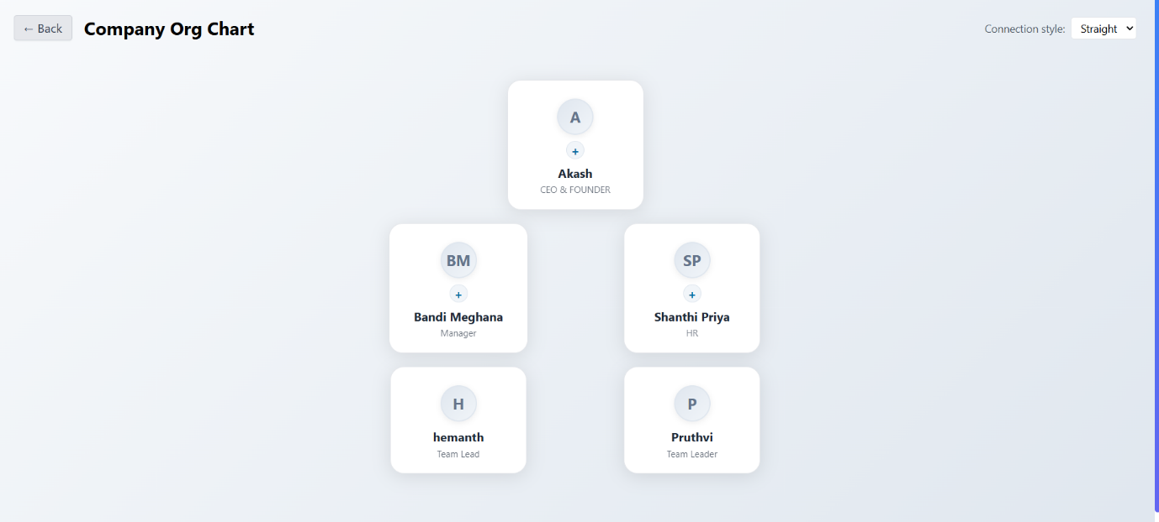
Displays the company hierarchy visually.
- Top-Level: CEO & Founder (Akash).
- Mid-Level: Manager (Bandi Meghana) & HR (Shanthi Priya).
- Lower-Level: Team Leads (Hemanth, Pruthvi).
- Connection Style: Can toggle between different chart layouts (Straight, Curved, etc.).
- Helps employees understand reporting structure & team hierarchy.

Voting & Polls
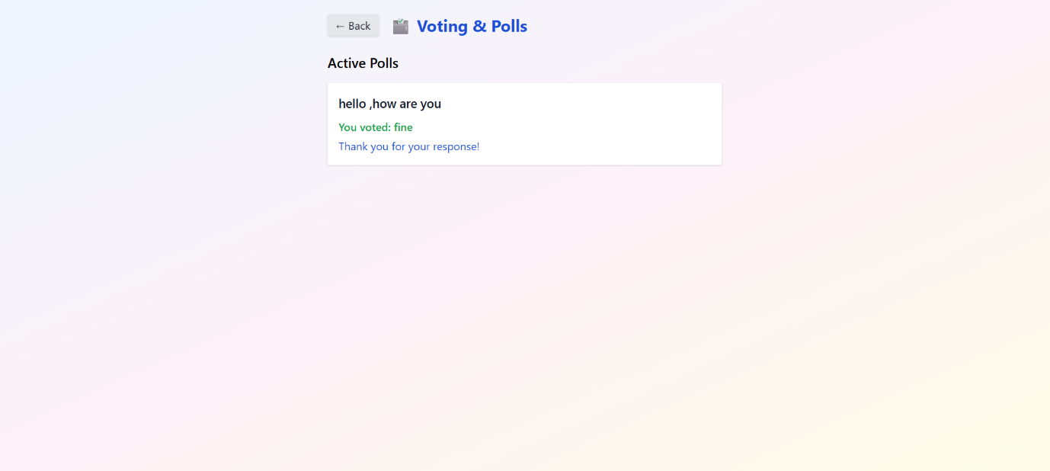
- Shows active polls created in the system.
- Users can cast their votes on available questions (e.g., “hello, how are you”).
- Once voted, it displays:
  - ✅ The option you selected
  - ✅ A confirmation message (“Thank you for your response!”).
- Helps gather quick feedback, opinions, or employee engagement insights.

CareerDevelopment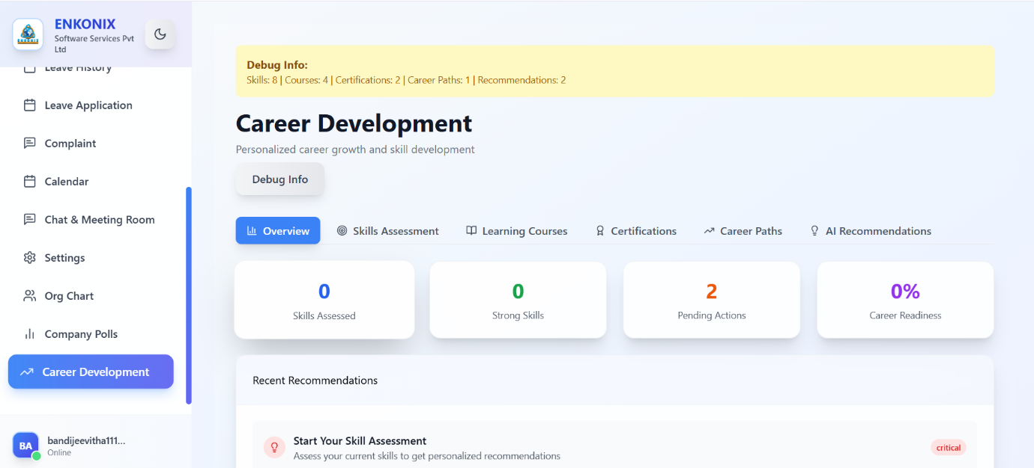
This module focuses on employee growth & skill-building.
Features:
- Debug Info (Admin/Dev-only view): Shows backend stats like Skills, Courses, Certifications, Career Paths, and Recommendations.
- Overview Dashboard:
  - 🔹 Skills Assessed → Number of skills already tested.
  - 🔹 Strong Skills → Recognized key strengths.
  - 🔹 Pending Actions → Tasks to complete (e.g., skill tests, certifications).
  - 🔹 Career Readiness (%) → Progress towards being career-ready.
- Tabs at Top:
  - Skills Assessment – Take assessments to measure abilities.
  - Learning Courses – Suggested training or learning paths.
  - Certifications – Track achieved or required certifications.
  - Career Paths – Recommended career journeys within the company.
  - AI Recommendations – Personalized suggestions using AI.
- Recent Recommendations – E.g., “Start Your Skill Assessment” with urgency level (critical).

