I have downloaded input data set from below site for my :

<https://catalog.data.gov/dataset?res_format=XML>

dataset: LA_2010CensusPopulationsbyZipCode.xml

creating hive table :

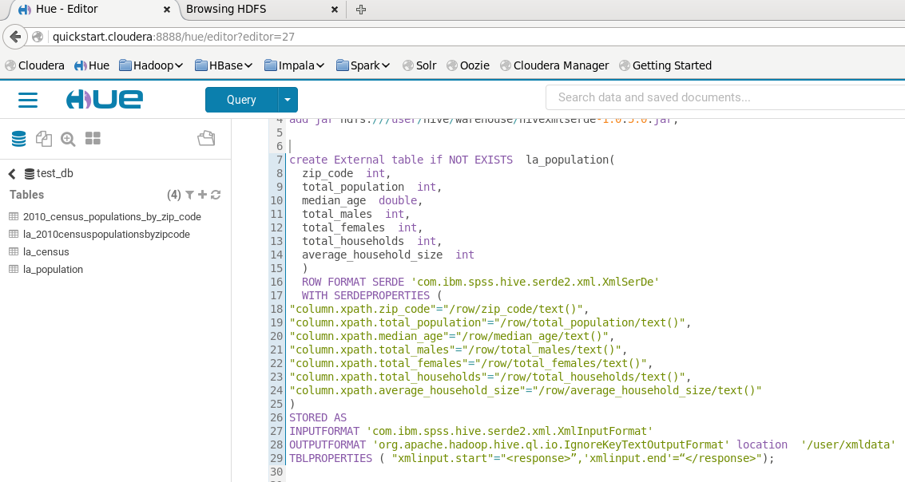

Creating Hive view:

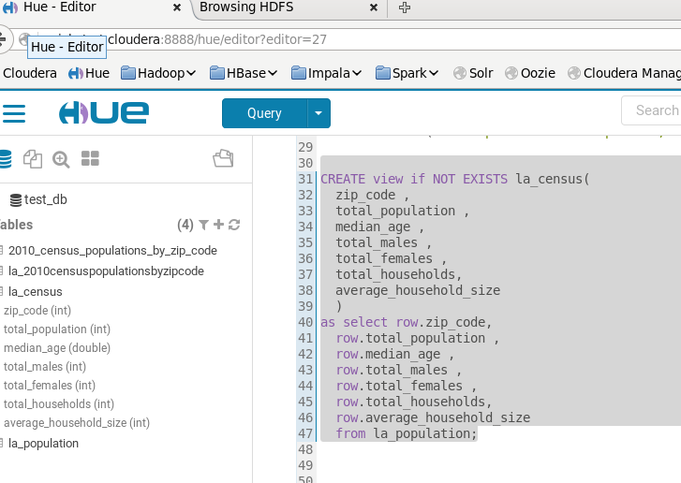

output of view:

