Name – BandiSreesaicharan

Roll – 2403A54088

Batch – 03(Data science)

Task Assignment - 01

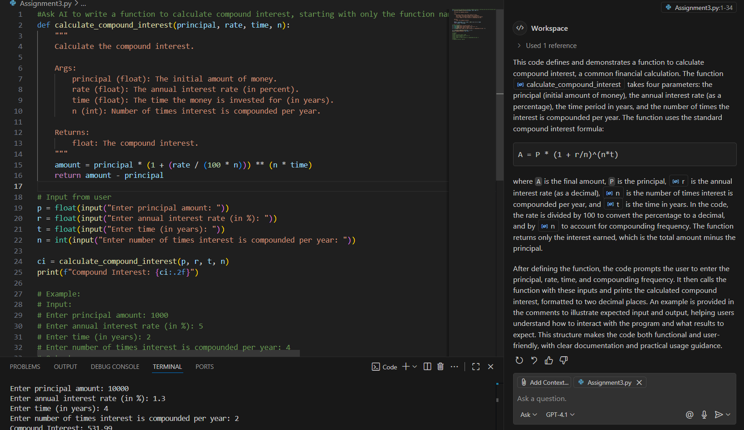  
  
Task Assignment – 02:   
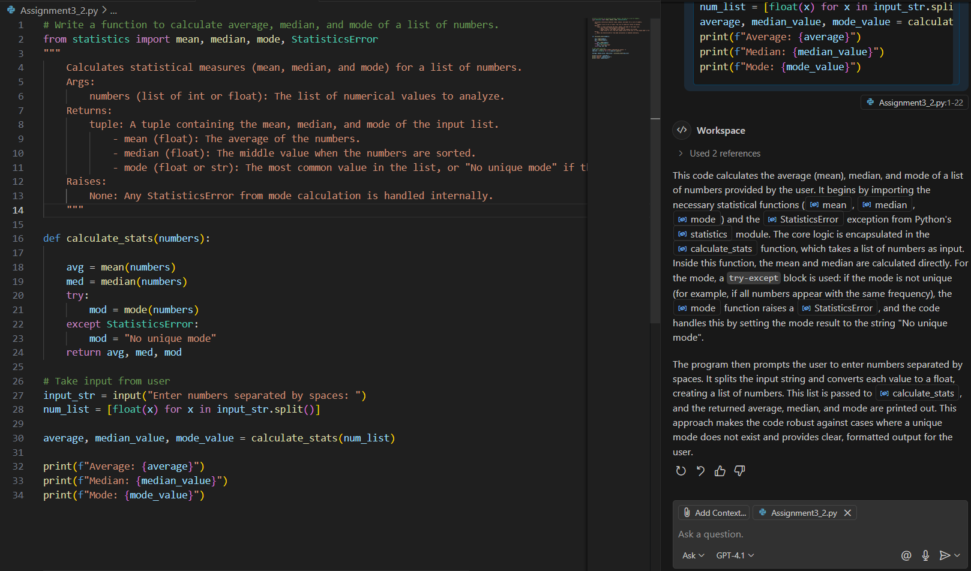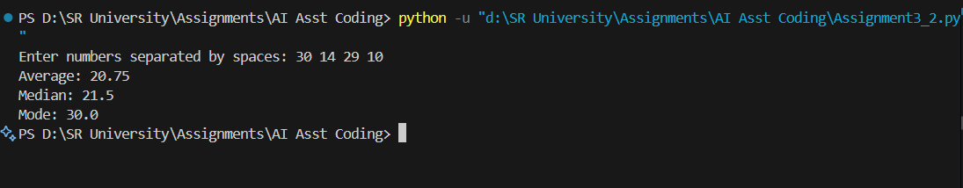

Task Assignment – 03:

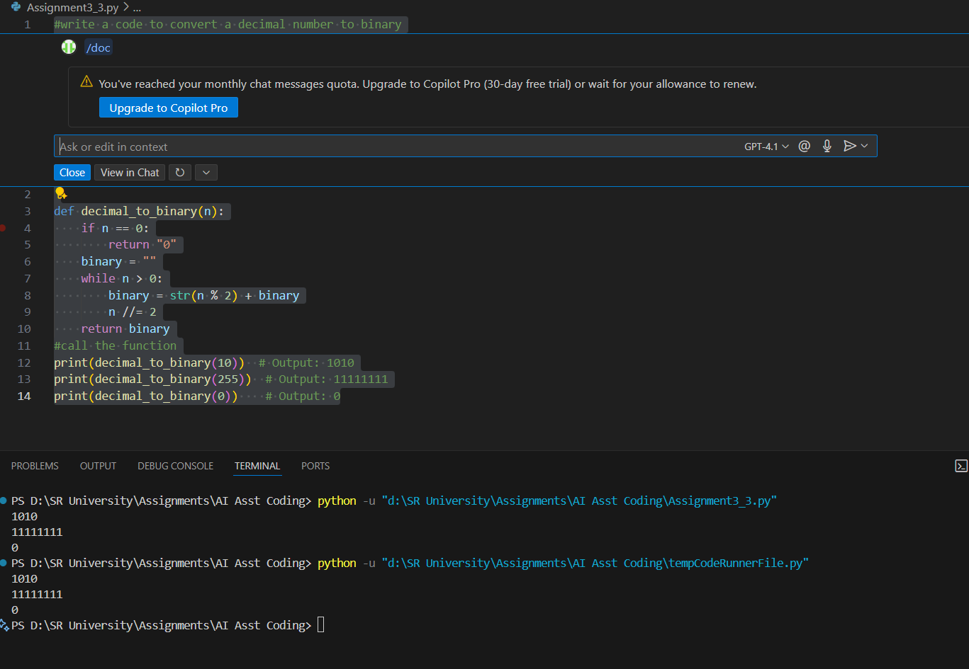

Tast Assignment – 04:

